FORESIGHT
AI Model Testing and Evaluation Report
Problem definition, data, training, evaluation, robustness, limitations and deployment verification of the Foresight spoilage classifier.

Project: Foresight — visual produce-spoilage estimation (research prototype)
Document: F — AI model testing and evaluation
Date: 17 October 2026
Workspace: /Users/nandu/Downloads/foresight
Deployed model: vit_b16_primary@epoch9 (backend/models/foresight_vit.pt)
Every number in this document is generated by releases/final_review/build/build_reports.py from saved run logs and result files; nothing is hand-entered. Labels such as NOT RUN, NOT AVAILABLE, BLOCKED or SIMULATED mark results that do not exist.

Contents
1 Problem statement and intended use
2 Do the labels support a spoilage interpretation?
3 Dataset provenance, eligibility and balance
4 Training methodology and split
5 Architecture and rationale
6 Training curves and test results
7 Error analysis
8 Robustness
9 Comparison against baselines
10 Human visible-decay labels and the visible-decay check
11 Pilot U-Net and proxy shelf-life
12 Limitations
13 Reproducibility
14 Deployment inference tests and verdict

(Right-click → Update Field in Word if the contents list appears empty.)

1 Problem statement and intended use
Task: given one RGB photograph of a single fruit or vegetable from six supported types, predict (a) the produce type and (b) whether it shows the visual characteristics of TR-6 images labelled 'Spoiled'. Intended use: an educational research prototype that flags visible spoilage cues. It is not a food-safety determination, cannot see internal decay, and its shelf-life output is a proxy (days until the dataset's 'Spoiled' label), not measured remaining shelf life.
Table 1. Prediction scope.
Output | Classes / form | Supported?
Produce type | Banana, Carrot, Guava, Indian Gooseberry, Mango, Tomato | YES
Spoilage | Not spoiled / Spoiled (softmax score, uncalibrated) | YES
Shelf-life (days) | proxy: days until TR-6 'Spoiled' label | PROXY
Decay mask / area | pilot U-Net (machine-generated training masks) | PILOT
Visible decay (image-level) | probe trained on human labels | YES
Multiple items per photo | — | NO (single-item mode)

2 Do the labels support a spoilage interpretation?
The spoilage target is the TR-6 Classified/{Spoiled, Not_spoiled} folder label supplied by the dataset authors. Evidence gathered: (i) every Classified image is a byte-identical copy of a Normal image, i.e. the labels were assigned to an existing time series; (ii) within each produce type the label is a function of capture date — the last Not_spoiled capture precedes the first Spoiled capture for 6 of 6 produce types (Banana: NS 2025-09-11→2025-09-13, S 2025-09-15→2025-09-18; Carrot: NS 2025-07-25→2025-07-26, S 2025-07-28→2025-08-04; Guava: NS 2025-06-25→2025-06-28, S 2025-06-30→2025-07-05; Indian Gooseberry: NS 2025-07-23→2025-08-12, S 2025-08-13→2025-09-08; Mango: NS 2025-09-20→2025-09-26, S 2025-09-29→2025-10-03; Tomato: NS 2025-07-23→2025-09-24, S 2025-09-26→2025-10-03); (iii) 170 thermal contents carry both labels and were excluded; (iv) visual inspection shows clear decay for Spoiled banana, carrot and guava, but many Spoiled Indian Gooseberries look fresh. Conclusion: the labels support the interpretation 'resembles the dataset authors' later-stage (spoiled) images', which partly coincides with visible decay. They were not independently verified, and the model's outputs must be described accordingly.

3 Dataset provenance, eligibility and balance
Source: TriModal Ripeness 6 (Bagyammal et al., 2025; Figshare DOI 10.6084/m9.figshare.30783827.v1; CC BY 4.0). Of 10,776 unique image contents, 5,335 sRGB contents were eligible (excluded: conflicting spoilage labels 170, modality out of scope thermal 5,084, no spoilage label normal only 187). Exact duplicates collapse to one sample; no image or capture session appears in more than one split. Class balance: Tomato/Not spoiled is 2,073 of 5,335 images; Spoiled is 1,665 (31.2%). Macro-F1 is therefore the primary metric.

4 Training methodology and split
60/20/20 split by capture session within each produce × label stratum (seed 42): 3,177 / 1,087 / 1,071 (59.55% / 20.37% / 20.07%). Augmentation only on training images; normalisation statistics from the pretrained checkpoint (none fitted on TR-6); checkpoint selected on validation; test evaluated once.

5 Architecture and rationale
ViT-B/16 pretrained on ImageNet-21k and fine-tuned on ImageNet-1k (timm augreg2), fine-tuned end to end with two linear heads on the CLS embedding (dropout 0.1). Self-attention: Attention(Q,K,V) = softmax(QKᵀ/√d_k)V with 12 heads × 12 layers over 196 patches. Loss: L = CE(produce) + CE(spoilage). Rationale: strong transfer from large-scale pretraining for a small dataset; global attention captures spatially distributed decay; attention rollout gives an architecture-native explanation; the specification required a ViT.
Table 2. Hyperparameters (actual values from the run configuration).
Hyperparameter | Value
Backbone | vit_base_patch16_224.augreg2_in21k_ft_in1k
Input | 224×224 RGB; mean [0.5, 0.5, 0.5], std [0.5, 0.5, 0.5]
Optimiser | AdamW, weight decay 0.01
Learning rate | backbone 2e-05, heads 0.0002; 1.0 epoch warm-up + cosine
Batch / epochs / patience | 16 / 12 / 4
Augmentation | conventional (crop, flips, ±15° rotation, brightness/contrast ±0.15; no hue/saturation)
Loss weights | λ_type 1.0, λ_spoil 1.0
Seed | 42
Device / software | mps; torch 2.14.1, timm 1.0.30, Python 3.11.16
Epochs run / selected | 12 / 9
Manifest SHA-256 | fef8f50c818be6ae…

6 Training curves and test results
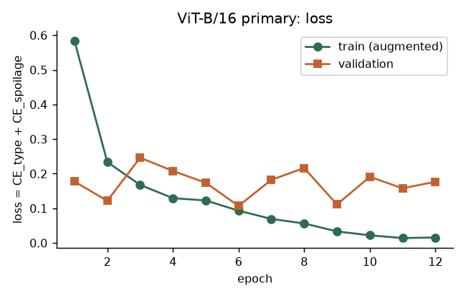
Figure 1. Training and validation loss.
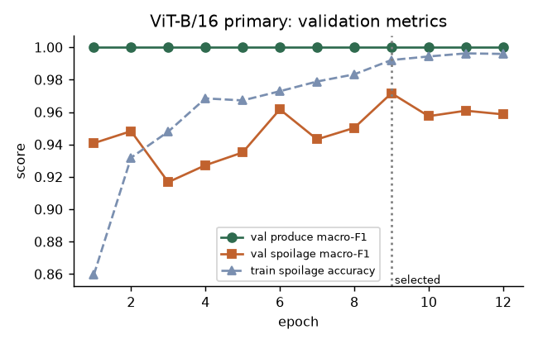
Figure 2. Validation macro-F1 per epoch.
Table 3. Final test-set results (selected checkpoint, n = 1,071).
Metric | Produce type | Spoilage
Accuracy | 1.0000 | 0.9608
Macro precision | 1.0000 | 0.9667
Macro recall | 1.0000 | 0.9430
Macro-F1 | 1.0000 | 0.9536
ROC-AUC | 1.0000 (OvR) | 0.9893
Spoilage macro-F1, session-bootstrap 95% CI | – | 0.903 – 0.988
Spoiled recall, session-bootstrap 95% CI | – | 0.773 – 0.984
Expected calibration error (10 bins) | – | 0.038

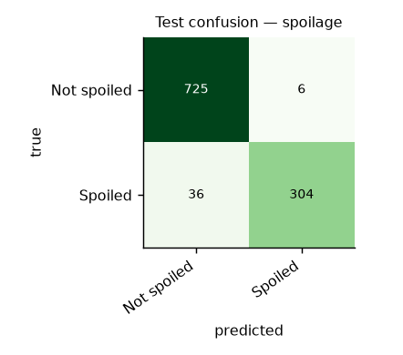
Figure 3. Spoilage confusion matrix (test).
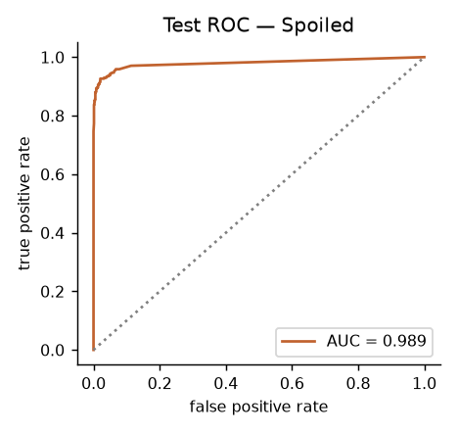
Figure 4. Spoilage ROC curve (test).

7 Error analysis
False negatives (Spoiled → Not spoiled): 36; false positives: 6. The cost of a false negative (spoiled food judged acceptable) is higher, so Spoiled recall (0.894) is the key weakness.
Table 4. Test errors per stratum.
Produce | True label | n | Errors | Error rate
Banana | Not spoiled | 34 | 0 | 0.0%
Banana | Spoiled | 34 | 0 | 0.0%
Carrot | Not spoiled | 17 | 0 | 0.0%
Carrot | Spoiled | 68 | 0 | 0.0%
Guava | Not spoiled | 35 | 0 | 0.0%
Guava | Spoiled | 68 | 0 | 0.0%
Indian Gooseberry | Not spoiled | 170 | 6 | 3.5%
Indian Gooseberry | Spoiled | 102 | 27 | 26.5%
Mango | Not spoiled | 51 | 0 | 0.0%
Mango | Spoiled | 34 | 2 | 5.9%
Tomato | Not spoiled | 424 | 0 | 0.0%
Tomato | Spoiled | 34 | 7 | 20.6%

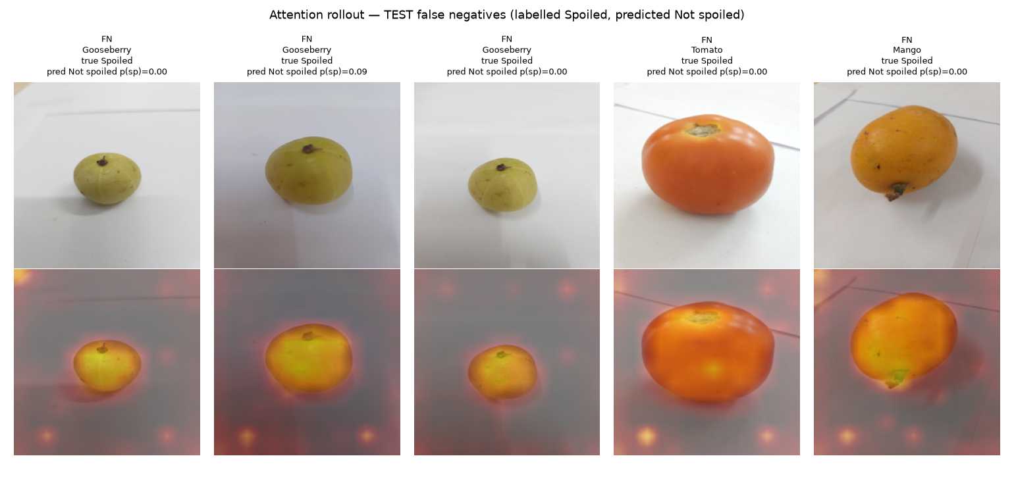
Figure 5. Representative false negatives (Spoiled → Not spoiled) with attention rollout.
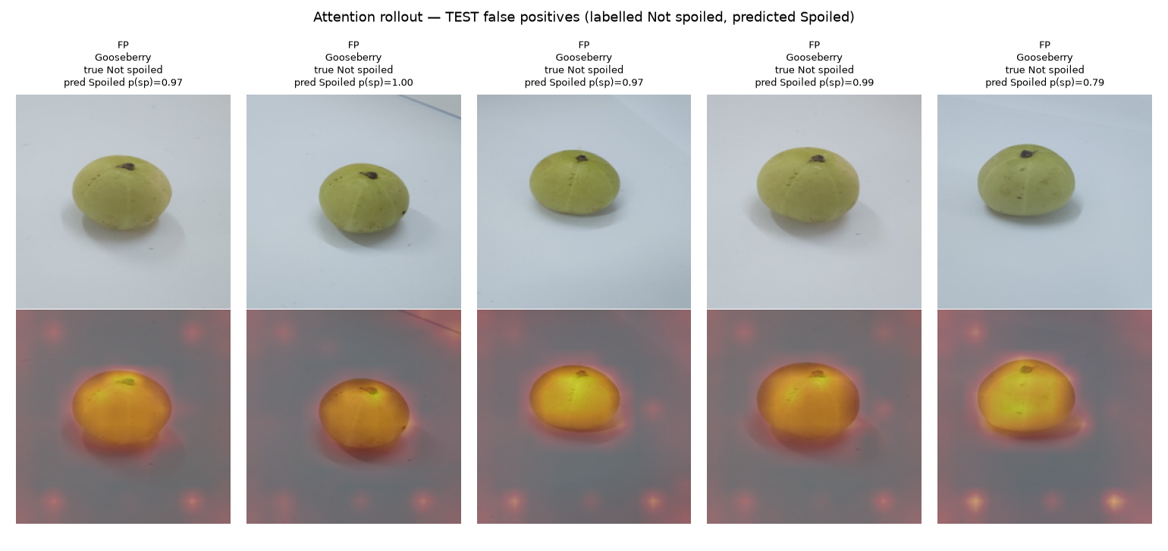
Figure 6. Representative false positives (Not spoiled → Spoiled) with attention rollout.
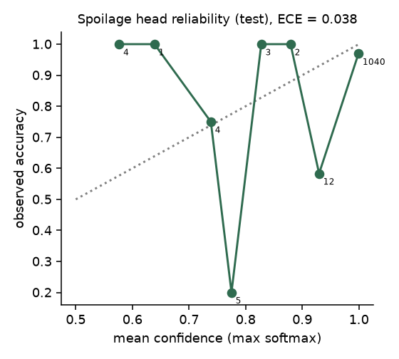
Figure 7. Reliability diagram: errors are made with high confidence.

8 Robustness
Robustness to image noise was measured on deterministic corruptions of the test split (Document C). Additional variation tests: horizontal flip and mild Gaussian noise (σ = 0.02) left the spoilage prediction unchanged for 97.3% and 96.7% of 150 test images, respectively.
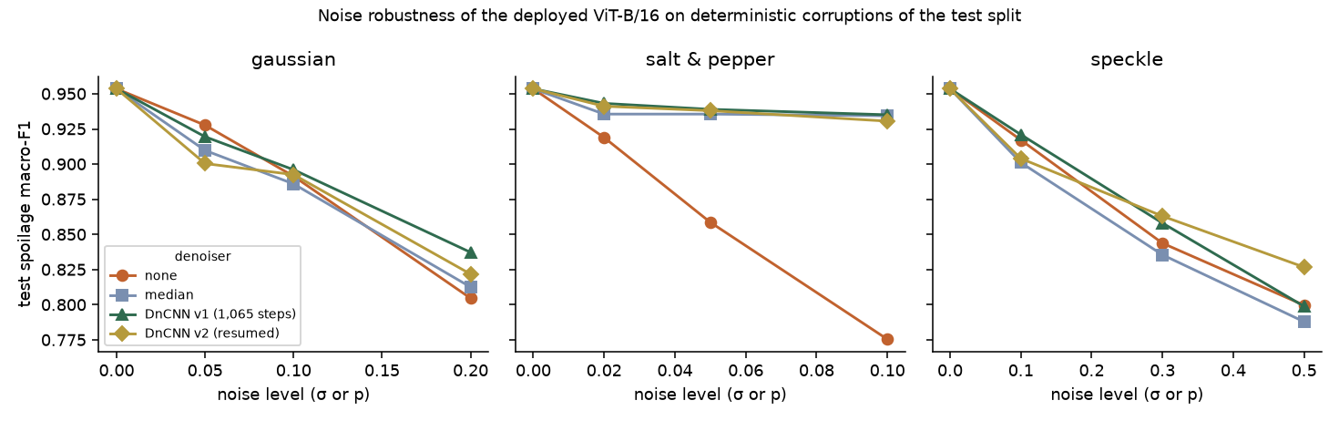
Figure 8. Spoilage macro-F1 under Gaussian, salt-and-pepper and speckle noise.

9 Comparison against baselines
Table 5. Baselines vs deployed model (test spoilage).
Model | Macro-F1 | Accuracy | ROC-AUC
Majority class (Not spoiled) | 0.406 | 0.683 | 0.500
Colour histogram + LogReg | 0.828 | 0.857 | 0.885
Frozen ViT-B + LogReg | 0.916 | 0.930 | 0.979
ViT-B/16 fine-tuned (deployed) | 0.954 | 0.961 | 0.989
Source: Majority-class values computed from test support (always predicting Not spoiled).

10 Human visible-decay labels and the visible-decay check
A 180-image annotation round in Label Studio produced image-level human decisions (no polygons were drawn, so U-Net segmentation remains BLOCKED). 165 images received a definite decision. Agreement with the TR-6 folder label is 73.9%: Spoiled-labelled images showed visible decay in 72/109, Not-spoiled-labelled images in 6/56.
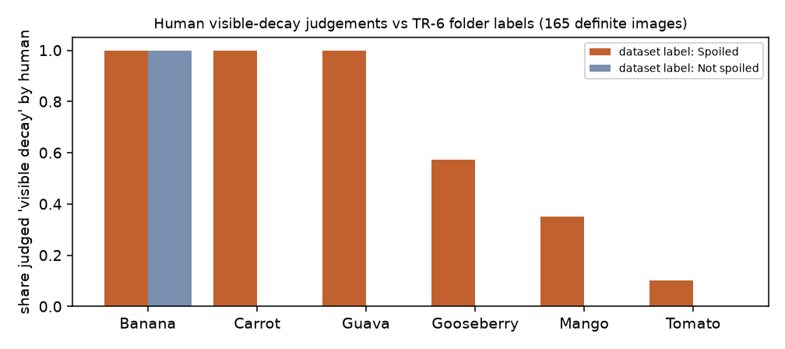
Figure 9. Share of images judged to show visible decay by the human annotator, per produce and TR-6 folder label.
Table 6. Test agreement with human visible-decay labels (n = 29; probe C = 0.1 selected on validation).
Predictor | Accuracy (95% Wilson CI) | Macro-F1 | ROC-AUC
Visible-decay probe on deployed ViT embedding (served by the API) | 0.931 (0.78–0.98) | 0.931 | 0.986
Spoilage head used as a decay check (p ≥ 0.5) | 0.897 (0.74–0.96) | 0.895 | 0.881
Source: artifacts/experiments/visible_decay/results.json
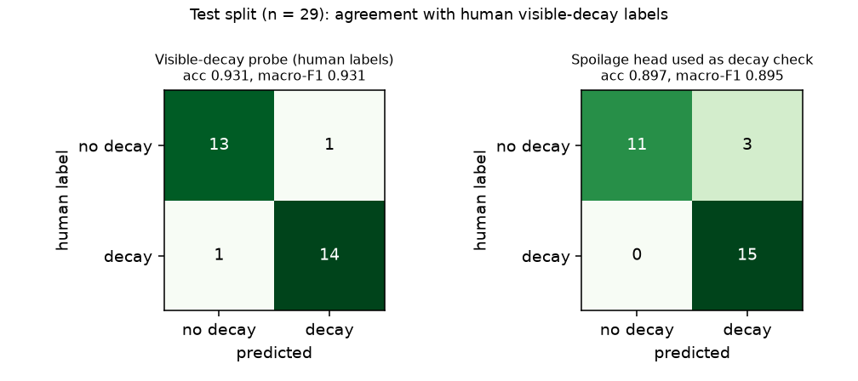
Figure 10. Test confusion matrices against human visible-decay labels.
The probe is trained on one annotator's judgements of 102 images; the test set is small and the intervals overlap, so it is an indicative, human-aligned check rather than a validated detector. It is shown in the UI as 'Visible decay check'.

11 Pilot U-Net and proxy shelf-life
Three further components are served by /api/analyze alongside the ViT classifier. Each is labelled in the API and UI with what it was trained on.
Table 7. Additional components: status, training data and held-out results.
Component | Status | Training data | Held-out result | Caveat
Visible-decay check (logistic probe on ViT embedding) | COMPLETE | 102 human image-level decisions (train split) | test n=29: accuracy 0.931 (95% CI 0.78–0.98), AUC 0.986 | one annotator; small test set
U-Net segmentation (fruit + decay), ResNet-18 encoder | IN PROGRESS | 102 MACHINE-GENERATED masks (colour/darkness heuristics, decay only on human-judged decay images) | n=63 val+test: fruit Dice 0.981, decay Dice 0.593 vs machine masks | PILOT — not human ground truth; human polygons still needed
Proxy shelf-life (ridge on ViT embedding) | COMPLETE | 3,177 train images; target = days until the series' first TR-6 'Spoiled' capture | test n=1071: MAE 4.29 d, RMSE 6.24 d, R² 0.888 (baseline MAE 9.95 d) | PROXY from date-based labels; not measured shelf life

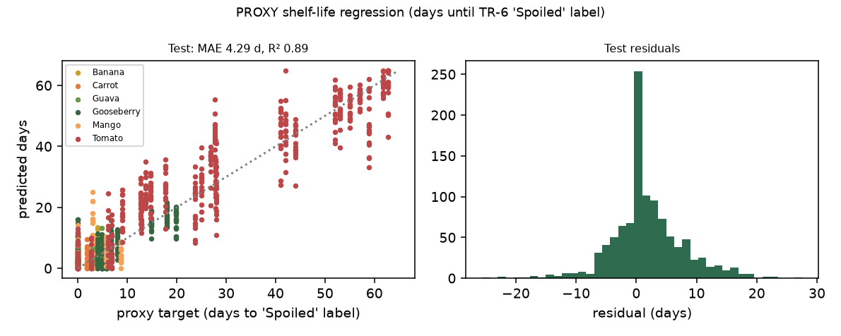
Figure 11. Proxy shelf-life: predicted vs target days on the test split, and residuals.
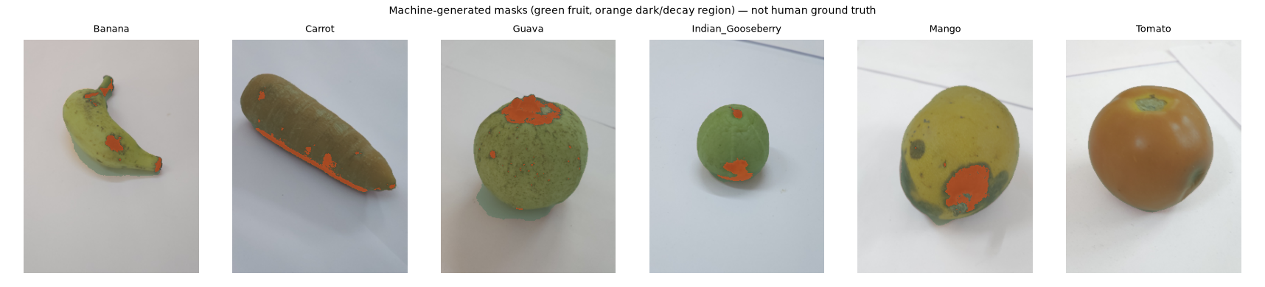
Figure 12. Machine-generated training masks for the pilot U-Net (green fruit, orange dark/decay region). Not human ground truth.
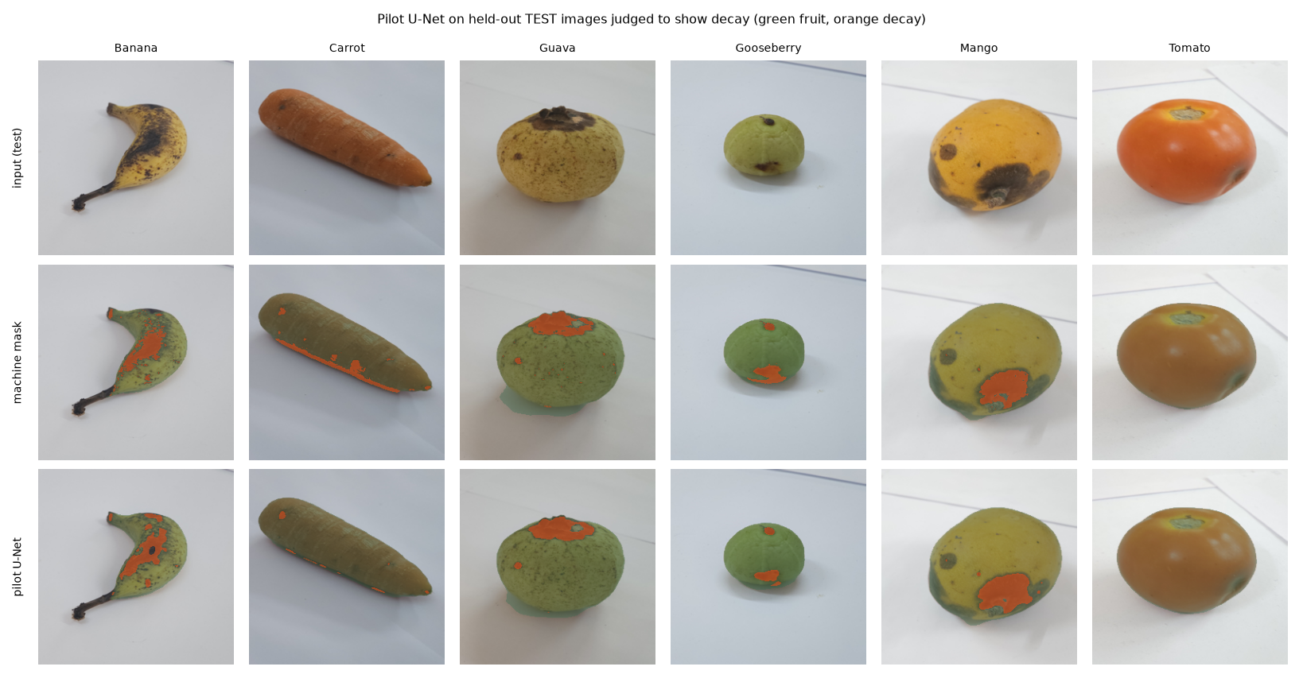
Figure 13. Pilot U-Net on held-out test images: input, machine-generated reference mask and U-Net prediction.
The U-Net demonstrates the complete segmentation pipeline (data → masks → training with BCE + Dice → API → UI overlay and decay-coverage %). Because its reference masks are machine-generated, its Dice/IoU measure agreement with those masks, not with human decay boundaries; decay Dice is also inflated by images with no decay (both masks empty count as perfect). A validated U-Net requires human-drawn polygons.

12 Limitations
- Specimen leakage: TR-6 has no specimen IDs; the same fruits appear in train and test. A day-grouped split lowers performance (Document C).
- Labels are date-based folder labels, not independent assessments of spoilage.
- Lab images on plain backgrounds; real phone photos are untested; out-of-distribution inputs are always mapped to one of six classes (low-confidence warning below 0.60 is a heuristic).
- Confidence is uncalibrated on errors; UI tier thresholds (0.5 / 0.3) are heuristics.
- Single training seed for the deployed model.

13 Reproducibility
- Split: python3 ml/data/make_splits.py --inventory dataset-preparation/tr6-audit/output_rerun_2026-10-15/file_inventory.csv --out artifacts/dataset/v1 --seed 42 (byte-identical on re-run)
- Train: .venv/bin/python ml/train/train_vit.py --run-id vit_b16_primary --epochs 12 --patience 4
- Evaluate: .venv/bin/python ml/evaluate/evaluate_vit.py --run artifacts/runs/vit_b16_primary --split test
- Environment: ml/requirements.txt (pinned versions).

14 Deployment inference tests and verdict
The checkpoint served by the backend is byte-identical to the evaluated run (SHA-256 49c40d4f65f94311…). Real-model tests R01–R04 pass, and the live end-to-end test analysed 60 held-out full-resolution originals over HTTP (produce 60/60, spoilage 57/60) with median latency 48 ms.
Verdict: the model is genuinely trained (logged 12-epoch run, validation-selected checkpoint, single held-out test evaluation) and usable in the application for its stated scope — single-item, six produce types, visual spoilage cues on TR-6-like images. It is not validated for real-world photos, food-safety decisions or shelf-life estimation.

