FORESIGHT
Case Study: Foresight — Visual Produce-Spoilage Estimation with Leakage-Controlled Deep Learning
How a public fruit-spoilage dataset was audited, modelled, explained and turned into a working, tested web application.

Project: Foresight
Document: Review 3 — case study
Date: 17 October 2026
Team: [Team names and roll numbers]
Repository: /Users/nandu/Downloads/foresight
Every number in this document is generated by releases/final_review/build/build_reports.py from saved run logs and result files; nothing is hand-entered. Labels such as NOT RUN, NOT AVAILABLE, BLOCKED or SIMULATED mark results that do not exist.

Contents
1 Executive summary
2 Background and problem
3 Stakeholders and requirements
4 The data challenge
5 Solution approach
5.1 Core model
5.2 Supporting models and experiments
5.3 System architecture
6 Results
7 Human annotation study
8 Implementation and verification
9 Challenges and lessons learned
10 Ethical considerations and SDG relevance
11 Limitations
12 Conclusion and next steps
13 References

(Right-click → Update Field in Word if the contents list appears empty.)

1 Executive summary
Foresight estimates, from one photograph of a single fruit or vegetable, its produce type, whether it shows the visual characteristics of spoilage, whether decay is visible, the decayed area, a proxy shelf-life and an explanation heat-map. The core model, a fine-tuned ViT-B/16, reaches a held-out test spoilage macro-F1 of 0.954 (accuracy 96.1%, ROC-AUC 0.989) and perfect produce classification on 1,071 test images. It is integrated into a FastAPI backend and a React interface, and verified end to end with automated, contract and browser tests.
The most important lesson of the case is that the dataset determined the validity of the results more than the model did: the public dataset contained complete duplicate copies, conflicting labels and date-based labels, all of which had to be found and controlled before any metric could be trusted.
Headline result: spoilage macro-F1 0.954 (session-bootstrap 95% CI 0.903–0.988)
Key risk found: a random split would leak an exact copy of ~60% of test images into training
Key insight from human annotation: only 72/109 'Spoiled'-labelled images show visible decay
Status: working prototype; validated U-Net and true shelf-life remain future work

2 Background and problem
Post-harvest loss of fruit and vegetables is a major source of food waste in India. Retailers, exporters and households decide what to sell, use or discard by visual inspection, which is subjective and slow. Most published fruit-quality models answer only 'spoiled or not' and are rarely checked for data leakage, so reported accuracies can be inflated.
The project goal was a research prototype that: (1) uses only a phone-style RGB photo; (2) produces several interpretable outputs rather than a single label; (3) explains its decisions; and (4) reports only metrics that survive leakage-controlled evaluation. It is explicitly not a food-safety tool: the interface states 'visual estimate — not a food-safety guarantee'.

3 Stakeholders and requirements
Table 1. Stakeholders and what they need from the system.
Stakeholder | Need | How Foresight addresses it
Household / retailer | Quick, understandable advice | Card with produce type, spoilage, decay %, shelf-life estimate and a plain-language action
Course reviewers | Real models, real metrics, explainability | Logged training runs, untouched test set, ablations, XAI, test evidence
Researchers / dataset users | Reusable, leakage-safe data | TR-6+ manifests, split files and validation scripts (IEEE DataPort package)
Developers | Maintainable, testable system | FastAPI + React with 37 backend/ML tests, 7 frontend tests and an E2E script

4 The data challenge
The project uses TriModal Ripeness 6 (TR-6): 21,653 files (19.8 GiB) of sRGB images, thermal IR-fusion images and methane logs for six produce types. A full audit before modelling found:
- Every one of the 10,796 images in the 'Classified' folder is a byte-identical copy of an image in the 'Normal' folder — only 10,776 unique images exist.
- 170 images appear under both 'Spoiled' and 'Not_spoiled' (all thermal) — contradictory labels.
- Each capture session holds 17 near-identical views of one fruit, and each produce type is a small number of specimens photographed over consecutive days.
- Within every produce type, all 'Not spoiled' captures precede all 'Spoiled' captures: the label marks a stage of a time series.
Table 2. Measured leakage of test images into training for different split strategies (no model needed).
Split strategy | Exact duplicate in train | Same capture session in train | Same produce-day in train
random split of raw sRGB files (Classified + Normal copies), seed 42 | 59.8% | 100.0% | 100.0%
random split of de-duplicated contents (no grouping), seed 42 | 0.0% | 99.9% | 100.0%
session-grouped split v1 (used for all main results) | 0.0% | 0.0% | 76.2%
day-grouped sensitivity split | 0.0% | 0.0% | 1.5%

Decision: de-duplicate by SHA-256, exclude conflicting labels, use sRGB only (the app receives phone photos), and split 60/20/20 by capture session within each produce × label stratum. This produced 5,335 eligible images: 3,177 train, 1,087 validation and 1,071 test, with zero duplicate or session leakage.
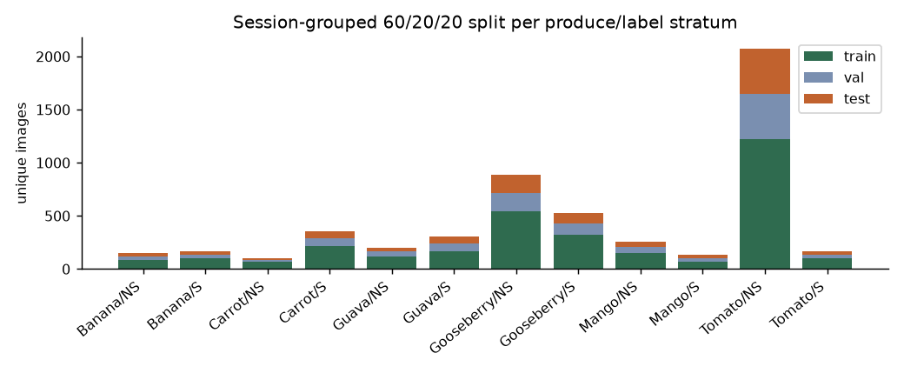
Figure 1. Session-grouped 60/20/20 split per produce × label stratum.

5 Solution approach

5.1 Core model
A pretrained ViT-B/16 was fine-tuned with two heads (produce type, spoilage) using AdamW (backbone LR 2e-05, heads 0.0002), conservative augmentation that avoids colour shifts, and early stopping on validation macro-F1. Training took 54.7 minutes on an Apple M5 laptop; the checkpoint from epoch 9 was selected on validation and scored once on test.

5.2 Supporting models and experiments
Table 3. Components and their role.
Component | Role | In the app?
ViT-B/16 two-head classifier | produce type + spoilage | YES
Visible-decay probe | image-level visible decay, trained on human labels | YES
Pilot U-Net (ResNet-18 encoder) | fruit and decay mask, decay coverage % | YES (labelled pilot)
Ridge regressor | proxy shelf-life (days until 'Spoiled' label) | YES (labelled proxy)
Attention rollout | explanation heat-map | YES
Conditional DCGAN | synthetic training images (experiment) | research only
DnCNN / median filter | denoising (robustness experiment) | research only
Logistic-regression baselines, K-means | baselines and exploratory clustering | research only

5.3 System architecture
React (Vite) UI → FastAPI backend (upload validation, structured errors, CORS) → inference service (models loaded once at startup) → deterministic result composer (warnings, overlays) → SQLite history. Uploaded images are never stored. Mock predictions exist only for UI development, are off by default and are labelled 'DEMO MOCK DATA'.

6 Results
Table 4. Held-out test results of the deployed model (n = 1,071).
Task | Accuracy | Macro precision | Macro recall | Macro-F1 | ROC-AUC
Produce type | 1.000 | 1.000 | 1.000 | 1.000 | 1.000
Spoilage | 0.961 | 0.967 | 0.943 | 0.954 | 0.989

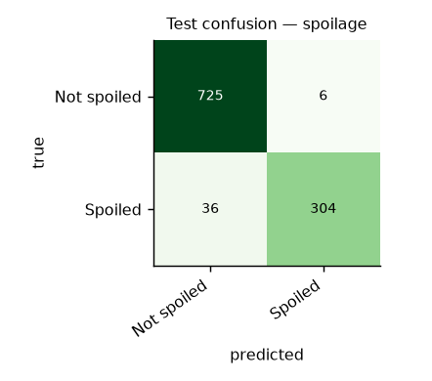
Figure 2. Spoilage confusion matrix on the test set.
Table 5. Model comparison on the same test split (spoilage macro-F1).
Model | Spoilage macro-F1
Colour histogram + logistic regression | 0.828
Frozen ViT-B/16 + logistic regression | 0.916
ViT-S/16, real images only (3 seeds) | 0.914 ± 0.006
ViT-S/16 + conventional augmentation (3 seeds) | 0.928 ± 0.007
ViT-S/16 + augmentation + GAN images (3 seeds) | 0.919 ± 0.018
ViT-B/16 fine-tuned (deployed) | 0.954

- Conventional augmentation helped slightly (+0.013 (per seed: +0.010, +0.004, +0.026)); GAN images did not (-0.009 (per seed: +0.000, +0.008, -0.035)).
- Testing on unseen capture days lowered macro-F1 by 0.098 (3 seeds) — the main score is optimistic about new days.
- Strong synthetic noise lowers spoilage macro-F1 to about 0.78–0.80; a 3×3 median filter repairs salt-and-pepper noise.
- Attention rollout focuses on the fruit; masking the highlighted patches lowers confidence 10× more than masking random patches.
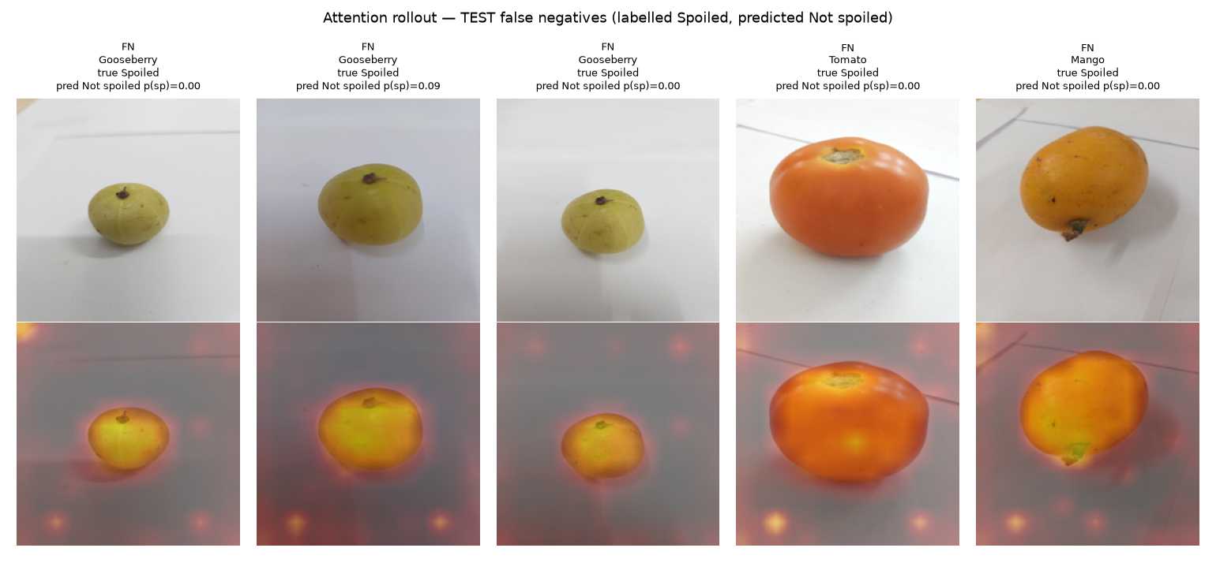
Figure 3. Attention rollout on test errors: 'Spoiled'-labelled fruit that looks fresh.

7 Human annotation study
To test what the 'Spoiled' label means, 180 images (stratified across produce, label and split) were reviewed by a human annotator in Label Studio. Of 165 definite decisions, the human saw visible decay in 72/109 'Spoiled'-labelled images and in 6/56 'Not spoiled' ones — overall agreement 73.9%.
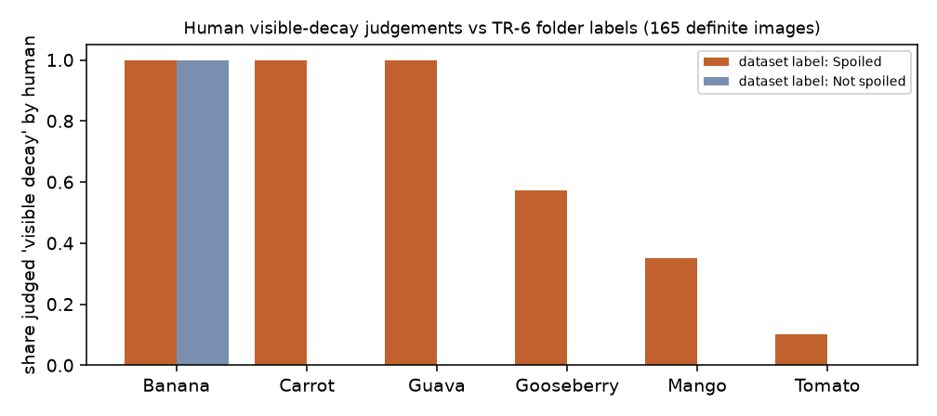
Figure 4. Share of images judged to show visible decay, per produce and dataset label.
These decisions trained a visible-decay check that reached 0.931 accuracy on 29 held-out test images (95% CI 0.78–0.98). The annotation round recorded image-level decisions but no drawn polygons, so the U-Net in the app is a pilot trained on machine-generated masks gated by those human decisions.

8 Implementation and verification
Table 6. Verification evidence.
Check | Result
Backend + ML automated tests (pytest) | 37 passed in 4.84s
Frontend tests (Vitest) | 7 passed
Frontend production build | passes
Live end-to-end checks | 11/11; 60/60 produce and 57/60 spoilage correct on held-out originals
UI ↔ API contract | 44/44 fields present
Median end-to-end latency | 48 ms (Apple M5, MPS)
Failure handling | 415 wrong type, 400 corrupt, 413 too large, 503 model missing — all shown in the UI

9 Challenges and lessons learned
Table 7. What went wrong and what was learned.
Challenge | What happened | Lesson
Duplicated dataset | Classified folder was a copy of Normal | Hash every file before splitting; never trust folder structure
Hidden leakage | 17 views per session, same fruit over days | Group splits by capture session; measure day-level leakage too
Label meaning | 'Spoiled' follows date, not always visible decay | Validate labels with humans before claiming what a model detects
Unstable ablation | First ViT-S run peaked at epoch 1 (LR too high) | Use several seeds and report validation and test separately
GAN quality | Synthetic images mostly unrecognisable to the classifier | Check synthetic data with a real-data model before training on it
Annotation | First round produced decisions but no polygons | Pilot the annotation tool and give a short hands-on guide first
Honest UI | Original UI showed fabricated detections and shelf-life | Show only what a model produced; label pilots and proxies

10 Ethical considerations and SDG relevance
- The tool never claims food is safe to eat; uncertainty, pilot and proxy outputs are labelled in the interface.
- No personal data is collected; uploaded images are not stored.
- The dataset is CC BY 4.0 and its authors are credited; derived data is shared as metadata only.
- SDG 12.3 (halve food waste and reduce food losses along supply chains): early visual triage can prioritise produce for use before it is lost.
- SDG 2 (zero hunger): reducing post-harvest loss increases available food.

11 Limitations
- The same physical fruits appear in training and test (TR-6 has no specimen IDs).
- All images are lab photos on plain backgrounds; real phone photos are untested.
- Confidence is poorly calibrated on errors.
- The U-Net is a pilot trained on machine-generated masks; shelf-life is a proxy derived from dataset labels.
- Single-item photos only; no multi-item detection.

12 Conclusion and next steps
Foresight shows that a leakage-controlled, explainable and fully tested spoilage prototype can be built from a public dataset on a laptop. Its value lies as much in the auditing and evaluation discipline as in the model accuracy.
- Draw human decay polygons and train a validated U-Net.
- Collect and evaluate on real-world phone photos.
- Calibrate confidence scores.
- Deploy the backend and frontend to a public host.
- Publish TR-6+ on IEEE DataPort.

13 References
- T. Bagyammal, Y. A. P. T. S, K. Deepak and D. Unnikrishnan, “TriModal Ripeness 6,” figshare, 2025, doi: 10.6084/m9.figshare.30783827.v1.
- A. Dosovitskiy et al., “An image is worth 16x16 words: Transformers for image recognition at scale,” in Proc. ICLR, 2021.
- S. Abnar and W. Zuidema, “Quantifying attention flow in transformers,” in Proc. ACL, 2020.
- O. Ronneberger, P. Fischer and T. Brox, “U-Net: Convolutional networks for biomedical image segmentation,” in Proc. MICCAI, 2015.
- A. Radford, L. Metz and S. Chintala, “Unsupervised representation learning with deep convolutional generative adversarial networks,” in Proc. ICLR, 2016.
- K. Zhang, W. Zuo, Y. Chen, D. Meng and L. Zhang, “Beyond a Gaussian denoiser: Residual learning of deep CNN for image denoising,” IEEE Trans. Image Process., vol. 26, no. 7, 2017.

