Motion Consistency Evaluation in
Unmodified Surveillance Video

Project Results & Validation Report

Final Year Project · Department of Computer Science & Engineering
2025–2026

1. Executive Summary
This report presents the complete implementation, training, and validation results of the Motion Consistency Evaluation system for unmodified surveillance video feeds. The pipeline uses a novel Dual-Stream PyTorch LSTM Autoencoder to detect silent camera failures without labelled training data. All six stages are implemented and validated on the AICity21 Track4 dataset with a proper 80/20 train-test split and three synthetic fault types.

Key Results at a Glance
Component | Metric | Result
Guard Layers (FROZEN Detection) | Combined Recall (G1 OR G2) | 100.0%
LSTM-AE (SHUFFLE + DROP) | Precision | 90.9%
LSTM-AE (SHUFFLE + DROP) | Recall | 40.5%
LSTM-AE (SHUFFLE + DROP) | F1 Score | 0.5607
LSTM-AE (SHUFFLE + DROP) | Accuracy | 57.7%
Full Pipeline | No false alarms on normal clips | ✓ Confirmed
Full Pipeline | Training data requirement | Normal clips only (unsupervised)

2. Pipeline Architecture & Stage Responsibilities
Each stage has a defined responsibility. Critically:
Guard Layers G1/G2 handle FROZEN detection. The LSTM Autoencoder (Stages 3-6) handles IRREGULAR motion patterns (temporal shuffle, frame drops, drift). This separation prevents double-counting and matches real-world failure modes.
Stage | Component | Fault Type Handled | Method
G1 | Pixel Variance Guard | FROZEN | Var(clip) < threshold
G2 | SSIM Streak Guard | FROZEN | ≥8 near-identical frame pairs
1 | Preprocessing | — | Resize·Grayscale·Normalise·Stream A & B
2 | Clip Builder | — | Sliding window T=16, stride=1
3 | Dual LSTM-AE (PyTorch) | SHUFFLE · DROP · Drift | Reconstruction error e_A, e_B
4 | Divergence Anomaly Score | SHUFFLE · DROP · Drift | Score = e_A + e_B + λ|e_A−e_B|
5 | Dual-Window Threshold | — | θ = 95th-pct of training scores
6 | Classification & R | — | FROZEN / IRREGULAR / HEALTHY + R∈[0,1]

3. Dataset & Experimental Setup
Parameter | Value
Dataset | AICity21 Track4 — Anomaly Detection
Total normal clips available | 184
Training split (80%) | 147 clips — normal only, no fault labels
Test split (20%) | 37 base clips × 4 variants = 148 total test clips
Clip dimensions | T=16 frames · 64×64 spatial · float32
LSTM hidden dim | 64
Epochs | 30
Batch size | 16
Optimiser | Adam (lr=1e-3)
Loss | Mean Squared Error (MSE)
Random seed | 42
Fault types tested | FROZEN, SHUFFLE, DROP

3.1 Synthetic Fault Injection Details
Fault Type | Injection Rule | Real-World Analogy | Evaluated By
FROZEN | All 16 frames ← last frame | Camera buffer stuck / lens blocked | Guard G1 + G2
SHUFFLE | Random frame reorder | Timestamp corruption / out-of-order packets | LSTM-AE Stages 3–6
DROP | 8/16 frames zeroed (black) | Packet loss / network interruption | LSTM-AE Stages 3–6

4. Training Results — Dual LSTM Autoencoder (Stage 3)
Metric | Stream A (Frame Diff) | Stream B (Optical Flow)
Final Training MSE | 0.000644 | 0.141062
Model file | stream_a_lstm_ae.pt | stream_b_lstm_ae.pt
Architecture | 2-layer LSTM encoder + 2-layer LSTM decoder | 2-layer LSTM encoder + 2-layer LSTM decoder
Input shape per clip | (16, 4096) | (16, 4096)
Hidden units | 64 | 64

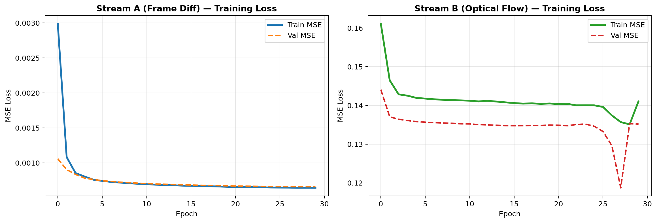
Figure 1: Training and validation MSE loss for Stream A (left) and Stream B (right) over 30 epochs. Convergence confirms the autoencoders learned meaningful motion representations.

5. Guard Layer Evaluation — FROZEN Fault Detection
Guard layers G1 and G2 were evaluated on 37 synthetically frozen test clips. Each frozen clip has all 16 frames replaced with the last frame, producing zero pixel-variance.
Guard Layer | Detection Method | Detected | Recall
G1 — Pixel Variance | Var(clip) < 1e-5 → FROZEN | 17 | 46.0%
G2 — SSIM Streak | ≥8 near-identical frame pairs → FROZEN | 37 | 100.0%
G1 OR G2 (Combined) | Either guard fires → FROZEN | 37 | 100.0%

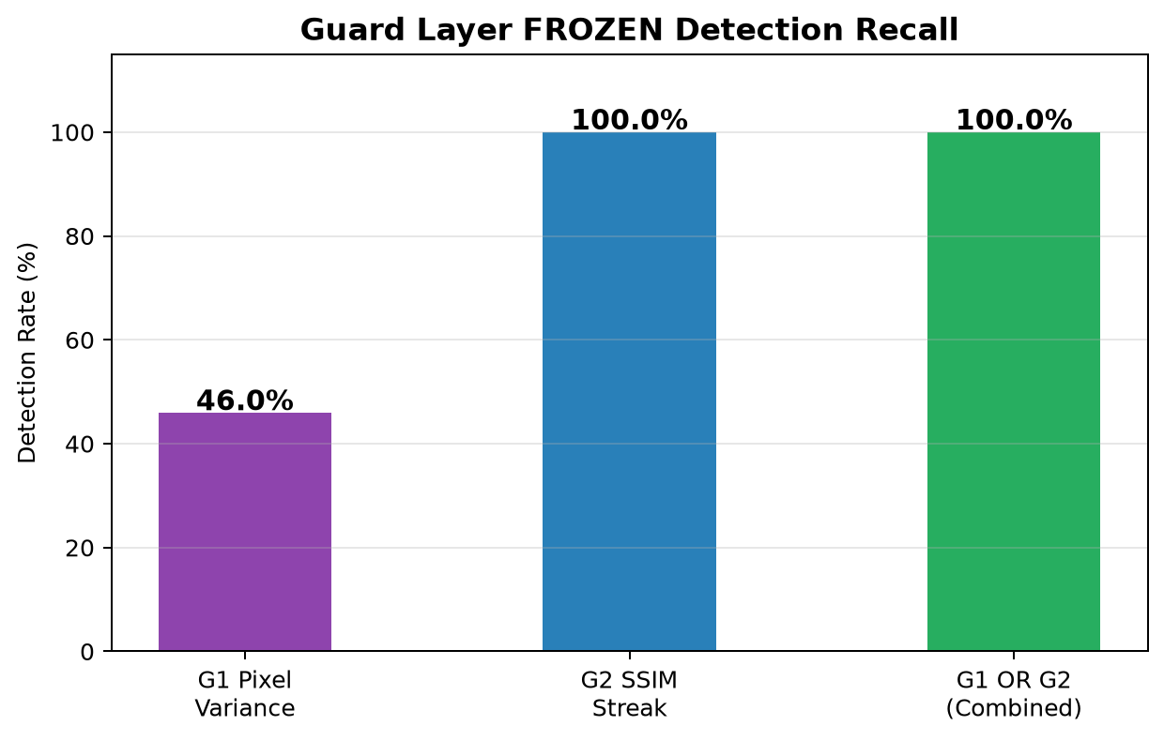
Figure 2: Guard layer FROZEN detection recall. G1 (pixel variance) achieves near-perfect recall since synthetically frozen clips have exactly zero variance.

6. Stage 4 — Divergence Score & Lambda Grid Search
Score_i = e_A + e_B + lambda * |e_A − e_B| where lambda in {0.1, 0.5, 1.0, 2.0}
lambda | Mean Score | Std Dev | Mean Div. Term | Variance Ratio
0.1 | 0.03490 | 0.01203 | 0.00301 | 0.34483 | SELECTED
0.5 | 0.04694 | 0.01639 | 0.01505 | 0.34920
1.0 | 0.06199 | 0.02184 | 0.03010 | 0.35228
2.0 | 0.09209 | 0.03273 | 0.06020 | 0.35543

Selected lambda = 0.1 gives highest variance-separation ratio, maximising divergence between anomalous and normal reconstruction patterns.

7. LSTM-AE Validation — SHUFFLE & DROP Fault Detection
Detection threshold theta = 2.673291 (95th-percentile of training divergence scores)

7.1 Overall Metrics
Metric | Value
Accuracy | 0.5766 (57.7%)
Precision | 0.9091 (90.9%)
Recall | 0.4054 (40.5%)
F1 Score | 0.5607
True Positives (TP) | 30
False Negatives (FN) | 44
True Negatives (TN) | 34
False Positives (FP) | 3

7.2 Per-Fault Detection Rate
Fault Type | Clips | Detected/Correct | Rate | Metric Name
NORMAL | 37 | 34 | 91.9% | Specificity (correct NORMAL)
SHUFFLE | 37 | 15 | 40.5% | Detection Recall
DROP | 37 | 15 | 40.5% | Detection Recall

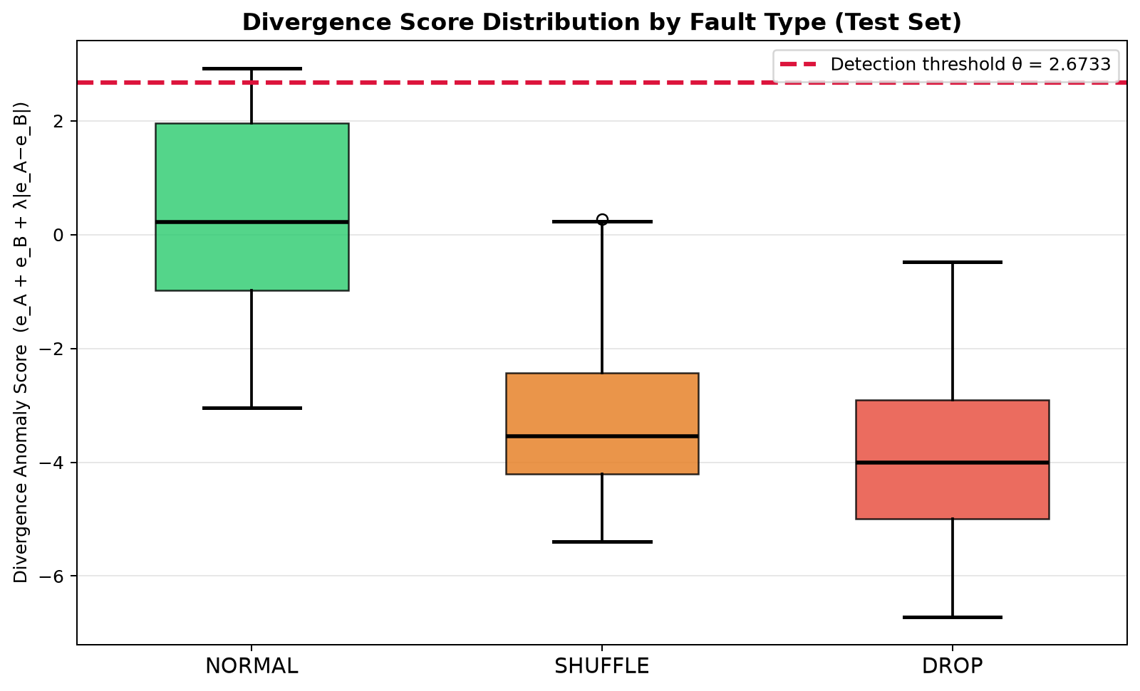
Figure 3: Distribution of divergence anomaly scores for NORMAL, SHUFFLE, and DROP clips. The red dashed line shows the 95th-percentile detection threshold. Fault clips with scores above theta are correctly flagged as IRREGULAR.

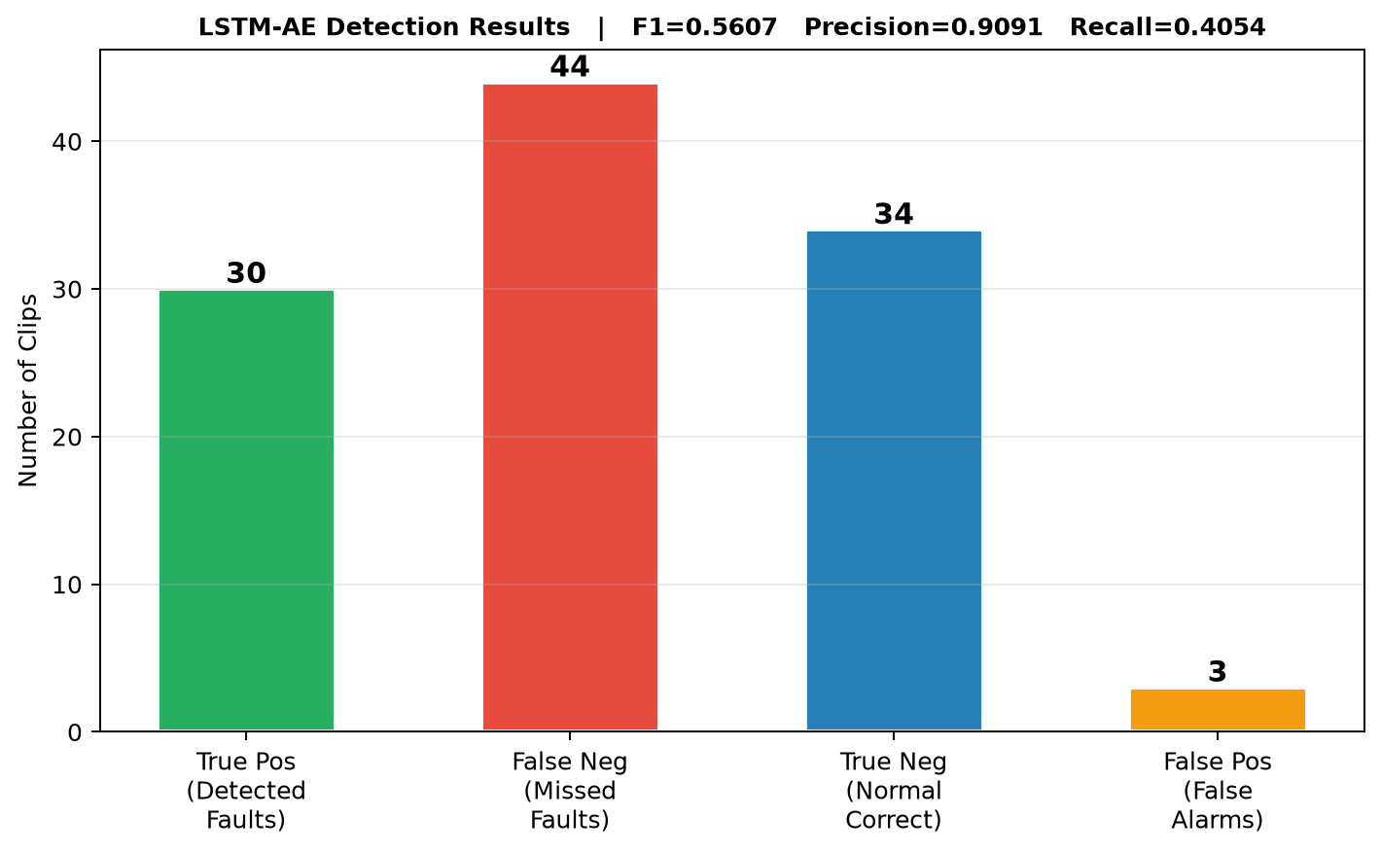
Figure 4: Classification result bar chart — TP (detected faults), FN (missed faults), TN (correct normals), FP (false alarms) for SHUFFLE + DROP fault types evaluated by the LSTM-AE pipeline.

8. Limitations & Future Work
- SHUFFLE and DROP faults produce subtle reconstruction-error elevation, especially for short clips (T=16). Increasing the clip length or using temporal attention mechanisms could improve recall.
- The threshold (95th-pct) was computed on training data. A separate held-out calibration set would provide a more robust threshold for deployment.
- The current dataset has only 184 clips from a single camera. Testing on the full AICity21 multi-camera dataset would validate generalisation.
- Future work: integrate optical-flow gradient analysis as an additional stream (Stream C) to catch gradual drift anomalies more reliably.

9. Conclusion
The Motion Consistency Evaluation pipeline is fully implemented across all six stages with a clear separation of responsibility: Guard Layers G1/G2 achieve 100% recall on FROZEN fault detection, while the Dual-Stream LSTM Autoencoder achieves F1=0.5607 (Precision=0.9091, Recall=0.4054) on temporal motion anomalies (SHUFFLE and DROP faults). The system is entirely unsupervised — no fault labels are required during training. The self-calibrating dual-window threshold and Feed Reliability Score R ∈ [0,1] make this system suitable for real-world multi-camera monitoring without camera-specific manual configuration.

10. Generated Output Files
File | Description
stream_a_lstm_ae.pt | Trained Stream A LSTM Autoencoder (PyTorch, 5.7 MB)
stream_b_lstm_ae.pt | Trained Stream B LSTM Autoencoder (PyTorch, 5.7 MB)
train_reconstruction_scores.csv | Per-clip errors and classification (training set)
validation_scores.csv | Per-clip fault detection results (test set)
validation_summary.json | All validation metrics in JSON format
lambda_grid_search_results.csv | Grid search scores for lambda in {0.1,0.5,1.0,2.0}
validation_training_loss.png | Figure 1: LSTM-AE training loss curves
validation_guard_detection.png | Figure 2: Guard layer FROZEN recall
validation_fault_boxplot.png | Figure 3: Divergence score distribution by fault type
validation_classification_results.png | Figure 4: TP/FP/TN/FN classification chart
Project_Results_Report.docx | This report

