Design for Additive Manufacturing
Edge AI
AI Powered Posture Correction System on Edge Devices

Submitted to

Mr. Pandarasamy Arjunan


Submitted by
B Nanditha - 25052
MVNS Manjusha – 24991
Plaksha Joshi – 24544
Rimzhim Arrora -24938
Smart Manufacturing
Department of Design and Manufacturing
Overview:
- To design a functional compliant mechanism using the YinSyn topology optimization tool in MATLAB.
- The mechanism includes specified input and output displacements and fixed regions
- To interpret and modify using DfAM (Design for Additive Manufacturing) principles, and fabricate using a polymer 3D printing process.
- The final device was to be hand-actuated and demonstrate useful functionality.

Initial Design:
Specifications:
- Fixed Edges: 1
- Edge coordinates:
  - Start: 0.0, 0.5
  - End: 0.0, 3.5
- Domain specifications:
  - Lower left: 0.0, 0.0
  - Upper right: 7.0, 4.0
- Number of Elements:
  - Along x – direction: 140
  - Along y – direction : 80
- Number of holes: 1
  - Lower left: 3.5, 1.0
  - Upper right: 7.0, 3.0
- Input Forces applied: 2
  - Force position-1: 1.0, 3.5, y direction in the negative, Force applied
  - Force position-2: 1.0, 0.5, y direction in the positive, Force applied
- Output displacement: 1
  - Coordinates: 3.0, 2.0, x direction positive

Sketch:
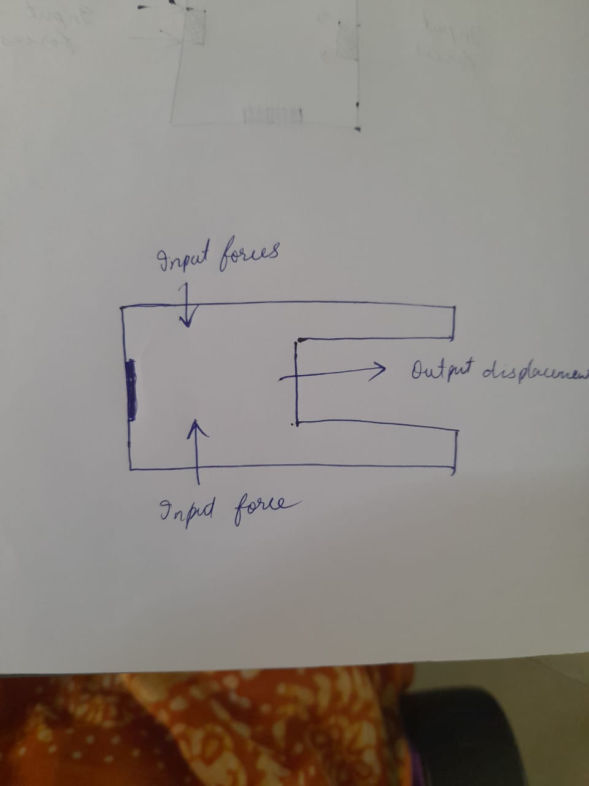

Initial Designs:

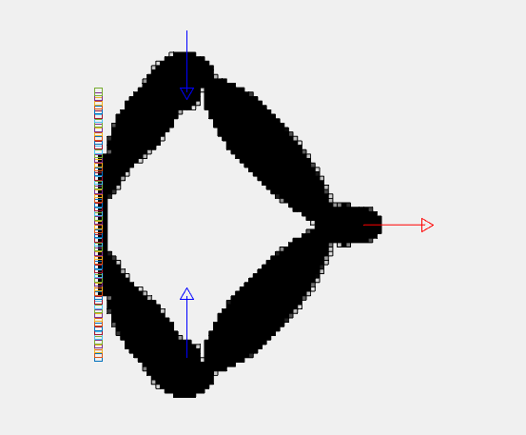

Deformation:
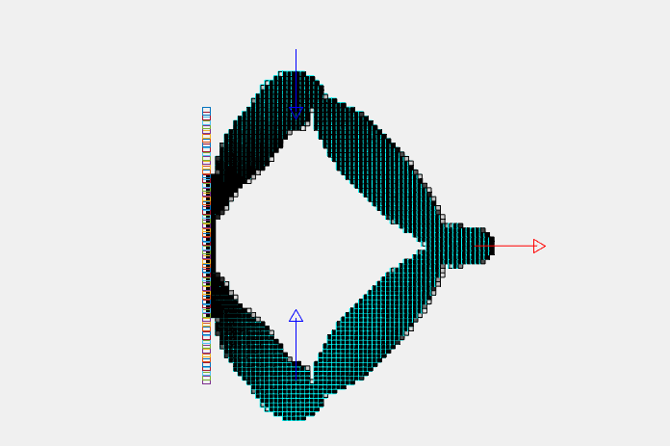
CAD Models designed:
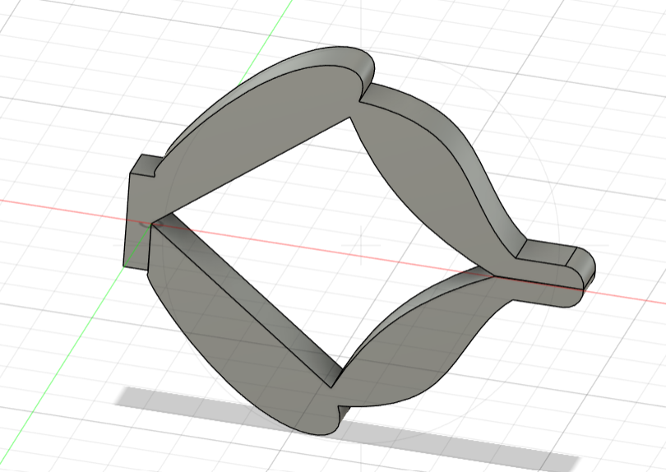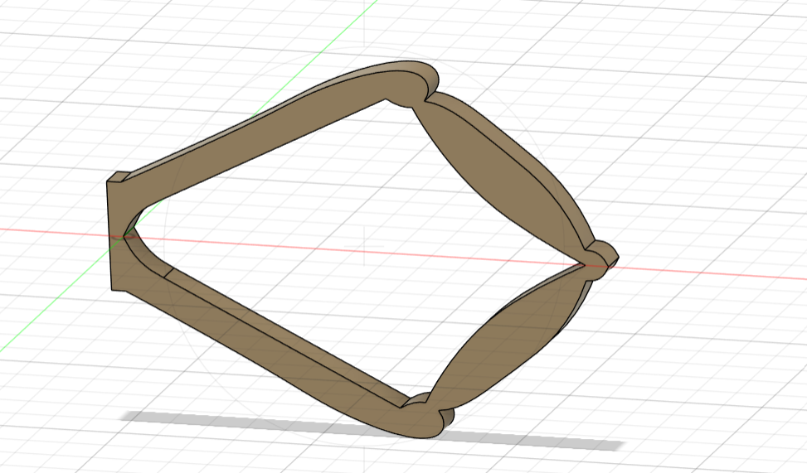

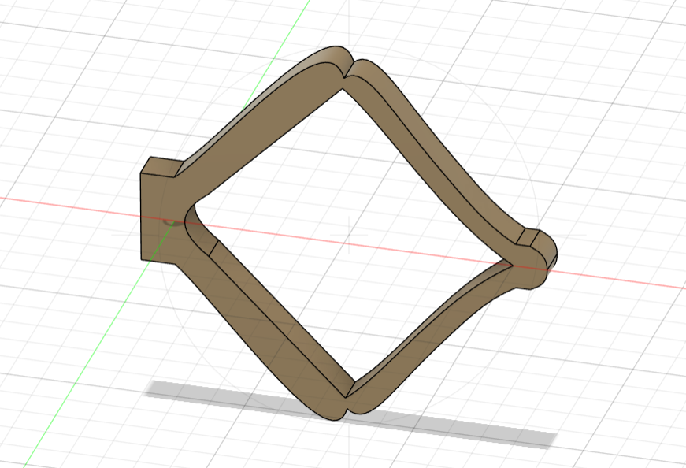

Problems occurred:
- While simulation, it was observed that the forces required at the input side were more than 20N, which is very high and not feasible
- The narrow and centralized topology may dampen the output response, yielding only minimal lateral motion even under significant input force.
- The curvature and shape of the connecting elements do not offer strong mechanical leverage for the output motion.
- This design isn’t conducive to being handheld—there are no clear input grips or comfortable surfaces to apply force.

Final Design:
Specifications:
- Fixed Edges: 1
- Edge coordinates:
  - Start: 10.0, 0
  - End: 30.0, 5.0
- Domain specifications: 4
  - 0,20,5,30
  - 10,0,30,5
  - 15,45,25,70
  - 35,20,40,30

- Number of Elements:
  - Along x – direction: 40
  - Along y – direction : 70
- Number of holes: 0
- Input Forces applied: 4
  - Force position-1: 0, 30, x direction in the positive, Force applied
  - Force position-2: 0, 20, x direction in the positive, Force applied
  - Force position-3: 40, 30, x direction in the negative, Force applied
  - Force position-4: 40,20, x direction in the negative, Force applied

- Output displacement: 3
  - Position 1 : 15,70, y directions positive
  - Position 2 : 20,70, y direction positive
  - Position 3 : 25,70, y direction positive

Sketch:

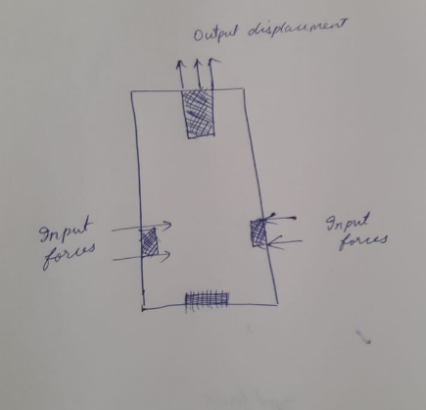

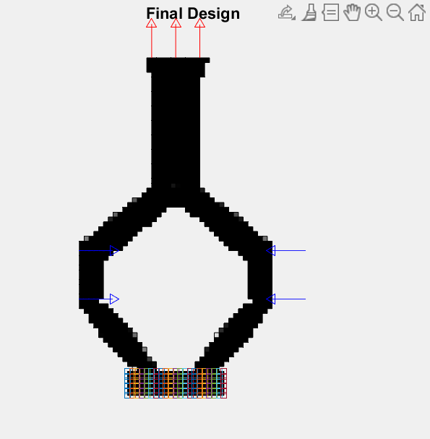

Deformation:

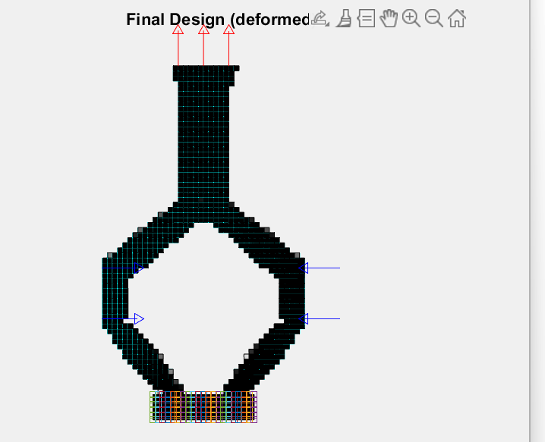
Final CAD Model

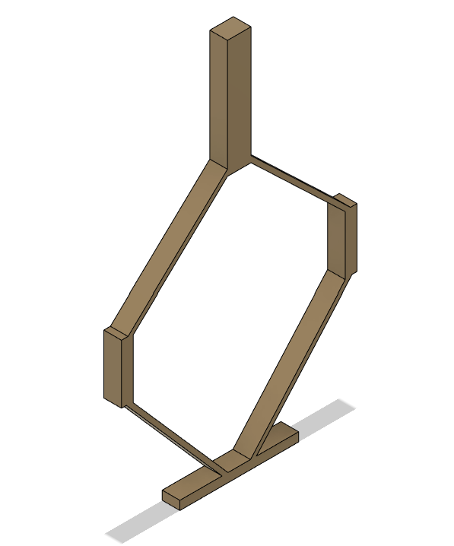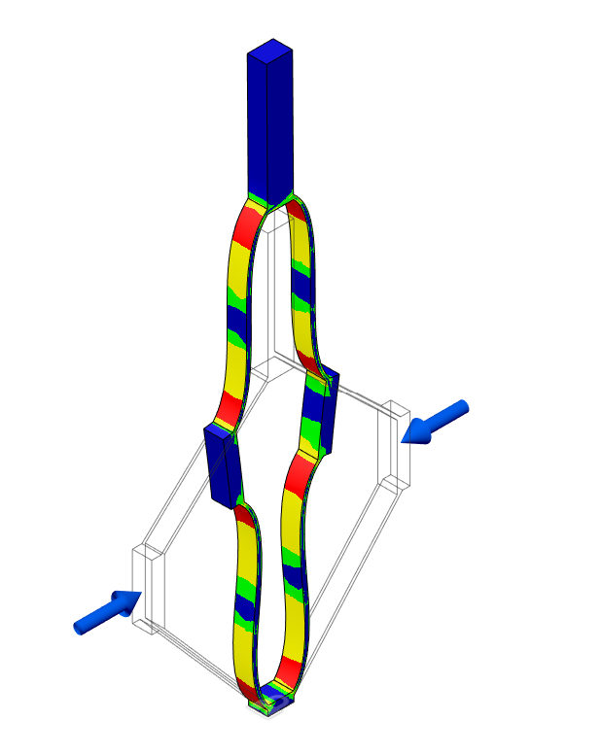

Improvements done:
- Clear mechanical path from vertical input to horizontal displacement using angled arms.
- Minimal geometry with defined load paths and uniform thickness
- Vertical and bottom arms act as intuitive input levers for hand-actuation
- Fully symmetrical about central axis, ensuring stable and predictable actuation

DfAM Rules Applied:
  - Maintained minimum wall thickness ≥ 1 mm for PLA
  - Avoided overhangs > 45° to reduce need for supports
  - Single-part, monolithic design for compliance and durability
  - Rounded transitions at joints to reduce stress concentrations

Applications:
  - The improved compliant mechanism can function as a manual ejector to push out or release an object horizontally when a vertical force is applied.
  - It can be used in Battery or component ejector in compact devices or kits, card or cartridge ejection (e.g., SD cards, USB drives) in custom enclosures.
Solid Model and Fabrication
- Printing Material: PLA
- Printer: FDM desktop printer

Print Outcome:
The final print demonstrated flexibility. When pressed at the top, the central arc deformed and the side arms opened outward as expected

Conclusion:
- Through iterative design using YinSyn, a practical and functional compliant mechanism was developed.
- The first attempt guided critical learnings on flexibility and print constraints. The final version, interpreted from topology output and adapted using DfAM rules, was successfully fabricated and tested

