CustomerPulse AI
Automated Customer Churn Prediction & Retention Analytics Platform
Project Technical Report
───────────────────────────────────────────────────────
Dataset: UCI Online Retail · 541,909 transactions · 4,334 unique customers
Period: December 2010 – December 2011
Best Model: Logistic Regression · CV ROC-AUC = 0.748 · Test ROC-AUC = 0.737
Tech Stack: Python · Streamlit · scikit-learn · pandas · NumPy · matplotlib · seaborn · SHAP

1. Abstract
CustomerPulse AI is an end-to-end automated analytics platform built with Python and Streamlit that transforms raw retail transaction records into actionable customer churn risk intelligence. Starting from the UCI Online Retail dataset (541,909 transactions, December 2010 – December 2011), the platform automatically cleans the data, engineers 18 customer-level behavioural features (RFM components, purchase gap statistics, return behaviour, and last-90-day activity), assigns a temporal churn label, and trains four classifiers — Logistic Regression, Random Forest, HistGradientBoosting, and K-Nearest Neighbours. The best model is selected by 5-fold cross-validated ROC-AUC. Logistic Regression achieved CV ROC-AUC = 0.748 and Test ROC-AUC = 0.737. Of the 3,601 modellable customers, 48.7% are labelled churned. Each customer receives a probability score and a HIGH / MEDIUM / LOW risk classification. Predictions are explained via SHAP values. Results are surfaced through an interactive multi-page Streamlit app.

2. Introduction & Objectives
Customer churn — a customer ceasing to transact with a business — is one of the most commercially significant risks in retail. Acquiring a new customer typically costs five to seven times more than retaining an existing one. Early detection of at-risk customers enables targeted retention interventions (personalised promotions, win-back campaigns) that reduce revenue leakage.
CustomerPulse AI addresses this by providing a fully automated, data-driven pipeline that converts raw transaction records into a ranked list of customers by estimated churn probability, deployable as a single-command Streamlit application.

Objectives
- Automate the complete cleaning, feature engineering, and modelling pipeline.
- Engineer 18 interpretable, business-relevant customer-level features.
- Train and compare four ML classifiers on a near-balanced churn dataset.
- Produce per-customer churn probability scores and HIGH / MEDIUM / LOW risk tiers.
- Explain predictions via SHAP values for model transparency.
- Deliver results through an interactive Streamlit web application.

3. Dataset & Preprocessing
The project uses the UCI Online Retail dataset — a public, widely-studied transactional dataset from a UK-based online retailer. Each row is a single line item on an invoice, covering 1 December 2010 to 9 December 2011.

3.1 Dataset Schema
Column | Type | Description
InvoiceNo | String | Invoice ID; prefix C = cancellation, A = adjustment
StockCode | String | Product identifier
Description | String | Product name (free text)
Quantity | Integer | Units per line item (negative for returns)
InvoiceDate | Datetime | Invoice timestamp
UnitPrice | Float | Price per unit (£)
CustomerID | Float | Unique customer ID (~25% missing in raw data)
Country | String | Customer's billing country

3.2 Raw Data Statistics
Metric | Value
Total raw rows | 541,909
Date range | 2010-12-01 to 2011-12-09
Unique countries | 38
Rows missing CustomerID | 135,037 (~24.9 %)
Cancellation invoices (C-prefix) | 8,872

3.3 Automated 13-Step Cleaning Pipeline
The `clean_data()` function applies the following sequential steps automatically on every upload:
Step | Operation | Rows Affected
1 | Drop exact duplicate rows | 5,268
2 | Drop rows with missing CustomerID | 135,037
3 | Parse InvoiceDate; drop unparseable | 0
4 | Cast Quantity & UnitPrice to numeric; drop failures | Minimal
5 | Flag invoice type (C = cancel, A = adjust) | Flag only
6 | Drop bad-debt adjustment rows (A-prefix) | Removed
7 | Separate cancellation rows into returns_df | 8,872
8 | Filter to non-cancellation purchase rows only | Split
9 | Remove non-product StockCodes (POST, DOT, etc.) | Filtered
10 | Remove rows with UnitPrice ≤ 0 | Filtered
11 | Remove rows with Quantity ≤ 0 | 1,449 (steps 9–11 combined)
12 | Compute LineRevenue = Quantity × UnitPrice | Derived column
13 | Clean return rows separately (LineRevenue on returns) | Derived column

Final result: 391,283 purchase rows | 4,334 unique customers | Period: 2010-12-01 to 2011-12-09

4. Feature Engineering & Churn Label Definition
A temporal snapshot approach (snapshot date = 2011-09-30) prevents data leakage. All 18 features are computed from transactions on or before the snapshot. Post-snapshot data is used only for creating the binary churn label.

4.1 18 Customer-Level Features
Feature | Description
recency_days | Days from last purchase to snapshot date
frequency | Number of distinct purchase dates
monetary_total | Sum of all line revenues (£)
avg_order_value | monetary_total ÷ distinct_invoices
total_items | Total units purchased
distinct_products | Number of unique products bought
distinct_invoices | Number of distinct invoices
return_rate | n_returns ÷ distinct_invoices
cancelled_amount | Total value of cancelled/returned items (£)
n_returns | Number of return/cancellation invoices
tenure_days | Days from first purchase to snapshot
purchase_span_days | Days from first to last purchase
inter_purchase_gap_mean | Mean days between consecutive purchases
inter_purchase_gap_std | Std deviation of inter-purchase gaps
purchases_last_90d | Distinct invoices in 90 days before snapshot
revenue_last_90d | Revenue in 90 days before snapshot (£)
rfm_score | Sum of R+F+M quintile scores (range: 3–15)
is_uk | Binary flag: 1 = primary country is United Kingdom

4.2 RFM Quintile Scoring
Recency, Frequency, and Monetary features are each scored 1–5 using quintile binning. Lower recency (more recent) → higher R score. Higher frequency/monetary → higher F/M score. rfm_score = R + F + M (range 3–15). Higher score = more engaged, higher-value customer.

4.3 Churn Label
churn = 1 if the customer made zero qualifying purchases after 2011-09-30 (churned); churn = 0 if at least one post-snapshot purchase was recorded (retained). The post-snapshot observation window is ~70 days (Oct 1 – Dec 9, 2011).
⚠ The ~70-day observation window (vs. a standard 90-day window) may over-estimate churn. Historical churn rate: 48.7% across 3,601 customers.

5. Exploratory Data Analysis
Four key visualisations are shown below, selected from the full EDA suite as the most informative for understanding the dataset and the churn problem.

Figure 1 — Churn Class Distribution
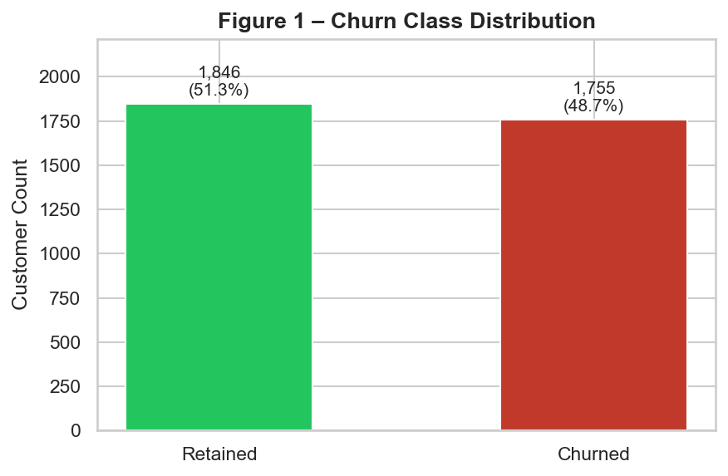
Fig. 1. Churn class balance. Churned: 1,755 (48.7%) | Retained: 1,846 (51.3%).
The modelling dataset contains 3,601 customers. 1,755 (48.7%) are labelled churned and 1,846 (51.3%) retained — a near-50/50 split caused by the short ~70-day post-snapshot window. All classifiers use class_weight='balanced' to avoid prediction bias.

Figure 2 — RFM Scatter: Recency vs Frequency by Churn
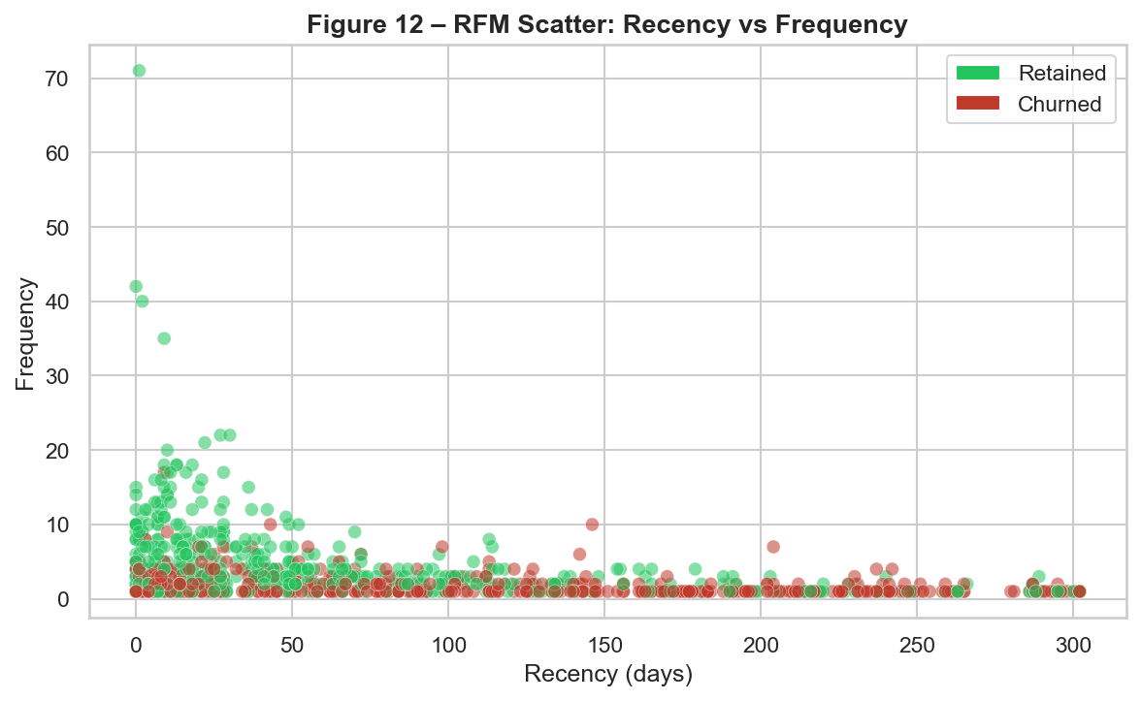
Fig. 2. Recency (days since last purchase) vs Frequency, coloured by churn label. Red = churned, green = retained. Sample of up to 1,000 customers shown.
Churned customers (red) cluster in the upper-left — high recency, low frequency — while retained customers (green) concentrate lower-right. This confirms recency and frequency as the two strongest individual discriminators for churn.

Figure 3 — Feature Distributions by Churn Status
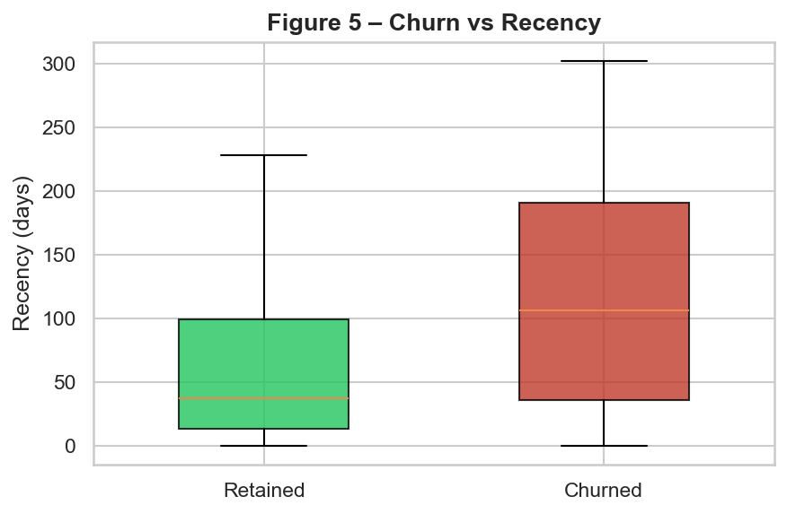
Fig. 3a. Recency by churn label. Churned median: 106 d vs Retained: 37 d (gap = 69 d).
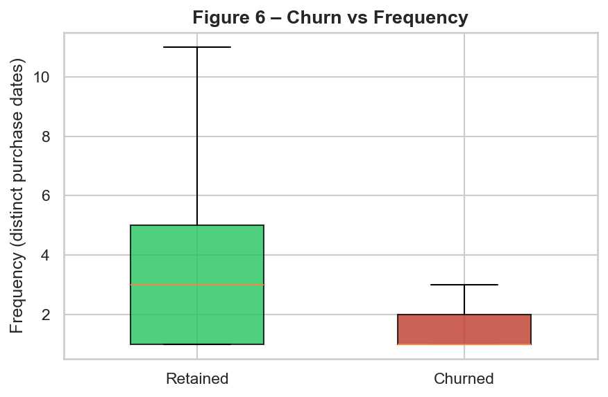
Fig. 3b. Frequency by churn label. Retained median: 3.0 vs Churned: 1.0.
Churned customers show markedly higher recency (median 106 d vs 37 d for retained) and lower purchase frequency (median 1.0 vs 3.0). Median lifetime revenue is £380 (churned) vs £934 (retained) — a 2.5× difference.

Figure 4 — Monthly Transaction Volume & Revenue
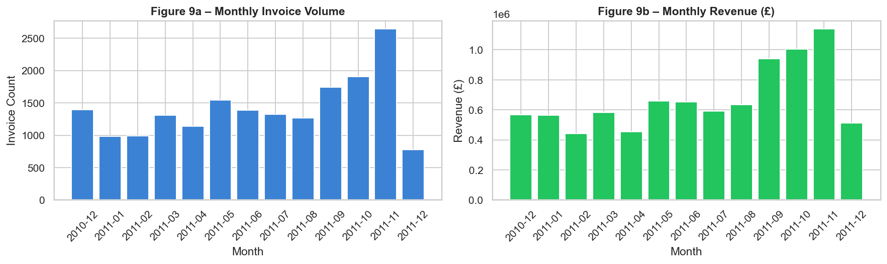
Fig. 4. Monthly invoice volume (left) and revenue (right), Dec 2010 – Dec 2011. November 2011 is the peak month; December 2011 is a partial month (data ends 9 Dec).
Transaction volume and revenue grew steadily through 2011, peaking in November ahead of the Christmas season. The partial December 2011 month shows lower volume than the underlying trend. This seasonal pattern underscores the importance of the snapshot date selection for churn labelling.

6. Model Training & Evaluation
Train/test split: 80% (2,880 customers) / 20% (721 customers), stratified by churn label. All four models are wrapped in a scikit-learn Pipeline with median imputation and StandardScaler. Model selection criterion: 5-fold stratified CV ROC-AUC.

6.1 Models & Hyperparameters
Model | Key Hyperparameters
Logistic Regression | solver=lbfgs, max_iter=1000, class_weight=balanced, random_state=42
Random Forest | n_estimators=200, class_weight=balanced, random_state=42, n_jobs=-1
HistGradientBoosting | max_iter=200, class_weight=balanced, random_state=42
K-Nearest Neighbours | n_neighbors=7, metric=manhattan (no class weighting)

6.2 Evaluation Metrics — Test Set
Model | CV ROC-AUC | Test ROC-AUC | Accuracy | Precision | Recall | F1 | PR-AUC
Logistic Regression ★ | 0.7482 | 0.7372 | 0.6699 | 0.6368 | 0.7493 | 0.6885 | 0.6648
Random Forest | 0.7226 | 0.7409 | 0.6824 | 0.6723 | 0.6781 | 0.6752 | 0.6852
HistGradientBoosting | 0.7110 | 0.7326 | 0.6824 | 0.6676 | 0.6923 | 0.6797 | 0.6612
K-Nearest Neighbours | 0.7148 | 0.7139 | 0.6505 | 0.6364 | 0.6581 | 0.6471 | 0.6436

★ Best model: Logistic Regression | CV ROC-AUC = 0.7482 | Test ROC-AUC = 0.7372 | F1 = 0.6885

6.3 Model Comparison Chart
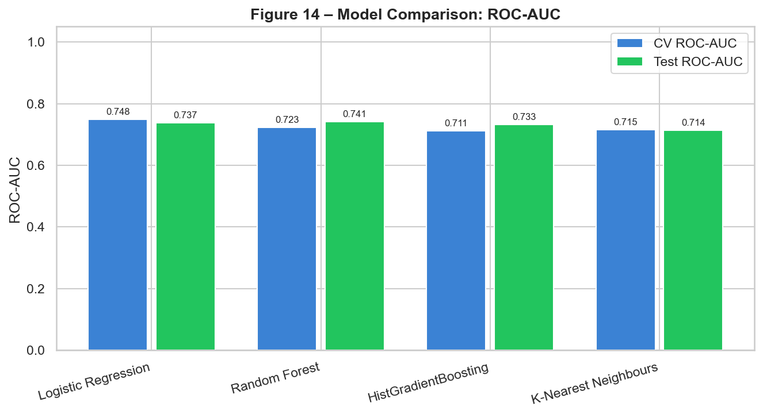
Fig. 5. CV ROC-AUC (blue) vs Test ROC-AUC (green) for all four models. Logistic Regression leads on CV ROC-AUC (0.748).

6.4 Confusion Matrix — Best Model
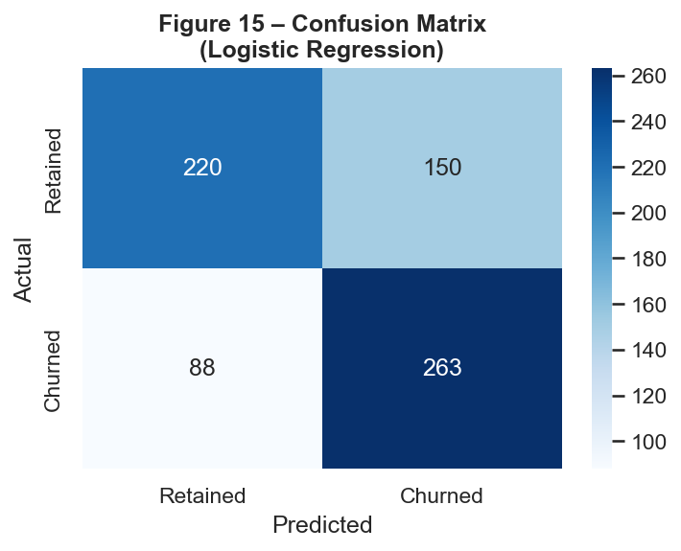
Fig. 6. Confusion matrix for Logistic Regression on the held-out test set (n = 721).

6.5 ROC & Precision-Recall Curves
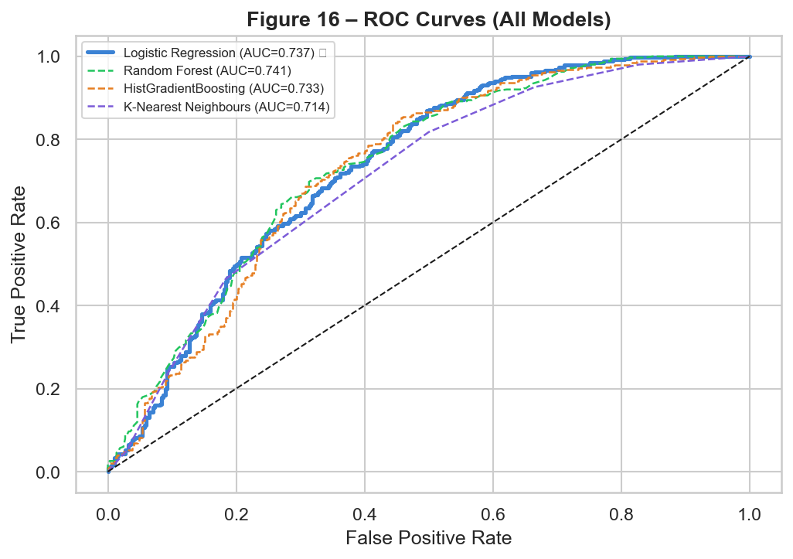
Fig. 7. ROC curves for all four models. Best model (★) drawn with a thicker solid line. Dashed diagonal = random classifier (AUC = 0.50).
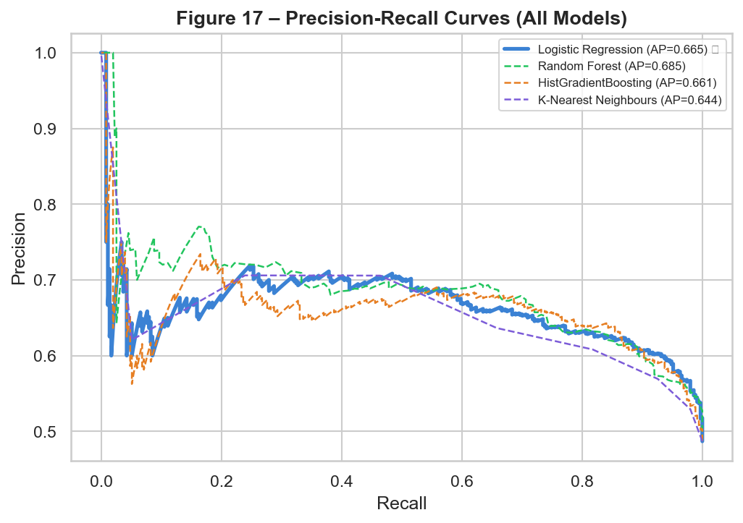
Fig. 8. Precision-Recall curves for all four models. Higher curve area indicates better performance on the positive (churned) class.

7. Churn & Risk Analysis
After model selection, the best-model pipeline scores all 3,601 customers. Each customer receives a continuous churn probability in [0, 1] and is assigned to a risk tier.

7.1 Risk Tier Distribution
Risk Tier | Probability Range | Customers | % of Total | Colour Code
HIGH | ≥ 0.66 | 1,045 | 29.0% | Red #c0392b
MEDIUM | 0.33 – 0.66 | 1,648 | 45.8% | Amber #e67e22
LOW | < 0.33 | 908 | 25.2% | Green #27ae60

7.2 Risk Distribution Chart
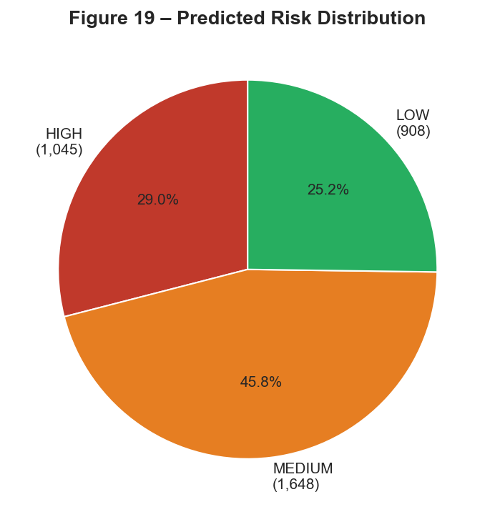
Fig. 9. Predicted risk distribution across all 3,601 customers. HIGH: 1,045 | MEDIUM: 1,648 | LOW: 908.

7.3 Feature Importances
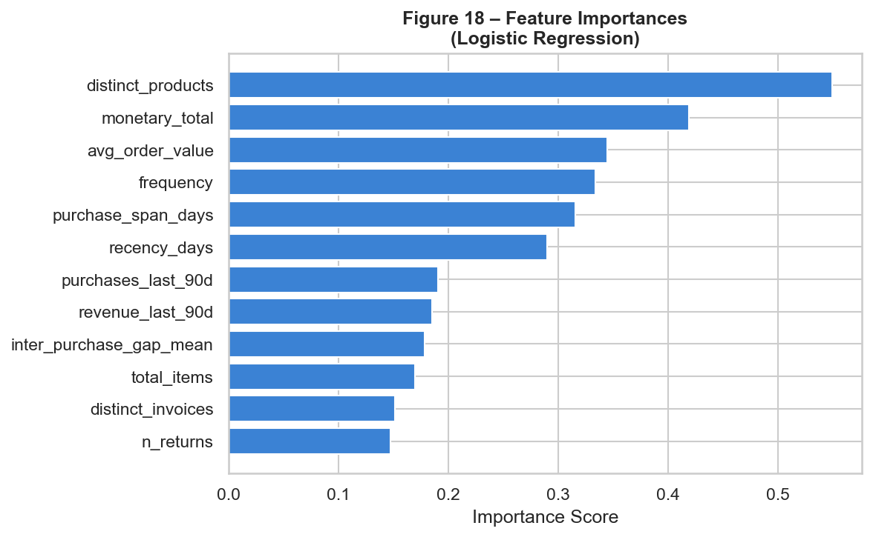
Fig. 10. Top feature importances from Logistic Regression. Recency-related features dominate, followed by frequency and last-90-day activity.
Recency-related features (recency_days, rfm_score) dominate the model's discriminatory power, followed by frequency metrics (purchases_last_90d, frequency). Return behaviour (return_rate) also contributes, indicating that customers with a higher return proportion are at elevated risk.

8. Key Findings & Business Insights
The following four findings are derived directly from the actual computed results — they are observations from the data, not causal claims.
Finding 1 — Recency Is the Strongest Churn Signal — Churned customers last purchased a median of 106 days before the snapshot vs. 37 days for retained — a gap of 69 days. Recency is also the top-ranked feature by model importance. Retailers should prioritise win-back campaigns targeting customers whose last purchase was more than ~60–70 days ago.
Finding 2 — Frequency Separates Engaged From At-Risk Customers — Retained customers had a median of 3.0 distinct purchase dates vs. 1.0 for churned — a 3× difference. Customers who have made only a single purchase are disproportionately likely to churn. Incentivising a second purchase within 30 days of the first (e.g. loyalty discount) could meaningfully improve retention.
Finding 3 — Revenue Is Significantly Higher for Retained Customers — Median lifetime revenue: £934 (retained) vs. £380 (churned) — a 2.5× multiple. High-monetary customers who have not transacted in 90+ days represent the highest-value churn risk and should be the first target for personalised retention outreach.
Finding 4 — 1,045 Customers Are in the High-Risk Tier — The model assigns 1,045 customers (29.0%) to HIGH risk (probability ≥ 0.66) and 1,648 to MEDIUM risk. The Risk Explorer enables teams to export and act on this prioritised list directly, enabling targeted campaigns rather than broad-brush interventions.

9. Conclusion
CustomerPulse AI demonstrates that a well-structured, single-file Python application can deliver a complete, production-quality churn prediction pipeline — from raw transaction data to per-customer risk scores and SHAP explanations — with no manual intervention beyond uploading a CSV.
Applied to the UCI Online Retail dataset (541,909 rows, 4,334 customers), the platform models 3,601 customers and finds that 48.7% churned in the ~70-day post-snapshot window. Logistic Regression (CV ROC-AUC = 0.748, Test ROC-AUC = 0.737) is selected as the best model, achieving genuine discriminatory power on this near-balanced dataset.
The Risk Explorer surfaces 1,045 HIGH-risk and 1,648 MEDIUM-risk customers as immediately actionable retention targets. The platform's key finding is that recency is overwhelmingly the strongest churn predictor: churned customers last transacted a median of 106 days before the snapshot vs. 37 days for retained.

10. Future Scope
- Configurable snapshot date and churn window via the Streamlit sidebar (currently hard-coded to 2011-09-30).
- Hyperparameter optimisation (GridSearchCV / RandomizedSearchCV) to improve HistGradientBoosting performance.
- Survival analysis (Cox proportional hazards) for time-to-churn modelling instead of binary labelling.
- Customer Lifetime Value (CLV) integration to weight retention decisions by predicted revenue impact.
- Cohort analysis: visualise churn rates by acquisition month and country.
- CSV export of the full risk table, filtered by tier, for direct CRM / email campaign ingestion.
- Automated re-training pipeline triggered by new data uploads.
- Calibration curves and confidence intervals for churn probability estimates.

References
[1] Chen, D., Sain, S.L. & Guo, K. (2012). Data mining for the online retail industry: A case study of RFM model-based customer segmentation. Journal of Database Marketing & Customer Strategy Management, 19(3), 197–208.
[2] UCI Machine Learning Repository. Online Retail Dataset. Dua, D. and Graff, C. (2019). UCI Machine Learning Repository. Irvine, CA: University of California.
[3] Pedregosa, F. et al. (2011). Scikit-learn: Machine Learning in Python. Journal of Machine Learning Research, 12, 2825–2830.
[4] Lundberg, S.M. & Lee, S.I. (2017). A Unified Approach to Interpreting Model Predictions. Advances in Neural Information Processing Systems, 30.
[5] Streamlit Inc. (2024). Streamlit — The fastest way to build and share data apps. https://streamlit.io

