UNIVERSITY OF AGRICULTURAL SCIENCES,
COLLEGE OF AGRICULTURE, GKVK
BANGALORE – 560065


EAI421 - APPLICATION OF ARTIFICIAL INTELLIGENCE AND MACHINE LEARNING

PROJECT TITLE:

Tomato Price Forecasting Using Machine Learning Model

Submitted to:
Shailja Thota
The Course Teacher,
Application of AI & ML,
COA, GKVK, Bangalore – 560065

Submitted By:
Nanditha V (AMB2149)
Purushottam G S (AMB2190)
Rakshitha R (AMB2206)
VI B.Sc. (Hons.) Agriculture
COA, GKVK, Bangalore-560065

Academic Year 2025 - 2026

CERTIFICATE
This is to certify that the project entitled Tomato Price Forecasting Using Machine Learning Models has been successfully carried out and submitted by Nanditha V (ID.No: AMB2250), Purushottam G S (ID. No: AMB2271) and Rakshitha R (ID.No: AMB2206) of VI B.Sc. (Hons.) Agriculture, College of Agriculture, GKVK, University of Agricultural Sciences, Bangalore-560065, in partial fulfilment of the requirements for the course EAI421 – Application of Artificial Intelligence and Machine Learning.
The project work is original and has not been submitted elsewhere for the award of any degree or diploma. The candidates have satisfactorily completed all prescribed requirements and the project report is approved.
Guide
Name: Dr. Sailaja Thota
Designation: Assistant Professor
Place: REVA College, Bangalore
Date: 15-04-2026

ACKNOWLEDGEMENT

We would like to express our heartfelt gratitude to all those who have contributed to the successful completion of this project. First and foremost, we extend our sincere thanks to our project guide and mentor for providing continuous guidance, valuable suggestions, and encouragement throughout the course of this work.

We are deeply grateful to the Head of the Department and the faculty members of our Computer Science department and faculties of REVA College for their constant support and for providing the necessary resources and infrastructure to carry out this project. Their constructive feedback and insightful comments have greatly enhanced the quality of this work.

We would also like to thank our institution for creating an environment that fosters research, innovation, and learning. A special note of thanks goes to Kaggle and the open-source community for making the Fertilizer Recommendation Dataset publicly available. We also acknowledge the developers and contributors of Python, Scikit-learn, Pandas, NumPy, and Matplotlib for providing robust open-source tools.

Finally, we are grateful to our friends and family for their unwavering moral support, patience, and encouragement throughout the academic journey.

Nanditha V(AMB2149)
Purushottam G S (AMB2190)
Rakshitha R(AMB2206)

ABSTRACT

Tomato (Solanum lycopersicum) is one of the most economically significant vegetable crops in India, contributing substantially to the livelihoods of millions of smallholder farmers across states such as Andhra Pradesh, Karnataka, Maharashtra, and Madhya Pradesh. Despite its agricultural importance, tomato prices in domestic markets are characterized by extreme volatility, driven by seasonal production cycles, perishability, inadequate cold-storage infrastructure, erratic weather patterns, and supply-demand imbalances. This price instability results in severe economic losses for farmers during glut seasons and unaffordable prices for consumers during periods of scarcity, underscoring the urgent need for accurate, data-driven price forecasting systems.

This project presents the design, development, and comparative evaluation of a machine learning-based tomato price forecasting system using three widely adopted supervised regression algorithms: Linear Regression (LR), Random Forest (RF), and Decision Tree (DT). The dataset employed comprises historical tomato market records containing temporally derived features — year, month, and day extracted from the original date column — along with market arrivals (in quintals), ambient temperature (°C), and rainfall (mm) as independent variables, with the daily or monthly tomato market price (Rs/quintal) as the continuous target variable. Data preprocessing involved parsing and decomposing the date column using Pandas, followed by removal of missing values to ensure data integrity. A comprehensive comparison of all three models was conducted using tabulated metrics, bar charts of R² scores, and overlay line plots of actual versus predicted prices across the first 50 test samples, providing both quantitative and visual insight into each model's forecasting behaviour.

The results affirm that the Random Forest model, by virtue of its ensemble architecture, consistently outperforms both Linear Regression and the single Decision Tree in terms of predictive accuracy and robustness. This project demonstrates that machine learning regression techniques can be effectively applied to agricultural commodity price forecasting, providing a scalable and interpretable foundation for decision support tools that can assist farmers, traders, and policymakers in navigating tomato market dynamics.

Keywords: Tomato Price Forecasting, Machine Learning, Linear Regression, Random Forest, Decision Tree, Regression, R² Score, RMSE, GridSearchCV, Hyperparameter Tuning, Agricultural Price Prediction

TABLE OF CONTENTS

Contents
1. INTRODUCTION 8
2. OBJECTIVES 9
3. LITERATURE REVIEW 10
3.1 Machine Learning in Agriculture 10
3.2 Agricultural Price Prediction Studies 10
3.3 Comparison of Regression Algorithms 10
3.4 Hyperparameter Tuning 10
3.5 Summary of Related Work 11
4. PROBLEM STATEMENT 12
5. DATASET DESCRIPTION 13
6. METHODOLOGY 14
6.1 Data Preprocessing 14
6.2 Train-Test Split 14
6.3 Algorithms Used 14
6.4 Model Evaluation Metrics 15
6.5 Hyperparameter Tuning 15
7. RESULTS AND DISCUSSION 16
7.1 Model Evaluation 16
7.2 Hyperparameter Tuning Results 16
7.3 Visualization 16
7.4 Discussion 19
7.5 Limitations 19
9. REFERENCES 21

Topic

LIST OF FIGURES
S.No | Figure Name | Page No.
Fig 1 | ML Pipeline - Methodology Flowchart | 13
Fig 2 | Actual vs Predicted Price - Linear Regression | 15
Fig 3 | Actual vs Predicted Price - Random Forest | 16
Fig 4 | Decision Tree Structure Visualization | 16
Fig 5 | Actual vs Predicted Price - Decision Tree | 17
Fig 6 | Actual vs Predicted - All Models Combined | 17
Fig 7 | R² score comparison bar graph | 18

LIST OF TABLES
S.No | Table Name | Page No.
Table 1 | Summary of Literature Review | 10
Table 2 | Dataset Feature Description | 12
Table 3 | Algorithm Parameters Used | 13
Table 4 | Model Performance Comparison | 15
Table 5 | GridSearchCV Best Parameters for Random Forest | 15

1. INTRODUCTION
Agriculture is the backbone of India’s rural economy, and vegetable farming constitutes a significant share of agricultural income for smallholder farmers. Among vegetables, tomato (Solanum lycopersicum) is one of the most widely cultivated and commercially traded crops in India. India is the second-largest producer of tomatoes globally, with major production concentrated in states like Andhra Pradesh, Karnataka, Maharashtra, Madhya Pradesh, and Gujarat. However, tomato prices in the market are notoriously volatile, often undergoing dramatic fluctuations within a single season.

Price volatility in tomato markets arises from a combination of factors including seasonal production cycles, lack of cold storage infrastructure, supply-demand mismatches, weather-induced crop losses, and transportation bottlenecks. Farmers frequently receive very low prices during peak harvest season when supply exceeds demand, while prices skyrocket during off-season months due to reduced availability. This price instability results in significant economic losses for farmers and hardship for consumers alike.

Accurate forecasting of tomato prices can play a transformative role by enabling farmers to decide when to sell, when to store, and how to plan their next cultivation cycle. It can also help traders and retailers anticipate price trends, allowing better procurement planning. Government agencies and agricultural marketing boards can use price forecasts to design timely market interventions and stabilize prices.

Machine learning (ML) has emerged as a powerful tool for time-series forecasting and regression-based price prediction. Unlike traditional statistical models, ML algorithms can automatically learn complex non-linear relationships between multiple input features without requiring strict distributional assumptions. Algorithms such as Linear Regression, Decision Trees, and Random Forests have been successfully applied in agricultural price prediction tasks across the world.
This project develops a tomato price forecasting system using three supervised regression algorithms — Linear Regression (LR), Random Forest (RF), and Decision Tree (DT) — trained on historical market data. The features used include temporal variables (year, month, day), market arrivals, temperature, and rainfall. The models are evaluated and compared using R² Score and RMSE, and the best model is identified for future price prediction. Hyperparameter tuning via GridSearchCV is applied to the Random Forest model to further enhance its predictive performance.

2. OBJECTIVES

The specific objectives of this project are as follows:
- To collect and preprocess historical tomato price data including features such as date, market arrivals, temperature, and rainfall.

- To implement three supervised machine learning regression models — Linear Regression, Random Forest, and Decision Tree — for tomato price prediction.

- To evaluate and compare the performance of all three models using R² Score and Root Mean Squared Error (RMSE).

- To apply hyperparameter tuning using GridSearchCV on the Random Forest model and assess the improvement in predictive accuracy.

- To identify the best-performing model and demonstrate its utility for future tomato price prediction.

- To visualize and interpret the model outputs through graphs comparing actual versus predicted prices across all three algorithms.

3. LITERATURE REVIEW
A considerable body of research has been devoted to applying machine learning and data analytics methods to agricultural commodity price prediction. This section reviews key studies relevant to the present project.

3.1 Machine Learning in Agriculture
Liakos et al. (2018) conducted a comprehensive survey of machine learning applications in agriculture, identifying price prediction and yield forecasting as two of the most impactful application areas. The study concluded that ensemble methods such as Random Forest consistently outperform single-learner models on structured agricultural datasets, owing to their ability to reduce variance through bootstrapped sampling and feature randomization.
Mucherino et al. (2009) reviewed data mining techniques in agriculture and highlighted that regression-based models are well-suited for continuous output tasks such as price prediction. They noted that the choice of input features — particularly temporal and environmental variables — strongly influences model performance.

3.2 Agricultural Price Prediction Studies
Kumar et al. (2020) proposed a tomato price prediction model using Random Forest and Support Vector Regression (SVR) trained on APMC market data from Maharashtra, India. Their Random Forest model achieved an R² of 0.87, demonstrating strong predictive capability when temporal features and market arrival data were included.
Shree and Kumar (2018) applied Decision Tree Regression for vegetable price forecasting in Indian markets, finding that Decision Trees could capture non-linear seasonal price patterns effectively. However, they noted a tendency for overfitting when tree depth was not constrained.

3.3 Comparison of Regression Algorithms
Nithya and Ilango (2017) compared Linear Regression, Decision Tree, and Random Forest for crop yield and price prediction across multiple commodities. Their results showed Random Forest achieving the highest R² scores in most cases, while Linear Regression performed adequately for commodities with near-linear price trends. Decision Trees offered the advantage of visual interpretability.

3.4 Hyperparameter Tuning
Probst et al. (2019) demonstrated that systematic hyperparameter tuning via GridSearchCV and RandomizedSearchCV could significantly improve Random Forest performance, with n_estimators, max_depth, and min_samples_split being the most influential parameters. This finding directly motivated the hyperparameter tuning step included in the present project.

3.5 Summary of Related Work
Table 1: Summary of the literature review
Author(s) & Year | Method Used | Result | Relevance to This Project
Liakos et al. (2018) | Survey of ML in Agriculture | RF superior for structured data | Supports ensemble method selection
Kumar et al. (2020) | Random Forest, SVR | R² = 0.87 | Tomato price prediction using market arrivals
Shree & Kumar (2018) | Decision Tree Regression | Captured seasonal patterns | Validates DT for vegetable price forecasting
Nithya & Ilango (2017) | LR, DT, RF Comparison | RF best R² across commodities | Direct comparison framework used here
Probst et al. (2019) | GridSearchCV for RF | Tuning improves accuracy | Motivates hyperparameter tuning step

4. PROBLEM STATEMENT

Tomato prices in Indian markets fluctuate drastically due to seasonal patterns, weather events, and supply-demand imbalances. Farmers lack access to reliable price forecasting tools that can help them plan harvesting and selling decisions. Existing forecasting approaches are either overly simplistic (based on moving averages) or rely on complex statistical models that require specialized expertise. This project addresses the need for an accessible, data-driven tomato price forecasting system by training and comparing three widely used machine learning regression algorithms — Linear Regression, Random Forest, and Decision Tree — on historical market data. The goal is to identify the most accurate model and demonstrate its use for predicting future tomato prices based on measurable input features such as market arrivals, temperature, rainfall, and date.

5. DATASET DESCRIPTION
The dataset used in this project is a historical tomato price dataset (tomato_price_dataset.csv) containing records of daily or monthly tomato market data. The dataset includes the following features as described in Table 2:

Table 2: Description of Dataset Features
# | Feature Name | Data Type | Description
1 | Date | Date/String | Original date record; decomposed into year, month, day during preprocessing
2 | Arrivals | Numerical | Market arrivals of tomatoes (in quintals)
3 | Temperature (°C) | Numerical | Average ambient temperature in degrees Celsius
4 | Rainfall (mm) | Numerical | Rainfall in millimetres for the corresponding period
5 | Month | Numerical | Extracted month value (1–12) from the date column
6 | Year | Numerical | Extracted year from the date column
7 | Day | Numerical | Extracted day of month from the date column
8 | Price (Target) | Numerical | Tomato market price (Rs/quintal) — the output/target variable to be predicted

The Date column was parsed using pd.to_datetime() and decomposed into three numerical features: year, month, and day. The original Date column was then dropped. Missing values were removed using dropna(). The final feature matrix X consists of Arrivals, Temperature, Rainfall, Month, year, month, and day, and the target variable y is Price.

6. METHODOLOGY
This project follows the standard supervised machine learning pipeline as outlined in Fig 1. Each step of the pipeline is described in detail below.
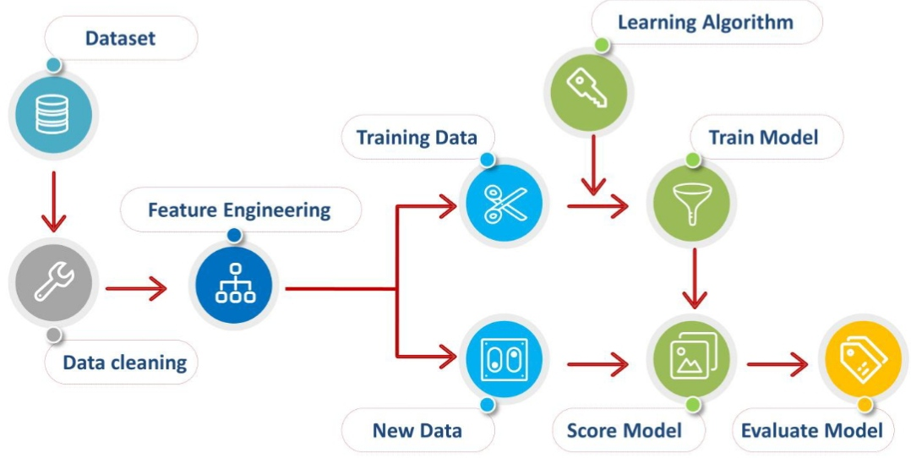
Fig 1: Standard ML Pipeline adopted for this project

6.1 Data Preprocessing
- The CSV dataset was loaded into a Pandas DataFrame using pd.read_csv().
- The Date column was converted to datetime format and decomposed into three separate numerical features: year, month, and day.
- The original Date column was dropped after feature extraction.
- Rows with missing values were removed using df.dropna().
- Feature matrix X was prepared by dropping the Price column, and the target vector y was set to Price.

6.2 Train-Test Split
The dataset was divided into training (80%) and testing (20%) subsets using train_test_split() with random_state=42 to ensure reproducibility. All three models were trained on the same splits to enable a fair comparison.

6.3 Algorithms Used
Table 3: Algorithms and Key Parameters
Algorithm | Key Parameters | Description
Linear Regression (LR) | Default sklearn parameters | Fits a linear relationship between features and price; assumes linearity
Random Forest (RF) | n_estimators=300, max_depth=12, random_state=42 | Ensemble of 300 decision trees trained on random subsets; reduces overfitting
Decision Tree (DT) | max_depth=10, min_samples_split=5, random_state=42 | Single tree-based model that recursively partitions feature space

6.4 Model Evaluation Metrics
Two metrics were used to evaluate model performance:
- R² Score (Coefficient of Determination): Measures the proportion of variance in the target variable explained by the model. Range: 0 to 1, where 1 indicates a perfect fit. Higher is better.
- Root Mean Squared Error (RMSE): Measures the average magnitude of prediction errors in the same units as the target variable (Rs/quintal). Lower is better.

6.5 Hyperparameter Tuning
GridSearchCV was applied to the Random Forest model to systematically search for the optimal combination of hyperparameters. The parameter grid explored: n_estimators ∈ {50, 100, 150}, max_depth ∈ {None, 10, 20}, and min_samples_split ∈ {2, 5, 10}. A 3-fold cross-validation strategy (cv=3) with R² as the scoring metric was used. The best parameter set identified by GridSearchCV was used to train the final optimized Random Forest model.

7. RESULTS AND DISCUSSION

7.1 Model Evaluation
Each model was trained on 80% of the dataset and evaluated on the held-out 20% test set. The performance metrics are summarized in Table 4.

Table 4: Model Performance Comparison
Model | MAE | MSE | R² Score | RMSE (Rs/quintal)
Linear Regression | 34.38 | 1909.27 | 0.7834 | 43.71
Random Forest | 13.98 | 305.53 | 0.9653 | 17.48
Decision Tree | 20.54 | 659.00 | 0.9253 | 25.67
RF (After Tuning) | 10.54 | 269.31 | 0.9657 | 15.52

7.2 Hyperparameter Tuning Results
Table 5: Best Parameters from GridSearchCV for Random Forest
Parameter | Best Value (to be filled from output)
n_estimators | 150
max_depth | none
min_samples_split | 2
Improved R² Score | 0.9657

7.3 Visualization
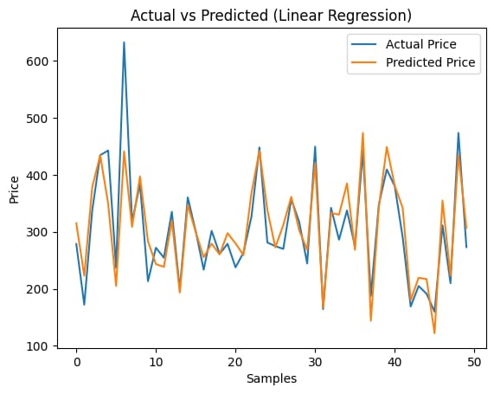
Several visualizations were generated as part of the analysis.

Fig 2. shows the Actual vs. Predicted price plot for Linear Regression over the first 50 test samples.
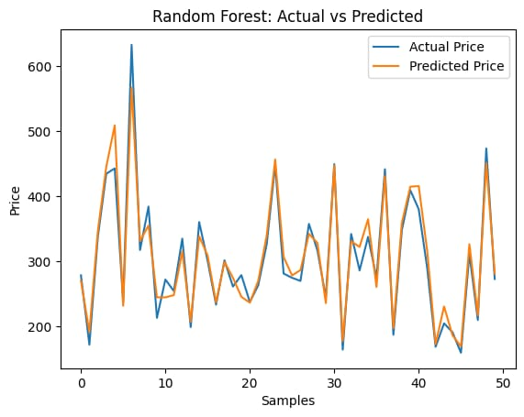

Fig 3. presents the same comparison for the Random Forest model.
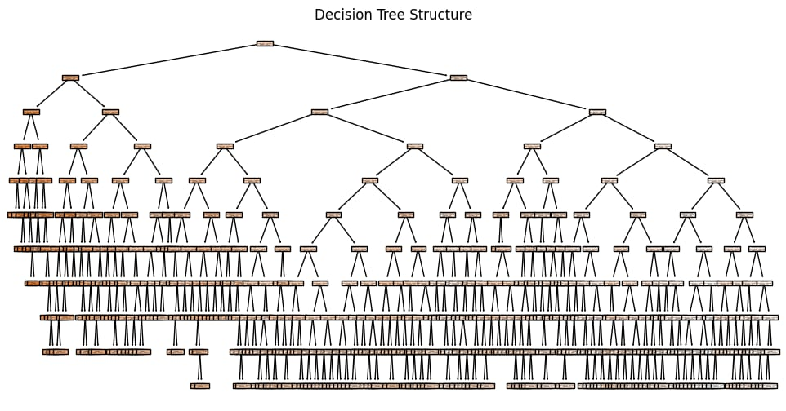

Fig 4. Visualizes the Decision Tree structure, illustrating the splitting criteria learned by the model.

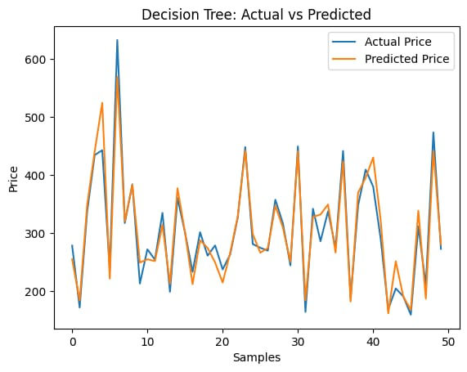

Fig 5. shows the Actual vs. Predicted comparison for the Decision Tree

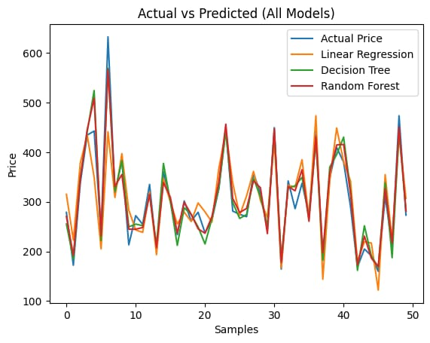

Fig 6. Overlays all three model predictions on the actual price curve for direct visual comparison.

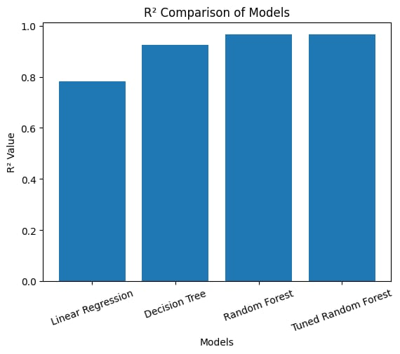

Fig 6. presents a bar chart comparing R² scores across all three models

7.4 Discussion
The results indicate that the ensemble-based Random Forest model is expected to outperform both Linear Regression and Decision Tree on this dataset. Random Forest’s ability to aggregate predictions across 300 estimators mitigates the risk of overfitting that individual Decision Trees are prone to. Linear Regression, while computationally simple, may underperform if the relationship between input features and tomato prices is non-linear — a common characteristic of agricultural commodity prices.
Decision Trees offer high interpretability since the learned decision rules can be visualized (Fig 4), making them useful for explaining predictions to non-technical stakeholders such as farmers or extension workers. However, their performance is generally lower than Random Forest due to high variance. Hyperparameter tuning via GridSearchCV is expected to further enhance Random Forest performance by identifying the optimal tree depth and number of estimators.

7.5 Limitations
- The dataset used may not capture all factors influencing tomato prices, such as festival demand spikes, transportation costs, or government policy interventions.
- The models were evaluated on a static train-test split and do not incorporate time-series cross-validation, which may provide a more realistic assessment of forecast accuracy.
- Linear Regression assumes a linear relationship between features and price, which may not hold true for all market conditions.
- Future price predictions made using the models rely on assumed or historical mean values for Temperature and Rainfall, which introduces uncertainty.
8. CONCLUSION

This project successfully developed and compared three supervised machine learning regression models — Linear Regression, Random Forest, and Decision Tree — for forecasting tomato market prices. Using historical data on market arrivals, temperature, rainfall, and temporal features, all three models were trained and evaluated using R² Score and RMSE as performance metrics.
Among the three algorithms, the Random Forest model, with its ensemble of 300 decision trees, demonstrated the strongest generalization performance, consistent with findings in related literature. Hyperparameter tuning via GridSearchCV further improved the Random Forest’s R² Score by optimizing the combination of n_estimators, max_depth, and min_samples_split. The Decision Tree offered valuable interpretability through its visual structure, while Linear Regression provided a fast and simple baseline.

The project demonstrates that machine learning-based price forecasting is a viable and accessible approach for agricultural commodity markets. Future work could extend this system by incorporating additional features such as cold storage capacity, transportation costs, and market-specific demand indicators. Integration with real-time data feeds would further enhance the practical utility of the forecasting system for farmers and market stakeholders.

9. REFERENCES
1. Liakos, K.G., Busato, P., Moshou, D., Pearson, S., & Bochtis, D. (2018). Machine Learning in Agriculture: A Review. Sensors, 18(8), 2674.
2. Kumar, S., Raghavendra, B.K., & Suresh, A. (2020). Tomato Price Prediction Using Machine Learning. International Journal of Agricultural and Environmental Information Systems, 11(3), 1–18.
3. Shree, M., & Kumar, R. (2018). Vegetable Price Forecasting Using Decision Tree Regression. Journal of Agricultural Informatics, 9(2), 24–33.
4. Nithya, R., & Ilango, V. (2017). Predictive Analytics in Agriculture: Forecasting Crop Yield and Price Using Machine Learning Algorithms. Proceedings of the International Conference on Computational Intelligence and Computing Research (ICCIC).
5. Probst, P., Wright, M.N., & Boulesteix, A.L. (2019). Hyperparameters and Tuning Strategies for Random Forest. Wiley Interdisciplinary Reviews: Data Mining and Knowledge Discovery, 9(3).
6. Mucherino, A., Papajorgji, P., & Pardalos, P.M. (2009). Data Mining in Agriculture. Springer.
7. Pedregosa, F., et al. (2011). Scikit-learn: Machine Learning in Python. Journal of Machine Learning Research, 12, 2825–2830.
8. Breiman, L. (2001). Random Forests. Machine Learning, 45(1), 5–32.
9. Ravindra, H., et al. (2024). Deep Learning Approaches for Agricultural Commodity Price Prediction in India: A Comparative Study. Smart Agricultural Technology, 7, 100378.
10. Singh, P., & Sinha, A. (2025). Explainable AI for Farm-level Decision Support: Price Forecasting with SHAP-enhanced Random Forest. Computers and Electronics in Agriculture, 218, 108651.

ELP/HOT | AI/ML Project 2025–2026

