1 Table - user_details

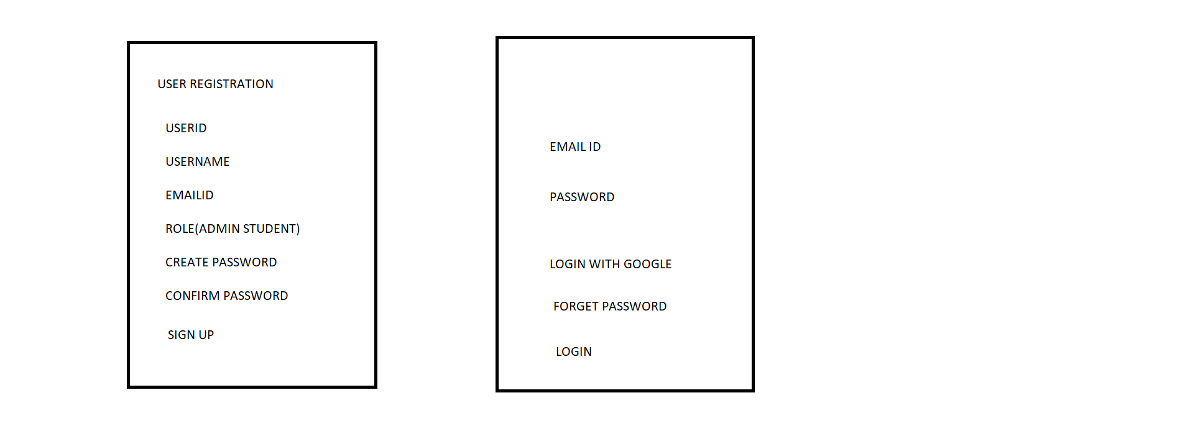

Admin ->

Create Category (Admin)

Reserve

Non Reserve

AC Reserve

Reserve

Total Seat Define

Fees

Locker

Room No

NO Reserve

Total Seat Define

Fees

Locker

Room No

AC Reserve

Total Seat Define

Fees

Locker

Room No

Admin provide Book For Student

Books details

Book Number

Book Name

Book Author Name

Book Types

Availability

Book Price

Admin See seat details how many available and filed

Student Id

Student Name

Seat Id   
Seat Type

Locker No

Join Date

Status

Book Details

**Student Login**

**Seat Availabilty**

**Category wise details**

**Addmission Form**

**Table admission_form**

Addmission id

StudentId

Student name

Email ID

Mobile No

Parent Mobile

Address

Date

SeatBooK No

Locker No

Room No

Payment Gatway

Submit

As possible we can and Book Table Functionality

Payment process

Payment id

Transaction Id

Date

Time

Final receipt details table

Reciept Id

Addmission id

Seat no

Name

Fees paid

Status

Finally Recipt send to Student as well as Notification

–––

Role Student -> going to Addmission -> Admission form before Seat Details