

**A Python Project for Academic Year 2024 - 2025**

**RENTAL CAR MANAGEMENT SYSTEM**

Subject Code : 05BC3404

Subject Name : Python Programing

Submitted By : Nandni korat

Hasti trambadiya

Jinal kanani

[92300527028 ]

[92300527029 ]

[92300527036 ]

SubmittedTo:

Prof. Riddhi Joshi

**Introduction**

* The Car Rental Management System is a Python-based console application designed to manage and maintain records for a car rental service. It handles customer information, booking details, car preferences, and journey plans using simple file-based storage. This system eliminates the need for an external database by relying on CSV files, making it lightweight and easy to manage.
* The system provides a **menu-driven interface** where users can add, update, search, and delete customer records. It also allows users to clear all data or display a summary of names with booking dates. The goal of this project is to simplify rental management for small car rental businesses using Python's standard libraries.

**Technical Information**

**Technologies Used**

* **Programming Language:Python 3.x**
* **Data Storage:CSV (Comma-Separated Values) and TXT FILE**
* **Libraries Used:**
  + **csv – For reading and writing data to CSV files.**
  + **os – For handling file operations.**

**Development Tools**

* **Code Editor:**
* **Visual Studio Code (VS Code)**
* **PyCharm**
* **Execution Environment:**
* **Command Line Interface (CLI) / Terminal**
* **Version Control System:**
* **Git (optional, for tracking changes)**

**System Requirements**

* **Software:**
* Python 3.x
* Any text editor or Python IDE
* CLI or Terminal for execution
* **Hardware:**
* Basic system capable of running Python
* At least 512MB RAM
* Minimal disk space for CSV storage

**Project Structure**

* The core functionalities are implemented in a single Python file **rental_car(last one**).py. It performs customer data handling, booking details management, and basic CRUD operations.

Car_Rental_Management/

│── rental(1)(last one).py # Main Python script

│── rental_car.csv # Data file (created automatically)

**Diagram(s)**

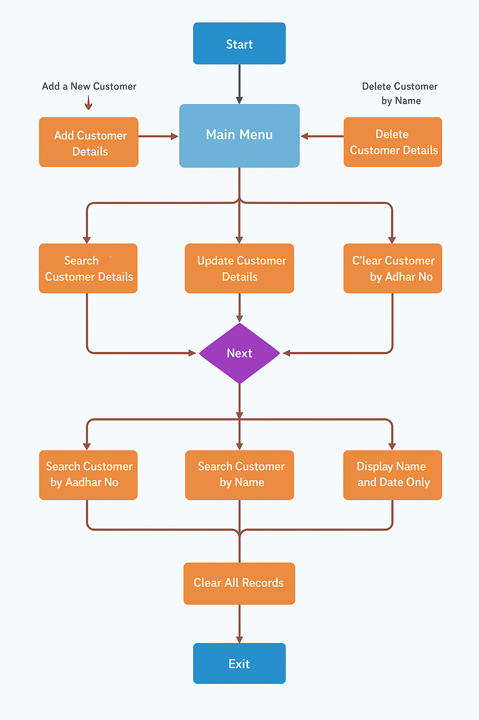

[Flow chart of Rental car Management System ]

**Features**

* Add customer and booking details
* View all customer records
* Delete a customer record using Aadhar number
* Update customer information
* Search by Aadhar number or name
* Display names with booking dates
* Clear all records (reset database)
* Prevent duplicate entries by checking existing Aadhar numbers

**Output Screenshots**

**Below are the screenshots of the system's functionality:**

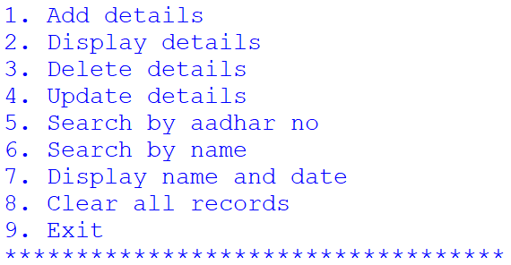

**MAIN MENU**

**Adding a Customers**

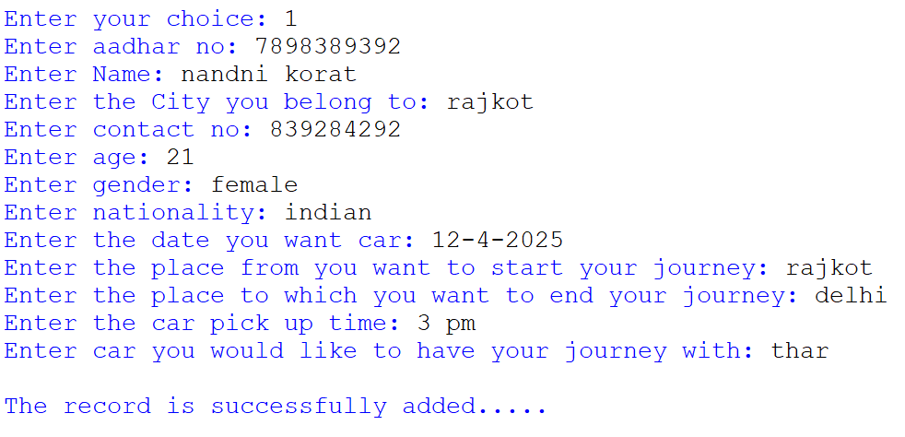

**Delete Customers**

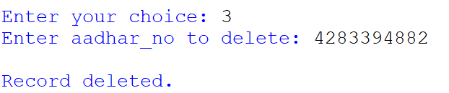

**Display customers details**

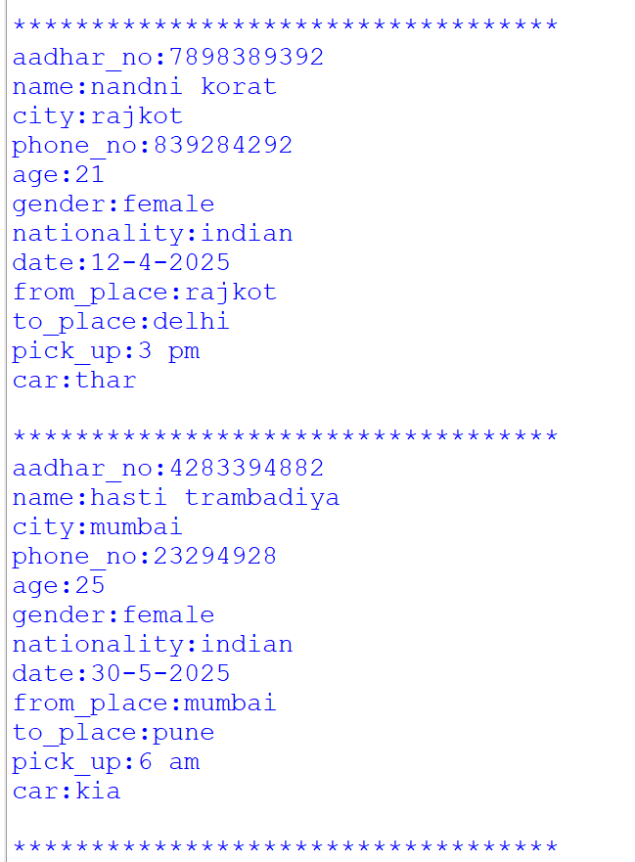

**Update CustomersDetails**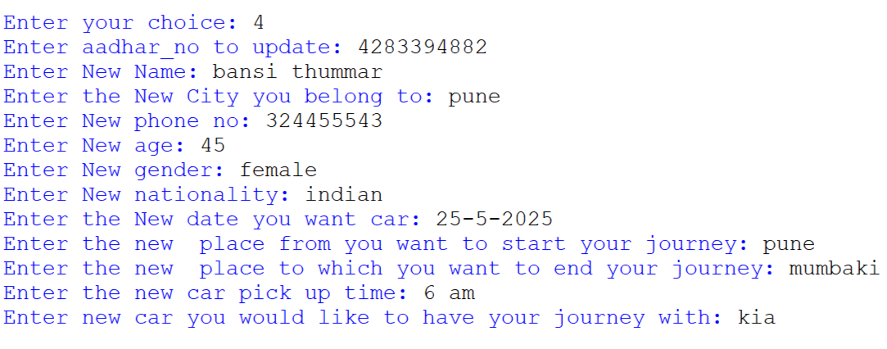

**Search Customers by Name**

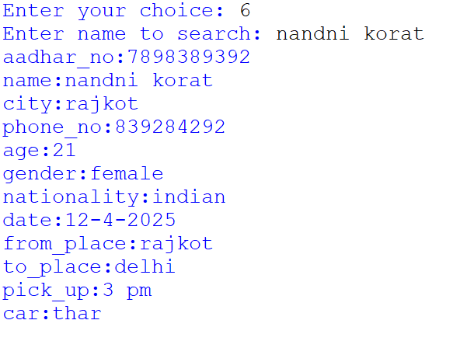

**Display only Name and Date Details**

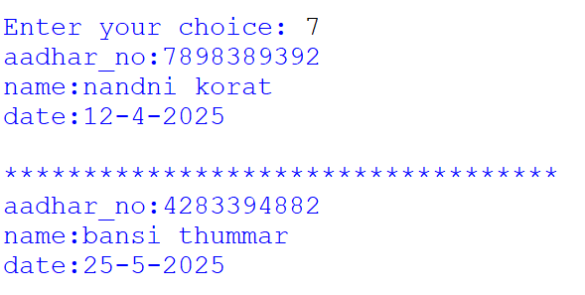

**Search Customers by Aadhar no**

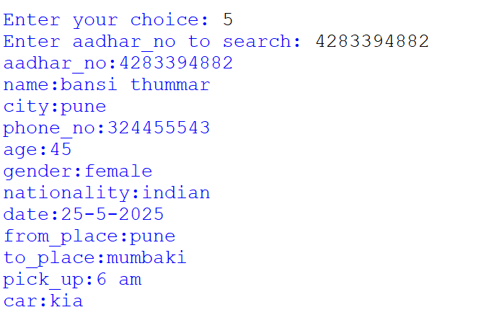

**Clear All Records**

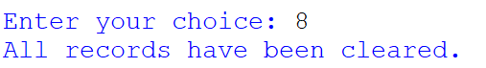

**Learning Objectives**

This project helps in understanding and developing essential skills, including:

* **File handling using Python's csv module: Enables reading from and writing to CSV files for structured data storage without using databases.**
* **Creating CLI-based user interfaces: Develops interactive, text-based menus for user-friendly command-line navigation.**
* **Implementing CRUD operations: Teaches how to Create, Read, Update, and Delete records in a programmatic and structured way.**
* **Input validation and handling: Ensures data accuracy and prevents errors by checking user inputs before processing.**
* **Python data structures and functions: Utilizes lists, strings, and functions to organize and manipulate data efficiently.**
* **Logical structuring of code using menu-driven loops: Implements continuous user interaction through structured loops and conditional logic.**
* **Error handling for file operations: Prevents program crashes by managing file-related exceptions like missing or unreadable files.**
* **Project organization and modularity: Encourages clean, maintainable code by separating logic into reusable and well-defined functions.**

**Conclusion**

* The Car Rental Management System offers a simple, effective way to manage rental operations for small businesses. It uses Python's core features to maintain customer records, update details, and track bookings without relying on databases. The project demonstrates efficient data handling, functional programming techniques, and the benefits of structured console-based interfaces.
* Future improvements may include GUI development using Tkinter or PyQt, adding automated billing, and moving from CSV-based storage to a relational database for scalability.