Day 4: Hands on:
• Identify master data domains in NYC taxi dataset (zones, vendors, rate codes)
• For each domain, document:
• Business owner (simulated)
• Business justification (why is this master data?)
• Update frequency and change triggers
• Quality requirements and thresholds
• Approval workflow (who can create/update/retire?)
• Create simple matching algorithm for duplicate detection
• Design golden record strategy for taxi zones with survivorship rules documented
• Build master data tables in RDS with audit columns (created_by, updated_by, approved_by, version)

Task 1 - • Identify master data domains in NYC taxi dataset (zones, vendors, rate codes)
Looked at the NYC Taxi dataset and decided which entities are master data. Master data is typically relatively static reference data used across the business.
For the NYC Taxi dataset, common master data domains are:
- Taxi Zones – locations like boroughs, neighborhoods, or pickup/drop-off zones.
- Vendors – the taxi companies or service providers.
- Rate Codes – different fare types (standard, flat, night, etc.).

Task 2 - •For each domain, document:
• Business owner (simulated)
• Business justification (why is this master data?)
• Update frequency and change triggers
• Quality requirements and thresholds
• Approval workflow (who can create/update/retire?)

Created a table in a document with the following columns for each domain:
- Domain Name (e.g., Taxi Zones, Vendors, Rate Codes)
- Business Owner (simulated – e.g., “Data Steward – Taxi Operations”)
- Business Justification (why it’s master data)
- Update Frequency & Change Triggers (how often data changes and why)
- Quality Requirements & Thresholds (e.g., no nulls, valid codes)
- Approval Workflow (who can create/update/retire records)

Domain | Business Owner | Business Justification | Update Frequency & Change Triggers | Quality Requirements & Thresholds | Approval Workflow
Taxi Zones (PULocationID, DOLocationID) | Taxi Operations Data Steward | Reference for all trips, used to join with fares and calculate metrics | Quarterly updates if zones change | No nulls, valid zone codes | Data Steward approves changes, Admin can create/update
Vendors (VendorID) | Vendor Management | Reference for taxi providers, used in reporting | As new vendors are onboarded | Valid IDs, no duplicates | Data Steward creates/updates, Admin approves
Rate Codes (RatecodeID) | Finance/Data Analyst | Reference for fare types, used for billing and reporting | Rarely changes, only if TLC adds new rate | Valid codes, no nulls | Analyst proposes changes, Data Steward approves

Task 3 - Build master data tables in RDS with audit columns (created_by, updated_by, approved_by, version)
• Create simple matching algorithm for duplicate detection
• Design golden record strategy for taxi zones with survivorship rules documented

Action : Created PostgreSQL instance in AWS RDS:
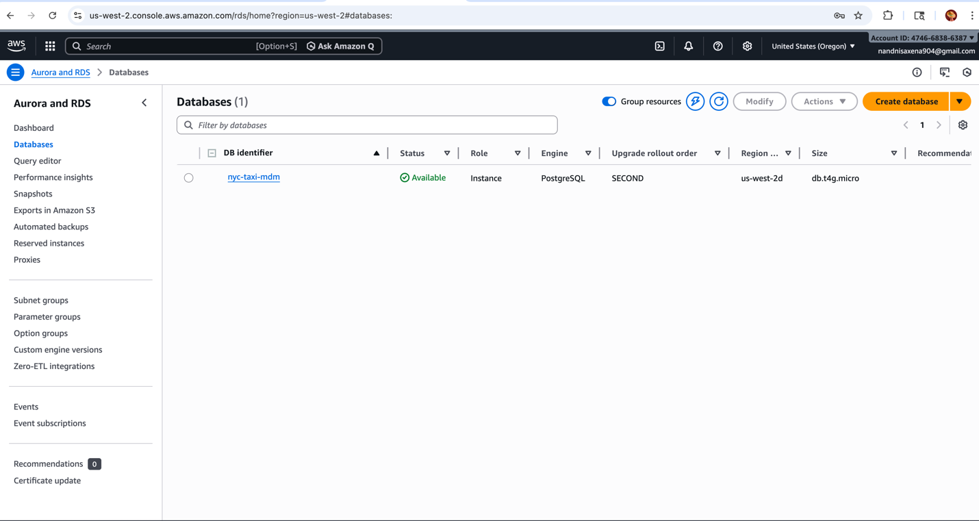

Connected same DB instance in PGAdmin4
