**Network Task**

**Task Description:**

1.Get me the IP address of a particular domain (guvi.in). How do I find my CPU/memory usage of my server?. Test the connectivity between 2 nodes?

ubuntu@ip-172-31-2-34:~$

ubuntu@ip-172-31-2-34:~$ ping guvi.in

PING guvi.in (104.26.5.88) 56(84) bytes of data.

64 bytes from 104.26.5.88 (104.26.5.88): icmp_seq=1 ttl=54 time=1.02 ms

64 bytes from 104.26.5.88 (104.26.5.88): icmp_seq=2 ttl=54 time=1.18 ms

^C

--- guvi.in ping statistics ---

2 packets transmitted, 2 received, 0% packet loss, time 1002ms

rtt min/avg/max/mdev = 1.021/1.099/1.177/0.078 ms

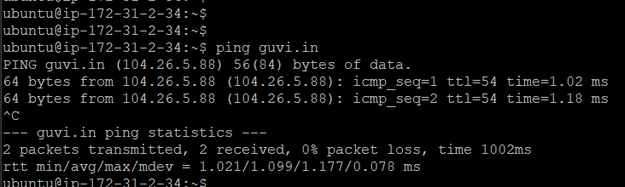

ubuntu@ip-172-31-2-34:~$ dig guvi.in

; <<>> DiG 9.18.28-0ubuntu0.22.04.1-Ubuntu <<>> guvi.in

;; global options: +cmd

;; Got answer:

;; ->>HEADER<<- opcode: QUERY, status: NOERROR, id: 43153

;; flags: qr rd ra; QUERY: 1, ANSWER: 3, AUTHORITY: 0, ADDITIONAL: 1

;; OPT PSEUDOSECTION:

; EDNS: version: 0, flags:; udp: 65494

;; QUESTION SECTION:

;guvi.in. IN A

;; ANSWER SECTION:

guvi.in. 272 IN A 172.67.70.207

guvi.in. 272 IN A 104.26.5.88

guvi.in. 272 IN A 104.26.4.88

;; Query time: 0 msec

;; SERVER: 127.0.0.53#53(127.0.0.53) (UDP)

;; WHEN: Fri Jan 17 18:10:13 UTC 2025

;; MSG SIZE rcvd: 84

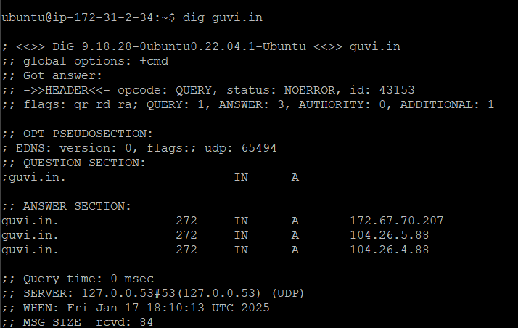

ubuntu@ip-172-31-2-34:~$ top

top - 17:58:54 up 11 days, 10:43, 2 users, load average: 0.00, 0.00, 0.00

Tasks: 103 total, 2 running, 101 sleeping, 0 stopped, 0 zombie

%Cpu(s): 0.0 us, 0.0 sy, 0.0 ni, 87.3 id, 0.0 wa, 0.0 hi, 0.0 si, 12.7 st

MiB Mem : 957.4 total, 161.9 free, 187.9 used, 607.6 buff/cache

MiB Swap: 0.0 total, 0.0 free, 0.0 used. 608.7 avail Mem

PID USER PR NI VIRT RES SHR S %CPU %MEM TIME+ COMMAND

1 root 20 0 167592 12916 8308 S 0.0 1.3 0:09.28 systemd

2 root 20 0 0 0 0 S 0.0 0.0 0:00.06 kthreadd

3 root 20 0 0 0 0 S 0.0 0.0 0:00.00 pool_workqueue_release

4 root 0 -20 0 0 0 I 0.0 0.0 0:00.00 kworker/R-rcu_g

5 root 0 -20 0 0 0 I 0.0 0.0 0:00.00 kworker/R-rcu_p

6 root 0 -20 0 0 0 I 0.0 0.0 0:00.00 kworker/R-slub_

7 root 0 -20 0 0 0 I 0.0 0.0 0:00.00 kworker/R-netns

10 root 0 -20 0 0 0 I 0.0 0.0 0:00.00 kworker/0:0H-events_highpri

12 root 0 -20 0 0 0 I 0.0 0.0 0:00.00 kworker/R-mm_pe

13 root 20 0 0 0 0 I 0.0 0.0 0:00.00 rcu_tasks_rude_kthread

14 root 20 0 0 0 0 I 0.0 0.0 0:00.00 rcu_tasks_trace_kthread

15 root 20 0 0 0 0 S 0.0 0.0 0:00.94 ksoftirqd/0

16 root 20 0 0 0 0 I 0.0 0.0 0:02.08 rcu_sched

17 root rt 0 0 0 0 S 0.0 0.0 0:05.90 migration/0

18 root -51 0 0 0 0 S 0.0 0.0 0:00.00 idle_inject/0

19 root 20 0 0 0 0 S 0.0 0.0 0:00.00 cpuhp/0

20 root 20 0 0 0 0 S 0.0 0.0 0:00.00 kdevtmpfs

21 root 0 -20 0 0 0 I 0.0 0.0 0:00.00 kworker/R-inet_

23 root 20 0 0 0 0 S 0.0 0.0 0:00.00 kauditd

24 root 20 0 0 0 0 S 0.0 0.0 0:00.20 khungtaskd

25 root 20 0 0 0 0 S 0.0 0.0 0:00.00 oom_reaper

ubuntu@ip-172-31-2-34:~$

ubuntu@ip-172-31-2-34:~$

ubuntu@ip-172-31-2-34:~$ free

total used free shared buff/cache available

Mem: 980384 192392 165784 892 622208 623360

Swap: 0 0 0

ubuntu@ip-172-31-2-34:~$

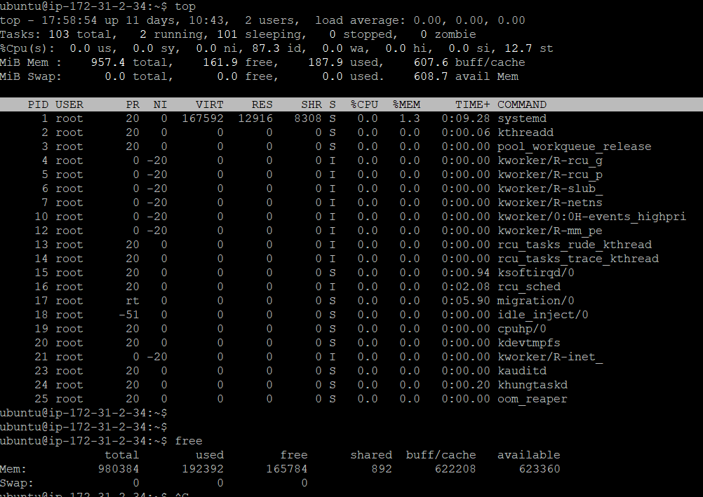

2.I have deployed an application in guvi.com:9000, and logs show my app is running, but I’m unable to view the page. Check whether my port is open or not ?

**Port is closed**  
ubuntu@ip-172-31-2-34:~$

ubuntu@ip-172-31-2-34:~$ telnet guvi.com 9000

Trying 104.21.79.166...

Trying 172.67.146.154...

Trying 2606:4700:3031::6815:4fa6...

Trying 2606:4700:3037::ac43:929a...

telnet: Unable to connect to remote host: Network is unreachable

ubuntu@ip-172-31-2-34:~$

