# Fleet Management System

Name: Nandana.k

Roll No : 59

Course Name : Programming in C

Date: 17/07/24

**Introduction**

**Brief Overview of the Project**

The Vehicle and Driver Management System is a console-based application that allows users to manage a fleet of vehicles and their assigned drivers. The application provides functionalities to add vehicles and drivers, assign vehicles to drivers, and display the current list of vehicles and drivers.

**Problem Statement**

In many organizations, managing vehicles and their drivers can be cumbersome. This project addresses the need for an efficient system that simplifies tracking and management of vehicles and drivers.

**Objective**

The main objective of this project is to develop a simple and user-friendly application that facilitates the addition, assignment, and listing of vehicles and drivers in a structured manner.

**System Requirements**

**Hardware Requirements**

* Minimum of 1 GHz processor
* 1 GB RAM
* 100 MB of free disk space

**Software Requirements**

* C compiler (e.g., GCC)
* Operating System: Windows/Linux/Mac OS

**Design and Development**

**Description of the Program Logic**

The program consists of several key functionalities implemented in C:

1. **Adding Vehicles:** Users can input vehicle details including plate number and model.
2. **Adding Drivers:** Users can input driver names, initially with no assigned vehicle.
3. **Assigning Vehicles:** Users can assign a specific vehicle to a driver based on the driver's name.
4. **Displaying Lists:** Users can view the current list of vehicles and drivers with their details.

**Flowchart or Pseudocode**

**Pseudocode:**

BEGIN

Initialize vehicles and drivers arrays

WHILE true DO

Display menu

Get user choice

CASE choice OF

1: Call addVehicle()

2: Call addDriver()

3: Call assignVehicle()

4: Call showVehicles()

5: Call showDrivers()

6: Exit

DEFAULT: Print "Invalid choice"

END CASE

END WHILE

## **Testing and Results**

**Test Cases**

1. ***Adding Vehicles:***
   * Input: Plate - ABC123, Model - Toyota
   * Expected: Vehicle added successfully.
2. ***Adding Drivers*:**
   * Input: Name - David
   * Expected: Driver added successfully.
3. ***Assigning Vehicles*:**
   * Input: Driver Name - David, Plate - ABC123
   * Expected: Vehicle ABC123 assigned to David.
4. ***Display Vehicles and Drivers:***
   * Command: Show Vehicles/Drivers
   * Expected: Lists display correctly.

**Output Screenshots Or Results**

***1.Adding Vehicles*:**

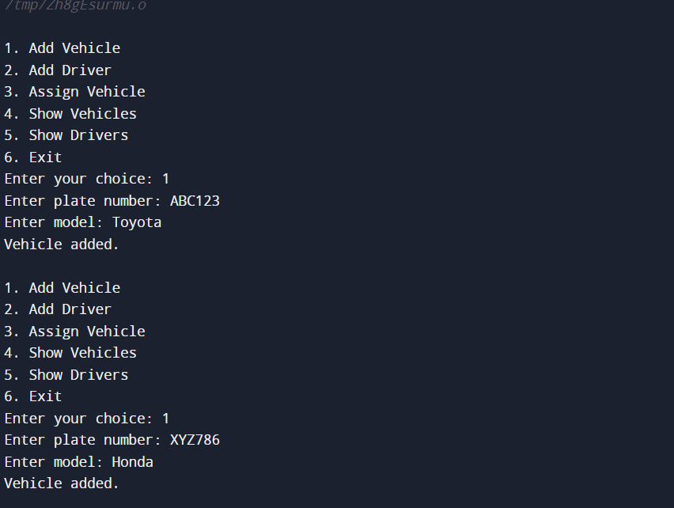

***2.Adding Drivers*:**

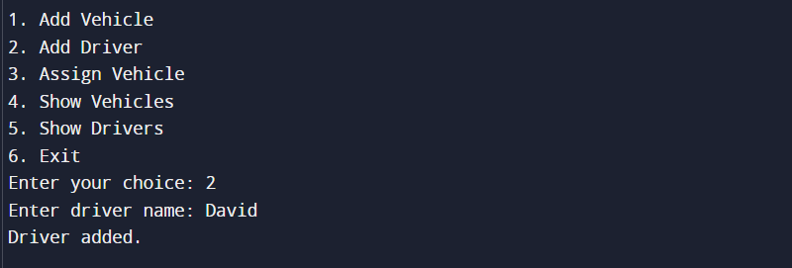

*3.* ***Assigning Vehicles:***

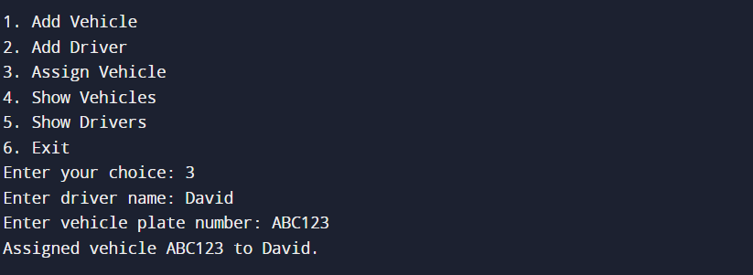

1. ***Display Vehicles and Drivers:***

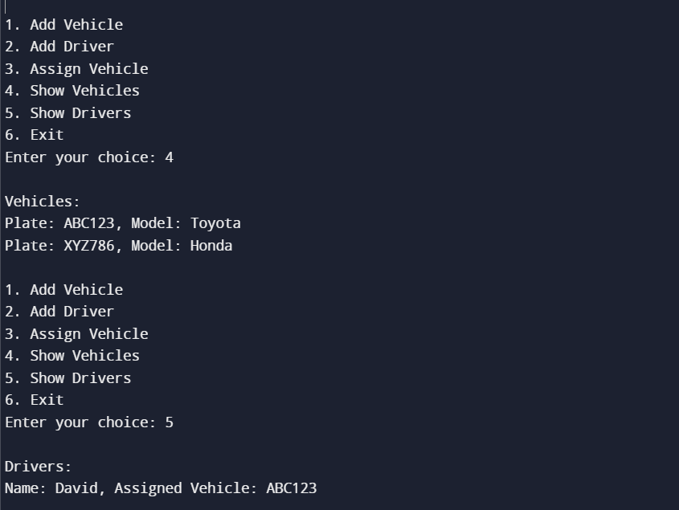

**Discussion of Results**

The implementation successfully allows the management of vehicles and drivers, with the ability to add, assign, and display them as intended. The system efficiently handles up to a maximum of 10 vehicles and 10 drivers.

**Conclusion**

**Summary of the Project**

The Vehicle and Driver Management System offers a simple yet effective way to manage vehicle assignments within an organization. It meets the basic requirements of adding and managing vehicle and driver information.

**Future Enhancements**

Future versions could include:

* Persistent storage of vehicle and driver data (e.g., using files or databases).
* Enhanced user interface (e.g., graphical user interface).
* More detailed vehicle and driver attributes (e.g., contact info, vehicle type).

**Reference**

* C Programming Language, Kernighan and Ritchie
* Online C documentation and resources

**Appendices**

**Code Listing**

