User Management Service — Full Documentation

1. Purpose & Scope
The User Management Service is one of three microservices in the UoM MIS
event-driven backend (the other two — Auth Service and Notification Service —
are owned by other teams and are not built here). It owns:
- Student registration (single-entry and bulk Excel/CSV upload)
- Staff/admin registration (single-entry)
- The users and bulkUploadBatches MongoDB collections
- The async registration handshake with Auth Service and Notification Service
over RabbitMQ
Explicitly out of scope (per the originating spec, confirmed not built here):
- Keycloak/LDAP integration itself (Auth Service owns this — we only verify
JWTs against Keycloak's JWKS endpoint, we never talk to Keycloak/LDAP to
create accounts)
- Actual email/SMS sending (Notification Service owns this — we only publish
the event that tells it to)
- The Admin/User frontends
- API Gateway (Kong) configuration
This service never stores a password, and never calls Auth Service or
Notification Service directly over HTTP — the only channel between the three
microservices is RabbitMQ (see §6).

2. Architecture Overview
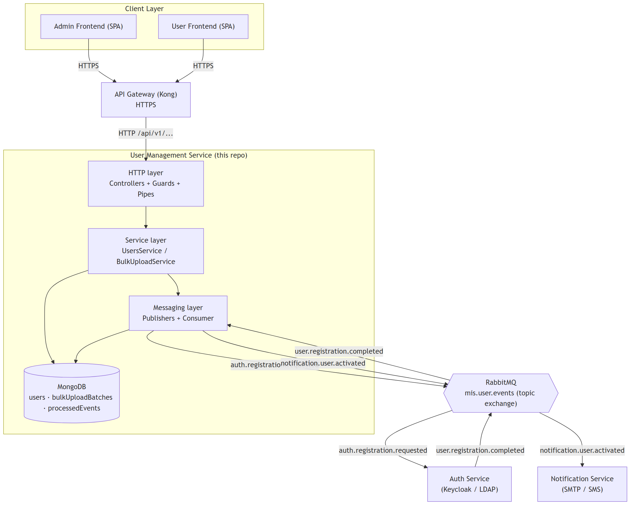
Key architectural decisions baked into this diagram:
- HTTP only exists between the client-facing Gateway and this service — every
other microservice-to-microservice interaction is async, via the single
topic exchange mis.user.events.
- This service owns its own MongoDB database exclusively — no other service
reads or writes it directly.

3. Actors & Use Cases
Actors:
- Admin — the only human actor that calls this service directly (via the
Gateway); authenticated as role: admin in their JWT.
- Auth Service — external system, replies asynchronously via RabbitMQ.
- Notification Service — external system, receives events via RabbitMQ,
never talks back to this service.
- Anyone (unauthenticated) — read endpoints (GET /users, GET /users/:id,
GET /bulk-uploads/:batchId, GET /health) require no token today; see
§9 Known limitations for the caveat.
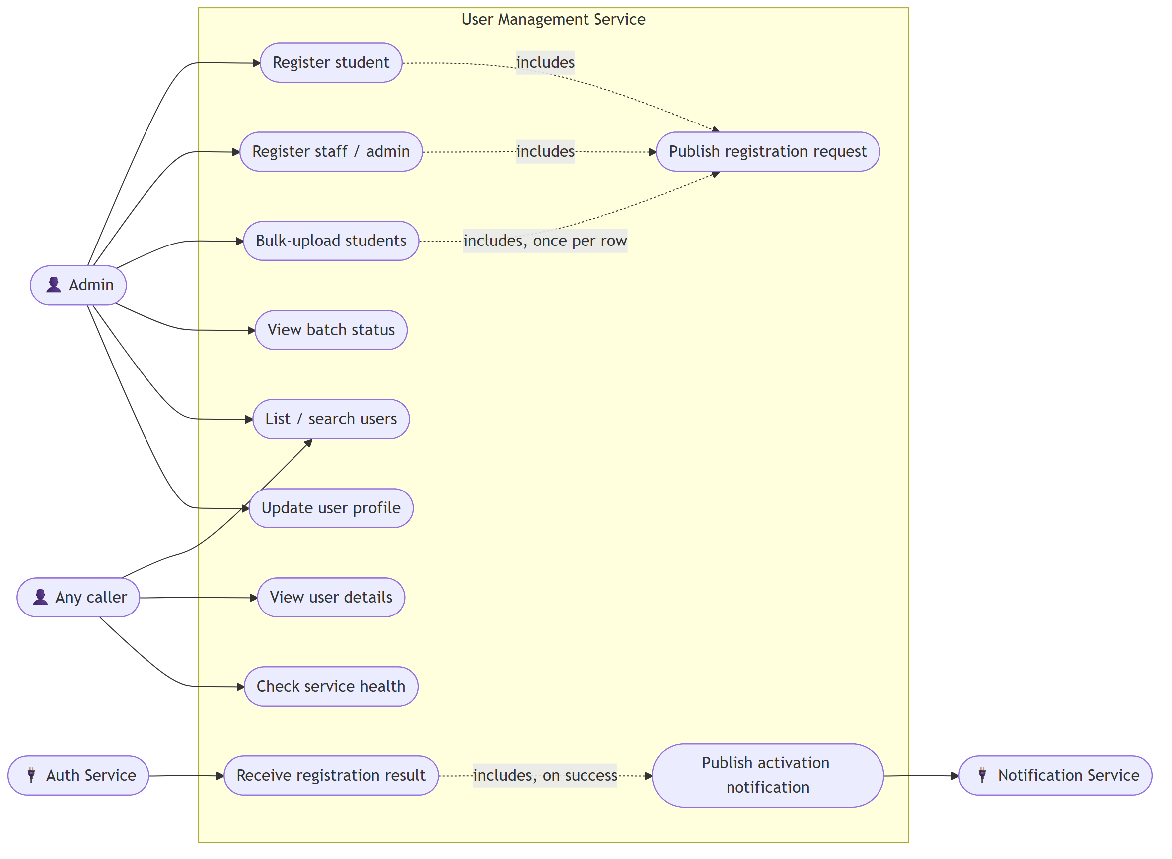

Use case narratives
Use case | Trigger | Outcome
Register student | Admin submits single-student form | pending user created, auth.registration.requested published, 202 returned with userId
Register staff/admin | Admin submits single staff/admin form | Same as above, role taken from the request body
Bulk-upload students | Admin uploads Excel/CSV + batch metadata | File parsed and validated up front; on any row error, zero users are created and the batch records the rejection; otherwise one pending user + one publish per valid row
View batch status | Admin (or anyone) queries a batchId | Batch totals + live authStatus counts across the batch's users
List / search users | Any caller, with filters | Paginated list
View user details | Any caller, by id | Single user document
Update user profile | Admin, by id | Editable fields only — not username/role/authStatus
Check service health | Any caller | Liveness probe
Publish registration request | Internal — fired by the three registration use cases | auth.registration.requested event on mis.user.events
Receive registration result | Auth Service replies async | authStatus updated to active/failed; idempotent against redelivery
Publish activation notification | Internal — fired only when the result above is a success | notification.user.activated event on mis.user.events

4. Database Schema (ERD)

STUDENT_DETAILS/STAFF_DETAILS are embedded sub-documents
(@Schema({ _id: false })), not separate collections — only one is populated
per user, depending on role. batchId only exists on bulk-uploaded users.
PROCESSED_EVENT.correlationId is a loose reference (a string carried
through from the RabbitMQ envelope) — Mongo has no FK enforcement across
collections, so nothing guarantees it points at a real USER._id beyond the
application logic always setting it that way.

5. Sequence Diagrams

5.1 Single registration — success path
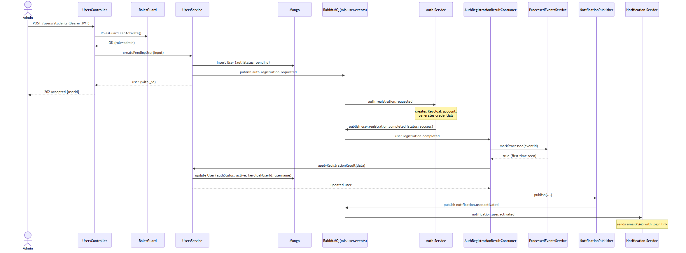

5.2 Single registration — Auth Service rejects it
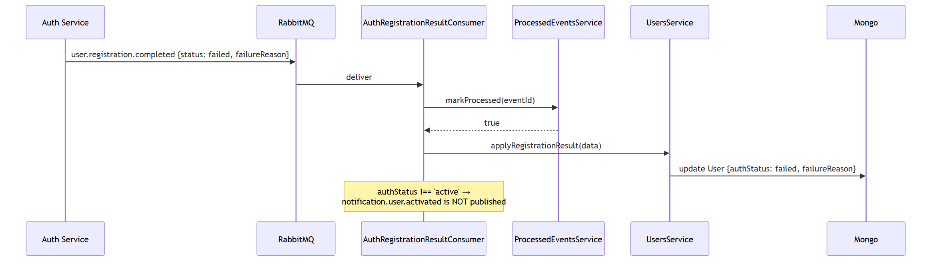

5.3 Redelivery — idempotency in action
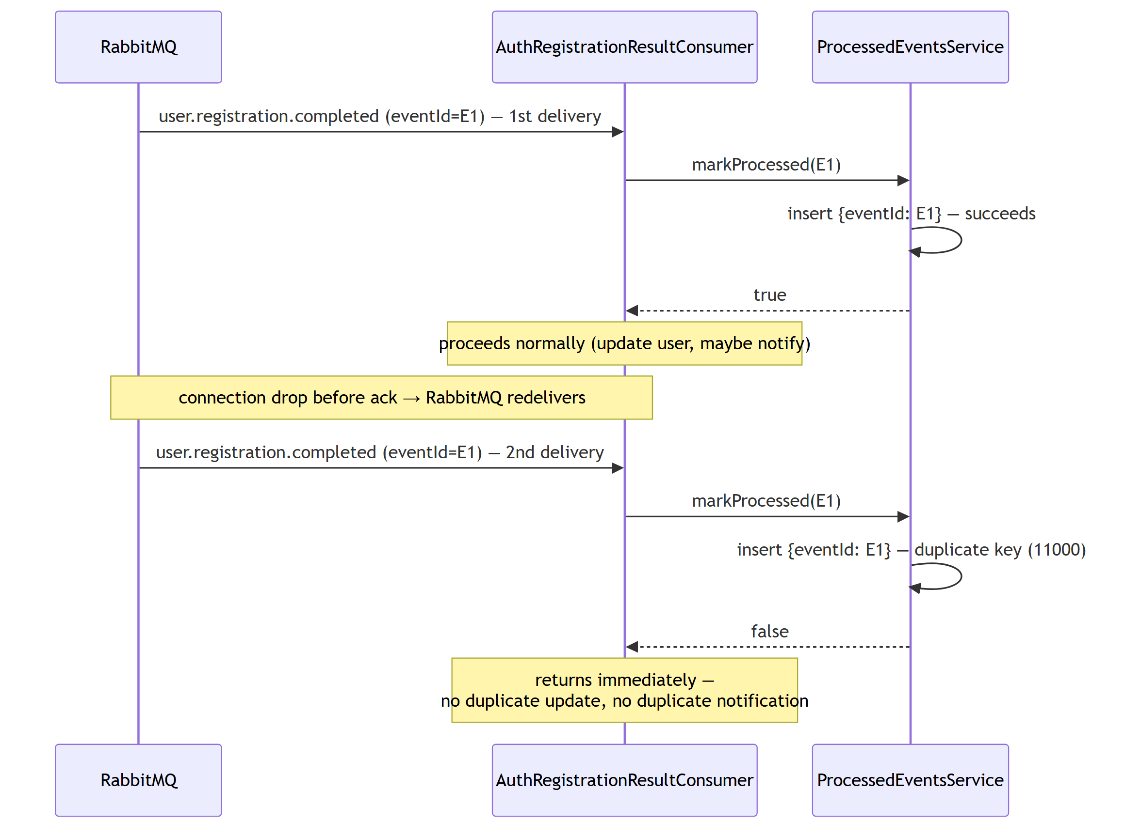

5.4 Bulk upload — parse failure vs. partial row failure
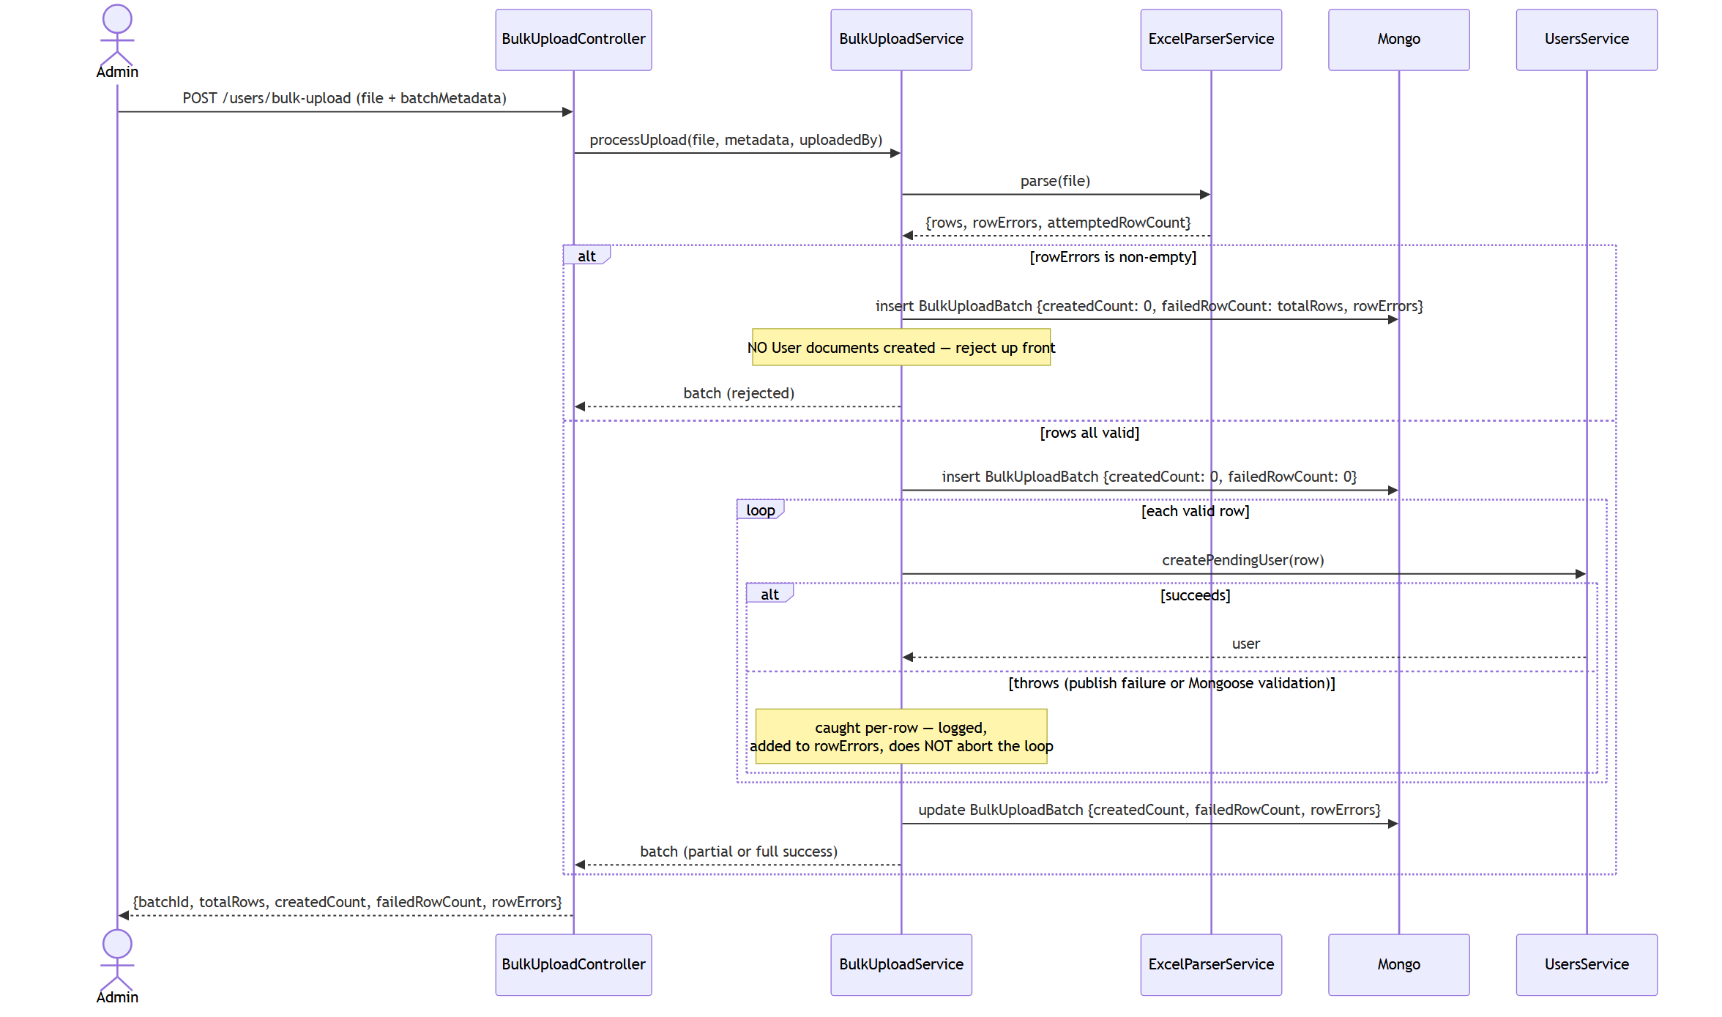

5.5 RBAC — token verification (stub vs. JWKS)
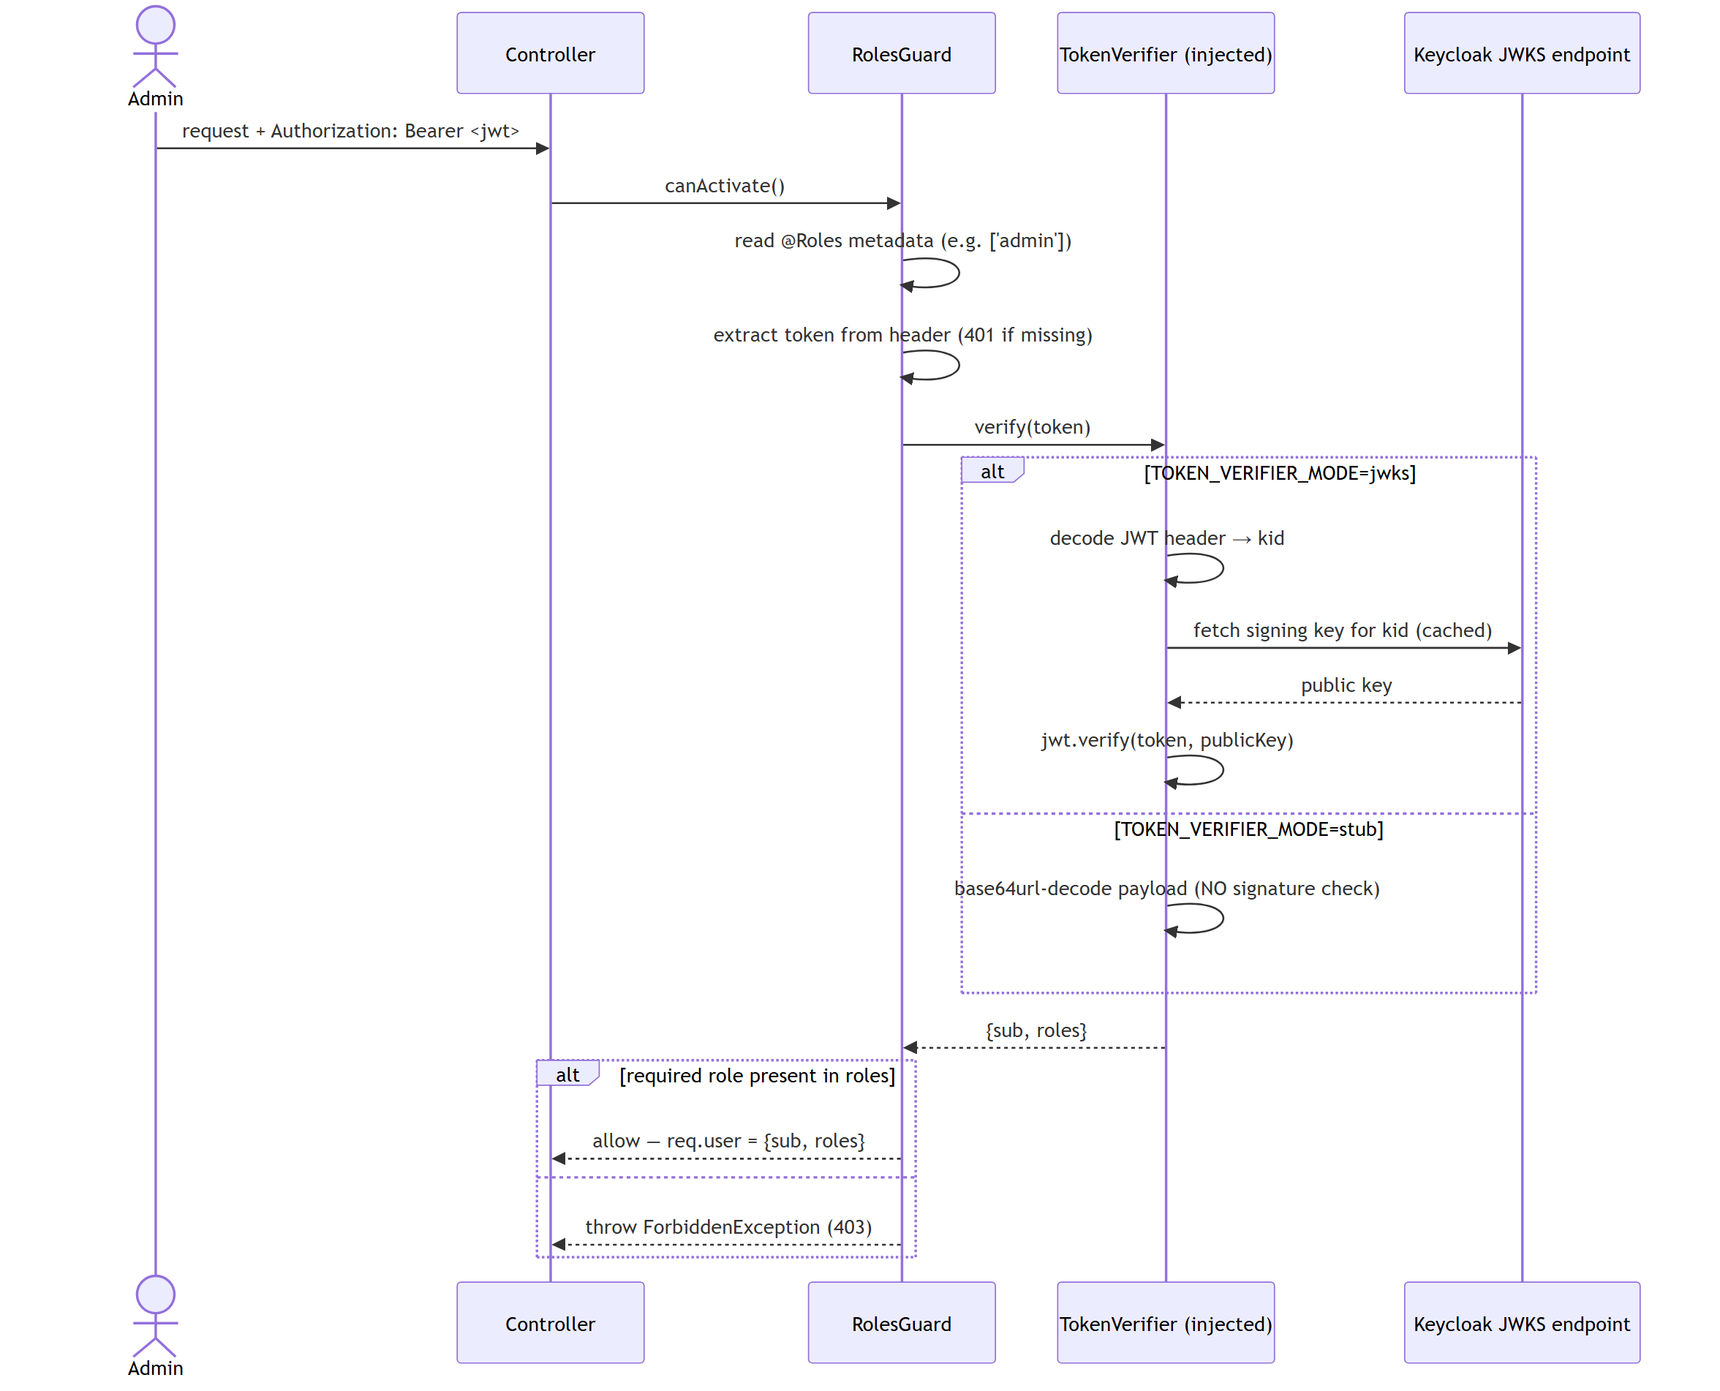

6. State Diagram — `authStatus` lifecycle
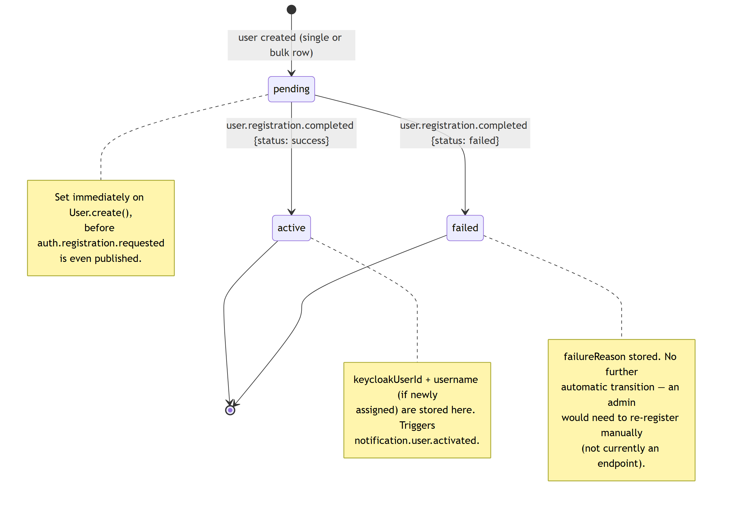

7. Module Reference
Path | Responsibility
config/configuration.ts | Single @nestjs/config factory — every env var flows through here
common/guards/token-verifier.interface.ts | TokenVerifier interface + DI token
common/guards/keycloak-jwks-token-verifier.ts | Real JWT verification via jsonwebtoken + jwks-rsa
common/guards/stub-token-verifier.ts | Unsigned decode, local dev/test only
common/guards/roles.guard.ts | RolesGuard — the actual per-route auth enforcement
common/decorators/roles.decorator.ts | @Roles(...) metadata decorator
common/filters/http-exception.filter.ts | Normalizes all error responses
common/interceptors/logging.interceptor.ts | One structured JSON log line per request
common/utils/admin-id.util.ts | Maps a Keycloak sub (UUID) → deterministic Mongo ObjectId
common/common.module.ts | Wires RolesGuard + TOKEN_VERIFIER, exported to whoever needs them
users/schemas/user.schema.ts | The users collection
users/dto/*.ts | Request validation for all /users/* endpoints
users/users.service.ts | Core logic: create-pending, apply-result, list/find/update
users/users.controller.ts | /users/* HTTP routes
users/users.module.ts | Wires the above; forwardRef to MessagingModule
bulk-upload/schemas/bulk-upload-batch.schema.ts | The bulkUploadBatches collection
bulk-upload/parsers/excel-parser.service.ts | Column-mapped Excel/CSV parsing + row validation
bulk-upload/dto/bulk-upload-metadata.dto.ts | Validates the multipart batchMetadata field
bulk-upload/bulk-upload.service.ts | Orchestrates parse → per-row create → batch status
bulk-upload/bulk-upload.controller.ts | /users/bulk-upload, /bulk-uploads/:batchId
bulk-upload/bulk-upload.module.ts | Wires the above
messaging/envelope.util.ts | buildEnvelope() — single source of envelope shape
messaging/contracts/*.ts | Event payload interfaces + exchange/queue name constants
messaging/publishers/*.ts | AuthRegistrationPublisher, NotificationPublisher
messaging/consumers/auth-registration-result.consumer.ts | Consumes user.registration.completed
messaging/idempotency/*.ts | processedEvents collection + markProcessed() guard
messaging/mock/mock-auth.consumer.ts | Dev-only simulated Auth Service reply
messaging/messaging.module.ts | RabbitMQModule.forRootAsync + wires all of the above
health/health.controller.ts | GET /health
main.ts | Bootstrap — loads .env, global prefix, pipes, filter, interceptor
app.module.ts | Root module composition
(Full prose walkthrough of every file, including the "why" behind several
non-obvious decisions, is in ../README.md — this table is the map, that's
the terrain.)

8. API Reference
Base path /api/v1 (except /health). Write endpoints require
Authorization: Bearer <jwt> with admin in the token's roles.

`POST /users/students` — admin
Request body (CreateStudentDto):
{
"firstName": "Amal",
"lastName": "Perera",
"nameWithInitials": "A.B. Perera",
"fullName": "Amal Bandara Perera",
"title": "Mr",
"dateOfBirth": "2003-01-15",
"nic": "200301501234",
"primaryEmail": "amal.perera@example.com",
"secondaryEmail": "amal.p@gmail.com",
"gender": "Male",
"currentAddress": "12 Lake Drive, Colombo",
"homeTelephoneNo": "0112345678",
"mobileNo": "0771234567",
"permanentAddress": "12 Lake Drive, Colombo",
"telephone": "0112345678",
"studentDetails": {
"registrationNo": "200301A",
"registrationDate": "2025-09-01",
"degree": "BSc Eng",
"faculty": "Engineering",
"level": "L1",
"department": "CSE",
"departmentGroup": "Group A",
"specialization": "Software Engineering",
"academicYear": "2025/2026",
"administrativeBatch": "2025",
"alIndexNumber": "1234567",
"zScore": 1.8532,
"medium": "English",
"meritCategory": "District",
"districtNo": "11",
"religionNo": "01",
"ethnicityNo": "02"
}
}
Required: firstName, lastName, nameWithInitials, dateOfBirth, nic,
primaryEmail, `studentDetails.{registrationNo, degree, level, department,
academicYear, administrativeBatch}`. Everything else optional.
Response 202 Accepted:
{ "userId": "6a4f6aa82749314f41ce024d" }

`POST /users/staff` — admin
Same shape, role: "staff" | "admin" in the body, staffDetails instead of
studentDetails (departmentDivision, officeExtension?, designation,
category?).

`POST /users/bulk-upload` — admin
Multipart form: file (.xlsx/.csv) + batchMetadata (JSON-stringified):
{
"role": "student",
"degree": "BSc Eng",
"faculty": "Engineering",
"department": "CSE",
"specialization": "Software Engineering",
"level": "L1",
"academicYear": "2025/2026",
"administrativeBatch": "2025",
"registrationDate": "2025-09-01"
}
Required: role (currently only student is actually processed —
staff is rejected with 400, see §9),
department, level, academicYear, administrativeBatch.
Response:
{
"batchId": "6a55c4120629bcd1e54eeb86",
"totalRows": 12,
"createdCount": 11,
"failedRowCount": 1,
"rowErrors": ["Row 9: broker unreachable — Auth Service could not be notified"]
}

`GET /users` — no auth required
Query params: role, authStatus, batchId, search, page (default 1),
limit (default 20).

`GET /users/:id` — no auth required

`PATCH /users/:id` — admin
Body (UpdateUserDto, all optional): firstName, lastName,
nameWithInitials, fullName, title, primaryEmail, secondaryEmail,
gender, currentAddress, homeTelephoneNo, mobileNo,
permanentAddress, telephone. Not editable: username, role,
authStatus.

`GET /bulk-uploads/:batchId` — no auth required
{
"batch": { "_id": "...", "fileName": "...", "totalRows": 12, "createdCount": 11, "failedRowCount": 1, "rowErrors": [] },
"authStatusCounts": { "pending": 2, "active": 8, "failed": 1 }
}

`GET /health`
{ "status": "ok", "timestamp": "2026-07-14T09:32:13.005Z" }

9. Known Limitations & Spec Gaps
- Read endpoints are unauthenticated. GET /users, GET /users/:id, and
GET /bulk-uploads/:batchId have no guard, matching the spec's literal "on
all *write* endpoints" — worth confirming this is actually intended before
shipping, since GET /users currently returns full PII (NIC, DOB, address,
phone) to anyone who can reach the service.
- Bulk upload is student-only. The spec says it should be "structured so
it can be reused for staff later" — the schema and BulkUploadBatch.role
already allow staff, but BulkUploadService.processUpload throws 400
for anything other than student today; the Excel column map is
student-specific.
- `DOB` vs. schema requirement mismatch. The upload template's column
table doesn't mark DOB as "Must" even though User.dateOfBirth is
required: true, and marks Permanent address as "Must" even though the
schema doesn't require it. Rows missing DOB pass the parser's row
validation but fail at User.create() — caught per-row (doesn't abort the
batch) rather than at the earlier file-level check.
- `processedEvents` has no TTL/cleanup. Deliberately simple for a
single-instance dev setup; grows unboundedly in a long-lived deployment.
- Failed registrations have no retry endpoint. Once authStatus: failed,
there's no built-in way to re-trigger auth.registration.requested — an
admin would need to re-register the user from scratch (a new document).
- Username auto-assignment format is unconfirmed with the Auth team (spec
§9, open item) — MockAuthConsumer invents role.last6ofid as a
placeholder format purely for local testing.

10. Non-Functional Requirements Coverage
Requirement | How it's met
DTO validation, 400 on failure | Global ValidationPipe (whitelist, transform, forbidNonWhitelisted)
Publish failure ≠ silent orphan | Single registration: rethrown, surfaces as a failed HTTP response. Bulk: caught per-row, tallied into rowErrors/failedRowCount, visible via the status endpoint
Structured JSON logging | LoggingInterceptor (per-request) + every service/consumer logs JSON.stringify({...}) with correlationId where relevant
.env.example | Present, all 5 required vars + 2 dev-only flags
Unit tests | UsersService, BulkUploadService, both consumers — 15 tests, Mongo/AMQP mocked
docker-compose.yml for local dev | Mongo + RabbitMQ (management UI) + this service

11. Environment Variables
Variable | Default (if unset) | Purpose
MONGODB_URI | mongodb://localhost:27017/user-management | Mongo connection string
RABBITMQ_URI | amqp://localhost:5672 | RabbitMQ connection string
RABBITMQ_EXCHANGE | mis.user.events | Topic exchange name
KEYCLOAK_JWKS_URI | *(empty — throws if used in jwks mode)* | JWKS endpoint for real token verification
PORT | 3000 | HTTP listen port
LOGIN_URL | http://localhost:4200/login | Included in notification.user.activated payload
TOKEN_VERIFIER_MODE | jwks | stub (no signature check, local dev/test) or jwks (real Keycloak verification)
AUTH_SERVICE_MOCK_ENABLED | false (unset) | true registers MockAuthConsumer, simulating Auth Service replies. Local dev/test only — the consumer's constructor throws if NODE_ENV=production as a backstop
TOKEN_VERIFIER_MODE and AUTH_SERVICE_MOCK_ENABLED are deliberately kept
separate — they gate unrelated concerns (auth bypass vs. message-flow
simulation) and conflating them would make it easy to accidentally leave one
on.

12. Testing
npx jest apps/user-management
test/users.service.spec.ts, test/bulk-upload.service.spec.ts,
test/messaging.consumer.spec.ts — 15 pure unit tests. Mongoose models and
AmqpConnection are mocked; no real Mongo/RabbitMQ needed to run them.

13. Deployment
docker-compose.yml + Dockerfile live in apps/user-management/, but the
Dockerfile's build context is the monorepo root (../..) since this app
shares one root package.json/node_modules with api-gateway/auth/
notification — not a per-app install.
docker compose -f apps/user-management/docker-compose.yml up -d
Brings up Mongo, RabbitMQ (management UI on :15672), and the service
itself on :3000, with TOKEN_VERIFIER_MODE=stub and
AUTH_SERVICE_MOCK_ENABLED=true by default for a fully self-contained local
stack — override both via env for anything resembling a real deployment.

14. Troubleshooting Log (real issues hit while building this)
Kept here as institutional memory — these are exactly the kind of thing that
re-bites the next person who touches this service.
- jose@6 is ESM-only, crashes CommonJS webpack build with
ERR_REQUIRE_ESM.** Worse, jwks-rsa@4.x depends on jose@^6 internally,
so the crash resurfaced one dependency layer down even after removing our
own jose import. Fixed by using jsonwebtoken + jwks-rsa@^3.2.2
(pinned below 4.x, which depends on jose@^4 — the last dual CJS/ESM
release).
- RolesGuard/TOKEN_VERIFIER registered on AppModule, but consumed by
controllers in sibling modules (UsersModule, BulkUploadModule).**
Nest's DI doesn't grant a module access to its *parent's* providers, only
to what it explicitly imports — this crashed on boot with
Nest can't resolve dependencies of RolesGuard, only caught by actually
starting the app (not by unit tests or the build). Fixed by extracting
CommonModule, imported by both.
- exceljs's own index.d.ts declares `interface Buffer extends
ArrayBuffer {}`**, a module-local shadow of the real Buffer type that
breaks structural typing for workbook.xlsx.load(buffer). Not a
dependency-version conflict (ruled out by deduping @types/node) — an
upstream defect in exceljs's own types. Fixed with a targeted as any at
that one call site.
- Cross-drive `node_modules` resolution failure when a throwaway test
script lived outside the repo (C:\...\Temp\... vs. the repo on D:\...)
— Node resolves node_modules by walking up from the script's own path,
so it never found the repo's dependencies. Any ad-hoc script needs to live
inside the repo to resolve its packages.
- `EADDRINUSE` port collisions happened repeatedly during iterative dev
— a background instance from a previous test run left the port held while
a new nest start tried to bind it. Not a code bug; just a reminder to
check Get-NetTCPConnection -LocalPort <port> before assuming a fresh
start failed for a real reason.

