Smart Complaint Management System: Software Requirements, Test Plan, and Architecture & Design Specification

I. INTRODUCTION

A. Problem Statement
Managing complaints manually is difficult and time-consuming. Users often do not know the status of their complaints, and administrators struggle to organise, assign and track them. SCMS provides one centralised platform where users submit and track complaints and administrators manage, assign, update and resolve them efficiently.

B. Purpose, Scope and Audience
This document specifies what SCMS must do (Section II), how it will be verified (Section III) and how it is structured (Section IV). SCMS 1.0 covers account management, complaint lifecycle management, feedback and administrative handling. Notifications by e-mail/SMS and native mobile apps are out of scope. The audience is the development team, course evaluators and testers.

C. Definitions and Acronyms
- FR/NFR: Functional / Non-Functional Requirement
- SR: Security Requirement
- RBAC: Role-Based Access Control
- JWT: JSON Web Token
- DAL: Data Access Layer
- RTM: Requirements Traceability Matrix
- UAT: User Acceptance Testing

D. Feasibility Study
- Technical: Buildable with standard web technologies and MySQL.
- Economic: Relies on free, open-source tools, so cost is low.
- Operational: The interface is simple for both users and administrators.
- Schedule: A four-member team can build and test it within the project timeline.
Conclusion: The system is technically, economically, operationally, and schedule feasible.

II. SOFTWARE REQUIREMENTS SPECIFICATION

A. Overall Description
- Product perspective: SCMS is a new, self-contained web application: a browser client talks over HTTPS to a REST API server, which persists data in a MySQL database.
- User classes:
  - A1 (User): Registers, submits and tracks complaints and gives feedback.
  - A2 (Administrator): Views, categorises, assigns, updates and resolves complaints.
- Operating environment: Latest two versions of Chrome, Firefox and Edge on desktop and mobile; server on Ubuntu 22.04 with Node.js 20 and MySQL 8.
- Constraints and assumptions: Only open-source tools are used; departments are pre-configured by the administrator; users have a valid e-mail address and Internet access.

Table I: Actors and Use Cases
ID | Actor | Use Cases
A1 | User | Register, Login, Submit Complaint, Track Complaint, Provide Feedback
A2 | Administrator | Admin Login, View Complaints, Categorize Complaint, Assign Complaint, Update Complaint, Resolve Complaint

B. Use Case Model
The system boundary contains two actors and eleven use cases. Each use case maps to at least one FR in Table II and is traced to tests in Table VIII.

C. Functional Requirements

Table II: Functional Requirements
ID | Requirement (The system shall...)
FR01 | Let a new user register with name, unique e-mail and a password of $>8$ characters containing a letter and a digit, and let users and administrators log in with e-mail and password; duplicate e-mails are rejected.
FR02 | Let an authenticated user submit a complaint with title ($<100$ chars), description ($≤1000$ chars), category and an optional JPG/PNG/PDF attachment ($≤5MB$).
FR03 | Assign every complaint a unique ID of the form CMP-YYYY-NNNNNN at submission and display it to the user.
FR04 | Show the owner of a complaint its current status (Submitted, Assigned, In Progress, Resolved, Closed) and its timestamped status history.
FR05 | Let an administrator list all complaints, filter them by status, category and date range, and set or change a complaint's category.
FR06 | Let an administrator assign a complaint to exactly one department from a predefined list, changing its status to Assigned.
FR07 | Let an administrator change a complaint's status only along the defined workflow, with a remark ($<500$ chars), and mark it Resolved with a resolution note; every change records time and admin ID.
FR08 | Let the owner submit exactly one feedback (rating 1–5, optional comment $<300$ chars) per complaint, only after it is Resolved.

D. Non-Functional Requirements

Table III: Non-Functional Requirements
ID | Attribute | Measurable Requirement
NFR01 | Security | Every non-public page and API shall require a valid session; access shall follow SR1–SR6.
NFR02 | Usability | A first-time user shall submit a complaint in $≤3min$ without training; every main task shall be reachable in $≤3clicks$ from the dashboard; layouts shall work from 360 to 1920 px width.
NFR03 | Performance | $95\%$ of login, submit and track requests shall complete in $<2s$, with 100 concurrent users.
NFR04 | Reliability | No committed complaint data shall be lost: all writes are transactional, availability $\ge99\%$ per month, daily backups kept for 7 days.
NFR05 | Privacy | A complaint and its owner's personal data shall be visible only to that owner and to administrators; data shall travel only over HTTPS.
NFR06 | Maintainability | Code shall be layered so one module changes without editing others; service-layer unit-test coverage $>70\%$; zero ESLint errors.

E. External Interface Requirements
- User Interface: Responsive web pages with separate User and Administrator dashboards.
- Software Interfaces: REST/JSON API and MySQL 8 via a pooled driver.
- Communication: HTTPS (TLS 1.2 or higher) only.

F. Security Requirements

Security Objectives:
- SO1 Confidentiality: Only authorised parties can read user and complaint data.
- SO2 Integrity: Complaint records and status history cannot be altered by unauthorised actors.
- SO3 Accountability: Every administrative action is attributable to a specific administrator.

Security Requirements:
- SR1: Passwords shall be stored only as bcrypt hashes (cost $>10$) and never logged.
- SR2: Sessions shall use signed JWTs that expire 60 minutes after issue.
- SR3: RBAC and ownership checks shall be enforced server-side on every API call; violations return 403/404.
- SR4: Five consecutive failed logins shall lock the account for 15 minutes.
- SR5: All inputs shall be validated server-side, all SQL shall use parameterised queries, and output shall be encoded to prevent injection and XSS.
- SR6: All traffic shall use HTTPS, and every admin action shall be written to an audit log (who, what, when).
(Mapping: SR1, SR2 and SR4 realise SO1; SR3 and SR5 realise SO1 and SO2; SR6 realises SO3.)

III. TEST PLAN
- Introduction: Test plan ID SCMS-TP-1.0. Verifies FR01–FR08, NFR01–NFR06, and SR1–SR6 against the design.
- Test Items: SCMS 1.0 build including React web client, Node.js/Express API (Auth, Complaint, Assignment, Feedback services), middleware, DAL, and MySQL schema.
- Features to be Tested: Registration and login (FR01); complaint submission and ID generation (FR02, FR03); tracking (FR04); admin view, filter and categorise (FR05); assignment (FR06); status workflow and resolution (FR07); feedback rules (FR08); access control, privacy and security controls (NFR01, NFR05, SR1–SR6); response time (NFR03); data durability (NFR04); usability (NFR02); maintainability (NFR06).
- Features Not to be Tested: E-mail/SMS notifications, native mobile apps, loads above 100 concurrent users, legacy browsers, infrastructure penetration testing.
- Approach:
  - Unit Tests (Jest): Cover service-layer logic ($>70\%$ statement coverage).
  - Integration Tests (Supertest): API endpoint tests using seeded database.
  - System Tests (Selenium): End-to-end browser workflows.
  - Performance Tests (JMeter): Load and concurrent user testing.
  - Usability Testing: Timed tasks with 5 new users.
  - Design Techniques: Equivalence partitioning, boundary-value analysis (BVA), state-transition testing.
5.1 Security Validation: Tests include brute-force lockout (SR4), expired tokens (SR2), password hash verification (SR1), vertical/horizontal escalation checks (SR3), injection/XSS payloads (SR5), HTTP-to-HTTPS redirect (SR6), and OWASP ZAP baseline scans.
- Pass/Fail Criteria: Actual result equals expected result. Release requires $100\%$ security and high-priority test pass rate, $>95\%$ overall pass rate, and zero open critical/high defects.
- Suspension and Resumption: Suspended if smoke test fails or database is unavailable; resumes upon passing smoke tests on fixed build.
- Environment & Deliverables: Ubuntu 22.04, Node.js 20, MySQL 8 with synthetic data (1000 complaints, 50 users). Tools: Jest, Supertest, Selenium, JMeter, OWASP ZAP. Deliverables: Test plan, test cases, test logs, defect reports, and summary report.
- Responsibilities and Schedule:
  - N. Jeevan Naga Deep: Test lead and security tests.
  - M. Nikhil Sai: Unit and integration tests.
  - Nandakishore PV: System and usability tests.
  - N. K. M. S. Akhil: Performance and reliability tests.
  - Timeline: Week 1 Unit, Week 2 Integration, Week 3 System/Security/Performance, Week 4 UAT & Summary.
- Risks: Schedule pressure mitigated by prioritizing security/high-priority features. Real personal data is never used.

Table IV: Test Cases (Functional, Non-Functional, Security)
TC ID | Req. | Type | Test Description / Input | Expected Result
TC01 | FR01 | Functional | Register with name "Ravi K", unused email & "Pass1234"; re-register with same email. | 201 Created; role User; second attempt returns 409 "email already registered".
TC02 | FR01 | Functional | Log in with valid user credentials, then valid administrator credentials. | JWT issued; routes to correct dashboard.
TC03 | FR02 | Functional (BVA) | Submit complaints with 100 & 101 char titles, and 5.0 MB & 5.1 MB attachments. | 100 chars & 5.0 MB accepted; 101 chars & 5.1 MB rejected with 422.
TC04 | FR02, FR03 | Functional | Submit two valid complaints sequentially. | Both saved (201); distinct CMP-YYYY-NNNNNN IDs displayed.
TC05 | FR04 | Functional | Owner opens complaint moved to Assigned and In Progress. | Status "In Progress" displayed with 3 timestamped history entries.
TC06 | FR05, FR06, SR6 | Functional | Admin filters status=Submitted, sets category "Electrical", assigns to "Maintenance". | Submitted listed; status updated to Assigned; history and audit-log rows updated.
TC07 | FR07 | Functional (State) | Admin moves Assigned $→$ In Progress $→$ Resolved with remarks; attempts Resolved $→$ Submitted. | Valid transitions saved; invalid transition returns 409 and status remains unchanged.
TC08 | FR08 | Functional (BVA) | Owner rates Resolved complaint 4, re-rates it, rates unresolved complaint, submits rating 6. | First feedback 201; repeat 409; unresolved 409; rating 6 returns 422.
TC09 | NFR01, SR2, SR3 | Security | Call PATCH /complaints/{id}/assign with User token; call protected API with no token or 61-min expired token. | 403 for User token; 401 for missing/expired token; no data modified.
TC10 | NFR05, SR3 | Security | User A requests GET /complaints/{id} for a complaint owned by User B. | 404 returned; response contains no field of B's complaint.
TC11 | SR1, SR4 | Security | Enter wrong password 5 times, then correct one; inspect users table. | Account locked for 15 min (423); only bcrypt hashes stored.
TC12 | SR5, SR6 | Security | Login email OR 1=1; description <script>alert(1)</script>; plain HTTP request; OWASP ZAP scan. | Login rejected; script escaped; HTTP redirects to HTTPS via 301; zero High/Medium ZAP alerts.
TC13 | NFR03 | Performance | JMeter: 100 concurrent virtual users for 10 min (60% track, 30% submit, 10% login). | 95th-percentile response time $<2s$; error rate $<1\%$.
TC14 | NFR04 | Reliability | Stop API server during submission and restart; restore database from daily backup. | Partial rows rolled back; committed data intact; successful restore.
TC15 | NFR02 | Usability | Five first-time users submit and track a complaint without training. | All submit within 3 min; tasks reached in $<3$ clicks.
TC16 | NFR06 | Maintainability | Run ESLint and Jest coverage; add comment-length rule to Feedback service and re-run suite. | Zero lint errors; service coverage $\ge70\%$; only Feedback files modified; tests pass.

IV. SOFTWARE ARCHITECTURE & DESIGN SPECIFICATION

A. Architectural Pattern
SCMS uses a layered (three-tier) client-server architecture:
- Presentation Tier: React single-page application (SPA).
- Application Tier: Node.js/Express (Routes $→$ Middleware $→$ Services $→$ DAL).
- Data Tier: MySQL database.
Each layer only calls the layer directly below it to ensure separation of concerns, single enforcement point for security (NFR01, SR3), and easy maintainability (NFR06).

B. Component Description and Traceability
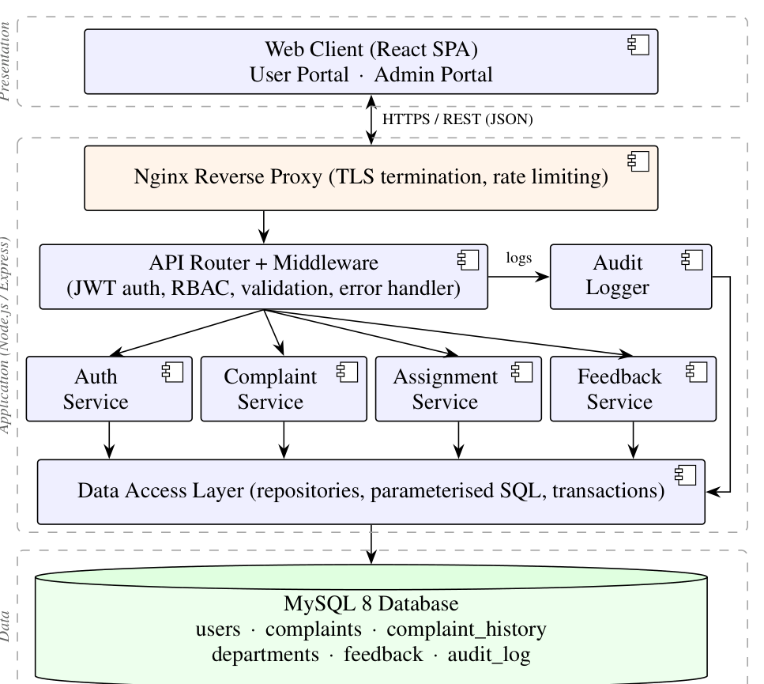
Fig. 2. UML component diagram of SCMS (three tiers).

Table V: Component Description and Requirement Traceability
Component | Responsibility | Realises
Web Client | User and Admin pages, client-side validation, output encoding | FR01–08, NFR02
Nginx Proxy | TLS termination, HTTP $→$ HTTPS redirect, rate limiting | SR6, NFR03
API Router + Middleware | Routing, JWT verification, RBAC, input validation, central error handling | NFR01, SR2, SR3, SR5
Audit Logger | Records who did what and when for admin actions | SR6, FR07
Auth Service | Registration, login, bcrypt hashing, lockout | FR01, SR1, SR4
Complaint Service | Submission, ID generation, tracking, categorisation, status workflow, ownership checks | FR02–05, FR07, NFR05
Assignment Service | Department list and complaint assignment | FR06
Feedback Service | One feedback per resolved complaint | FR08
DAL | Repositories, parameterised queries, transactions | NFR04, SR5
MySQL DB | Persistent storage, daily backups | NFR04

C. Security Architecture
- Transport: Nginx terminates TLS 1.2+ and redirects HTTP to HTTPS (SR6).
- Authentication: Auth Service hashes passwords with bcrypt and issues HS256 JWTs (60-min expiry) stored in environment variables (SR1, SR2, SR4).
- Authorisation: Middleware verifies roles; Complaint Service enforces ownership (returns 404 for unauthorized access) (SR3, NFR05).
- Input Validation: Middleware schema validation, parameterised SQL in DAL, and React output encoding (SR5).
- Data Security: Least-privilege DB accounts without DDL rights (NFR04).
- Accountability: Audit Logger tracks administrative actions (SO3).

D. Other Architectural Views
- Deployment: Browser $→$ Nginx Proxy $→$ Node.js Application Server $→$ MySQL Database (Application and DB hosted on private network).
- Data Schemas:
  - USER(user_id, name, email, password_hash, role, failed_attempts, locked_until)
  - COMPLAINT(complaint_id, user_id, title, description, category, status, dept_id, created_at)
  - COMPLAINT_HISTORY(id, complaint_id, old_status, new_status, remark, changed_by, changed_at)
  - DEPARTMENT(dept_id, name)
  - FEEDBACK(complaint_id [unique], rating, comment)
  - AUDIT_LOG(id, admin_id, action, target, at)
- Complaint States: Submitted $→$ Assigned $→$ In Progress $→$ Resolved $→$ Closed (after feedback or 7 days).

E. API Design
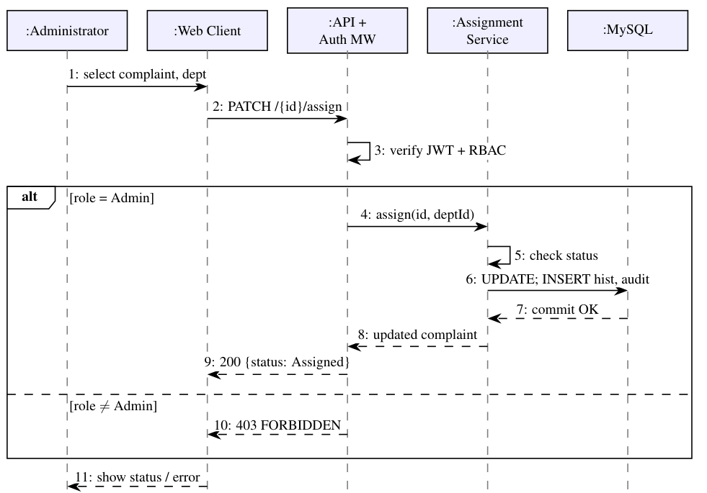
Fig. 4. Sequence diagram: Assign Complaint with RBAC check.
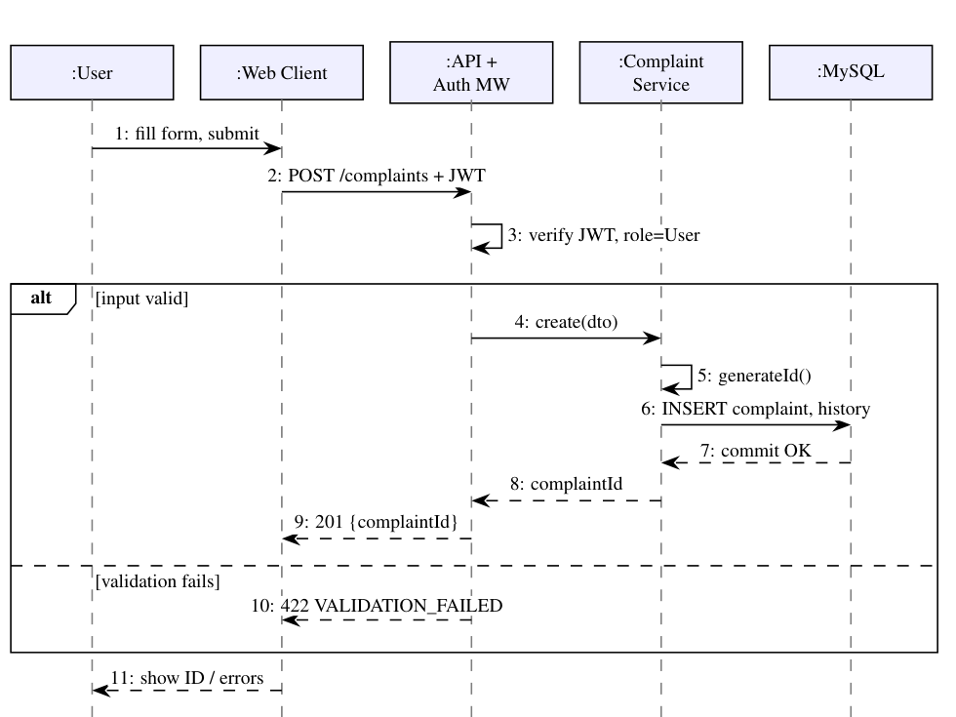
Fig. 3. Sequence diagram: Submit Complaint.

Table VI: REST API Endpoints
Method | Endpoint | Role | Purpose (Success)
POST | /api/v1/auth/register | Public | Create account (201)
POST | /api/v1/auth/login | Public | Return JWT and role (200)
POST | /api/v1/complaints | User | Submit, return ID (201)
GET | /api/v1/complaints | User/Admin | Own list / all with filters (200)
GET | /api/v1/complaints/{id} | Owner/Admin | Details and history (200)
PATCH | /api/v1/complaints/{id}/category | Admin | Set category (200)
PATCH | /api/v1/complaints/{id}/assign | Admin | Assign department (200)
PATCH | /api/v1/complaints/{id}/status | Admin | Update/resolve with remark (200)
POST | /api/v1/complaints/{id}/feedback | Owner | Rating and comment (201)

F. Error Handling

Table VII: Error Code Mapping
HTTP Code | Label | When Triggered
400 | BAD_REQUEST | Malformed JSON or parameters
401 | UNAUTHENTICATED | Missing, invalid, or expired JWT
403 | FORBIDDEN | Role not allowed for the action
404 | NOT_FOUND | Resource absent or not owned by caller
409 | CONFLICT | Duplicate e-mail/feedback, invalid state transition
422 | VALIDATION_FAILED | Field rules violated (length, type, size)
423 | ACCOUNT_LOCKED | Lockout after 5 failed logins
429 | RATE_LIMITED | Too many requests from one client
500 | INTERNAL_ERROR | Unexpected failure (details logged only)

V. REQUIREMENTS TRACEABILITY MATRIX

Table VIII: Requirements Traceability Matrix
Req. | Component | Use Case | API | Tests
FR01 | Auth Service | Register, Login, Admin Login | /auth/* | TC01, TC02
FR02 | Complaint Service | Submit Complaint | POST /complaints | TC03, TC04
FR03 | Complaint Service | Submit Complaint | POST /complaints | TC04
FR04 | Complaint Service | Track Complaint | GET /complaints/{id} | TC05
FR05 | Complaint Service | View, Categorize | GET /complaints, PATCH /category | TC06
FR06 | Assignment Service | Assign Complaint | PATCH /assign | TC06
FR07 | Complaint Svc, Audit Logger | Update, Resolve | PATCH /status | TC07
FR08 | Feedback Service | Provide Feedback | POST /feedback | TC08
NFR01 | Middleware | All (access control) | All protected APIs | TC09
NFR02 | Web Client | All | All | TC15
NFR03 | All Tiers | All | All | TC13
NFR04 | DAL, MySQL | Complaint Management | Write APIs | TC14
NFR05 | Middleware, Complaint Service | Track, View | GET /complaints/{id} | TC10
NFR06 | Layered Structure | System Maintenance | All | TC16
SR1, SR4 | Auth Service | Register, Login | /auth/* | TC11
SR2, SR3 | Middleware | All protected | All | TC09, TC10
SR5 | Middleware, DAL | Login, Submit | All | TC12
SR6 | Nginx, Audit Logger | Admin use cases | All | TC06, TC12

VI. CONCLUSION
This report delivers the Part-1 artefacts for SCMS: an IEEE-format SRS with eight measurable FRs, six NFRs, a use case model and a security section with three objectives and six requirements; an IEEE 829 test plan with a dedicated security-validation approach and sixteen test cases; and an architecture and design specification with a layered architecture, component and sequence diagrams, security architecture, API design and error-handling strategy. The RTM confirms that every requirement is realised by a component and verified by at least one test.

