NAME:-C NANDA KISHOR REDDY
REG NO:-192324048

ITA1409 –
ETHICAL HACKING FOR ENUMERATING WINDOWS
LAB MANUAL
EXPRIMENT NO:4
EXPERIMENT NAME: INFORMATION GATHERING USING THEHARVESTER Procedure:
STEP 1: Open Terminal in the kali Linux
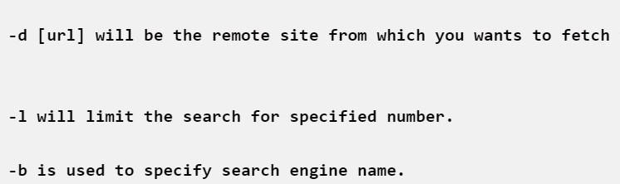

STEP 2: Run the following command
OUTPUT:
