**Day 3 -Mongo DB Task**

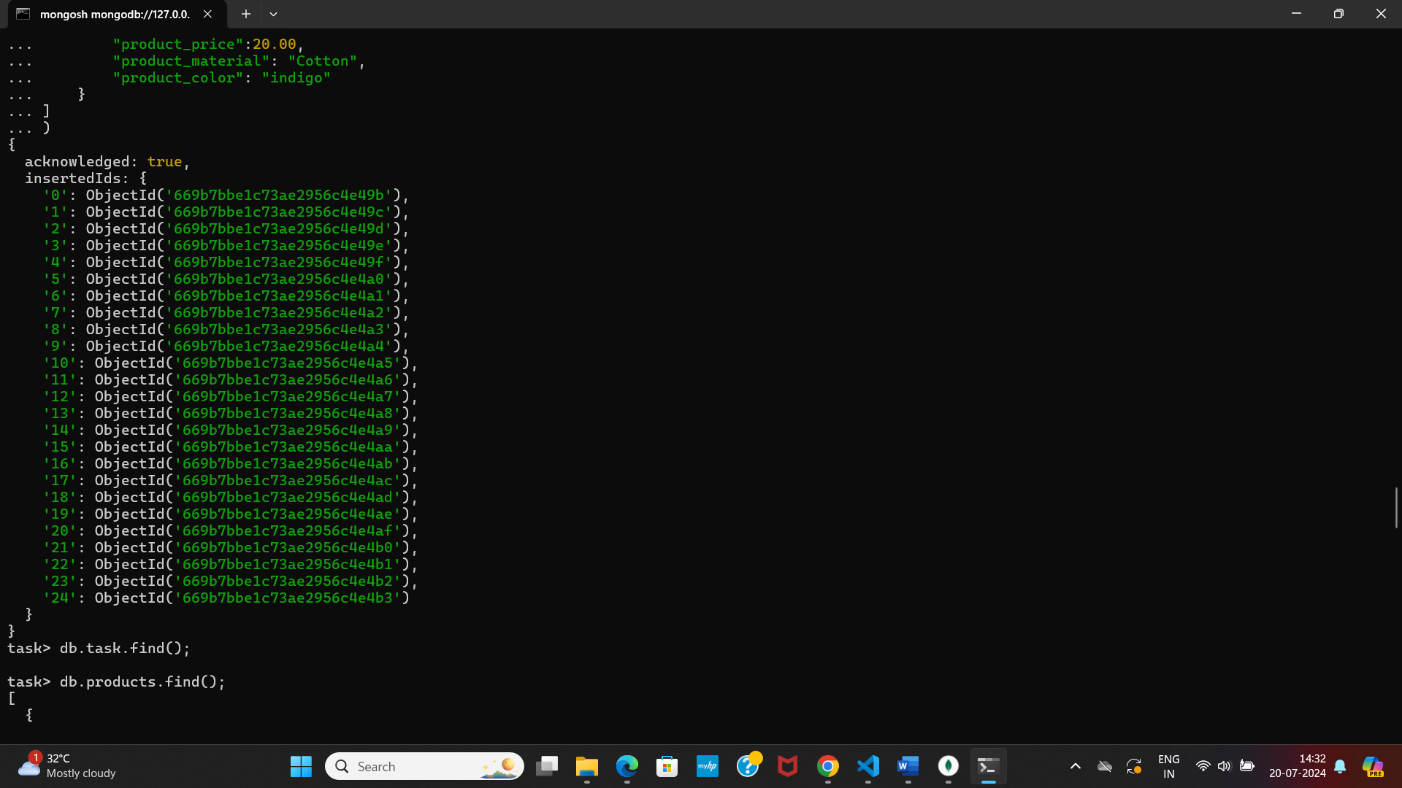

**1.Find all the information about each products**

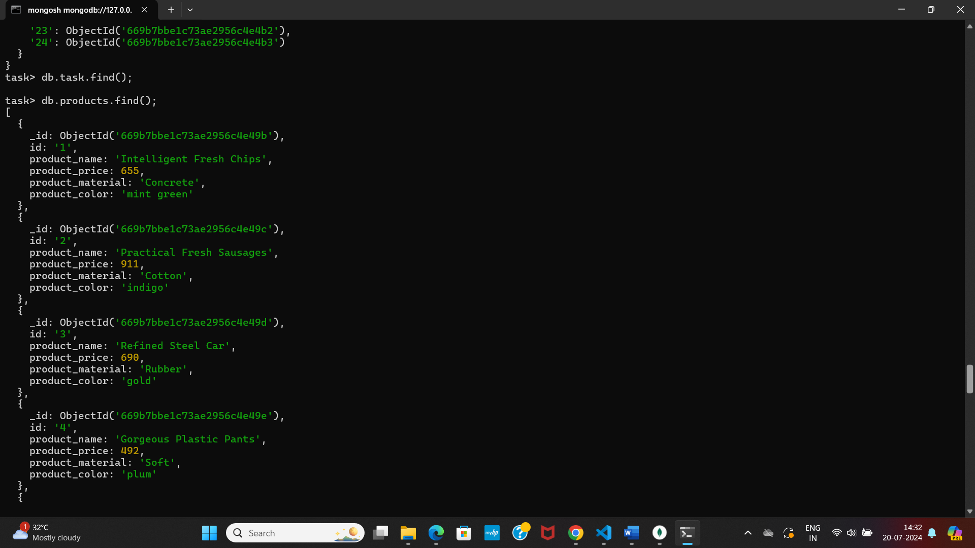

**2.Find the product price which are between 400 to 800**

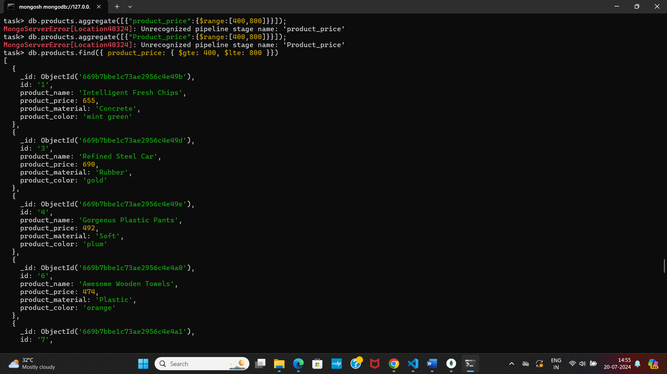

**3. Find the product price which are not between 400 to 800?**

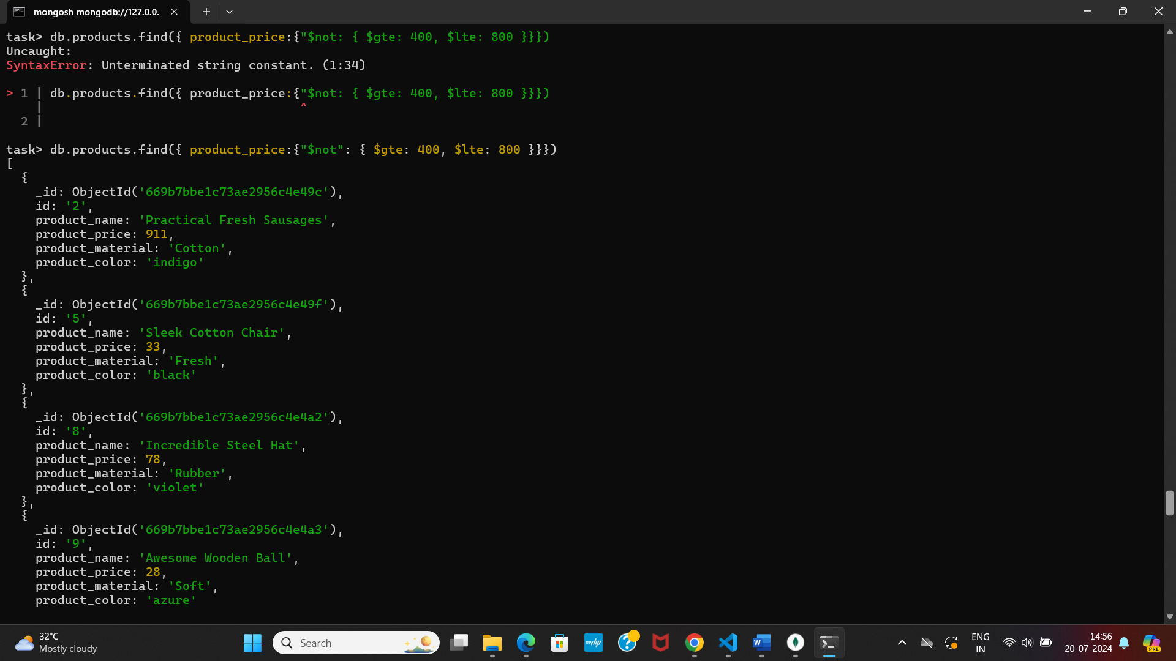

**4.List the four products which are greater than 500 in price?**

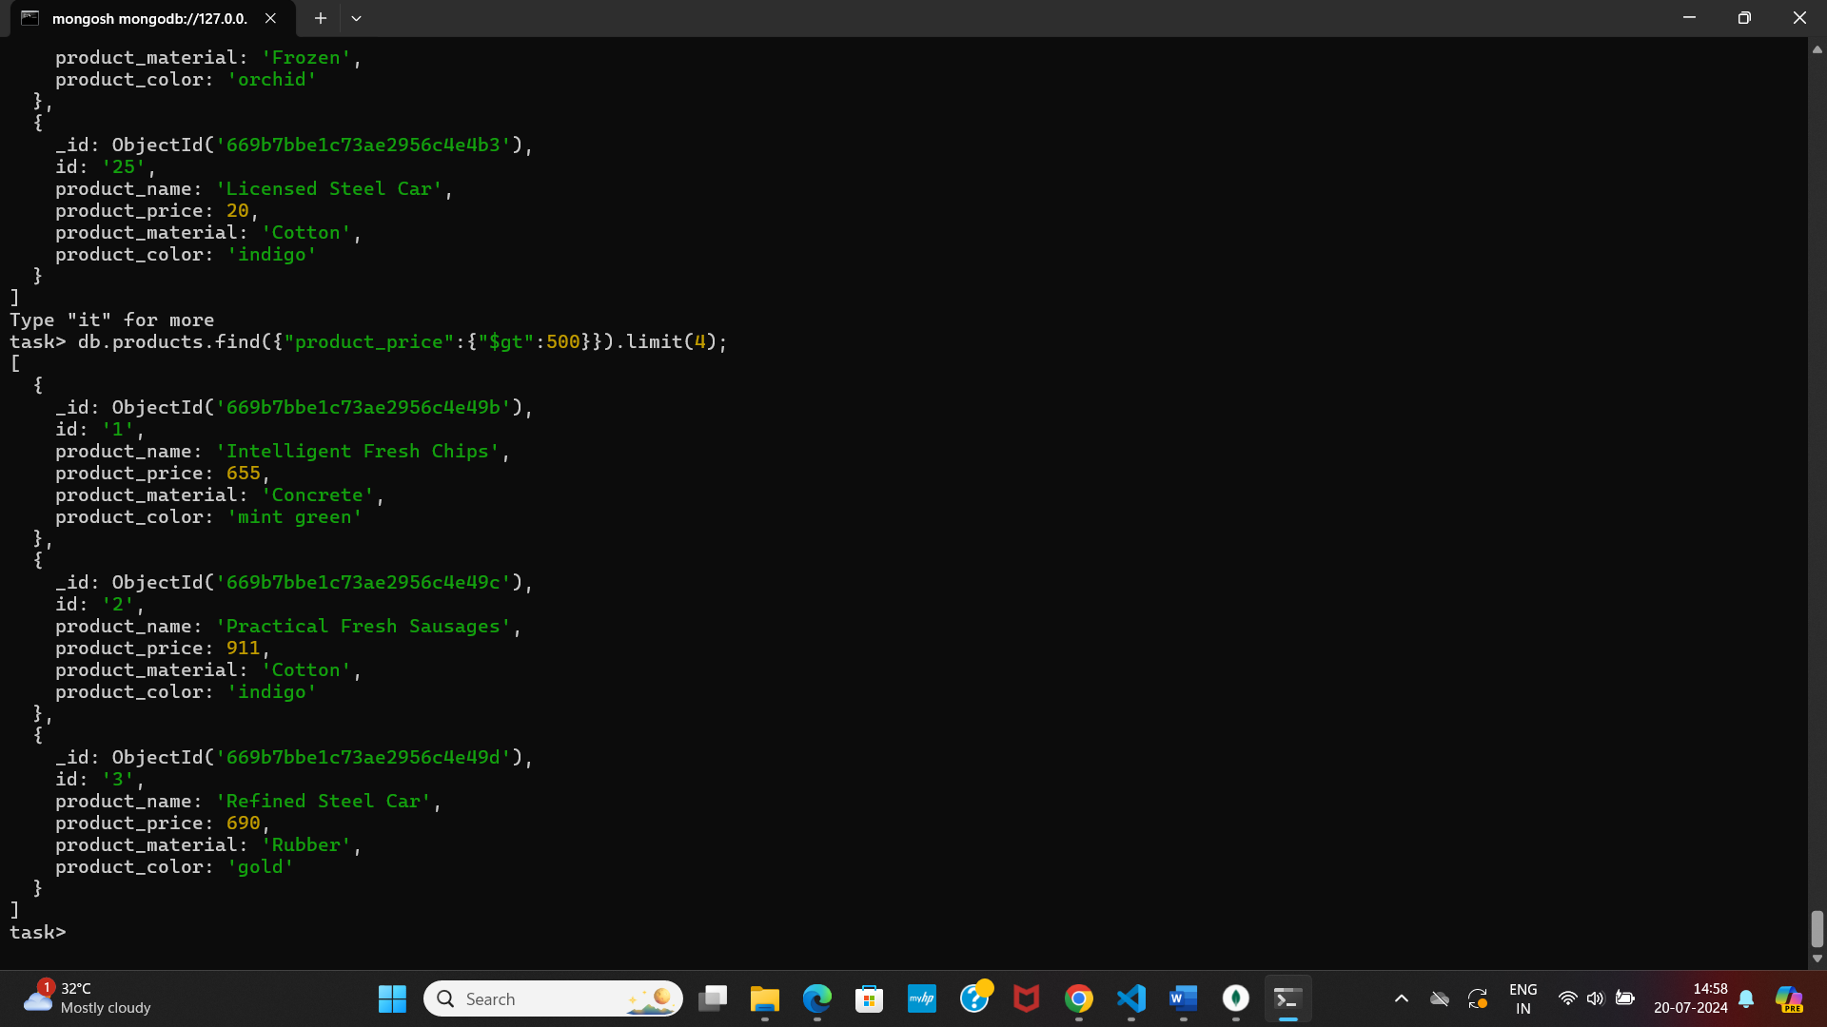

**5.Find the product name and product material of each products.**

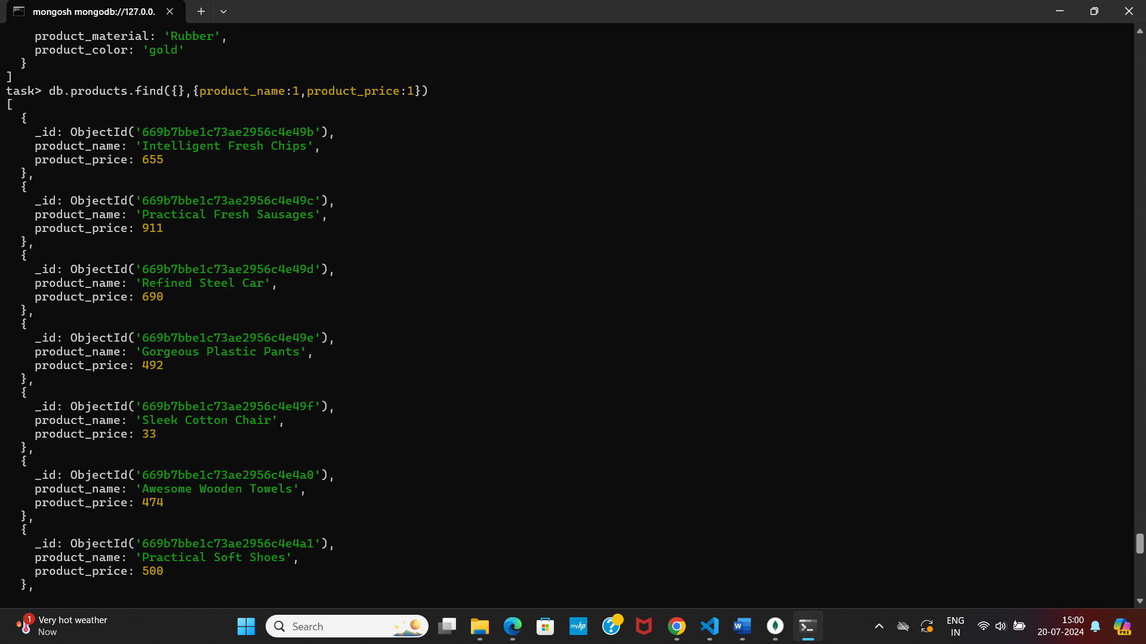

**6.Find the product with a row id of 10**

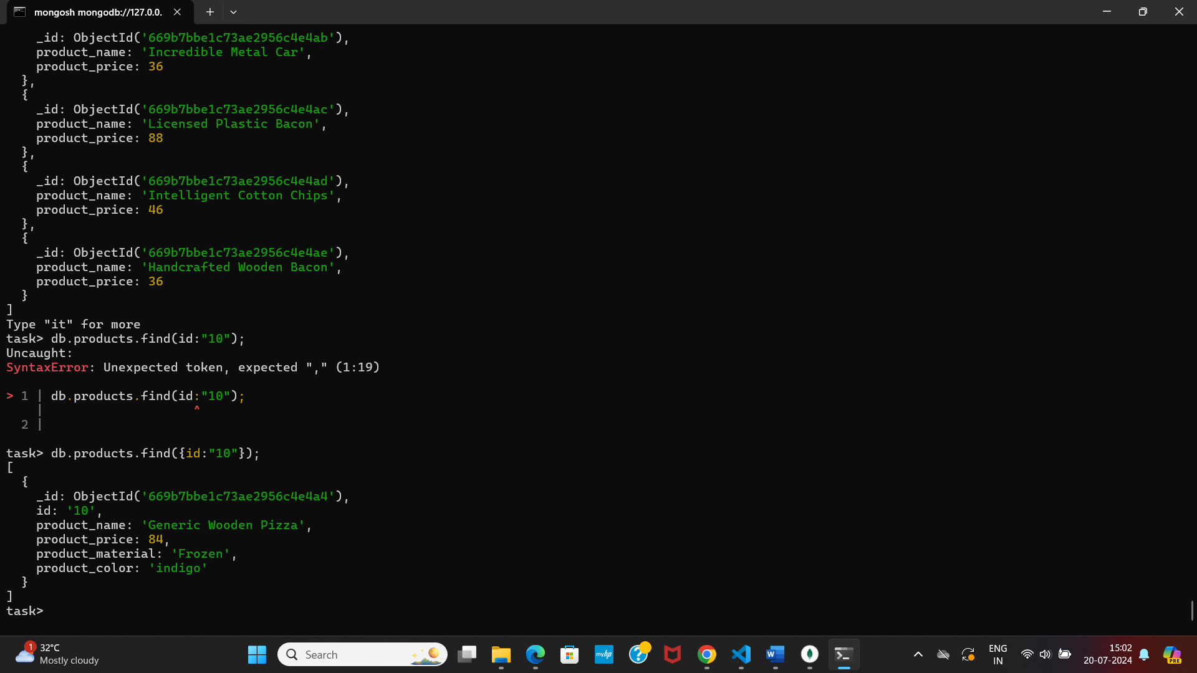

**7.** **Find only the product name and product material**

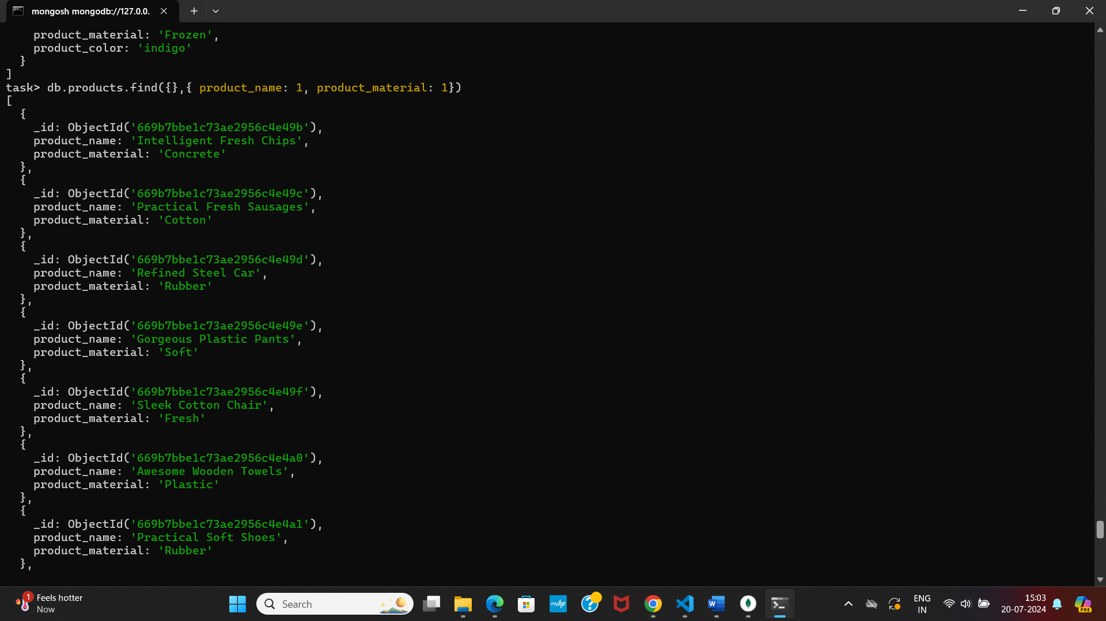

**8.** **Find all products which contain the value of soft in product material**

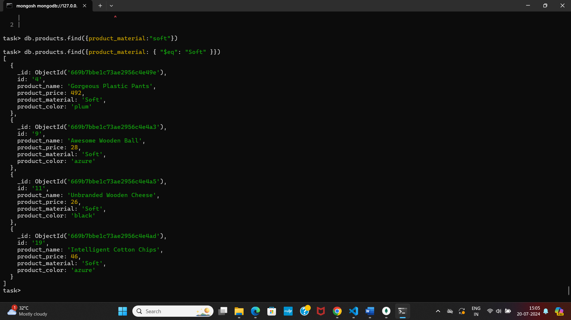

**9.** **Find products which contain product color indigo  and product price 492.00**

