Sql Lesson 1:Select queries 101

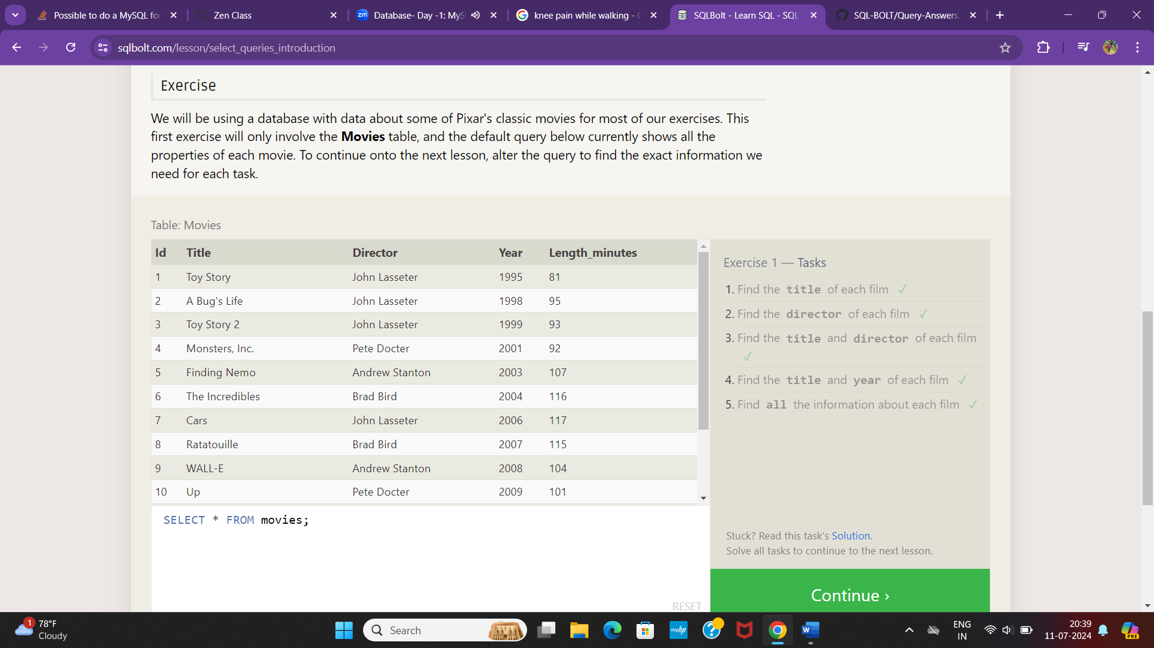

Sql Lesson 2:Queries With Contraints

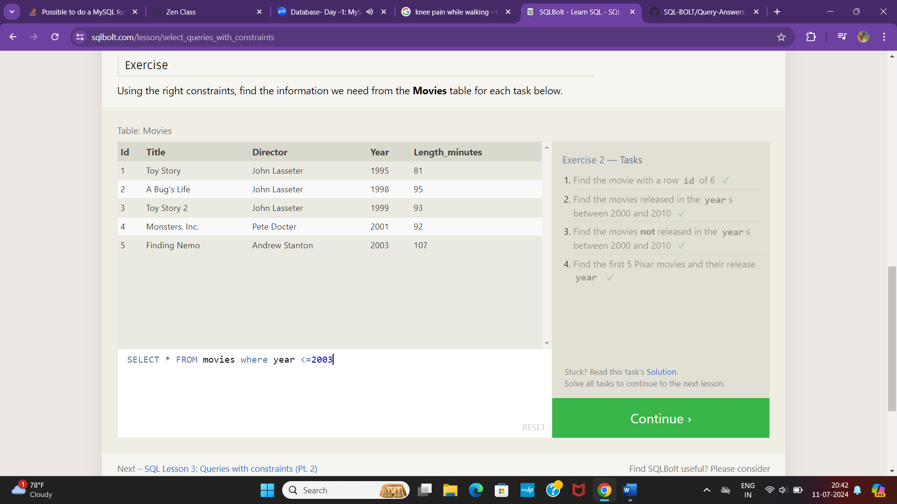

SQL Lesson 3:Queries with Contraints

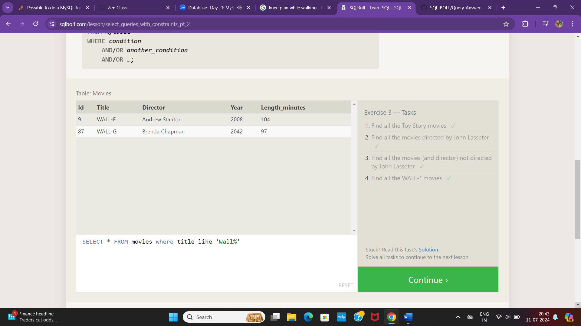

Sql Lesson 4:Filtering and Sorting Query results

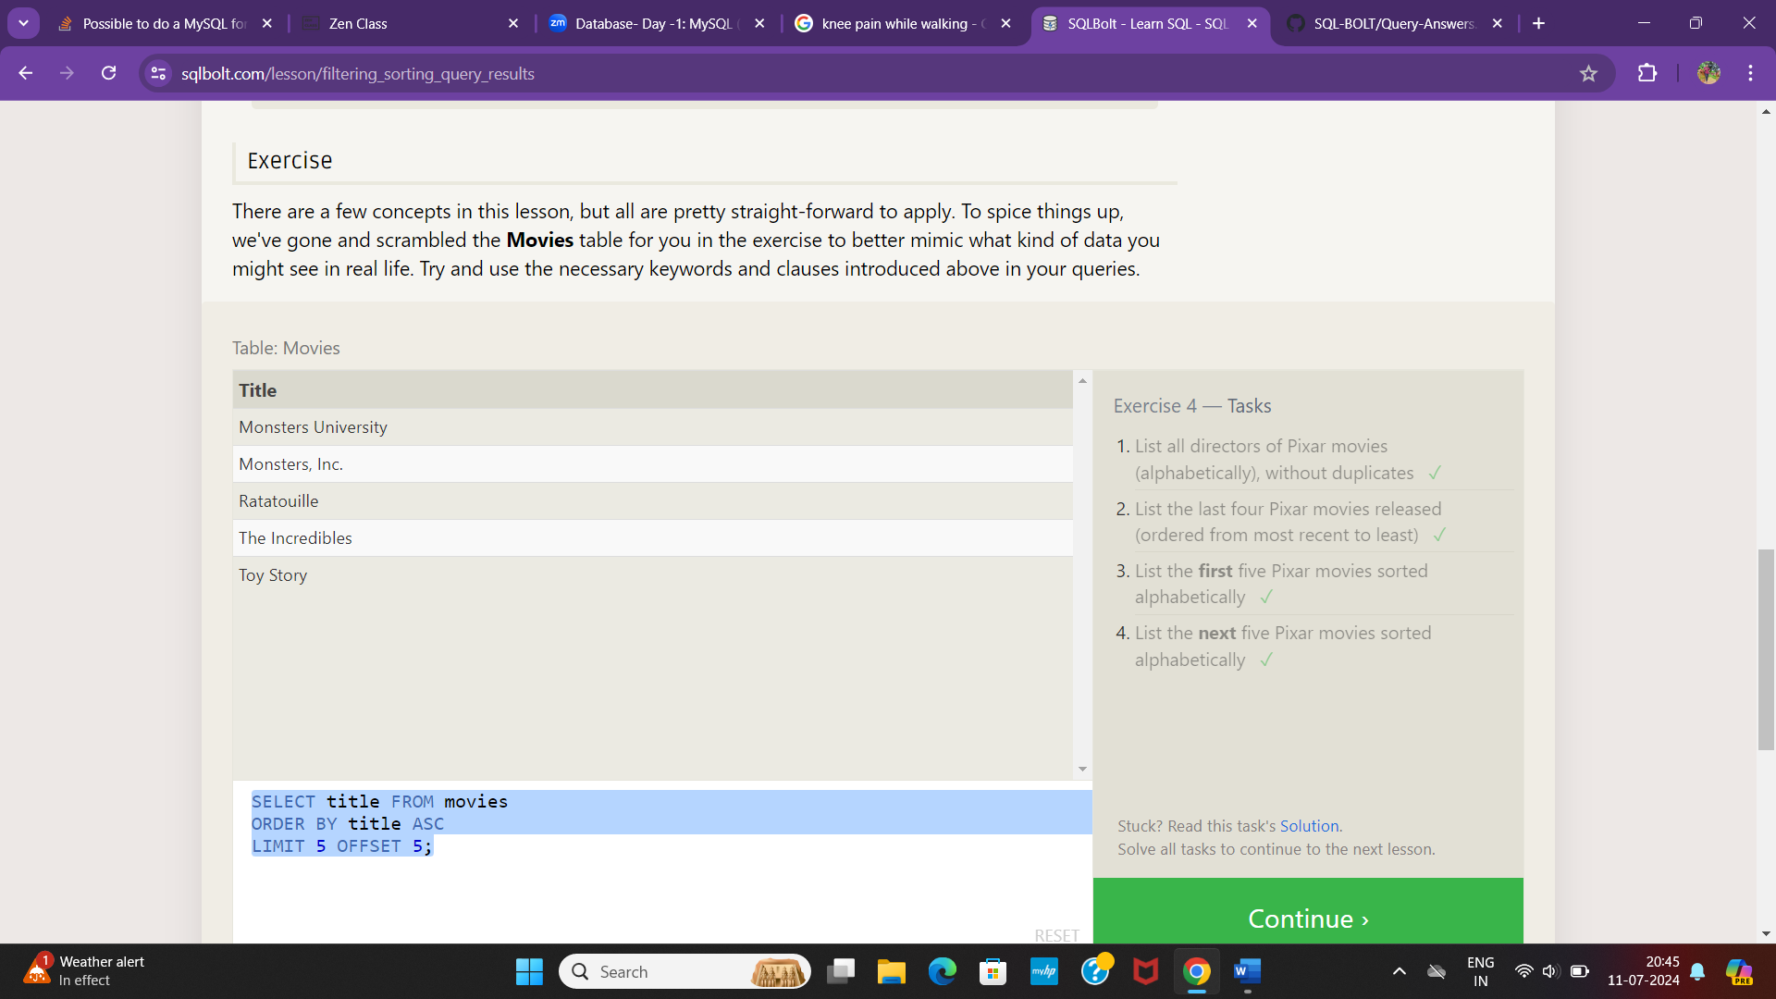

**Sql Review :Simple Select Queries**

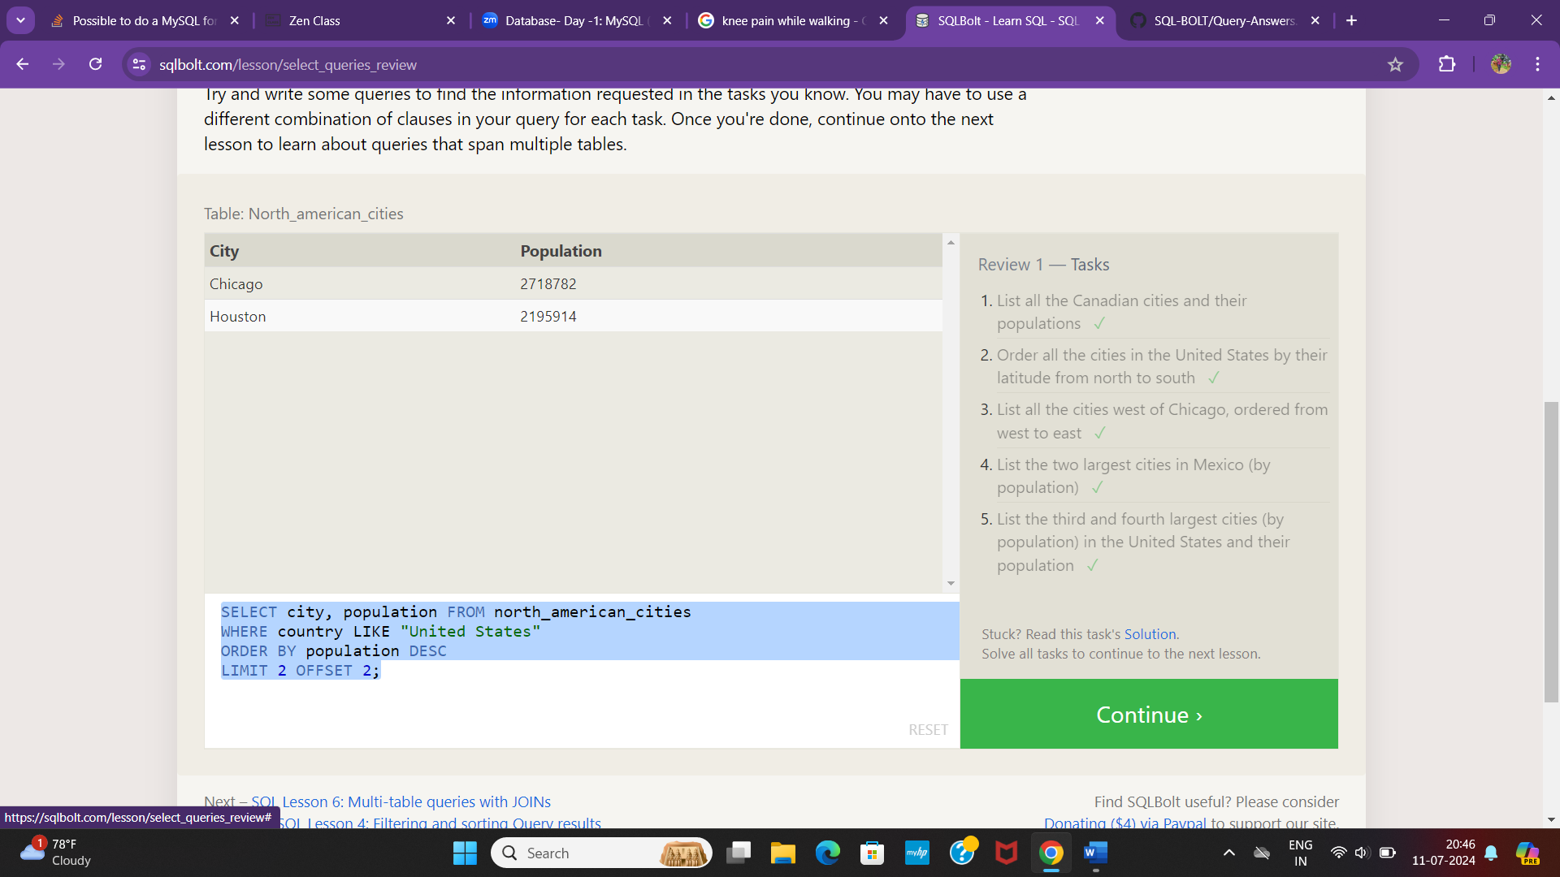

Sql Lesson 6:Multi Table Queries with Joins

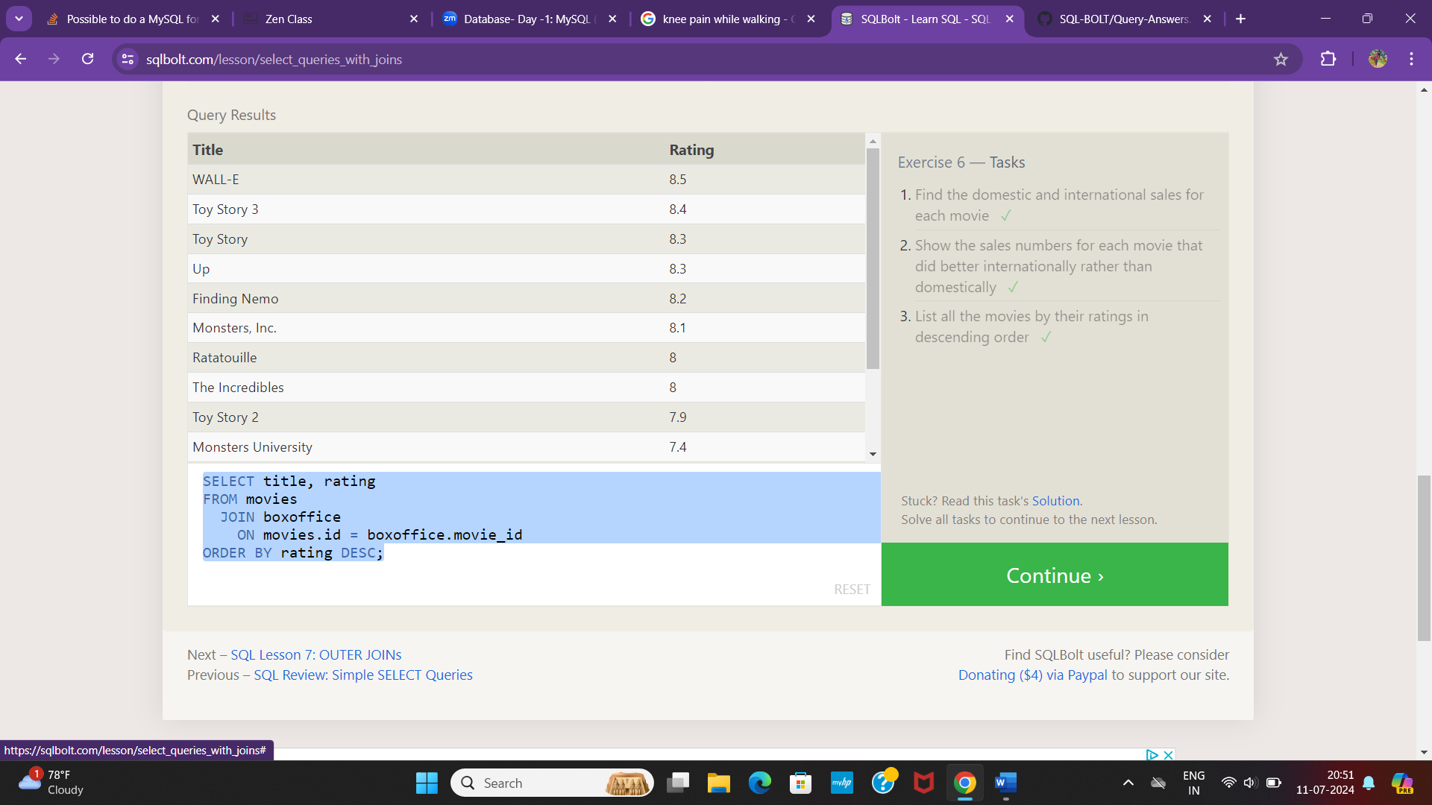

Sql Lesson:7 Outer Join

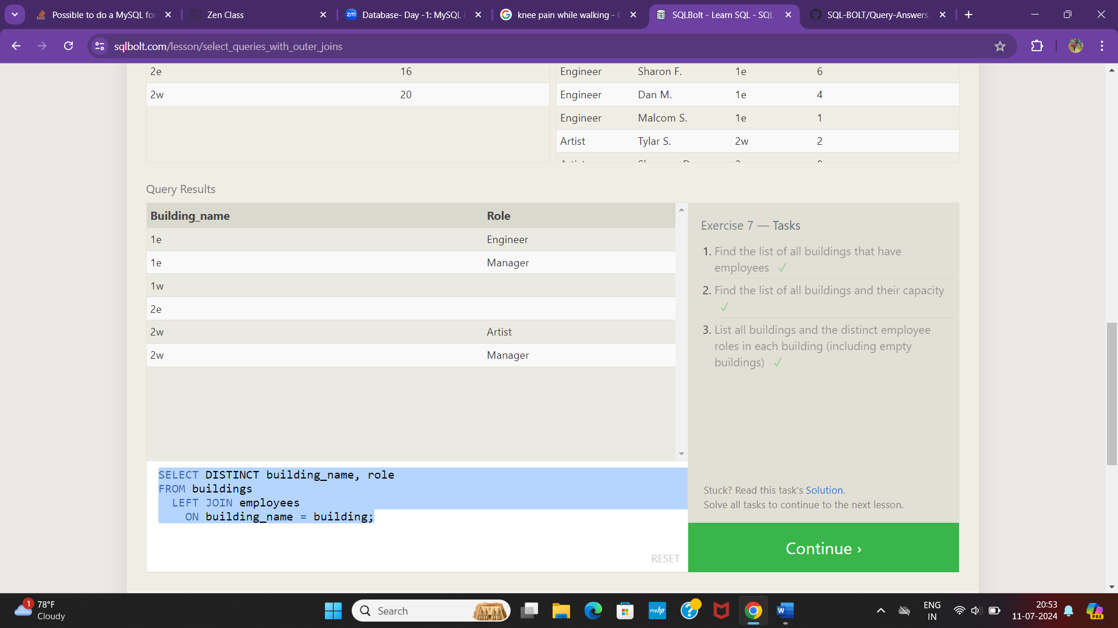

Sql Lesson 8:A short note on NULLS

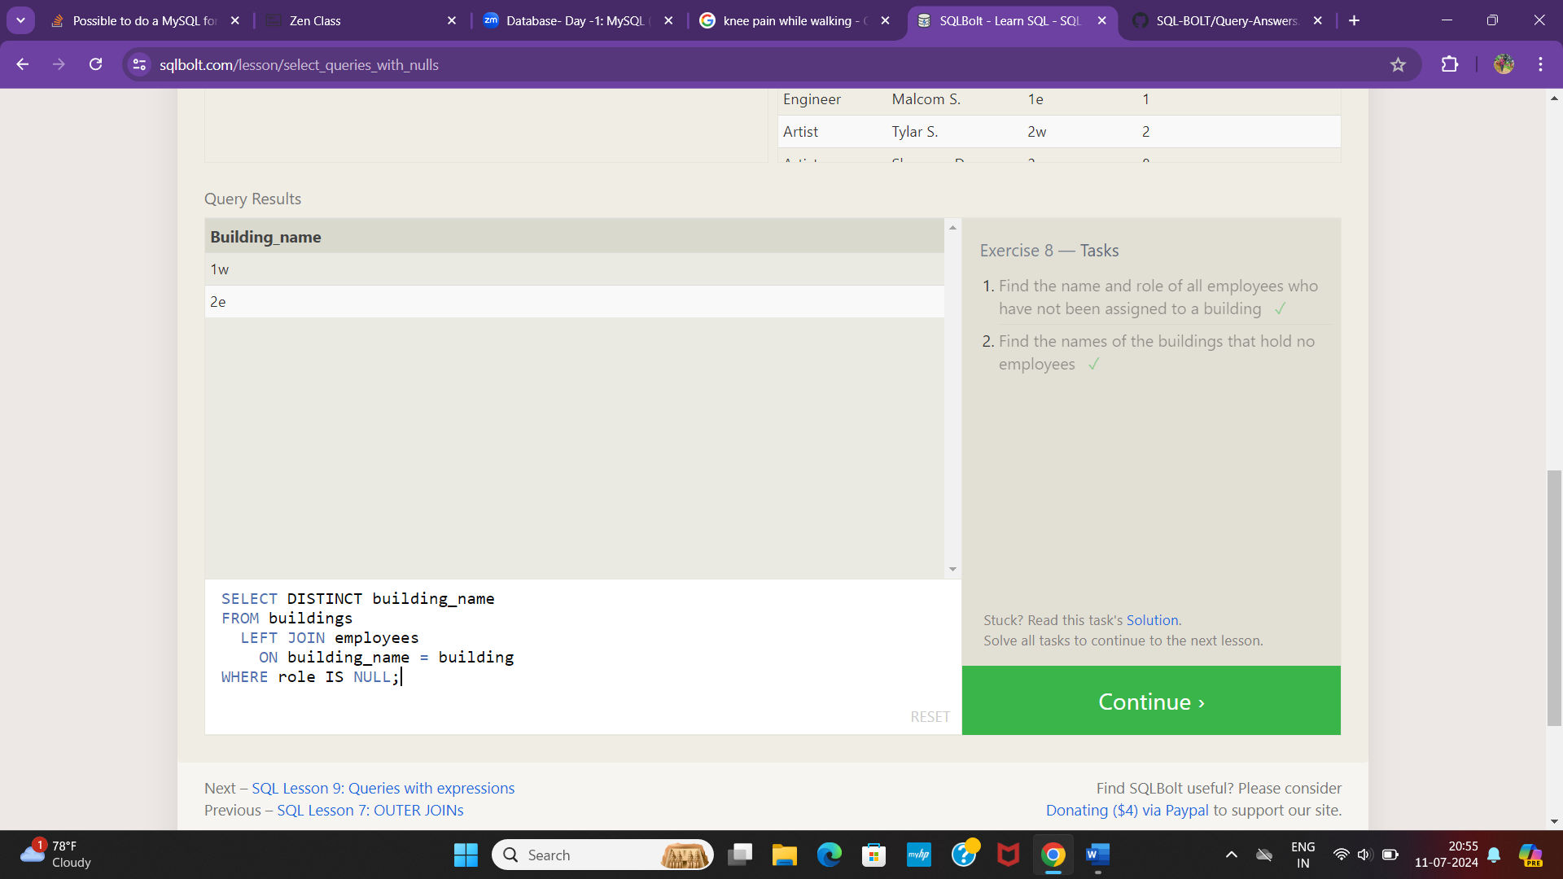

Sql Lesson 9:Queries with expressions

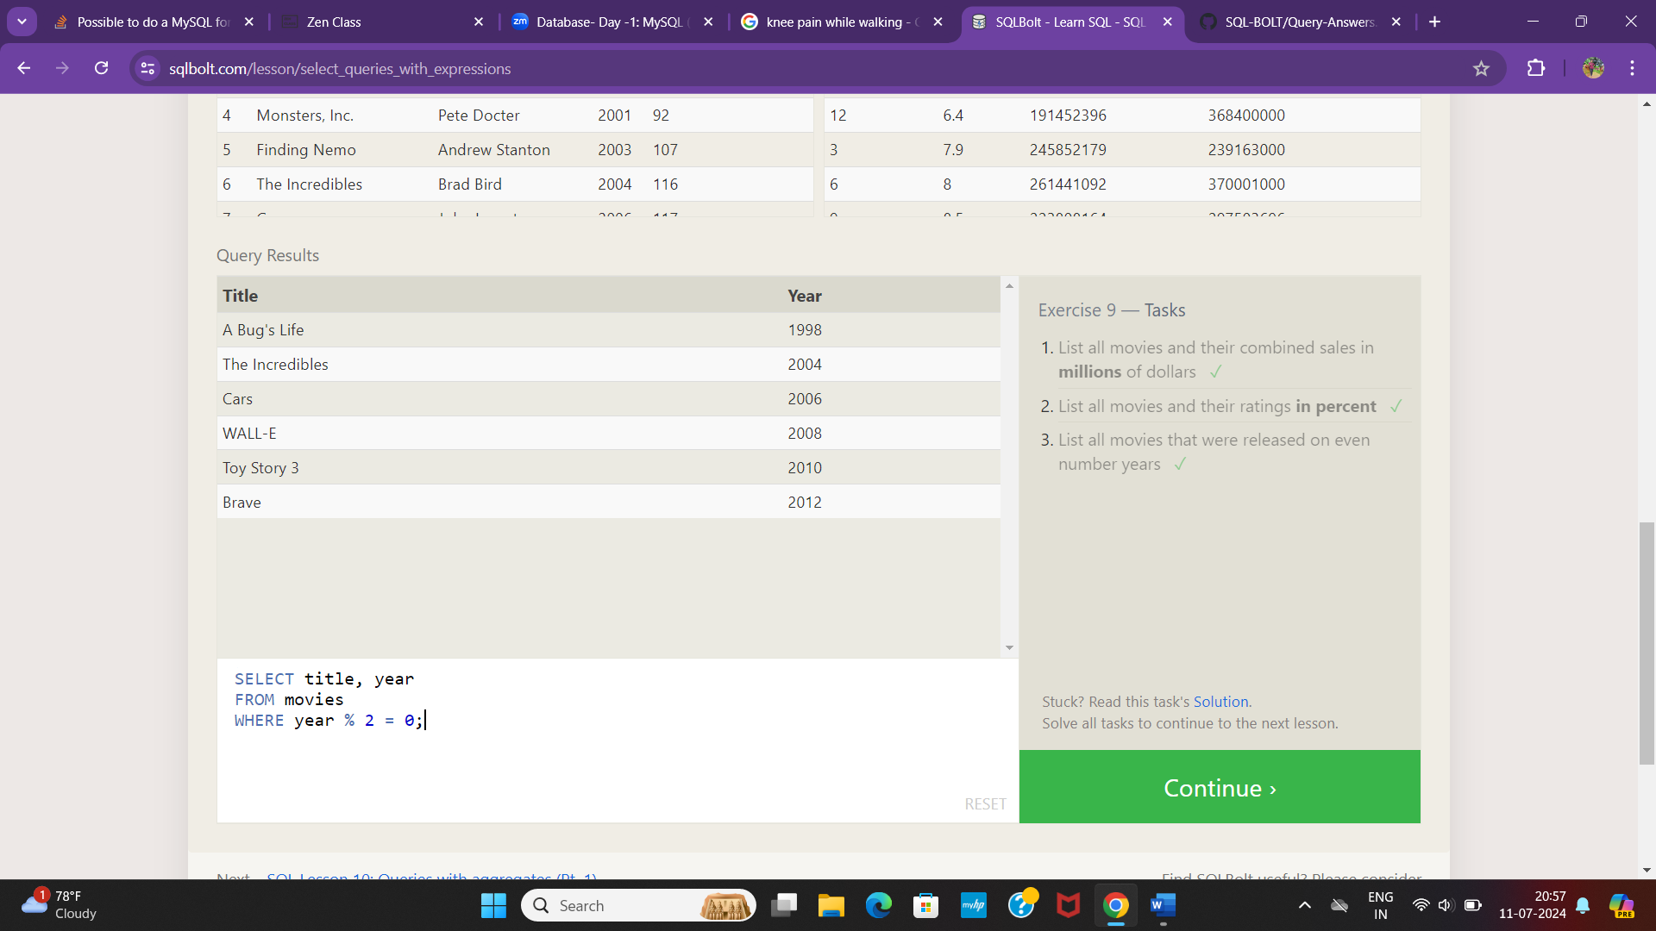

Sql Lesson 10:Queries with Aggregates

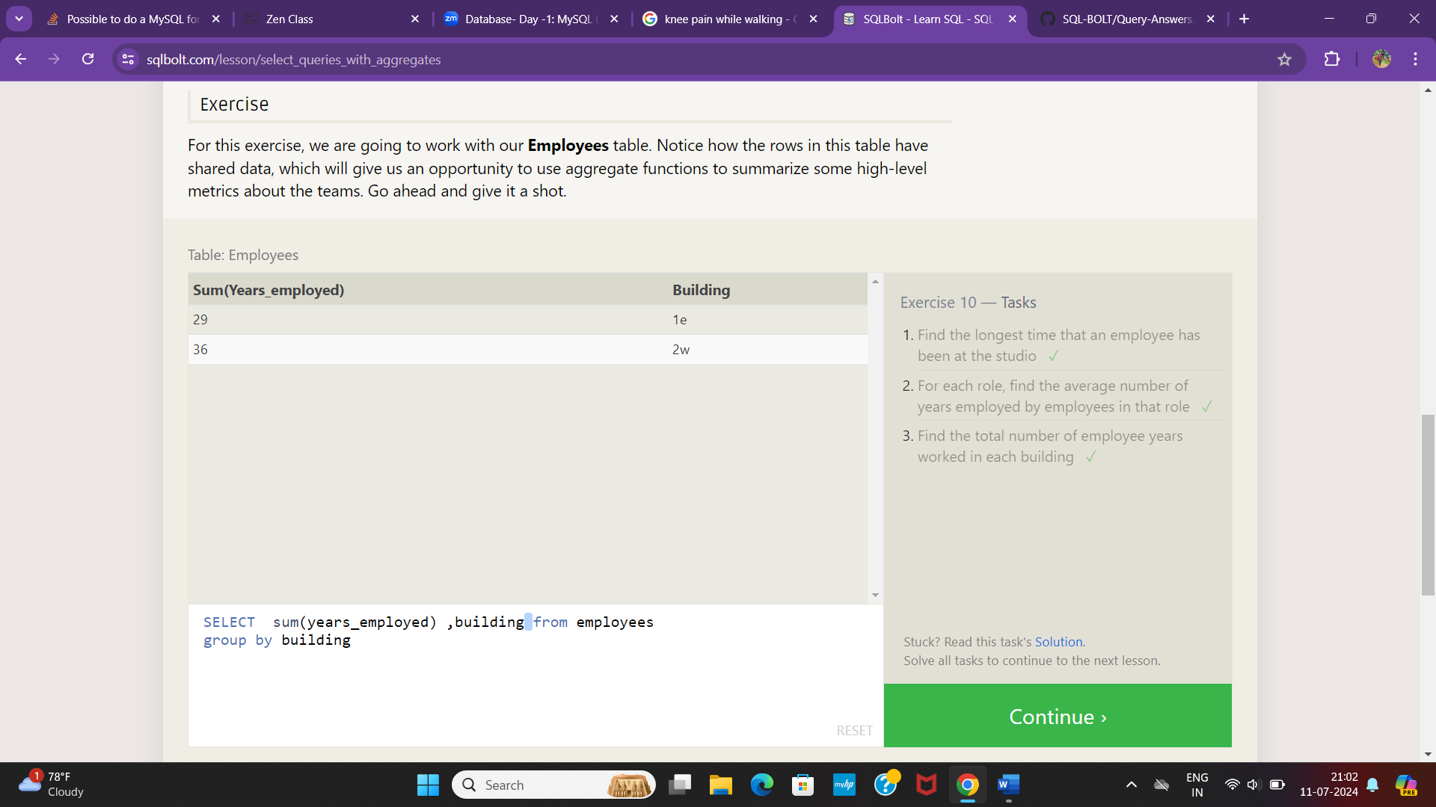

Sql Lesson 11:Queris with Aggretes

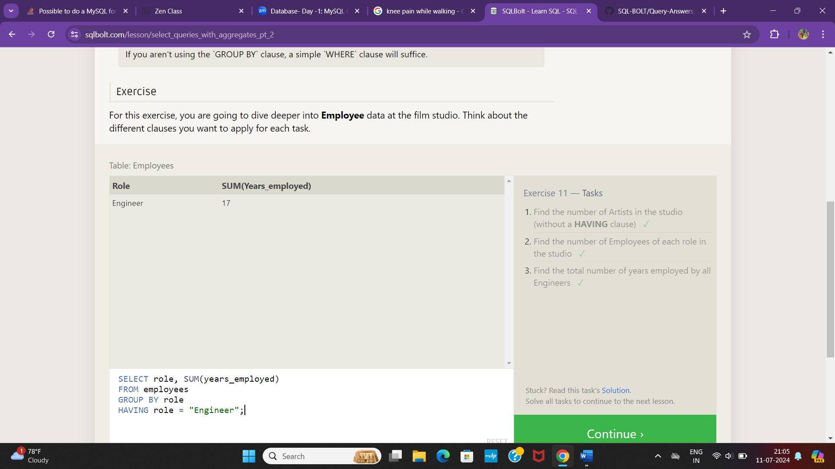

Sql Lesson 12:order of execution of a query

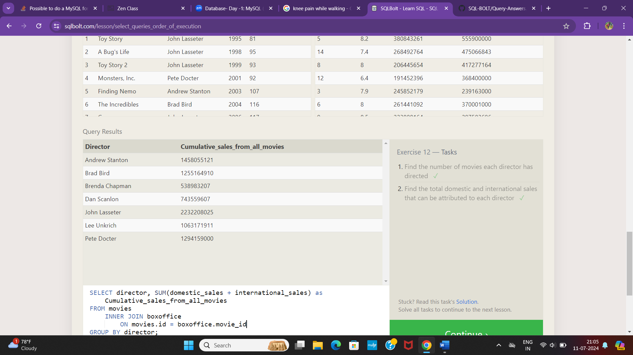

Sql Lesson 13: Inserting rows

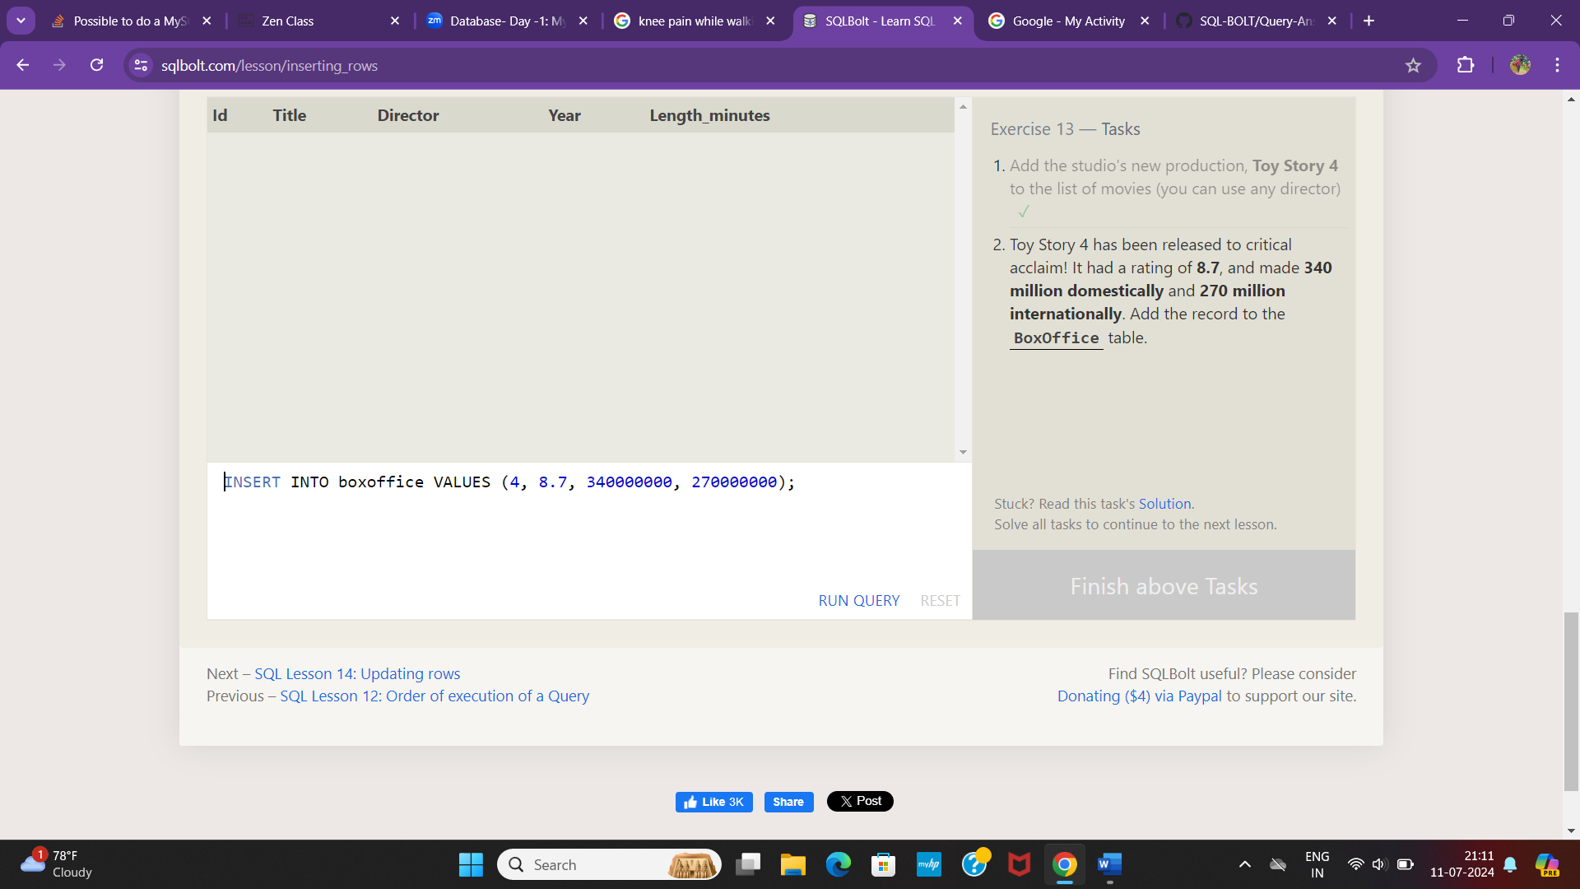

Sql Lesson 14:updating rows

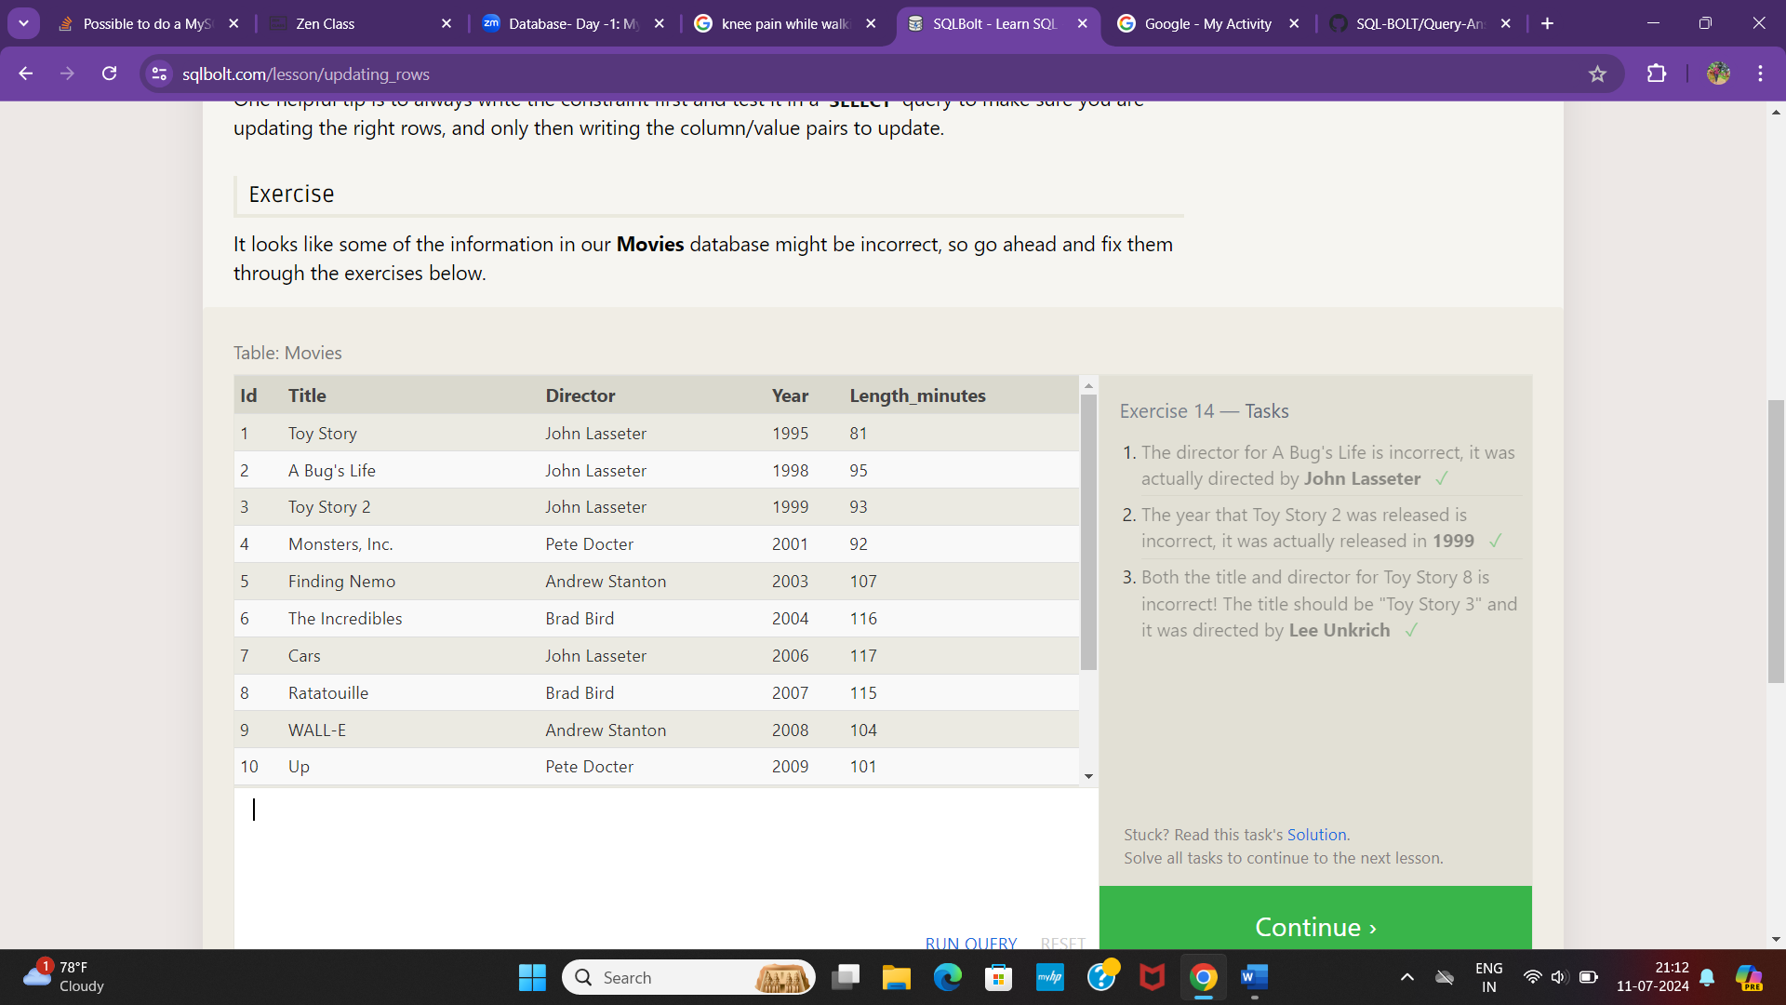

Sql Lesson 15:Deleting rows

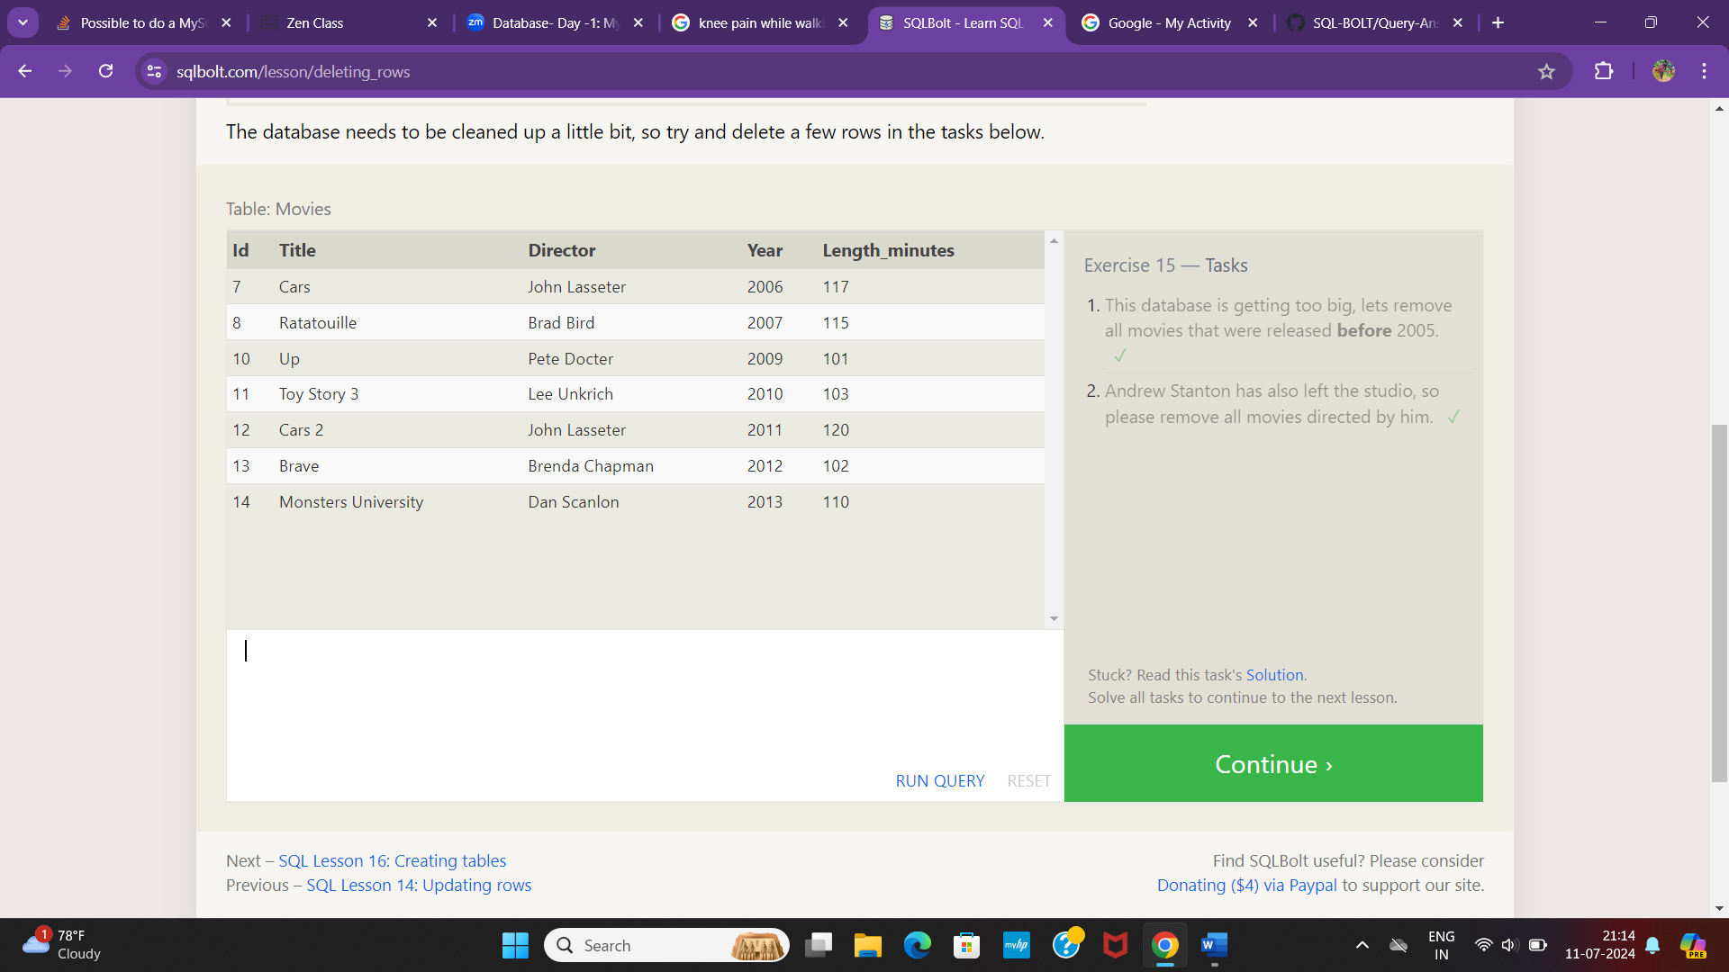

Sql lesson 16:Creating tables

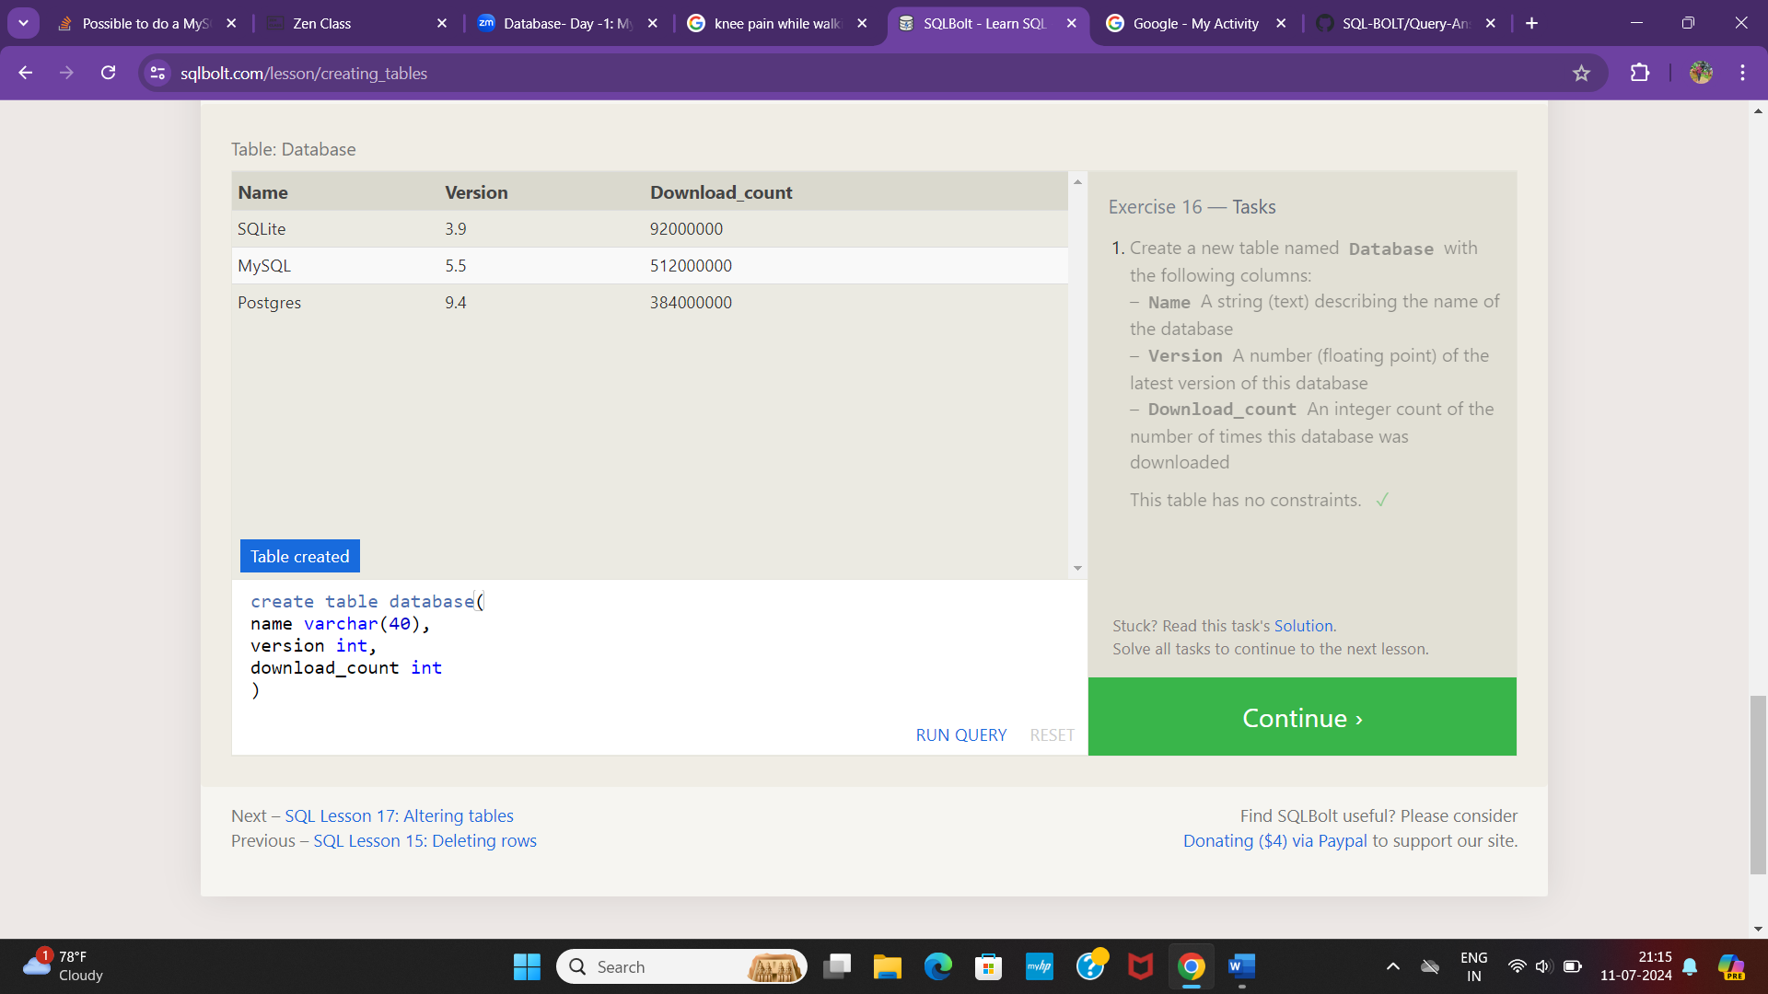

Sql lesson 17:Altering tables

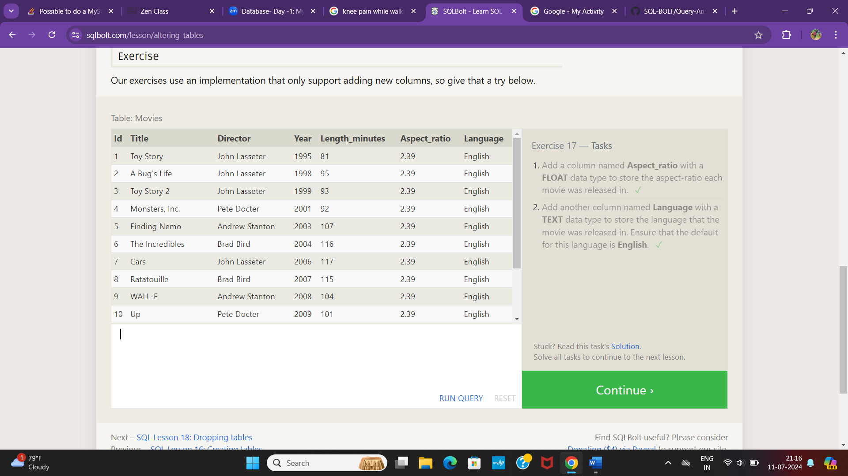

Sql lesson 18:Dropping tables

