**Zen class Db design**

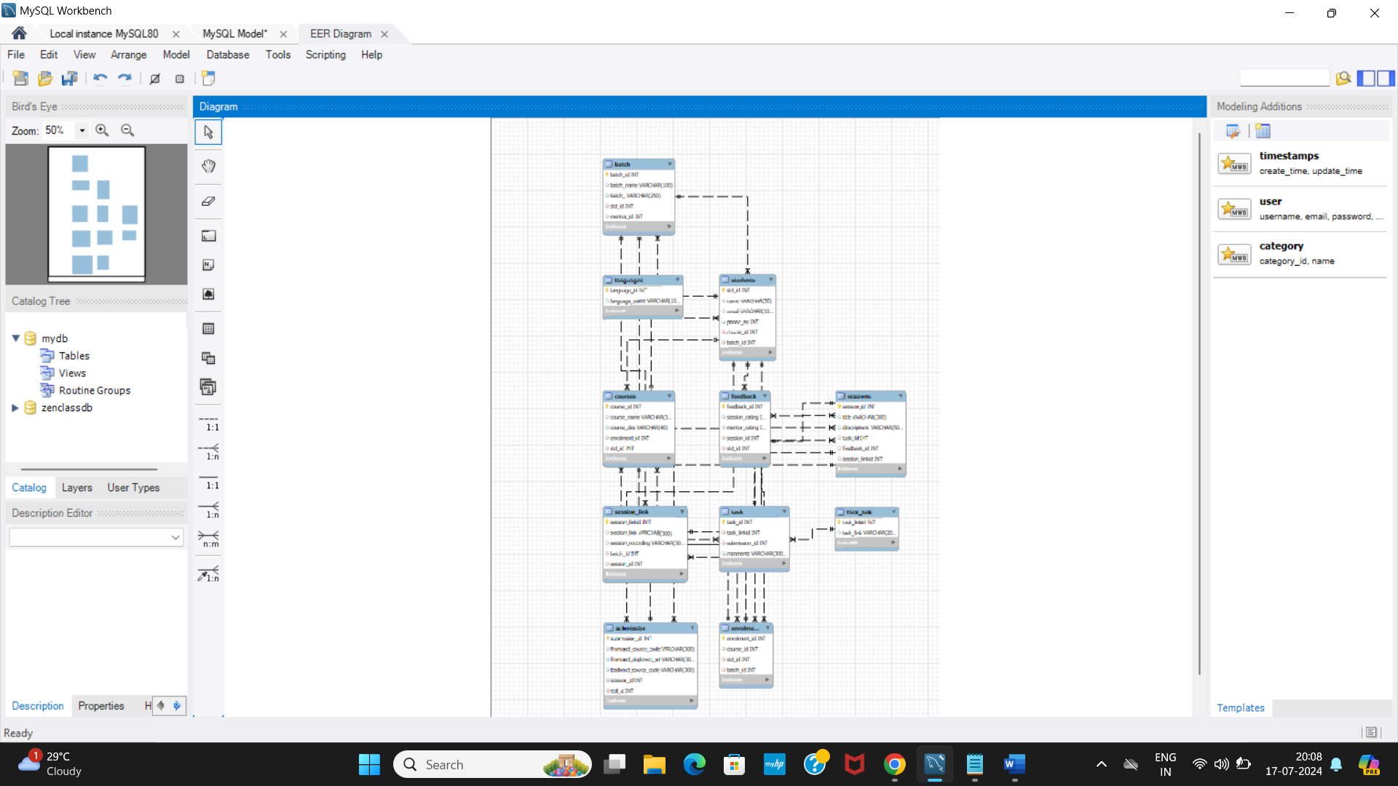

**Query:**

**create table batch(**

**batch_id int primary key,**

**batch_name varchar(100),**

**batch_ varchar(250),**

**std_id int ,**

**mentor_id int**

**);**

**create table students(**

**std_id int primary key ,**

**name varchar(30),**

**email varchar(100),**

**phone_no int,**

**course_id int,**

**batch_id int**

**);**

**create table courses(**

**course_id int primary key,**

**course_name varchar(30),**

**course_des varchar(40),**

**enrolment_id int,**

**std_id int**

**);**

**create table enrolments(**

**enrolment_id int primary key,**

**course_id int,**

**std_id int ,**

**batch_id int**

**);**

**create table session_link(**

**session_linkid int primary key,**

**session_link varchar(300),**

**session_recording varchar(300),**

**batch_id int,**

**session_id int**

**);**

**create table task(**

**task_id int primary key,**

**task_linkid int,**

**submission_id int,**

**comments varchar(3000)**

**);**

**create table feedback(**

**feedback_id int primary key,**

**session_rating int,**

**mentor_rating int,**

**session_id int,**

**std_id int**

**);**

**create table sessions(**

**session_id int primary key,**

**title varchar(300),**

**descriptions varchar(500),**

**task_id int,**

**feedback_id int,**

**session_linkid int**

**);**

**create table submission(**

**submission_id int primary key,**

**frontend_source_code varchar(300),**

**frontend_deployed_url varchar(300),**

**backend_source_code varchar(300),**

**session_id int,**

**std_id int**

**);**

**create table task_link(**

**task_linkid int primary key,**

**task_link varchar (200)**

**);**

**create table languages**

**(**

**language_id int primary key,**

**language_name varchar(100)**

**);**

**alter table batch add foreign key (std_id) references students(std_id);**

**alter table enrolments add foreign key(course_id) references courses(course_id);**

**alter table enrolments add foreign key(std_id) references students(std_id);**

**alter table enrolments add foreign key(batch_id) references batch(batch_id);**

**alter table courses add foreign key (enrolment_id) references enrolments(enrolment_id);**

**alter table courses add foreign key(std_id) references students(std_id);**

**alter table students add foreign key (course_id) references courses (course_id);**

**alter table students add foreign key (batch_id) references batch (batch_id);**

**alter table session_link add foreign key(session_id) references sessions(session_id);**

**alter table session_link add foreign key(batch_id) references batch(batch_id);**

**alter table task add foreign key(task_linkid) references task_link(task_linkid);**

**alter table task add foreign key(submission_id) references submission(submission_id);**

**alter table feedback add foreign key(session_id) references sessions(session_id);**

**alter table feedback add foreign key(std_id) references students(std_id);**

**alter table sessions add foreign key(session_linkid) references session_link(session_linkid);**

**alter table sessions add foreign key(task_id) references task (task_id);**

**alter table sessions add foreign key(feedback_id) references feedback(feedback_id);**

**alter table submission add foreign key(session_id) references sessions (session_id);**

**alter table submission add foreign key(std_id) references students(std_id);**