**Day 36 Task:**

**1.Find all the topics and tasks which are thought in the mouth of October.**

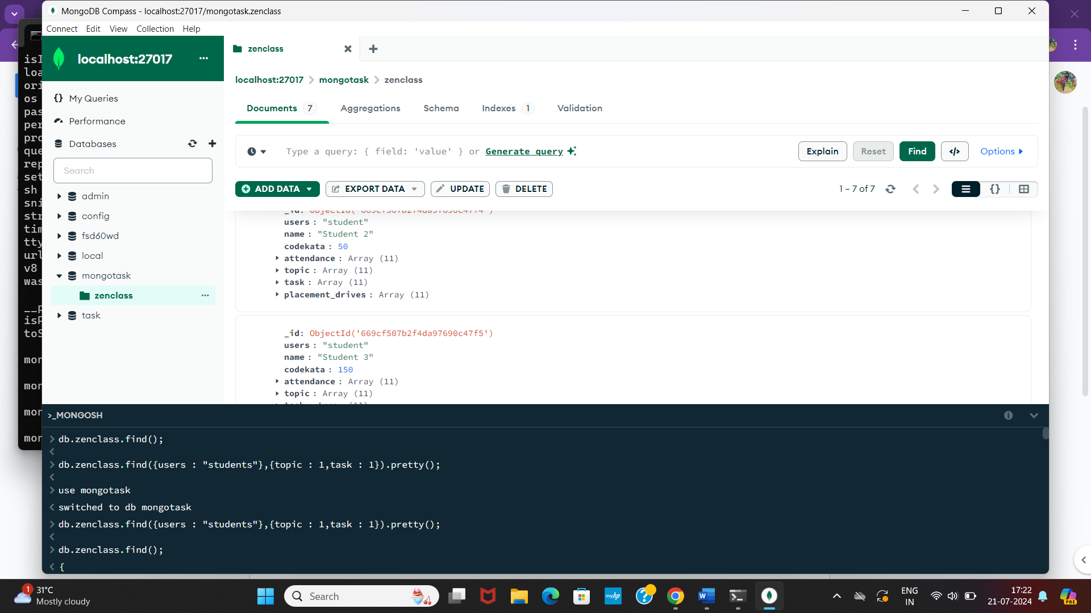

**2.**

**Find all the company drives which appeared between 15-oct-2020 and 31-oct-2020**

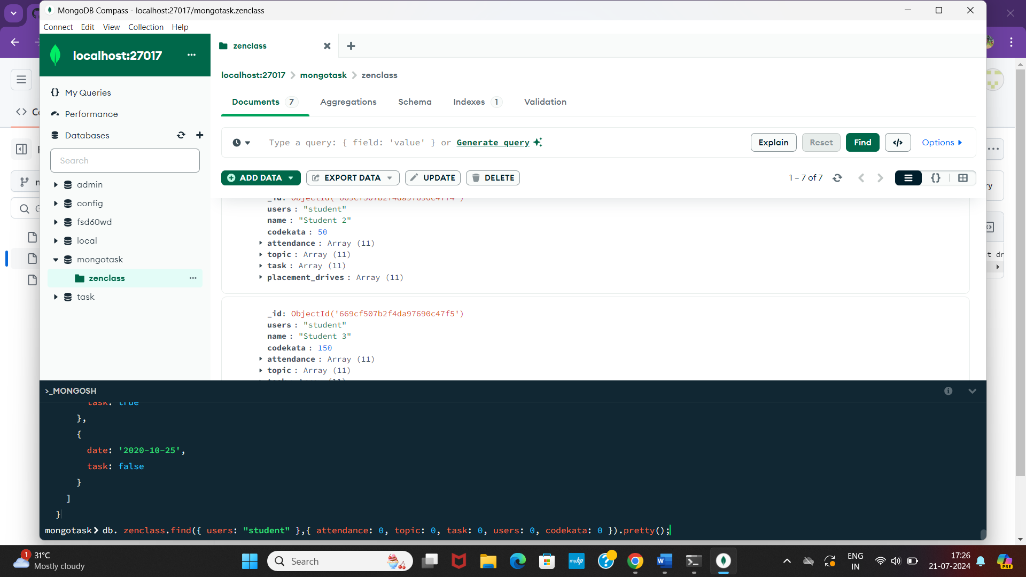

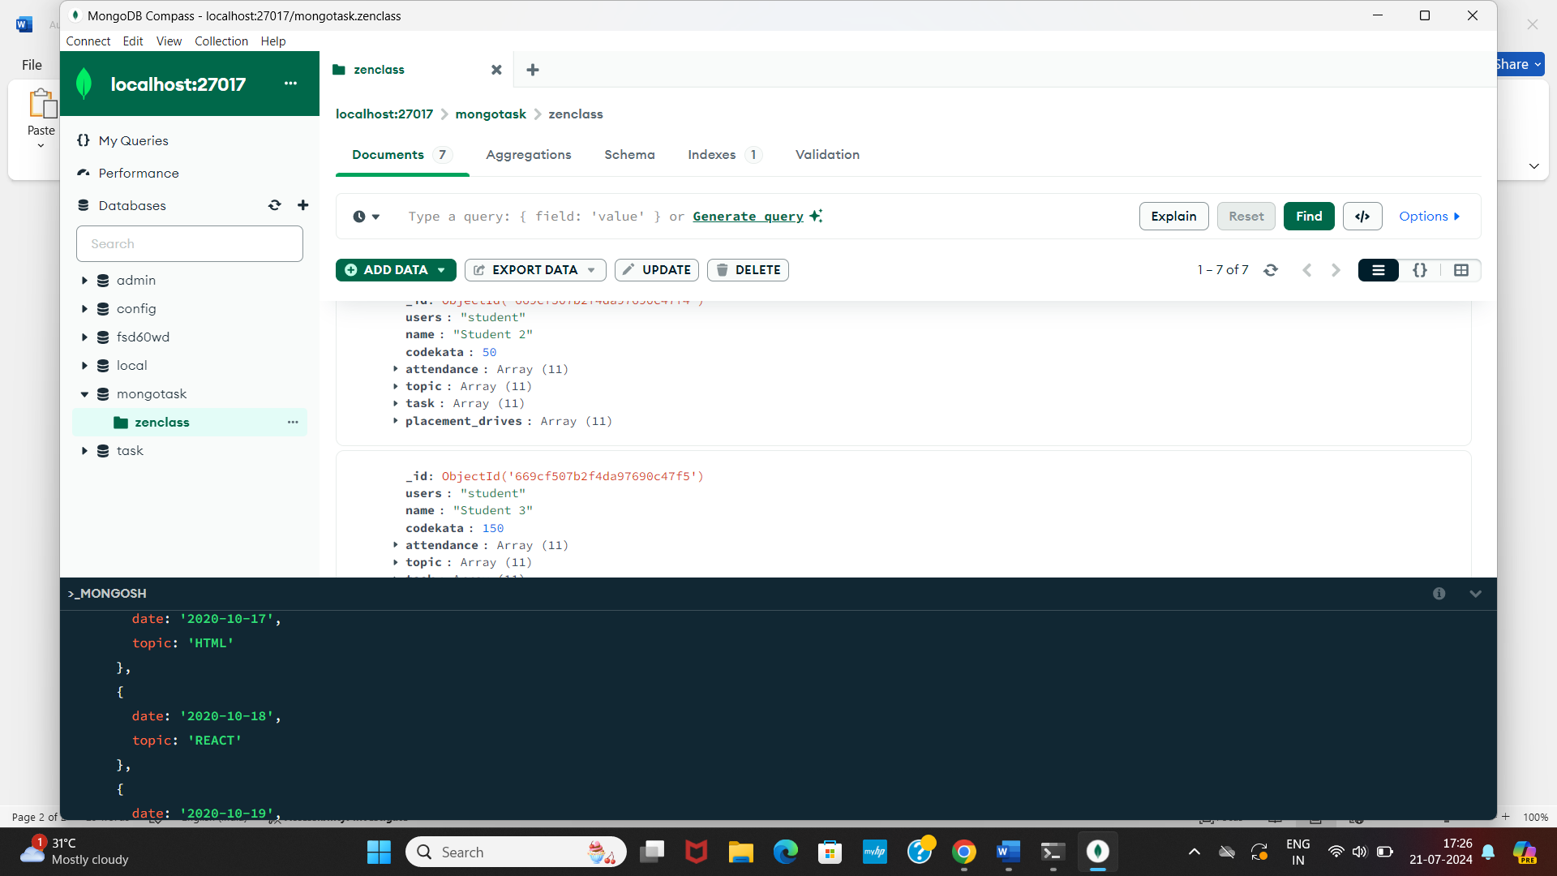

**3.Find all the company drives and students who are appeared for the placement.**

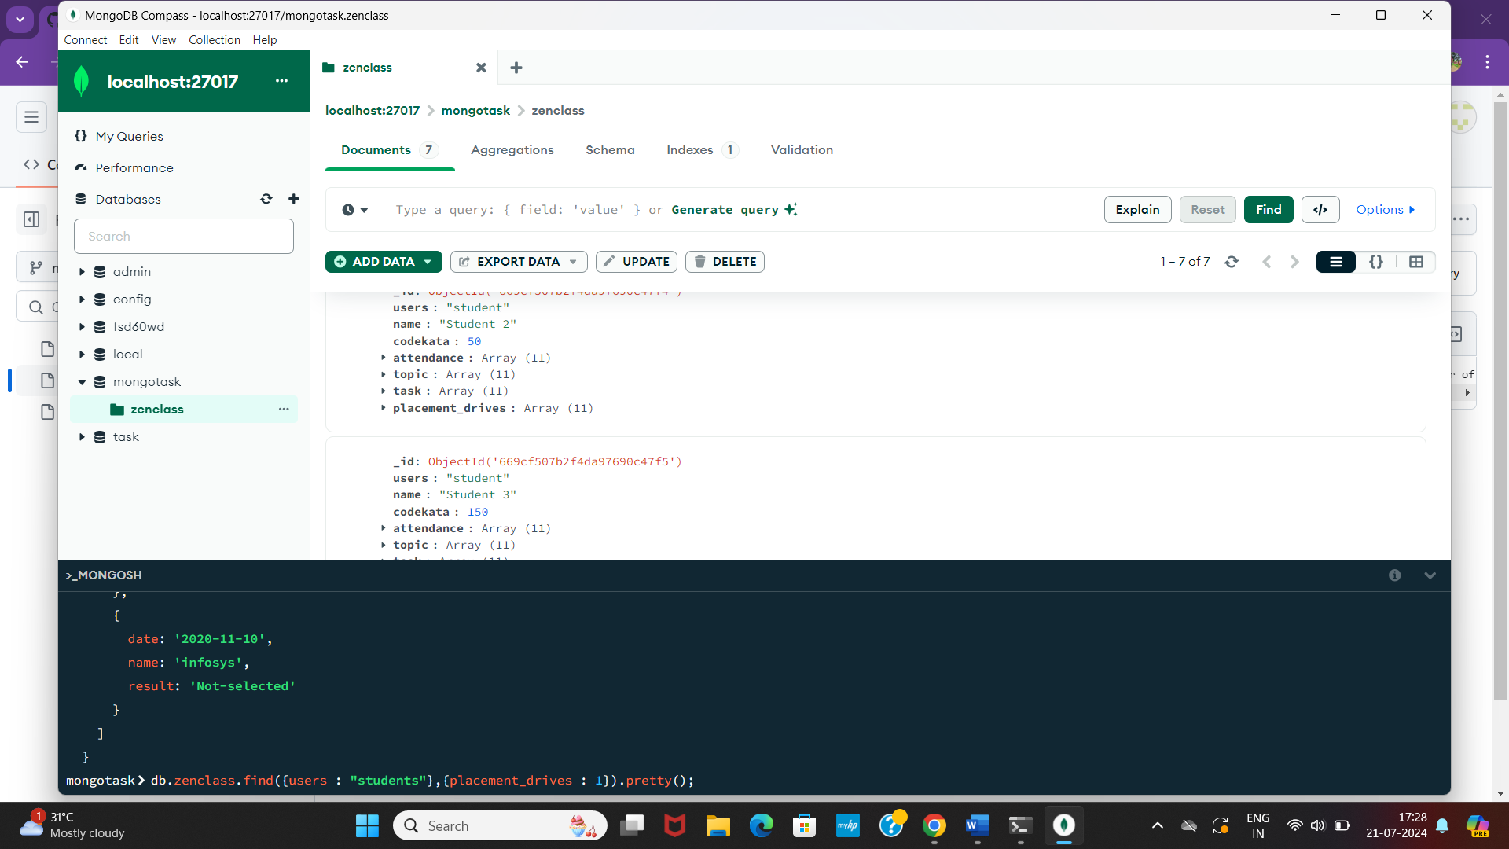

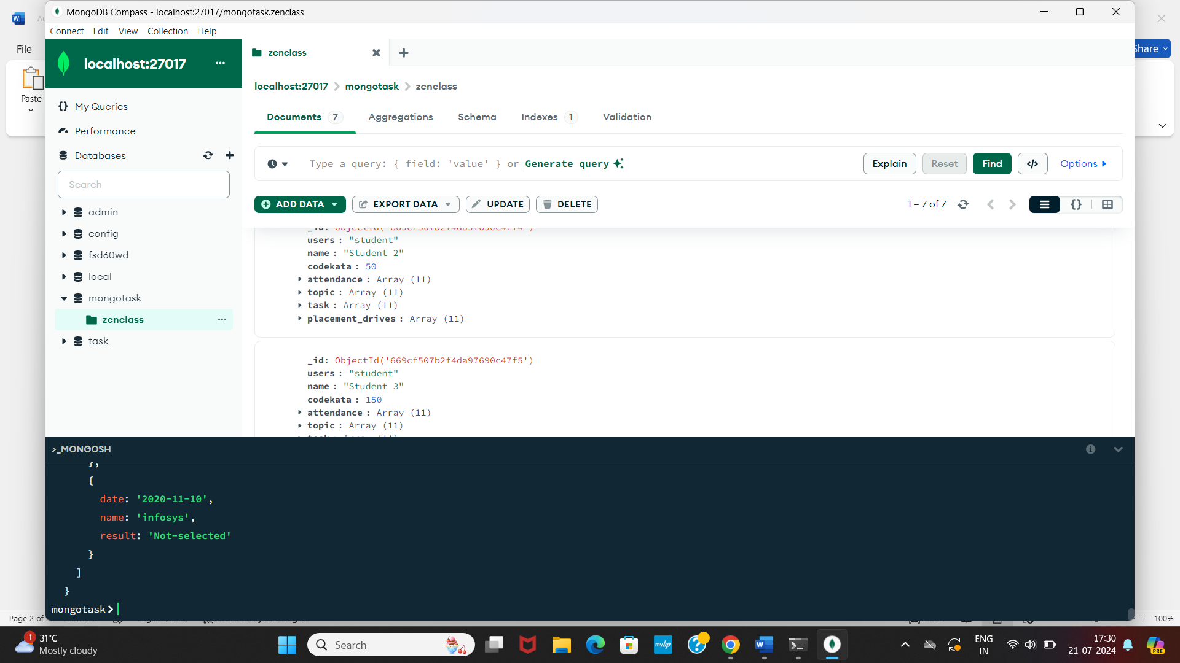

**4.Find the number of problems solved by the user in codekata**

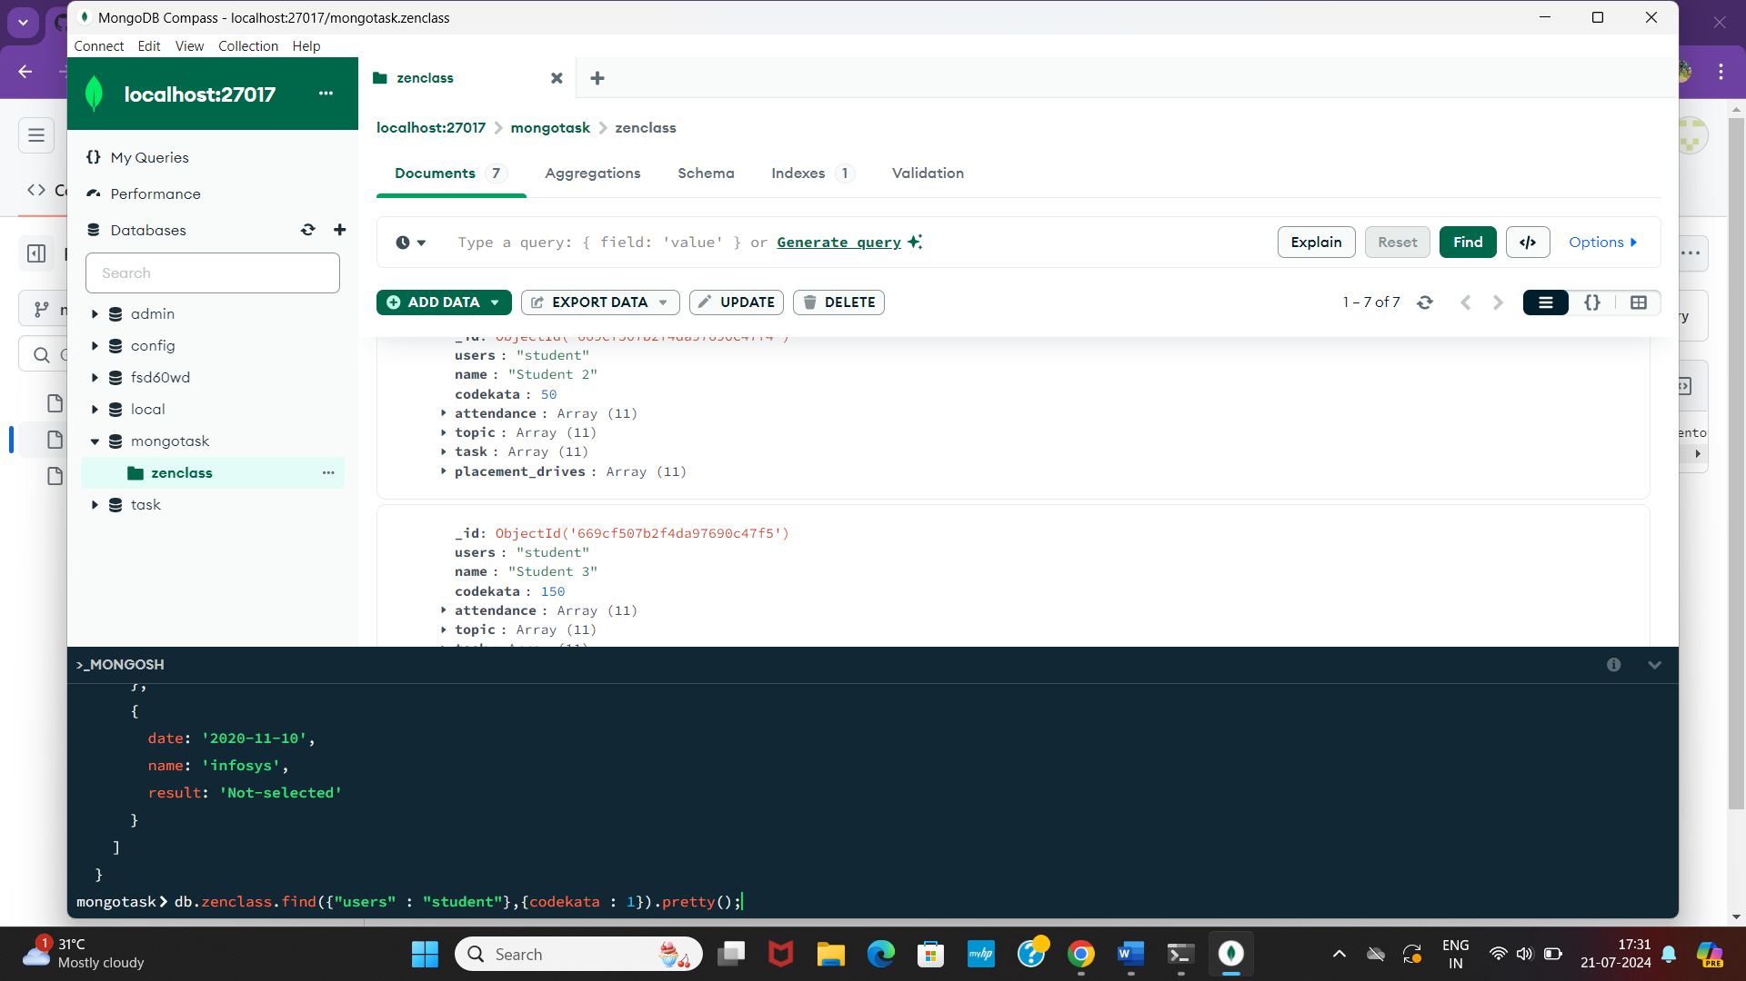 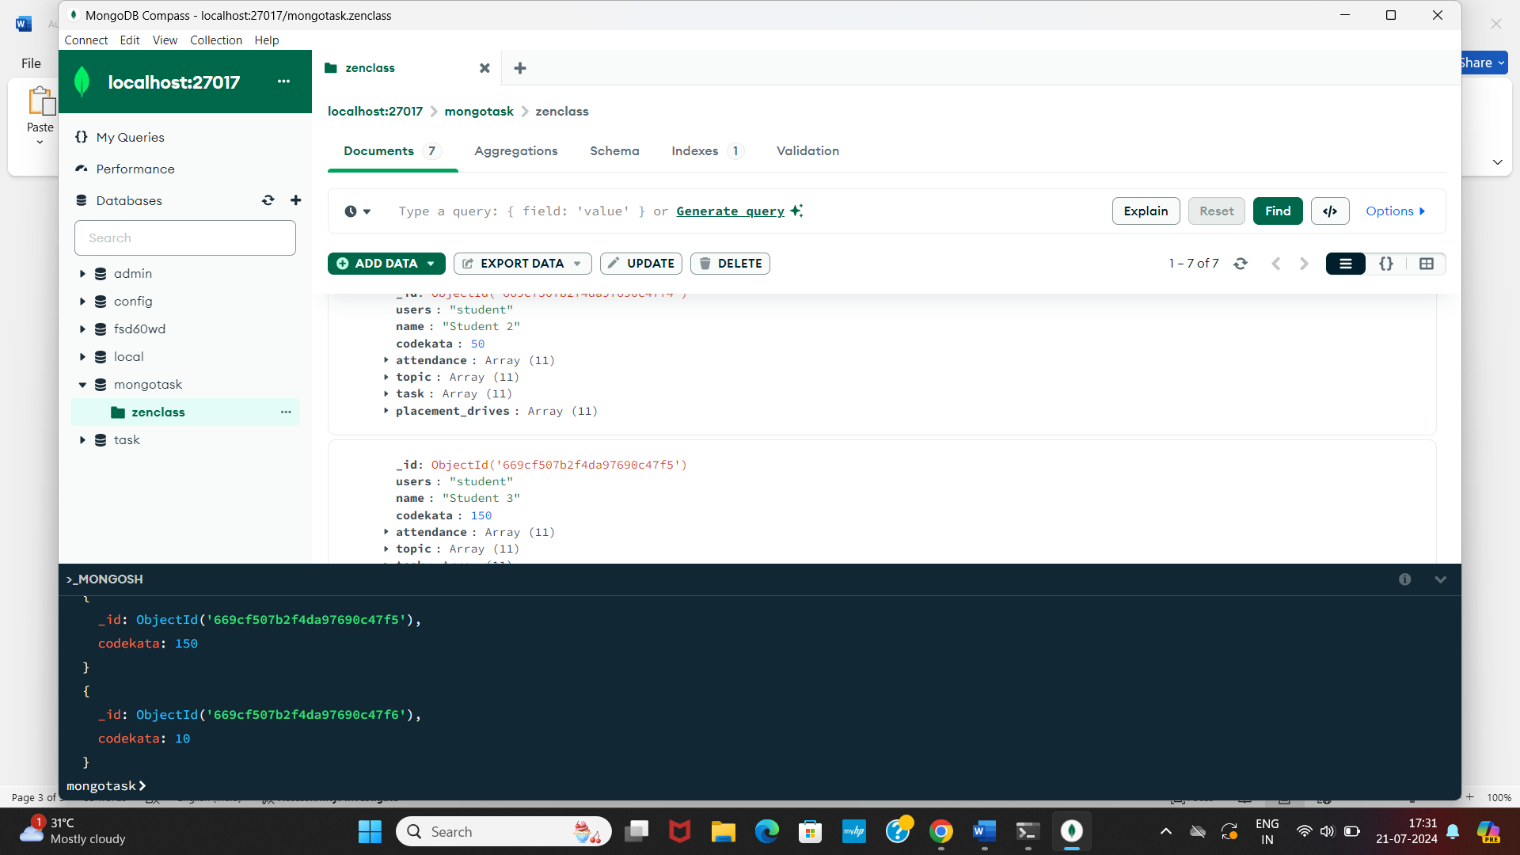

**6.Find the number of users who are absent and task is not submitted between 15-oct-2020 and 31-oct-2020**

