SNAPSHOTS:

Database is created through C# using Code First Approach no need to create db through ssms

DeptMaster Table is overriding using seed method

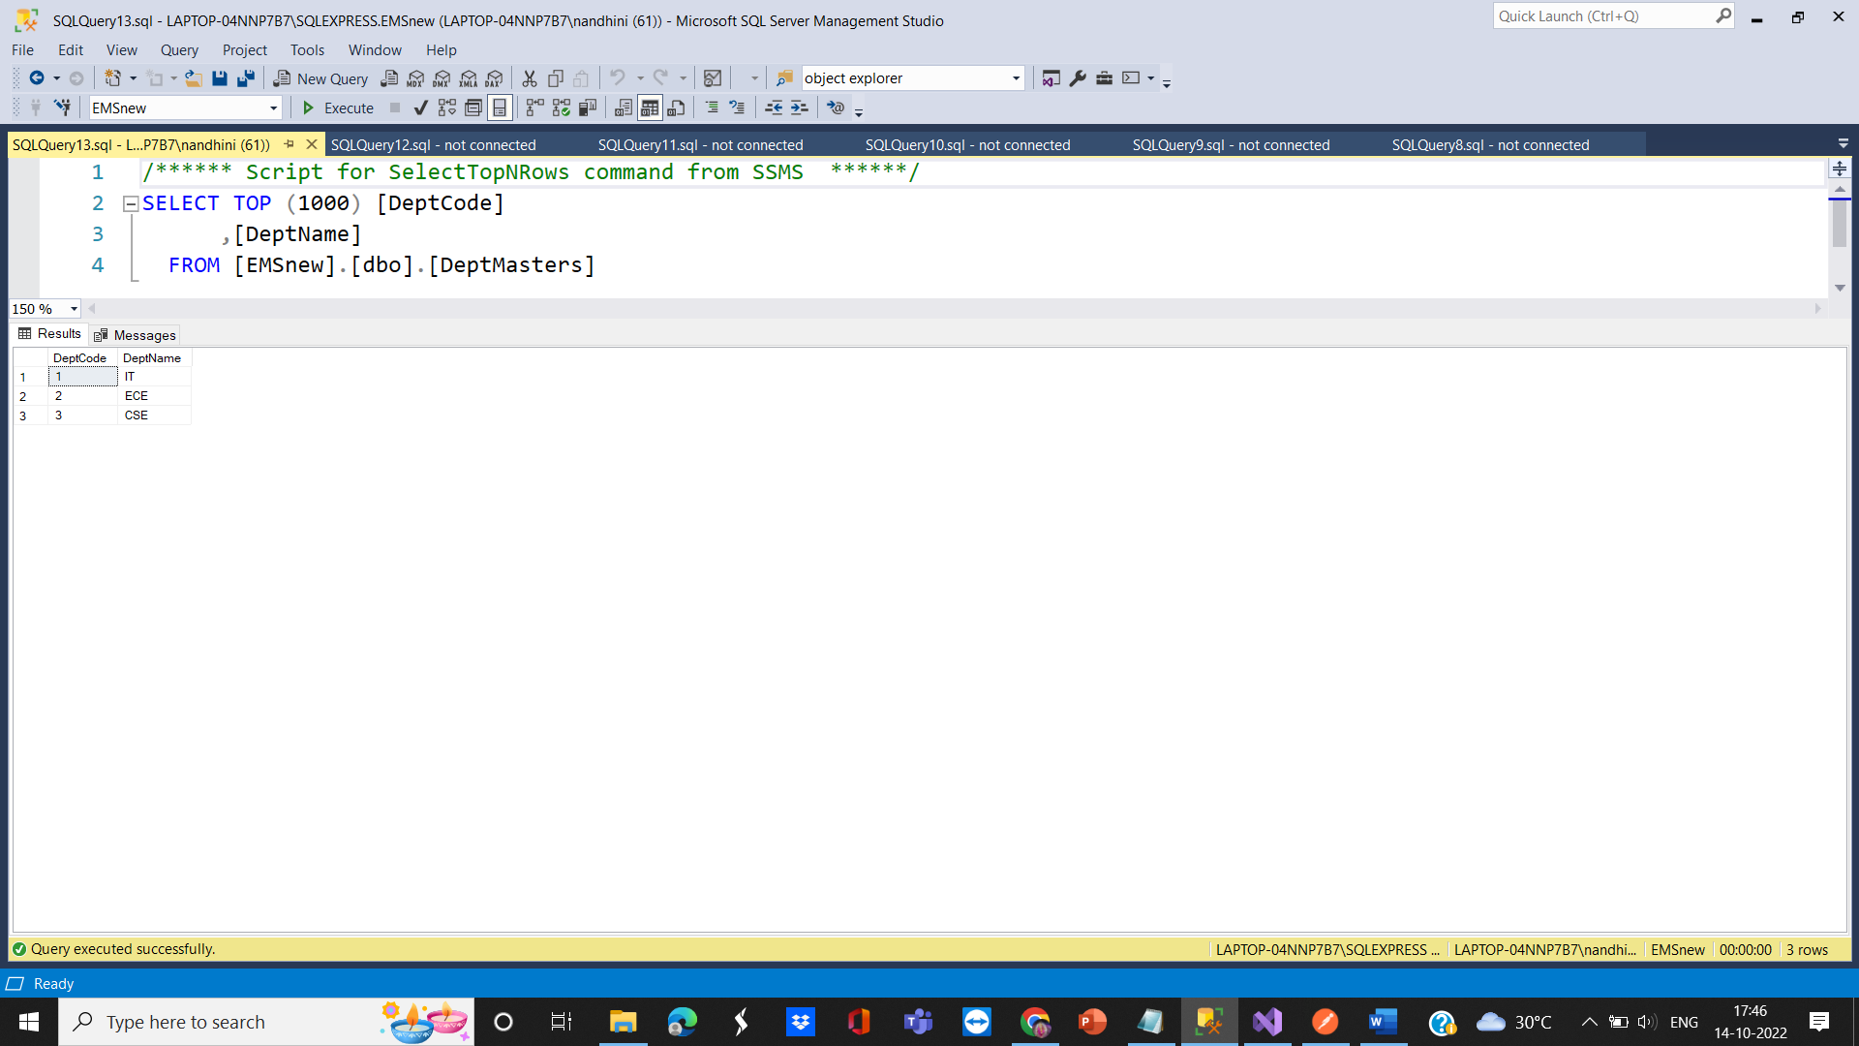

EmpProfile Table

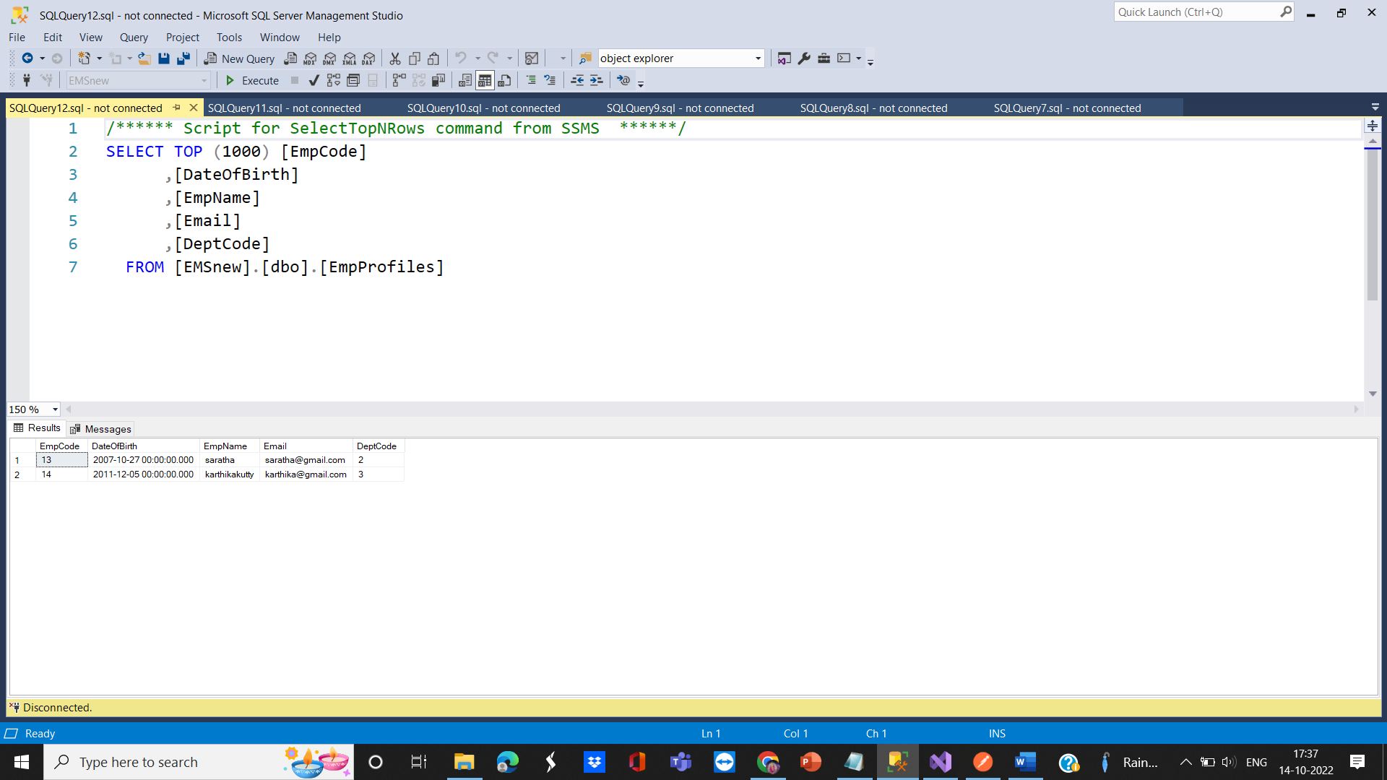

I am using web api testing tool – Postman

GET – https://localhost:44363//Getallemps

GERTBYID – https://localhost:44363//GetEmpbyid/13

PUT – https://localhost:44363//UpdateEmps/14

POST – https://localhost:44363//AddEmps

DELETE – <https://localhost:44363//DeleteEmps/12>

GETALL

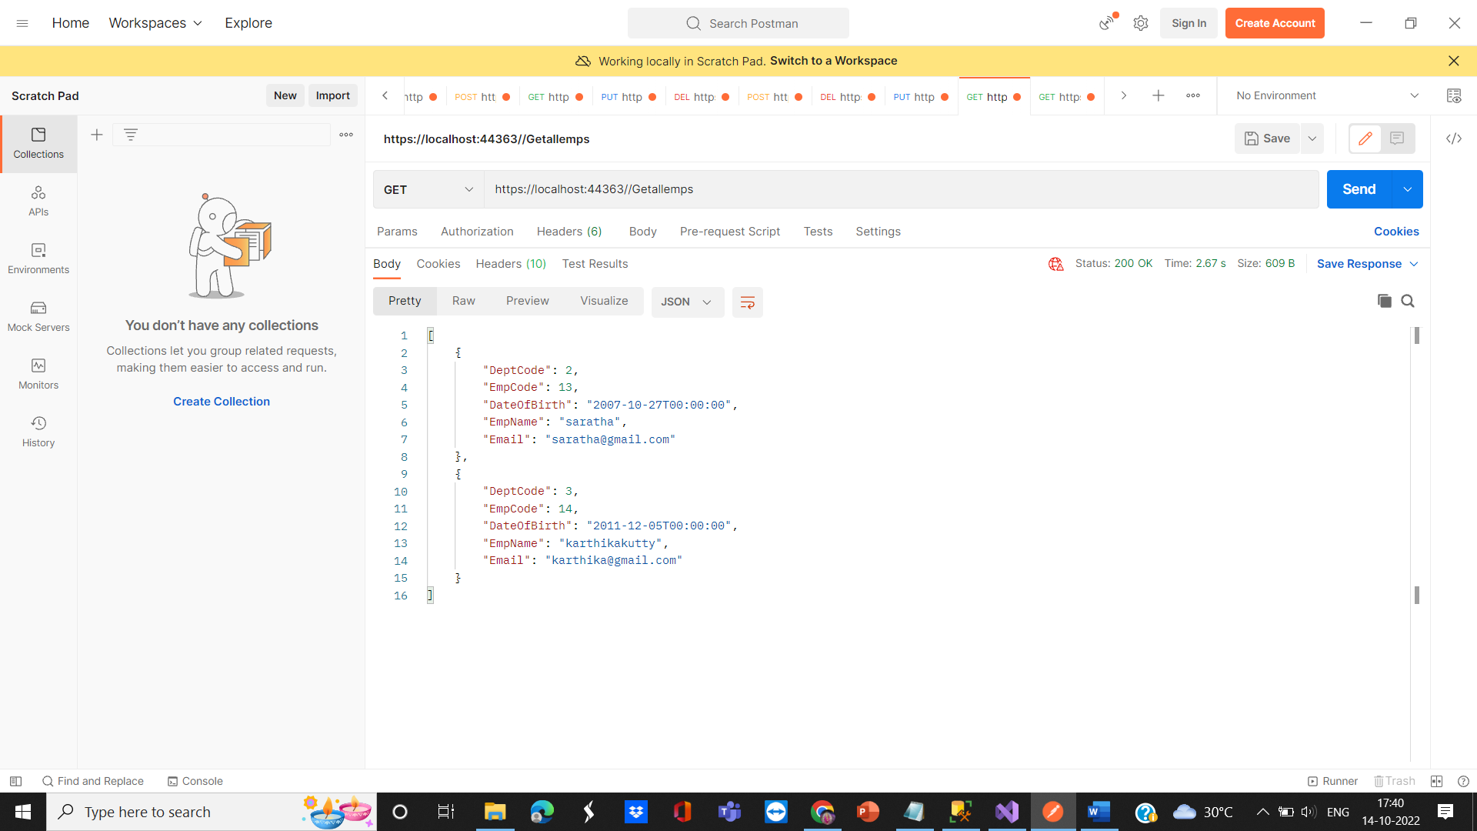

GETBYID

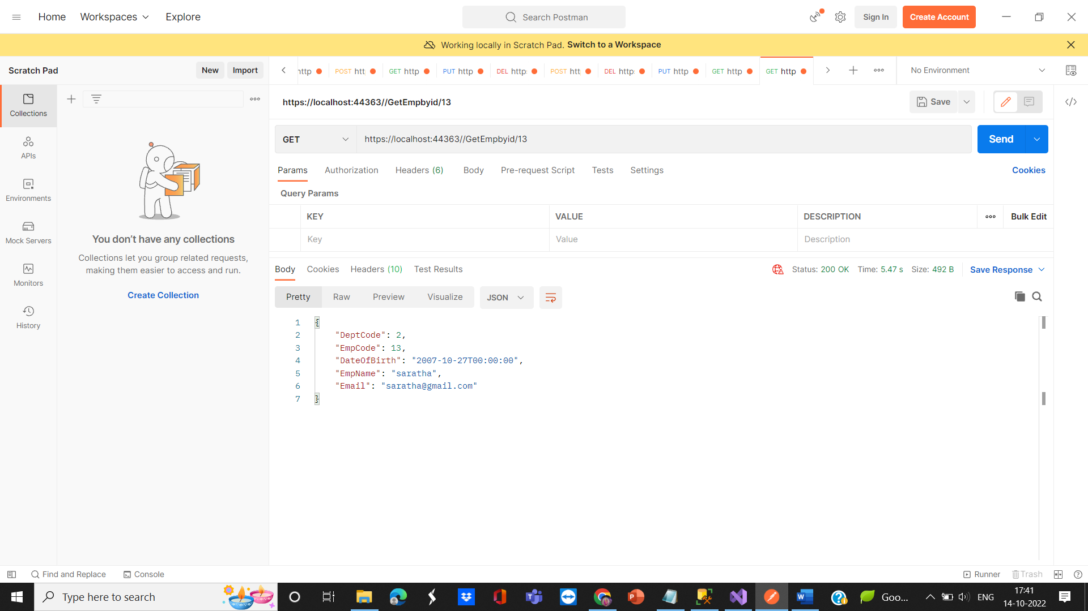

POST - ADD A EMPLOYEE

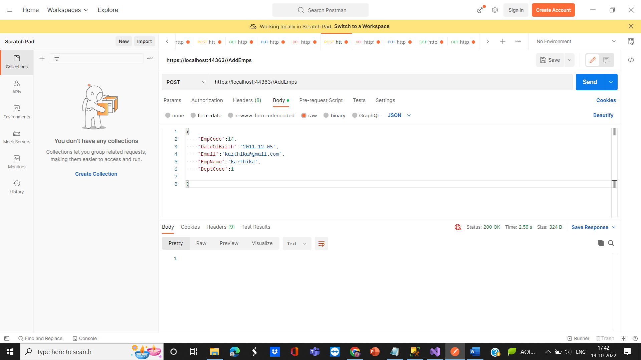

PUT – UPDATE

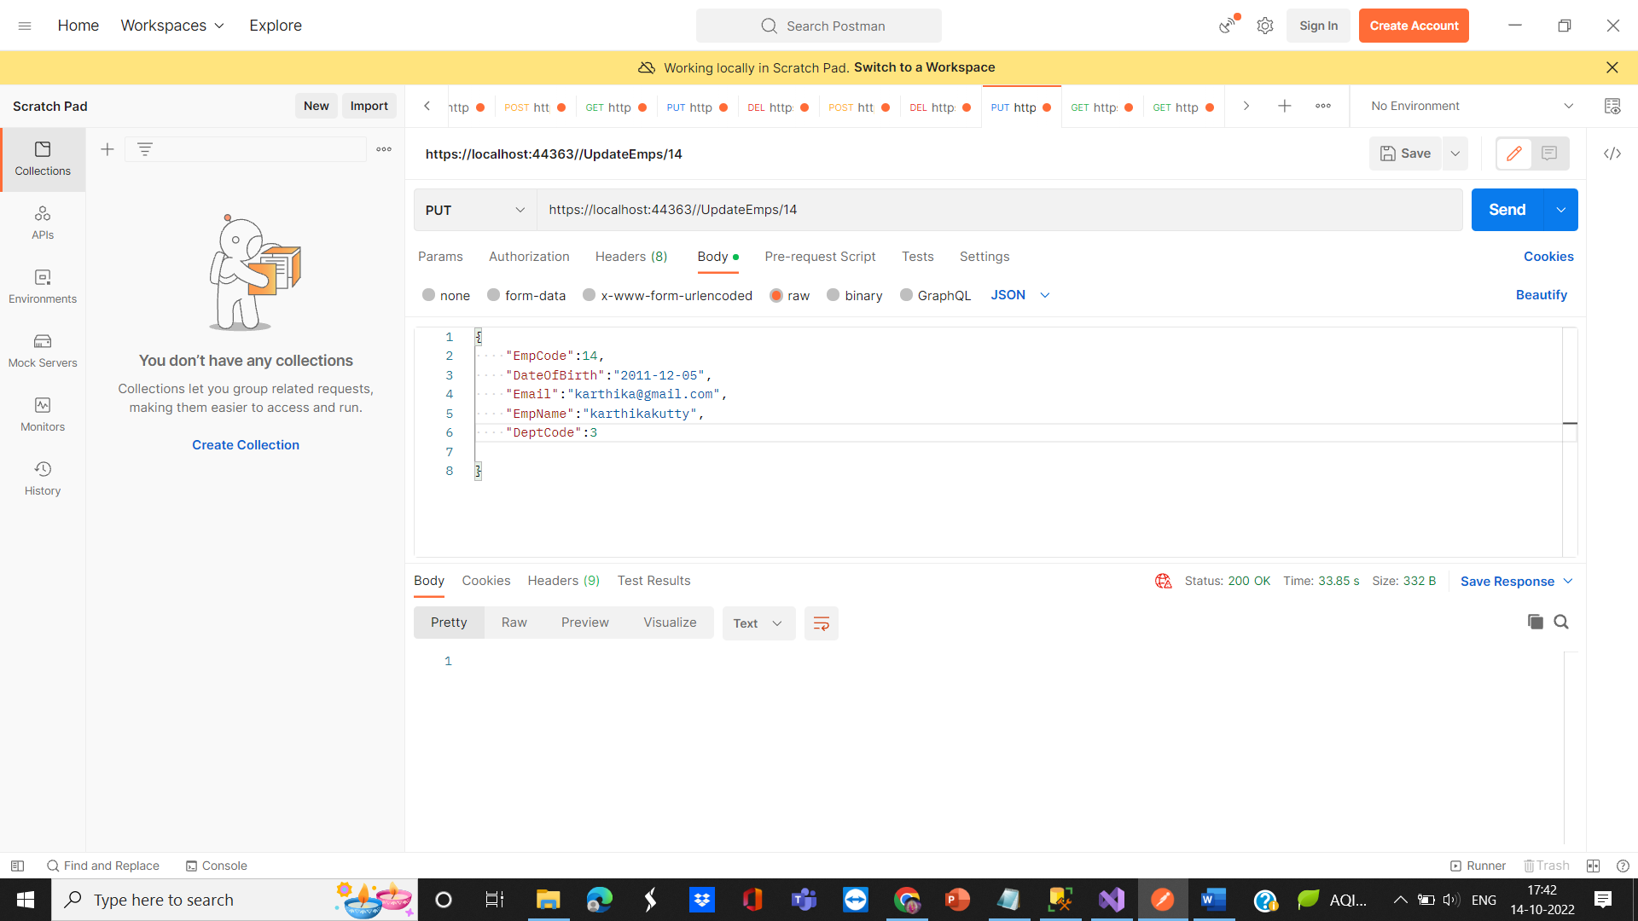

DELETE –

