Screenshots:

1. Docker Desktop output after creating MVC application with docker support

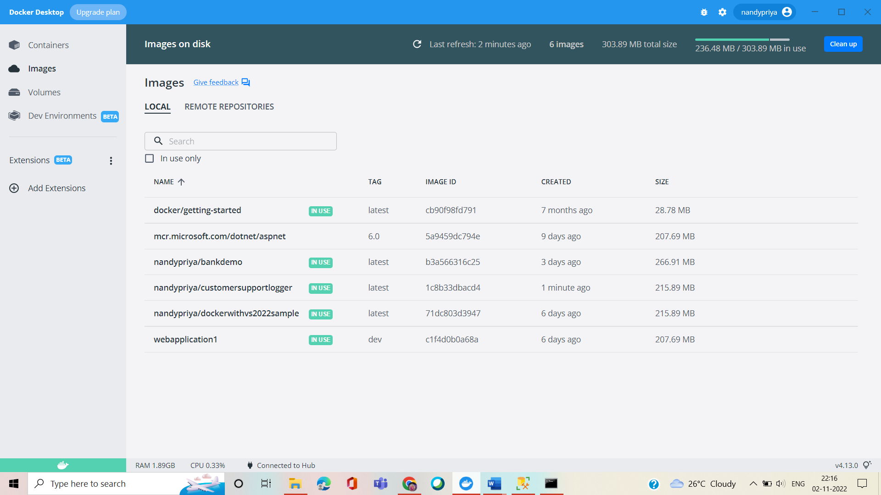

1. After creating SQLServer database on Azure

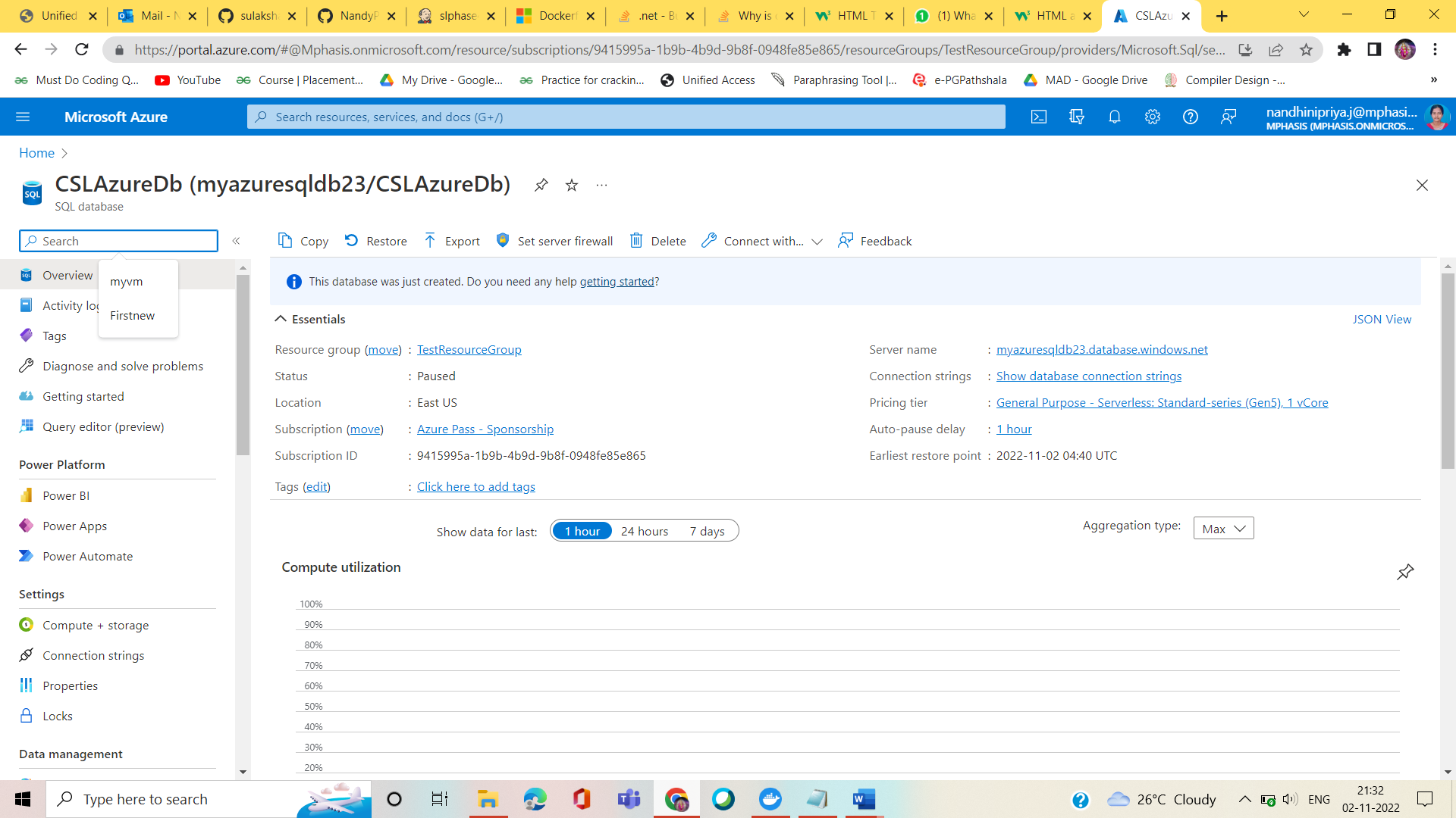

1. After testing all test cases

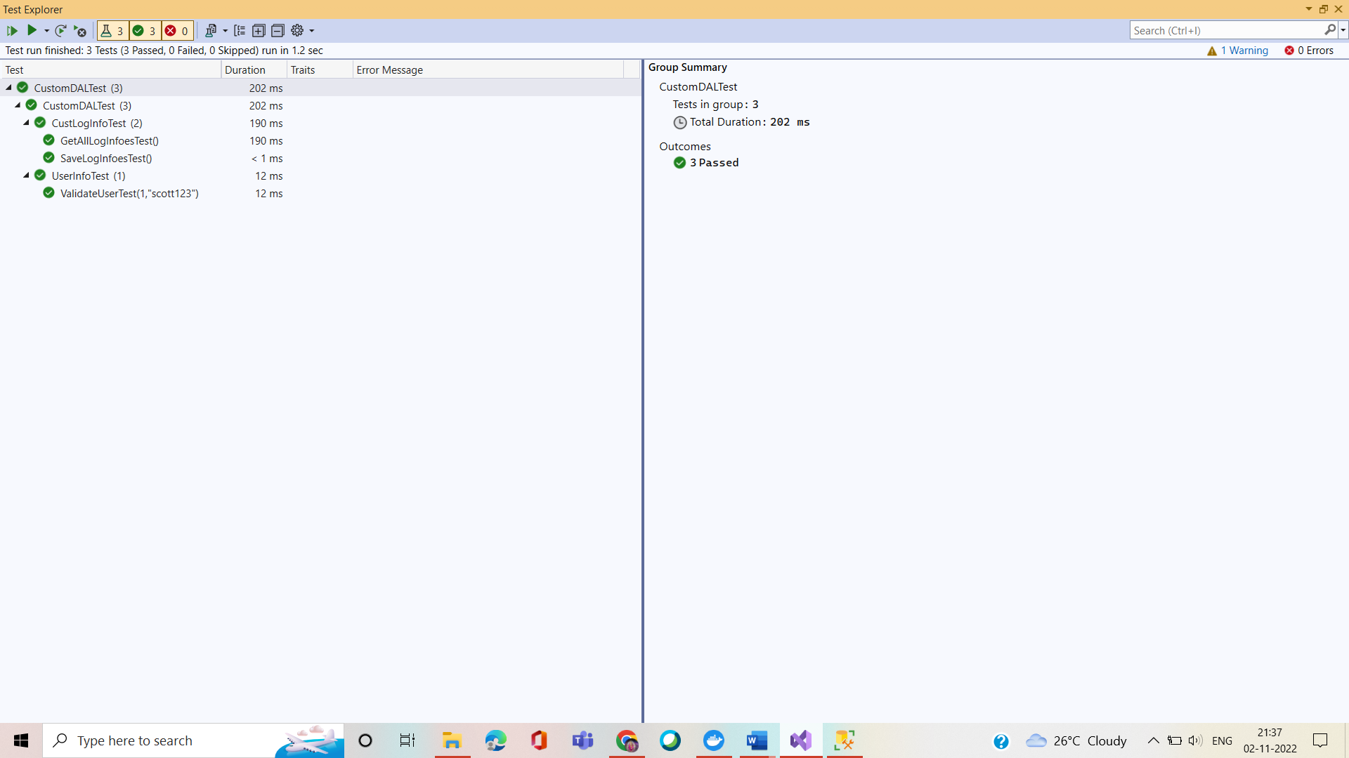

4. After executing MVC application

a. Customer executive login

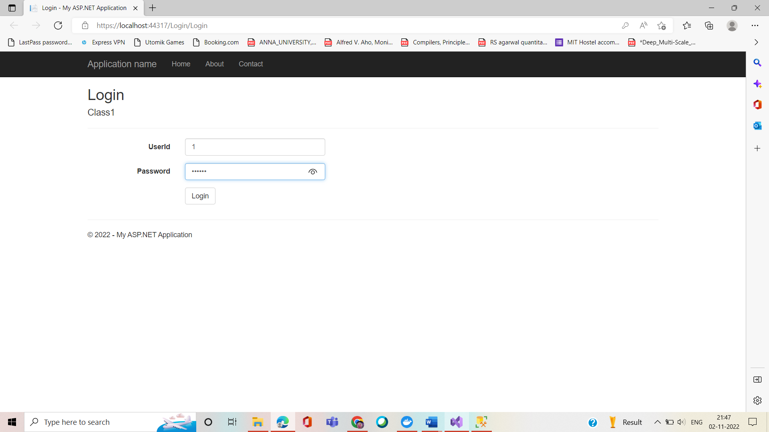

b. After saving log complaint information

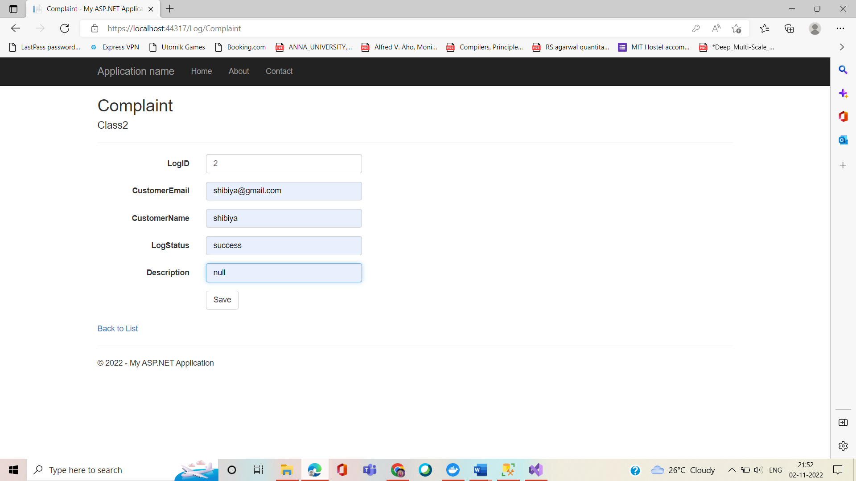

c. Verifying results into the database by connecting to SQL Server Management Studio (SSMS)

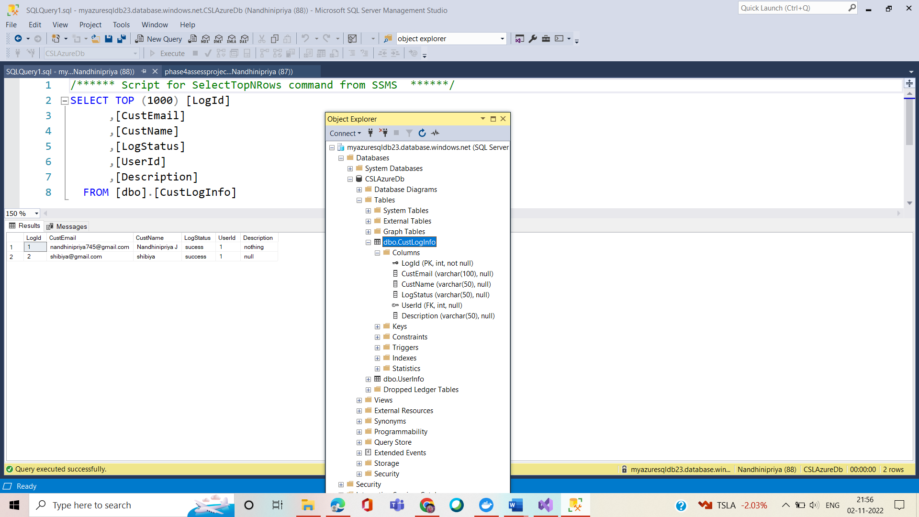

1. After successfully building a project in Jenkins

