ALGORITHM OF THE PROJECT:

**Step1:** Create a sample text file in Notepad. Follow these steps:

(i)Paste the student details text in Notepad.

(ii)Save the file as p1.txt.

**Step2:** Start Microsoft Visual Studio.

**Step 3: On the File menu, point to New, and then select Project.**

**Step 4:** Select **Visual C# Projects** under **Project Types**, and then select **Console Application** under **Templates**.

**Step 5:** Add the following code at the beginning of the Program.cs file:

**Step 6:** using.System.IO;

**Step 7:** Add the following code to the Main method:

public string Name;

public int std;

public List<Program> ReadUser()

{

List<Program> lstUser;

string[] content1 = File.ReadAllLines("C:\\Users\\narmatha\\Documents\\studentdetails1.txt");

if (content1 != null)

{

string[] s1;

lstUser = new List<Program>();

for (int i = 0; i < content1.GetLength(0); i++)

{

s1 = Regex.Split(content1[i], ",");

//need some validation

if (s1 != null && s1.GetLength(0) > 1)

{

Program obj = new Program();

obj.Name = s1[0];

int.TryParse(s1[1], out obj.std);

lstUser.Add(obj);

}

}

Console.WriteLine("Sorting based on names in a text file:");

Console.WriteLine("-------------------------------------------");

foreach (var i in lstUser.OrderBy(o => o.Name).ToList())

{

Console.WriteLine("Name:" + i.Name +" "+ "Std:" + i.std);

}

Console.WriteLine("---------------------------------------");

}

else

{

Console.WriteLine("Empty!!");

}

return null;

}

public void search11()

{

var con = File.ReadAllLines("C:\\Users\\narmatha\\Documents\\studentdetails1.txt");

Console.WriteLine("Enter the name already in txt file so that u can search");

string fu = Console.ReadLine();

foreach (string item in con)

{

if (item.Contains(fu))

{

Console.WriteLine(item + " " + "is found");

}

}

}

**Step 8:** Sort the data using name and regex function. Split by (,) and sort the names, also search the names using contains method

**Step 9:** On the **Debug** menu, select **Start** to compile and to run the application. Press ENTER to close the **Console** window. The **Console** window displays the contents of the studentdetails1.txt file

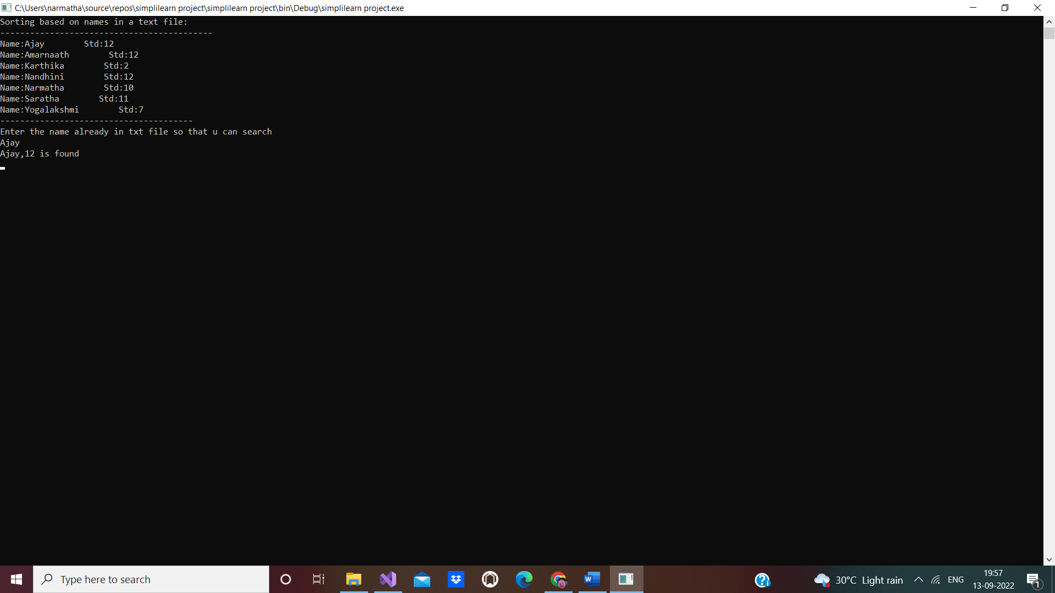

**Studentdetails1.txt:**

