**Retrieve Student Data from a Text File with the Option of Sorting and Searching.**

**Snapshots:**

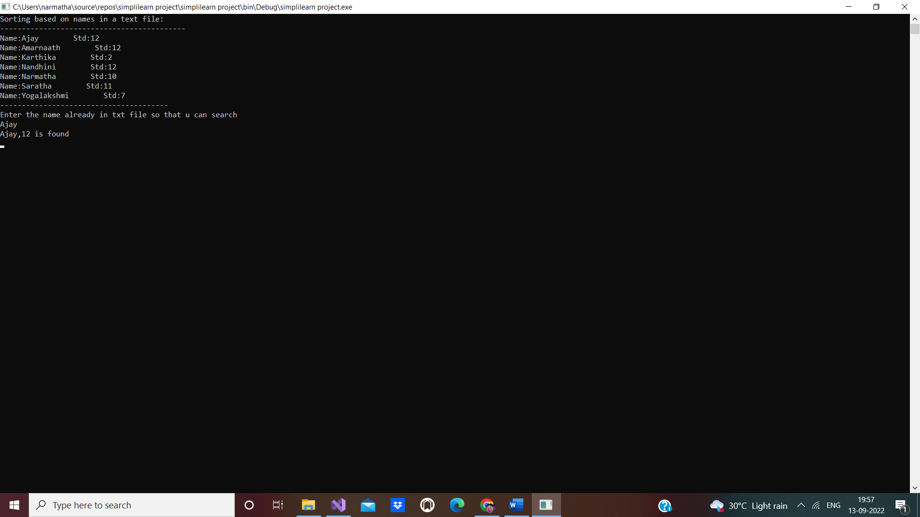

**Studentdetails1.txt:**

