CHAPTER 1
INTRODUCTION
1.1 Project Description
The Cherry Hospital Management System Web Application is a comprehensive digital solution designed to optimize hospital operations and patient care. It centralizes patient data, appointments, and supporting Hospital Staffs and Doctors in managing records, appointments, prescriptions, and reporting, while enabling patients to conveniently book and manage appointments online. The system aims to establish an efficient, secure, and patient-centric healthcare environment.
1.2 Motivation
The motivation for the Cherry Hospital Management System is from the need to overcome traditional challenges such as manual inefficiencies, poor patient experiences due to fragmented information, and data security risks. The system aims to improve these areas by centralizing data, streamlining processes, and enhancing overall patient-provider interactions.
1.3 Objectives
The primary objectives of the Cherry Hospital Management System are:
  - Develop a secure, efficient, and user-friendly web application for hospital operations and patient record management.
  - Enable Hospital Staff and Doctors to securely manage patient records.
  - Provide tools for Hospital Staff and Doctors to efficiently manage appointment schedules and prescriptions.
  - Allow Patients secure online appointment booking and viewing of their appointment details.
  - Ensure high data accuracy and security for patient health information.
  - Provide an intuitive and responsive user interface.
  - Implement robust authentication and authorization for staff, doctors and patient roles.

1.4 Case Scenario of the System
A Patient logs into their portal to manage healthcare interactions. They can easily book new appointments by selecting a doctor, date, and time. The system confirms the booking. Patients can also view existing and past appointments and access a summary of their basic medical history, staying informed about their health records.
1.5 System Advantages
The Cherry Hospital Management System offers significant advantages:
- Enhanced Efficiency: Automates tasks, reducing workload and errors.
- Improved Patient Care: Instant access to history for informed decisions; convenient online services.
- Increased Data Accuracy & Security: Centralized, encrypted data with robust access controls ensures privacy and integrity.
- Better Resource Management: Optimizes scheduling and hospital capacity.
- Reduced Paperwork & Environmental Impact: Promotes a digital, eco-friendly operation.
- Streamlined Communication: Automated reminders and announcements improve patient engagement.
1.6 Software Requirements
The system is implemented using this software requirements:
- Operating System: Windows 11
- Database Management System: Oracle 11g
- Programming Language: HTML, CSS, JavaScript, J2EE
- Web Server: Apache Tomcat Server 9
1.7 Hardware Requirements
This system is implemented using this hardware requirements:
- Processor: AMD Ryzen 5
- RAM: 8 GB

CHAPTER 2

SYSTEM DESIGN

2.1 Class Diagram
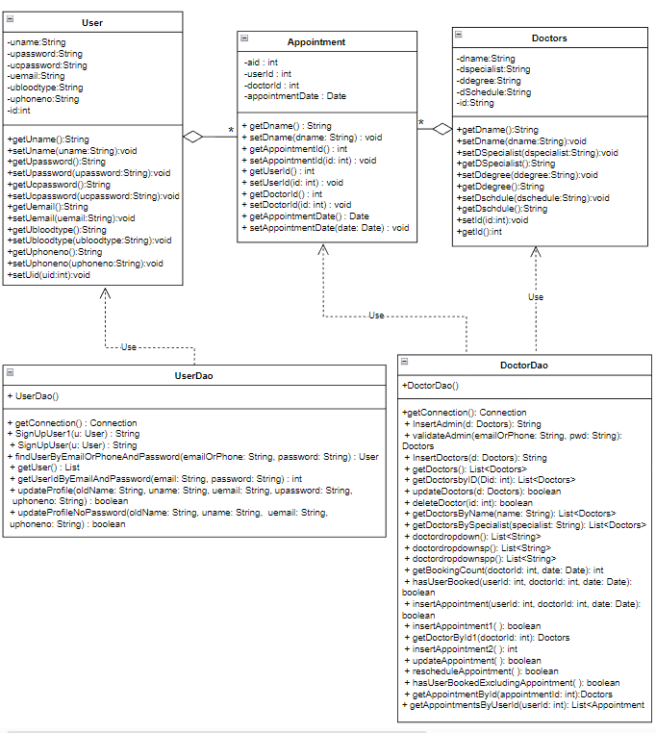

Figure : 2.1.1 Class Diagram for Cherry Hospital Management System

The class diagram for the Cherry Hospital Management System illustrates the system’s main classes, their attributes, methods, and relationships. The key classes include User, Receptionist, Doctor, and Appointment. The User class manages patient information and login credentials, while the Doctor class stores details such as name, specialty, and availability. The Appointment class handles the booking process, linking users and doctors and enforcing constraints like the maximum number of appointments per doctor. Associations and dependencies between these classes define how the system’s components interact and maintain data consistency. Notifications to users, such as booking confirmations or alerts, are managed externally through servlets rather than as a separate class.

2.2 Sequence Diagram
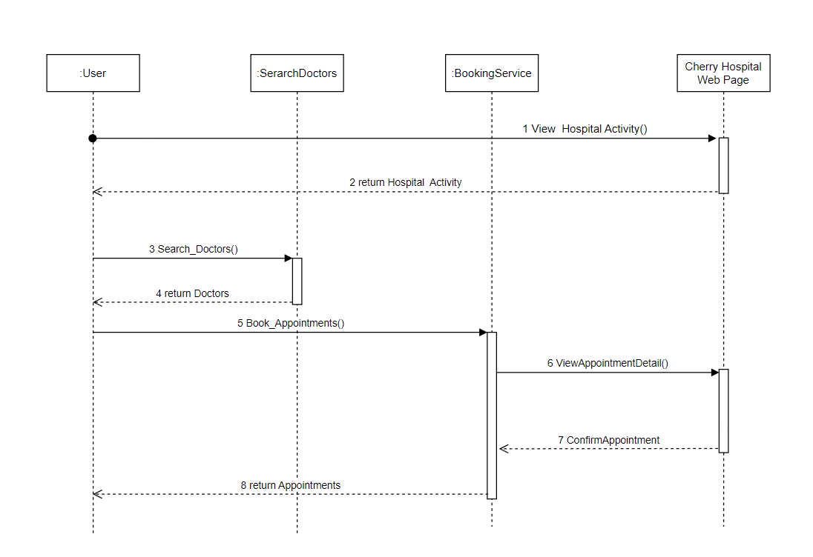

Figure : 2.2.1 Sequence Diagram for Booking an appointment

The sequence diagram for the Cherry Hospital Management System illustrates how users interact with the system to book appointments with doctors. Users first log in to the system, search for doctors by name or specialty, and select a suitable doctor and time slot. The system checks the database for existing bookings and doctor availability, then confirms the appointment or notifies the user if the doctor is fully booked or the user has already booked. This sequence ensures smooth coordination between the user, the system, and the database, providing a clear flow for managing appointments efficiently.

2.3 Collaboration Diagram
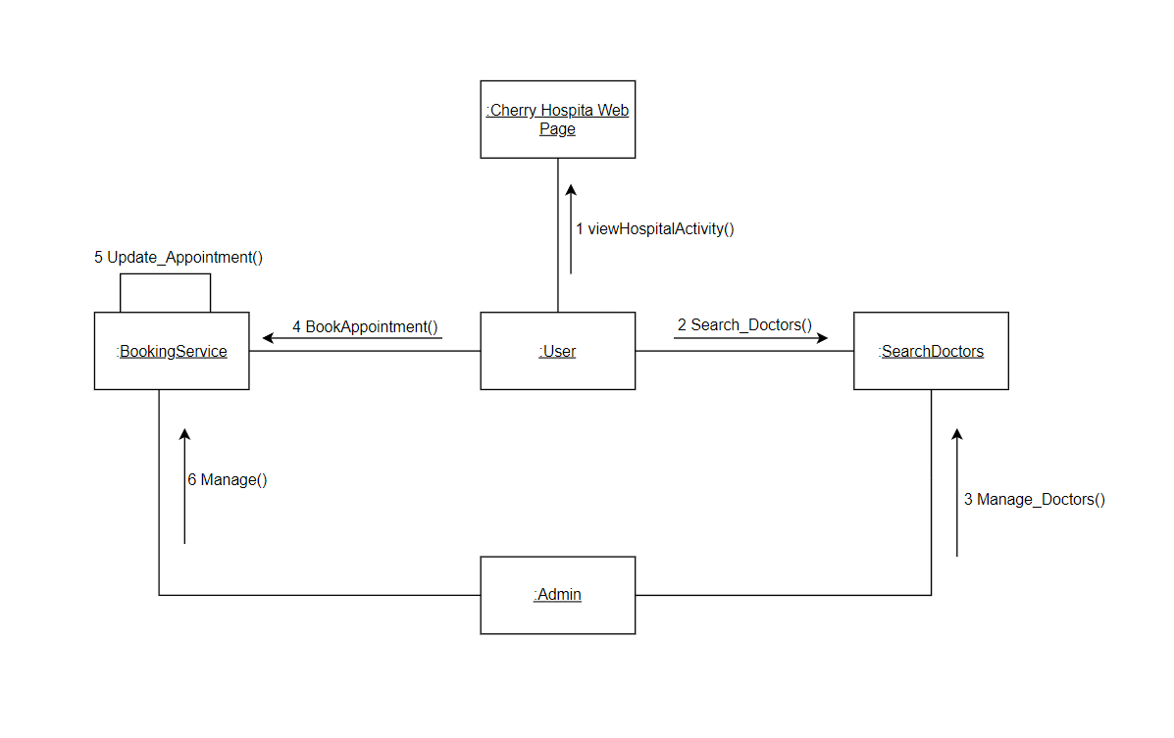

Figure : 2.3.1 Collaboration Diagram for Cherry Hospital Management System

The collaboration diagram for the Cherry Hospital Management System illustrates interactions between the main components: users log in, search for doctors, and book appointments. The system communicates with the database to verify user credentials, check doctor availability, and record appointments. Conditional responses, such as successful bookings, fully booked alerts, or duplicate booking warnings, are handled through the system’s interactions with users. This diagram highlights how users, the system, and the database collaborate to ensure efficient appointment management and smooth operation of the hospital.

2.4 Use Case Diagram
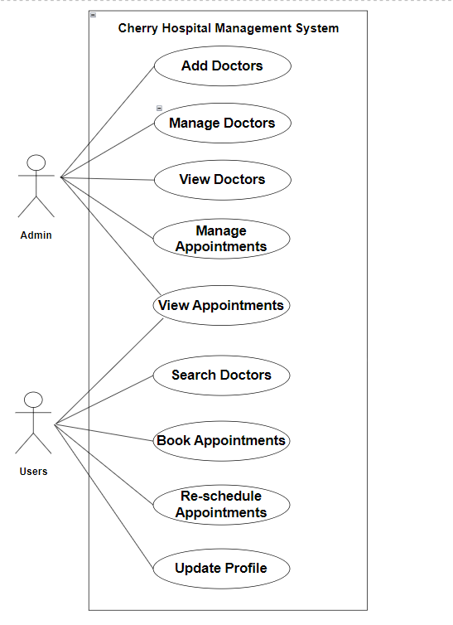

Figure : 2.4.1 Use Case Diagram for Cherry Hospital Management System

In this diagram, users first log in, search for doctors, and select a suitable appointment slot. The system checks the database for existing bookings and doctor availability, then confirms the appointment or notifies the user if the doctor is fully booked or already booked. Receptionists or administrative staff can manage doctor schedules and update availability. The database handles storing user, doctor, and appointment information, ensuring accurate and consistent records. This interaction ensures smooth coordination between users, the system, and staff for efficient hospital operations.

2.5 Mapping Objects Classes to Tables
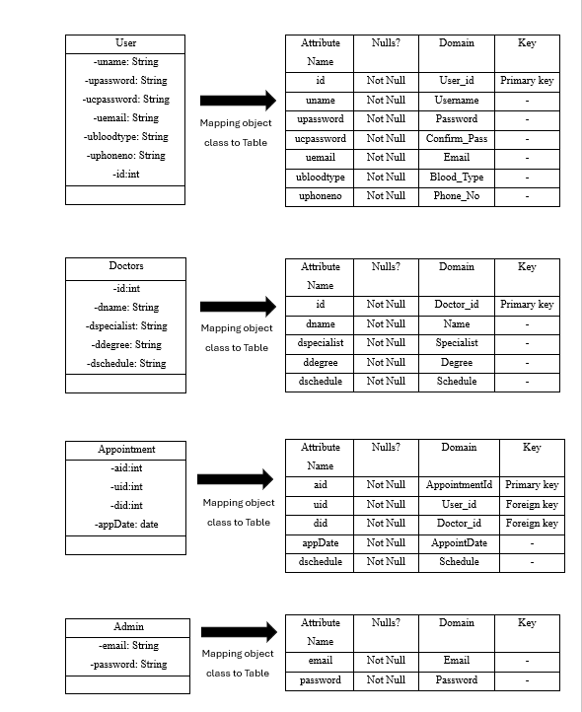

Chapter 3
Implementation

3.1 Code Implementation Using Java

//User
package SignUp;  import java.io.Serializable;  public class User implements Serializable{  private static final long serialVersionUID = 1L;  String uname;  int uid;  String upassword;  String ucpassword;  String uemail;  String ubloodtype;  String uphoneno;  public String getUname() {  return uname;  }  public void setUname(String uname) {  this.uname = uname;  }  public String getUpassword() {  return upassword;  }  public void setUpassword(String upassword) {  this.upassword = upassword;  }  public String getUcpassword() {  return ucpassword;  }  Public void setUcpassword(String ucpassword) {  this.ucpassword = ucpassword;  }  //Doctors  package Insert;  import java.io.Serializable;  import java.sql.Date;  public class Doctors implements Serializable {  private int id;  private int did;  private int aid;  private String dname;  private String dspecialist;  private String ddegree;  private String dschedule;  private String aemail;  private String apassword;  private Date appointmentDate;  private int tempDoctorId;  private int tempAppointmentId;  private java.sql.Date tempAppointmentDate;  public int getTempAppointmentId() {  return tempAppointmentId;  }  public void setTempAppointmentId(int tempAppointmentId) {  this.tempAppointmentId = tempAppointmentId;  }  public int getTempDoctorId() {  return tempDoctorId;  }  public void setTempDoctorId(int tempDoctorId) {  this.tempDoctorId = tempDoctorId;  }  this.apassword = apassword;  }  public int getDid() {  return id;  }  public void setDid (int (did) {  this.id = did;  }  public String getDname() {  return dname;  }  public void setDspecialist(String dspecialist) {  this.dspecialist = dspecialist;  }  public String getDdegree() {  return ddegree;  }  public void setDdegree(String ddegree) {  this.ddegree = ddegree;  }  public String getDschedule() {  return dschedule;  }  public void setDschedule(String dschedule) {  this.dschedule = dschedule;  }  } | public String getUemail() {  return uemail;  }  public void setUemail (String uemail) {  this.uemail = uemail;  }  public String getUbloodtype() {  return ubloodtype;  }  public void setUbloodtype(String ubloodtype) {  this.ubloodtype = ubloodtype;  }  public String getUphoneno() {  return uphoneno;  }  public void setUphoneno(String uphoneno) {  this.uphoneno = uphoneno;  }  public static long getSerialversionuid() {  return serialVersionUID;  }  public int getUid() {  return uid;  }  public void setUid (int uid) {  this.uid = uid.  }  }  //Appointment  package Insert;  import java.sql.Date;  public class Appointment {  private int appointmentId; // rename from aid to appointmentId for clarity  private int userId;  private int doctorId;  private Date appointmentDate;  private String dname;  public String getDname() {  return dname;  }  public void setDname(String dname) {  this.dname = dname;  }  public int getAppointmentId() {  return appointmentId;  }  public void setAppointmentId(int appointmentId) {  this.appointmentId = appointmentId;  }  public int getUserId() {  return userId;  }  public void setUserId(int userId) {  this.userId = userId;  }  public int getDoctorId() {  return doctorId;  }  public void setDoctorId(int doctorId) {  this.doctorId = doctorId;  }  public Date getAppointmentDate() {  return appointmentDate;  }  public void setAppointmentDate(Date appointmentDate) {  this.appointmentDate =appointmentDate;  }  }

