**ONLINE MUSIC SYSTEM - FOSTR**

**ER Diagram :**

1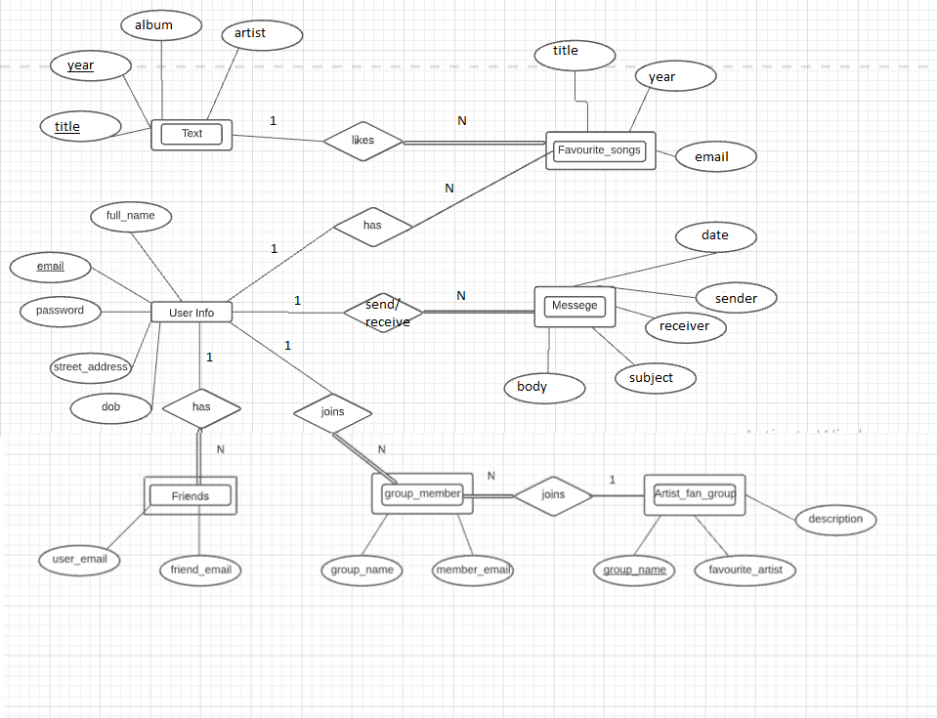

**Relational Schema (SQL CREATE TABLE)**

CREATE TABLE userinfo(

Full_name VARCHAR(30) NOT NULL,

email VARCHAR(45) NOT NULL,

password VARCHAR(15) NOT NULL,

street_addr VARCHAR(50) NOT NULL,

dob DATE NOT NULL,

PRIMARY KEY(email)

);

CREATE TABLE Songs(

title VARCHAR(20) NOT NULL,

year YEAR(4) NOT NULL,

album VARCHAR(20) NOT NULL,

artist VARCHAR(30) NOT NULL,

PRIMARY KEY(title, year)

);

CREATE TABLE Favourite_Songs(

title VARCHAR(20) NOT NULL,

year YEAR(4) NOT NULL,

email VARCHAR(45) NOT NULL,

CONSTRAINT fav_songs_FK1 FOREIGN KEY(title,year) REFERENCES Songs(title, year),

CONSTRAINT fav_songs_FK2 FOREIGN KEY(email) REFERENCES userinfo(email)

);

CREATE TABLE Friends(

user_email VARCHAR(45) NOT NULL,

friend_email VARCHAR(45) NOT NULL,

CONSTRAINT friend_FK FOREIGN KEY(friend_email) REFERENCES userinfo(email),

CONSTRAINT user_FK FOREIGN KEY(user_email) REFERENCES userinfo(email)

);

CREATE TABLE Artist_fan_group(

group_name VARCHAR(45) NOT NULL,

favourite_artist VARCHAR(45) NOT NULL,

description VARCHAR(45),

PRIMARY KEY(group_name)

);

CREATE TABLE Message(

Date_time DATETIME NOT NULL,

sender VARCHAR(45),

receiver VARCHAR(45),

subject VARCHAR(45) NOT NULL,

body VARCHAR(100) NOT NULL,

CONSTRAINT msg_FK1 FOREIGN KEY(sender) REFERENCES userinfo(email),

CONSTRAINT msg_FK2 FOREIGN KEY(receiver) REFERENCES userinfo(email)

);

CREATE TABLE group_members(

group_name VARCHAR(45) NOT NULL,

member_email VARCHAR(45) NOT NULL,

CONSTRAINT group_name_FK FOREIGN KEY(group_name) REFERENCES Artist_fan_group(group_name),

CONSTRAINT mem_email_FK FOREIGN KEY(member_email) REFERENCES userinfo(email)

);

**Web Interface**

* Web programming language used : **Python**
* Database used : **MySQL**
* Database connection is made using : **Flask**
* Front-end is made using : **HTML**, **CSS**

**Register :** New user has to create account using “Register”.

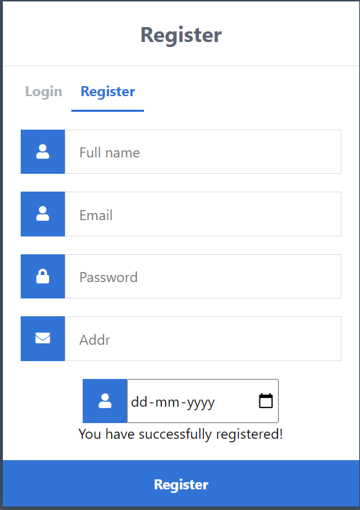 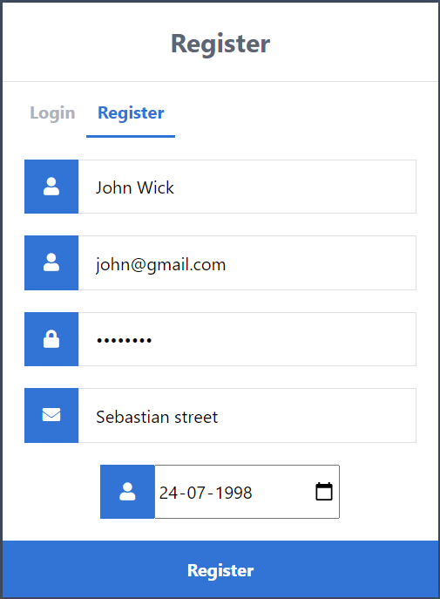

**Login :** Once the user is registered, user can login using email and password.

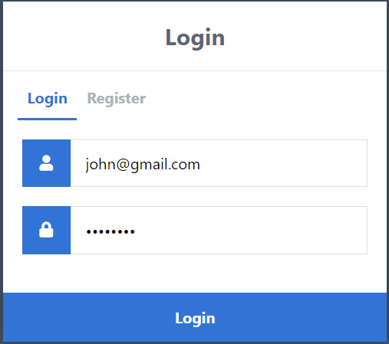

**Home screen :** Home screen consists of options for songs, friends, fan groups, messages etc.

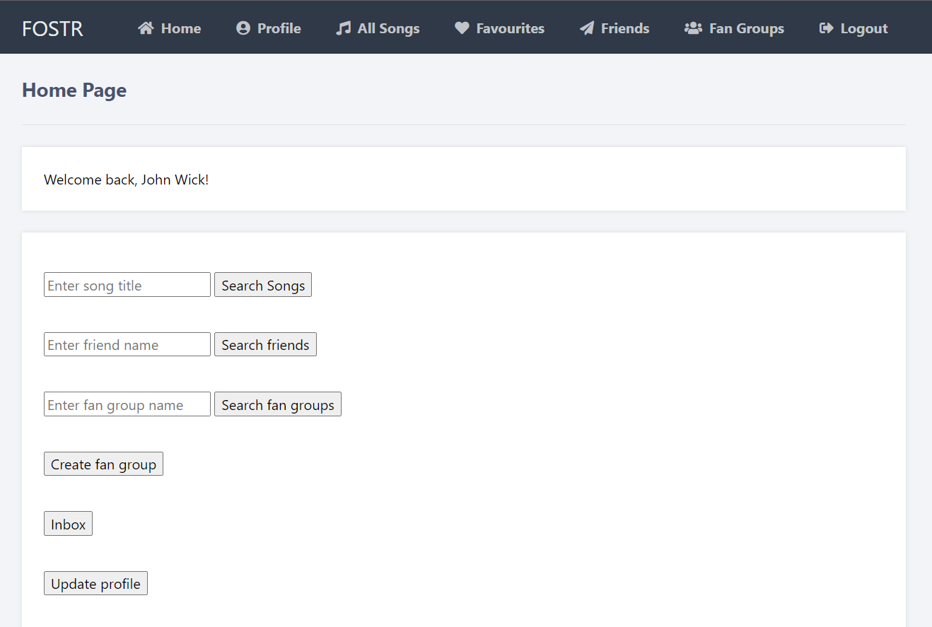

**Profile :** Profile tab contains user info.

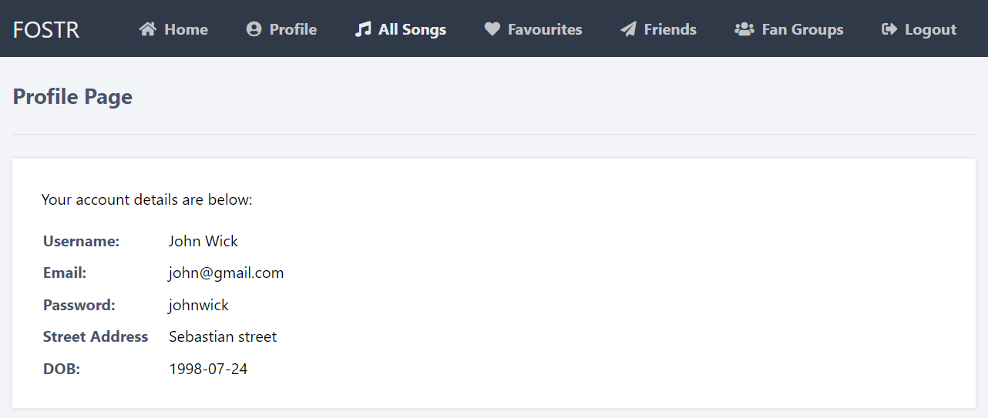

Similarly, other tabs are as follows :

**All Songs :** This tab shows all the songs in the songs table. Add button in the all songs list can be used to add the song to favourites.

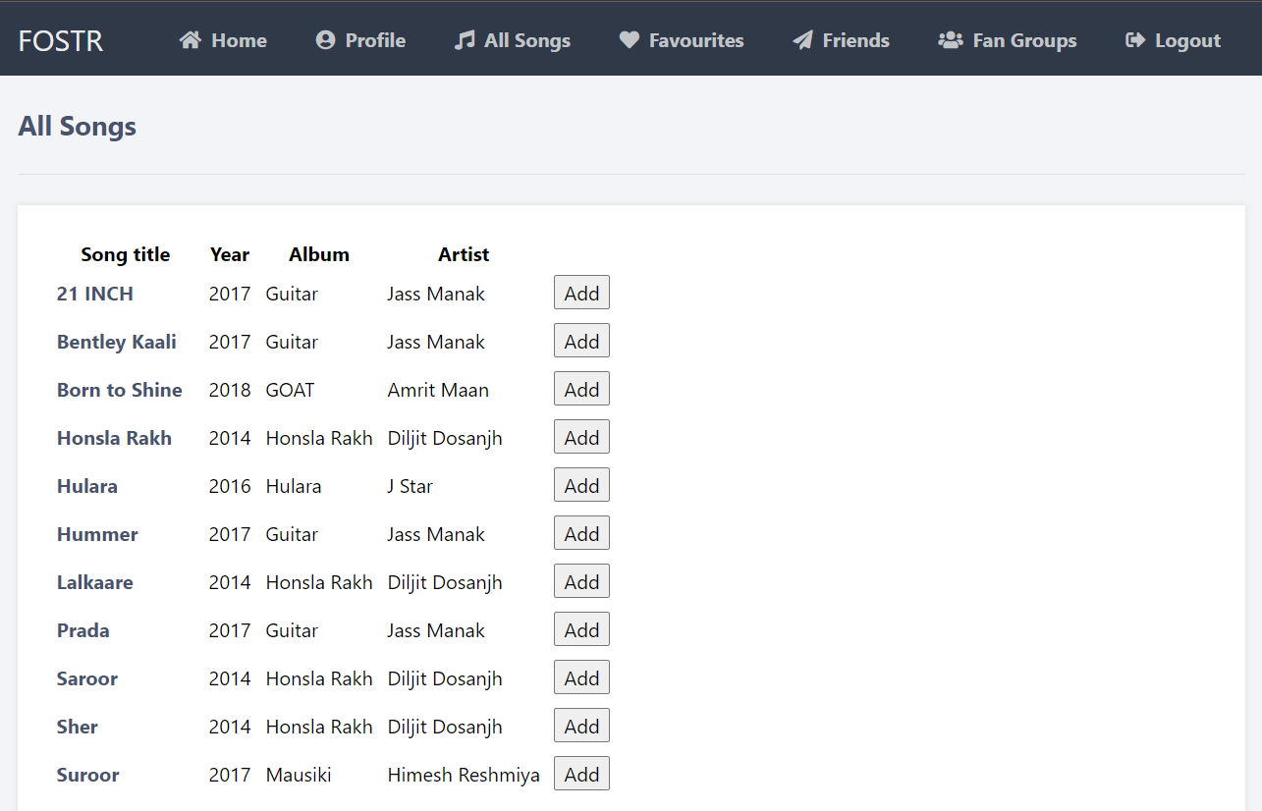

**Favourites :** This tab shows favourite songs of the user. Remove button in the favourite song list can be used to remove a song from favourites.

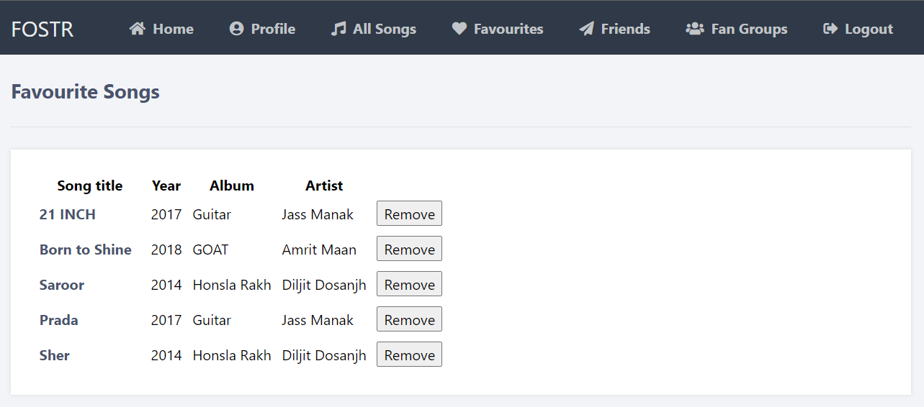

**Friends :** This tab show user’s friend list. Message button in this list is used to send message to a friend and remove button is for removing friend from the friend list.

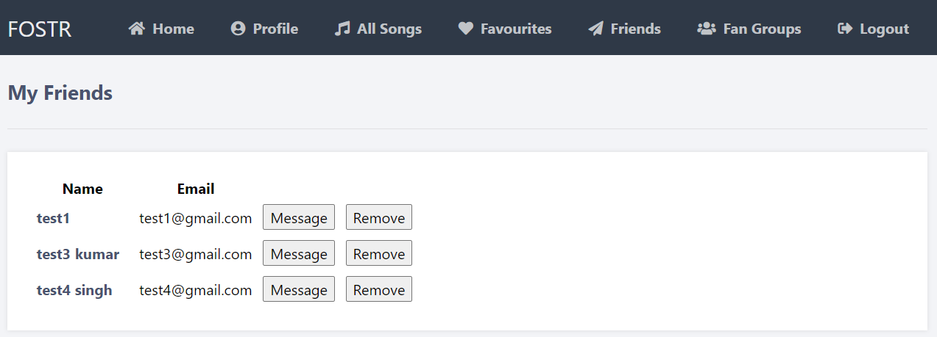

**Fan Groups :** This tab show the fan groups joined by the user. Message button is for sending message to each member in the fan group and exit button is for exiting from the fan group.

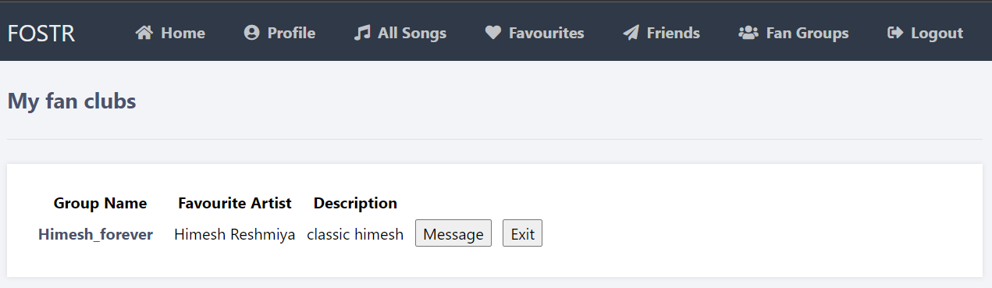

**Logout :** This tab is for logging out.

**Searching a song and adding to the favourites :**

In home tab, enter the keyword matching the title of the song in the text field and then press

“Search song” button.

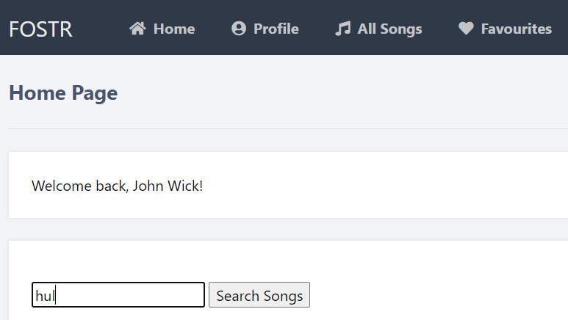

Songs whose title contains the keyword entered into the text field appear. Use the “Add” button to add the song to favourites.

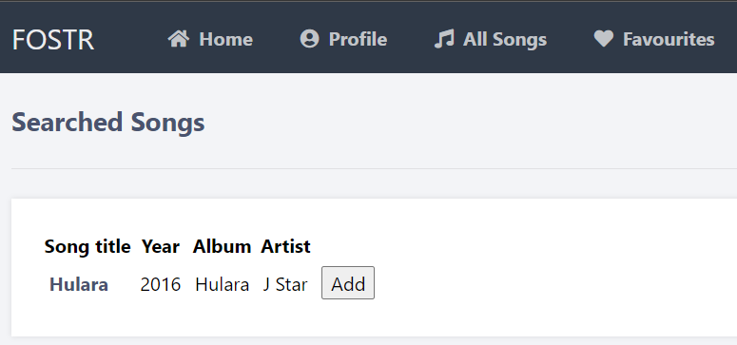

**Searching a friend and adding to the friend list :**

In home tab, enter the keyword matching the name of a friend in the text field and then press

“Search friends” button.

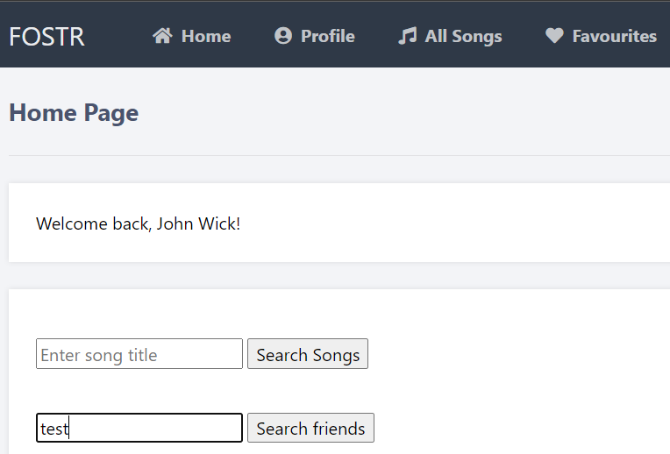

Users whose name contains the keyword entered into the text field appears. Use the “Add” button to add the user to friend list.

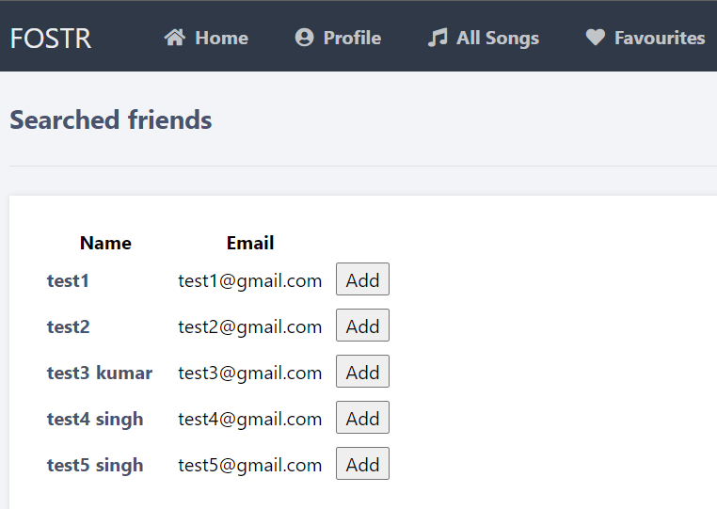

**Searching and joining a fan group :**

In home tab, enter the keyword matching the name of a fan group in the text field and then press “Search fan groups” button.

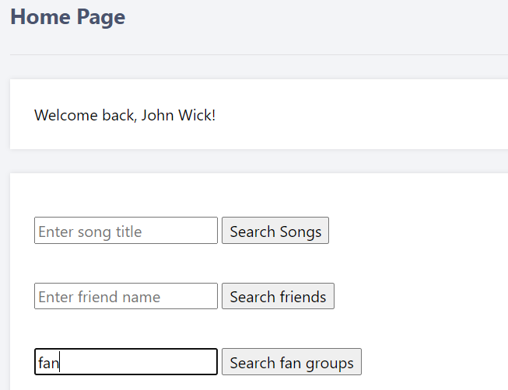

Fan groups whose name contains the keyword entered into the text field appears. Use the “Add” button to join the fan group.

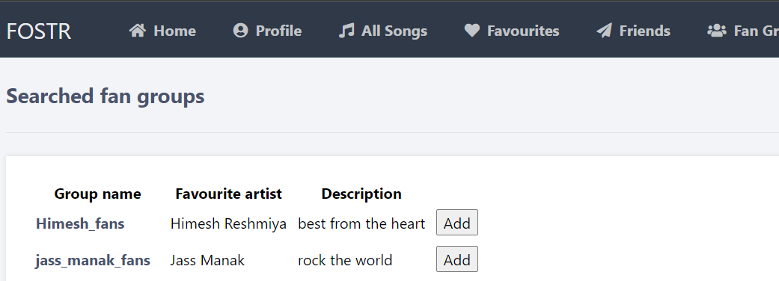

**Creating a new fan group :**

To create a new fan group use the “Create fan group” button.

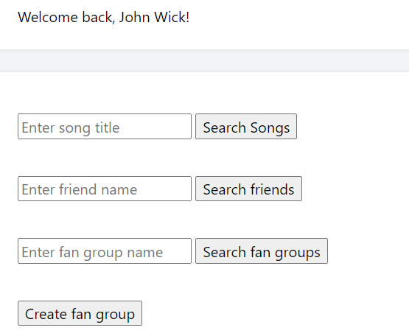

Enter the details in the form and press “Create” button.

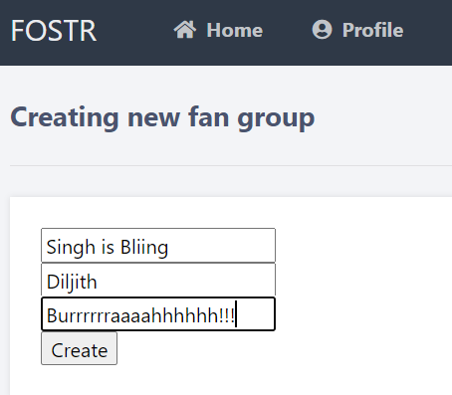

Check the joined fan group list.

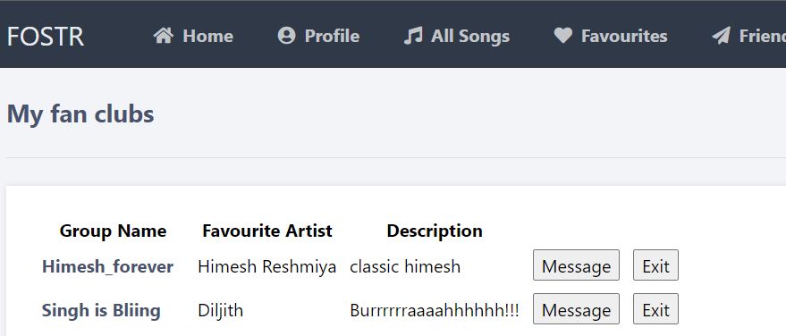

**Checking sent and received messages :**

In home page use the “Inbox” button the see all the messages sent and received.

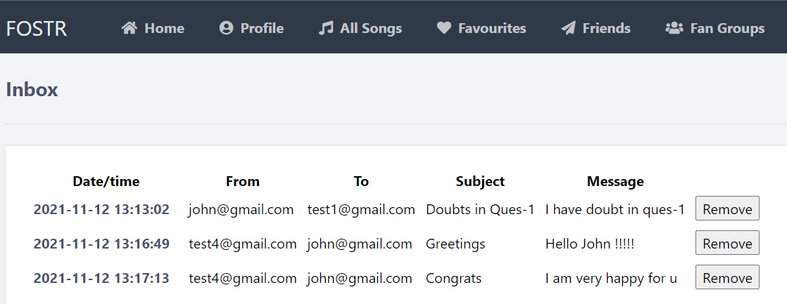

**Deleting messages from inbox :**

Use the “Remove” button against each message to delete a message from inbox.

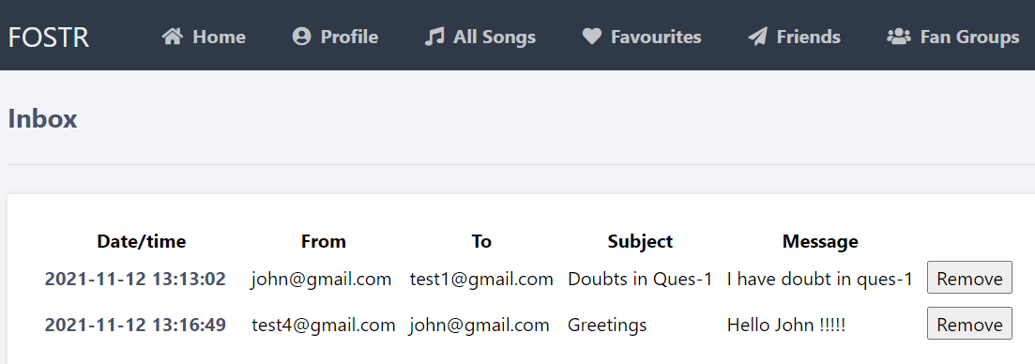

**Updating profile :**

In home page, use the “Update profile” button the make changes to the name, password and street address.

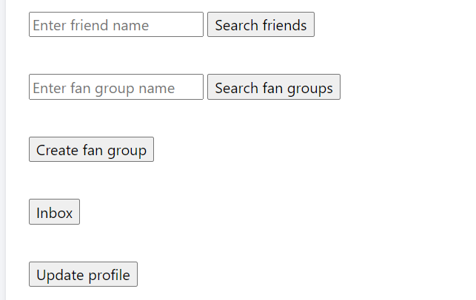

Insert new values in the respective textfield and press on “Update”.

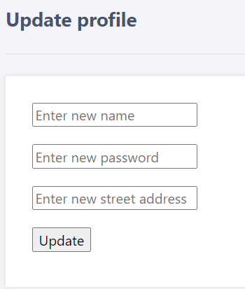 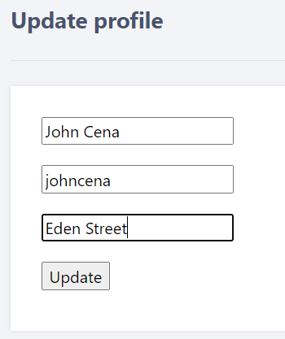

In the home page go to the profile tab to see the changes.

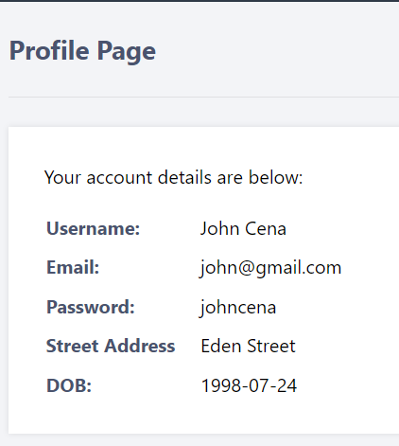

**Report Generation using email id :**

In home page use the text field corresponding to “Generate report” button. Enter the email id of a user and press on the button.

25

Report is generated.

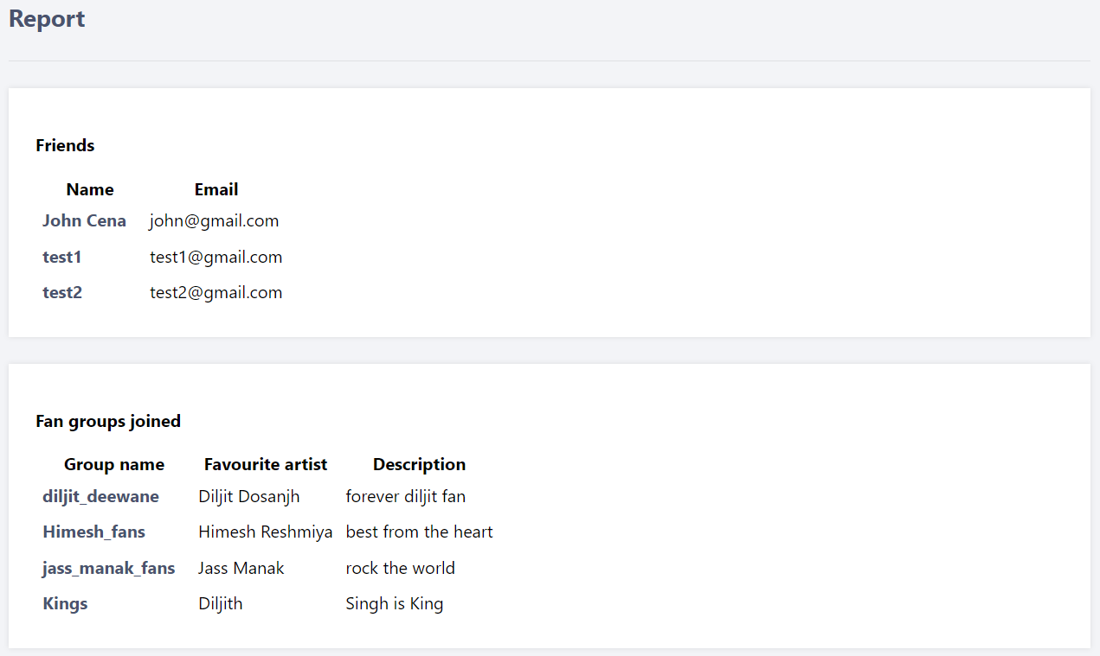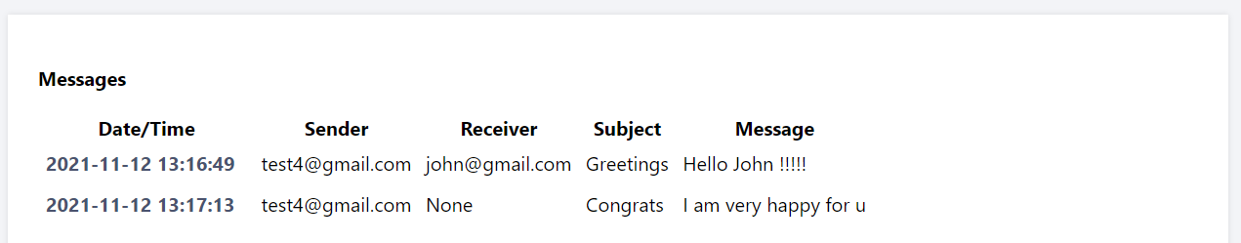

**Sending message to a friend in friend list :**

Click on “Friends” tab and press “Message” button for the friend to whom you want to send the message.

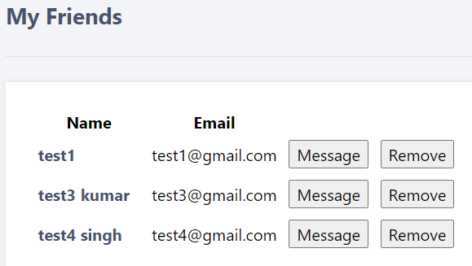

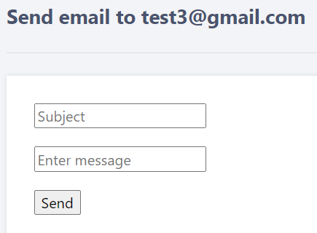 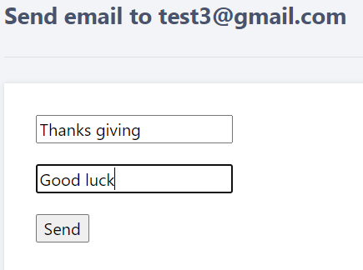

Open inbox to check the sent message.

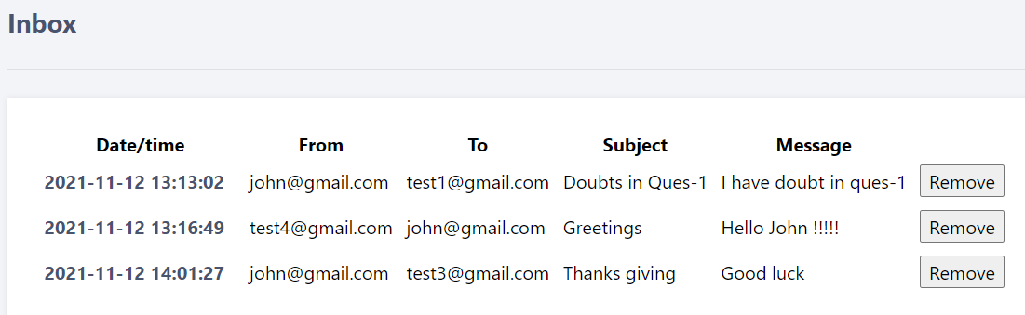

**Sending message in fan group :**

Click on “Fan groups” tab and press “Message” button for the fan group in which you want to send the message.

