---

artifacts:

files:

- app.war

#- appspec.yml

discard-paths: true

phases:

install:

runtime-versions:

java: corretto8

commands:

- "apt-get install git unzip -y"

- "chmod 700 build.sh"

- "sh build.sh"

- "mv ROOT.war app.war"

version: 0.2

# Make sure you use runtime-versions section that specifies version 8 of Java if you use the #Ubuntu standard image 4.0:

# Create endpoints for if you dont use NAT gateway:

# com.amazonaws.region.git-codecommit:

# com.amazonaws.region.codecommit

# com.amazonaws.us-east-1.s3

===================================

---

artifacts:

files:

- ROOT.war

discard-paths: true

phases:

install:

runtime-versions:

java: openjdk8

commands:

- "apt-get install git -y"

- "chmod 700 build.sh"

- "sh build.sh"

version: 0.2

We need to create two IAM Roles for Code Deploy.

1. IAM Role for EC2 Instance with permissions for S3FullAccesss & [AWSCodeDeployFullAccess](https://console.aws.amazon.com/iam/home?region=us-east-1#/policies/arn%3Aaws%3Aiam%3A%3Aaws%3Apolicy%2FAWSCodeDeployFullAccess)
2. IAM Role for [CodeDeployService](https://console.aws.amazon.com/iam/home?region=us-east-1#/roles/AWS-B25-CodeDeployService-Role)

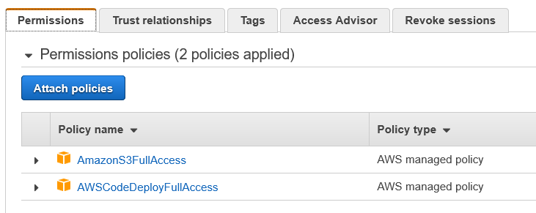

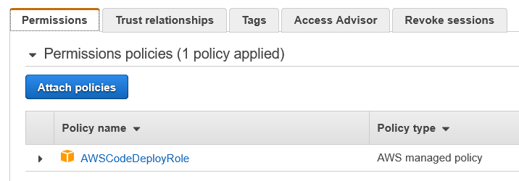

Install Code Deploy Agent:

Use AMI ami-032930428bf1abbff for below activity.

sudo yum update -y

sudo yum install ruby -y

sudo yum install wget -y

cd /home/ec2-user

wget https://aws-codedeploy-us-east-1.s3.us-east-1.amazonaws.com/latest/install

chmod +x ./install

sudo ./install auto

sudo service codedeploy-agent start

sudo service codedeploy-agent status

Install Tomcat:

Use AMI ami-032930428bf1abbff for below activity.

sudo yum install java-1.8.0 -y

sudo yum remove java-1.7.0-openjdk -y

yum update -y

yum install tomcat8 tomcat8-webapps -y -

sudo service tomcat8 start

BEFORE GOING TO CODE DEPLOY, MAKE SURE YOU ADDED appspec.yml file in the same location on the buil.sh in the repo. Also add appsiec.yml in the build artifacts along with war file.

Make sure you give the name exactly as **appspec.yml**

version: 0.0

os: linux

files:

- source: ROOT.war

destination: /var/lib/tomcat8/webapps/

buildspec.yml for CodeBuild ECS Deploy:

version: 0.2

phases:

install:

runtime-versions:

docker: 18

pre_build:

commands:

- echo Pre-Build started on `date`

- echo Logging in to Amazon ECR...

- aws --version

- $(aws ecr get-login --region $AWS_DEFAULT_REGION --no-include-email)

- REPOSITORY_URI=721834156908.dkr.ecr.us-east-1.amazonaws.com/shravani

- COMMIT_HASH=$(echo $CODEBUILD_RESOLVED_SOURCE_VERSION | cut -c 1-7)

- IMAGE_TAG=${COMMIT_HASH:=latest}

build:

commands:

- echo Build started on `date`

- echo Building the Docker image...

- docker build -t $REPOSITORY_URI:latest .

- docker tag $REPOSITORY_URI:latest $REPOSITORY_URI:$IMAGE_TAG

post_build:

commands:

- echo Build completed on `date`

- echo Pushing the Docker images...

- docker push $REPOSITORY_URI:latest

- docker push $REPOSITORY_URI:$IMAGE_TAG

- echo Writing image definitions file...

- printf '[{"name":"shravani","imageUri":"%s"}]' $REPOSITORY_URI:$IMAGE_TAG > imagedefinitions.json

artifacts:

files: imagedefinitions.json