<https://aws.amazon.com/blogs/aws/new-import-existing-resources-into-a-cloudformation-stack/>

<https://docs.aws.amazon.com/AWSCloudFormation/latest/UserGuide/aws-attribute-deletionpolicy.html>

Importing all infra from VPC to Instances Pitfalls:

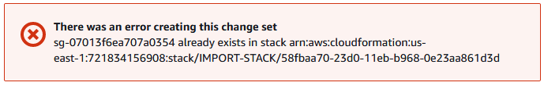

Remove Outputs config for the template.

Give below for all resources

"DeletionPolicy": "Retain",

Remove IGW VPC attachment, Routable association from the config.