**Step 1:** First, open the Cisco packet tracer desktop and select the devices given below:

|  |  |  |  |
| --- | --- | --- | --- |
| **S.no** | **Device** | **Model - name** | **Qty** |
| 1 | PC | pc | 8 |
| 2 | Switch | 2960-24TT | 4 |
| 3 | Router | 2811 | 2 |

**IP addressing tables for PCs**

|  |  |  |  |  |
| --- | --- | --- | --- | --- |
| **S.no** | **Device** | **IPv4 address** | **Subnet mask** | **Default Gateway** |
| 1 | Pc0 | 192.168.1.1 | 255.255.255.0 | 192.168.1.100 |
| 2 | Pc1 | 192.168.1.254 | 255.255.255.0 | 192.168.1.100 |
| 3 | Pc2 | 192.168.2.1 | 255.255.255.128 | 192.168.2.100 |
| 4 | Pc3 | 192.168.2.2 | 255.255.255.128 | 192.168.2.100 |
| 5 | Pc4 | 192.168.2.129 | 255.255.255.192 | 192.168.2.190 |
| 6 | Pc5 | 192.168.2.194 | 255.255.255.192 | 192.168.2.190 |
| 7 | Pc6 | 192.168.2.222 | 255.255.255.224 | 192.168.2.222 |
| 8 | Pc7 | 192.168.2.194 | 255.255.255.224 | 192.168.2.222 |

* Then, create a network topology as shown below the image.
* Use an Automatic connecting cable to connect the devices with others.

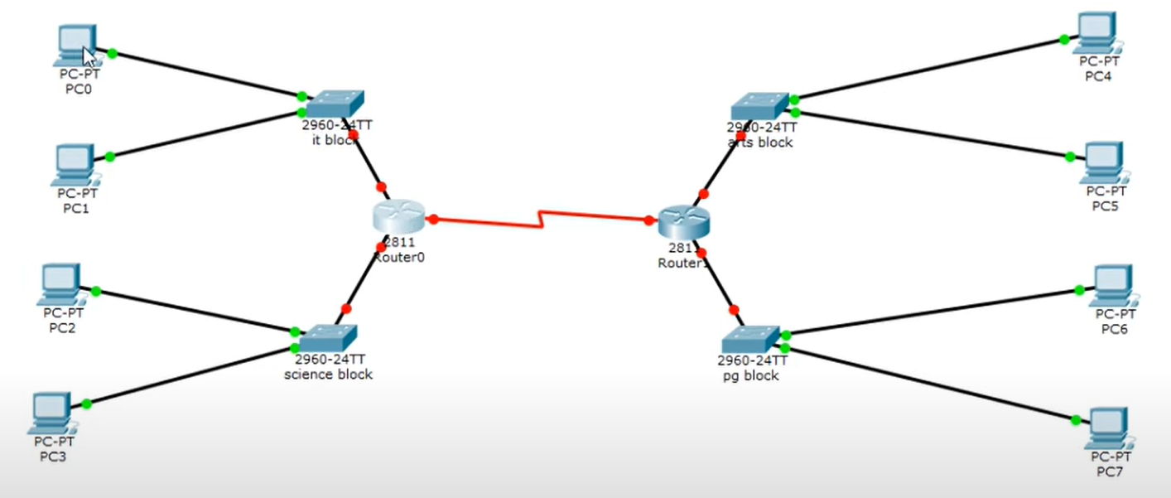

**Step 2:** Configure the PCs (hosts) with IPv4 address and Subnet Mask according to the IP addressing table given above.

* To assign an IP address in PC0, click on PC0.
* Then, go to desktop and then IP configuration and there you will IPv4 configuration.
* Fill IPv4 address and subnet mask.

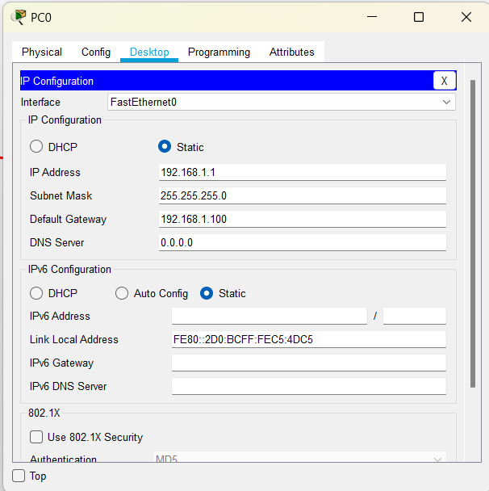

* Repeat the same procedure with other PCs to configure them thoroughly.

**Step 3:** Configure router with IP address and subnet mask.

**IP Addressing Table Router**

|  |  |  |  |  |
| --- | --- | --- | --- | --- |
| **S.no** | **Device** | **Interface** | **IPv4**  **address** | **Subnet mask** |
| 1 | Router 0 | |  | | --- | | FastEthernet 0/0 | | FastEthernet 0/1 | | Serial 0/3/0 | | |  | | --- | | 192.168.1.100 | | 192.168.2.100 | | 192.168.2.225 | | |  | | --- | | 255.255.255.0 | | 255.255.255.128 | | 255.255.255.252 | |
| 2 | Router 1 | |  | | --- | | FastEthernet 0/0 | | FastEthernet 0/1 | | Serial 0/3/0 | | |  | | --- | | 192.168.2.190 | | 192.168.2.222 | | 192.168.2.226 | | |  | | --- | | 255.255.255.192 | | 255.255.255.224 | | 255.255.255.252 | |

* 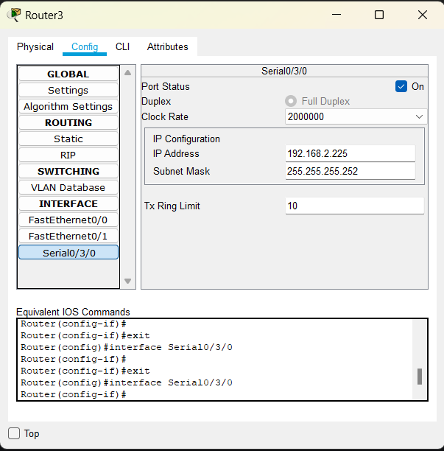To assign an IP address in router0, click on router0.
* Then, go to config and then Interfaces.
* Then, configure the IP address in FastEthernet and serial ports according to IP addressing Table.
* Fill IPv4 address and subnet mask.
* Repeat the same procedure with other routers to configure them thoroughly.

**Step 4:** After configuring all of the devices we need to assign the routes to the routers.

To assign static routes to the particular router:

* First, click on router0 then Go to CLI.
* Then type the commands and IP information given below.

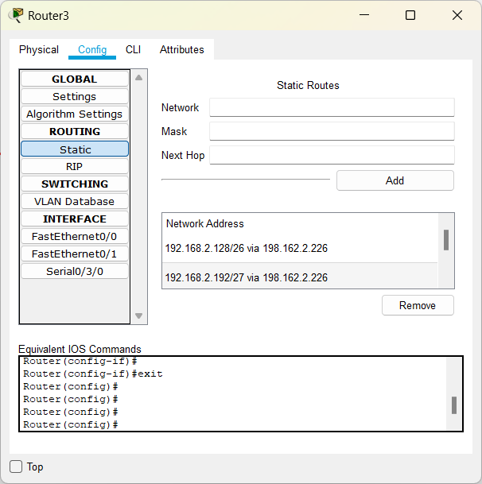

**Step 5:** Verifying the network by pinging the IP address of any PC. We will use the ping command to do so.

* First, click on PC0 then Go to the command prompt
* Then type ping <IP address of targeted node>
* As we can see in the below image we are getting replies which means the connection is working very fine

**Example :** ping 192.168.2.2

