Pizza Hut Sales Analysis

Introduction
Pizza Hut is a globally recognized brand in the fast-food industry, offering a wide variety of pizzas and complementary products. This sales analysis aims to uncover valuable insights from customer order data to help identify performance trends and potential business opportunities. By examining various factors such as order volume, revenue, pizza preferences, and time-based trends, the goal is to optimize strategic decision-making.

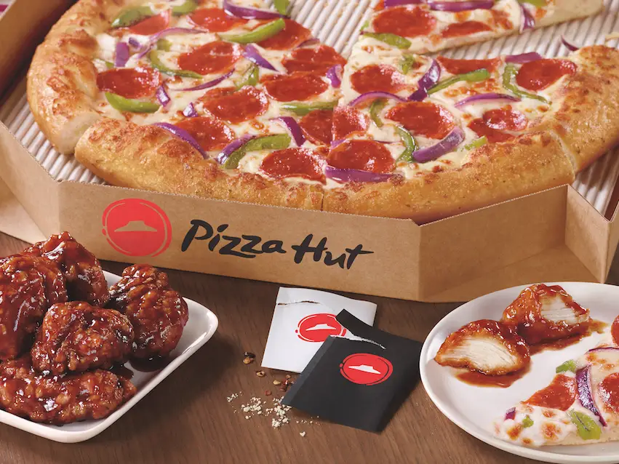

Objective

To analyze Pizza Hut sales data using SQL with the goal of uncovering insights into customer ordering patterns, revenue trends, and pizza preferences. This project aims to enhance data analysis skills by applying SQL queries to extract meaningful information from real-world datasets.

Problem Statement
Pizza Hut collects a lot of data from customer orders, like what pizzas are bought, when they are bought, and how many are sold. But this data is not being used properly to improve the business. Business Context Pizza Hut wants to strengthen its understanding of customer preferences and purchasing trends. This analysis aims to provide actionable insights that will:
● Identify the most popular pizzas.
● Understand peak ordering times and customer preferences.
● Analyze revenue contributions by pizza category.
● Offer recommendations based on data insights.

Dataset Description
The Pizza Hut sales dataset is composed of four CSV files that represent orders, pizzas, and item details. Below is the description of each file and its columns
1. pizzas.csv
pizzas.csv
Contains information about specific pizza variants.
- pizza_id: Unique identifier for each pizza variant.
- pizza_type_id: Foreign key linking to the pizza type.
- size: Size of the pizza (e.g., S, M, L).
- price: Price of the pizza for the specified size.
2. pizza_types.csv
pizza_types.csv
Provides descriptive details about different pizza types.
- pizza_type_id: Unique identifier for each pizza type.
- name: Name of the pizza type.
- category: Category of the pizza (e.g., Chicken, Veggie, Classic).
- ingredients: List of ingredients used in the pizza.
3. orders.csv
Records order-level information.
- order_id: Unique identifier for each order.
- date: Date when the order was placed.
- time: Time when the order was placed.
4. order_details.csv
Details individual items within each order.
- order_details_id: Unique identifier for each item entry.
- order_id: Foreign key linking to the orders table.
- pizza_id: Identifier for the pizza variant ordered.
- quantity: Number of units ordered for that pizza
Queries & Results
- Total Orders Count
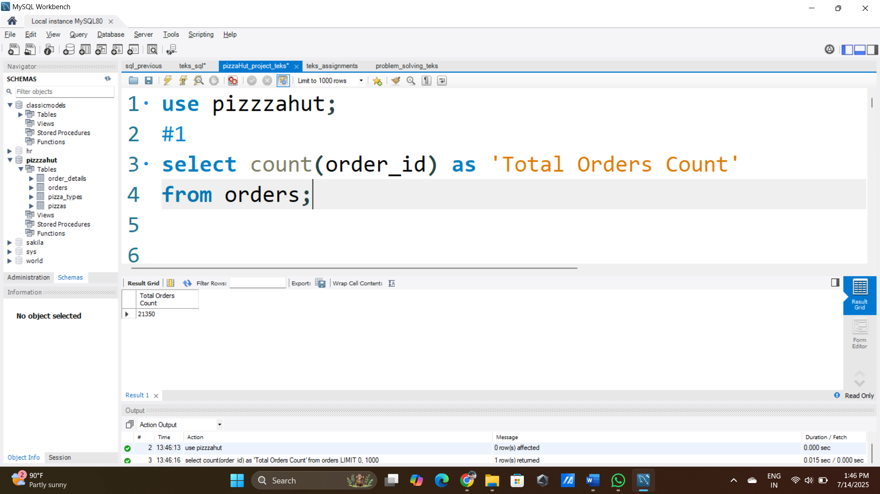

Query Description:
This SQL query calculates the total number of orders placed in the system by counting all entries in the orders table. The COUNT(order_id) function tallies each order record, and the result is labeled as 'Total Orders Count' for easy interpretation.

- Revenue Calculation
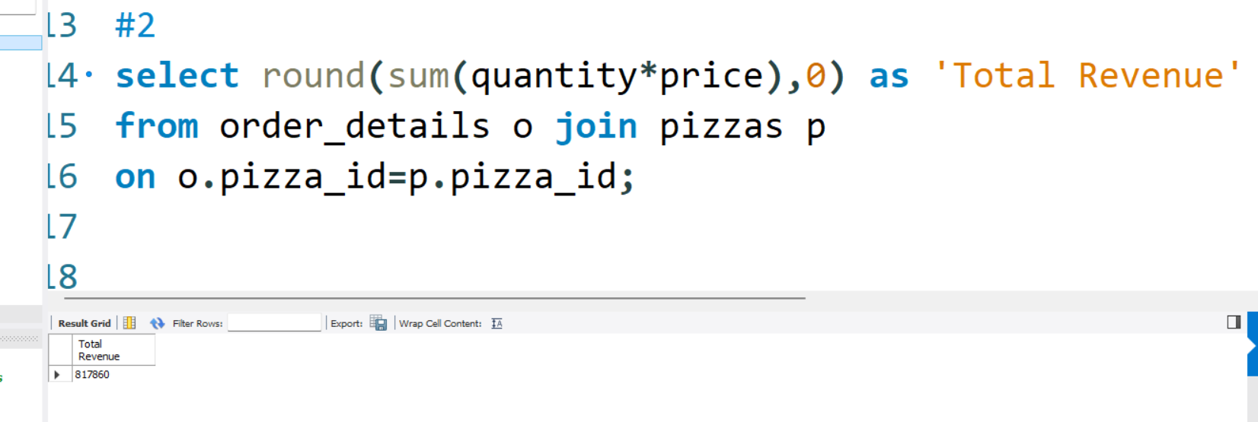Query Description:
This query calculates the total revenue generated from all pizza orders. It performs a join between the order_details and pizzas tables using the pizza_id to link each order with its corresponding pizza. The revenue for each order item is computed by multiplying the quantity by the price of the pizza, and the SUM function aggregates this across all records. The result is rounded to the nearest whole number using the ROUND function and labeled as 'Total Revenue'.

- Most expensive pizza
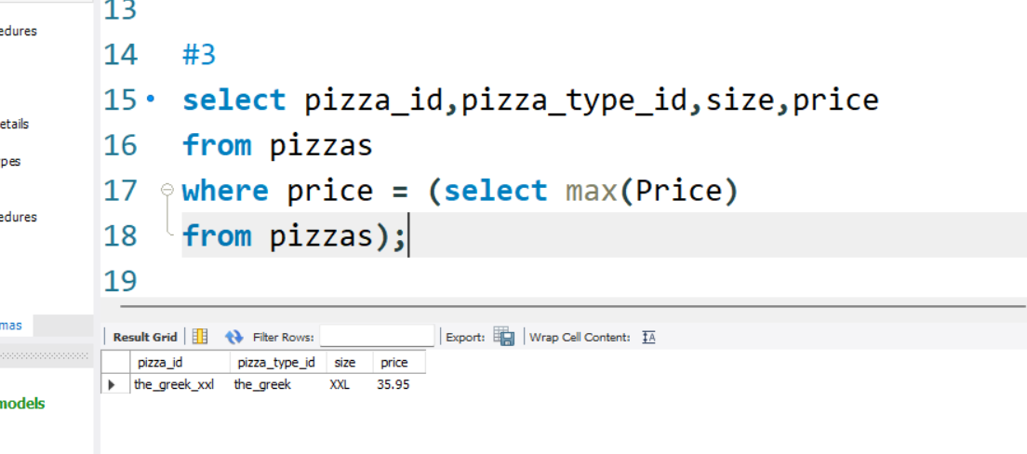
Query Description:
This SQL query retrieves the details of the most expensive pizza from the pizzas table. It selects the pizza_id, pizza_type_id, size, and price for the pizza(s) whose price matches the maximum price in the table. The subquery (SELECT MAX(price) FROM pizzas) identifies the highest price, and the outer query filters and returns all pizzas with that price.

- Most ordered pizza size
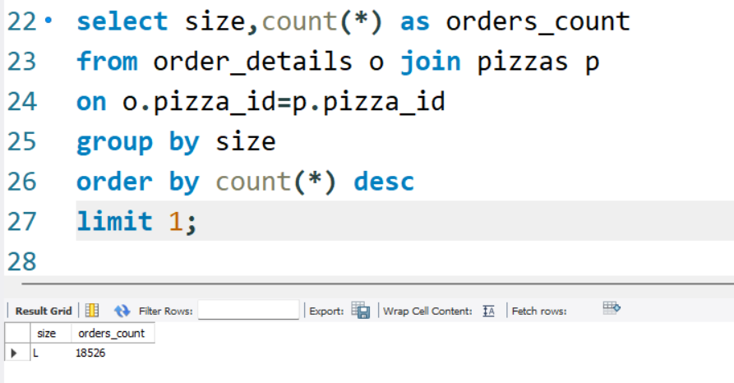
Query Description:
This SQL query identifies the most popular pizza size based on the number of orders. It joins the order_details and pizzas tables using pizza_id, groups the results by size, and counts how many times each size was ordered. The ORDER BY count(*) DESC clause sorts the sizes from most to least ordered, and LIMIT 1 returns only the top-selling pizza size.
- Top 5 Popular Pizzas
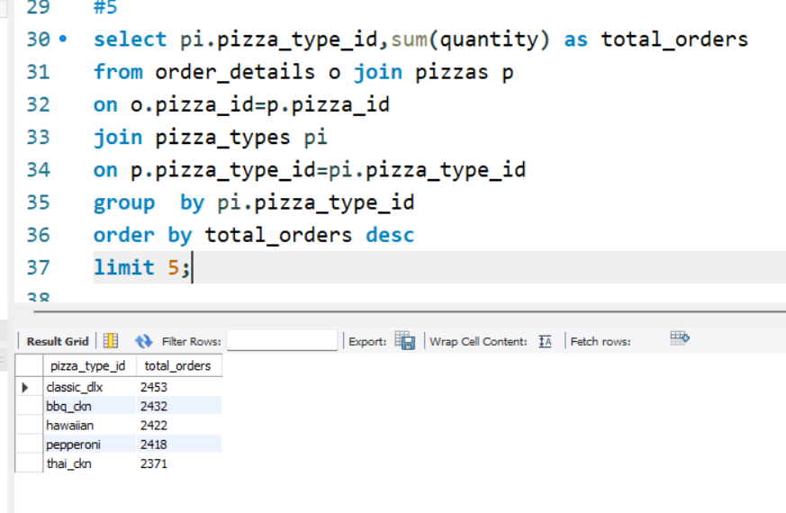
Query Description:
This SQL query identifies the top 5 most ordered pizza types. It joins the order_details, pizzas, and pizza_types tables using pizza_id and pizza_type_id to link order records with their corresponding pizza types. It then groups the data by pizza_type_id and calculates the total quantity ordered for each type using SUM(quantity). The results are sorted in descending order by total orders, and LIMIT 5 ensures that only the top 5 best-selling pizza types are returned.
- Pizza Quantity by Category
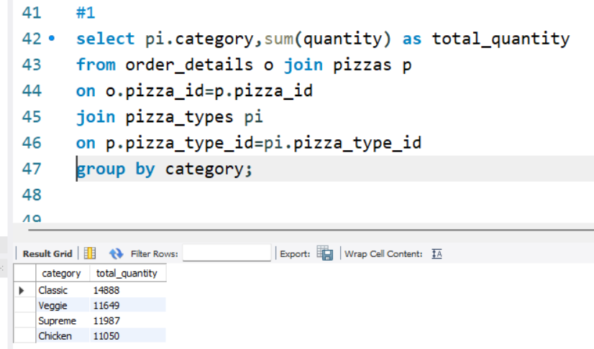
Query Description:
This query calculates the total quantity of pizzas ordered per category (e.g., Classic, Veggie, etc.).
It joins order_details, pizzas, and pizza_types tables and groups the data by category.
The result helps analyze category-wise demand across all orders.
- Order Trends by Hour
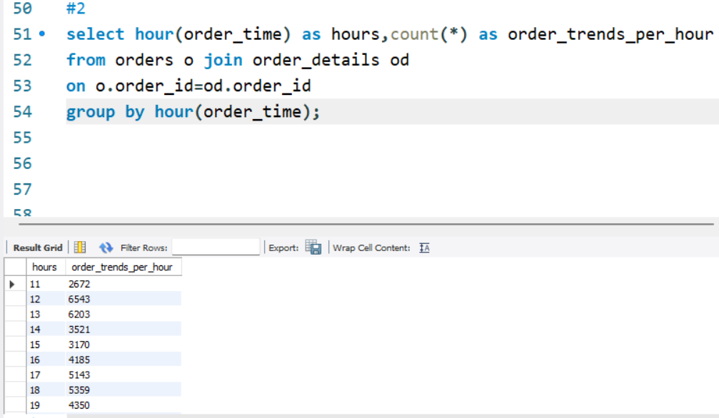

Query Description:
This query analyzes order trends by hour of the day.It extracts the hour from the order_time field and counts how many orders occurred in each hour.The output helps identify peak ordering hours for better staffing and service planning.
- Pizza Distribution by Category
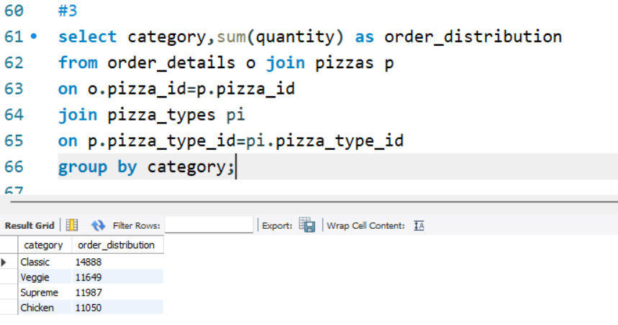
Query Description:
This SQL query calculates the total number of pizzas ordered in each category.
It joins order_details, pizzas, and pizza_types tables, then groups the data by category and sums the quantity.The result reveals the order distribution across pizza categories, aiding in demand analysis.
- Average orders per day 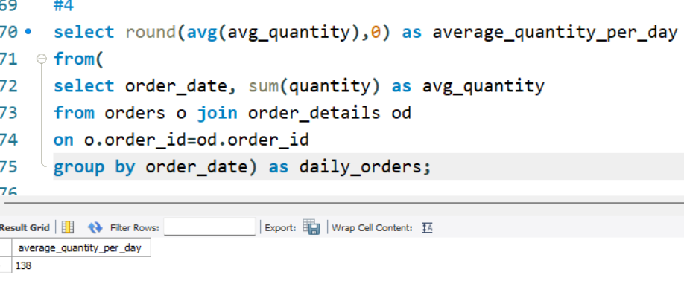
Query Description:
This SQL query calculates the average quantity of pizzas ordered per day. It begins by joining the orders and order_details tables and grouping the data by order_date to get the total quantity of pizzas sold each day. The outer query then computes the average of these daily totals using the AVG function. The result is rounded to the nearest whole number and labeled as 'average_quantity_per_day', providing a clear metric of daily pizza demand.

- Top 3 pizzas by revenue
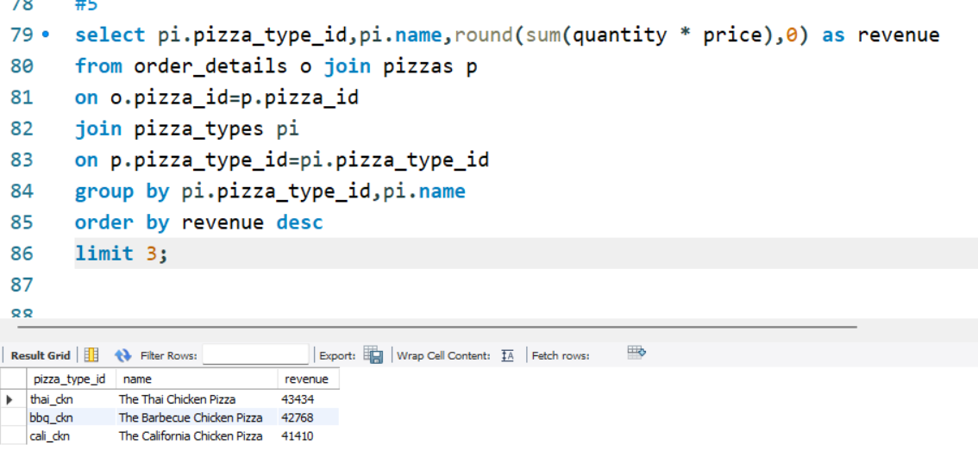
Query Description:
This query identifies the top 3 highest revenue-generating pizza types.It joins order_details, pizzas, and pizza_types, calculates revenue by multiplying quantity * price, and groups the result by pizza type and name.The pizzas are sorted in descending order of revenue, and only the top 3 performers are displayed.
- Revenue contribution by pizza types
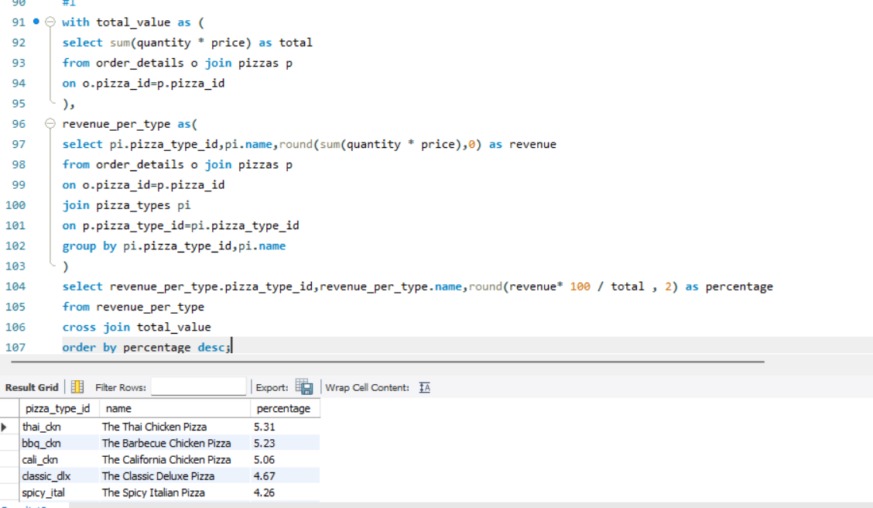
Query Description:
This query computes the revenue contribution percentage of each pizza type.Using two CTEs, it first calculates the total revenue and then the revenue per pizza type.A cross join combines the results to determine each type's share of total revenue.The output ranks pizza types based on their financial impact in descending order.
- Cumulative revenue
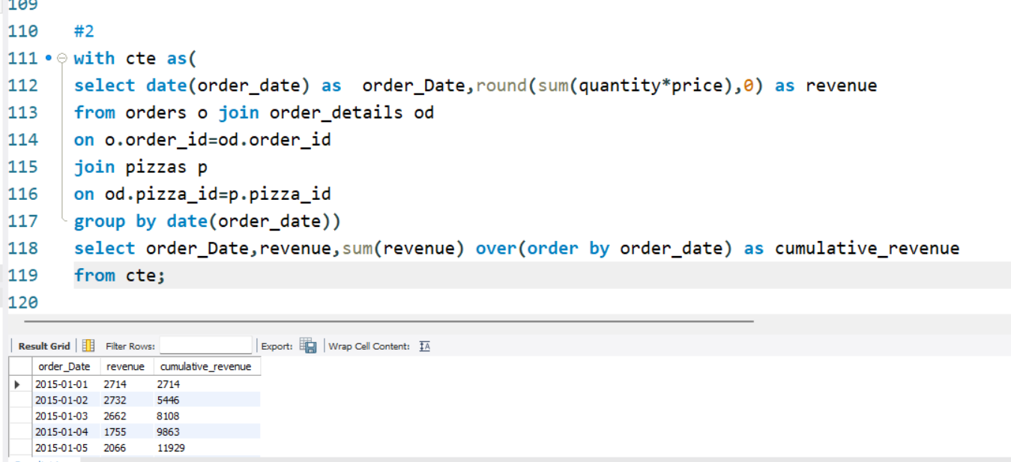
Query Description:
This query calculates the daily and cumulative revenue from pizza orders.
A CTE groups revenue by order_date using quantity * price, rounded to the nearest whole number.
The main query uses a window function to compute a running total (cumulative_revenue) over time.It helps track revenue growth trends and monitor business performance chronologically.
- ranking pizza by revenue
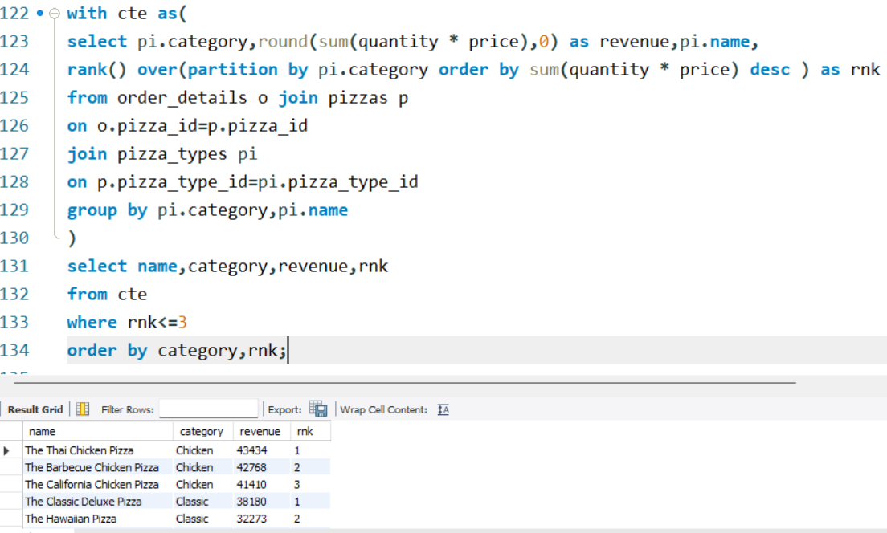
Query Description:
This query identifies the top 3 revenue-generating pizzas within each category.
Using a CTE, it calculates revenue per pizza and ranks them using the RANK() window function partitioned by category.
Only pizzas with rank 1 to 3 are selected, providing a breakdown of best performers by category.
The final result is sorted by category and rank for easy comparison.

Insights & Recommendations
Insights
- The overall sales performance is strong, with steady daily demand and a few pizza types contributing heavily to total revenue.
- Certain pizza sizes and categories are clearly more popular among customers, indicating well-defined preferences.
- Revenue is concentrated in a small group of high-performing pizzas, suggesting a classic 80/20 pattern in sales.
- Orders peak during specific hours of the day, revealing valuable trends in customer behavior and ordering habits.
- Category-wise sales and revenue distribution suggest that some categories outperform others, possibly due to pricing, ingredients, or marketing influence.
- Cumulative revenue trends indicate stable or growing business over time, useful for forecasting and growth tracking.
Recommendations
- Product Focus: Prioritize top-selling pizzas in marketing and inventory planning. Consider launching new variants based on popular types.
- Menu Optimization: Streamline low-performing items and introduce limited-time offers to experiment with new flavors.
- Promotional Strategy: Schedule discounts or combo deals during off-peak hours to drive more consistent sales throughout the day.
- Inventory Management: Use average daily demand and size preference insights to optimize raw material purchases and reduce food waste.
- Customer Experience: Improve operations during peak hours by increasing staffing and reducing delivery time to enhance satisfaction.
- Growth Planning: Leverage high-performing categories to create brand campaigns, loyalty programs, or expand into new markets or cities.

