**Voyage Vista : Illuminating Insights from Uber Expeditionary Analysis**

**Project Description:**

Uber is a multinational transportation network company that operates a ride-hailing platform. It was founded in 2009 by Garrett Camp and Travis Kalanick and is based in San Francisco, California. Uber provides a convenient way for individuals to request rides from drivers who use their own personal vehicles.   
Uber Driver Analysis refers to the Analyzing the number of trips taken by Uber drivers can provide insights into their overall activity and the demand for rides in specific areas. Daily, Weekly, or Monthly Analysis: Uber's data can be analyzed on a daily, weekly, monthly basis to understand the trends and patterns of trip volumes. This analysis can help identify peak hours or days of high demand and optimize driver availability during those times. Trips can be analyzed based on geographic regions or specific cities to identify areas with higher demand. This analysis can help Uber drivers decide where to focus their driving efforts for maximum efficiency and profitability. The Major of our project is to use data Analyzing techniques to find unknown patterns in the Uber Drives dataset. The research is carried out on Uber drives data collected from the year 2016.

**Technical Architecture:**

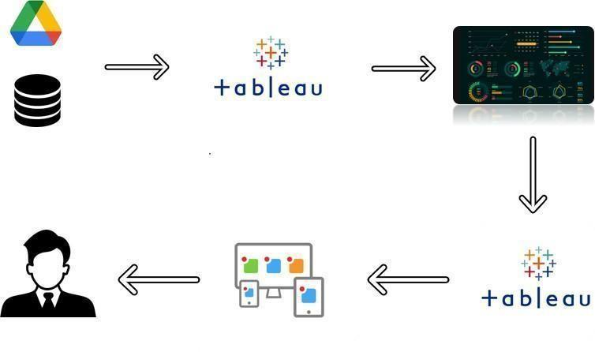

**Project Flow:**

To accomplish this, we have to complete all the activities listed below,

* + Define Problem / Problem Understanding
    - Specify the business problem
    - Business requirements
    - Literature Survey
  + Data Collection & Extraction
    - Collect the dataset
    - Connect Dataset with Tableau
  + Data Preparation
    - Prepare the Data for Visualization
  + Data Visualizations
    - No of Unique Visualizations
  + Dashboard
    - Responsive and Design of Dashboard
  + Story
    - No of Scenes of Story
  + Performance Testing
    - Utilization of Data Filters
    - No of Visualizations/ Graphs
  + Publishing
    - Publishing Dashboard and Story on Tableau Public
  + Project Demonstration & Documentation
    - Record explanation Video for project end to end solution
    - Project Documentation-Step by step project development procedure

# Milestone 1: Define Problem / Problem Understanding

## Activity 1: Specify the business problem

Refer Project Description

## Activity 2: Business requirements

Driver Performance Evaluation: Determine the criteria for evaluating driver performance,

such as customer ratings, completion rate, cancellation rate, average trip duration, and

driver feedback. These metrics can help identify top-performing drivers and areas

for improvement.

Efficiency Analysis: Assess driver efficiency by analyzing metrics such as average time

spent waiting for passengers, average distance driven per trip, and idle time between trips.

This analysis can help identify opportunities to optimize driver utilization and reduce

downtime.

Supply and Demand Analysis: Understand the relationship between driver supply and

passenger demand in different areas and at different times. Identify peak hours and high-

demand areas to optimize driver allocation and increase customer satisfaction.

Route Optimization: Analyze driver routes and identify patterns to optimize navigation and

reduce travel time. By analyzing historical trip data and using mapping algorithms, you

can suggest more efficient routes to drivers, enhancing their performance and reducing fuel

costs.

## Activity 3: Literature Survey (Student Will Write)

A literature survey conducted by students exploring YouTube channels would typically involve researching existing studies, academic papers, and publications related to the topic

# Milestone 2: Data Collection

Data collection is the process of gathering and measuring information on variables of interest, in an established systematic fashion that enables one to answer stated research questions, test hypotheses, and evaluate outcomes and generate insights from the data.

## Activity 1: Collect the dataset

Please use the link to download the dataset:

<https://www.kaggle.com/code/mohamed08/exploratory-data-analysis-for-uber-trips/input>

## Activity 1.1: Understand the data

Data contains all the meta information regarding the columns described in the CSV files. We have provided a csv file.

### Column Description for Uber Drives- 2016.csv:

* START_DATE: 2 JAN 2016 – 1 JAN 2017.
* END_DATE: 2 JAN 2016 – 1 JAN 2017.
* START: Cary, New York, Durham, Downtown, Midtown, Midtown East, Houston, Gulfton, Whitebridge, Houston, Morrisville and 798 Others.
* STOP: Cary, New York, Durham, Downtown, Midtown, Midtown East, Houston, Gulfton, Whitebridge, Houston, Morrisville and 798 Others.
* Miles Covered: 0.5-1220.92
* Purpose: Meeting, Temporary Site, Customer Visit, Meal/Entertain, Errand/Supplies, Airport, Between Offices, charity, commute, moving.

### Activity 3: Connect Dataset with Tableau

Explanation video link:

<https://drive.google.com/file/d/1pjsP8eRr0PwPuVt4oKehaLLwpRfUFhDV/view?usp=sharing>

# Milestone 3: Data Preparation

### Activity 1: Prepare the Data for Visualization

Preparing the data for visualization involves cleaning the data to remove irrelevant or missing data, transforming the data into a format that can be easily visualized, exploring the data to identify patterns and trends, filtering the data to focus on specific subsets of data, preparing the data for visualization software, and ensuring the data is accurate and complete. This process helps to make the data easily understandable and ready for creating visualizations to gain insights into our analysis.

# Milestone 4: Data Visualization

Data visualization is the process of creating graphical representations of data in order to help people understand and explore information. The goal of data visualization is to make complex data sets more accessible, intuitive, and easier to interpret. By using visual elements such as charts, graphs, and maps, data visualizations can help people quickly identify patterns, trends, and outliers in the data.

## Activity 1: No of Unique Visualizations

The number of unique visualizations that can be created with a given dataset. Some common types of visualizations that can be used to analyze the performance and efficiency of a project include bar charts, line charts, heat maps, scatter plots, pie charts, Maps etc. These visualizations can be used to compare performance, track changes over time, show distribution, and relationships between variables.

### Activity 1.1: Miles Covered per Category and Purpose Analysis

### Explanation video link:

<https://drive.google.com/file/d/1PnqwqaTlObOvhGRca4QCbGFeKbgOW7Ji/view?usp=sharing>

### Activity 1.2: Miles Covered in Category Analysis

### Explanation video link: <https://drive.google.com/file/d/1__WQGqcVWxi2lpx4HFdIATCLQlDRJ1Fc/view?usp=sharing>

**Activity 1.3: Month wise Uber Miles Analysis**

### Explanation video link:

[**https://drive.google.com/file/d/1YKwCna4MnUjOKJdbGWCIlHQEm0WFDqX5/view?usp=sharing**](https://drive.google.com/file/d/1YKwCna4MnUjOKJdbGWCIlHQEm0WFDqX5/view?usp=sharing)

### Activity 1.4: Week wise Uber Miles Analysis

**Explanation video link:**

[**https://drive.google.com/file/d/1zAJDlWaHTb0neFZfCl9rkr_dn9EK526V/view?usp=sharing**](https://drive.google.com/file/d/1zAJDlWaHTb0neFZfCl9rkr_dn9EK526V/view?usp=sharing)

**Activity 1.5: Quarter wise Uber Miles Analysis**

### Explanation video link:

[**https://drive.google.com/file/d/1YW1qLUoE_DtKQXA2Wd7vMBuQeO2jud81/view?usp=sharing**](https://drive.google.com/file/d/1YW1qLUoE_DtKQXA2Wd7vMBuQeO2jud81/view?usp=sharing)

**Activity 1.6: Month wise Uber Trips Analysis**

### Explanation video link:

[**https://drive.google.com/file/d/1ejCMFlntO-OwaFb_tV1PrW1LSATqKtg0/view?usp=sharing**](https://drive.google.com/file/d/1ejCMFlntO-OwaFb_tV1PrW1LSATqKtg0/view?usp=sharing)

**Activity 1.7: Quarter wise Uber Trips Analysis**

### Explanation video link:

[**https://drive.google.com/file/d/1qsTuilI8PWFHTxo-OSEZUsxhovrwWYio/view?usp=sharing**](https://drive.google.com/file/d/1qsTuilI8PWFHTxo-OSEZUsxhovrwWYio/view?usp=sharing)

**Activity 1.8: Hour wise Uber Trips Analysis**

### Explanation video link:

[**https://drive.google.com/file/d/1a2uR0qRPl0SpXVj-FDEMlxSk1XbK5k1E/view?usp=sharing**](https://drive.google.com/file/d/1a2uR0qRPl0SpXVj-FDEMlxSk1XbK5k1E/view?usp=sharing)

# Milestone 5: Dashboard

A dashboard is a graphical user interface (GUI) that displays information and data in an organized, easy-to-read format. Dashboards are often used to provide real-time monitoring and analysis of data, and are typically designed for a specific purpose or use case. Dashboards can be used in a variety of settings, such as business, finance, manufacturing, healthcare, and many other industries. They can be used to track key performance indicators (KPIs), monitor performance metrics, and display data in the form of charts, graphs, and tables.

## Activity :1- Responsive and Design of Dashboard

The responsiveness and design of a dashboard for Data-Driven insights on YouTube channels Analysis is crucial to ensure that the information is easily understandable and actionable. Key considerations for designing a responsive and effective dashboard include user-centered design, clear and concise information, interactivity, data-driven approach, accessibility, customization, and security. The goal is to create a dashboard that is user-friendly, interactive, and data-driven, providing actionable insights.

### Explanation video link:

<https://drive.google.com/file/d/16RPNwGAZXymkXEO3BQAkiFJK8SLkK7N5/view?usp=sharing>

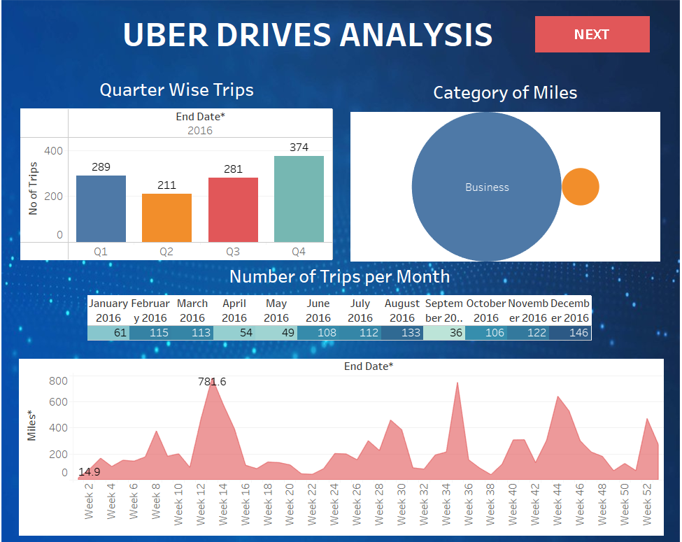

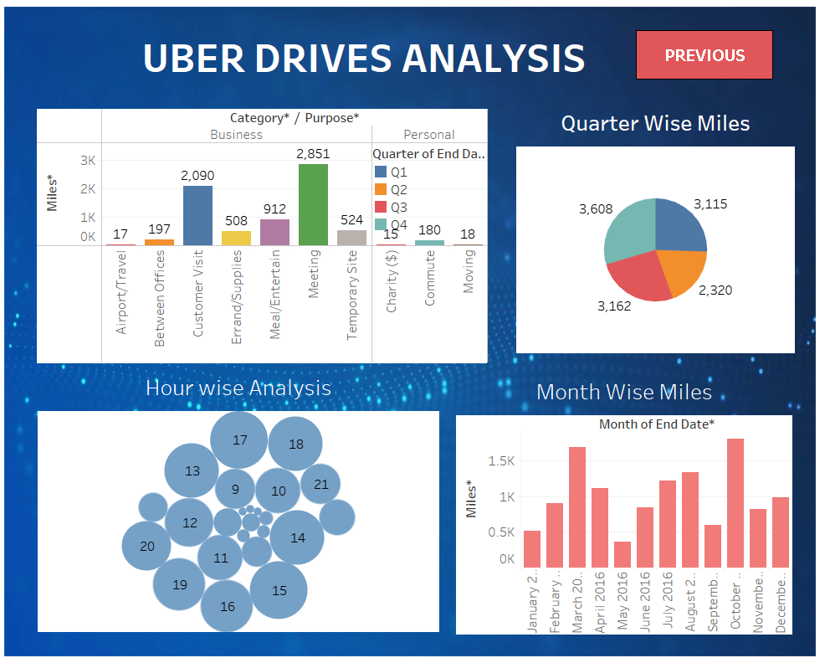

# Milestone 6: Story

A data story is a way of presenting data and analysis in a narrative format, with the goal of making the information more engaging and easier to understand. A data story typically includes a clear introduction that sets the stage and explains the context for the data, a body that presents the data and analysis in a logical and systematic way, and a conclusion that summarizes the key findings and highlights their implications. Data stories can be told using a variety of mediums, such as reports, presentations, interactive visualizations, and videos.

## Activity:1- No of Scenes of Story

The number of scenes in a storyboard for Data-Driven insights on YouTube channels Analysis will depend on the complexity of the analysis and the specific insights that are trying to be conveyed. A storyboard is a visual representation of the data analysis process and it breaks down the analysis into a series of steps or scenes.

### Explanation video link:

[**https://drive.google.com/file/d/15CDU70IE0BTqIW2cvxOiuRK3vVnWpqKU/view**](https://drive.google.com/file/d/15CDU70IE0BTqIW2cvxOiuRK3vVnWpqKU/view)

# 

# 

# 

# 

# 

# 

# 

# 

# Milestone 7: Performance Testing

## Activity 1: Utilization of Filters

# 

**Activity 2: No of Visualizations/ Graphs**

1. Bar graph showing Purpose of Uber with Miles covered.

2. Bubble chart showing distribution of Miles with Category.

3. Bar graph showing Quarter with Number of Trips

4. Highlight Table shows Month with Number of Trips.

5. Bar graph showing Month with Miles.

6. Area Chart showing Week with Miles.

7. Pie chart showing Quarter with Miles.

8. Bubble Chart showing Hour with Number of Trips.

9. Tree Map showing Distance between the Start and Stop Locations.

# Milestone 8: Publishing

Publishing helps us to track and monitor key performance metrics, to communicate results and progress. help a publisher stay informed, make better decisions, and communicate their performance to others.

### Publishing dashboard and reports to tableau public

Step 1 Go to data Source and Select Extract so that .hyper extension files are created and save it at your desktop.

(please wait for pop up of file to save)

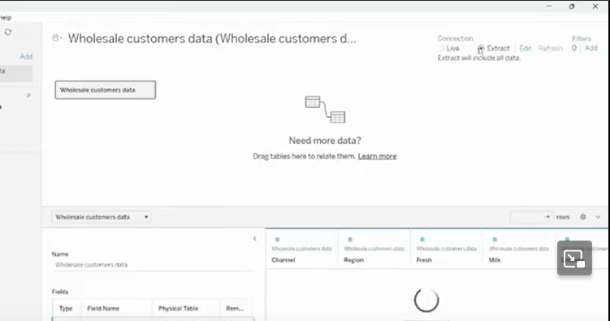

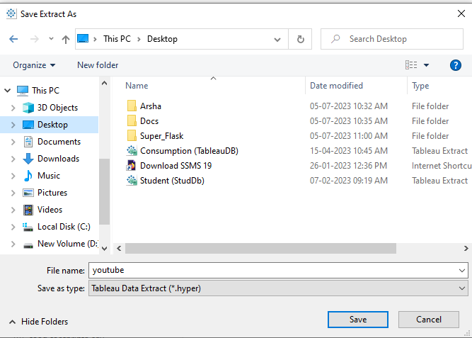

Step 2: Go to Dashboard/story, click on share button on the top ribbon

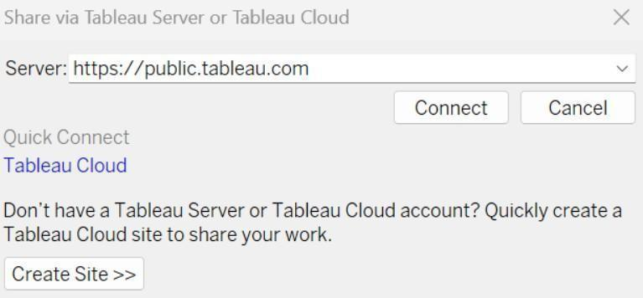

Give the server address of your tableau public account and click on connect.

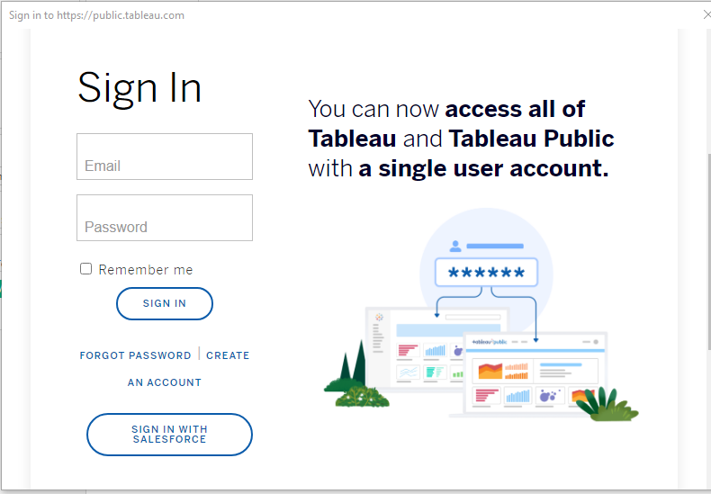

Sign in to your Tableau Public account or create a new account if you don't have one. You can visit the Tableau Public website (public.tableau.com) and click on the "Sign In" or "Join" button.

In the "Tableau Public Sign In" window, enter your Tableau Public account credentials and click "Sign In."

Next, you'll need to provide a title and description for your workbook. Fill in the appropriate details in the provided field of workbook Title

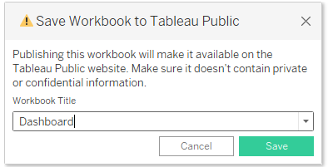

Click on the "Save" button to start the publishing process. Tableau Desktop will upload your workbook to Tableau Public.

Once the upload is complete, a browser window will automatically open, displaying your published workbook on Tableau Public. Review the workbook to ensure that everything appears as expected.

So in Similar way we can also publish Story to tableau public.

**ExplanationVideo1:** [**https://drive.google.com/file/d/1ueEaxP0Usd_LIl5JmGdhz3x_xWXSWFV8/view?usp=sharing**](https://drive.google.com/file/d/1ueEaxP0Usd_LIl5JmGdhz3x_xWXSWFV8/view?usp=sharing)

# Milestone 9: Project Demonstration & Documentation

Below mentioned deliverables to be submitted along with other deliverables.

## Activity 1: Record explanation Video for project end to end solution

**Activity 2: Project Documentation-Step by step project development procedure**

Create a document as per the template provided.