Web Technology Lab 2025-26

Course Faculty: Prof. Dr. J Vimala Devi
Course Name & code: Web Technology Lab 22CSL35

Semester: 3rd 2025 Date: 18-12-2025

TITLE OF THE WORK | Design and Development of an Online Electronics E-Commerce Platform
STUDENT NAME | Kishan G N
USN | 1DS24CS098
ABSTRACT OF THE WORK | In the modern digital age, an online presence has become essential for businesses to attract customers and remain competitive. This project presents the design and development of a Bakery Business Portfolio Website that enables users to explore bakery products, add items to a shopping cart, view the total cost, and place orders online. The website aims to provide a simple and user-friendly interface that enhances customer engagement and improves business visibility.  The system is developed using core web technologies including HTML for structuring the content, CSS for styling and layout, and JavaScript for implementing client-side interactivity and dynamic features. All functionalities are handled on the client side without backend or database integration, ensuring simplicity, fast performance, and ease of understanding. This project serves as a practical learning model for beginners in web development, demonstrating how a real-world business website can be created using fundamental web technologies.
INTRODUCTION | In today’s rapidly evolving digital era, establishing a strong online presence has become a necessity for businesses of all sizes, including small and local enterprises such as bakeries. Customers increasingly rely on the internet to explore products, compare prices, and place orders conveniently from anywhere. A well-designed business portfolio website not only enhances visibility but also builds trust, improves customer engagement, and expands business reach beyond physical boundaries.  This project focuses on the development of a Bakery Business Portfolio Website that provides an interactive and user-friendly platform for showcasing bakery products. The website allows users to explore a variety of baked goods, view product details and prices, add items to a shopping cart, calculate the total cost, and proceed with placing an order. Additional features such as customer feedback and a simple login interface further enhance user interaction and overall experience.  The website is built using HTML for structuring web content, CSS for styling and layout design, and JavaScript for implementing dynamic functionality and client-side interactivity. Since the entire system operates on the client side without backend integration, it remains lightweight, fast, and easy to deploy. This project serves as an excellent learning example for beginners in web development, demonstrating how core web technologies can be used to create a functional and realistic business website while understanding fundamental concepts such as DOM manipulation, event handling, and user interface design.

DESIGN | The design of the online bakery website follows modern e-commerce UI principles:  • A clean and attractive homepage showcasing bakery products  • Simple and user-friendly login interface  • Bakery items displayed using responsive product cards  • High-quality images of cakes, breads, and pastries sourced from the web  • Shopping cart section with add, remove, and quantity control features  • Organized product layout for easy browsing  • Clear navigation for smooth user experience  The website layout is fully responsive and adapts effectively to different screen sizes, including desktops, tablets, and mobile devices, ensuring accessibility across all devices.
PLATFORM USED | The following tools and technologies were used in the development of this project:  - HTML5 – For structuring the web pages  - CSS3 – For styling, layout, and visual effects  - JavaScript – For dynamic behavior such as cart operations  - VS Code – Code editor for development  - Browser localStorage – To store cart items temporarily  - Netlify – For hosting and deploying the website
CODE LINK (GITHUB/ GOOGLE DRIVE) | LIVE WEBSITE URL :  CODE LINK :
CONCLUSION | The Online Bakery Website project successfully demonstrates the design and development of a functional and user-friendly business portfolio website using core web technologies. The platform allows users to browse bakery products, add items to a shopping cart, view the total cost, and place orders in a simple and interactive manner. By using HTML, CSS, and JavaScript, the website provides an engaging user experience without the need for backend integration.  This project highlights the practical application of front-end web development concepts such as responsive design, DOM manipulation, and client-side interactivity. It serves as an effective learning model for beginners and shows how a small business like a bakery can benefit from an online presence to reach more customers. The project can be further enhanced in the future by adding features such as online payment, user authentication, and database integration.
SCREENSHOT OF  THE BUSINESS PORTFOLIO | 1.Login Page: 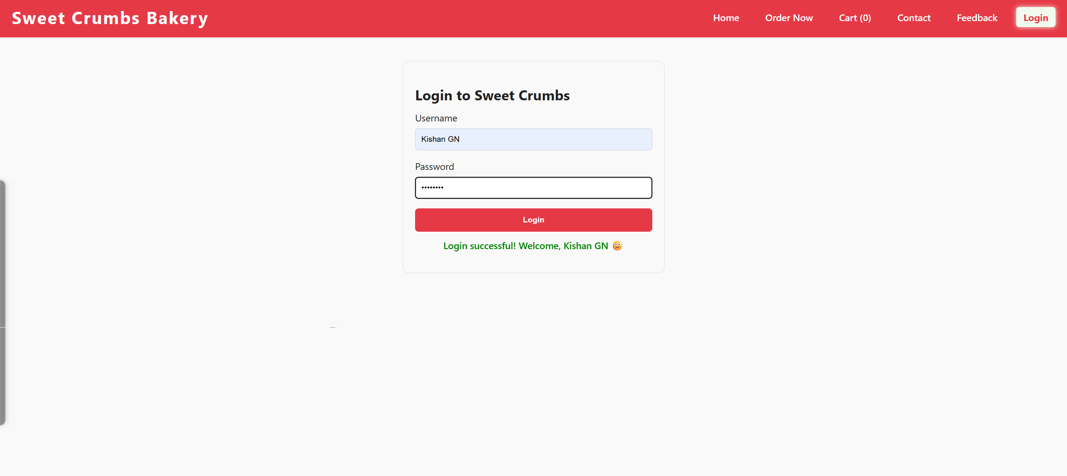  2.Home Page with Products:  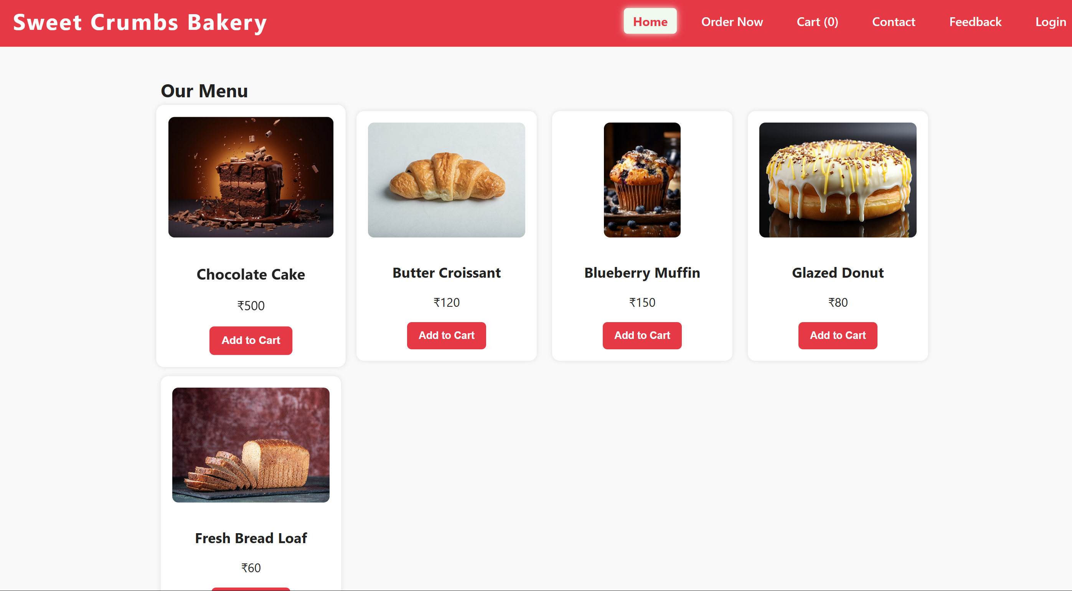  3.Shopping Cart Section :  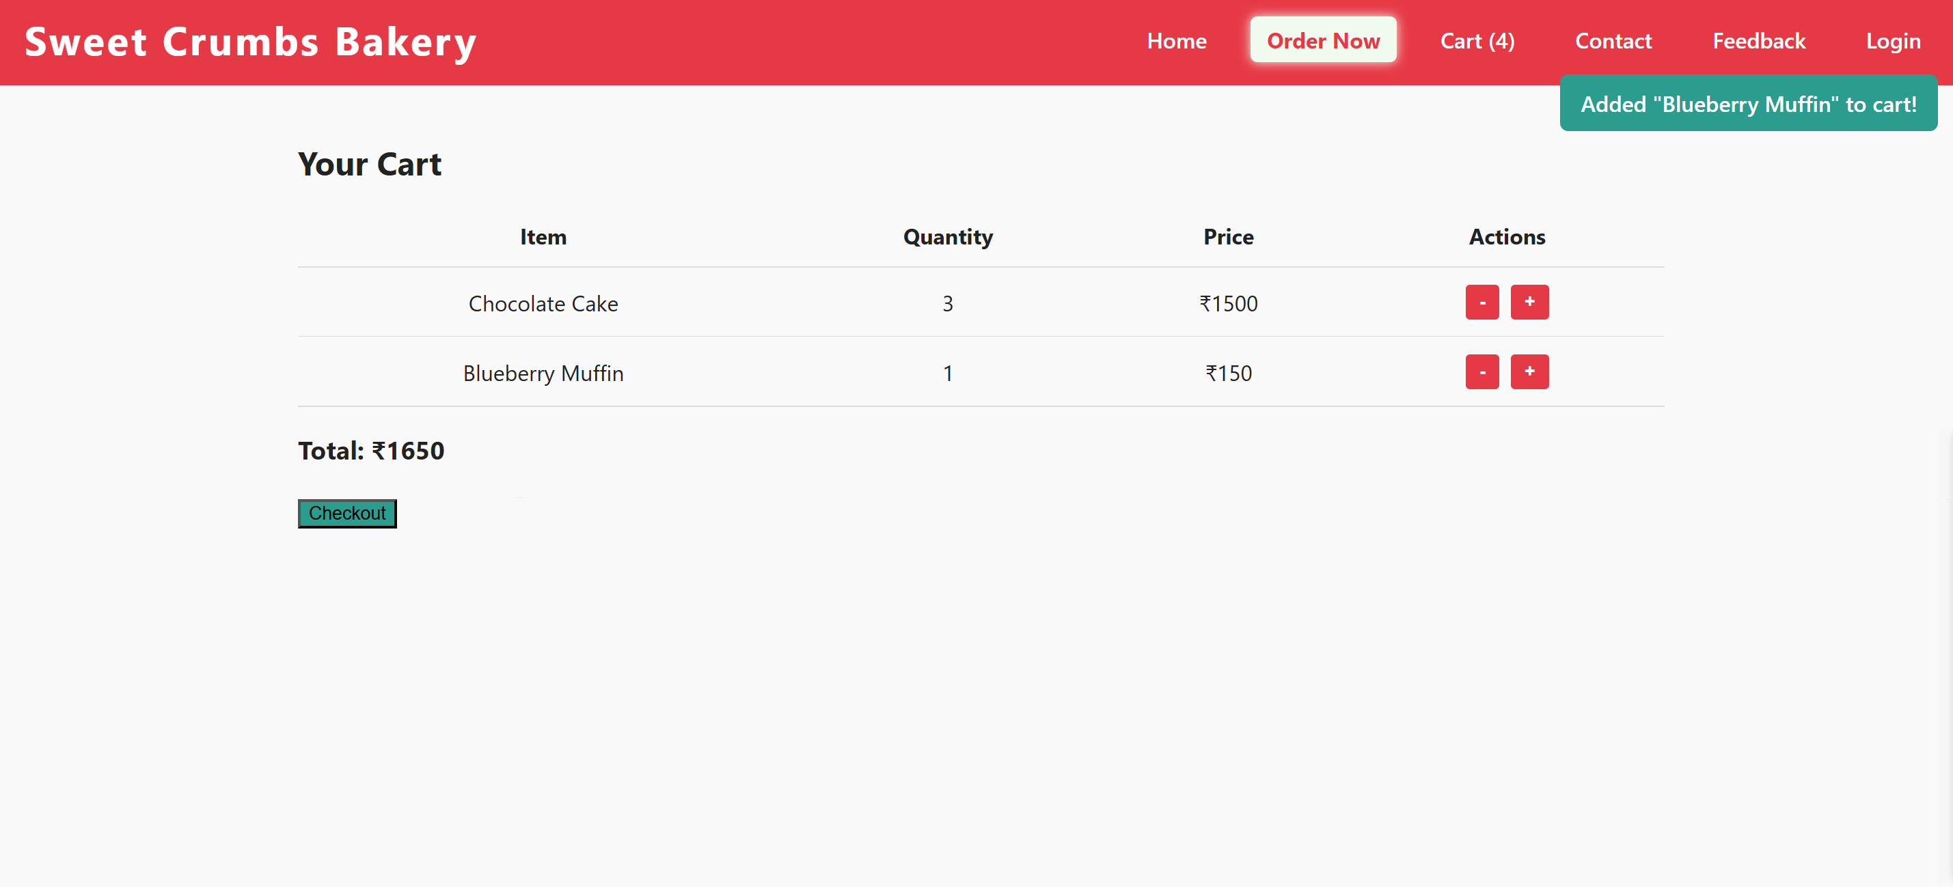  4. Feedback Form:  