**华为认证系列教程**

**HCNA-HNTD入门**

**华为网络技术与设备**

**实验指导书**



**华为技术有限公司**

|  |
| --- |
| 版权声明  **版权所有 © 华为技术有限公司 2016。 保留一切权利。**  本书所有内容受版权法保护，华为拥有所有版权，但注明引用其他方的内容除外。未经华为技术有限公司事先书面许可，任何人、任何组织不得将本书的任何内容以任何方式进行复制、经销、翻印、存储于信息检索系统或使用于任何其他任何商业目的。  版权所有 侵权必究。  **商标声明**  image001和其他华为商标均为华为技术有限公司的商标。  本文档提及的其他所有商标或注册商标，由各自的所有人拥有。 |

**华为认证系列教程**

**HCNA-HNTD华为网络技术与设备**

**实验指导书**

**第2.2版本**

**华为认证体系介绍**

华为认证是华为凭借多年信息通信技术人才培养经验及对行业发展的深刻理解，基于ICT产业链人才职业发展生命周期，以学院化的职业技术认证为指引，搭载华为“云－管－端”融合技术，推出覆盖IP、IT、CT技术领域的认证体系，是业界唯一的ICT全技术领域认证体系。

基于IP、IT、CT技术，华为公司提供了工程师、资深工程师和专家三类技术认证等级，为ICT从业者提供了层次化的培训认证。华为认证包括10个领域，12个技术方向的认证，是业界唯一覆盖ICT全技术领域的认证体系。

HCNA是对企业网络初级知识和技能的认证。证明您具备配置和维护小型企业网络的能力。HCNA认证考查工程师协助设计、部署小型企业网络和基本网络运维的能力。目的是考察企业网络工程师使用华为网络设备搭建小型企业路由交换网络的能力，使之能承载基本的语音、无线、云、安全和存储等网络应用，满足企业对网络的使用需求。HCNA定位于企业网络技术领域具备初级知识和技能水平的专业人士。侧重于对初级企业网络技术的考察和认证。具备HCNA证书的工程师是公认的具备小型企业网络通用技术和基本设计能力的专业人士。

HCNP-R&S是对企业网络高级知识和技能的认证。目的是帮助企业网络工程师使用华为网络设备搭建完整的中小型企业网络，并支撑企业所需的语音、无线、云、安全和存储等应用全面地集成到网络之中，满足企业各种应用对网络的使用需求，并提供较高的安全性、可用性和可靠性。HCNP-R&S定位于企业网络技术领域具备高级知识和技能水平的专业人士。侧重于对中小型企业网络技术的考察和认证。具备HCNP-R&S证书的工程师是公认的具备中小型企业网络构建和管理能力的专业人士。

HCIE-R&S是对企业网络专家级知识和技能的认证。目的是帮助企业网络高级工程师搭建完整的大型复杂企业网络，支撑企业所需的语音、无线、云、安全和存储等应用全面集成到网络之中，满足企业各种应用对网络的使用需求。同时能够提供完整的故障排除能力，可根据企业和网络技术发展来规划企业网络，并提高安全性、可用性和可靠性。HCIE-R&S定位于企业网络技术领域中具备专家知识和技能水平的专业人士。侧重于对大型复杂企业网络技术的考察和认证。具备HCIE-R&S证书的工程师是公认的具备大型复杂企业网络构建、优化和管理能力的专业人士。

华为认证协助您打开行业之窗，开启改变之门，屹立在ICT世界的潮头浪尖！

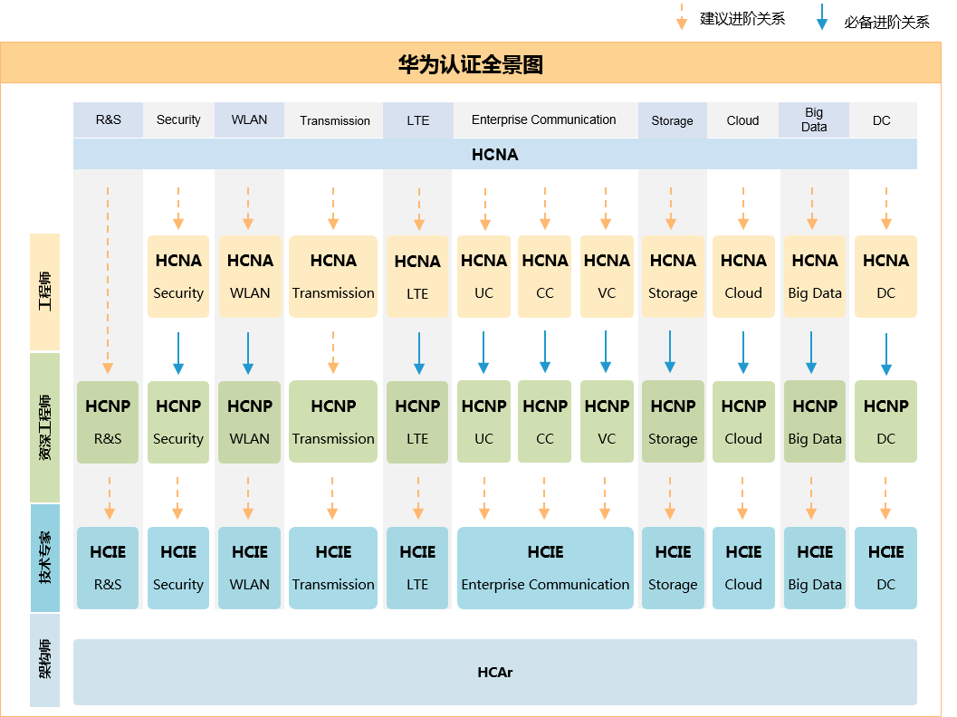

**本书常用图标**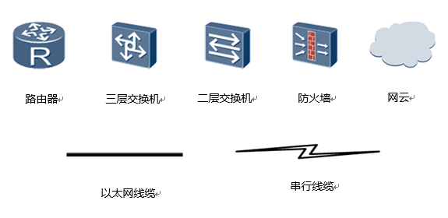

**实验环境说明**

组网介绍

本实验环境面向准备HCNA-HNTD考试的网络工程师，内容由HCNA-HNTD的VRP基础操作、路由协议原理、以太网交换技术、广域网技术、网络安全技术等部分的实验组成。

实验设备包括路由器3台，交换机4台。每套实验环境适用于2名学员同时上机操作。

设备介绍

为了满足HCNA-HNTD实验需要，建议每套实验环境采用以下配置：

设备名称、型号与版本的对应关系如下：

|  |  |  |
| --- | --- | --- |
| 设备名称 | 设备型号 | 软件版本 |
| R1 | AR 2220E | V2R7 |
| R2 | AR 2220E | V2R7 |
| R3 | AR 2220E | V2R7 |
| S1 | S5720-36C-EI-AC | V2R8 |
| S2 | S5720-36C-EI-AC | V2R8 |
| S3 | S3700-28TP-EI-AC | V1R6C5 |
| S4 | S3700-28TP-EI-AC | V1R6C5 |

**目录**

第一章 使用eNSP搭建基础网络 1

实验1-1 搭建基础IP网络 1

第二章 设备基础配置 11

实验2-1 设备基础配置 11

第三章 STP和RSTP 22

实验3-1 配置STP 22

实验3-2 配置RSTP 42

第四章 路由配置 51

实验4-1 配置静态路由和缺省路由 51

实验4-2 配置RIPv1和RIPv2 68

实验4-3 RIPv2路由汇总和认证 81

实验4-4 OSPF单区域配置 98

第五章 FTP和DHCP 115

实验5-1 配置FTP业务 115

实验5-2 配置DHCP 123

第一章 使用eNSP搭建基础网络

实验1-1 搭建基础IP网络

学习目标

* 掌握eNSP模拟器的基本设置方法
* 掌握使用eNSP搭建简单的端到端网络的方法
* 掌握在eNSP中使用Wireshark捕获IP报文的方法

## **场景**

在本实验中，您将熟悉华为eNSP模拟器的基本使用，并使用模拟器自带的抓包软件捕获网络中的报文，以便更好地理解IP网络的工作原理。

操作步骤

1. 启动eNSP

本步骤介绍eNSP模拟器的启动与初始化界面。通过模拟器的使用将能够帮助您快速学习与掌握TCP/IP的原理知识，熟悉网络中的各种操作。

开启eNSP后，您将看到如下界面。左侧面板中的图标代表eNSP所支持的各种产品及设备。中间面板则包含多种网络场景的样例。

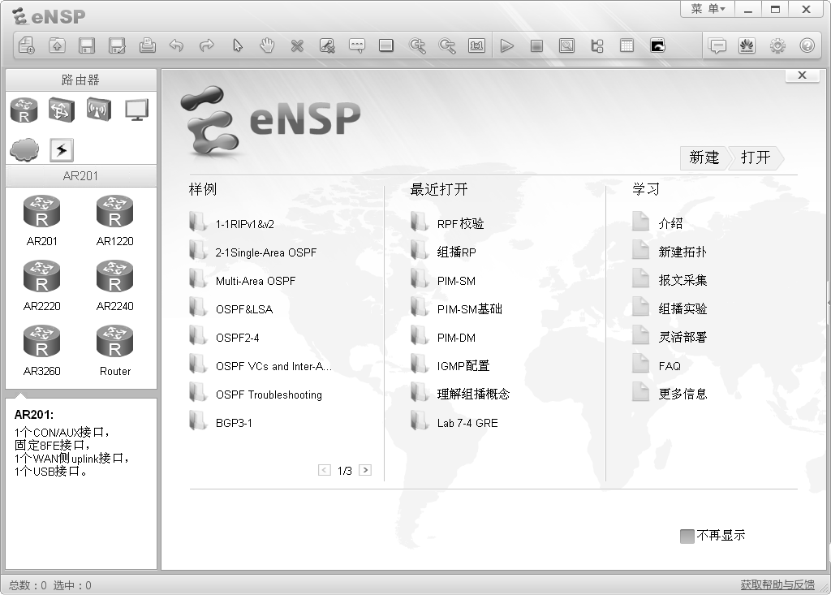

单击窗口左上角的“新建”图标，创建一个新的实验场景。

您可以在弹出的空白界面上搭建网络拓扑图，练习组网，分析网络行为。在本示例中，您需要使用两台终端系统建立一个简单的端到端网络。

1. 建立拓扑

在左侧面板顶部，单击“终端”图标。在显示的终端设备中，选中“PC”图标，把图标拖动到空白界面上。



使用相同步骤，再拖动一个PC图标到空白界面上，建立一个端到端网络拓扑。PC设备模拟的是终端主机，可以再现真实的操作场景。

1. 建立一条物理连接

在左侧面板顶部，单击“设备连线”图标。在显示的媒介中，选择“Copper (Ethernet)”图标。单击图标后，光标代表一个连接器。单击客户端设备，会显示该模拟设备包含的所有端口。单击“Ethernet 0/0/1”选项，连接此端口。

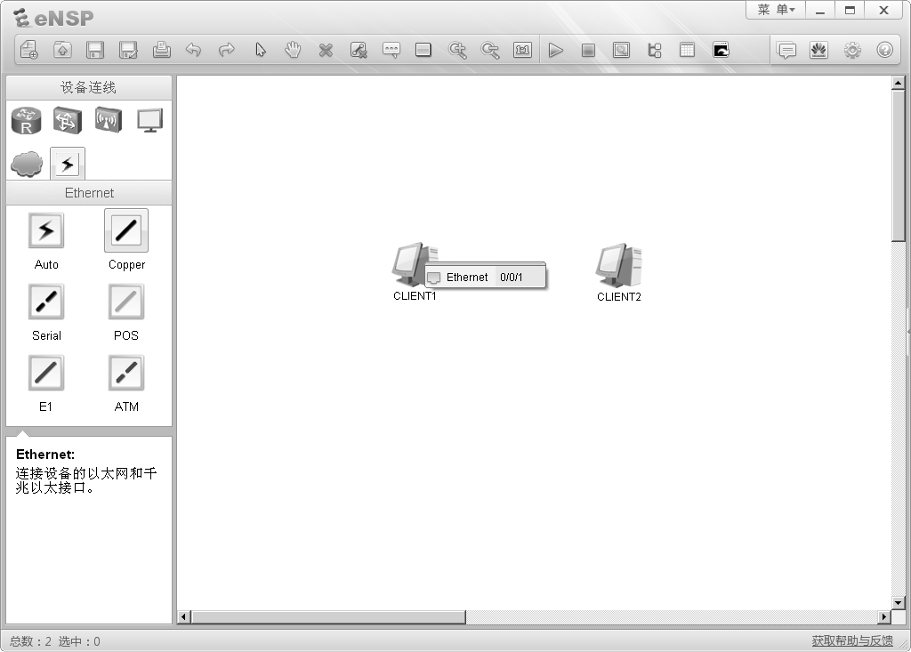

单击另外一台设备并选择“Ethernet 0/0/1”端口作为该连接的终点，此时，两台设备间的连接完成。

可以观察到，在已建立的端到端网络中，连线的两端显示的是两个红点，表示该连线连接的两个端口都处于Down状态。

1. 进入终端系统配置界面

右击一台终端设备，在弹出的属性菜单中选择“设置”选项，查看该设备的系统配置信息。

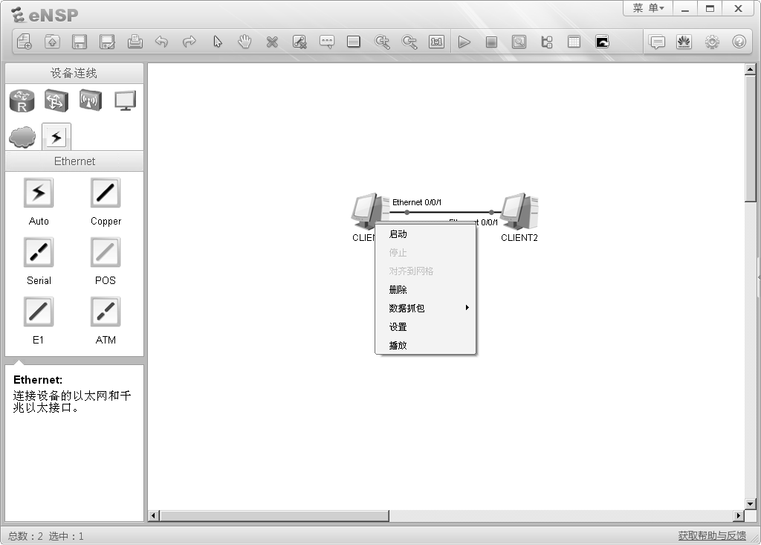

弹出的设置属性窗口包含“基础配置”、“命令行”、“组播”与“UDP发包工具”四个标签页，分别用于不同需求的配置。

1. 配置终端系统

选择“基础配置”标签页，在“主机名”文本框中输入主机名称。在“IPv4配置”区域，单击“静态”选项按钮。在“IP地址”文本框中输入IP地址。建议按照下图所示配置IP地址及子网掩码。配置完成后，单击窗口右下角的“应用”按钮。再单击“CLIENT1”窗口右上角的关闭该窗口。

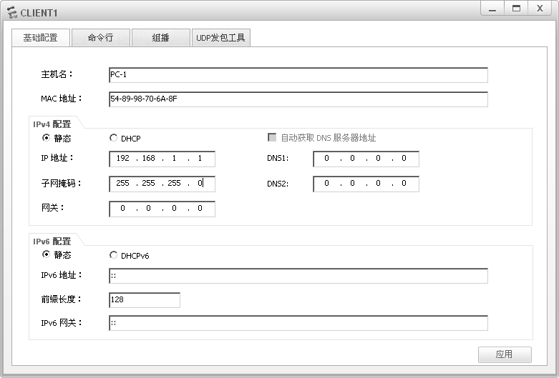

使用相同步骤配置CLIENT2。建议将CLIENT2的IP地址配置为192.168.1.2，子网掩码配置为255.255.255.0。

完成基础配置后，两台终端系统可以成功建立端到端通信。

1. 启动终端系统设备

可以使用以下两种方法启动设备：

* 右击一台设备，在弹出的菜单中，选择“启动”选项，启动该设备。
* 拖动光标选中多台设备（如下图），通过右击显示菜单，选择“启动”选项，启动所有设备。

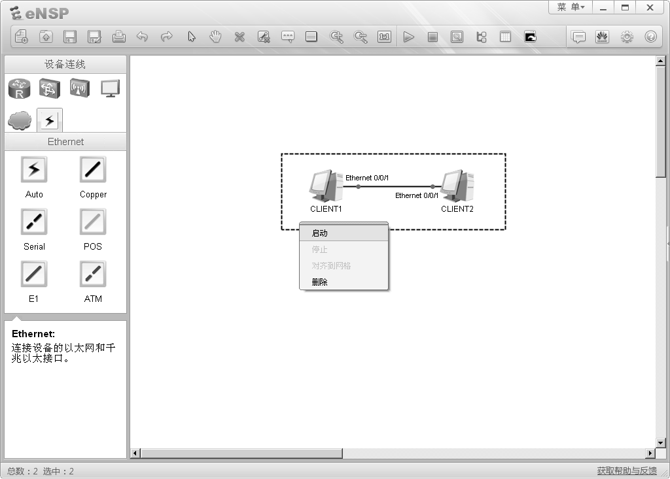

设备启动后，线缆上的红点将变为绿色，表示该连接为Up状态。

当网络拓扑中的设备变为可操作状态后，您可以监控物理链接中的接口状态与介质传输中的数据流。

1. 捕获接口报文

选中设备并右击，在显示的菜单中单击“数据抓包”选项后，会显示设备上可用于抓包的接口列表。从列表中选择需要被监控的接口。

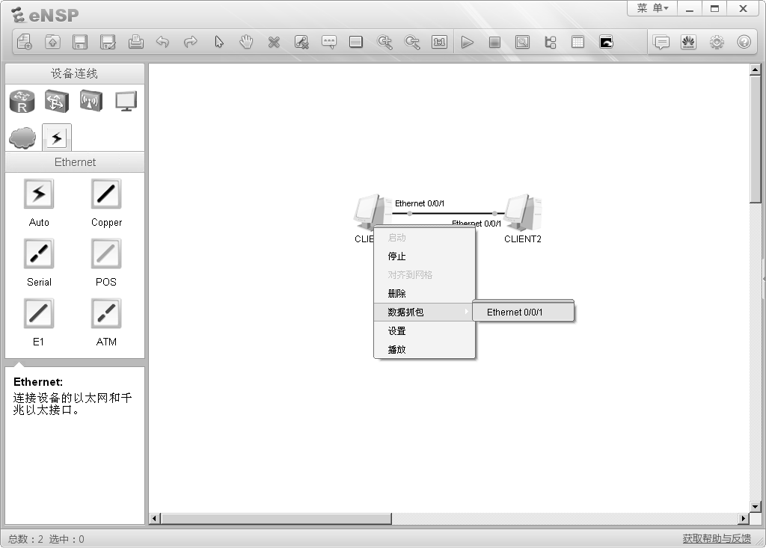

接口选择完成后，Wireshark抓包工具会自动激活，捕获选中接口所收发的所有报文。如需监控更多接口，重复上述步骤，选择不同接口即可，Wireshark将会为每个接口激活不同实例来捕获数据包。

根据被监控设备的状态，Wireshark可捕获选中接口上产生的所有流量，生成抓包结果。在本实例的端到端组网中，需要先通过配置来产生一些流量，再观察抓包结果。

1. 生成接口流量

可以使用以下两种方法打开命令行界面：

* 双击设备图标，在弹出的窗口中选择“命令行”标签页。
* 右击设备图标，在弹出的属性菜单中，选择“设置”选项，然后在弹出的窗口中选择“命令行” 标签页。

产生流量最简单的方法是使用ping命令发送ICMP报文。在命令行界面输入ping <*ip address*>命令，其中<*ip address*>设置为对端设备的IP地址。

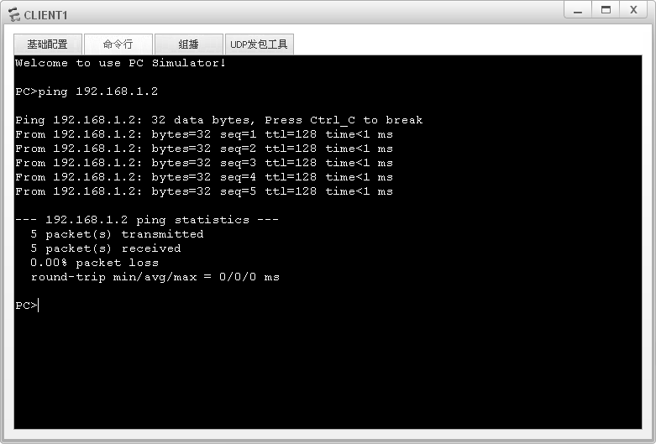

生成的流量会在该界面的回显信息中显示，包含发送的报文和接收的报文。

生成流量之后，通过Wireshark捕获报文并生成抓包结果。您可以在抓包结果中查看到IP网络的协议的工作过程，以及报文中所基于OSI参考模型各层的详细内容。

1. 观察捕获的报文

查看Wireshark所抓取到的报文的结果。

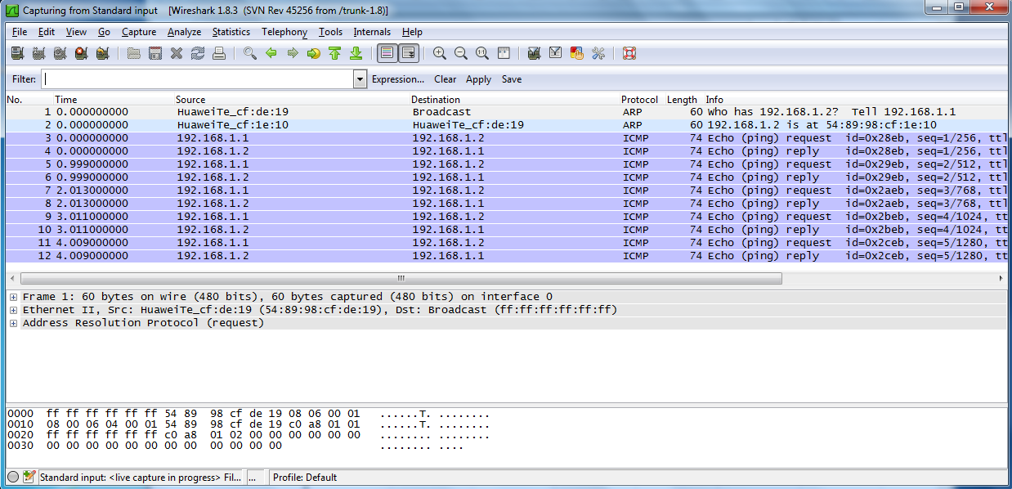

Wireshark程序包含许多针对所捕获报文的管理功能。其中一个比较常用的功能是过滤功能，可用来显示某种特定报文或协议的抓包结果。在菜单栏下面的“Filter”文本框里输入过滤条件就可以使用该功能。最简单的过滤方法是在文本框中先输入协议名称（小写字母），再按回车键。在本示例中，Wireshark抓取了ICMP与ARP两种协议的报文。在“Filter”文本框中输入icmp或arp再按回车键后，在回显中就将只显示ICMP或ARP报文的捕获结果。

Wireshark界面包含三个面板，分别显示的是数据包列表、每个数据包的内容明细以及数据包对应的十六进制的数据格式。报文内容明细对于理解协议报文格式十分重要，同时也显示了基于OSI参考模型的各层协议的详细信息。

第二章 设备基础配置

实验2-1 设备基础配置

学习目标

* 掌握设备系统参数的配置方法，包括设备名称、系统时间及系统时区
* 掌握Console口空闲超时时长的配置方法
* 掌握登录信息的配置方法
* 掌握登录密码的配置方法
* 掌握保存配置文件的方法
* 掌握配置路由器接口IP地址的方法
* 掌握测试两台直连路由器连通性的方法
* 掌握重启设备的方法

## **拓扑图**

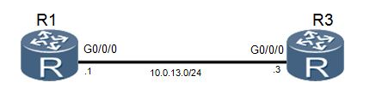

图2.1 设备基础配置拓扑图

## **场景**

您是公司的网络管理员，现在公司购买了两台华为AR G3系列路由器。路由器在使用之

前，需要先配置路由器的设备名称、系统时间及登录密码等管理信息。

## **操作步骤**

1. 查看系统信息

执行**display version**命令，查看路由器的软件版本与硬件信息。

<Huawei>display version

Huawei Versatile Routing Platform Software

VRP (R) software, Version 5.160 (AR2200 V200R007C00SPC600)

Copyright (C) 2011-2016 HUAWEI TECH CO., LTD

Huawei AR2220E Router uptime is 0 week, 3 days, 21 hours, 43 minutes

BKP 0 version information:

......output omit......

命令回显信息中包含了VRP版本，设备型号和启动时间等信息。

1. 修改系统时间

VRP系统会自动保存时间，但如果时间不正确，可以在用户视图下执行**clock timezone**命令和**clock datetime**命令修改系统时间。

<Huawei>clock timezone Local add 08:00:00

<Huawei>clock datetime 12:00:00 2016-03-11

您可以修改Local字段为当前地区的时区名称。如果当前时区位于UTC+0时区的西部，需要把add字段修改为minus。

执行**display clock**命令查看生效的新系统时间。

<Huawei>display clock

2016-03-11 12:00:10

Friday

Time Zone(Local) : UTC+08:00

1. 帮助功能和命令自动补全功能

在系统中输入命令时，问号是通配符，Tab键是自动补全命令的快捷键。

<Huawei>display ?

Cellular Cellular interface

aaa AAA

access-user User access

accounting-scheme Accounting scheme

acl <Group> acl command group

actived-alarm Actived alarm

actual Current actual

alarm Alarm

als Als

antenna Current antenna that outputting radio

anti-attack Specify anti-attack configurations

ap <Group> ap command group

ap-auth-mode Display AP authentication mode

......output omit......

在输入信息后输入“？”可查看以输入字母开头的命令。如输入“dis？”，设备将输出所有以dis开头的命令。

在输入的信息后增加空格，再输入“？”，这时设备将尝试识别输入的信息所对应的命令，然后输出该命令的其他参数。例如输入“dis ？”，如果只有display命令是以dis开头的，那么设备将输出display命令的参数；如果以dis开头的命令还有其他的，设备将报错。

另外可以使用键盘上Tab键补全命令，比如键入“dis”后，按键盘“Tab”键可以将命令补全为“display”。如有多个以“dis”开头的命令存在，则在多个命令之间循环切换。

命令在不发生歧义的情况下可以使用简写，如“display”可以简写为“dis”或“disp”等，“interface”可以简写为“int”或“inter”等。

1. 进入系统视图

使用**system-view**命令可以进入系统视图，这样才可以配置接口、协议等内容。

<Huawei>system-view

Enter system view, return user view with Ctrl+Z.

1. 修改设备名称

配置设备时，为了便于区分，往往给设备定义不同的名称。如下我们依照实验拓扑图，修改设备名称。

修改R1路由器的设备名称为R1。

[Huawei]sysname R1

[R1]

修改R3路由器的设备名称为R3。

[Huawei]sysname R3

[R3]

1. 配置登录信息

配置登陆标语信息来进行提示或进行登陆警告。执行**header shell information**命令配置登录信息。

[R1]header shell information "Welcome to the Huawei certification lab."

退出路由器命令行界面，再重新登录命令行界面，查看登录信息是否已经修改。

[R1]quit

<R1>quit

Configuration console exit, please press any key to log on

Welcome to the Huawei certification lab.

<R1>

1. 配置Console口参数

默认情况下，通过Console口登陆无密码，任何人都可以直接连接到设备，进行配置。

为避免由此带来的风险，可以将Console接口登录方式配置为密码认证方式，密码为密文形式的“Huawei@123”。

空闲时间指的是经过没有任何操作的一定时间后，会自动退出该配置界面，再次登陆会根据系统要求，提示输入密码进行验证。

设置空闲超时时间为20分钟，默认为10分钟。

[R1]user-interface console 0

[R1-ui-console0]authentication-mode password

[R1-ui-console0]set authentication password cipher

Warning: The "password" authentication mode is not secure, and it is strongly recommended to use "aaa" authentication mode.

Enter Password(<8-128>):

Confirm password:

[R1-ui-console0] idle-timeout 20 0

执行**display this**命令查看配置结果。

[R1-ui-console0]display this

[V200R007C00SPC600]

#

user-interface con 0

authentication-mode password

set authentication password cipher %^%#[cR8Y%Qf_6Ra=OPEu'SFa*b$4hjW[O!/dX,6>9xW:ZQMPh6R1SbJt2SW`Y]:%^%#

idle-timeout 20 0

user-interface vty 0

authentication-mode aaa

user privilege level 15

user-interface vty 1 4

#

return

退出系统，并使用新配置的密码登录系统。需要注意的是，在路由器第一次初始化启动时，也需要配置密码。

[R1-ui-console0]**return**

<R1>**quit**

Configuration console exit, please press any key to log on

Login authentication

Password:

Welcome to Huawei certification lab

<R1>

1. 配置接口IP地址和描述信息

配置R1上GigabitEthernet 0/0/0接口的IP地址。使用点分十进制格式（如255.255.255.0）或根据子网掩码前缀长度配置子网掩码。

[R1]interface GigabitEthernet 0/0/0

[R1-GigabitEthernet0/0/0]ip address 10.0.13.1 24

[R1-GigabitEthernet0/0/0]description This interface connects to R3-G0/0/0

在当前接口视图下，执行**display this**命令查看配置结果。

[R1-GigabitEthernet0/0/0]display this

[V200R007C00SPC600]

#

interface GigabitEthernet0/0/0

description This interface connects to R3-G0/0/0

ip address 10.0.13.1 255.255.255.0

#

return

执行**display interface**命令查看接口信息。

[R1]display interface GigabitEthernet0/0/0

GigabitEthernet0/0/0 current state : UP

Line protocol current state : UP

Last line protocol up time : 2016-03-11 04:13:09

Description:This interface connects to R3-G0/0/0

Route Port,The Maximum Transmit Unit is 1500

Internet Address is 10.0.13.1/24

IP Sending Frames' Format is PKTFMT_ETHNT_2, Hardware address is 5489-9876-830b

Last physical up time : 2016-03-10 03:24:01

Last physical down time : 2016-03-10 03:25:29

Current system time: 2016-03-11 04:15:30

Port Mode: FORCE COPPER

Speed : 100, Loopback: NONE

Duplex: FULL, Negotiation: ENABLE

Mdi : AUTO, Clock : -

Last 300 seconds input rate 2296 bits/sec, 1 packets/sec

Last 300 seconds output rate 88 bits/sec, 0 packets/sec

Input peak rate 7392 bits/sec,Record time: 2016-03-10 04:08:41

Output peak rate 1120 bits/sec,Record time: 2016-03-10 03:27:56

Input: 3192 packets, 895019 bytes

Unicast: 0, Multicast: 1592

Broadcast: 1600, Jumbo: 0

Discard: 0, Total Error: 0

CRC: 0, Giants: 0

Jabbers: 0, Throttles: 0

Runts: 0, Symbols: 0

Ignoreds: 0, Frames: 0

Output: 181 packets, 63244 bytes

Unicast: 0, Multicast: 0

Broadcast: 181, Jumbo: 0

Discard: 0, Total Error: 0

Collisions: 0, ExcessiveCollisions: 0

Late Collisions: 0, Deferreds: 0

Input bandwidth utilization threshold : 100.00%

Output bandwidth utilization threshold: 100.00%

Input bandwidth utilization : 0.01%

Output bandwidth utilization : 0%

从命令回显信息中可以看到，接口的物理状态与协议状态均为Up，表示对应的物理层与数据链路层均可用。

配置R3上GigabitEthernet 0/0/0接口的IP地址与描述信息。

[R3]interface GigabitEthernet 0/0/0

[R3-GigabitEthernet0/0/0]ip address 10.0.13.3 255.255.255.0 [R3-GigabitEthernet0/0/0]description This interface connects to R1-G0/0/0

配置完成后，通过执行ping命令测试R1和R3间的连通性。

<R1>ping 10.0.13.3

PING 10.0.13.3: 56 data bytes, press CTRL_C to break

Reply from 10.0.13.3: bytes=56 Sequence=1 ttl=255 time=35 ms

Reply from 10.0.13.3: bytes=56 Sequence=2 ttl=255 time=32 ms

Reply from 10.0.13.3: bytes=56 Sequence=3 ttl=255 time=32 ms

Reply from 10.0.13.3: bytes=56 Sequence=4 ttl=255 time=32 ms

Reply from 10.0.13.3: bytes=56 Sequence=5 ttl=255 time=32 ms

--- 10.0.13.3 ping statistics ---

5 packet(s) transmitted

5 packet(s) received

0.00% packet loss

round-trip min/avg/max = 32/32/35 ms

1. 查看当前设备上存储的文件列表

在用户视图下执行**dir**命令，查看当前目录下的文件列表。

<R1>dir

Directory of flash:/

Idx Attr Size(Byte) Date Time(LMT) FileName

0 -rw- 1,738,816 Mar 10 2016 11:50:24 web.zip

1 -rw- 68,288,896 Mar 10 2016 14:17:5 ar2220E-v200r007c00spc600.cc

2 -rw- 739 Mar 10 2016 16:01:17 vrpcfg.zip

1,927,476 KB total (1,856,548 KB free)

<R3>dir

Directory of flash:/

Idx Attr Size(Byte) Date Time(LMT) FileName

0 -rw- 1,738,816 Mar 10 2016 11:50:58 web.zip

1 -rw- 68,288,896 Mar 10 2016 14:19:0 ar2220E-v200r007c00spc600.cc

2 -rw- 739 Mar 10 2016 16:03:04 vrpcfg.zip

1,927,476 KB total (1,855,076 KB free)

1. 管理设备配置文件

执行**display saved-configuration**命令查看保存的配置文件。

<R1>display saved-configuration

There is no correct configuration file in FLASH

系统中没有已保存的配置文件。执行**save**命令保存当前配置文件。

<R1>save

The current configuration will be written to the device.

Are you sure to continue? (y/n)[n]:**y**

It will take several minutes to save configuration file, please wait............

Configuration file had been saved successfully

Note: The configuration file will take effect after being activated

重新执行**display saved-configuration**命令查看已保存的配置信息。

<R1>display saved-configuration

[V200R007C00SPC600]

#

sysname R1

header shell information "Welcome to Huawei certification lab"

#

board add 0/1 1SA

board add 0/2 1SA

……**output omit**……

执行**display current-configuration**命令查看当前配置信息。

<R1>display current-configuration

[V200R007C00SPC600]

#

sysname R1

header shell information "Welcome to Huawei certification lab"

#

board add 0/1 1SA

board add 0/2 1SA

board add 0/3 2FE

……**output omit**……

一台路由器可以存储多个配置文件。执行**display startup**命令查看下次启动时使用的配置文件。

<R3>display startup

MainBoard:

Startup system software: flash:/AR2220E-v200R007C00SPC600.cc

Next startup system software: flash:/AR2220E-V200R007C00SPC600.cc

Backup system software for next startup: null

Startup saved-configuration file: null

Next startup saved-configuration file: flash:/vrpcfg.zip

Startup license file: null

Next startup license file: null

Startup patch package: null

Next startup patch package: null

Startup voice-files: null

Next startup voice-files: null

删除闪存中的配置文件。

<R1>reset saved-configuration

This will delete the configuration in the flash memory.

The device configurations will be erased to reconfigure.

Are you sure? (y/n)[n]:**y**

Clear the configuration in the device successfully.

<R3>reset saved-configuration

This will delete the configuration in the flash memory.

The device configurations will be erased to reconfigure.

Are you sure? (y/n)[n]:**y**

Clear the configuration in the device successfully.

1. 重启设备

执行**reboot**命令重启路由器。

<R1>reboot

Info: The system is now comparing the configuration, please wait.

Warning: All the configuration will be saved to the next startup configuration. Continue ? [y/n]:**n**

System will reboot! Continue ? [y/n]:**y**

Info: system is rebooting ,please wait...

<R3>reboot

Info: The system is now comparing the configuration, please wait.

Warning: All the configuration will be saved to the next startup configuration. Continue ? [y/n]:**n**

System will reboot! Continue ? [y/n]:**y**

系统提示是否保存当前配置，可根据实验要求决定是否保存当前配置。如果无法确定是否保存，则不保存当前配置。

## **配置文件**

[R1]display current-configuration

[V200R007C00SPC600]

#

sysname R1

header shell information "Welcome to Huawei certification lab"

#

interface GigabitEthernet0/0/0

description This interface connects to R3-G0/0/0

ip address 10.0.13.1 255.255.255.0

#

user-interface con 0

authentication-mode password

set authentication password cipher %$%$4D0K*-E"t/I7[{HD~kgW,%dgkQQ!&|;XTDq9SFQJ.27M%dj,%$%$

idle-timeout 20 0

#

return

[R3]dispay current-configuration

[V200R007C00SPC600]

#

sysname R3

#

interface GigabitEthernet0/0/0

description This interface connect to R1-G0/0/0

ip address 10.0.13.3 255.255.255.0

#

user-interface con 0

authentication-mode password

set authentication password cipher %$%$M8\HO3:72:ERQ8JLoHU8,%t+lE:$9=a7"8%yMoARB]$B%t.,%$%$

user-interface vty 0 4

#

return

第三章 STP和RSTP

实验3-1 配置STP

学习目标

* 掌握启用和禁用STP的方法
* 掌握修改交换机STP模式的方法
* 掌握修改桥优先级，控制根桥选举的方法
* 掌握修改端口优先级，控制根端口和指定端口选举的方法
* 掌握修改端口开销，控制根端口和指定端口选举的方法
* 掌握边缘端口的配置方法

## **拓扑图**

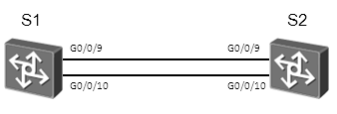

图3.1 配置STP实验拓扑图

## **场景**

您是公司的网络管理员，为了避免网络中的环路问题，需要在网络中的交换机上配置STP。本实验中，您还需要通过修改桥优先级来控制STP的根桥选举，并通过配置STP的一些特性来加快STP的收敛速度。

操作步骤

1. 配置STP并验证

为了保证实验结果的准确性，必须先关闭无关的端口。

配置STP之前，先关闭S1上的G0/0/1、G0/0/2、G0/0/3、G0/0/13、G0/0/14端口，S2的G0/0/1、G0/0/2、G0/0/3、G0/0/6、G0/0/7端口，S3上的E0/0/1、E0/0/7、E0/0/13端口，S4上的E0/0/1、E0/0/6、E0/0/14端口。确保设备以空配置启动。如果STP被禁用，则执行stp enable命令启用STP。

<Quidway>system-view

Enter system view, return user view with Ctrl+Z.

[Quidway]sysname S1

[S1]interface GigabitEthernet 0/0/1

[S1-GigabitEthernet0/0/1]shutdown

[S1-GigabitEthernet0/0/1]quit

[S1]interface GigabitEthernet 0/0/2

[S1-GigabitEthernet0/0/2]shutdown

[S1-GigabitEthernet0/0/2]quit

[S1]interface GigabitEthernet 0/0/3

[S1-GigabitEthernet0/0/3]shutdown

[S1-GigabitEthernet0/0/3]quit

[S1]interface GigabitEthernet 0/0/13

[S1-GigabitEthernet0/0/13]shutdown

[S1-GigabitEthernet0/0/13]quit

[S1]interface GigabitEthernet 0/0/14

[S1-GigabitEthernet0/0/14]shutdown

[S1-GigabitEthernet0/0/14]quit

<Quidway>system-view

Enter system view, return user view with Ctrl+Z.

[Quidway]sysname S2

[S2]interface GigabitEthernet 0/0/1

[S2-GigabitEthernet0/0/1]shutdown

[S2-GigabitEthernet0/0/1]quit

[S2]interface GigabitEthernet 0/0/2

[S2-GigabitEthernet0/0/2]shutdown

[S2-GigabitEthernet0/0/2]quit

[S2]interface GigabitEthernet 0/0/3

[S2-GigabitEthernet0/0/3]shutdown

[S2-GigabitEthernet0/0/3]quit

[S2]interface GigabitEthernet 0/0/6

[S2-GigabitEthernet0/0/6]shutdown

[S2-GigabitEthernet0/0/6]quit

[S2]interface GigabitEthernet 0/0/7

[S2-GigabitEthernet0/0/7]shutdown

[S2-GigabitEthernet0/0/7]quit

<Quidway>system-view

Enter system view, return user view with Ctrl+Z.

[Quidway]sysname S3

[S3]interface Ethernet 0/0/1

[S3-Ethernet0/0/1]shutdown

[S3-Ethernet0/0/1]quit

[S3]interface Ethernet 0/0/13

[S3-Ethernet0/0/13]shutdown

[S3-Ethernet0/0/13]quit

[S3]interface Ethernet 0/0/7

[S3-Ethernet0/0/7]shutdown

<Quidway>system-view

Enter system view, return user view with Ctrl+Z.

[Quidway]sysname S4

[S4]inter Ethernet 0/0/1

[S4-Ethernet0/0/1]shutdown

[S4-Ethernet0/0/1]quit

[S4]inter Ethernet 0/0/14

[S4-Ethernet0/0/14]shutdown

[S4-Ethernet0/0/14]quit

[S4]interface Ethernet 0/0/6

[S4-Ethernet0/0/6]shutdown

本实验中，S1和S2之间有两条链路。在S1和S2上启用STP，并把S1配置为根桥。

[S1]stp mode stp

Info: This operation may take a few seconds. Please wait for a moment...done.

[S1]stp root primary

[S2]stp mode stp

Info: This operation may take a few seconds. Please wait for a moment...done.

[S2]stp root secondary

执行**display stp brief**命令查看STP信息。

<S1>display stp brief

MSTID Port Role STP State Protection

0 GigabitEthernet0/0/9 DESI FORWARDING NONE

0 GigabitEthernet0/0/10 DESI FORWARDING NONE

<S2>display stp brief

MSTID Port Role STP State Protection

0 GigabitEthernet0/0/9 ROOT FORWARDING NONE

0 GigabitEthernet0/0/10 ALTE DISCARDING NONE

执行**display stp interface**命令查看端口的STP状态。

<S1>display stp interface GigabitEthernet 0/0/10

-------[CIST Global Info][Mode STP]-------

CIST Bridge :0 .d0d0-4ba6-aab0

Config Times :Hello 2s MaxAge 20s FwDly 15s MaxHop 20

Active Times :Hello 2s MaxAge 20s FwDly 15s MaxHop 20

CIST Root/ERPC :0 .d0d0-4ba6-aab0 / 0 (This bridge is the root)

CIST RegRoot/IRPC :0 .d0d0-4ba6-aab0 / 0

CIST RootPortId :0.0

BPDU-Protection :Disabled

CIST Root Type :Primary root

TC or TCN received :11

TC count per hello :0

STP Converge Mode :Normal

Share region-configuration :Enabled

Time since last TC :0 days 1h:43m:55s

Number of TC :29

Last TC occurred :GigabitEthernet0/0/9

----[Port10(GigabitEthernet0/0/10)][FORWARDING]----

Port Protocol :Enabled

Port Role :Designated Port

Port Priority :128

Port Cost(Dot1T ) :Config=auto / Active=20000

Designated Bridge/Port :0.d0d0-4ba6-aab0 / 128.10

Port Edged :Config=default / Active=disabled

Point-to-point :Config=auto / Active=true

Transit Limit :6 packets/s

Protection Type :None

Port STP Mode :STP

Port Protocol Type :Config=auto / Active=dot1s

BPDU Encapsulation :Config=stp / Active=stp

PortTimes :Hello 2s MaxAge 20s FwDly 15s RemHop 20

TC or TCN send :52

TC or TCN received :0

BPDU Sent :3189

TCN: 0, Config: 3189, RST: 0, MST: 0

BPDU Received :5

TCN: 0, Config: 5, RST: 0, MST: 0

Last forwarding time: 2016/11/21 14:55:11 UTC

<S2>display stp interface GigabitEthernet 0/0/10

-------[CIST Global Info][Mode STP]-------

CIST Bridge :4096 .d0d0-4ba6-ac20

Config Times :Hello 2s MaxAge 20s FwDly 15s MaxHop 20

Active Times :Hello 2s MaxAge 20s FwDly 15s MaxHop 20

CIST Root/ERPC :0 .d0d0-4ba6-aab0 / 20000

CIST RegRoot/IRPC :4096 .d0d0-4ba6-ac20 / 0

CIST RootPortId :128.9 (GigabitEthernet0/0/9)

BPDU-Protection :Disabled

CIST Root Type :Secondary root

TC or TCN received :122

TC count per hello :0

STP Converge Mode :Normal

Share region-configuration :Enabled

Time since last TC :0 days 1h:50m:0s

Number of TC :17

Last TC occurred :GigabitEthernet0/0/9

----[Port10(GigabitEthernet0/0/10)][DISCARDING]----

Port Protocol :Enabled

Port Role :Alternate Port

Port Priority :128

Port Cost(Dot1T ) :Config=auto / Active=20000

Designated Bridge/Port :0.d0d0-4ba6-aab0 / 128.10

Port Edged :Config=default / Active=disabled

Point-to-point :Config=auto / Active=true

Transit Limit :6 packets/s

Protection Type :None

Port STP Mode :STP

Port Protocol Type :Config=auto / Active=dot1s

BPDU Encapsulation :Config=stp / Active=stp

PortTimes :Hello 2s MaxAge 20s FwDly 15s RemHop 0

TC or TCN send :0

TC or TCN received :18

BPDU Sent :2

TCN: 0, Config: 2, RST: 0, MST: 0

BPDU Received :3317

TCN: 0, Config: 3317, RST: 0, MST: 0

1. 控制根桥选举

执行**display stp**命令查看根桥信息。根桥设备的CIST Bridge与CIST Root/ERPC字段取值相同。

<S1>display stp

-------[CIST Global Info][Mode STP]-------

CIST Bridge :0 .d0d0-4ba6-aab0

Config Times :Hello 2s MaxAge 20s FwDly 15s MaxHop 20

Active Times :Hello 2s MaxAge 20s FwDly 15s MaxHop 20

CIST Root/ERPC :0 .d0d0-4ba6-aab0 / 0 (This bridge is the root)

CIST RegRoot/IRPC :0 .d0d0-4ba6-aab0 / 0

CIST RootPortId :0.0

BPDU-Protection :Disabled

CIST Root Type :Primary root

TC or TCN received :11

TC count per hello :0

STP Converge Mode :Normal

Share region-configuration :Enabled

Time since last TC :0 days 2h:32m:25s

……output omit……

<S2>display stp

-------[CIST Global Info][Mode STP]-------

CIST Bridge :4096 .d0d0-4ba6-ac20

Config Times :Hello 2s MaxAge 20s FwDly 15s MaxHop 20

Active Times :Hello 2s MaxAge 20s FwDly 15s MaxHop 20

CIST Root/ERPC :0 .d0d0-4ba6-aab0 / 20000

CIST RegRoot/IRPC :4096 .d0d0-4ba6-ac20 / 0

CIST RootPortId :128.9 (GigabitEthernet0/0/9)

BPDU-Protection :Disabled

CIST Root Type :Secondary root

TC or TCN received :122

TC count per hello :0

STP Converge Mode :Normal

Share region-configuration :Enabled

Time since last TC :0 days 2h:35m:57s

……output omit……

通过配置优先级，使S2为根桥，S1为备份根桥。桥优先级取值越小，则优先级越高。把S1和S2的优先级分别设置为8192和4096。

[S1]undo stp root

[S1]stp priority 8192

[S2]undo stp root

[S2]stp priority 4096

执行**display stp**命令查看新的根桥信息。

<S1>display stp

-------[CIST Global Info][Mode STP]-------

CIST Bridge :8192 .d0d0-4ba6-aab0

Config Times :Hello 2s MaxAge 20s FwDly 15s MaxHop 20

Active Times :Hello 2s MaxAge 20s FwDly 15s MaxHop 20

CIST Root/ERPC :4096 .d0d0-4ba6-ac20 / 20000

CIST RegRoot/IRPC :8192 .d0d0-4ba6-aab0 / 0

CIST RootPortId :128.9 (GigabitEthernet0/0/9)

BPDU-Protection :Disabled

TC or TCN received :47

TC count per hello :0

STP Converge Mode :Normal

Share region-configuration :Enabled

Time since last TC :0 days 0h:6m:55s

……output omit……

<S2>display stp

-------[CIST Global Info][Mode STP]-------

CIST Bridge :4096 .d0d0-4ba6-ac20

Config Times :Hello 2s MaxAge 20s FwDly 15s MaxHop 20

Active Times :Hello 2s MaxAge 20s FwDly 15s MaxHop 20

CIST Root/ERPC :4096 .d0d0-4ba6-ac20 / 0 (This bridge is the root)

CIST RegRoot/IRPC :4096 .d0d0-4ba6-ac20 / 0

CIST RootPortId :0.0

BPDU-Protection :Disabled

TC or TCN received :135

TC count per hello :0

STP Converge Mode :Normal

Share region-configuration :Enabled

Time since last TC :0 days 0h:8m:4s

……output omit……

由上述回显信息中的灰色部分可以看出，S2已经变成新的根桥。

关闭S2的G0/0/9和G0/0/10端口，从而隔离S1与S2，模拟S2发生故障。

[S2]interface GigabitEthernet 0/0/9

[S2-GigabitEthernet0/0/9]shutdown

[S2-GigabitEthernet0/0/9]quit

[S2]interface GigabitEthernet 0/0/10

[S2-GigabitEthernet0/0/10]shutdown

<S1>display stp

-------[CIST Global Info][Mode STP]-------

CIST Bridge :8192 .d0d0-4ba6-aab0

Config Times :Hello 2s MaxAge 20s FwDly 15s MaxHop 20

Active Times :Hello 2s MaxAge 20s FwDly 15s MaxHop 20

CIST Root/ERPC :8192 .d0d0-4ba6-aab0 / 0 (This bridge is the root)

CIST RegRoot/IRPC :8192 .d0d0-4ba6-aab0 / 0

CIST RootPortId :0.0

BPDU-Protection :Disabled

TC or TCN received :174

TC count per hello :0

STP Converge Mode :Normal

Share region-configuration :Enabled

Time since last TC :0 days 0h:12m:51s

……output omit……

在上述回显信息中，灰色部分表明当S2故障时，S1变成根桥，然后开启S2之前关闭的接口。

[S2]interface GigabitEthernet 0/0/9

[S2-GigabitEthernet0/0/9]undo shutdown

[S2-GigabitEthernet0/0/9]quit

[S2]interface GigabitEthernet 0/0/10

[S2-GigabitEthernet0/0/10]undo shutdown

<S1>display stp

-------[CIST Global Info][Mode STP]-------

CIST Bridge :8192 .d0d0-4ba6-aab0

Config Times :Hello 2s MaxAge 20s FwDly 15s MaxHop 20

Active Times :Hello 2s MaxAge 20s FwDly 15s MaxHop 20

CIST Root/ERPC :4096 .d0d0-4ba6-ac20 / 20000

CIST RegRoot/IRPC :8192 .d0d0-4ba6-aab0 / 0

CIST RootPortId :128.34 (GigabitEthernet0/0/9)

BPDU-Protection :Disabled

TC or TCN received :195

TC count per hello :1

STP Converge Mode :Normal

Share region-configuration :Enabled

Time since last TC :0 days 0h:2m:59s

……output omit……

<S2>display stp

-------[CIST Global Info][Mode STP]-------

CIST Bridge :4096 .d0d0-4ba6-ac20

Config Times :Hello 2s MaxAge 20s FwDly 15s MaxHop 20

Active Times :Hello 2s MaxAge 20s FwDly 15s MaxHop 20

CIST Root/ERPC :4096 .d0d0-4ba6-ac20 / 0 (This bridge is the root)

CIST RegRoot/IRPC :4096 .d0d0-4ba6-ac20 / 0

CIST RootPortId :0.0

BPDU-Protection :Disabled

TC or TCN received :146

TC count per hello :0

STP Converge Mode :Normal

Share region-configuration :Enabled

Time since last TC :0 days 0h:2m:20s

……output omit……

在上述回显信息中，灰色部分表明S2已经恢复正常，重新变成根桥。

1. 控制根端口选举

在S1上执行**display stp brief**命令查看端口角色。

<S1>display stp brief

MSTID Port Role STP State Protection

0 GigabitEthernet0/0/9 ROOT FORWARDING NONE

0 GigabitEthernet0/0/10 ALTE DISCARDING NONE

上述回显信息表明G0/0/9是根端口，G0/0/10是Alternate端口。通过修改端口优先级，使G0/0/10成为根端口，G0/0/9成为Alternate端口。

修改S2上G0/0/9和G0/0/10端口的优先级。

缺省情况下端口优先级为128。端口优先级取值越大，则优先级越低。在S2上，修改G0/0/9的端口优先级值为32，G0/0/10的端口优先级值为16。因此，S1上的G0/0/10端口优先级值大于S2的G0/0/10端口优先级，成为根端口。

[S2]interface GigabitEthernet 0/0/9

[S2-GigabitEthernet0/0/9]stp port priority 32

[S2-GigabitEthernet0/0/9]quit

[S2]interface GigabitEthernet 0/0/10

[S2-GigabitEthernet0/0/10]stp port priority 16

提示：此处是修改S2的端口优先级，而不是修改S1的端口优先级。

<S2>display stp interface GigabitEthernet 0/0/9

-------[CIST Global Info][Mode STP]-------

CIST Bridge :4096 .d0d0-4ba6-ac20

Config Times :Hello 2s MaxAge 20s FwDly 15s MaxHop 20

Active Times :Hello 2s MaxAge 20s FwDly 15s MaxHop 20

CIST Root/ERPC :4096 .d0d0-4ba6-ac20 / 0 (This bridge is the root)

CIST RegRoot/IRPC :4096 .d0d0-4ba6-ac20 / 0

CIST RootPortId :0.0

BPDU-Protection :Disabled

TC or TCN received :147

TC count per hello :0

STP Converge Mode :Normal

Share region-configuration :Enabled

Time since last TC :0 days 0h:7m:35s

Number of TC :41

Last TC occurred :GigabitEthernet0/0/10

----[Port34(GigabitEthernet0/0/9)][FORWARDING]----

Port Protocol :Enabled

Port Role :Designated Port

Port Priority :32

Port Cost(Dot1T ) :Config=auto / Active=20000

Designated Bridge/Port :4096.d0d0-4ba6-ac20 / 32.34

Port Edged :Config=default / Active=disabled

Point-to-point :Config=auto / Active=true

Transit Limit :6 packets/s

Protection Type :None

Port STP Mode :STP

Port Protocol Type :Config=auto / Active=dot1s

BPDU Encapsulation :Config=stp / Active=stp

PortTimes :Hello 2s MaxAge 20s FwDly 15s RemHop 20

TC or TCN send :35

TC or TCN received :2

BPDU Sent :1013

TCN: 0, Config: 1013, RST: 0, MST: 0

BPDU Received :2

TCN: 2, Config: 0, RST: 0, MST: 0

Last forwarding time: 2016/11/22 10:00:00 UTC

<S2>display stp interface GigabitEthernet 0/0/10

-------[CIST Global Info][Mode STP]-------

CIST Bridge :4096 .d0d0-4ba6-ac20

Config Times :Hello 2s MaxAge 20s FwDly 15s MaxHop 20

Active Times :Hello 2s MaxAge 20s FwDly 15s MaxHop 20

CIST Root/ERPC :4096 .d0d0-4ba6-ac20 / 0 (This bridge is the root)

CIST RegRootIRPC :4096 .d0d0-4ba6-ac20 / 0

CIST RootPortId :0.0

BPDU-Protection :Disabled

TC or TCN received :147

TC count per hello :0

STP Converge Mode :Normal

Share region-configuration :Enabled

Time since last TC :0 days 0h:8m:19s

Number of TC :41

Last TC occurred :GigabitEthernet0/0/10

----[Port35(GigabitEthernet0/0/10)][FORWARDING]----

Port Protocol :Enabled

Port Role :Designated Port

Port Priority :16

Port Cost(Dot1T ) :Config=auto / Active=20000

Designated Bridge/Port :4096.d0d0-4ba6-ac20 / 16.35

Port Edged :Config=default / Active=disabled

Point-to-point :Config=auto / Active=true

Transit Limit :6 packets/s

Protection Type :None

Port STP Mode :STP

Port Protocol Type :Config=auto / Active=dot1s

BPDU Encapsulation :Config=stp / Active=stp

PortTimes :Hello 2s MaxAge 20s FwDly 15s RemHop 20

TC or TCN send :35

TC or TCN received :1

BPDU Sent :1032

TCN: 0, Config: 1032, RST: 0, MST: 0

BPDU Received :2

TCN: 1, Config: 1, RST: 0, MST: 0

Last forwarding time: 2016/11/22 10:00:11 UTC

在S1上执行**display stp brief**命令查看端口角色。

<S1>display stp brief

MSTID Port Role STP State Protection

0 GigabitEthernet0/0/9 ALTE DISCARDING NONE

0 GigabitEthernet0/0/10 ROOT FORWARDING NONE

在上述回显信息中，灰色部分表明S1的G0/0/10端口是根端口，G0/0/9是Alternate端口。

关闭S1的GigabitEthernet 0/0/10端口，再查看端口角色。

[S1]interface GigabitEthernet 0/0/10

[S1-GigabitEthernet0/0/10]shutdown

<S1>display stp brief

MSTID Port Role STP State Protection

0 GigabitEthernet0/0/9 ROOT FORWARDING NONE

在上述回显信息中的灰色部分可以看出，S1的G0/0/9变成了根端口。在S2上恢复G0/0/9和G0/0/10端口的缺省优先级，并重新开启S1上关闭的端口。

[S2]interface GigabitEthernet 0/0/9

[S2-GigabitEthernet0/0/9]undo stp port priority

[S2-GigabitEthernet0/0/9]quit

[S2]interface GigabitEthernet 0/0/10

[S2-GigabitEthernet0/0/10]undo stp port priority

[S1]interface GigabitEthernet 0/0/10

[S1-GigabitEthernet0/0/10]undo shutdown

在S1上执行**display stp brief**命令和**display stp interface**命令查看端口角色。

<S1>display stp brief

MSTID Port Role STP State Protection

0 GigabitEthernet0/0/9 ROOT FORWARDING NONE

0 GigabitEthernet0/0/10 ALTE DISCARDING NONE

<S1>display stp interface GigabitEthernet 0/0/9

-------[CIST Global Info][Mode STP]-------

CIST Bridge :8192 .d0d0-4ba6-aab0

Config Times :Hello 2s MaxAge 20s FwDly 15s MaxHop 20

Active Times :Hello 2s MaxAge 20s FwDly 15s MaxHop 20

CIST Root/ERPC :4096 .d0d0-4ba6-ac20 / 20000

CIST RegRoot/IRPC :8192 .d0d0-4ba6-aab0 / 0

CIST RootPortId :128.34 (GigabitEthernet0/0/9)

BPDU-Protection :Disabled

TC or TCN received :314

TC count per hello :0

STP Converge Mode :Normal

Share region-configuration :Enabled

Time since last TC :0 days 0h:0m:37s

Number of TC :61

Last TC occurred :GigabitEthernet0/0/9

----[Port34(GigabitEthernet0/0/9)][FORWARDING]----

Port Protocol :Enabled

Port Role :Root Port

Port Priority :128

Port Cost(Dot1T ) :Config=auto / Active=20000

Designated Bridge/Port :4096.d0d0-4ba6-ac20 / 128.34

Port Edged :Config=default / Active=disabled

Point-to-point :Config=auto / Active=true

Transit Limit :6 packets/s

Protection Type :None

Port STP Mode :STP

Port Protocol Type :Config=auto / Active=dot1s

BPDU Encapsulation :Config=stp / Active=stp

PortTimes :Hello 2s MaxAge 20s FwDly 15s RemHop 0

TC or TCN send :37

TC or TCN received :70

BPDU Sent :122

TCN: 3, Config: 119, RST: 0, MST: 0

BPDU Received :1259

TCN: 0, Config: 1259, RST: 0, MST: 0

Last forwarding time: 2016/11/22 10:07:20 UTC

<S1>display stp interface GigabitEthernet 0/0/10

-------[CIST Global Info][Mode STP]-------

CIST Bridge :8192 .d0d0-4ba6-aab0

Config Times :Hello 2s MaxAge 20s FwDly 15s MaxHop 20

Active Times :Hello 2s MaxAge 20s FwDly 15s MaxHop 20

CIST Root/ERPC :4096 .d0d0-4ba6-ac20 / 20000

CIST RegRoot/IRPC :8192 .d0d0-4ba6-aab0 / 0

CIST RootPortId :128.34 (GigabitEthernet0/0/9)

BPDU-Protection :Disabled

TC or TCN received :314

TC count per hello :0

STP Converge Mode :Normal

Share region-configuration :Enabled

Time since last TC :0 days 0h:6m:25s

Number of TC :61

Last TC occurred :GigabitEthernet0/0/9

----[Port35(GigabitEthernet0/0/10)][DISCARDING]----

Port Protocol :Enabled

Port Role :Alternate Port

Port Priority :128

Port Cost(Dot1T ) :Config=auto / Active=20000

Designated Bridge/Port :4096.d0d0-4ba6-ac20 / 128.35

Port Edged :Config=default / Active=disabled

Point-to-point :Config=auto / Active=true

Transit Limit :6 packets/s

Protection Type :None

Port STP Mode :STP

Port Protocol Type :Config=auto / Active=dot1s

BPDU Encapsulation :Config=stp / Active=stp

PortTimes :Hello 2s MaxAge 20s FwDly 15s RemHop 0

TC or TCN send :0

TC or TCN received :17

BPDU Sent :2

TCN: 0, Config: 2, RST: 0, MST: 0

BPDU Received :209

TCN: 0, Config: 209, RST: 0, MST: 0

在上述回显信息中，灰色部分表明G0/0/9和G0/0/10的端口开销缺省情况下为20000。

修改S1上的G0/0/9端口开销值为200000。

[S1]interface GigabitEthernet 0/0/9

[S1-GigabitEthernet0/0/9]stp cost 200000

在S1上执行**display stp brief**命令和**display stp interface**命令查看端口角色。

<S1>display stp interface GigabitEthernet 0/0/9

-------[CIST Global Info][Mode STP]-------

CIST Bridge :8192 .d0d0-4ba6-aab0

Config Times :Hello 2s MaxAge 20s FwDly 15s MaxHop 20

Active Times :Hello 2s MaxAge 20s FwDly 15s MaxHop 20

CIST Root/ERPC :4096 .d0d0-4ba6-ac20 / 20000

CIST RegRoot/IRPC :8192 .d0d0-4ba6-aab0 / 0

CIST RootPortId :128.35 (GigabitEthernet0/0/10)

BPDU-Protection :Disabled

TC or TCN received :332

TC count per hello :1

STP Converge Mode :Normal

Share region-configuration :Enabled

Time since last TC :0 days 0h:9m:42s

Number of TC :61

Last TC occurred :GigabitEthernet0/0/9

----[Port34(GigabitEthernet0/0/9)][DISCARDING]----

Port Protocol :Enabled

Port Role :Alternate Port

Port Priority :128

Port Cost(Dot1T ) :Config=200000 / Active=200000

Designated Bridge/Port :4096.d0d0-4ba6-ac20 / 128.34

Port Edged :Config=default / Active=disabled

Point-to-point :Config=auto / Active=true

Transit Limit :6 packets/s

Protection Type :None

Port STP Mode :STP

Port Protocol Type :Config=auto / Active=dot1s

BPDU Encapsulation :Config=stp / Active=stp

PortTimes :Hello 2s MaxAge 20s FwDly 15s RemHop 0

TC or TCN send :37

TC or TCN received :80

BPDU Sent :122

TCN: 3, Config: 119, RST: 0, MST: 0

BPDU Received :1531

TCN: 0, Config: 1531, RST: 0, MST: 0

Last forwarding time: 2016/11/22 10:07:20 UTC

<S1>display stp brief

MSTID Port Role STP State Protection

0 GigabitEthernet0/0/9 ALTE DISCARDING NONE

0 GigabitEthernet0/0/10 ROOT FORWARDING NONE

此时，S1上的G0/0/10端口变为根端口。

配置文件

<S1>display current-configuration

#

!Software Version V200R008C00SPC500

sysname S1

#

stp mode stp

stp instance 0 priority 8192

#

interface GigabitEthernet0/0/1

shutdown

#

interface GigabitEthernet0/0/2

shutdown

#

interface GigabitEthernet0/0/3

shutdown

#

interface GigabitEthernet0/0/9

stp instance 0 cost 200000

#

interface GigabitEthernet0/0/10

#

interface GigabitEthernet0/0/13

shutdown

#

interface GigabitEthernet0/0/14

shutdown

#

user-interface con 0

user-interface vty 0 4

#

return

<S2>display current-configuration

#

!Software Version V200R008C00SPC500

sysname S2

#

stp mode stp

stp instance 0 priority 4096

#

interface GigabitEthernet0/0/1

shutdown

#

interface GigabitEthernet0/0/2

shutdown

#

interface GigabitEthernet0/0/3

shutdown

#

interface GigabitEthernet0/0/6

shutdown

#

interface GigabitEthernet0/0/7

shutdown

#

interface GigabitEthernet0/0/9

#

interface GigabitEthernet0/0/10

#

user-interface con 0

user-interface vty 0 4

#

return

<S3>display current-configuration

#

!Software Version V100R006C05

sysname S3

#

interface Ethernet0/0/1

shutdown

#

interface Ethernet0/0/13

shutdown

#

interface Ethernet0/0/7

shutdown

#

user-interface con 0

user-interface vty 0 4

#

return

<S4>display current-configuration

#

!Software Version V100R006C05

sysname S4

#

interface Ethernet0/0/14

shutdown

#

interface Ethernet0/0/1

shutdown

#

interface Ethernet0/0/6

shutdown

#

user-interface con 0

user-interface vty 0 4

#

return

实验3-2 配置RSTP

学习目标

* **掌握启用和禁用RSTP的配置方法**
* **掌握边缘端口的配置方法**
* **掌握RSTP BPDU保护功能的配置方法**
* **掌握RSTP环路保护功能的配置方法**

拓扑图



图3.2 配置RSTP实验拓扑图

场景

公司的网络使用了两层网络结构，核心层和接入层，并采用了冗余设计。您是公司的网络管理员，需要通过使用RSTP来避免网络中产生二层环路问题。本实验中，还将通过配置RSTP的一些特性来加快RSTP收敛速度，并配置相关保护功能。

操作步骤

1. 实验环境准备

如果本实验中您使用的是空配置设备，需要从步骤1开始，并跳过步骤2。如果使用的设备包含上一个实验的配置，请直接从步骤2开始。

为了保证实验结果的准确性，必须先关闭无关的端口。

在实验配置之前，先关闭S1上的G0/0/1、G0/0/2、G0/0/3、G0/0/13、G0/0/14端口，S2的G0/0/1、G0/0/2、G0/0/3、G0/0/6、G0/0/7端口，S3上的E0/0/1、E0/0/7、E0/0/13端口，S4上的E0/0/1、E0/0/6、E0/0/14端口，确保设备空配置启动。如果STP被禁用，则需执行**stp enable**命令启用STP。

<Quidway>system-view

Enter system view, return user view with Ctrl+Z.

[Quidway]sysname S1

[S1]interface GigabitEthernet 0/0/1

[S1-GigabitEthernet0/0/1]shutdown

[S1-GigabitEthernet0/0/1]quit

[S1]interface GigabitEthernet 0/0/2

[S1-GigabitEthernet0/0/2]shutdown

[S1-GigabitEthernet0/0/2]quit

[S1]interface GigabitEthernet 0/0/3

[S1-GigabitEthernet0/0/3]shutdown

[S1-GigabitEthernet0/0/3]quit

[S1]interface GigabitEthernet 0/0/13

[S1-GigabitEthernet0/0/13]shutdown

[S1-GigabitEthernet0/0/13]quit

[S1]interface GigabitEthernet 0/0/14

[S1-GigabitEthernet0/0/14]shutdown

[S1-GigabitEthernet0/0/14]quit

<Quidway>system-view

Enter system view, return user view with Ctrl+Z.

[Quidway]sysname S2

[S2]interface GigabitEthernet 0/0/1

[S2-GigabitEthernet0/0/1]shutdown

[S2-GigabitEthernet0/0/1]quit

[S2]interface GigabitEthernet 0/0/2

[S2-GigabitEthernet0/0/2]shutdown

[S2-GigabitEthernet0/0/2]quit

[S2]interface GigabitEthernet 0/0/3

[S2-GigabitEthernet0/0/3]shutdown

[S2-GigabitEthernet0/0/3]quit

[S2]interface GigabitEthernet 0/0/6

[S2-GigabitEthernet0/0/6]shutdown

[S2-GigabitEthernet0/0/6]quit

[S2]interface GigabitEthernet 0/0/7

[S2-GigabitEthernet0/0/7]shutdown

[S2-GigabitEthernet0/0/7]quit

<Quidway>system-view

Enter system view, return user view with Ctrl+Z.

[Quidway]sysname S3

[S3]interface Ethernet 0/0/1

[S3-Ethernet0/0/1]shutdown

[S3-Ethernet0/0/1]quit

[S3]interface Ethernet 0/0/13

[S3-Ethernet0/0/13]shutdown

[S3-Ethernet0/0/13]quit

[S3]interface Ethernet 0/0/7

[S3-Ethernet0/0/7]shutdown

<Quidway>system-view

Enter system view, return user view with Ctrl+Z.

[Quidway]sysname S4

[S4]inter Ethernet 0/0/1

[S4-Ethernet0/0/1]shutdown

[S4-Ethernet0/0/1]quit

[S4]inter Ethernet 0/0/14

[S4-Ethernet0/0/14]shutdown

[S4-Ethernet0/0/14]quit

[S4]interface Ethernet 0/0/6

[S4-Ethernet0/0/6]shutdown

1. 清除设备上已有的配置

清除S1上配置的STP优先级和开销，清除S2上配置的STP优先级。

[S1]undo stp priority

[S1]interface GigabitEthernet 0/0/9

[S1-GigabitEthernet0/0/9]undo stp cost

[S2]undo stp priority

1. 配置RSTP并验证RSTP配置

执行**stp mode rstp**命令配置S1和S2的STP模式为RSTP。

[S1]stp mode rstp

[S2]stp mode rstp

执行**display stp**命令查看RSTP的简要信息。

[S1]display stp

-------[CIST Global Info][Mode RSTP]-------

CIST Bridge :32768.d0d0-4ba6-aab0

Config Times :Hello 2s MaxAge 20s FwDly 15s MaxHop 20

Active Times :Hello 2s MaxAge 20s FwDly 15s MaxHop 20

CIST Root/ERPC :32768.d0d0-4ba6-aab0 / 0 (This bridge is the root)

CIST RegRoot/IRPC :32768.d0d0-4ba6-aab0 / 0

CIST RootPortId :0.0

BPDU-Protection :Disabled

TC or TCN received :362

TC count per hello :0

STP Converge Mode :Normal

Share region-configuration :Enabled

Time since last TC :0 days 0h:0m:45s

……output omit……

[S2]display stp

-------[CIST Global Info][Mode RSTP]-------

CIST Bridge :32768.d0d0-4ba6-ac20

Config Times :Hello 2s MaxAge 20s FwDly 15s MaxHop 20

Active Times :Hello 2s MaxAge 20s FwDly 15s MaxHop 20

CIST Root/ERPC :32768.d0d0-4ba6-aab0 / 20000

CIST RegRoot/IRPC :32768.d0d0-4ba6-ac20 / 0

CIST RootPortId :128.34 (GigabitEthernet0/0/9)

BPDU-Protection :Disabled

TC or TCN received :186

TC count per hello :0

STP Converge Mode :Normal

Share region-configuration :Enabled

Time since last TC :0 days 0h:3m:55s

……output omit……

1. 配置边缘端口

配置连接用户终端的端口为边缘端口。边缘端口可以不通过RSTP计算直接由Discarding状态转变为Forwarding状态。在本示例中，S1和S2上的G0/0/1端口都连接的是一台路由器，可以配置为边缘端口，以加快RSTP收敛速度。

[S1]interface GigabitEthernet 0/0/1

[S1-GigabitEthernet0/0/1]undo shutdown

[S1-GigabitEthernet0/0/1]stp edged-port enable

[S2]interface GigabitEthernet 0/0/1

[S2-GigabitEthernet0/0/1]undo shutdown

[S2-GigabitEthernet0/0/1]stp edged-port enable

1. 配置BPDU保护功能

边缘端口直接与用户终端相连，正常情况下不会收到BPDU报文。但如果攻击者向交换机的边缘端口发送伪造的BPDU报文，交换机会自动将边缘端口设置为非边缘端口，并重新进行生成树计算，从而引起网络震荡。在交换机上配置BPDU保护功能，可以防止该类攻击。

执行**stp bpdu-protection**命令，在S1和S2上配置BPDU保护功能。

[S1]stp bpdu-protection

[S2]stp bpdu-protection

执行**display stp brief**命令查看端口上配置的保护功能。

<S1>display stp brief

MSTID Port Role STP State Protection

0 GigabitEthernet0/0/1 DESI FORWARDING BPDU

0 GigabitEthernet0/0/9 DESI FORWARDING NONE

0 GigabitEthernet0/0/10 DESI FORWARDING NONE

<S2>display stp brief

MSTID Port Role STP State Protection

0 GigabitEthernet0/0/1 DESI FORWARDING BPDU

0 GigabitEthernet0/0/9 ROOT FORWARDING NONE

0 GigabitEthernet0/0/10 ALTE DISCARDING NONE

配置完成后，从上述回显的灰色部分可以看出，S1和S2上的G0/0/1端口已经配置BPDU保护功能。

1. 配置环路保护功能

在运行RSTP协议的网络中，交换机依靠不断接收来自上游设备的BPDU报文维持根端口和Alternate端口的状态。如果由于链路拥塞或者单向链路故障导致交换机收不到来自上游设备的BPDU报文，交换机会重新选择根端口。原先的根端口会转变为指定端口，而原先的阻塞端口会迁移到转发状态，从而会引起网络环路。可以在交换机上配置环路保护功能，避免此种情况发生。

首先在S2上查看端口角色。

[S2]display stp brief

MSTID Port Role STP State Protection

0 GigabitEthernet0/0/1 DESI FORWARDING BPDU

0 GigabitEthernet0/0/9 ROOT FORWARDING NONE

0 GigabitEthernet0/0/10 ALTE DISCARDING NONE

可以看到S2上的G0/0/9和G0/0/10端口分别为根端口和Alternate端口。在这两个端口上配置环路保护功能。

[S2]interface GigabitEthernet 0/0/9

[S2-GigabitEthernet0/0/9]stp loop-protection

[S2-GigabitEthernet0/0/9]quit

[S2]interface GigabitEthernet 0/0/10

[S2-GigabitEthernet0/0/10]stp loop-protection

执行**display stp brief**命令查看端口上配置的保护功能。

<S2>display stp brief

MSTID Port Role STP State Protection

0 GigabitEthernet0/0/1 DESI FORWARDING BPDU

0 GigabitEthernet0/0/9 ROOT FORWARDING LOOP

0 GigabitEthernet0/0/10 ALTE DISCARDING LOOP

因为S1是根桥，S1上的所有端口都是指定端口，无需配置环路保护功能。配置完成后，如果您把S2配置为根桥，可以使用相同的步骤在S1的根端口和Alternate端口上配置环路保护功能。

配置文件

<S1>display current-configuration

#

!Software Version V200R008C00SPC500

sysname S1

#

stp mode rstp

stp bpdu-protection

#

interface GigabitEthernet0/0/1

undo shutdown

stp edged-port enable

#

interface GigabitEthernet0/0/2

shutdown

#

interface GigabitEthernet0/0/3

shutdown

#

interface GigabitEthernet0/0/13

shutdown

#

interface GigabitEthernet0/0/14

shutdown

#

user-interface con 0

user-interface vty 0 4

#

return

<S2>display current-configuration

#

!Software Version V200R008C00SPC500

sysname S2

#

stp mode rstp

stp bpdu-protection

#

interface GigabitEthernet0/0/1

undo shutdown

stp edged-port enable

#

interface GigabitEthernet0/0/2

shutdown

#

interface GigabitEthernet0/0/3

shutdown

#

interface GigabitEthernet0/0/6

shutdown

#

interface GigabitEthernet0/0/7

shutdown

#

interface GigabitEthernet0/0/9

stp loop-protection

#

interface GigabitEthernet0/0/10

stp loop-protection

#

user-interface con 0

user-interface vty 0 4

#

return

<S3>display current-configuration

#

!Software Version V100R006C05

sysname S3

#

interface Ethernet0/0/1

shutdown

#

interface Ethernet0/0/13

shutdown

#

interface Ethernet0/0/7

shutdown

#

user-interface con 0

user-interface vty 0 4

#

return

<S4>display current-configuration

#

!Software Version V100R006C05

sysname S4

#

interface Ethernet0/0/14

shutdown

#

interface Ethernet0/0/1

shutdown

#

interface Ethernet0/0/6

shutdown

#

user-interface con 0

user-interface vty 0 4

#

return

第四章 路由配置

实验4-1 配置静态路由和缺省路由

学习目标

* 掌握静态路由的配置方法
* 掌握测试静态路由连通性的方法
* 掌握通过配置缺省路由实现本地网络与外部网络间的访问
* 掌握静态备份路由的配置方法

## **拓扑图**

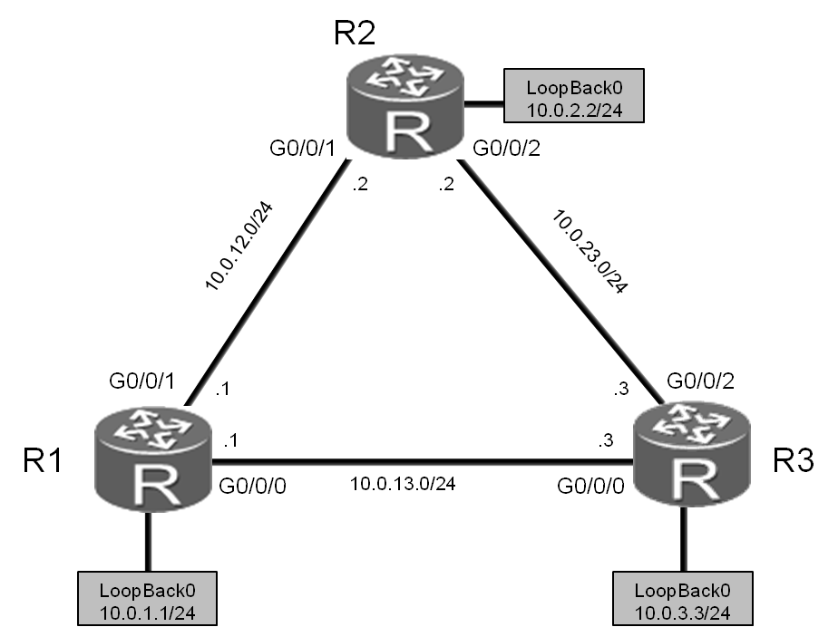

图4.1 静态路由和缺省路由实验拓扑图

## **场景**

您是公司的网络管理员。现在公司有一个总部与两个分支机构。其中R1为总部路由器，R2、R3为分支机构，总部与分支机构间通过以太网实现互连，且当前公司网络中没有配置任何路由协议。

由于网络的规模比较小，您可以配置通过静态路由和缺省路由来实现网络互通。IP编址信息如拓扑图所示。

## **操作步骤**

1. 基础配置和IP编址

在R1、R2和R3上配置设备名称和IP地址。

<Huawei>system-view

Enter system view, return user view with Ctrl+Z.

[Huawei]sysname R1

[R1]interface GigabitEthernet 0/0/0

[R1-GigabitEthernet0/0/0]ip address 10.0.13.1 24

[R1-GigabitEthernet0/0/0]quit

[R1]interface GigabitEthernet 0/0/1

[R1-GigabitEthernet0/0/1]ip address 10.0.12.1 24

[R1-GigabitEthernet0/0/1]quit

[R1]interface LoopBack 0

[R1-LoopBack0]ip address 10.0.1.1 24

执行**display current-configuration**命令，检查配置情况。

<R1>display ip interface brief

Interface IP Address/Mask Physical Protocol

......output omit......

GigabitEthernet0/0/0 10.0.13.1/24 up up

GigabitEthernet0/0/1 10.0.12.1/24 up up

GigabitEthernet0/0/2 unassigned up down

LoopBack0 10.0.1.1/24 up up(s)

......output omit......

<Huawei>system-view

Enter system view, return user view with Ctrl+Z.

[Huawei]sysname R2

[R2]interface GigabitEthernet 0/0/1

[R2-GigabitEthernet0/0/1]ip address 10.0.12.2 24

[R2-GigabitEthernet0/0/1]quit

[R2]interface GigabitEthernet0/0/2

[R2-GigabitEthernet0/0/2]ip add 10.0.23.2 24

[R2-GigabitEthernet0/0/2]quit

[R2]interface LoopBack0

[R2-LoopBack0]ip address 10.0.2.2 24

<R2>display ip interface brief

Interface IP Address/Mask Physical Protocol

......output omit......

GigabitEthernet0/0/0 unassigned up down

GigabitEthernet0/0/1 10.0.12.2/24 up up

GigabitEthernet0/0/2 10.0.23.2/24 up up

LoopBack0 10.0.2.2/24 up up(s)

......output omit......

<Huawei>system-view

Enter system view, return user view with Ctrl+Z.

[Huawei]sysname R3

[R3]interface GigabitEthernet 0/0/0

[R3-GigabitEthernet0/0/0]ip address 10.0.13.3 24

[R3-GigabitEthernet0/0/0]quit

[R3]interface GigabitEthernet0/0/2

[R3-GigabitEthernet0/0/2]ip address 10.0.23.3 24

[R3-GigabitEthernet0/0/2]quit

[R3]interface LoopBack 0

[R3-LoopBack0]ip address 10.0.3.3 24

<R3>display ip interface brief

Interface IP Address/Mask Physical Protocol

......output omit......

GigabitEthernet0/0/0 10.0.13.3/24 up up

GigabitEthernet0/0/1 unassigned up down

GigabitEthernet0/0/2 10.0.23.3/24 up up

LoopBack0 10.0.3.3/24 up up(s)

......output omit......

执行**ping**命令，检测R1与其它设备间的连通性。

<R1>ping 10.0.12.2

PING 10.0.12.2: 56 data bytes, press CTRL_C to break

Reply from 10.0.12.2: bytes=56 Sequence=1 ttl=255 time=30 ms

Reply from 10.0.12.2: bytes=56 Sequence=2 ttl=255 time=30 ms

Reply from 10.0.12.2: bytes=56 Sequence=3 ttl=255 time=30 ms

Reply from 10.0.12.2: bytes=56 Sequence=4 ttl=255 time=30 ms

Reply from 10.0.12.2: bytes=56 Sequence=5 ttl=255 time=30 ms

--- 10.0.12.2 ping statistics ---

5 packet(s) transmitted

5 packet(s) received

0.00% packet loss

round-trip min/avg/max = 30/30/30 ms

<R1>ping 10.0.13.3

PING 10.0.13.2: 56 data bytes, press CTRL_C to break

Reply from 10.0.13.3: bytes=56 Sequence=1 ttl=255 time=6 ms

Reply from 10.0.13.3: bytes=56 Sequence=2 ttl=255 time=2 ms

Reply from 10.0.13.3: bytes=56 Sequence=3 ttl=255 time=2 ms

Reply from 10.0.13.3: bytes=56 Sequence=4 ttl=255 time=2 ms

Reply from 10.0.13.3: bytes=56 Sequence=5 ttl=255 time=2 ms

--- 10.0.13.3 ping statistics ---

5 packet(s) transmitted

5 packet(s) received

0.00% packet loss

round-trip min/avg/max = 2/2/6 ms

执行**ping**命令，检测R2与其它设备间的连通性。

<R2>ping 10.0.23.3

PING 10.0.23.3: 56 data bytes, press CTRL_C to break

Reply from 10.0.23.3: bytes=56 Sequence=1 ttl=255 time=31 ms

Reply from 10.0.23.3: bytes=56 Sequence=2 ttl=255 time=31 ms

Reply from 10.0.23.3: bytes=56 Sequence=3 ttl=255 time=41 ms

Reply from 10.0.23.3: bytes=56 Sequence=4 ttl=255 time=31 ms

Reply from 10.0.23.3: bytes=56 Sequence=5 ttl=255 time=41 ms

--- 10.0.23.3 ping statistics ---

5 packet(s) transmitted

5 packet(s) received

0.00% packet loss

round-trip min/avg/max = 31/35/41 ms

1. 测试R2到目的网络10.0.13.0/24、10.0.3.0/24的连通性

<R2>ping 10.0.13.3

PING 10.0.13.3: 56 data bytes, press CTRL_C to break

Request time out

Request time out

Request time out

Request time out

Request time out

--- 10.0.13.3 ping statistics ---

5 packet(s) transmitted

0 packet(s) received

100.00% packet loss

<R2>ping 10.0.3.3

PING 10.0.3.3: 56 data bytes, press CTRL_C to break

Request time out

Request time out

Request time out

Request time out

Request time out

--- 10.0.3.3 ping statistics ---

5 packet(s) transmitted

0 packet(s) received

100.00% packet loss

R2如果要与10.0.3.0/24网络通信，需要R2上有去往该网段的路由信息，并且R3上也需要有到R2相应接口所在IP网段的路由信息。

上述检测结果表明，R2不能与10.0.3.3和10.0.13.3网络通信。

执行**display ip routing-table**命令，查看R2上的路由表。可以发现路由表中没有到这两个网段的路由信息。

<R2>display ip routing-table

Route Flags: R - relay, D - download to fib

-------------------------------------------------------------------------

Routing Tables: Public

Destinations : 13 Routes : 13

Destination/Mask Proto Pre Cost Flags NextHop Interface

10.0.2.0/24 Direct 0 0 D 10.0.2.2 LoopBack0

10.0.2.2/32 Direct 0 0 D 127.0.0.1 LoopBack0

10.0.2.255/32 Direct 0 0 D 127.0.0.1 LoopBack0

10.0.12.0/24 Direct 0 0 D 10.0.12.2 GigabitEthernet0/0/1

10.0.12.2/32 Direct 0 0 D 127.0.0.1 GigabitEthernet0/0/1

10.0.12.255/32 Direct 0 0 D 127.0.0.1 GigabitEthernet0/0/1

10.0.23.0/24 Direct 0 0 D 10.0.23.2 GigabitEthernet0/0/2

10.0.23.2/32 Direct 0 0 D 127.0.0.1 GigabitEthernet0/0/2

10.0.23.255/32 Direct 0 0 D 127.0.0.1 GigabitEthernet0/0/2

127.0.0.0/8 Direct 0 0 D 127.0.0.1 InLoopBack0

127.0.0.1/32 Direct 0 0 D 127.0.0.1 InLoopBack0

127.255.255.255/32 Direct 0 0 D 127.0.0.1 InLoopBack0

255.255.255.255/32 Direct 0 0 D 127.0.0.1 InLoopBack0

1. 在R2上配置静态路由

配置目的地址为10.0.13.0/24和10.0.3.0/24的静态路由，路由的下一跳配置为R3的G0/0/0接口IP地址10.0.23.3。默认静态路由优先级为60，无需额外配置路由优先级信息。

[R2]ip route-static 10.0.13.0 24 10.0.23.3

[R2]ip route-static 10.0.3.0 24 10.0.23.3

注意：在**ip route-static**命令中，24代表子网掩码长度，也可以写成完整的掩码形式如255.255.255.0。

<R2>display ip routing-table

Route Flags: R - relay, D - download to fib

------------------------------------------------------------------------------

Routing Tables: Public

Destinations : 15 Routes : 15

Destination/Mask Proto Pre Cost Flags NextHop Interface

10.0.2.0/24 Direct 0 0 D 10.0.2.2 LoopBack0

10.0.2.2/32 Direct 0 0 D 127.0.0.1 LoopBack0

10.0.2.255/32 Direct 0 0 D 127.0.0.1 LoopBack0

10.0.3.0/24 Static 60 0 RD 10.0.23.3 GigabitEthernet0/0/2

10.0.12.0/24 Direct 0 0 D 10.0.12.2 GigabitEthernet0/0/1

10.0.12.2/32 Direct 0 0 D 127.0.0.1 GigabitEthernet0/0/1

10.0.12.255/32 Direct 0 0 D 127.0.0.1 GigabitEthernet0/0/1

10.0.13.0/24 Static 60 0 RD 10.0.23.3 GigabitEthernet0/0/2

10.0.23.0/24 Direct 0 0 D 10.0.23.2 GigabitEthernet0/0/2

10.0.23.2/32 Direct 0 0 D 127.0.0.1 GigabitEthernet0/0/2

10.0.23.255/32 Direct 0 0 D 127.0.0.1 GigabitEthernet0/0/2

127.0.0.0/8 Direct 0 0 D 127.0.0.1 InLoopBack0

127.0.0.1/32 Direct 0 0 D 127.0.0.1 InLoopBack0

127.255.255.255/32 Direct 0 0 D 127.0.0.1 InLoopBack0

255.255.255.255/32 Direct 0 0 D 127.0.0.1 InLoopBack0

1. 配置备份静态路由

R2与网络10.0.13.3和10.0.3.3之间交互的数据通过R2与R3间的链路传输。如果R2和R3间的链路发生故障，R2将不能与网络10.0.13.3和10.0.3.3通信。

但是根据拓扑图可以看出，当R2和R3间的链路发生故障时，R2还可以通过R1与R3通信。所以可以通过配置一条备份静态路由实现路由的冗余备份。正常情况下，备份静态路由不生效。当R2和R3间的链路发生故障时，才使用备份静态路由传输数据。

配置备份静态路由时，需要修改备份静态路由的优先级，确保只有主链路故障时才使用备份路由。本任务中，需要将备份静态路由的优先级修改为80。

[R1]ip route-static 10.0.3.0 24 10.0.13.3

[R2]ip route-static 10.0.13.0 255.255.255.0 10.0.12.1 preference 80

[R2]ip route-static 10.0.3.0 24 10.0.12.1 preference 80

[R3]ip route-static 10.0.12.0 24 10.0.13.1

1. 验证静态路由

在R2的路由表中，查看当前的静态路由配置。

<R2>display ip routing-table

Route Flags: R - relay, D - download to fib

-------------------------------------------------------------------------

Routing Tables: Public

Destinations : 15 Routes : 15

Destination/Mask Proto Pre Cost Flags NextHop Interface

10.0.2.0/24 Direct 0 0 D 10.0.2.2 LoopBack0

10.0.2.2/32 Direct 0 0 D 127.0.0.1 LoopBack0

10.0.2.255/32 Direct 0 0 D 127.0.0.1 LoopBack0

10.0.3.0/24 Static 60 0 RD 10.0.23.3 GigabitEthernet0/0/2

10.0.12.0/24 Direct 0 0 D 10.0.12.2 GigabitEthernet0/0/1

10.0.12.2/32 Direct 0 0 D 127.0.0.1 GigabitEthernet0/0/1

10.0.12.255/32 Direct 0 0 D 127.0.0.1 GigabitEthernet0/0/1

10.0.13.0/24 Static 60 0 RD 10.0.23.3 GigabitEthernet0/0/2

10.0.23.0/24 Direct 0 0 D 10.0.23.2 GigabitEthernet0/0/2

10.0.23.2/32 Direct 0 0 D 127.0.0.1 GigabitEthernet0/0/2

10.0.23.255/32 Direct 0 0 D 127.0.0.1 GigabitEthernet0/0/2

127.0.0.0/8 Direct 0 0 D 127.0.0.1 InLoopBack0

127.0.0.1/32 Direct 0 0 D 127.0.0.1 InLoopBack0

127.255.255.255/32 Direct 0 0 D 127.0.0.1 InLoopBack0

255.255.255.255/32 Direct 0 0 D 127.0.0.1 InLoopBack0

路由表中包含两条静态路由。其中，Protocol字段的值是Static，表明该路由是静态路由。Preference字段的值是60，表明该路由使用的是默认优先级。

当R2和R3之间链路正常时，R2与网络10.0.13.3和10.0.3.3之间交互的数据通过R2与R3间的链路传输。执行**tracert**命令，可以查看数据的传输路径。

<R2>tracert 10.0.13.3

traceroute to 10.0.13.3(10.0.13.3), max hops: 30 ,packet length: 40,

press CTRL_C to break

1 10.0.23.3 40 ms 31 ms 30 ms

<R2>tracert 10.0.3.3

traceroute to 10.0.3.3(10.0.3.3), max hops: 30 ,packet length: 40,

press CTRL_C to break

1 10.0.23.3 40 ms 30 ms 30 ms

命令的回显信息证实R2将数据直接发送给R3，未经过其他设备。

1. 验证备份静态路由

关闭R2上的G0/0/2接口，模拟R2与R3间的链路发生故障，然后查看IP路由表的变化。

[R2]interface GigabitEthernet 0/0/2

[R2-GigabitEthernet0/0/2]shutdown

[R2-GigabitEthernet0/0/2]quit

注意与关闭接口之前的路由表情况作对比。

<R2>display ip routing-table

Route Flags: R - relay, D - download to fib

------------------------------------------------------------------------------

Routing Tables: Public

Destinations : 12 Routes : 12

Destination/Mask Proto Pre Cost Flags NextHop Interface

10.0.2.0/24 Direct 0 0 D 10.0.2.2 LoopBack0

10.0.2.2/32 Direct 0 0 D 127.0.0.1 LoopBack0

10.0.2.255/32 Direct 0 0 D 127.0.0.1 LoopBack0

10.0.3.0/24 Static 80 0 RD 10.0.12.1 GigabitEthernet0/0/1

10.0.12.0/24 Direct 0 0 D 10.0.12.2 GigabitEthernet0/0/1

10.0.12.2/32 Direct 0 0 D 127.0.0.1 GigabitEthernet0/0/1

10.0.12.255/32 Direct 0 0 D 127.0.0.1 GigabitEthernet0/0/1

10.0.13.0/24 Static 80 0 RD 10.0.12.1 GigabitEthernet0/0/1

127.0.0.0/8 Direct 0 0 D 127.0.0.1 InLoopBack0

127.0.0.1/32 Direct 0 0 D 127.0.0.1 InLoopBack0

127.255.255.255/32 Direct 0 0 D 127.0.0.1 InLoopBack0

255.255.255.255/32 Direct 0 0 D 127.0.0.1 InLoopBack0

在R2的路由表中，灰色所标记出的两条路由的下一跳和优先级均已发生变化。

检测R2到目的地址10.0.13.3以及R3上的10.0.3.3的连通性。

<R2>ping 10.0.3.3

PING 10.0.3.3: 56 data bytes, press CTRL_C to break

Reply from 10.0.3.3: bytes=56 Sequence=1 ttl=255 time=3 ms

Reply from 10.0.3.3: bytes=56 Sequence=2 ttl=255 time=2 ms

Reply from 10.0.3.3: bytes=56 Sequence=3 ttl=255 time=2 ms

Reply from 10.0.3.3: bytes=56 Sequence=4 ttl=255 time=2 ms

Reply from 10.0.3.3: bytes=56 Sequence=5 ttl=255 time=2 ms

--- 10.0.3.3 ping statistics ---

5 packet(s) transmitted

5 packet(s) received

0.00% packet loss

round-trip min/avg/max = 2/2/3 ms

<R2>ping 10.0.13.3

PING 10.0.13.3: 56 data bytes, press CTRL_C to break

Reply from 10.0.13.3: bytes=56 Sequence=1 ttl=255 time=3 ms

Reply from 10.0.13.3: bytes=56 Sequence=2 ttl=255 time=2 ms

Reply from 10.0.13.3: bytes=56 Sequence=3 ttl=255 time=2 ms

Reply from 10.0.13.3: bytes=56 Sequence=4 ttl=255 time=2 ms

Reply from 10.0.13.3: bytes=56 Sequence=5 ttl=255 time=2 ms

--- 10.0.13.3 ping statistics ---

5 packet(s) transmitted

5 packet(s) received

0.00% packet loss

round-trip min/avg/max = 2/2/3 ms

网络并未因为R2与R3之间的链路被关闭而中断。

执行**tracert**命令，查看数据包的转发路径。

<R2>tracert 10.0.13.3

traceroute to 10.0.13.3(10.0.13.3), max hops: 30 ,packet length: 40,press CTRL_C to break

1 10.0.12.1 40 ms 21 ms 21 ms

2 10.0.13.3 30 ms 21 ms 21 ms

<R2>tracert 10.0.3.3

traceroute to 10.0.3.3(10.0.3.3), max hops: 30 ,packet length: 40,press CTRL_C to break

1 10.0.12.1 40 ms 21 ms 21 ms

2 10.0.13.3 30 ms 21 ms 21 ms

命令的回显信息表明，R2发送的数据经过R1抵达R3设备。

1. 配置缺省路由实现网络的互通

打开R2上在步骤6中关闭的接口。

[R2]interface GigabitEthernet 0/0/2

[R2-GigabitEthernet0/0/2]undo shutdown

验证从R1到10.0.23.3网络的连通性。

[R1]ping 10.0.23.3

PING 10.0.23.3: 56 data bytes, press CTRL_C to break

Request time out

Request time out

Request time out

Request time out

Request time out

--- 10.0.23.3 ping statistics ---

5 packet(s) transmitted

0 packet(s) received

100.00% packet loss

因为R1上没有去往10.0.23.0网段的路由信息，所以报文无法到达R3。

<R1>display ip routing-table

Route Flags: R - relay, D - download to fib

-------------------------------------------------------------------------

Routing Tables: Public

Destinations : 14 Routes : 14

Destination/Mask Proto Pre Cost Flags NextHop Interface

10.0.1.0/24 Direct 0 0 D 10.0.1.1 LoopBack0

10.0.1.1/32 Direct 0 0 D 127.0.0.1 LoopBack0

10.0.1.255/32 Direct 0 0 D 127.0.0.1 LoopBack0

10.0.3.0/24 Static 60 0 RD 10.0.13.3 GigabitEthernet0/0/0

10.0.12.0/24 Direct 0 0 D 10.0.12.1 GigabitEthernet0/0/1

10.0.12.1/32 Direct 0 0 D 127.0.0.1 GigabitEthernet0/0/1

10.0.12.255/32 Direct 0 0 D 127.0.0.1 GigabitEthernet0/0/1

10.0.13.0/24 Direct 0 0 D 10.0.13.1 GigabitEthernet0/0/0

10.0.13.1/32 Direct 0 0 D 127.0.0.1 GigabitEthernet0/0/0

10.0.13.255/32 Direct 0 0 D 127.0.0.1 GigabitEthernet0/0/0

127.0.0.0/8 Direct 0 0 D 127.0.0.1 InLoopBack0

127.0.0.1/32 Direct 0 0 D 127.0.0.1 InLoopBack0

127.255.255.255/32 Direct 0 0 D 127.0.0.1 InLoopBack0

255.255.255.255/32 Direct 0 0 D 127.0.0.1 InLoopBack0

可以在R1上配置一条下一跳为10.0.13.3的缺省路由来实现网络的连通。

[R1]ip route-static 0.0.0.0 0.0.0.0 10.0.13.3

配置完成后，检测R1和10.0.23.3网络间的连通性。

<R1>ping 10.0.23.3

PING 10.0.23.3: 56 data bytes, press CTRL_C to break

Reply from 10.0.23.3: bytes=56 Sequence=1 ttl=255 time=3 ms

Reply from 10.0.23.3: bytes=56 Sequence=2 ttl=255 time=2 ms

Reply from 10.0.23.3: bytes=56 Sequence=3 ttl=255 time=2 ms

Reply from 10.0.23.3: bytes=56 Sequence=4 ttl=255 time=2 ms

Reply from 10.0.23.3: bytes=56 Sequence=5 ttl=255 time=2 ms

--- 10.0.23.3 ping statistics ---

5 packet(s) transmitted

5 packet(s) received

0.00% packet loss

round-trip min/avg/max = 2/2/3 ms

R1通过缺省路由实现了与网段10.0.23.0间的通信。

1. 配置备份缺省路由

当R1与R3间的链路发生故障时，R1可以使用备份缺省路由通过R2实现与10.0.23.3和10.0.3.3网络间通信。

配置两条备份路由，确保数据来回的双向都有路由。

[R1]ip route-static 0.0.0.0 0.0.0.0 10.0.12.2 preference 80

[R3]ip route-static 10.0.12.0 24 10.0.23.2 preference 80

1. 验证备份缺省路由

查看链路正常时R1上的路由条目。

<R1>display ip routing-table

Route Flags: R - relay, D - download to fib

------------------------------------------------------------------------

Routing Tables: Public

Destinations : 15 Routes : 15

Destination/Mask Proto Pre Cost Flags NextHop Interface

0.0.0.0/0 Static 60 0 RD 10.0.13.3 GigabitEthernet0/0/0

10.0.1.0/24 Direct 0 0 D 10.0.1.1 LoopBack0

10.0.1.1/32 Direct 0 0 D 127.0.0.1 LoopBack0

10.0.1.255/32 Direct 0 0 D 127.0.0.1 LoopBack0

10.0.3.0/24 Static 60 0 RD 10.0.13.3 GigabitEthernet0/0/0

10.0.12.0/24 Direct 0 0 D 10.0.12.1 GigabitEthernet0/0/1

10.0.12.1/32 Direct 0 0 D 127.0.0.1 GigabitEthernet0/0/1

10.0.12.255/32 Direct 0 0 D 127.0.0.1 GigabitEthernet0/0/1

10.0.13.0/24 Direct 0 0 D 10.0.13.1 GigabitEthernet0/0/0

10.0.13.1/32 Direct 0 0 D 127.0.0.1 GigabitEthernet0/0/0

10.0.13.255/32 Direct 0 0 D 127.0.0.1 GigabitEthernet0/0/0

127.0.0.0/8 Direct 0 0 D 127.0.0.1 InLoopBack0

127.0.0.1/32 Direct 0 0 D 127.0.0.1 InLoopBack0

127.255.255.255/32 Direct 0 0 D 127.0.0.1 InLoopBack0

255.255.255.255/32 Direct 0 0 D 127.0.0.1 InLoopBack0

关闭R1与R3上的G0/0/0接口模拟链路故障，然后查看R1的路由表。比较关闭接口前后的路由表变化情况。

[R1]interface GigabitEthernet0/0/0

[R1-GigabitEthernet0/0/0]shutdown

[R1-GigabitEthernet0/0/0]quit

[R3]interface GigabitEthernet0/0/0

[R3-GigabitEthernet0/0/0]shutdown

[R3-GigabitEthernet0/0/0]quit

<R1>display ip routing-table

Route Flags: R - relay, D - download to fib

-------------------------------------------------------------------------

Routing Tables: Public

Destinations : 11 Routes : 11

Destination/Mask Proto Pre Cost Flags NextHop Interface

0.0.0.0/0 Static 80 0 RD 10.0.12.2 GigabitEthernet0/0/1

10.0.1.0/24 Direct 0 0 D 10.0.1.1 LoopBack0

10.0.1.1/32 Direct 0 0 D 127.0.0.1 LoopBack0

10.0.1.255/32 Direct 0 0 D 127.0.0.1 LoopBack0

10.0.12.0/24 Direct 0 0 D 10.0.12.1 GigabitEthernet0/0/1

10.0.12.1/32 Direct 0 0 D 127.0.0.1 GigabitEthernet0/0/1

10.0.12.255/32 Direct 0 0 D 127.0.0.1 GigabitEthernet0/0/1

127.0.0.0/8 Direct 0 0 D 127.0.0.1 InLoopBack0

127.0.0.1/32 Direct 0 0 D 127.0.0.1 InLoopBack0

127.255.255.255/32 Direct 0 0 D 127.0.0.1 InLoopBack0

255.255.255.255/32 Direct 0 0 D 127.0.0.1 InLoopBack0

上述路由表中，缺省路由0.0.0.0的Preference值为80，表明备用的缺省路由已生效。

<R1>ping 10.0.23.3

PING 10.0.23.3: 56 data bytes, press CTRL_C to break

Reply from 10.0.23.3: bytes=56 Sequence=1 ttl=254 time=76 ms

Reply from 10.0.23.3: bytes=56 Sequence=2 ttl=254 time=250 ms

Reply from 10.0.23.3: bytes=56 Sequence=3 ttl=254 time=76 ms

Reply from 10.0.23.3: bytes=56 Sequence=4 ttl=254 time=76 ms

Reply from 10.0.23.3: bytes=56 Sequence=5 ttl=254 time=76 ms

--- 10.0.23.3 ping statistics ---

5 packet(s) transmitted

5 packet(s) received

0.00% packet loss

round-trip min/avg/max = 76/110/250 ms

网络并未因为R1与R3之间的链路被关闭而中断。执行**tracert**命令，查看数据包的转发路径。

<R1>tracert 10.0.23.3

traceroute to 10.0.23.3(10.0.23.2), max hops: 30 ,packet length: 40,press CTRL_C to break

1 10.0.12.2 30 ms 26 ms 26 ms

2 10.0.23.3 60 ms 53 ms 56 ms

结果显示报文通过R2（10.0.12.2）到达R3（10.0.23.3）。

## **配置文件**

<R1>display current-configuration

[V200R007C00SPC600]

#

sysname R1

#

interface GigabitEthernet0/0/0

shutdown

ip address 10.0.13.1 255.255.255.0

#

interface GigabitEthernet0/0/1

ip address 10.0.12.1 255.255.255.0

#

interface LoopBack0

ip address 10.0.1.1 255.255.255.0

#

ip route-static 0.0.0.0 0.0.0.0 10.0.13.3

ip route-static 0.0.0.0 0.0.0.0 10.0.12.2 preference 80

ip route-static 10.0.3.0 255.255.255.0 10.0.13.3

#

user-interface con 0

authentication-mode password

set authentication password cipher %$%$+L'YR&IZt'4,)>-*#lH",}%K-oJ_M9+'lOU~bD (\WTqB}%N,%$%$

user-interface vty 0 4

#

return

<R2>display current-configuration

[V200R007C00SPC600]

#

sysname R2

interface GigabitEthernet0/0/1

ip address 10.0.12.2 255.255.255.0

#

interface GigabitEthernet0/0/2

ip address 10.0.23.2 255.255.255.0

#

interface LoopBack0

ip address 10.0.2.2 255.255.255.0

#

ip route-static 10.0.3.0 255.255.255.0 10.0.23.3

ip route-static 10.0.3.0 255.255.255.0 10.0.12.1 preference 80

ip route-static 10.0.13.0 255.255.255.0 10.0.23.3

ip route-static 10.0.13.0 255.255.255.0 10.0.12.1 preference 80

#

user-interface con 0

authentication-mode password

set authentication password cipher %$%$1=cd%b%/O%Id-8X:by1N,+s}'4wD6TvO<I|/pd# #44C@+s#,%$%$

user-interface vty 0 4

#

return

<R3>display current-configuration

[V200R007C00SPC600]

#

sysname R3

#

interface GigabitEthernet0/0/0

shutdown

ip address 10.0.13.3 255.255.255.0

#

interface GigabitEthernet0/0/2

ip address 10.0.23.3 255.255.255.0

#

interface LoopBack0

ip address 10.0.3.3 255.255.255.0

#

ip route-static 10.0.12.0 255.255.255.0 10.0.13.1

ip route-static 10.0.12.0 255.255.255.0 10.0.23.2 preference 80

#

user-interface con 0

authentication-mode password

set authentication password cipher %$%$ksXDMg7Ry6yUU:63:DQ),#/sQg"@*S\U#.s.bHW xQ,y%#/v,%$%$

user-interface vty 0 4

#

return

实验4-2 配置RIPv1和RIPv2

学习目标

* **理解RIP路由协议的防环机制**
* **掌握RIPv1的配置方法**
* **掌握在特定网络和接口上启用RIP的方法**
* **掌握使用display和debugging命令测试RIP的方法**
* **掌握测试RIP路由网络连通性的方法**
* **掌握RIPv2的配置方法**

拓扑图

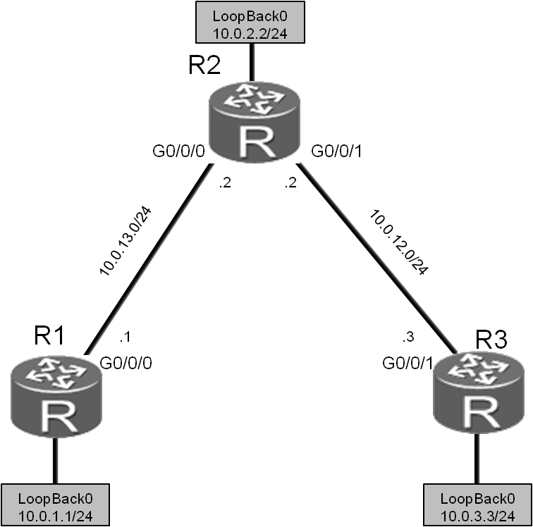

图4.2 配置RIPv1和RIPv2实验拓扑图

场景

您是公司的网络管理员。您所管理的小型网络中包含三台路由器，并规划了五个网络。您需要在网络中配置RIP路由协议来实现路由信息的相互传输。最初使用的是RIPv1，后来发现RIPv2更有优势，于是决定优化网络，使用RIPv2。

操作步骤

1. 实验环境准备

如果本任务中您使用的是空配置设备，需要从步骤1开始配置，然后跳过步骤2。如果使用的设备包含上一个实验的配置，请直接从步骤2开始配置。

<Huawei>system-view

Enter system view, return user view with Ctrl+Z.

[Huawei]sysname R1

[R1]interface GigabitEthernet 0/0/0

[R1-GigabitEthernet0/0/0]ip address 10.0.13.1 24

[R1-GigabitEthernet0/0/0]quit

[R1]interface LoopBack 0

[R1-LoopBack0]ip address 10.0.1.1 24

<Huawei>system-view

Enter system view, return user view with Ctrl+Z.

[Huawei]sysname R2

[R2]interface GigabitEthernet 0/0/1

[R2-GigabitEthernet0/0/1]ip address 10.0.12.2 24

[R2-GigabitEthernet0/0/1]quit

[R2]interface LoopBack 0

[R2-LoopBack0]ip address 10.0.2.2 24

<Huawei>system-view

Enter system view, return user view with Ctrl+Z.

[Huawei]sysname R3

[R3]interface LoopBack 0

[R3-LoopBack0]ip address 10.0.3.3 24

1. 清除设备上原有的配置

清除上一个实验中的静态路由配置并关闭无关的接口。

[R1]interface GigabitEthernet0/0/1

[R1-GigabitEthernet0/0/1]shutdown

[R1-GigabitEthernet0/0/1]quit

[R1]interface GigabitEthernet0/0/0

[R1-GigabitEthernet0/0/0]undo shutdown

[R1-GigabitEthernet0/0/0]quit

[R1]undo ip route-static 0.0.0.0 0.0.0.0

[R1]undo ip route-static 10.0.3.0 255.255.255.0

[R1]undo ip route-static 10.0.12.0 255.255.255.0

[R2]interface GigabitEthernet 0/0/2

[R2-GigabitEthernet0/0/2]shutdown

[R2-GigabitEthernet0/0/2]quit

[R2]undo ip route-static 10.0.3.0 255.255.255.0

[R2]undo ip route-static 10.0.13.0 255.255.255.0

[R3]interface GigabitEthernet 0/0/2

[R3-GigabitEthernet0/0/2]shutdown

[R3-GigabitEthernet0/0/2]quit

[R3]undo ip route-static 10.0.12.0 255.255.255.0

1. 配置IP地址

为R2和R3配置如下IP地址。

[R2]interface GigabitEthernet 0/0/0

[R2-GigabitEthernet0/0/0]ip address 10.0.13.2 24

[R3]interface GigabitEthernet0/0/1

[R3-GigabitEthernet0/0/1]ip address 10.0.12.3 24

测试R1与R2间的连通性。

<R1>ping 10.0.13.2

PING 10.0.13.2: 56 data bytes, press CTRL_C to break

Reply from 10.0.13.2: bytes=56 Sequence=1 ttl=255 time=30 ms

Reply from 10.0.13.2: bytes=56 Sequence=2 ttl=255 time=30 ms

Reply from 10.0.13.2: bytes=56 Sequence=3 ttl=255 time=30 ms

Reply from 10.0.13.2: bytes=56 Sequence=4 ttl=255 time=30 ms

Reply from 10.0.13.2: bytes=56 Sequence=5 ttl=255 time=30 ms

--- 10.0.13.2 ping statistics ---

5 packet(s) transmitted

5 packet(s) received

0.00% packet loss

round-trip min/avg/max = 30/30/30 ms

测试R2与R3间的连通性。

<R2>ping 10.0.12.3

PING 10.0.12.2: 56 data bytes, press CTRL_C to break

Reply from 10.0.12.3: bytes=56 Sequence=1 ttl=255 time=31 ms

Reply from 10.0.12.3: bytes=56 Sequence=2 ttl=255 time=31 ms

Reply from 10.0.12.3: bytes=56 Sequence=3 ttl=255 time=41 ms

Reply from 10.0.12.3: bytes=56 Sequence=4 ttl=255 time=31 ms

Reply from 10.0.12.3: bytes=56 Sequence=5 ttl=255 time=41 ms

--- 10.0.12.3 ping statistics ---

5 packet(s) transmitted

5 packet(s) received

0.00% packet loss

round-trip min/avg/max = 31/35/41 ms

1. 配置RIPv1协议

在R1上启动RIP协议，并将10.0.0.0网段发布到RIP协议中。

[R1]rip 1

[R1-rip-1]network 10.0.0.0

在R2上启动RIP协议，并将10.0.0.0网段发布到RIP协议中。

[R2]rip 1

[R2-rip-1]network 10.0.0.0

在R3上启动RIP协议，并将10.0.0.0网段发布到RIP协议中。

[R3]rip 1

[R3-rip-1]network 10.0.0.0

1. 验证RIPv1路由

查看R1、R2和R3的路由表。确保路由器已经学习到了如下显示信息中灰色阴影标注的RIP路由。

<R1>display ip routing-table

Route Flags: R - relay, D - download to fib

-------------------------------------------------------------------------

Routing Tables: Public

Destinations : 13 Routes : 13

Destination/Mask Proto Pre Cost Flags NextHop Interface

10.0.1.0/24 Direct 0 0 D 10.0.1.1 LoopBack0

10.0.1.1/32 Direct 0 0 D 127.0.0.1 LoopBack0

10.0.1.255/32 Direct 0 0 D 127.0.0.1 LoopBack0

10.0.2.0/24 RIP 100 1 D 10.0.13.2 GigabitEthernet0/0/0

10.0.3.0/24 RIP 100 2 D 10.0.13.2 GigabitEthernet0/0/0

10.0.12.0/24 RIP 100 1 D 10.0.13.2 GigabitEthernet0/0/0

10.0.13.0/24 Direct 0 0 D 10.0.13.1 GigabitEthernet0/0/0

10.0.13.1/32 Direct 0 0 D 127.0.0.1 GigabitEthernet0/0/0

10.0.13.255/32 Direct 0 0 D 127.0.0.1 GigabitEthernet0/0/0

127.0.0.0/8 Direct 0 0 D 127.0.0.1 InLoopBack0

127.0.0.1/32 Direct 0 0 D 127.0.0.1 InLoopBack0

127.255.255.255/32 Direct 0 0 D 127.0.0.1 InLoopBack0

255.255.255.255/32 Direct 0 0 D 127.0.0.1 InLoopBack0

<R2>display ip routing-table

Route Flags: R - relay, D - download to fib

------------------------------------------------------------------------

Routing Tables: Public

Destinations : 15 Routes : 15

Destination/Mask Proto Pre Cost Flags NextHop Interface

10.0.1.0/24 RIP 100 1 D 10.0.13.1 GigabitEthernet0/0/0

10.0.2.0/24 Direct 0 0 D 10.0.2.2 LoopBack0

10.0.2.2/32 Direct 0 0 D 127.0.0.1 LoopBack0

10.0.2.255/32 Direct 0 0 D 127.0.0.1 LoopBack0

10.0.3.0/24 RIP 100 1 D 10.0.12.3 GigabitEthernet0/0/1

10.0.12.0/24 Direct 0 0 D 10.0.12.2 GigabitEthernet0/0/1

10.0.12.2/32 Direct 0 0 D 127.0.0.1 GigabitEthernet0/0/1

10.0.12.255/32 Direct 0 0 D 127.0.0.1 GigabitEthernet0/0/1

10.0.13.0/24 Direct 0 0 D 10.0.13.2 GigabitEthernet0/0/0

10.0.13.2/32 Direct 0 0 D 127.0.0.1 GigabitEthernet0/0/0

10.0.13.255/32 Direct 0 0 D 127.0.0.1 GigabitEthernet0/0/0

127.0.0.0/8 Direct 0 0 D 127.0.0.1 InLoopBack0

127.0.0.1/32 Direct 0 0 D 127.0.0.1 InLoopBack0

127.255.255.255/32 Direct 0 0 D 127.0.0.1 InLoopBack0

255.255.255.255/32 Direct 0 0 D 127.0.0.1 InLoopBack0

<R3>display ip routing-table

Route Flags: R - relay, D - download to fib

-------------------------------------------------------------------------

Routing Tables: Public

Destinations : 13 Routes : 13

Destination/Mask Proto Pre Cost Flags NextHop Interface

10.0.1.0/24 RIP 100 2 D 10.0.12.2 GigabitEthernet0/0/1

10.0.2.0/24 RIP 100 1 D 10.0.12.2 GigabitEthernet0/0/1

10.0.3.0/24 Direct 0 0 D 10.0.3.3 LoopBack0

10.0.3.3/32 Direct 0 0 D 127.0.0.1 LoopBack0

10.0.3.255/32 Direct 0 0 D 127.0.0.1 LoopBack0

10.0.12.0/24 Direct 0 0 D 10.0.12.3 GigabitEthernet0/0/1

10.0.12.3/32 Direct 0 0 D 127.0.0.1 GigabitEthernet0/0/1

10.0.12.255/32 Direct 0 0 D 127.0.0.1 GigabitEthernet0/0/1

10.0.13.0/24 RIP 100 1 D 10.0.12.2 GigabitEthernet0/0/1

127.0.0.0/8 Direct 0 0 D 127.0.0.1 InLoopBack0

127.0.0.1/32 Direct 0 0 D 127.0.0.1 InLoopBack0

127.255.255.255/32 Direct 0 0 D 127.0.0.1 InLoopBack0

255.255.255.255/32 Direct 0 0 D 127.0.0.1 InLoopBack0

检测R1到IP地址10.0.12.3的连通性。如下所示R1和R3能够互通。

[R1]ping 10.0.12.3

PING 10.0.12.3: 56 data bytes, press CTRL_C to break

Reply from 10.0.12.3: bytes=56 Sequence=1 ttl=254 time=70 ms

Reply from 10.0.12.3: bytes=56 Sequence=2 ttl=254 time=65 ms

Reply from 10.0.12.3: bytes=56 Sequence=3 ttl=254 time=65 ms

Reply from 10.0.12.3: bytes=56 Sequence=4 ttl=254 time=65 ms

Reply from 10.0.12.3: bytes=56 Sequence=5 ttl=254 time=65 ms

--- 10.0.12.3 ping statistics ---

5 packet(s) transmitted

5 packet(s) received

0.00% packet loss

round-trip min/avg/max = 65/66/70 ms

执行**debugging**命令，查看RIPv1协议的定期更新情况。

执行**debugging**命令开启RIP调测功能。注意只能在用户视图下执行**debugging**命令。执行**display debugging**命令，查看当前的调测信息。执行**terminal debugging**命令，开启**debug**信息在终端屏幕上显示的功能。

路由器间的RIP交互信息显示如下：

<R1>debugging rip 1

<R1>display debugging

RIP Process id: 1

Debugs ON: SEND, RECEIVE, PACKET, TIMER, EVENT, BRIEF,

JOB, ROUTE-PROCESSING, ERROR,

REPLAY-PROTECT, GR

<R1>terminal debugging

Info: Current terminal debugging is on.

<R1>

Mar29 2016 09:45:07.860.1+00:00 R1 RIP/7/DBG: 6: 12734: RIP 1: Receiving v1 response on GigabitEthernet0/0/0 from 10.0.13.2 with 3 RTEs

<R1>

Mar 29 2016 09:45:07.860.2+00:00 R1 RIP/7/DBG: 6: 12785: RIP 1: Receive response from 10.0.13.2 on GigabitEthernet0/0/0

<R1>

Mar 29 2016 09:45:07.860.3+00:00 R1 RIP/7/DBG: 6: 12796: Packet: Version 1, Cmd response, Length 64

<R1>

Mar 29 2016 09:45:07.860.4+00:00 R1 RIP/7/DBG: 6: 12845: Dest 10.0.2.0, Cost 1

<R1>

Mar 29 2016 09:45:07.860.5+00:00 R1 RIP/7/DBG: 6: 12845: Dest 10.0.3.0, Cost 2

<R1>

Mar 29 2016 09:45:07.860.6+00:00 R1 RIP/7/DBG: 6: 12845: Dest 10.0.12.0, Cost 1

<R1>

Mar 29 2016 09:45:09.370.1+00:00 R1 RIP/7/DBG: 25: 5071: RIP 1: Periodic timer expired for interface GigabitEthernet0/0/1

执行**undo debugging rip** <*process-id*> or **undo debugging all**命令，关闭调测功能。

<R1>undo debugging rip 1

也可以使用带更多参数的命令查看某类型的调试信息，如**debug rip 1 event**查看路由器发出和收到的定期更新事件。其它参数可以使用“？”获取帮助。

<R1>debugging rip 1 event

<R1>

Mar 29 2016 10:00:04.880.1+00:00 R1 RIP/7/DBG: 25: 5719: RIP 1: Periodic timer expired for interface GigabitEthernet0/0/0 (10.0.13.1) and its added to periodic update queue

<R1>

Mar 29 2016 10:00:04.890.1+00:00 R1 RIP/7/DBG: 25: 6048: RIP 1: Interface GigabitEthernet0/0/0 (10.0.13.1) is deleted from the periodic update queue

<R1>undo debugging all

Info: All possible debugging has been turned off

警告：开启过多的调测功能将消耗路由器的大量资源，甚至可能导致宕机。因而，请慎重使用开启批量**debug**功能的命令，如**debug all**。

1. 配置RIPv2协议

基于前面的配置，只需在RIP子视图模式下配置version 2即可。

[R1]rip 1

[R1-rip-1]version 2

[R2]rip 1

[R2-rip-1]version 2

[R3]rip 1

[R3-rip-1]version 2

1. 验证RIPv2路由

查看R1、R2和R3上的路由表。

执行**display ip routing-table**命令，查看R1、R2和R3上的路由表。注意比较灰色标注部分路由条目与之前RIPv1路由条目的不同之处。

<R1>display ip routing-table

Route Flags: R - relay, D - download to fib

-------------------------------------------------------------------------

Routing Tables: Public

Destinations : 13 Routes : 13

Destination/Mask Proto Pre Cost Flags NextHop Interface

10.0.1.0/24 Direct 0 0 D 10.0.1.1 LoopBack0

10.0.1.1/32 Direct 0 0 D 127.0.0.1 LoopBack0

10.0.1.255/32 Direct 0 0 D 127.0.0.1 LoopBack0

10.0.2.0/24 RIP 100 1 D 10.0.13.2 GigabitEthernet0/0/0

10.0.3.0/24 RIP 100 2 D 10.0.13.2 GigabitEthernet0/0/0

10.0.12.0/24 RIP 100 1 D 10.0.13.2 GigabitEthernet0/0/0

10.0.13.0/24 Direct 0 0 D 10.0.13.1 GigabitEthernet0/0/0

10.0.13.1/32 Direct 0 0 D 127.0.0.1 GigabitEthernet0/0/0

10.0.13.255/32 Direct 0 0 D 127.0.0.1 GigabitEthernet0/0/0

127.0.0.0/8 Direct 0 0 D 127.0.0.1 InLoopBack0

127.0.0.1/32 Direct 0 0 D 127.0.0.1 InLoopBack0

127.255.255.255/32 Direct 0 0 D 127.0.0.1 InLoopBack0

255.255.255.255/32 Direct 0 0 D 127.0.0.1 InLoopBack0

<R2>display ip routing-table

Route Flags: R - relay, D - download to fib

-------------------------------------------------------------------------

Routing Tables: Public

Destinations : 15 Routes : 15

Destination/Mask Proto Pre Cost Flags NextHop Interface

10.0.1.0/24 RIP 100 1 D 10.0.13.1 GigabitEthernet0/0/0

10.0.2.0/24 Direct 0 0 D 10.0.2.2 LoopBack0

10.0.2.2/32 Direct 0 0 D 127.0.0.1 LoopBack0

10.0.2.255/32 Direct 0 0 D 127.0.0.1 LoopBack0

10.0.3.0/24 RIP 100 1 D 10.0.12.3 GigabitEthernet0/0/1

10.0.12.0/24 Direct 0 0 D 10.0.12.2 GigabitEthernet0/0/1

10.0.12.2/32 Direct 0 0 D 127.0.0.1 GigabitEthernet0/0/1

10.0.12.255/32 Direct 0 0 D 127.0.0.1 GigabitEthernet0/0/1

10.0.13.0/24 Direct 0 0 D 10.0.13.2 GigabitEthernet0/0/0

10.0.13.2/32 Direct 0 0 D 127.0.0.1 GigabitEthernet0/0/0

10.0.13.255/32 Direct 0 0 D 127.0.0.1 GigabitEthernet0/0/0

127.0.0.0/8 Direct 0 0 D 127.0.0.1 InLoopBack0

127.0.0.1/32 Direct 0 0 D 127.0.0.1 InLoopBack0

127.255.255.255/32 Direct 0 0 D 127.0.0.1 InLoopBack0

255.255.255.255/32 Direct 0 0 D 127.0.0.1 InLoopBack0

<R3>display ip routing-table

Route Flags: R - relay, D - download to fib

-------------------------------------------------------------------------

Routing Tables: Public

Destinations : 13 Routes : 13

Destination/Mask Proto Pre Cost Flags NextHop Interface

10.0.1.0/24 RIP 100 2 D 10.0.12.2 GigabitEthernet0/0/1

10.0.2.0/24 RIP 100 1 D 10.0.12.2 GigabitEthernet0/0/1

10.0.3.0/24 Direct 0 0 D 10.0.3.3 LoopBack0

10.0.3.3/32 Direct 0 0 D 127.0.0.1 LoopBack0

10.0.3.255/32 Direct 0 0 D 127.0.0.1 LoopBack0

10.0.12.0/24 Direct 0 0 D 10.0.12.3 GigabitEthernet0/0/1

10.0.12.3/32 Direct 0 0 D 127.0.0.1 GigabitEthernet0/0/1

10.0.12.255/32 Direct 0 0 D 127.0.0.1 GigabitEthernet0/0/1

10.0.13.0/24 RIP 100 1 D 10.0.12.2 GigabitEthernet0/0/1

127.0.0.0/8 Direct 0 0 D 127.0.0.1 InLoopBack0

127.0.0.1/32 Direct 0 0 D 127.0.0.1 InLoopBack0

127.255.255.255/32 Direct 0 0 D 127.0.0.1 InLoopBack0

255.255.255.255/32 Direct 0 0 D 127.0.0.1 InLoopBack0

检测R1到R3的G0/0/1接口（IP地址为10.0.12.3）的连通性。

<R1>ping 10.0.12.3

PING 10.0.12.3: 56 data bytes, press CTRL_C to break

Reply from 10.0.12.3: bytes=56 Sequence=1 ttl=254 time=74 ms

Reply from 10.0.12.3: bytes=56 Sequence=2 ttl=254 time=75 ms

Reply from 10.0.12.3: bytes=56 Sequence=3 ttl=254 time=75 ms

Reply from 10.0.12.3: bytes=56 Sequence=4 ttl=254 time=75 ms

Reply from 10.0.12.3: bytes=56 Sequence=5 ttl=254 time=75 ms

--- 10.0.12.3 ping statistics ---

5 packet(s) transmitted

5 packet(s) received

0.00% packet loss

round-trip min/avg/max = 74/74/75 ms

执行**debugging**命令，查看RIPv2协议定期更新情况。

<R1>terminal debugging

Info: Current terminal debugging is on.

<R1>debugging rip 1 event

<R1>

Mar 29 2016 10:41:04.490.1+00:00 R1 RIP/7/DBG: 25: 5719: RIP 1: Periodic timer expired for interface GigabitEthernet0/0/0 (10.0.13.1) and its added to periodic update queue

<R1>

Mar 29 2016 10:41:04.500.1+00:00 R1 RIP/7/DBG: 25: 6048: RIP 1: Interface GigabitEthernet0/0/0 (10.0.13.1) is deleted from the periodic update queue

<R1>undo debugging rip 1

<R1>debugging rip 1 packet

<R1>

Mar 29 2016 10:43:07.770.1+00:00 R1 RIP/7/DBG: 6: 12776: RIP 1: Sending response on interface GigabitEthernet0/0/0 from 10.0.13.1 to 224.0.0.9

<R1>

Mar 29 2016 10:43:07.770.2+00:00 R1 RIP/7/DBG: 6: 12796: Packet: Version 2, Cmd response, Length 24

<R1>

Mar 29 2016 10:43:07.770.3+00:00 R1 RIP/7/DBG: 6: 12864: Dest 10.0.1.0/24, Nexthop 0.0.0.0, Cost 1, Tag 0

<R1>undo debugging rip 1

附加练习：分析并验证

思考一下，在使用RIPv1时，一台路由器向它的邻居路由器发送路由更新时，仅发送网络号码信息，不发送掩码。这样接收路由更新的路由器可以依据哪些条件进行处理，生成对应的掩码信息？

RIPv1和RIPv2分别有哪些优缺点？

配置文件

<R1>display current-configuration

[V200R007C00SPC600]

#

sysname R1

#

interface GigabitEthernet0/0/0

ip address 10.0.13.1 255.255.255.0

#

interface GigabitEthernet0/0/1

shutdown

ip address 10.0.12.1 255.255.255.0

#

interface LoopBack0

ip address 10.0.1.1 255.255.255.0

#

rip 1

version 2

network 10.0.0.0

#

user-interface con 0

authentication-mode password

set authentication password cipher %$%$+L'YR&IZt'4,)>-*#lH",}%K-oJ_M9+'lOU~bD (\WTqB}%N,%$%$

user-interface vty 0 4

#

return

<R2>display current-configuration

[V200R007C00SPC600]

#

sysname R2

#

interface GigabitEthernet0/0/0

ip address 10.0.13.2 255.255.255.0

#

interface GigabitEthernet0/0/1

ip address 10.0.12.2 255.255.255.0

#

interface GigabitEthernet0/0/2

shutdown

ip address 10.0.23.2 255.255.255.0

#

interface LoopBack0

ip address 10.0.2.2 255.255.255.0

#

rip 1

version 2

network 10.0.0.0

#

user-interface con 0

authentication-mode password

set authentication password cipher %$%$1=cd%b%/O%Id-8X:by1N,+s}'4wD6TvO<I|/pd# #44C@+s#,%$%$

user-interface vty 0 4

#

return

<R3>display current-configuration

[V200R007C00SPC600]

#

sysname R3

#

interface GigabitEthernet0/0/0

shutdown

ip address 10.0.13.3 255.255.255.0

#

interface GigabitEthernet0/0/1

ip address 10.0.12.3 255.255.255.0

#

interface GigabitEthernet0/0/2

shutdown

ip address 10.0.23.3 255.255.255.0

#

interface LoopBack0

ip address 10.0.3.3 255.255.255.0

#

rip 1

version 2

network 10.0.0.0

#

user-interface con 0

authentication-mode password

set authentication password cipher %$%$ksXDMg7Ry6yUU:63:DQ),#/sQg"@*S\U#.s.bHW xQ,y%#/v,%$%$

user-interface vty 0 4

#

return

实验4-3 RIPv2路由汇总和认证

学习目标

* 掌握RIPv2路由汇总的配置方法
* 掌握配置RIP认证的方法
* 掌握RIP认证失败时故障排除的方法

## **拓扑图**

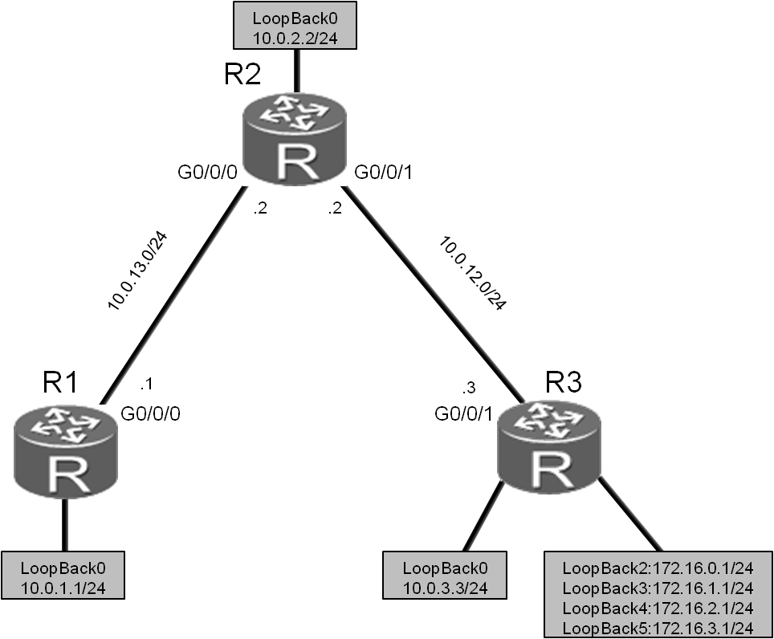

图4.3 RIPv2路由汇总和认证实验拓扑图

## **场景**

您是企业的网络管理员。为了更好地管理网络和优化路由表，需要在RIPv2网络中配置路由汇总来进行路由信息的控制和传递。

另外，为了防止恶意破坏者伪装成合法路由器，接收并修改路由信息，您还需要配置RIP认证功能来提高网络安全性。

## **操作步骤**

1. 实验环境准备

如果本任务中您使用的是空配置设备，那么从步骤1开始配置。如果使用的设备包含上一个实验的配置，请直接从步骤2开始配置。

R1、R2和R3的基础配置以及的IP地址的配置。

<Huawei>system-view

Enter system view, return user view with Ctrl+Z.

[Huawei]sysname R1

[R1]interface GigabitEthernet 0/0/0

[R1-GigabitEthernet0/0/0]ip address 10.0.13.1 24

[R1-GigabitEthernet0/0/0]quit

[R1]interface LoopBack 0

[R1-LoopBack0]ip address 10.0.1.1 24

<Huawei>system-view

Enter system view, return user view with Ctrl+Z.

[Huawei]sysname R2

[R2]interface GigabitEthernet 0/0/0

[R2-GigabitEthernet0/0/0]ip address 10.0.13.2 24

[R2-GigabitEthernet0/0/0]quit

[R2]interface GigabitEthernet 0/0/1

[R2-GigabitEthernet0/0/1]ip address 10.0.12.2 24

[R2-GigabitEthernet0/0/1]quit

[R2]interface LoopBack 0

[R2-LoopBack0]ip address 10.0.2.2 24

<Huawei>system-view

Enter system view, return user view with Ctrl+Z.

[Huawei]sysname R3

[R3]interface GigabitEthernet 0/0/1

[R3-GigabitEthernet0/0/1]ip address 10.0.12.3 24

[R3-GigabitEthernet0/0/1]quit

[R3]interface LoopBack 0

[R3-LoopBack0]ip address 10.0.3.3 24

配置完成后，检测网络连通性。

<R1>ping 10.0.13.2

PING 10.0.13.2: 56 data bytes, press CTRL_C to break

Reply from 10.0.13.2: bytes=56 Sequence=1 ttl=255 time=30 ms

Reply from 10.0.13.2: bytes=56 Sequence=2 ttl=255 time=30 ms

Reply from 10.0.13.2: bytes=56 Sequence=3 ttl=255 time=30 ms

Reply from 10.0.13.2: bytes=56 Sequence=4 ttl=255 time=30 ms

Reply from 10.0.13.2: bytes=56 Sequence=5 ttl=255 time=30 ms

--- 10.0.13.2 ping statistics ---

5 packet(s) transmitted

5 packet(s) received

0.00% packet loss

round-trip min/avg/max = 30/30/30 ms

<R2>ping 10.0.12.3

PING 10.0.12.3: 56 data bytes, press CTRL_C to break

Reply from 10.0.12.3: bytes=56 Sequence=1 ttl=255 time=31 ms

Reply from 10.0.12.3: bytes=56 Sequence=2 ttl=255 time=31 ms

Reply from 10.0.12.3: bytes=56 Sequence=3 ttl=255 time=41 ms

Reply from 10.0.12.3: bytes=56 Sequence=4 ttl=255 time=31 ms

Reply from 10.0.12.3: bytes=56 Sequence=5 ttl=255 time=41 ms

--- 10.0.12.3 ping statistics ---

5 packet(s) transmitted

5 packet(s) received

0.00% packet loss

round-trip min/avg/max = 31/35/41 ms

在R1、R2和R3上配置RIPv2路由协议。

[R1]rip 1

[R1-rip-1]version 2

[R1-rip-1]network 10.0.0.0

[R2]rip 1

[R2-rip-1]version 2

[R2-rip-1]network 10.0.0.0

[R3]rip 1

[R3-rip-1]version 2

[R3-rip-1]network 10.0.0.0

1. 配置环回地址。

在R3上创建多个环回接口并按照拓扑图配置IP地址。

[R3]interface LoopBack 2

[R3-LoopBack2]ip address 172.16.0.1 24

[R3-LoopBack2]quit

[R3]interface LoopBack 3

[R3-LoopBack3]ip address 172.16.1.1 24

[R3-LoopBack3]quit

[R3]interface LoopBack 4

[R3-LoopBack4]ip address 172.16.2.1 24

[R3-LoopBack4]quit

[R3]interface LoopBack 5

[R3-LoopBack5]ip address 172.16.3.1 24

1. 在RIP中发布环回接口地址

在R3上将环回接口的网段172.16.0.0发布到RIP协议中。

[R3]rip 1

[R3-rip-1]network 172.16.0.0

在R1上查看路由表。

<R1>display ip routing-table

Route Flags: R - relay, D - download to fib

-------------------------------------------------------------------------

Routing Tables: Public

Destinations : 17 Routes : 17

Destination/Mask Proto Pre Cost Flags NextHop Interface

10.0.1.0/24 Direct 0 0 D 10.0.1.1 LoopBack0

10.0.1.1/32 Direct 0 0 D 127.0.0.1 LoopBack0

10.0.1.255/32 Direct 0 0 D 127.0.0.1 LoopBack0

10.0.2.0/24 RIP 100 1 D 10.0.13.2 GigabitEthernet0/0/0

10.0.3.0/24 RIP 100 2 D 10.0.13.2 GigabitEthernet0/0/0

10.0.12.0/24 RIP 100 1 D 10.0.13.2 GigabitEthernet0/0/0

10.0.13.0/24 Direct 0 0 D 10.0.13.1 GigabitEthernet0/0/0

10.0.13.1/32 Direct 0 0 D 127.0.0.1 GigabitEthernet0/0/0

10.0.13.255/32 Direct 0 0 D 127.0.0.1 GigabitEthernet0/0/0

127.0.0.0/8 Direct 0 0 D 127.0.0.1 InLoopBack0

127.0.0.1/32 Direct 0 0 D 127.0.0.1 InLoopBack0

127.255.255.255/32 Direct 0 0 D 127.0.0.1 InLoopBack0

172.16.0.0/24 RIP 100 2 D 10.0.13.2 GigabitEthernet0/0/0

172.16.1.0/24 RIP 100 2 D 10.0.13.2 GigabitEthernet0/0/0

172.16.2.0/24 RIP 100 2 D 10.0.13.2 GigabitEthernet0/0/0

172.16.3.0/24 RIP 100 2 D 10.0.13.2 GigabitEthernet0/0/0

255.255.255.255/32 Direct 0 0 D 127.0.0.1 InLoopBack0

路由表中灰色阴影标注的部分表明，R1已经学习到了指定路由，但是这些路由是没有汇总的明细路由。

测试R1到网段172.16.0.0的连通性。

<R1>ping 172.16.0.1

PING 172.16.0.1: 56 data bytes, press CTRL_C to break

Reply from 172.16.0.1: bytes=56 Sequence=1 ttl=254 time=80 ms

Reply from 172.16.0.1: bytes=56 Sequence=2 ttl=254 time=79 ms

Reply from 172.16.0.1: bytes=56 Sequence=3 ttl=254 time=79 ms

Reply from 172.16.0.1: bytes=56 Sequence=4 ttl=254 time=79 ms

Reply from 172.16.0.1: bytes=56 Sequence=5 ttl=254 time=79 ms

--- 172.16.0.1 ping statistics ---

5 packet(s) transmitted

5 packet(s) received

0.00% packet loss

round-trip min/avg/max = 79/79/80 ms

1. 在R2上配置RIP手动路由汇总

在R2的G0/0/0接口执行**rip summary-address**命令，配置RIP路由汇总。四条路由172.16.0.0/24、172.16.1.0/24、172.16.2.0/24和172.16.3.0/24汇总成了一条172.16.0.0/16。

[R2]interface GigabitEthernet0/0/0

[R2-GigabitEthernet0/0/0]rip summary-address 172.16.0.0 255.255.0.0

查看R1的路由表中是否包含该汇总路由。

<R1>display ip routing-table

Route Flags: R - relay, D - download to fib

-------------------------------------------------------------------------

Routing Tables: Public

Destinations : 14 Routes : 14

Destination/Mask Proto Pre Cost Flags NextHop Interface

10.0.1.0/24 Direct 0 0 D 10.0.1.1 LoopBack0

10.0.1.1/32 Direct 0 0 D 127.0.0.1 LoopBack0

10.0.1.255/32 Direct 0 0 D 127.0.0.1 LoopBack0

10.0.2.0/24 RIP 100 1 D 10.0.13.2 GigabitEthernet0/0/0

10.0.3.0/24 RIP 100 2 D 10.0.13.2 GigabitEthernet0/0/0

10.0.12.0/24 RIP 100 1 D 10.0.13.2 GigabitEthernet0/0/0

10.0.13.0/24 Direct 0 0 D 10.0.13.1 GigabitEthernet0/0/0

10.0.13.1/32 Direct 0 0 D 127.0.0.1 GigabitEthernet0/0/0

10.0.13.255/32 Direct 0 0 D 127.0.0.1 GigabitEthernet0/0/0

127.0.0.0/8 Direct 0 0 D 127.0.0.1 InLoopBack0

127.0.0.1/32 Direct 0 0 D 127.0.0.1 InLoopBack0

127.255.255.255/32 Direct 0 0 D 127.0.0.1 InLoopBack0

172.16.0.0/16 RIP 100 2 D 10.0.13.2 GigabitEthernet0/0/0

255.255.255.255/32 Direct 0 0 D 127.0.0.1 InLoopBack0

从路由表中灰色阴影标注部分可以看出，此时路由表里面只显示了汇总路由，不再显示明细路由。

测试R1到网段172.16.0.0的连通性。

<R1>ping 172.16.0.1

PING 172.16.0.1: 56 data bytes, press CTRL_C to break

Reply from 172.16.0.1: bytes=56 Sequence=1 ttl=254 time=60 ms

Reply from 172.16.0.1: bytes=56 Sequence=2 ttl=254 time=59 ms

Reply from 172.16.0.1: bytes=56 Sequence=3 ttl=254 time=80 ms

Reply from 172.16.0.1: bytes=56 Sequence=4 ttl=254 time=60 ms

Reply from 172.16.0.1: bytes=56 Sequence=5 ttl=254 time=60 ms

--- 172.16.0.1 ping statistics ---

5 packet(s) transmitted

5 packet(s) received

0.00% packet loss

round-trip min/avg/max = 59/63/80 ms

上述信息表明，路由汇总减小了路由表的规模，而且并不影响网络的连通性。

1. 配置RIP认证

在R1和R2间配置明文认证，在R2和R3间配置MD5认证。认证密码均为“huawei”。

[R1]interface GigabitEthernet0/0/0

[R1-GigabitEthernet0/0/0]rip authentication-mode simple huawei

[R2]interface GigabitEthernet0/0/0

[R2-GigabitEthernet0/0/0]rip authentication-mode simple huawei

[R2-GigabitEthernet0/0/0]quit

[R2]interface GigabitEthernet0/0/1

[R2-GigabitEthernet0/0/1]rip authentication-mode md5 usual huawei

[R3]interface GigabitEthernet0/0/1

[R3-GigabitEthernet0/0/1]rip authentication-mode md5 usual huawei

配置完成后，验证路由是否受到了影响。

<R1>display ip routing-table

Route Flags: R - relay, D - download to fib

-------------------------------------------------------------------------

Routing Tables: Public

Destinations : 14 Routes : 14

Destination/Mask Proto Pre Cost Flags NextHop Interface

10.0.1.0/24 Direct 0 0 D 10.0.1.1 LoopBack0

10.0.1.1/32 Direct 0 0 D 127.0.0.1 LoopBack0

10.0.1.255/32 Direct 0 0 D 127.0.0.1 LoopBack0

10.0.2.0/24 RIP 100 1 D 10.0.13.2 GigabitEthernet0/0/0

10.0.3.0/24 RIP 100 2 D 10.0.13.2 GigabitEthernet0/0/0

10.0.12.0/24 RIP 100 1 D 10.0.13.2 GigabitEthernet0/0/0

10.0.13.0/24 Direct 0 0 D 10.0.13.1 GigabitEthernet0/0/0

10.0.13.1/32 Direct 0 0 D 127.0.0.1 GigabitEthernet0/0/0

10.0.13.255/32 Direct 0 0 D 127.0.0.1 GigabitEthernet0/0/0

127.0.0.0/8 Direct 0 0 D 127.0.0.1 InLoopBack0

127.0.0.1/32 Direct 0 0 D 127.0.0.1 InLoopBack0

127.255.255.255/32 Direct 0 0 D 127.0.0.1 InLoopBack0

172.16.0.0/16 RIP 100 2 D 10.0.13.2 GigabitEthernet0/0/0

255.255.255.255/32 Direct 0 0 D 127.0.0.1 InLoopBack0

<R2>display ip routing-table

Route Flags: R - relay, D - download to fib

-------------------------------------------------------------------------

Routing Tables: Public

Destinations : 19 Routes : 19

Destination/Mask Proto Pre Cost Flags NextHop Interface

10.0.1.0/24 RIP 100 1 D 10.0.13.1 GigabitEthernet0/0/0

10.0.2.0/24 Direct 0 0 D 10.0.2.2 LoopBack0

10.0.2.2/32 Direct 0 0 D 127.0.0.1 LoopBack0

10.0.2.255/32 Direct 0 0 D 127.0.0.1 LoopBack0

10.0.3.0/24 RIP 100 1 D 10.0.12.3 GigabitEthernet0/0/1

10.0.12.0/24 Direct 0 0 D 10.0.12.2 GigabitEthernet0/0/1

10.0.12.2/32 Direct 0 0 D 127.0.0.1 GigabitEthernet0/0/1

10.0.12.255/32 Direct 0 0 D 127.0.0.1 GigabitEthernet0/0/1

10.0.13.0/24 Direct 0 0 D 10.0.13.2 GigabitEthernet0/0/0

10.0.13.2/32 Direct 0 0 D 127.0.0.1 GigabitEthernet0/0/0

10.0.13.255/32 Direct 0 0 D 127.0.0.1 GigabitEthernet0/0/0

127.0.0.0/8 Direct 0 0 D 127.0.0.1 InLoopBack0

127.0.0.1/32 Direct 0 0 D 127.0.0.1 InLoopBack0

127.255.255.255/32 Direct 0 0 D 127.0.0.1 InLoopBack0

172.16.0.0/24 RIP 100 1 D 10.0.12.3 GigabitEthernet0/0/1

172.16.1.0/24 RIP 100 1 D 10.0.12.3 GigabitEthernet0/0/1

172.16.2.0/24 RIP 100 1 D 10.0.12.3 GigabitEthernet0/0/1

172.16.3.0/24 RIP 100 1 D 10.0.12.3 GigabitEthernet0/0/1

255.255.255.255/32 Direct 0 0 D 127.0.0.1 InLoopBack0

<R3>display ip routing-table

Route Flags: R - relay, D - download to fib

-------------------------------------------------------------------------

Routing Tables: Public

Destinations : 25 Routes : 25

Destination/Mask Proto Pre Cost Flags NextHop Interface

10.0.1.0/24 RIP 100 2 D 10.0.12.2 GigabitEthernet0/0/1

10.0.2.0/24 RIP 100 1 D 10.0.12.2 GigabitEthernet0/0/1

10.0.3.0/24 Direct 0 0 D 10.0.3.3 LoopBack0

10.0.3.3/32 Direct 0 0 D 127.0.0.1 LoopBack0

10.0.3.255/32 Direct 0 0 D 127.0.0.1 LoopBack0

10.0.12.0/24 Direct 0 0 D 10.0.12.3 GigabitEthernet0/0/1

10.0.12.3/32 Direct 0 0 D 127.0.0.1 GigabitEthernet0/0/1

10.0.12.255/32 Direct 0 0 D 127.0.0.1 GigabitEthernet0/0/1

10.0.13.0/24 RIP 100 1 D 10.0.12.2 GigabitEthernet0/0/1

127.0.0.0/8 Direct 0 0 D 127.0.0.1 InLoopBack0

127.0.0.1/32 Direct 0 0 D 127.0.0.1 InLoopBack0

127.255.255.255/32 Direct 0 0 D 127.0.0.1 InLoopBack0

172.16.0.0/24 Direct 0 0 D 172.16.0.1 LoopBack2

172.16.0.1/32 Direct 0 0 D 127.0.0.1 LoopBack2

172.16.0.255/32 Direct 0 0 D 127.0.0.1 LoopBack2

172.16.1.0/24 Direct 0 0 D 172.16.1.1 LoopBack3

172.16.1.1/32 Direct 0 0 D 127.0.0.1 LoopBack3

172.16.1.255/32 Direct 0 0 D 127.0.0.1 LoopBack3

172.16.2.0/24 Direct 0 0 D 172.16.2.1 LoopBack4

172.16.2.1/32 Direct 0 0 D 127.0.0.1 LoopBack4

172.16.2.255/32 Direct 0 0 D 127.0.0.1 LoopBack4

172.16.3.0/24 Direct 0 0 D 172.16.3.1 LoopBack5

172.16.3.1/32 Direct 0 0 D 127.0.0.1 LoopBack5

172.16.3.255/32 Direct 0 0 D 127.0.0.1 LoopBack5

255.255.255.255/32 Direct 0 0 D 127.0.0.1 InLoopBack0

1. RIPv2认证失败时故障排除

在R2的G0/0/0接口将认证密码修改为“huawei2”。

[R2]interface GigabitEthernet0/0/0

[R2-GigabitEthernet0/0/0]rip authentication-mode simple huawei2

然后查看R1的路由表，确认路由信息的学习情况。

<R1>display ip routing-table

Route Flags: R - relay, D - download to fib

-------------------------------------------------------------------------

Routing Tables: Public

Destinations : 10 Routes : 10

Destination/Mask Proto Pre Cost Flags NextHop Interface

10.0.1.0/24 Direct 0 0 D 10.0.1.1 LoopBack0

10.0.1.1/32 Direct 0 0 D 127.0.0.1 LoopBack0

10.0.1.255/32 Direct 0 0 D 127.0.0.1 LoopBack0

10.0.13.0/24 Direct 0 0 D 10.0.13.1 GigabitEthernet0/0/0

10.0.13.1/32 Direct 0 0 D 127.0.0.1 GigabitEthernet0/0/0

10.0.13.255/32 Direct 0 0 D 127.0.0.1 GigabitEthernet0/0/0

127.0.0.0/8 Direct 0 0 D 127.0.0.1 InLoopBack0

127.0.0.1/32 Direct 0 0 D 127.0.0.1 InLoopBack0

127.255.255.255/32 Direct 0 0 D 127.0.0.1 InLoopBack0

255.255.255.255/32 Direct 0 0 D 127.0.0.1 InLoopBack0

由于R1与R2之间的RIP认证密码不匹配，所以R1收不到从R2发来的任何RIP路由信息。

在R2的G0/0/0接口将认证密码恢复为“huawei”。

[R2]interface GigabitEthernet0/0/0

[R2-GigabitEthernet0/0/0]rip authentication-mode simple huawei

在R2的G0/0/1接口将认证模式修改为明文认证。

[R2]interface GigabitEthernet0/0/1

[R2-GigabitEthernet0/0/1]rip authentication-mode simple huawei

使用如下命令清除R3在密码错误之前从R2学到的路由信息。

<R3>reset ip routing-table statistics protocol rip

查看R3的路由表。

<R3>display ip routing-table

Route Flags: R - relay, D - download to fib

------------------------------------------------------------------------

Routing Tables: Public

Destinations : 22 Routes : 22

Destination/Mask Proto Pre Cost Flags NextHop Interface

10.0.3.0/24 Direct 0 0 D 10.0.3.3 LoopBack0

10.0.3.3/32 Direct 0 0 D 127.0.0.1 LoopBack0

10.0.3.255/32 Direct 0 0 D 127.0.0.1 LoopBack0

10.0.12.0/24 Direct 0 0 D 10.0.12.3 GigabitEthernet0/0/1

10.0.12.3/32 Direct 0 0 D 127.0.0.1 GigabitEthernet0/0/1

10.0.12.255/32 Direct 0 0 D 127.0.0.1 GigabitEthernet0/0/1

127.0.0.0/8 Direct 0 0 D 127.0.0.1 InLoopBack0

127.0.0.1/32 Direct 0 0 D 127.0.0.1 InLoopBack0

127.255.255.255/32 Direct 0 0 D 127.0.0.1 InLoopBack0

172.16.0.0/24 Direct 0 0 D 172.16.0.1 LoopBack2

172.16.0.1/32 Direct 0 0 D 127.0.0.1 LoopBack2

172.16.0.255/32 Direct 0 0 D 127.0.0.1 LoopBack2

172.16.1.0/24 Direct 0 0 D 172.16.1.1 LoopBack3

172.16.1.1/32 Direct 0 0 D 127.0.0.1 LoopBack3

172.16.1.255/32 Direct 0 0 D 127.0.0.1 LoopBack3

172.16.2.0/24 Direct 0 0 D 172.16.2.1 LoopBack4

172.16.2.1/32 Direct 0 0 D 127.0.0.1 LoopBack4

172.16.2.255/32 Direct 0 0 D 127.0.0.1 LoopBack4

172.16.3.0/24 Direct 0 0 D 172.16.3.1 LoopBack5

172.16.3.1/32 Direct 0 0 D 127.0.0.1 LoopBack5

172.16.3.255/32 Direct 0 0 D 127.0.0.1 LoopBack5

255.255.255.255/32 Direct 0 0 D 127.0.0.1 InLoopBack0

由于R2和R3使用不同的RIP认证模式，R3无法接收R2发布的RIP路由。

在R2的G0/0/1接口将认证模式恢复为MD5。

[R2]interface GigabitEthernet0/0/1

[R2-GigabitEthernet0/0/1]rip authentication-mode md5 usual huawei

验证R1、R2和R3的路由表中的路由条目是否已经恢复。注意，由于RIP是周期更新，因此可能需要稍等片刻才能恢复。

<R1>display ip routing-table

Route Flags: R - relay, D - download to fib

-------------------------------------------------------------------------

Routing Tables: Public

Destinations : 14 Routes : 14

Destination/Mask Proto Pre Cost Flags NextHop Interface

10.0.1.0/24 Direct 0 0 D 10.0.1.1 LoopBack0

10.0.1.1/32 Direct 0 0 D 127.0.0.1 LoopBack0

10.0.1.255/32 Direct 0 0 D 127.0.0.1 LoopBack0

10.0.2.0/24 RIP 100 1 D 10.0.13.2 GigabitEthernet0/0/0

10.0.3.0/24 RIP 100 2 D 10.0.13.2 GigabitEthernet0/0/0

10.0.12.0/24 RIP 100 1 D 10.0.13.2 GigabitEthernet0/0/0

10.0.13.0/24 Direct 0 0 D 10.0.13.1 GigabitEthernet0/0/0

10.0.13.1/32 Direct 0 0 D 127.0.0.1 GigabitEthernet0/0/0

10.0.13.255/32 Direct 0 0 D 127.0.0.1 GigabitEthernet0/0/0

127.0.0.0/8 Direct 0 0 D 127.0.0.1 InLoopBack0

127.0.0.1/32 Direct 0 0 D 127.0.0.1 InLoopBack0

127.255.255.255/32 Direct 0 0 D 127.0.0.1 InLoopBack0

172.16.0.0/16 RIP 100 2 D 10.0.13.2 GigabitEthernet0/0/0

255.255.255.255/32 Direct 0 0 D 127.0.0.1 InLoopBack0

[R2]display ip routing-table

Route Flags: R - relay, D - download to fib

-------------------------------------------------------------------------

Routing Tables: Public

Destinations : 19 Routes : 19

Destination/Mask Proto Pre Cost Flags NextHop Interface

10.0.1.0/24 RIP 100 1 D 10.0.13.1 GigabitEthernet0/0/0

10.0.2.0/24 Direct 0 0 D 10.0.2.2 LoopBack0

10.0.2.2/32 Direct 0 0 D 127.0.0.1 LoopBack0

10.0.2.255/32 Direct 0 0 D 127.0.0.1 LoopBack0

10.0.3.0/24 RIP 100 1 D 10.0.12.3 GigabitEthernet0/0/1

10.0.12.0/24 Direct 0 0 D 10.0.12.2 GigabitEthernet0/0/1

10.0.12.2/32 Direct 0 0 D 127.0.0.1 GigabitEthernet0/0/1

10.0.12.255/32 Direct 0 0 D 127.0.0.1 GigabitEthernet0/0/1

10.0.13.0/24 Direct 0 0 D 10.0.13.2 GigabitEthernet0/0/0

10.0.13.2/32 Direct 0 0 D 127.0.0.1 GigabitEthernet0/0/0

10.0.13.255/32 Direct 0 0 D 127.0.0.1 GigabitEthernet0/0/0

127.0.0.0/8 Direct 0 0 D 127.0.0.1 InLoopBack0

127.0.0.1/32 Direct 0 0 D 127.0.0.1 InLoopBack0

127.255.255.255/32 Direct 0 0 D 127.0.0.1 InLoopBack0

172.16.0.0/24 RIP 100 1 D 10.0.12.3 GigabitEthernet0/0/1

172.16.1.0/24 RIP 100 1 D 10.0.12.3 GigabitEthernet0/0/1

172.16.2.0/24 RIP 100 1 D 10.0.12.3 GigabitEthernet0/0/1

172.16.3.0/24 RIP 100 1 D 10.0.12.3 GigabitEthernet0/0/1

255.255.255.255/32 Direct 0 0 D 127.0.0.1 InLoopBack0

<R3>display ip routing-table

Route Flags: R - relay, D - download to fib

-------------------------------------------------------------------------

Routing Tables: Public

Destinations : 25 Routes : 25

Destination/Mask Proto Pre Cost Flags NextHop Interface

10.0.1.0/24 RIP 100 2 D 10.0.12.2 GigabitEthernet0/0/1

10.0.2.0/24 RIP 100 1 D 10.0.12.2 GigabitEthernet0/0/1

10.0.3.0/24 Direct 0 0 D 10.0.3.3 LoopBack0

10.0.3.3/32 Direct 0 0 D 127.0.0.1 LoopBack0

10.0.3.255/32 Direct 0 0 D 127.0.0.1 LoopBack0

10.0.12.0/24 Direct 0 0 D 10.0.12.3 GigabitEthernet0/0/1

10.0.12.3/32 Direct 0 0 D 127.0.0.1 GigabitEthernet0/0/1

10.0.12.255/32 Direct 0 0 D 127.0.0.1 GigabitEthernet0/0/1

10.0.13.0/24 RIP 100 1 D 10.0.12.2 GigabitEthernet0/0/1

127.0.0.0/8 Direct 0 0 D 127.0.0.1 InLoopBack0

127.0.0.1/32 Direct 0 0 D 127.0.0.1 InLoopBack0

127.255.255.255/32 Direct 0 0 D 127.0.0.1 InLoopBack0

172.16.0.0/24 Direct 0 0 D 172.16.0.1 LoopBack2

172.16.0.1/32 Direct 0 0 D 127.0.0.1 LoopBack2

172.16.0.255/32 Direct 0 0 D 127.0.0.1 LoopBack2

172.16.1.0/24 Direct 0 0 D 172.16.1.1 LoopBack3

172.16.1.1/32 Direct 0 0 D 127.0.0.1 LoopBack3

172.16.1.255/32 Direct 0 0 D 127.0.0.1 LoopBack3

172.16.2.0/24 Direct 0 0 D 172.16.2.1 LoopBack4

172.16.2.1/32 Direct 0 0 D 127.0.0.1 LoopBack4

172.16.2.255/32 Direct 0 0 D 127.0.0.1 LoopBack4

172.16.3.0/24 Direct 0 0 D 172.16.3.1 LoopBack5

172.16.3.1/32 Direct 0 0 D 127.0.0.1 LoopBack5

172.16.3.255/32 Direct 0 0 D 127.0.0.1 LoopBack5

255.255.255.255/32 Direct 0 0 D 127.0.0.1 InLoopBack0

## **配置文件**

<R1>display current-configuration

[V200R007C00SPC600]

#

sysname R1

#

interface GigabitEthernet0/0/0

ip address 10.0.13.1 255.255.255.0

rip authentication-mode simple cipher %$%$S2AJ2_mJ)Hf++RSng6^NN|Xl%$%$

#

interface LoopBack0

ip address 10.0.1.1 255.255.255.0

#

rip 1

version 2

network 10.0.0.0

#

user-interface con 0

authentication-mode password

set authentication password cipher %$%$+L'YR&IZt'4,)>-*#lH",}%K-oJ_M9+'lOU~bD (\WTqB}%N,%$%$

user-interface vty 0 4

#

return

<R2>display current-configuration

[V200R007C00SPC600]

#

sysname R2

#

interface GigabitEthernet0/0/0

ip address 10.0.13.2 255.255.255.0

rip authentication-mode simple cipher %$%$+Ob&JcQxU6mUJ(ZXLZY#OEXz%$%$

rip summary-address 172.16.0.0 255.255.0.0

#

interface GigabitEthernet0/0/1

ip address 10.0.12.2 255.255.255.0

rip authentication-mode md5 usual cipher %$%$C]'$.`NWGZ}|gLV%:XF>OG}|%$%$

#

interface LoopBack0

ip address 10.0.2.2 255.255.255.0

#

rip 1

version 2

network 10.0.0.0

#

user-interface con 0

authentication-mode password

set authentication password cipher %$%$1=cd%b%/O%Id-8X:by1N,+s}'4wD6TvO<I|/pd# #44C@+s#,%$%$

user-interface vty 0 4

#

return

<R3>display current-configuration

[V200R007C00SPC600]

#

sysname R3

#

interface GigabitEthernet0/0/1

ip address 10.0.12.3 255.255.255.0

rip authentication-mode md5 usual cipher %$%$_5VL+wN6FNe]rVKbh[E(O=E>%$%$

#

interface LoopBack0

ip address 10.0.3.3 255.255.255.0

#

interface LoopBack2

ip address 172.16.0.1 255.255.255.0

#

interface LoopBack3

ip address 172.16.1.1 255.255.255.0

#

interface LoopBack4

ip address 172.16.2.1 255.255.255.0

#

interface LoopBack5

ip address 172.16.3.1 255.255.255.0

#

rip 1

version 2

network 10.0.0.0

network 172.16.0.0

#

user-interface con 0

authentication-mode password

set authentication password cipher %$%$ksXDMg7Ry6yUU:63:DQ),#/sQg"@*S\U#.s.bHW xQ,y%#/v,%$%$

user-interface vty 0 4

#

return

实验4-4 OSPF单区域配置

学习目标

* **掌握OSPF中Router ID的配置方法**
* **掌握OSPF的配置方法**
* **掌握通过display命令查看OSPF运行状态的方法**
* **掌握使用OSPF发布缺省路由的方法**
* **掌握修改OSPF hello和dead时间的配置方法**
* **理解多路访问网络中的DR或BDR选举**
* **掌握OSPF路由优先级的修改方法**

## **拓扑图**

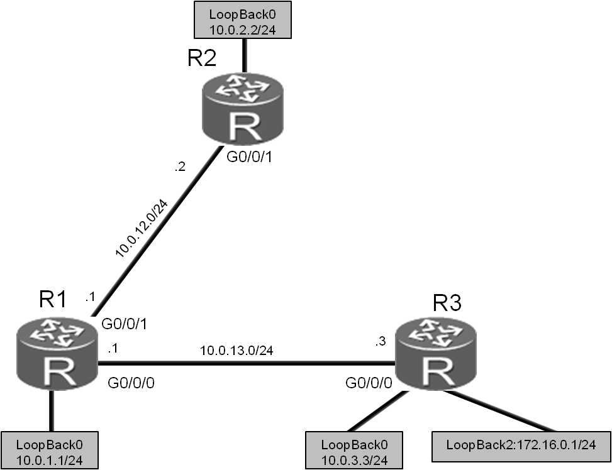

图4.4 OSPF单域配置实验拓扑图

场景

您是公司的网络管理员。现在公司网络中需要使用OSPF协议来进行路由信息的传递。规划网络中所有路由器属于OSPF的区域0。实际使用中需要向OSPF发布默认路由，此外您也希望通过这次部署了解DR/BDR选举的机制。

操作步骤

1. 实验环境准备

如果本任务中您使用的是空配置设备，需要从步骤1开始配置，然后跳过步骤2。如果使用的设备包含上一个实验的配置，请直接从步骤2开始配置。

基本配置以及IP编址。

<Huawei>system-view

Enter system view, return user view with Ctrl+Z.

[Huawei]sysname R1

[R1]interface GigabitEthernet 0/0/1

[R1-GigabitEthernet0/0/1]ip address 10.0.12.1 24

[R1-GigabitEthernet0/0/1]quit

[R1]interface GigabitEthernet 0/0/0

[R1-GigabitEthernet0/0/0]ip address 10.0.13.1 24

[R1-GigabitEthernet0/0/0]quit

[R1]interface LoopBack 0

[R1-LoopBack0]ip address 10.0.1.1 24

<Huawei>system-view

Enter system view, return user view with Ctrl+Z.

[Huawei]sysname R2

[R2]interface GigabitEthernet 0/0/1

[R2-GigabitEthernet0/0/1]ip address 10.0.12.2 24

[R2-GigabitEthernet0/0/1]quit

[R2]interface LoopBack 0

[R2-LoopBack0]ip address 10.0.2.2 24

<Huawei>system-view

Enter system view, return user view with Ctrl+Z.

[Huawei]sysname R3

[R3]interface GigabitEthernet 0/0/0

[R3-GigabitEthernet0/0/0]ip address 10.0.13.3 24

[R3-GigabitEthernet0/0/0]quit

[R3]interface LoopBack 0

[R3-LoopBack0]ip address 10.0.3.3 24

[R3-LoopBack0]quit

[R3]interface LoopBack 2

[R3-LoopBack2]ip address 172.16.0.1 24

1. 清除设备上原有的配置

打开必要的接口，关闭无关接口。

[R1]interface GigabitEthernet 0/0/1

[R1-GigabitEthernet0/0/1]undo shutdown

[R1-GigabitEthernet0/0/1]quit

[R2]interface GigabitEthernet 0/0/0

[R2-GigabitEthernet0/0/0]undo rip summary-address 172.16.0.0 255.255.0.0

[R2-GigabitEthernet0/0/0]shutdown

[R3]interface GigabitEthernet 0/0/0

[R3-GigabitEthernet0/0/0]undo shutdown

[R3-GigabitEthernet0/0/0]quit

[R3]interface GigabitEthernet 0/0/1

[R3-GigabitEthernet0/0/1]shutdown

[R3-GigabitEthernet0/0/1]quit

[R3]undo interface LoopBack 3

Info: This operation may take a few seconds. Please wait for a moment...succeeded.

[R3]undo interface LoopBack 4

Info: This operation may take a few seconds. Please wait for a moment...succeeded.

[R3]undo interface LoopBack 5

Info: This operation may take a few seconds. Please wait for a moment...succeeded.

删除设备上的RIP认证配置和RIP进程1。

[R1]interface GigabitEthernet 0/0/0

[R1-GigabitEthernet0/0/0]undo rip authentication-mode

[R1-GigabitEthernet0/0/0]quit

[R1]undo rip 1

Warning: The RIP process will be deleted. Continue?[Y/N]y

[R2]interface GigabitEthernet 0/0/0

[R2-GigabitEthernet0/0/0]undo rip authentication-mode

[R2-GigabitEthernet0/0/0]quit

[R2]interface GigabitEthernet 0/0/1

[R2-GigabitEthernet0/0/1]undo rip authentication-mode

[R2-GigabitEthernet0/0/1]quit

[R2]undo rip 1

Warning: The RIP process will be deleted. Continue?[Y/N]y

[R3]interface GigabitEthernet 0/0/1

[R3-GigabitEthernet0/0/1]undo rip authentication-mode

[R3-GigabitEthernet0/0/1]quit

[R3]undo rip 1

Warning: The RIP process will be deleted. Continue?[Y/N]y

1. 配置OSPF

将R1的Router ID配置为10.0.1.1（逻辑接口Loopback 0的地址），开启OSPF进程1（缺省进程），并将网段10.0.1.0/24、10.0.12.0/24和10.0.13.0/24发布到OSPF区域0。

[R1]ospf 1 router-id 10.0.1.1

[R1-ospf-1]area 0

[R1-ospf-1-area-0.0.0.0]network 10.0.1.0 0.0.0.255

[R1-ospf-1-area-0.0.0.0]network 10.0.13.0 0.0.0.255

[R1-ospf-1-area-0.0.0.0]network 10.0.12.0 0.0.0.255

注意：同一个路由器可以开启多个OSPF进程，默认进程号为1，由于进程号只具有本地意义，所以同一路由域的不同路由器可以使用相同或不同的OSPF进程号。另外**network**命令后面需使用反掩码。

将R2的Router ID配置为10.0.2.2，开启OSPF进程1，并将网段10.0.12.0/24和10.0.2.0/24发布到OSPF区域0。

[R2]ospf 1 router-id 10.0.2.2

[R2-ospf-1]area 0

[R2-ospf-1-area-0.0.0.0]network 10.0.2.0 0.0.0.255

[R2-ospf-1-area-0.0.0.0]network 10.0.12.0 0.0.0.255

…output omit…

Mar 30 2016 09:41:39+00:00 R2 %%01OSPF/4/NBR_CHANGE_E(l)[5]:Neighbor changes event: neighbor status changed. (ProcessId=1, NeighborAddress=10.0.12.1, NeighborEvent=LoadingDone, NeighborPreviousState=Loading, NeighborCurrentState=Full)

当回显信息中包含“NeighborCurrentState=Full”信息时，表明邻接关系已经建立。

将R3的Router ID配置为10.0.3.3，开启OSPF进程1，并将网段10.0.3.0/24和10.0.13.0/24发布到OSPF区域0。

[R3]ospf 1 router-id 10.0.3.3

[R3-ospf-1]area 0

[R3-ospf-1-area-0.0.0.0]network 10.0.3.0 0.0.0.255

[R3-ospf-1-area-0.0.0.0]network 10.0.13.0 0.0.0.255

…output omit…

Mar 30 2016 16:05:34+00:00 R3 %%01OSPF/4/NBR_CHANGE_E(l)[5]:Neighbor changes event: neighbor status changed. (ProcessId=1, NeighborAddress=10.0.13.1, NeighborEvent=LoadingDone, NeighborPreviousState=Loading, NeighborCurrentState=Full)

1. 验证OSPF配置

待OSPF收敛完成后，查看R1、R2和R3上的路由表。

<R1>display ip routing-table

Route Flags: R - relay, D - download to fib

-------------------------------------------------------------------------

Routing Tables: Public

Destinations : 15 Routes : 15

Destination/Mask Proto Pre Cost Flags NextHop Interface

10.0.1.0/24 Direct 0 0 D 10.0.1.1 LoopBack0

10.0.1.1/32 Direct 0 0 D 127.0.0.1 LoopBack0

10.0.1.255/32 Direct 0 0 D 127.0.0.1 LoopBack0

10.0.2.2/32 OSPF 10 1 D 10.0.12.2 GigabitEthernet0/0/1

10.0.3.3/32 OSPF 10 1 D 10.0.13.3 GigabitEthernet0/0/0

10.0.12.0/24 Direct 0 0 D 10.0.12.1 GigabitEthernet0/0/1

10.0.12.1/32 Direct 0 0 D 127.0.0.1 GigabitEthernet0/0/1

10.0.12.255/32 Direct 0 0 D 127.0.0.1 GigabitEthernet0/0/1

10.0.13.0/24 Direct 0 0 D 10.0.13.1 GigabitEthernet0/0/0

10.0.13.1/32 Direct 0 0 D 127.0.0.1 GigabitEthernet0/0/0

10.0.13.255/32 Direct 0 0 D 127.0.0.1 GigabitEthernet0/0/0

127.0.0.0/8 Direct 0 0 D 127.0.0.1 InLoopBack0

127.0.0.1/32 Direct 0 0 D 127.0.0.1 InLoopBack0

127.255.255.255/32 Direct 0 0 D 127.0.0.1 InLoopBack0

255.255.255.255/32 Direct 0 0 D 127.0.0.1 InLoopBack0

<R2>display ip routing-table

Route Flags: R - relay, D - download to fib

-------------------------------------------------------------------------

Routing Tables: Public

Destinations : 13 Routes : 13

Destination/Mask Proto Pre Cost Flags NextHop Interface

10.0.1.1/32 OSPF 10 1 D 10.0.12.1 GigabitEthernet0/0/1

10.0.2.0/24 Direct 0 0 D 10.0.2.2 LoopBack0

10.0.2.2/32 Direct 0 0 D 127.0.0.1 LoopBack0

10.0.2.255/32 Direct 0 0 D 127.0.0.1 LoopBack0

10.0.3.3/32 OSPF 10 2 D 10.0.12.1 GigabitEthernet0/0/1

10.0.12.0/24 Direct 0 0 D 10.0.12.2 GigabitEthernet0/0/1

10.0.12.2/32 Direct 0 0 D 127.0.0.1 GigabitEthernet0/0/1

10.0.12.255/32 Direct 0 0 D 127.0.0.1 GigabitEthernet0/0/1

10.0.13.0/24 OSPF 10 2 D 10.0.12.1 GigabitEthernet0/0/1

127.0.0.0/8 Direct 0 0 D 127.0.0.1 InLoopBack0

127.0.0.1/32 Direct 0 0 D 127.0.0.1 InLoopBack0

127.255.255.255/32 Direct 0 0 D 127.0.0.1 InLoopBack0

255.255.255.255/32 Direct 0 0 D 127.0.0.1 InLoopBack0

<R3>display ip routing-table

Route Flags: R - relay, D - download to fib

-------------------------------------------------------------------------

Routing Tables: Public

Destinations : 16 Routes : 16

Destination/Mask Proto Pre Cost Flags NextHop Interface

10.0.1.1/32 OSPF 10 1 D 10.0.13.1 GigabitEthernet0/0/0

10.0.2.2/32 OSPF 10 2 D 10.0.13.1 GigabitEthernet0/0/0

10.0.3.0/24 Direct 0 0 D 10.0.3.3 LoopBack0

10.0.3.3/32 Direct 0 0 D 127.0.0.1 LoopBack0

10.0.3.255/32 Direct 0 0 D 127.0.0.1 LoopBack0

10.0.12.0/24 OSPF 10 2 D 10.0.13.1 GigabitEthernet0/0/0

10.0.13.0/24 Direct 0 0 D 10.0.13.3 GigabitEthernet0/0/0

10.0.13.3/32 Direct 0 0 D 127.0.0.1 GigabitEthernet0/0/0

10.0.13.255/32 Direct 0 0 D 127.0.0.1 GigabitEthernet0/0/0

127.0.0.0/8 Direct 0 0 D 127.0.0.1 InLoopBack0

127.0.0.1/32 Direct 0 0 D 127.0.0.1 InLoopBack0

127.255.255.255/32 Direct 0 0 D 127.0.0.1 InLoopBack0

172.16.0.0/24 Direct 0 0 D 172.16.0.1 LoopBack2

172.16.0.1/32 Direct 0 0 D 127.0.0.1 LoopBack2

172.16.0.255/32 Direct 0 0 D 127.0.0.1 LoopBack2

255.255.255.255/32 Direct 0 0 D 127.0.0.1 InLoopBack0

检测R2和R1（10.0.1.1）以及R2和R3（10.0.3.3）间的连通性。

<R2>ping 10.0.1.1

PING 10.0.1.1: 56 data bytes, press CTRL_C to break

Reply from 10.0.1.1: bytes=56 Sequence=1 ttl=255 time=37 ms

Reply from 10.0.1.1: bytes=56 Sequence=2 ttl=255 time=42 ms

Reply from 10.0.1.1: bytes=56 Sequence=3 ttl=255 time=42 ms

Reply from 10.0.1.1: bytes=56 Sequence=4 ttl=255 time=45 ms

Reply from 10.0.1.1: bytes=56 Sequence=5 ttl=255 time=42 ms

--- 10.0.1.1 ping statistics ---

5 packet(s) transmitted

5 packet(s) received

0.00% packet loss

round-trip min/avg/max = 37/41/45 ms

<R2>ping 10.0.3.3

PING 10.0.3.3: 56 data bytes, press CTRL_C to break

Reply from 10.0.3.3: bytes=56 Sequence=1 ttl=254 time=37 ms

Reply from 10.0.3.3: bytes=56 Sequence=2 ttl=254 time=42 ms

Reply from 10.0.3.3: bytes=56 Sequence=3 ttl=254 time=42 ms

Reply from 10.0.3.3: bytes=56 Sequence=4 ttl=254 time=42 ms

Reply from 10.0.3.3: bytes=56 Sequence=5 ttl=254 time=42 ms

--- 10.0.3.3 ping statistics ---

5 packet(s) transmitted

5 packet(s) received

0.00% packet loss

round-trip min/avg/max = 37/41/42 ms

执行**display ospf peer**命令，查看OSPF邻居状态。

<R1>display ospf peer

OSPF Process 1 with Router ID 10.0.1.1

Neighbors

Area 0.0.0.0 interface 10.0.12.1(GigabitEthernet0/0/1)'s neighbors

Router ID: 10.0.2.2 Address: 10.0.12.2

State: Full Mode:Nbr is Master Priority: 1

DR: 10.0.12.1 BDR: 10.0.12.2 MTU: 0

Dead timer due in 32 sec

Retrans timer interval: 5

Neighbor is up for 00:47:59

Authentication Sequence: [ 0 ]

Neighbors

Area 0.0.0.0 interface 10.0.13.1(GigabitEthernet0/0/0)'s neighbors

Router ID: 10.0.3.3 Address: 10.0.13.3

State: Full Mode:Nbr is Master Priority: 1

DR: 10.0.13.1 BDR: 10.0.13.3 MTU: 0

Dead timer due in 34 sec

Retrans timer interval: 5

Neighbor is up for 00:41:44

Authentication Sequence: [ 0 ]

**display ospf peer**命令显示所有OSPF邻居的详细信息。本任务中，在10.0.13.0网段上R1是DR。由于DR选举是非抢占模式，如果OSPF进程不重启，R3将不会取代R1的DR角色。

执行**display ospf peer brief**命令，可以查看简要的OSPF邻居信息。

<R1>display ospf peer brief

OSPF Process 1 with Router ID 10.0.1.1

Peer Statistic Information

-------------------------------------------------------------------------

Area Id Interface Neighbor id State

0.0.0.0 GigabitEthernet0/0/0 10.0.3.3 Full

0.0.0.0 GigabitEthernet0/0/1 10.0.2.2 Full

-------------------------------------------------------------------------

<R2>display ospf peer brief

OSPF Process 1 with Router ID 10.0.2.2

Peer Statistic Information

-------------------------------------------------------------------------

Area Id Interface Neighbor id State

0.0.0.0 GigabitEthernet0/0/1 10.0.1.1 Full

-------------------------------------------------------------------------

<R3>display ospf peer brief

OSPF Process 1 with Router ID 10.0.3.3

Peer Statistic Information

-------------------------------------------------------------------------

Area Id Interface Neighbor id State

0.0.0.0 GigabitEthernet0/0/0 10.0.1.1 Full

-------------------------------------------------------------------------

1. 修改OSPF hello和dead时间参数

在R1上执行**display ospf interface GigabitEthernet 0/0/0**命令，查看OSPF默认的hello和dead时间。

<R1>display ospf interface GigabitEthernet 0/0/0

OSPF Process 1 with Router ID 10.0.1.1

Interfaces

Interface: 10.0.13.1 (GigabitEthernet0/0/0)

Cost: 1 State: DR Type: Broadcast MTU: 1500

Priority: 1

Designated Router: 10.0.13.1

Backup Designated Router: 10.0.13.3

Timers: Hello 10 , Dead 40 , Poll 120 , Retransmit 5 , Transmit Delay 1

在R1的GE0/0/0接口执行**ospf timer**命令，将OSPF hello和dead时间分别修改为15秒和60秒。

[R1]interface GigabitEthernet 0/0/0

[R1-GigabitEthernet0/0/0]ospf timer hello 15

[R1-GigabitEthernet0/0/0]ospf timer dead 60

Mar 30 2016 16:58:39+00:00 R1 %%01OSPF/3/NBR_DOWN_REASON(l)[1]:Neighbor state leaves full or changed to Down. (ProcessId=1, NeighborRouterId=10.0.3.3, NeighborAreaId=0, NeighborInterface=GigabitEthernet0/0/0,NeighborDownImmediate reason=Neighbor Down Due to Inactivity, NeighborDownPrimeReason=Interface Parameter Mismatch, NeighborChangeTime=2013-11-30 16:58:39)

<R1>display ospf interface GigabitEthernet 0/0/0

OSPF Process 1 with Router ID 10.0.1.1

Interfaces

Interface: 10.0.13.1 (GigabitEthernet0/0/0)

Cost: 1 State: DR Type: Broadcast MTU: 1500

Priority: 1

Designated Router: 10.0.13.1

Backup Designated Router: 10.0.13.3

Timers: Hello 15 , Dead 60 , Poll 120 , Retransmit 5 , Transmit Delay 1

在R1上查看OSPF邻居状态。

<R1>display ospf peer brief

OSPF Process 1 with Router ID 10.0.1.1

Peer Statistic Information

-------------------------------------------------------------------------

Area Id Interface Neighbor id State

0.0.0.0 GigabitEthernet0/0/1 10.0.2.2 Full

-------------------------------------------------------------------------

上述回显信息表明，R1只有一个邻居，那就是R2。因为R1和R3上的OSPF hello和dead时间取值不同，所以R1无法与R3建立OSPF邻居关系。

在R3的GE0/0/0接口执行**ospf timer**命令，将OSPF hello和dead时间分别修改为15秒和60秒。

[R3]interface GigabitEthernet 0/0/0

[R3-GigabitEthernet0/0/0]ospf timer hello 15

[R3-GigabitEthernet0/0/0]ospf timer dead 60

…output omit…

Mar 30 2016 17:03:33+00:00 R3 %%01OSPF/4/NBR_CHANGE_E(l)[4]:Neighbor changes event: neighbor status changed. (ProcessId=1, NeighborAddress=10.0.13.1, NeighborEvent=LoadingDone, NeighborPreviousState=Loading, NeighborCurrentState=Full)

<R3>display ospf interface GigabitEthernet 0/0/0

OSPF Process 1 with Router ID 10.0.3.3

Interfaces

Interface: 10.0.13.3 (GigabitEthernet0/0/0)

Cost: 1 State: DR Type: Broadcast MTU: 1500

Priority: 1

Designated Router: 10.0.13.3

Backup Designated Router: 10.0.13.1

Timers: Hello 15 , Dead 60 , Poll 120 , Retransmit 5 , Transmit Delay 1

再次在R1上查看OSPF邻居状态。

<R1>display ospf peer brief

OSPF Process 1 with Router ID 10.0.1.1

Peer Statistic Information

------------------------------------------------------------------------

Area Id Interface Neighbor id State

0.0.0.0 GigabitEthernet0/0/0 10.0.3.3 Full

0.0.0.0 GigabitEthernet0/0/1 10.0.2.2 Full

-------------------------------------------------------------------------

1. OSPF缺省路由发布及验证

在R3上配置缺省路由并发布到OSPF域内。

[R3]ip route-static 0.0.0.0 0.0.0.0 LoopBack 2

[R3]ospf 1

[R3-ospf-1]default-route-advertise

查看R1和R2的路由表。可以看到，R1和R2均已经学习到了R3发布的缺省路由。

<R1>display ip routing-table

Route Flags: R - relay, D - download to fib

-------------------------------------------------------------------------

Routing Tables: Public

Destinations : 16 Routes : 16

Destination/Mask Proto Pre Cost Flags NextHop Interface

0.0.0.0/0 O_ASE 150 1 D 10.0.13.3 GigabitEthernet0/0/0

10.0.1.0/24 Direct 0 0 D 10.0.1.1 LoopBack0

10.0.1.1/32 Direct 0 0 D 127.0.0.1 LoopBack0

10.0.1.255/32 Direct 0 0 D 127.0.0.1 LoopBack0

10.0.2.2/32 OSPF 10 1 D 10.0.12.2 GigabitEthernet0/0/1

10.0.3.3/32 OSPF 10 1 D 10.0.13.3 GigabitEthernet0/0/0

10.0.12.0/24 Direct 0 0 D 10.0.12.1 GigabitEthernet0/0/1

10.0.12.1/32 Direct 0 0 D 127.0.0.1 GigabitEthernet0/0/1

10.0.12.255/32 Direct 0 0 D 127.0.0.1 GigabitEthernet0/0/1

10.0.13.0/24 Direct 0 0 D 10.0.13.1 GigabitEthernet0/0/0

10.0.13.1/32 Direct 0 0 D 127.0.0.1 GigabitEthernet0/0/0

10.0.13.255/32 Direct 0 0 D 127.0.0.1 GigabitEthernet0/0/0

127.0.0.0/8 Direct 0 0 D 127.0.0.1 InLoopBack0

127.0.0.1/32 Direct 0 0 D 127.0.0.1 InLoopBack0

127.255.255.255/32 Direct 0 0 D 127.0.0.1 InLoopBack0

255.255.255.255/32 Direct 0 0 D 127.0.0.1 InLoopBack0

<R2>display ip routing-table

Route Flags: R - relay, D - download to fib

-------------------------------------------------------------------------

Routing Tables: Public

Destinations : 14 Routes : 14

Destination/Mask Proto Pre Cost Flags NextHop Interface

0.0.0.0/0 O_ASE 150 1 D 10.0.12.1 GigabitEthernet0/0/1

10.0.1.1/32 OSPF1 0 1 D 10.0.12.1 GigabitEthernet0/0/1

10.0.2.0/24 Direct 0 0 D 10.0.2.2 LoopBack0

10.0.2.2/32 Direct 0 0 D 127.0.0.1 LoopBack0

10.0.2.255/32 Direct 0 0 D 127.0.0.1 LoopBack0

10.0.3.3/32 OSPF 10 2 D 10.0.12.1 GigabitEthernet0/0/1

10.0.12.0/24 Direct 0 0 D 10.0.12.2 GigabitEthernet0/0/1

10.0.12.2/32 Direct 0 0 D 127.0.0.1 GigabitEthernet0/0/1

10.0.12.255/32 Direct 0 0 D 127.0.0.1 GigabitEthernet0/0/1

10.0.13.0/24 OSPF 10 2 D 10.0.12.1 GigabitEthernet0/0/1

127.0.0.0/8 Direct 0 0 D 127.0.0.1 InLoopBack0

127.0.0.1/32 Direct 0 0 D 127.0.0.1 InLoopBack0

127.255.255.255/32 Direct 0 0 D 127.0.0.1 InLoopBack0

255.255.255.255/32 Direct 0 0 D 127.0.0.1 InLoopBack0

<R3>display ip routing-table

Route Flags: R - relay, D - download to fib

-------------------------------------------------------------------------

Routing Tables: Public

Destinations : 17 Routes : 17

Destination/Mask Proto Pre Cost Flags NextHop Interface

0.0.0.0/0 Static 60 0 D 172.16.0.1 LoopBack2

10.0.1.1/32 OSPF 10 1 D 10.0.13.1 GigabitEthernet0/0/0

10.0.2.2/32 OSPF 10 2 D 10.0.13.1 GigabitEthernet0/0/0

10.0.3.0/24 Direct 0 0 D 10.0.3.3 LoopBack0

10.0.3.3/32 Direct 0 0 D 127.0.0.1 LoopBack0

10.0.3.255/32 Direct 0 0 D 127.0.0.1 LoopBack0

10.0.12.0/24 OSPF 10 2 D 10.0.13.1 GigabitEthernet0/0/0

10.0.13.0/24 Direct 0 0 D 10.0.13.3 GigabitEthernet0/0/0

10.0.13.3/32 Direct 0 0 D 127.0.0.1 GigabitEthernet0/0/0

10.0.13.255/32 Direct 0 0 D 127.0.0.1 GigabitEthernet0/0/0

127.0.0.0/8 Direct 0 0 D 127.0.0.1 InLoopBack0

127.0.0.1/32 Direct 0 0 D 127.0.0.1 InLoopBack0

127.255.255.255/32 Direct 0 0 D 127.0.0.1 InLoopBack0

172.16.0.0/24 Direct 0 0 D 172.16.0.1 LoopBack2

172.16.0.1/32 Direct 0 0 D 127.0.0.1 LoopBack2

172.16.0.255/32 Direct0 0 D 127.0.0.1 LoopBack2

255.255.255.255/32 Direct0 0 D 127.0.0.1 InLoopBack0

使用**ping**命令，检测R2与172.16.0.1/24网段之间的连通性。

<R2>ping 172.16.0.1

PING 172.16.0.1: 56 data bytes, press CTRL_C to break

Reply from 172.16.0.1: bytes=56 Sequence=1 ttl=254 time=47 ms

Reply from 172.16.0.1: bytes=56 Sequence=2 ttl=254 time=37 ms

Reply from 172.16.0.1: bytes=56 Sequence=3 ttl=254 time=37 ms

Reply from 172.16.0.1: bytes=56 Sequence=4 ttl=254 time=37 ms

Reply from 172.16.0.1: bytes=56 Sequence=5 ttl=254 time=37 ms

--- 172.16.0.1 ping statistics ---

5 packet(s) transmitted

5 packet(s) received

0.00% packet loss

round-trip min/avg/max = 37/39/47 ms

1. 控制OSPF DR/BDR的选举

执行**display ospf peer**命令，查看R1和R3的DR/BDR角色。

<R1>display ospf peer 10.0.3.3

OSPF Process 1 with Router ID 10.0.1.1

Neighbors

Area 0.0.0.0 interface 10.0.13.1(GigabitEthernet0/0/0)'s neighbors

Router ID: 10.0.3.3 Address: 10.0.13.3

State: Full Mode:Nbr is Master Priority: 1

DR: 10.0.13.3 BDR: 10.0.13.1 MTU: 0

Dead timer due in 49 sec

Retrans timer interval: 5

Neighbor is up for 00:17:40

Authentication Sequence: [ 0 ]

上述回显信息表明，由于默认OSPF路由器优先级（数值为1）相同，但R3的Router ID 10.0.3.3大于R1的Router ID 10.0.1.1，所以R3为DR，R1为BDR。

执行**ospf dr-priority**命令，修改R1和R3的DR优先级。

[R1]interface GigabitEthernet 0/0/0

[R1-GigabitEthernet0/0/0]ospf dr-priority 200

[R3]interface GigabitEthernet 0/0/0

[R3-GigabitEthernet0/0/0]ospf dr-priority 100

默认情况下，DR/BDR的选举采用的是非抢占模式。路由器优先级修改后，不会自动重新选举DR。因此，需要重置R1和R3间的OSPF邻居关系。

先关闭然后再打开R1和R3上的Gigabit Ethernet 0/0/0接口，重置R1和R3间的OSPF邻居关系。

[R3]interface GigabitEthernet0/0/0

[R3-GigabitEthernet0/0/0]shutdown

[R1]interface GigabitEthernet0/0/0

[R1-GigabitEthernet0/0/0]shutdown

[R1-GigabitEthernet0/0/0]undo shutdown

[R3-GigabitEthernet0/0/0]undo shutdown

执行**display ospf peer**命令，查看R1和R3的DR/BDR角色。

[R1]display ospf peer 10.0.3.3

OSPF Process 1 with Router ID 10.0.1.1

Neighbors

Area 0.0.0.0 interface 10.0.13.1(GigabitEthernet0/0/0)'s neighbors

Router ID: 10.0.3.3 Address: 10.0.13.3

State: Full Mode:Nbr is Master Priority: 100

DR: 10.0.13.1 BDR: 10.0.13.3 MTU: 0

Dead timer due in 52 sec

Retrans timer interval: 5

Neighbor is up for 00:00:25

Authentication Sequence: [ 0 ]

上述信息表明，R1的DR优先级高于R3，因此R1被选举为DR，而R3成为了BDR。

## **配置文件**

<R1>display current-configuration

[V200R007C00SPC600]

#

sysname R1

#

interface GigabitEthernet0/0/0

ip address 10.0.13.1 255.255.255.0

ospf dr-priority 200

ospf timer hello 15

#

interface GigabitEthernet0/0/1

ip address 10.0.12.1 255.255.255.0

#

interface LoopBack0

ip address 10.0.1.1 255.255.255.0

#

ospf 1 router-id 10.0.1.1

area 0.0.0.0

network 10.0.1.0 0.0.0.255

network 10.0.12.0 0.0.0.255

network 10.0.13.0 0.0.0.255

#

user-interface con 0

authentication-mode password

set authentication password cipher %$%$+L'YR&IZt'4,)>-*#lH",}%K-oJ_M9+'lOU~bD (\WTqB}%N,%$%$

user-interface vty 0 4

#

return

<R2>display current-configuration

[V200R007C00SPC600]

#

sysname R2

#

interface GigabitEthernet0/0/1

ip address 10.0.12.2 255.255.255.0

#

interface LoopBack0

ip address 10.0.2.2 255.255.255.0

#

ospf 1 router-id 10.0.2.2

area 0.0.0.0

network 10.0.2.0 0.0.0.255

network 10.0.12.0 0.0.0.255

#

user-interface con 0

authentication-mode password

set authentication password cipher %$%$1=cd%b%/O%Id-8X:by1N,+s}'4wD6TvO<I|/pd# #44C@+s#,%$%$

user-interface vty 0 4

#

return

<R3>display current-configuration

[V200R007C00SPC600]

#

sysname R3

#

interface GigabitEthernet0/0/0

ip address 10.0.13.3 255.255.255.0

ospf dr-priority 100

ospf timer hello 15

#

interface LoopBack0

ip address 10.0.3.3 255.255.255.0

#

interface LoopBack2

ip address 172.16.0.1 255.255.255.0

#

ospf 1 router-id 10.0.3.3

default-route-advertise

area 0.0.0.0

network 10.0.3.0 0.0.0.255

network 10.0.13.0 0.0.0.255

#

ip route-static 0.0.0.0 0.0.0.0 LoopBack2

#

user-interface con 0

authentication-mode password

set authentication password cipher %$%$ksXDMg7Ry6yUU:63:DQ),#/sQg"@*S\U#.s.bHW xQ,y%#/v,%$%$

user-interface vty 0 4

#

return

第五章 FTP和DHCP

实验5-1 配置FTP业务

学习目标

* **理解建立FTP连接的过程**
* **掌握FTP服务器参数的配置**
* **掌握与FTP服务器传输文件的方法**

拓扑图

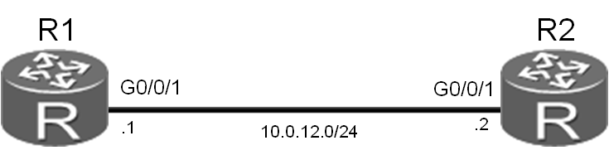

图5.1 配置FTP业务实验拓扑图

场景

您是公司的网络管理员，需要在公司网络上配置FTP业务。您需要把一台路由器配置为FTP服务器，客户端可以通过TCP连接与FTP服务器之间传输文件。

操作步骤

1. 实验环境准备

如果本任务中您使用的是空配置设备，那么请从步骤1开始配置。如果使用的设备包含上一个实验的配置，请直接从步骤2开始配置。

<Huawei>system-view

Enter system view, return user view with Ctrl+Z.

[Huawei]sysname R1

[R1]interface GigabitEthernet 0/0/1

[R1-GigabitEthernet0/0/1]ip address 10.0.12.1 24

<Huawei>system-view

Enter system view, return user view with Ctrl+Z.

[Huawei]sysname R2

[R2]interface GigabitEthernet 0/0/1

[R2-GigabitEthernet0/0/1]ip address 10.0.12.2 24

测试R1和R2之间的连通性。

[R1]ping 10.0.12.2

PING 10.0.12.2: 56 data bytes, press CTRL_C to break

Reply from 10.0.12.2: bytes=56 Sequence=1 ttl=255 time=10 ms

Reply from 10.0.12.2: bytes=56 Sequence=2 ttl=255 time=1 ms

Reply from 10.0.12.2: bytes=56 Sequence=3 ttl=255 time=1 ms

Reply from 10.0.12.2: bytes=56 Sequence=4 ttl=255 time=10 ms

Reply from 10.0.12.2: bytes=56 Sequence=5 ttl=255 time=1 ms

--- 10.0.12.2 ping statistics ---

5 packet(s) transmitted

5 packet(s) received

0.00% packet loss

round-trip min/avg/max = 1/4/10 ms

1. 在路由器上启用FTP业务。

默认情况下，路由器的FTP功能并未启用。使用FTP业务之前，必须先启用FTP功能。配置R1为FTP服务器，R2为客户端。

[R1]ftp server enable

Info: Succeeded in starting the FTP server

[R1]set default ftp-directory flash:/

通过在AAA中设置用户名和密码，授权FTP合法用户连接到FTP服务器。这样，非法用户就无法连接FTP服务器，降低了安全风险。

[R1]aaa

[R1-aaa]local-user huawei password cipher huawei123

Info: Add a new user.

[R1-aaa]local-user huawei service-type ftp

Info: The cipher password has been changed to an irreversible-cipher password.

Warning: The user access modes include Telnet, FTP or HTTP, and so security risks exist.

Info: After you change the rights (including the password, access type, FTP directory, and level) of a local user, the rights of users already online do not change. The change takes effect to users who go online after the change.

[R1-aaa]local-user huawei privilege level 15

Info: After you change the rights (including the password, access type, FTP directory, and level) of a local user, the rights of users already online do not change. The change takes effect to users who go online after the change.

[R1-aaa]local-user huawei ftp-directory flash:

Info: After you change the rights (including the password, access type, FTP directory, and level) of a local user, the rights of users already online do not change. The change takes effect to users who go online after the change.

[R1]display ftp-server

FTP server is running

Max user number 5

User count 0

Timeout value(in minute) 30

Listening port 21

Acl number 0

FTP server's source address 0.0.0.0

配置完成后，可以看到R1为FTP服务器，默认情况下监听TCP 21号端口。

1. 建立FTP客户端与服务器的连接。

建立从客户端（R2）到FTP服务器（R1）的连接。

<R2>ftp 10.0.12.1

Trying 10.0.12.1 ...

Press CTRL+K to abort

Connected to 10.0.12.1.

220 FTP service ready.

User(10.0.12.1:(none)):huawei

331 Password required for huawei.

Enter password:

230 User logged in.

[R2-ftp]

输入正确的用户名和密码后，可以成功登陆FTP服务器。

下载文件前或者上传文件后，执行**dir**命令查看文件的详细信息。

[R2-ftp]dir

200 Port command okay.

150 Opening ASCII mode data connection for *.

drwxrwxrwx 1 noone nogroup 0 May 03 18:03 .

-rwxrwxrwx 1 noone nogroup 114552448 Jan 19 2012 AR2220E-V200R006C10SPC300.cc

-rwxrwxrwx 1 noone nogroup 159858 May 03 17:59 mon_file.txt

-rwxrwxrwx 1 noone nogroup 304700 Mar 03 11:11 sacrule.dat

-rwxrwxrwx 1 noone nogroup 783 Mar 03 11:12 default_local.cer

-rwxrwxrwx 1 noone nogroup 0 Dec 20 2015 brdxpon_snmp_cfg.efs

-rwxrwxrwx 1 noone nogroup 777 May 03 18:03 vrpcfg.zip

drwxrwxrwx 1 noone nogroup 0 Mar 10 11:14 update

drwxrwxrwx 1 noone nogroup 0 May 03 18:03 localuser

drwxrwxrwx 1 noone nogroup 0 Mar 17 10:45 dhcp

-rwxrwxrwx 1 noone nogroup 460 May 03 18:03 private-data.txt

-rwxrwxrwx 1 noone nogroup 126352896 Mar 10 11:09 AR2220E-V200R007C00SPC600.cc

drwxrwxrwx 1 noone nogroup 0 Mar 10 11:15 shelldir

-rwxrwxrwx 1 noone nogroup 11606 May 03 18:00 mon_lpu_file.txt

drwxrwxrwx 1 noone nogroup 0 Mar 18 14:45 huawei

-rwxrwxrwx 1 noone nogroup 120 Mar 18 15:02 text.txt

226 Transfer complete.

FTP: 1112 byte(s) received in 0.134 second(s) 8.29Kbyte(s)/sec.

配置文件的传输模式。

[R2-ftp]binary

200 Type set to I.

在FTP服务器上下载文件。

[R2-ftp]get vrpcfg.zip vrpnew.zip

200 Port command okay.

150 Opening BINARY mode data connection for vrpcfg.zip.

226 Transfer complete.

FTP: 120 byte(s) received in 0.678 second(s) 176.99byte(s)/sec.

从FTP服务器上下载文件后，执行**bye**命令关闭连接。

[R2-ftp]bye

221 Server closing.

<R2>dir

Directory of flash:/

Idx Attr Size(Byte) Date Time(LMT) FileName

0 -rw- 114,552,448 Jan 19 2012 15:32:52 AR2220E-V200R006C10SPC300.cc

1 -rw- 270,176 Apr 30 2016 03:17:08 mon_file.txt

2 -rw- 304,700 Mar 03 2016 11:11:44 sacrule.dat

3 -rw- 783 Mar 03 2016 11:12:22 default_local.cer

4 -rw- 0 Dec 20 2015 00:06:14 brdxpon_snmp_cfg.efs

5 -rw- 775 Apr 29 2016 17:51:48 vrpcfg.zip

6 drw- - Mar 10 2016 11:28:46 update

7 drw- - Apr 23 2016 17:33:38 localuser

8 drw- - Mar 21 2016 20:59:46 dhcp

9 -rw- 394 Apr 29 2016 17:51:50 private-data.txt

10 -rw- 126,352,896 Mar 10 2016 11:14:40 AR2220E-V200R007C00SPC600.cc

11 drw- - Mar 10 2016 11:29:20 shelldir

12 -rw- 23,950 Apr 27 2016 16:06:06 mon_lpu_file.txt

13 -rw- 120 Mar 24 2016 11:45:44 huawei.zip

14 -rw- 777 May 10 2016 14:23:43 vrpnew.zip

可以通过**put**命令把一个文件上传到FTP服务器，上传的同时也可以为该文件配置新的文件名。

[R2-ftp]put vrpnew.zip vrpnew2.zip

200 Port command okay.

150 Opening BINARY mode data connection for vrpnew2.zip.

226 Transfer complete.

FTP: 120 byte(s) sent in 0.443 second(s) 270.88byte(s)/sec.

上传文件后，执行**dir**命令查看文件是否存在于FTP服务器上。

<R1>dir

Directory of flash:/

Idx Attr Size(Byte) Date Time(LMT) FileName

0 -rw- 286,620 Mar 14 2016 09:22:20 sacrule.dat

1 -rw- 512,000 Mar 28 2016 14:39:16 mon_file.txt

2 -rw- 1,738,816 Mar 17 2016 12:05:36 web.zip

3 -rw- 48,128 Mar 10 2016 14:16:56 ar2220E_v200r001sph001.pat

4 -rw- 120 Mar 28 2016 10:09:50 iascfg.zip

5 -rw- 699 Mar 28 2016 17:52:38 vrpcfg.zip

6 -rw- 93,871,872 Mar 14 2016 09:13:26 ar2220E-V200R007C00SPC600.cc

7 -rw- 512,000 Mar 28 2016 14:40:20 mon_lpu_file.txt

8 -rw- 699 Mar 02 2016 15:44:16 vrpnew2.zip

分别在R1和R2上删除创建的vrpnew.zip和vrpnew2.zip文件。

<R1>delete flash:/vrpnew2.zip

Delete flash:/vrpnew2.zip? (y/n)[n]:y

Info: Deleting file flash:/vrpnew2.zip...succeed.

<R2>delete flash:/vrpnew.zip

Delete flash:/vrpnew.zip? (y/n)[n]:y

Info: Deleting file flash:/vrpnew.zip...succeed.

注意：删除配置文件时，请慎重执行，避免删除R1和R2上的整个flash:/目录。

## **配置文件**

<R1>display current-configuration

[V200R007C00SPC600]

#

sysname R1

ftp server enable

set default ftp-directory flash:

#

aaa

authentication-scheme default

authorization-scheme default

accounting-scheme default

domain default

domain default_admin

local-user admin password cipher %$%$=i~>Xp&aY+*2cEVcS-A23Uwe%$%$

local-user admin service-type http

local-user huawei password cipher %$%$f+~&ZkCn]NUX7m.t;tF9R48s%$%$

local-user huawei privilege level 15

local-user huawei ftp-directory flash:/

local-user huawei service-type ftp

#

interface GigabitEthernet0/0/1

ip address 10.0.12.1 255.255.255.0

#

user-interface con 0

authentication-mode password

set authentication password cipher %$%$+L'YR&IZt'4,)>-*#lH",}%K-oJ_M9+'lOU~bD (\WTqB}%N,%$%$

user-interface vty 0 4

#

return

<R2>display current-configuration

[V200R007C00SPC600]

#

sysname R2

ftp server enable

set default ftp-directory flash:

#

aaa

authentication-scheme default

authorization-scheme default

accounting-scheme default

domain default

domain default_admin

local-user admin password cipher %$%$=i~>Xp&aY+*2cEVcS-A23Uwe%$%$

local-user admin service-type http

local-user huawei password cipher %$%$<;qM3D/O;ZLqy/"&6wEESdg$%$%$

local-user huawei privilege level 15

local-user huawei ftp-directory flash:/

local-user huawei service-type ftp

#

interface GigabitEthernet0/0/1

ip address 10.0.12.2 255.255.255.0

#

user-interface con 0

authentication-mode password

set authentication password cipher %$%$1=cd%b%/O%Id-8X:by1N,+s}'4wD6TvO<I|/pd# #44C@+s#,%$%$

user-interface vty 0 4

#

return

实验5-2 配置DHCP

学习目标

* **掌握DHCP全局地址池的配置方法**
* **掌握DHCP接口地址池的配置方法**
* **掌握在交换机端口启用DHCP发现功能和IP地址分配功能的方法**

## **拓扑图**

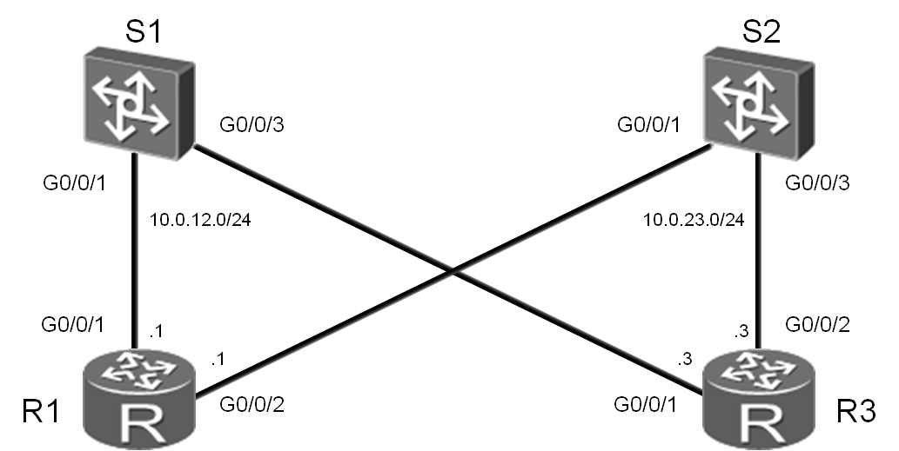

图5.2 配置DHCP实验拓扑图

场景

您是公司的网络管理员，公司网络需要配置DHCP业务，将网关路由器R1和R3配置为DHCP服务器，并配置全局地址池和接口地址池，为接入层设备分配IP地址。

操作步骤

1. 实验环境准备。

如果本任务中您使用的是空配置设备，需要从步骤1开始，并跳过步骤2。如果使用的设备包含上一个实验的配置，请直接从步骤2开始。

按照实验拓扑图进行基础配置以及IP编址，暂时关闭R1上的G0/0/2接口和R3上的G0/0/1接口。

<Huawei>system-view

Enter system view, return user view with Ctrl+Z.

[Huawei]sysname R1

[R1]interface GigabitEthernet 0/0/1

[R1-GigabitEthernet0/0/1]ip address 10.0.12.1 24

[R1-GigabitEthernet0/0/1]quit

<Huawei>system-view

Enter system view, return user view with Ctrl+Z.

[Huawei]sysname R3

[R3]interface GigabitEthernet 0/0/1

[R3-GigabitEthernet0/0/1]ip address 10.0.12.3 24

[R3-GigabitEthernet0/0/1]shutdown

[R3-GigabitEthernet0/0/1]quit

[R3]interface GigabitEthernet 0/0/2

[R3-GigabitEthernet0/0/2]ip address 10.0.23.3 24

<Quidway>system-view

Enter system view, return user view with Ctrl+Z.

[Quidway]sysname S1

<Quidway>system-view

Enter system view, return user view with Ctrl+Z.

[Quidway]sysname S2

1. 清除设备上已有的配置。

重新开启R3上的G0/0/2接口。

[R3]interface GigabitEthernet 0/0/2

[R3-GigabitEthernet0/0/2]undo shutdown

1. 进行其他准备配置。

关闭S1和S2上其他无关端口。

[S1]interface GigabitEthernet 0/0/9

[S1-GigabitEthernet0/0/9]shutdown

[S1-GigabitEthernet0/0/9]quit

[S1]interface GigabitEthernet 0/0/10

[S1-GigabitEthernet0/0/10]shutdown

[S1-GigabitEthernet0/0/10]quit

[S1]interface GigabitEthernet 0/0/13

[S1-GigabitEthernet0/0/13]shutdown

[S1-GigabitEthernet0/0/13]quit

[S1]interface GigabitEthernet 0/0/14

[S1-GigabitEthernet0/0/14]shutdown

[S2]interface GigabitEthernet 0/0/6

[S2-GigabitEthernet0/0/6]shutdown

[S2]interface GigabitEthernet 0/0/7

[S2-GigabitEthernet0/0/7]shutdown

[S2-GigabitEthernet0/0/7]quit

[S2]interface GigabitEthernet 0/0/9

[S2-GigabitEthernet0/0/9]shutdown

[S2-GigabitEthernet0/0/9]quit

[S2]interface GigabitEthernet 0/0/10

[S2-GigabitEthernet0/0/10]shutdown

[S2-GigabitEthernet0/0/10]quit

[R1]interface GigabitEthernet 0/0/2

[R1-GigabitEthernet0/0/2]ip address 10.0.23.1 24

[R1-GigabitEthernet0/0/2]shutdown

确认S1上的G0/0/9，G0/0/10，G0/0/13，G0/0/14端口已关闭，S2上的G0/0/6，G0/0/7， G0/0/9，G0/0/10端口已关闭。

<S1>display interface brief

…output omit…

Interface PHY Protocol InUti OutUti inErrors outErrors

GigabitEthernet0/0/1 up up 0.01% 0.01% 0 0

GigabitEthernet0/0/2 up up 0.01% 0.01% 0 0

GigabitEthernet0/0/3 down down 0% 0% 0 0

GigabitEthernet0/0/4 up up 0% 0.01% 0 0

GigabitEthernet0/0/5 up up 0% 0.01% 0 0

GigabitEthernet0/0/6 down down 0% 0% 0 0

GigabitEthernet0/0/7 down down 0% 0% 0 0

GigabitEthernet0/0/8 down down 0% 0% 0 0

GigabitEthernet0/0/9 *down down 0% 0% 0 0

GigabitEthernet0/0/10 *down down 0% 0% 0 0

GigabitEthernet0/0/11 down down 0% 0% 0 0

GigabitEthernet0/0/12 down down 0% 0% 0 0

GigabitEthernet0/0/13 *down down 0% 0% 0 0

GigabitEthernet0/0/14 *down down 0% 0% 0 0

…output omit…

<S2>display interface brief

…output omit…

GigabitEthernet0/0/1 up up 0% 4.06% 0 0

GigabitEthernet0/0/2 up up 0% 4.06% 0 0

GigabitEthernet0/0/3 up up 0% 4.06% 0 0

GigabitEthernet0/0/4 up up 0% 20.40% 0 0

GigabitEthernet0/0/5 up up 0% 20.40% 0 0

GigabitEthernet0/0/6 *down down 0% 2.04% 0 0

GigabitEthernet0/0/7 *down down 2.03% 2.03% 0 0

GigabitEthernet0/0/8 down down 0% 0% 0 0

GigabitEthernet0/0/9 *down down 1.91% 1.91% 0 0

GigabitEthernet0/0/10 *down down 3.95% 0.12% 0 0

GigabitEthernet0/0/11 up up 0% 4.06% 0 0

GigabitEthernet0/0/12 up up 0% 4.06% 0 0

…output omit…

确认R1上只有G0/0/2端口被关闭，R3上只有G0/0/1端口被关闭。

<R1>display ip interface brief

…output omit…

GigabitEthernet0/0/1 10.0.12.1/24 up up

GigabitEthernet0/0/2 10.0.23.1/24 *down down

…output omit…

<R3>display ip interface brief

…output omit…

GigabitEthernet0/0/1 10.0.12.3/24 *down down

GigabitEthernet0/0/2 10.0.23.3/24 up up

…output omit…

1. 启用DHCP功能。

默认情况下，DHCP功能并未启用。在路由器上启用DHCP功能。

[R1]dhcp enable

[R3]dhcp enable

1. 创建全局IP地址池。

在R1和R2上分别创建名为pool1和pool2的地址池，并配置地址池中地址的起始范围、网关地址和地址租期。

[R1]ip pool pool1

Info: It's successful to create an IP address pool.

[R1-ip-pool-pool1]network 10.0.12.0 mask 24

[R1-ip-pool-pool1]gateway-list 10.0.12.1

[R1-ip-pool-pool1]lease day 1 hour 12

[R1]interface GigabitEthernet 0/0/1

[R1-GigabitEthernet0/0/1]dhcp select global

[R3]ip pool pool2

Info: It's successful to create an IP address pool.

[R3-ip-pool-pool2]network 10.0.23.0 mask 24

[R3-ip-pool-pool2]gateway-list 10.0.23.3

[R3-ip-pool-pool2]lease day 1 hour 12

[R3]interface GigabitEthernet 0/0/2

[R3-GigabitEthernet0/0/2]dhcp select global

在路由器上执行**display ip pool name** <*name*>命令，查看配置的IP地址池中的参数。

<R1>display ip pool name pool1

Pool-name : pool1

Pool-No : 0

Lease : 1 Days 12 Hours 0 Minutes

Domain-name : -

DNS-server0 : -

NBNS-server0 : -

Netbios-type : -

Position : Local Status : Unlocked

Gateway-0 : 10.0.12.1

Network : 10.0.12.0

Mask : 255.255.255.0

VPN instance : --

-------------------------------------------------------------------------- Start End Total Used Idle(Expired) Conflict Disable

--------------------------------------------------------------------------

10.0.12.1 10.0.12.254 253 0 253(0) 0 0

--------------------------------------------------------------------------

配置S1通过缺省管理端口VLANIF 1向DHCP服务器（R1）申请IP地址。在S2上使用相同配置向R3申请IP地址。

[S1]dhcp enable

[S1]interface Vlanif 1

[S1-Vlanif1]ip address dhcp-alloc

<S1>display ip interface brief

…output omit…

Interface IP Address/Mask Physical Protocol

MEth0/0/1 unassigned down down

NULL0 unassigned up up(s)

Vlanif1 10.0.12.254/24 up up

验证S1从R1上名为pool1的DHCP地址池获取IP地址，S2从R3上名为pool2的DHCP地址池获取IP地址。

<R1>display ip pool name pool1

Pool-name : pool1

Pool-No : 0

Lease : 1 Days 12 Hours 0 Minutes

Domain-name : -

DNS-server0 : -

NBNS-server0 : -

Netbios-type : -

Position : Local Status : Unlocked

Gateway-0 : 10.0.12.1

Network : 10.0.12.0

Mask : 255.255.255.0

VPN instance : --

--------------------------------------------------------------------------

Start End Total Used Idle(Expired) Conflict Disable

--------------------------------------------------------------------------

10.0.12.1 10.0.12.254 253 1 252(0) 0 0

-------------------------------------------------------------------------

<R3>display ip pool name pool2

Pool-name : pool2

Pool-No : 0

Lease : 1 Days 12 Hours 0 Minutes

Domain-name : -

DNS-server0 : -

NBNS-server0 : -

Netbios-type : -

Position : Local Status : Unlocked

Gateway-0 : 10.0.23.3

Network : 10.0.23.0

Mask : 255.255.255.0

VPN instance : --

--------------------------------------------------------------------------

Start End Total Used Idle(Expired) Conflict Disable

--------------------------------------------------------------------------

10.0.23.1 10.0.23.254 253 1 252(0) 0 0

--------------------------------------------------------------------------

进行新的配置前，确保R1和R3上的全局地址池配置已经完成。

1. 创建接口地址池。

关闭R1上的G0/0/1接口，R3上的G0/0/2接口。

[R1]interface GigabitEthernet 0/0/1

[R1-GigabitEthernet0/0/1]shutdown

[R3]interface GigabitEthernet 0/0/2

[R3-GigabitEthernet0/0/2]shutdown

执行**dhcp select interface**命令开启接口的DHCP服务功能，指定路由器从接口地址池分配地址。此时，我们还不希望激活网络中的DHCP服务，所以先不用开启这两个接口。

[R1]interface GigabitEthernet 0/0/2

[R1-GigabitEthernet0/0/2]dhcp select interface

[R3]interface GigabitEthernet 0/0/1

[R3-GigabitEthernet0/0/1]dhcp select interface

从R1和R3的接口地址池中为DNS业务预留IP地址，并设置接口地址池的地址租期。

[R1-GigabitEthernet0/0/2]dhcp server dns-list 10.0.23.254

[R1-GigabitEthernet0/0/2]dhcp server excluded-ip-address 10.0.23.254

[R1-GigabitEthernet0/0/2]dhcp server lease day 1 hour 12

[R3-GigabitEthernet0/0/1]dhcp server dns-list 10.0.12.254

[R3-GigabitEthernet0/0/1]dhcp server excluded-ip-address 10.0.12.254

[R3-GigabitEthernet0/0/1]dhcp server lease day 1 hour 12

在路由器上执行**display ip pool interface**命令，查看配置的接口地址池参数。此处以R1为例。

<R1>display ip pool interface GigabitEthernet0/0/2

Pool-name : GigabitEthernet0/0/2

Pool-No : 1

Lease : 1 Days 12 Hours 0 Minutes

Domain-name : -

DNS-server0 : 10.0.23.254

NBNS-server0 : -

Netbios-type : -

Position : Interface Status : Unlocked

Gateway-0 : 10.0.23.1

Network : 10.0.23.0

Mask : 255.255.255.0

VPN instance : --

--------------------------------------------------------------------------

Start End Total Used Idle(Expired) Conflict Disable

--------------------------------------------------------------------------

10.0.23.1 10.0.23.254 253 0 252(0) 0 1

--------------------------------------------------------------------------

关闭S2上VLANIF 1接口以清除接口现有的IP地址，然后重新开启此接口以便重新从R1的接口地址池获取新的IP地址。

[S2]interface Vlanif 1

[S2-Vlanif1]shutdown

[S2-Vlanif1]undo shutdown

开启R1的G0/0/2接口，使R1可以通过此接口从接口地址池中分配IP地址。

[R1]interface GigabitEthernet0/0/2

[R1-GigabitEthernet0/0/2]undo shutdown

验证R1从接口地址池中为S2的VLANIF1接口分配了新的IP地址。

<R1>display ip pool interface GigabitEthernet0/0/2

Pool-name : GigabitEthernet0/0/2

Pool-No : 1

Lease : 1 Days 12 Hours 0 Minutes

Domain-name : -

DNS-server0 : 10.0.23.254

NBNS-server0 : -

Netbios-type : -

Position : Interface Status : Unlocked

Gateway-0 : 10.0.23.1

Network : 10.0.23.0

Mask : 255.255.255.0

VPN instance : --

--------------------------------------------------------------------------

Start End Total Used Idle(Expired) Conflict Disable

--------------------------------------------------------------------------

10.0.23.1 10.0.23.254 253 1 251(0) 0 1

--------------------------------------------------------------------------

<S2>display ip interface brief

…output omit…

Interface IP Address/Mask Physical Protocol

MEth0/0/1 unassigned down down

NULL0 unassigned up up(s)

Vlanif1 10.0.23.253/24 up up

在上述回显信息，灰色部分表明R1从接口地址池中为客户端的VLANIF1接口分配了IP地址。

关闭S1上VLANIF 1接口以清除接口现有的IP地址，然后重新开启此接口以便重新从R3的接口地址池获取新的IP地址。

[S1]interface Vlanif 1

[S1-Vlanif1]shutdown

[S1-Vlanif1]undo shutdown

开启R3的G0/0/1接口，使R3可以通过此接口从接口地址池中分配IP地址。

[R3]interface GigabitEthernet 0/0/1

[R3-GigabitEthernet0/0/1]undo shutdown

验证R3从接口地址池中为S1的VLANIF1接口分配了新的IP地址。

<R3>display ip pool interface GigabitEthernet0/0/1

Pool-name : GigabitEthernet0/0/1

Pool-No : 1

Lease : 1 Days 12 Hours 0 Minutes

Domain-name : -

DNS-server0 : 10.0.12.254

NBNS-server0 : -

Netbios-type : -

Position : Interface Status : Unlocked

Gateway-0 : 10.0.12.3

Network : 10.0.12.0

Mask : 255.255.255.0

VPN instance : --

--------------------------------------------------------------------------

Start End Total Used Idle(Expired) Conflict Disable

--------------------------------------------------------------------------

10.0.12.1 10.0.12.254 253 1 251(0) 0 1

--------------------------------------------------------------------------

<S1>display ip interface brief

…output omit…

Interface IP Address/Mask Physical Protocol

MEth0/0/1 unassigned down down

NULL0 unassigned up up(s)

Vlanif1 10.0.12.253/24 up up

注意：交换机获取地址后会自动生成一条指向DHCP服务器的缺省静态路由，详见如下配置文件。

## **配置文件**

[R1]display current-configuration

[V200R007C00SPC600]

#

sysname R1

#

dhcp enable

#

ip pool pool1

gateway-list 10.0.12.1

network 10.0.12.0 mask 255.255.255.0

lease day 1 hour 12 minute 0

#

interface GigabitEthernet0/0/1

shutdown

ip address 10.0.12.1 255.255.255.0

dhcp select global

#

interface GigabitEthernet0/0/2

ip address 10.0.23.1 255.255.255.0

dhcp select interface

dhcp server excluded-ip-address 10.0.23.254

dhcp server lease day 1 hour 12 minute 0

dhcp server dns-list 10.0.23.254

#

user-interface con 0

authentication-mode password

set authentication password cipher %$%$+L'YR&IZt'4,)>-*#lH",}%K-oJ_M9+'lOU~bD

(\WTqB}%N,%$%$user-interface vty 0 4

#

return

[R3]display current-configuration

[V200R007C00SPC600]

#

sysname R3

#

dhcp enable

#

ip pool pool2

gateway-list 10.0.23.3

network 10.0.23.0 mask 255.255.255.0

lease day 1 hour 12 minute 0

#

interface GigabitEthernet0/0/1

ip address 10.0.12.3 255.255.255.0

dhcp select interface

dhcp server excluded-ip-address 10.0.12.254

dhcp server lease day 1 hour 12 minute 0

dhcp server dns-list 10.0.12.254

#

interface GigabitEthernet0/0/2

shutdown

ip address 10.0.23.3 255.255.255.0

dhcp select global

#

user-interface con 0

authentication-mode password

set authentication password cipher %$%$ksXDMg7Ry6yUU:63:DQ),#/sQg"@*S\U#.s.bHW

xQ,y%#/v,%$%$

user-interface vty 0 4

#

return

<S1>display current-configuration

#

!Software Version V200R008C00SPC500

sysname S1

#

dhcp enable

#

interface Vlanif1

ip address dhcp-alloc

#

ip route-static 0.0.0.0 0.0.0.0 10.0.12.3

#

user-interface con 0

user-interface vty 0 4

#

return

<S2>display current-configuration

#

!Software Version V200R008C00SPC500

sysname S2

#

dhcp enable

#

interface Vlanif1

ip address dhcp-alloc

#

ip route-static 0.0.0.0 0.0.0.0 10.0.23.1

#

user-interface con 0

user-interface vty 0 4

#

return