生成树基础配置

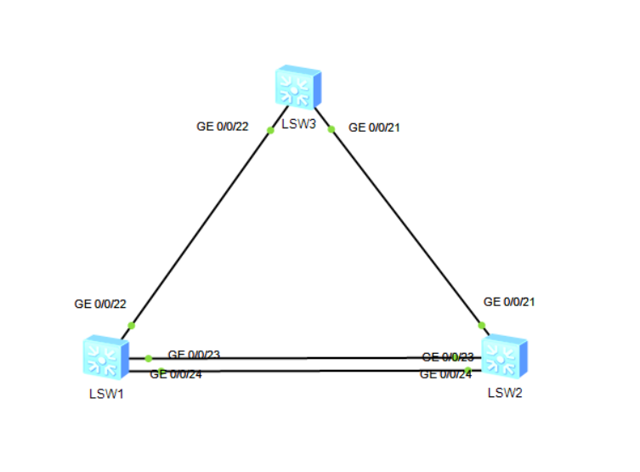

**LSW1**

#

sysname LSW1

#

stp mode stp

stp instance 0 root primary

#

cluster enable

ntdp enable

ndp enable

#

drop illegal-mac alarm

#

diffserv domain default

#

drop-profile default

#

aaa

authentication-scheme default

authorization-scheme default

accounting-scheme default

domain default

domain default_admin

local-user admin password simple admin

local-user admin service-type http

#

interface Vlanif1

#

interface MEth0/0/1

#

interface Eth-Trunk1

#

interface GigabitEthernet0/0/1

#

interface GigabitEthernet0/0/2

#

interface GigabitEthernet0/0/3

#

interface GigabitEthernet0/0/4

#

interface GigabitEthernet0/0/5

#

interface GigabitEthernet0/0/6

#

interface GigabitEthernet0/0/7

#

interface GigabitEthernet0/0/8

#

interface GigabitEthernet0/0/9

#

interface GigabitEthernet0/0/10

#

interface GigabitEthernet0/0/11

#

interface GigabitEthernet0/0/12

#

interface GigabitEthernet0/0/13

#

interface GigabitEthernet0/0/14

#

interface GigabitEthernet0/0/15

#

interface GigabitEthernet0/0/16

#

interface GigabitEthernet0/0/17

#

interface GigabitEthernet0/0/18

#

interface GigabitEthernet0/0/19

#

interface GigabitEthernet0/0/20

#

interface GigabitEthernet0/0/21

#

interface GigabitEthernet0/0/22

#

interface GigabitEthernet0/0/23

eth-trunk 1

#

interface GigabitEthernet0/0/24

eth-trunk 1

#

interface NULL0

#

user-interface con 0

user-interface vty 0 4

#

return

**LWS2**

#

sysname LSW2

#

stp mode stp

stp instance 0 root secondary

#

cluster enable

ntdp enable

ndp enable

#

drop illegal-mac alarm

#

diffserv domain default

#

drop-profile default

#

aaa

authentication-scheme default

authorization-scheme default

accounting-scheme default

domain default

domain default_admin

local-user admin password simple admin

local-user admin service-type http

#

interface Vlanif1

#

interface MEth0/0/1

#

interface Eth-Trunk1

#

interface GigabitEthernet0/0/1

#

interface GigabitEthernet0/0/2

#

interface GigabitEthernet0/0/3

#

interface GigabitEthernet0/0/4

#

interface GigabitEthernet0/0/5

#

interface GigabitEthernet0/0/6

#

interface GigabitEthernet0/0/7

#

interface GigabitEthernet0/0/8

#

interface GigabitEthernet0/0/9

#

interface GigabitEthernet0/0/10

#

interface GigabitEthernet0/0/11

#

interface GigabitEthernet0/0/12

#

interface GigabitEthernet0/0/13

#

interface GigabitEthernet0/0/14

#

interface GigabitEthernet0/0/15

#

interface GigabitEthernet0/0/16

#

interface GigabitEthernet0/0/17

#

interface GigabitEthernet0/0/18

#

interface GigabitEthernet0/0/19

#

interface GigabitEthernet0/0/20

#

interface GigabitEthernet0/0/21

#

interface GigabitEthernet0/0/22

#

interface GigabitEthernet0/0/23

eth-trunk 1

#

interface GigabitEthernet0/0/24

eth-trunk 1

#

interface NULL0

#

user-interface con 0

user-interface vty 0 4

#

return

**LSW3**

#

sysname LSW3

#

stp mode stp

#

cluster enable

ntdp enable

ndp enable

#

drop illegal-mac alarm

#

diffserv domain default

#

drop-profile default

#

aaa

authentication-scheme default

authorization-scheme default

accounting-scheme default

domain default

domain default_admin

local-user admin password simple admin

local-user admin service-type http

#

interface Vlanif1

#

interface MEth0/0/1

#

interface GigabitEthernet0/0/1

#

interface GigabitEthernet0/0/2

#

interface GigabitEthernet0/0/3

#

interface GigabitEthernet0/0/4

#

interface GigabitEthernet0/0/5

#

interface GigabitEthernet0/0/6

#

interface GigabitEthernet0/0/7

#

interface GigabitEthernet0/0/8

#

interface GigabitEthernet0/0/9

#

interface GigabitEthernet0/0/10

#

interface GigabitEthernet0/0/11

#

interface GigabitEthernet0/0/12

#

interface GigabitEthernet0/0/13

#

interface GigabitEthernet0/0/14

#

interface GigabitEthernet0/0/15

#

interface GigabitEthernet0/0/16

#

interface GigabitEthernet0/0/17

#

interface GigabitEthernet0/0/18

#

interface GigabitEthernet0/0/19

#

interface GigabitEthernet0/0/20

#

interface GigabitEthernet0/0/21

#

interface GigabitEthernet0/0/22

#

interface GigabitEthernet0/0/23

#

interface GigabitEthernet0/0/24

#

interface NULL0

#

user-interface con 0

user-interface vty 0 4

#

Return

**VLSM规划的路由环境**

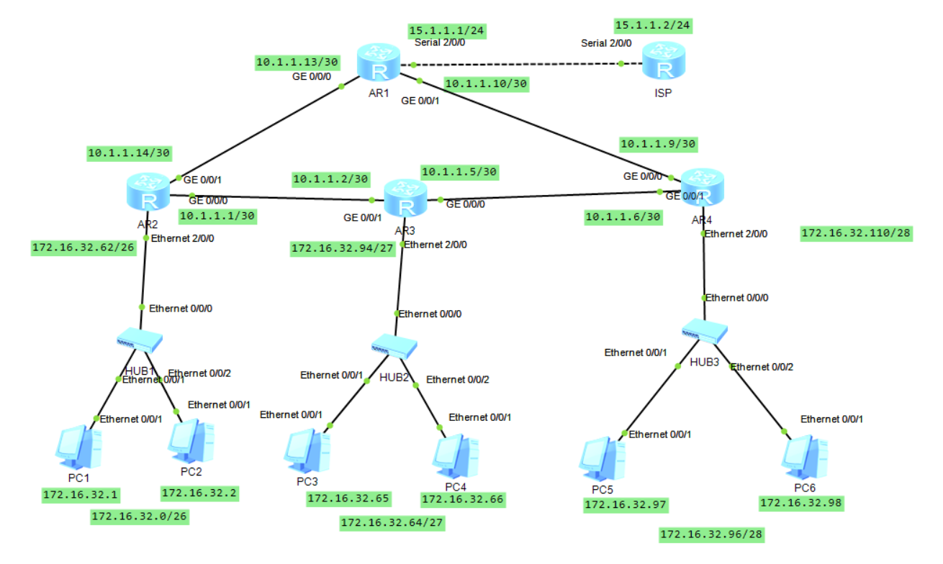

**AR1**

#

sysname AR1

#

board add 0/2 2SA

#

snmp-agent local-engineid 800007DB03000000000000

snmp-agent

#

clock timezone China-Standard-Time minus 08:00:00

#

portal local-server load portalpage.zip

#

drop illegal-mac alarm

#

set cpu-usage threshold 80 restore 75

#

aaa

authentication-scheme default

authorization-scheme default

accounting-scheme default

domain default

domain default_admin

local-user admin password cipher %$%$K8m.Nt84DZ}e#<0`8bmE3Uw}%$%$

local-user admin service-type http

#

firewall zone Local

priority 15

#

interface Serial2/0/0

link-protocol ppp

ip address 15.1.1.1 255.255.255.0

#

interface Serial2/0/1

link-protocol ppp

#

interface GigabitEthernet0/0/0

ip address 10.1.1.13 255.255.255.252

#

interface GigabitEthernet0/0/1

ip address 10.1.1.10 255.255.255.252

#

interface GigabitEthernet0/0/2

#

interface NULL0

#

rip 1

undo summary

default-route originate

version 2

network 10.0.0.0

#

ip route-static 0.0.0.0 0.0.0.0 15.1.1.2

#

user-interface con 0

authentication-mode password

user-interface vty 0 4

user-interface vty 16 20

#

wlan ac

#

Return

**AR2**

#

sysname AR2

#

board add 0/2 2FE

#

snmp-agent local-engineid 800007DB03000000000000

snmp-agent

#

clock timezone China-Standard-Time minus 08:00:00

#

portal local-server load portalpage.zip

#

drop illegal-mac alarm

#

set cpu-usage threshold 80 restore 75

#

aaa

authentication-scheme default

authorization-scheme default

accounting-scheme default

domain default

domain default_admin

local-user admin password cipher %$%$K8m.Nt84DZ}e#<0`8bmE3Uw}%$%$

local-user admin service-type http

#

firewall zone Local

priority 15

#

interface Ethernet2/0/0

ip address 172.16.32.62 255.255.255.192

#

interface Ethernet2/0/1

#

interface GigabitEthernet0/0/0

ip address 10.1.1.1 255.255.255.252

#

interface GigabitEthernet0/0/1

ip address 10.1.1.14 255.255.255.252

#

interface GigabitEthernet0/0/2

#

interface NULL0

#

rip 1

undo summary

version 2

network 10.0.0.0

network 172.16.0.0

#

user-interface con 0

authentication-mode password

user-interface vty 0 4

user-interface vty 16 20

#

wlan ac

#

Return

**AR3**

#

sysname AR3

#

board add 0/2 2FE

#

snmp-agent local-engineid 800007DB03000000000000

snmp-agent

#

clock timezone China-Standard-Time minus 08:00:00

#

portal local-server load portalpage.zip

#

drop illegal-mac alarm

#

set cpu-usage threshold 80 restore 75

#

aaa

authentication-scheme default

authorization-scheme default

accounting-scheme default

domain default

domain default_admin

local-user admin password cipher %$%$K8m.Nt84DZ}e#<0`8bmE3Uw}%$%$

local-user admin service-type http

#

firewall zone Local

priority 15

#

interface Ethernet2/0/0

ip address 172.16.32.94 255.255.255.224

#

interface Ethernet2/0/1

#

interface GigabitEthernet0/0/0

ip address 10.1.1.5 255.255.255.252

rip metricout 2

#

interface GigabitEthernet0/0/1

ip address 10.1.1.2 255.255.255.252

#

interface GigabitEthernet0/0/2

#

interface NULL0

#

rip 1

undo summary

version 2

network 10.0.0.0

network 172.16.0.0

#

user-interface con 0

authentication-mode password

user-interface vty 0 4

user-interface vty 16 20

#

wlan ac

#

Return

**AR4**

#

sysname AR4

#

board add 0/2 2FE

#

snmp-agent local-engineid 800007DB03000000000000

snmp-agent

#

clock timezone China-Standard-Time minus 08:00:00

#

portal local-server load portalpage.zip

#

drop illegal-mac alarm

#

set cpu-usage threshold 80 restore 75

#

aaa

authentication-scheme default

authorization-scheme default

accounting-scheme default

domain default

domain default_admin

local-user admin password cipher %$%$K8m.Nt84DZ}e#<0`8bmE3Uw}%$%$

local-user admin service-type http

#

firewall zone Local

priority 15

#

interface Ethernet2/0/0

ip address 172.16.32.110 255.255.255.240

#

interface Ethernet2/0/1

#

interface GigabitEthernet0/0/0

ip address 10.1.1.9 255.255.255.252

#

interface GigabitEthernet0/0/1

ip address 10.1.1.6 255.255.255.252

#

interface GigabitEthernet0/0/2

#

interface NULL0

#

rip 1

undo summary

version 2

network 10.0.0.0

network 172.16.0.0

#

user-interface con 0

authentication-mode password

user-interface vty 0 4

user-interface vty 16 20

#

wlan ac

#

return

**ISP**

#

sysname ISP

#

board add 0/2 2SA

#

snmp-agent local-engineid 800007DB03000000000000

snmp-agent

#

clock timezone China-Standard-Time minus 08:00:00

#

portal local-server load portalpage.zip

#

drop illegal-mac alarm

#

set cpu-usage threshold 80 restore 75

#

aaa

authentication-scheme default

authorization-scheme default

accounting-scheme default

domain default

domain default_admin

local-user admin password cipher %$%$K8m.Nt84DZ}e#<0`8bmE3Uw}%$%$

local-user admin service-type http

#

firewall zone Local

priority 15

#

interface Serial2/0/0

link-protocol ppp

ip address 15.1.1.2 255.255.255.0

#

interface Serial2/0/1

link-protocol ppp

#

interface GigabitEthernet0/0/0

#

interface GigabitEthernet0/0/1

#

interface GigabitEthernet0/0/2

#

interface NULL0

#

ip route-static 172.16.32.0 255.255.255.0 15.1.1.1

#

user-interface con 0

authentication-mode password

user-interface vty 0 4

user-interface vty 16 20

#

wlan ac

#

return

OSPF外部路由引入与聚合配置

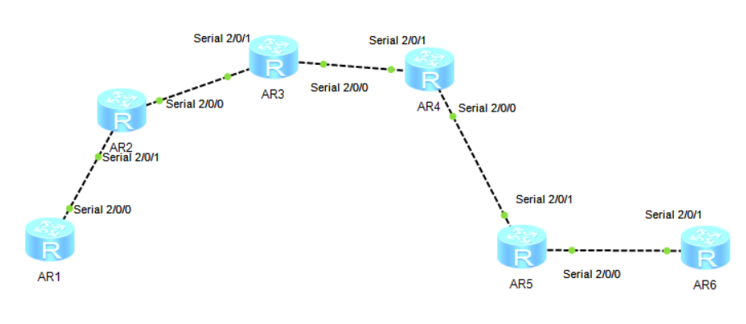**AR1**

#

sysname AR1

#

board add 0/2 2SA

#

snmp-agent local-engineid 800007DB03000000000000

snmp-agent

#

clock timezone China-Standard-Time minus 08:00:00

#

portal local-server load portalpage.zip

#

drop illegal-mac alarm

#

set cpu-usage threshold 80 restore 75

#

aaa

authentication-scheme default

authorization-scheme default

accounting-scheme default

domain default

domain default_admin

local-user admin password cipher %$%$K8m.Nt84DZ}e#<0`8bmE3Uw}%$%$

local-user admin service-type http

#

firewall zone Local

priority 15

#

interface Serial2/0/0

link-protocol ppp

ip address 192.168.12.1 255.255.255.0

#

interface Serial2/0/1

link-protocol ppp

#

interface GigabitEthernet0/0/0

#

interface GigabitEthernet0/0/1

#

interface GigabitEthernet0/0/2

#

interface NULL0

#

interface LoopBack0

ip address 1.1.1.1 255.255.255.255

#

interface LoopBack1

ip address 10.1.1.1 255.255.255.252

#

interface LoopBack2

ip address 10.1.1.5 255.255.255.252

#

ospf 10

asbr-summary 172.16.0.0 255.255.0.0

default-route-advertise

area 0.0.0.1

network 10.1.1.0 0.0.0.255

network 192.168.12.1 0.0.0.0

#

rip 1

#

ip route-static 0.0.0.0 0.0.0.0 LoopBack0 200.1.1.1

#

user-interface con 0

authentication-mode password

user-interface vty 0 4

user-interface vty 16 20

#

wlan ac

#

return

**AR2**

#

sysname AR2

#

board add 0/2 2SA

#

snmp-agent local-engineid 800007DB03000000000000

snmp-agent

#

clock timezone China-Standard-Time minus 08:00:00

#

portal local-server load portalpage.zip

#

drop illegal-mac alarm

#

set cpu-usage threshold 80 restore 75

#

aaa

authentication-scheme default

authorization-scheme default

accounting-scheme default

domain default

domain default_admin

local-user admin password cipher %$%$K8m.Nt84DZ}e#<0`8bmE3Uw}%$%$

local-user admin service-type http

#

firewall zone Local

priority 15

#

interface Serial2/0/0

link-protocol ppp

ip address 192.168.23.2 255.255.255.0

#

interface Serial2/0/1

link-protocol ppp

ip address 192.168.12.2 255.255.255.0

#

interface GigabitEthernet0/0/0

#

interface GigabitEthernet0/0/1

#

interface GigabitEthernet0/0/2

#

interface NULL0

#

ospf 10

area 0.0.0.0

network 192.168.23.2 0.0.0.0

area 0.0.0.1

abr-summary 10.1.1.0 255.255.255.0

network 192.168.12.2 0.0.0.0

#

user-interface con 0

authentication-mode password

user-interface vty 0 4

user-interface vty 16 20

#

wlan ac

#

return

**AR3**

#

sysname AR3

#

board add 0/2 2SA

#

snmp-agent local-engineid 800007DB03000000000000

snmp-agent

#

clock timezone China-Standard-Time minus 08:00:00

#

portal local-server load portalpage.zip

#

drop illegal-mac alarm

#

set cpu-usage threshold 80 restore 75

#

aaa

authentication-scheme default

authorization-scheme default

accounting-scheme default

domain default

domain default_admin

local-user admin password cipher %$%$K8m.Nt84DZ}e#<0`8bmE3Uw}%$%$

local-user admin service-type http

#

firewall zone Local

priority 15

#

interface Serial2/0/0

link-protocol ppp

ip address 192.168.34.3 255.255.255.0

#

interface Serial2/0/1

link-protocol ppp

ip address 192.168.23.3 255.255.255.0

#

interface GigabitEthernet0/0/0

#

interface GigabitEthernet0/0/1

#

interface GigabitEthernet0/0/2

#

interface NULL0

#

interface LoopBack0

ip address 3.3.3.3 255.255.255.255

#

ospf 10

area 0.0.0.0

network 192.168.23.3 0.0.0.0

area 0.0.0.2

network 192.168.34.3 0.0.0.0

vlink-peer 192.168.34.4

#

user-interface con 0

authentication-mode password

user-interface vty 0 4

user-interface vty 16 20

#

wlan ac

#

return

**AR4**

#

sysname AR4

#

board add 0/2 2SA

#

snmp-agent local-engineid 800007DB03000000000000

snmp-agent

#

clock timezone China-Standard-Time minus 08:00:00

#

portal local-server load portalpage.zip

#

drop illegal-mac alarm

#

set cpu-usage threshold 80 restore 75

#

aaa

authentication-scheme default

authorization-scheme default

accounting-scheme default

domain default

domain default_admin

local-user admin password cipher %$%$K8m.Nt84DZ}e#<0`8bmE3Uw}%$%$

local-user admin service-type http

#

firewall zone Local

priority 15

#

interface Serial2/0/0

link-protocol ppp

ip address 192.168.45.4 255.255.255.0

#

interface Serial2/0/1

link-protocol ppp

ip address 192.168.34.4 255.255.255.0

#

interface GigabitEthernet0/0/0

#

interface GigabitEthernet0/0/1

#

interface GigabitEthernet0/0/2

#

interface NULL0

#

interface LoopBack0

ip address 4.4.4.4 255.255.255.255

#

ospf 10

area 0.0.0.2

network 192.168.34.4 0.0.0.0

vlink-peer 192.168.23.3

vlink-peer 192.168.34.3

area 0.0.0.3

network 192.168.45.4 0.0.0.0

#

user-interface con 0

authentication-mode password

user-interface vty 0 4

user-interface vty 16 20

#

wlan ac

#

Return

**AR5**

#

sysname AR5

#

board add 0/2 2SA

#

snmp-agent local-engineid 800007DB03000000000000

snmp-agent

#

clock timezone China-Standard-Time minus 08:00:00

#

portal local-server load portalpage.zip

#

drop illegal-mac alarm

#

set cpu-usage threshold 80 restore 75

#

aaa

authentication-scheme default

authorization-scheme default

accounting-scheme default

domain default

domain default_admin

local-user admin password cipher %$%$K8m.Nt84DZ}e#<0`8bmE3Uw}%$%$

local-user admin service-type http

#

firewall zone Local

priority 15

#

interface Serial2/0/0

link-protocol ppp

ip address 192.168.56.5 255.255.255.0

#

interface Serial2/0/1

link-protocol ppp

ip address 192.168.45.5 255.255.255.0

#

interface GigabitEthernet0/0/0

#

interface GigabitEthernet0/0/1

#

interface GigabitEthernet0/0/2

#

interface NULL0

#

ospf 10

import-route ospf 20

area 0.0.0.3

network 192.168.45.5 0.0.0.0

#

ospf 20

import-route ospf 10

area 0.0.0.0

network 192.168.56.5 0.0.0.0

#

user-interface con 0

authentication-mode password

user-interface vty 0 4

user-interface vty 16 20

#

wlan ac

#

return

**AR6**

#

sysname AR6

#

board add 0/2 2SA

#

snmp-agent local-engineid 800007DB03000000000000

snmp-agent

#

clock timezone China-Standard-Time minus 08:00:00

#

portal local-server load portalpage.zip

#

drop illegal-mac alarm

#

set cpu-usage threshold 80 restore 75

#

aaa

authentication-scheme default

authorization-scheme default

accounting-scheme default

domain default

domain default_admin

local-user admin password cipher %$%$K8m.Nt84DZ}e#<0`8bmE3Uw}%$%$

local-user admin service-type http

#

firewall zone Local

priority 15

#

interface Serial2/0/0

link-protocol ppp

#

interface Serial2/0/1

link-protocol ppp

ip address 192.168.56.6 255.255.255.0

#

interface GigabitEthernet0/0/0

#

interface GigabitEthernet0/0/1

#

interface GigabitEthernet0/0/2

#

interface NULL0

#

interface LoopBack1

ip address 172.16.0.1 255.255.255.0

#

interface LoopBack2

ip address 172.16.1.1 255.255.255.0

#

interface LoopBack3

ip address 172.16.2.1 255.255.255.0

#

interface LoopBack4

ip address 172.16.3.1 255.255.255.0

#

ospf 20

area 0.0.0.0

network 172.16.0.0 0.0.0.3

network 192.168.56.6 0.0.0.0

#

user-interface con 0

authentication-mode password

user-interface vty 0 4

user-interface vty 16 20

#

wlan ac

#

return