Contents
Introduction ii
Objective ii
1 Architecture & Design Documentation 1
1.1 Architecture Diagram 1
1.2 Data Flow 2
1.3 Design Justification 2
1.4 Step-by-Step Product Selection Documentation 3
1.5 Cost Estimation (AWS-based Example) 3
1.6 Scalability Design 3
1.7 Implementation Roadmap 4
2. Technical Implementation & Functionality 4
2.1 Infrastructure as Code (Terraform) 4
2.2 Deployment Process 4
2.3 Reliability and Monitoring 5
2.4 Autoscaling 5
2.5 Data Persistence 5
2.6 Reliability and Monitoring 5
2.7 Advantages of Chosen Technologies 6
Conclusion 6

Introduction
This project is a cloud-native web application deployed on AWS using a containerized architecture.It leverages Terraform for Infrastructure as Code (IaC), Amazon EKS (Elastic Kubernetes Service) for container orchestration, and Redis for caching. The application backend is developed using Flask (Python) and serves a simple web interface through HTML templates.

Objective
The project’s goal is to build a fully automated, cloud-deployed web application that demonstrates how modern DevOps tools (Terraform, Kubernetes, Docker, AWS, Redis) work together to deliver a scalable, fault-tolerant, and efficient cloud system.

1 Architecture & Design Documentation

1.1 Architecture Diagram
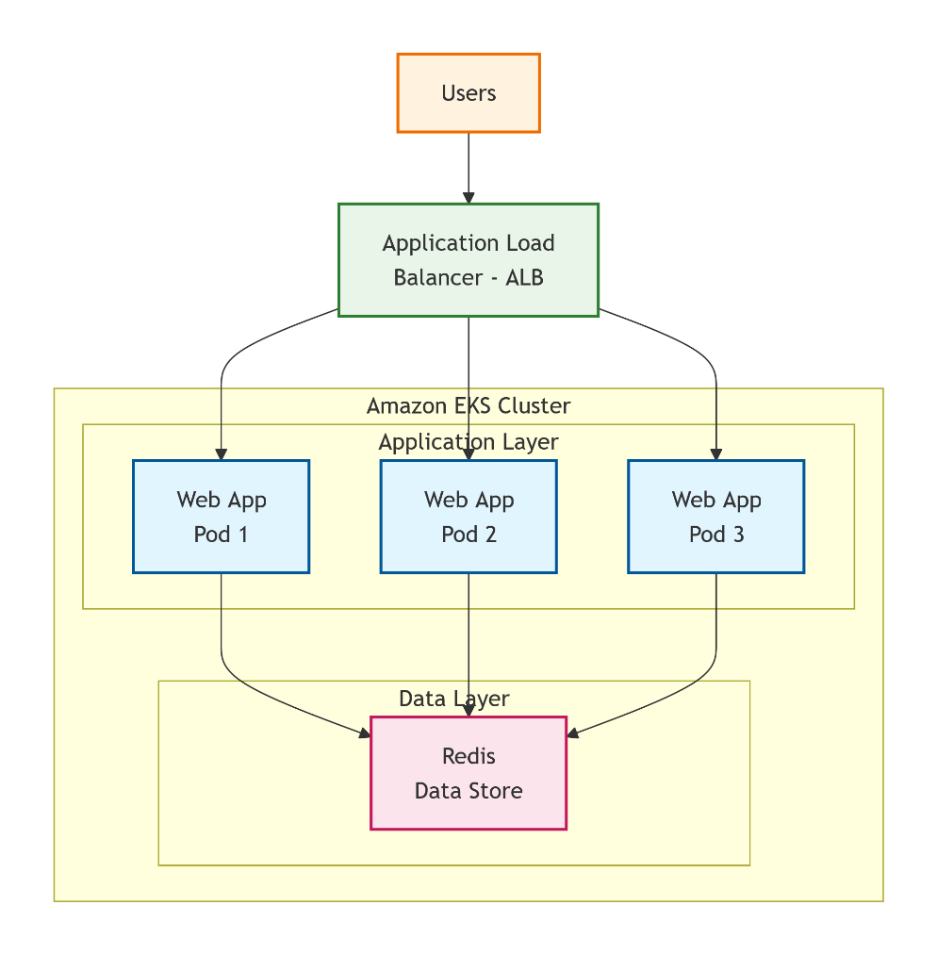

1.2 Data Flow
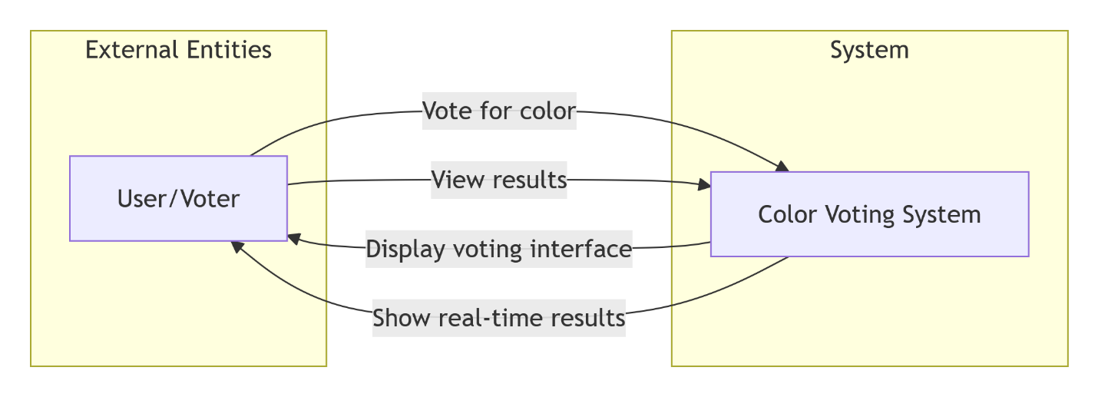

1.3 Design Justification

Component | Purpose | Justification
Flask (Python) | Backend web framework | Lightweight, easy to containerize, and integrates well with REST APIs and Redis.
Redis | Caching & session management | Provides in-memory data storage to improve performance and reduce latency.
Docker | Containerization | Ensures consistent environments between local, testing, and production.
Kubernetes (EKS) | Container orchestration | Manages deployment, scaling, and reliability of containers automatically.
Terraform | Infrastructure as Code | Enables automated, version-controlled provisioning of AWS resources.
AWS (EKS, ALB, VPC) | Cloud platform | Provides reliability, scalability, and global reach with managed services.
HTML + CSS (Frontend) | Web interface | Simple, responsive frontend for user interaction.

1.4 Step-by-Step Product Selection Documentation
- Compute Platform Selection
  - Chosen: AWS Elastic Kubernetes Service (EKS)
  - Reason: Managed Kubernetes reduces operational overhead and integrates with other AWS services (IAM, CloudWatch).
- Containerization
  - Chosen: Docker
  - Reason: Enables reproducible builds and portable deployments.
- Orchestration
  - Chosen: Kubernetes
  - Reason: Supports auto-healing, scaling, and rolling updates.
- Infrastructure Management
  - Chosen: Terraform
  - Reason: Infrastructure as Code (IaC) ensures reproducibility and collaboration across teams.
- Caching Layer
  - Chosen: Redis
  - Reason: In-memory key-value store for fast data retrieval.
- Load Balancing
  - Chosen: AWS Application Load Balancer (ALB)
  - Reason: Provides intelligent routing and automatic SSL termination.

1.5 Cost Estimation (AWS-based Example)

Resource | Service | Estimated Monthly Cost (USD)
EKS Cluster (t3.medium x 2 nodes) | Compute | $70
ALB | Networking | $20
Redis (Elasticache or self-hosted pod) | Cache | $15
S3/EBS Storage | Data | $10
Terraform & Monitoring | Misc | $5
Total Estimated Cost |  | ~$120/month
Note: Costs depend on actual usage, region, and scaling.

1.6 Scalability Design
- Horizontal Scaling: Kubernetes automatically adds more pods during high load.
- Vertical Scaling: Instance types can be upgraded through Terraform.
- Auto-scaling Policies: Configured at both pod and node level (using HPA and Cluster Autoscaler).
- Caching Layer: Redis offloads read operations, enhancing throughput.
- Load Balancer: Distributes requests evenly among healthy pods.

1.7 Implementation Roadmap

Phase | Tasks | Tools
Phase 1 | Code Application (Flask + HTML/CSS) | Python, Flask
Phase 2 | Containerize the app | Docker
Phase 3 | Write IaC scripts | Terraform
Phase 4 | Deploy infrastructure (EKS, ALB, VPC) | AWS, Terraform
Phase 5 | Deploy application & Redis via Kubernetes manifests | kubectl, YAML
Phase 6 | Testing and monitoring setup | CloudWatch, logs
Phase 7 | Implement autoscaling & backup | EKS autoscaler, AWS backup

2. Technical Implementation & Functionality

2.1 Infrastructure as Code (Terraform)
Terraform automates AWS resource provisioning through .tf files:
- main.tf: Defines provider and backend configuration.
- eks.tf: Creates the EKS cluster and worker nodes.
- alb.tf: Sets up an Application Load Balancer.
Advantages:
- Reproducible and version-controlled deployments.
- Easy rollback and modification through code.
- Enables collaborative DevOps workflow.

2.2 Deployment Process
- Build Docker image
- docker build -t flask-app .
- Push to container registry (e.g., ECR)
- docker push <ecr-repo-url>/flask-app
- Deploy on EKS
- kubectl apply -f kubernetes/deployment.yaml
- kubectl apply -f kubernetes/redis.yaml
- Access via ALB public endpoint
Advantages:
- Automated deployment using CI/CD pipelines (GitHub Actions / Jenkins).
- Declarative and consistent configurations.

2.3 Reliability and Monitoring
- AWS CloudWatch: Centralized monitoring and alerting.
- Kubernetes Health Probes: Liveness/readiness checks for app pods.
- Load Balancer health checks: Ensures only healthy pods receive traffic.
- Backup strategy: Automated snapshotting via Terraform or AWS Backup.
Advantages:
- Minimizes downtime through automated recovery.
- Provides visibility into system performance.

2.4 Autoscaling
- Horizontal Pod Autoscaler (HPA) adjusts pods based on CPU/memory metrics.
- Cluster Autoscaler adds/removes nodes automatically.
- ALB scales incoming requests dynamically.
Advantages:
- Reduces costs by scaling down during low traffic.
- Maintains performance during peak load.

2.5 Data Persistence
- Redis handles transient in-memory data (sessions, caching).
- Persistent Volumes (EBS/S3) store durable data (if used for user uploads).
- Kubernetes persistent volumes ensure data is retained even if pods restart.
Advantages:
- Separation of stateful and stateless services.
- Increased fault tolerance and recoverability.

2.6 Reliability and Monitoring
- AWS CloudWatch: Centralized monitoring and alerting.
- Kubernetes Health Probes: Liveness/readiness checks for app pods.
- Load Balancer health checks: Ensures only healthy pods receive traffic.
- Backup strategy: Automated snapshotting via Terraform or AWS Backup.
Advantages:
- Minimizes downtime through automated recovery.
- Provides visibility into system performance.

2.7 Advantages of Chosen Technologies

Technology | Advantages
Flask | Lightweight, fast to develop, ideal for microservices.
Docker | Portable, reproducible environments.
Kubernetes (EKS) | Auto-scaling, self-healing, high availability.
Redis | Lightning-fast caching; enhances responsiveness.
Terraform | Versioned, automated infrastructure; minimizes manual work.
AWS Services | Managed, secure, and globally scalable.

Conclusion
This project demonstrates a complete cloud-native deployment pipeline that integrates:
- Application Development (Flask)
- Infrastructure Automation (Terraform)
- Container Orchestration (EKS)
- Caching and Scaling (Redis + Kubernetes autoscaling)
- Load Balancing and Reliability (AWS ALB + CloudWatch)
The chosen architecture ensures scalability, cost-efficiency, and high availability, making it suitable for real-world production deployments.

