Contents

Introduction 3

**Company Background** 3

**Business case:** 3

**Current website stack technology:** 4

**Goals** 4

**Budget** 5

**Scope** 5

**Out of Scope** 5

**Competition** 5

**Timeline** 5

**Risks Management** 6

**Risk Breakdown Structure** 7

**Risks in projects** 7

**Common project risks** 7

**Risk Management Process** 8

**Risk Assessment Matrix** 9

**Risk Management Matrix** 10

**Identified Risks** 10

**Attached documents:**  10

**Stakeholders** 10

**Communication Plan** 11

Business Analysis Planning 12

**Stakeholder Mapping and Requirements Gathering** 12

**Estimating and Prioritizing Business Analysis Tasks** 19

**Tasks - Milestones** 19

**Tasks – Estimative with Top-Down Technique** 20

**Tasks – Prioritization with Moscow Technique** 21

**Requirements Elicitation and Collaboration** 24

**Business Requirements** 24

**Stakeholder Requirements** 25

**Solution Requirements** 26

Conclusion 27

**New website stack technology premisses** 27

**Why Microsoft Azure stack?** 27

**Why WordPress as the Content Management System (CSM)?** 27

**Proposed website stack technology** 27

**New Infrastructure required:** 28

**Infrastructure already in use:** 28

**Resources needed:** 29

References 30

Figure 1 - Smartsheet.com (scenarios to evaluate risks) 7

Figure 2 - ISO 9001:2015 – Risk Process Management 9

Figure 3 - Smartsheet.com (risk assessment matrix template) 9

Figure 4 - Smartsheet.com (risk management matrix template) 10

Figure 5 - Smartsheet.com (project stakeholder model template) 12

Project Charter

|  |  |
| --- | --- |
| **Project Name:** NS Clothing New Website | |
| **Project Sponsor**: NS Clothing CEO | **Project Manager**: Elaine da Silva |
| **Date Created**: 1/5/2024 | **Date Approved**: |

# Introduction

## **Company Background**

Nova Scotia Clothing is a family-owned company founded in 1999 to provide affordable prices located in Nova Scotia. The original idea was to provide casual clothing to the growing student population that came to Nova Scotia in search of a good education.

Born in a time when the Internet was not a reality, the company focused its business on small stores in the main shopping malls across the province.

From 2010, with the expansion of the business on the Internet, the company created a website to diversify its business. Until recently, its managers didn't believe that online sales would be a promising business. However, after the pandemic, the market underwent significant changes, Nova Scotia clothing lost market share and the need for change became not just a desire of the new generation of managers, but an obligation, otherwise the company would disappear.

## **Business case:**

**Nova Scotia Clothing** is a company that specializes in selling clothing online. The company has been in business for over 5 years and has a loyal customer base. However, the company has been facing some challenges lately. The website is outdated and not user-friendly, which has led to a decrease in sales. The company has also been facing stiff competition from other online retailers. Also, small clothing designers in Nova Scotia are struggling to find a sustainable business model due to high inflation, rising operating costs, and shrinking Canadian demand.

The company’s goal is to improve its online shopping platform to increase sales and customer satisfaction. The company wants to create a seamless shopping experience for its customers, which includes easy navigation, fast loading times, and a user-friendly interface. The company also wants to improve its product recommendations and search functionality to help customers find what they are looking for quickly.

To achieve these goals, the company has identified several challenges that need to be addressed. Firstly, the company needs to update its website to make it more modern and user-friendly. This includes improving the website’s design, layout, and functionality. Secondly, the company needs to improve its product recommendations and search functionality. This can be achieved by using artificial intelligence and machine learning algorithms to analyze customer data and provide personalized recommendations. Finally, the company needs to improve its customer service by providing fast and efficient support to customers.

Overall, Nova Scotia Clothing is committed to improving its online shopping platform to provide a better shopping experience for its customers and increase sales. By addressing the challenges and investing in the right resources, the company is confident that it can achieve its goals and remain competitive in the online retail market.

## **Current website stack technology:**

The Company's current IT landscape is supported by two outsourced companies. Processor Services Ltda, which provides a local computer network infrastructure service, printers and user support, and Allegra Ltda, which provides the MS-Azure cloud service, which includes MS-Office 365 and MS-Dynamics 365.

The e-Commerce shopping was built in 2001 to have another sales channel, and also to provide more convenience for the customers. The goal was to follow the market trend and offer the same products found in the stores.

The e-Commerce shopping has kept the same features since then, and it hasn't had any substantial changes.

The actual website platform is based on the following technologies:

* Front-end: PHP
* Back-end: PHP
* Application Server: Apache
* Database: MySQL
* SO: Linux Ubuntu
* On Premise

## **Goals**

* Improve product recommendations and search functionality to increase conversion rate by 10% in 1 year.
* Improve customer service by providing fast and efficient support to customers to reduce customer dissatisfaction rate by 15% in 1 year.
* Increase NS Clothing sales by 20% and market share by 10% in 2 years.

## **Budget**

Initially, the budget for the project is $700,000, including the people and infrastructure.

## **Scope**

It created a new website based on the latest technologies to meet the company's needs and objectives, as well as reaching its target audience.

## **Out of Scope**

Selection and contracting of partner companies for the implementation of the guidelines suggested in this document.

## **Competition**

<https://anothershopboutique.com/collections/sweaters-cardigans>

<https://shopincandescent.ca/>

Our competitors already have websites attractive and modern which provide a good user experience.

## **Timeline**

The board set a deadline of 6 months from the approval of the project proposal.

## **Risks Management**

According to ISO 9001:2015, risk can be represented as the effect of uncertainty on objectives (positive or negative). In other words, managing risks is nothing more than managing uncertainties.

* **Threats**: uncertainties that could harm the company or prevent it from achieving an objective.
* **Opportunities**: are the uncertainties that can benefit the company or help it achieve an objective.

The task of identifying risks and opportunities is essential to:

* Ensure intended results.
* Increase desirable effects.
* prevent or reduce undesirable effects.
* Achieve improvement.

ISO 9001 also suggests that the company achieves a risk mindset. **Risk mindset** is a concept that must be **present** and **widespread** throughout the organization.

A risk mindset involves knowing, monitoring and, most importantly, acting on those risks. The standard proposes a simple but very powerful tool: 5W2H.

To summarize, risk management is the process of identifying, analyzing, prioritizing, and acting on the most relevant uncertainties. [1]

## **Risk Breakdown Structure**

Figure 1 - Smartsheet.com (scenarios to evaluate risks)

## **Risks in projects**

In projects, risk management is fundamental because a project is a temporary effort with an expected objective, performed for the first time and often involving several variables (different teams, external resources, and estimates). Risks should be identified during the planning phase with brainstorming, and lessons learned from past projects.

Risk management in projects will increase productivity by making better use of resources such as time, money, and people. It will also reduce costs through better resource management and error prevention. And finally, it will improve the quality of your products and services through more assertive scoping, implementation of real improvements, and continuous learning.[2]

## **Common project risks**

* Unavailability of necessary planned resources: a person goes on vacation or gets sick in the middle of the project.
* Scope change: when the customer asks for "just a few more things" in the project.
* Poor performance: tasks planned to take x take 2x as long, impacting the schedule.
* Reduction of the originally planned budget.
* External changes that are outside the project's control but can affect it: changes in the economic scenario, changes in government regulations, environmental disasters.

## **Risk Management Process**

Risk management is a continuous and systematic process that involves identifying, evaluating, and mitigating the risks that an organization may face. This process is typically divided into several phases.

* **Risk Identification**: the organization identifies and catalogs the potential events that could affect its objectives. This can include internal and external events, such as changes in the regulatory environment, natural disasters, technology failures, and others.
* **Risk Analysis**: once identified, risks are analyzed in terms of probability and impact. Probability refers to the likelihood of the event occurring, while impact refers to the severity of the consequences should the event occur.
* **Risk Evaluation (prioritization)**: based on the risk analysis, an assessment is made to determine which risks are most significant to the organization. This involves prioritizing risks based on their likelihood and impact, often using risk matrices.
* **Risk Treatment (response planning)**: based on the risk matrix, the organization develops strategies to address the identified risks. This may include actively mitigating risks, transferring risks to others (for example, through insurance), accepting risks, or even avoiding certain activities that pose unacceptable risks.
* **Controls and monitoring**: risk response strategies are implemented, and controls are established to continuously monitor the effectiveness of these strategies. This may include the implementation of policies, procedures, and monitoring systems.
* **Communication and documentation**: it is critical to communicate the results of risk management to all relevant stakeholders. Appropriate documentation is maintained to record the risks identified, the response strategies adopted, and the results of monitoring.
* **Continuous review and updating**: risk management is an ongoing process. Conditions in the business environment may change, new risks may emerge, and the effectiveness of response strategies may need to be adjusted. It is therefore essential to review and update the risk management process on a regular basis.

These phases form a continuous cycle, and risk management is a key component of **corporate governance** to ensure the **long-term sustainability** and **success** of an organization.[3]

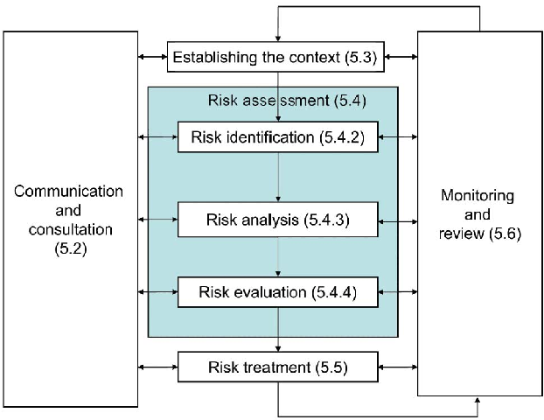

Figure 2 - ISO 9001:2015 – Risk Process Management

## **Risk Assessment Matrix**

Figure 3 - Smartsheet.com (risk assessment matrix template)

## **Risk Management Matrix**

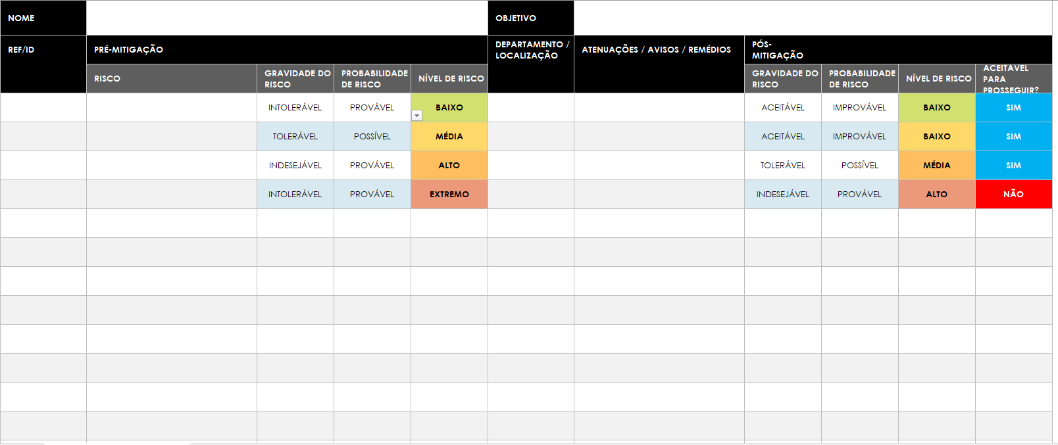

Figure 4 - Smartsheet.com (risk management matrix template)

## **Identified Risks**

There are many complexities and challenges associated with developing an eCommerce website. Identifying and managing potential risks is critical to ensuring the successful completion and functionality of the project. Here are some common risks associated with eCommerce website development:

## **Attached documents: [4]**

* **Matrix for risk management**: Assignment1_Risk-Management-Matrix.xlsx.
* **Matrix to identify the level of risk**: Assignment1_Risk-Assessment-Matrix.xlsx.
* **Action plan for risk treatment**: Assignment1_Risk-Action-Plan.xlsx.
* **Scenarios for identifying risks**: Assignment1_Risk-Breakdown-Structure.xlsx.

## **Stakeholders**

* Emma Lombard (CEO)
* Paula Schultz (Operations Manager)
* Elisa Thomas (Customer Service Manager)
* Ana Scott (Finance Manager)
* Logistics Partner
* Suppliers
* Customers
* Government

## **Communication Plan**

|  |  |  |  |  |  |
| --- | --- | --- | --- | --- | --- |
| **Description** | **Frequency** | **Channel** | **Audience** | **Owner** | |
| Project Status update | weekly | MS-Project | All internal stakeholders  and project members | | Project Manager |
| Virtual project team meetings | monthly | MS-Teams | All project members,  stakeholders (optional) | | Project Manager |
| External stakeholders updates | as needed | MS-Teams | Project manager and project stakeholders | | Project Manager e Project Sponsor |
| Milestone and deliverable updates | as needed | MS-Project Intranet | Project members | | Project members |
| Project check-ins | daily | MS-Teams | Project members | | Project members |
| Announcements | as needed | Intranet | All company | | Project members |
| Meetings invitation | as needed | MS-Outlook | All project members, all stakeholders | | Project members |

Table 1- Table 1- Asana.com (communication plan template)

# Business Analysis Planning

## **Stakeholder Mapping and Requirements Gathering**

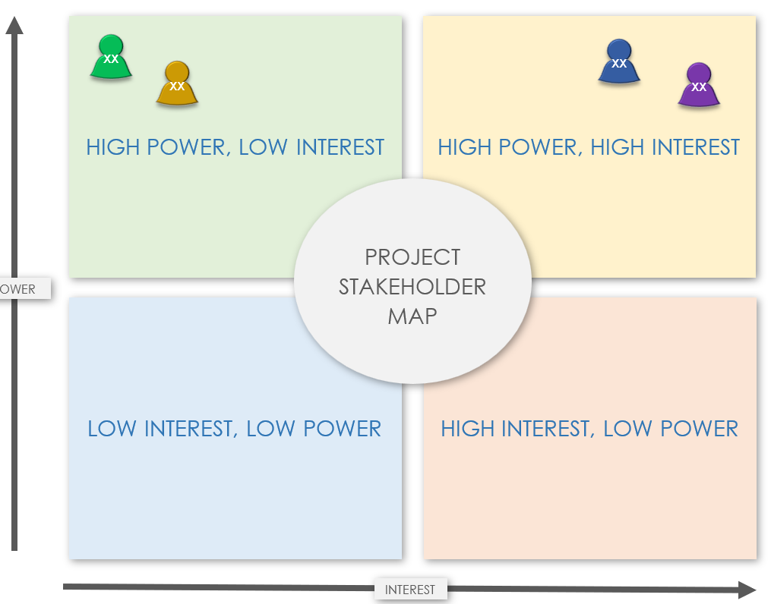

Figure 5 - Smartsheet.com (project stakeholder model template)

|  |  |
| --- | --- |
| Emma Lombard (CEO) | |
| **Interest:** High | **Influence:** High |
| **Business Requirements:**  **Measurement:** Identify key performance indicators (KPIs) for measuring the success of the website.  **Brand Representation:** ensure the website reflects the company's brand image, values, and messaging.  **Competitive Advantage:** identify features or functionalities that can give the company a competitive edge.  **Stakeholder Requirements:**  **Monitoring & Analytics:** implement analytics tools to gather data on user behavior, sales metrics, and website performance.  **AI and Machine Learning for Product Recommendations:**  Implement AI and machine learning algorithms to analyze customer behavior and preferences.  Utilize historical purchase data and browsing behavior to provide personalized product recommendations.  Integrate a robust recommendation engine into the website for a tailored shopping experience.  **Enhanced Search Functionality:**  Implement an advanced search functionality using AI-powered algorithms.  Include filters, sorting options, and predictive search to assist customers in finding products quickly.  Optimize the search engine to ensure accurate and relevant results.  **Solution Requirements:**  **Scalability:** plan for future growth by ensuring the website is scalable to accommodate increased traffic and functionalities.  **Content Management:** provide an easy-to-use content management system (CMS) for updating website content.  **Technology Stack:** define the technology stack based on the company's infrastructure and requirements.  **Security & Privacy:** implement robust security measures to protect sensitive data and ensure customer privacy. | |

|  |  |
| --- | --- |
| Paula Schultz (Operations Manager) | |
| **Interest:** High | **Influence:** High |
| **Stakeholder Requirements:**  **Efficient Workflow**: streamline processes and workflows through the website to enhance operational efficiency.  **Solution Requirements:**  **Inventory Management:** integrate inventory management systems to keep track of stock levels. | |

|  |  |
| --- | --- |
| Elisa Thomas (Customer Service Manager) | |
| **Interest:** High | **Influence:** High |
| **Business Requirements:**  **Feedback Mechanism:** implement a feedback mechanism on the website to gather customer opinions. Regularly analyze feedback to identify areas for continuous improvement.  **Stakeholder Requirements:**  **Customer Support Features**: implement features like live chat, contact forms, and FAQs to facilitate customer support.  **Solution Requirements:**  **Order Tracking:** include order tracking functionalities to keep customers informed about their purchases. | |

|  |  |
| --- | --- |
| Ana Scott (Finance Manager) | |
| **Interest:** High | **Influence:** High |
| **Business Requirements:**  **Financial Transactions:**  Ensure secure and efficient processing of financial transactions on the website.  Implement payment gateways that meet financial compliance standards.  **Invoicing and Billing:**  Integrate invoicing and billing features to streamline financial processes.  Provide an option for generating invoices and receipts for transactions.  **Expense Tracking:**  If applicable, incorporate tools for tracking and managing expenses related to the website's operations.  **Auditing and Compliance:**  Provide features that support auditing processes and ensure compliance with financial auditing standards.  **Tax Compliance:**  Ensure the website adheres to tax regulations and provides necessary documentation for tax compliance.  **Stakeholder Requirements:**  **Reporting and Analytics:**  Implement financial reporting and analytics tools to monitor revenue, expenses, and other financial metrics.  Ensure the availability of reports that can assist in financial decision-making.  **Integration with Financial Systems:**  Integrate the website with existing financial systems or accounting software used by the company.  **Solution Requirements:**  **Security Measures:**  Implement additional security measures for financial data to prevent unauthorized access and ensure compliance with financial regulations.  **Financial User Roles:**  Define specific user roles and permissions related to financial access and activities on the website.  **Cost Control Measures:**  Implement features or alerts that help in controlling and monitoring costs associated with website operations. | |

|  |  |
| --- | --- |
| Logistics Partner | |
| **Interest:** Low | **Influence:** High |
| **Business Requirements:**  **Shipping Integration:** implement shipping integrations for real-time tracking and coordination with logistics partners.  **Solution Requirements:**  **API Integration:** provide necessary APIs for logistics partners to seamlessly integrate their systems. | |

|  |  |
| --- | --- |
| Suppliers | |
| **Interest:** High | **Influence:** Low |
| **Business Requirements:**  **Supplier Portal:** create a portal for suppliers to manage inventory, update product information, and communicate with the company.  **Solution Requirements:**  **Order Management:** facilitate order processing and communication between suppliers and the company. | |

|  |  |
| --- | --- |
| Customers | |
| **Interest:** Low | **Influence:** Low |
| **Business Requirements:**  **Secure Transactions:** implement secure payment gateways to ensure the safety of customer transactions.  **User-Friendly Interface:** ensure the website is easy to navigate with a user-friendly interface for customers.  **Stakeholder Requirements:**  **Marketing & Promotion:**  Develop a comprehensive marketing strategy to promote the revamped website.  Utilize social media, email campaigns, and influencer partnerships to increase brand awareness.  Offer promotions or loyalty programs to encourage repeat business.  **Solution Requirements:**  **Mobile Responsiveness:** ensure the website is accessible and functional across various devices, especially mobile phones. | |

|  |  |
| --- | --- |
| Government | |
| **Interest:** Low | **Influence:** High |
| **Business Requirements:**  **Tax Compliance:**  Ensure the website adheres to tax regulations and provides necessary documentation for tax compliance.  **Compliance:** ensure the website complies with relevant regulations and standards applicable to the industry.  **Solution Requirements:**  **Accessibility:** make the website accessible to individuals with disabilities to comply with accessibility standards. | |

## [**Estimating and Prioritizing Business Analysis Tasks**](https://nscconline.brightspace.com/d2l/le/content/296913/viewContent/4553633/View)

For estimating was used the Top-Down technique. This meth method of Estimating by Analogy, also known as Top-Down Estimating, uses the actual costs or time of previous projects similar in size, scope, and complexity to define the estimates for the current project.

In this top-down analysis, you develop an overview of the expected schedule first, using previous projects or previous experience as a guide.

## **Tasks - Milestones**

1. Project Planning and Analysis.
2. Domain and Hosting: define and contract.
3. Platform and Technology selection: define, contract, and install.
4. Website Design: personas, layout, brand, prototyping.
5. Front-End Development: WordPress.
6. Back-End Development: database structures, business logic, integrations with legacy systems, WooCommerce: WordPress plugin that adds e-commerce functionality to WordPress websites.
7. Shopping Cart, Checkout, and Payment: integration with payment platforms.
8. Content Creation: website content (text, images, videos).
9. AI and Machine Learning for Product Recommendations: implement AI and machine learning algorithms to analyze customer behavior and preferences.
10. Enhanced Search Functionality: Elasticsearch
11. Monitoring & Analytics: implement analytics tools to gather data on user behavior, sales metrics, and website performance to support decision-making.
12. Product Management: images, descriptions, pricing, categorization, tagging, and inventory.
13. Compliance and Regulations: tax compliance, auditing, regulations.
14. User Authentication and Authorization: Azure Active Directory.
15. Security & Privacy: Implement SSL encryption for secure data transmission.
16. Quality Assurance: test functionality, usability, performance, and security. Perform cross-browser and cross-device testing.
17. Training and Documentation: training for content creators and administrators on how to update and manage the website.
18. Launch: announce the launch of the website to stakeholders and users.
19. Marketing and Promotion: utilize social media, email, and other channels for promotion.
20. Analytics Setup: set up analytics tools to track website performance and user behavior (Google Analytics).
21. Maintenance: optimize website speed, SEO, and user experience based on analytics insights.
22. Feedback and Iteration: from users and stakeholders.

## **Tasks – Estimative with Top-Down Technique**

| **TASK** | **COST** | **TIME** | **PEOPLE** |
| --- | --- | --- | --- |
| Project Planning and Analysis. | $6,ooo | 30 days | 1 Business Analyst |
| Domain and Hosting: define and contract. | $10,000 | 5 days | 1 Business Analyst 1 Finance Manager |
| Platform and Technology selection: define, contract, and install. | $100,000 | 5 days | 1 Business Analyst 1 Finance Manager 1 DevOps Engineer |
| Website Design: personas, layout, brand, prototyping. | $12,000 | 60 days  from developing to approval | 2 UX Analysts 1 UI Analyst/Dev |
| Front-End Development: WordPress, WooCommerce. | $60,000 | 90 days | 2 Fullstack (UI) developers  WordPress, WooCommerce |
| Back-End Development: database structures, business logic, integrations with legacy systems, WooCommerce: WordPress plugin that adds e-commerce functionality to WordPress websites. | $60,000 | 90 days | 2 SQL Server DBA / Back-End developers: SQL Server |
| Shopping Cart, Checkout, and Payment: integration with payment platforms. | $10,000 | 15 days | 1 Back-End  developer |
| Content Creation: website content (text, images, videos). | $30,000 | 60 days | 2 editors 1 approver |
| AI and Machine Learning for Product Recommendations: implement AI and machine learning algorithms to analyze customer behavior and preferences. | $30,000 | 30 days | 1 Data Scientist |
| Enhanced Search Functionality: with Elasticsearch | $30,000 | 30 days | 1 Elasticsearch  Specialist |
| Monitoring & Analytics: implement analytics tools to gather data on user behavior, sales metrics, and website performance to support decision-making. | $20,000 | 30 days | 1 Data Analyst |
| Product Management: images, descriptions, pricing, categorization, tagging, and inventory. | $8,000 | 30 days | 1 from Operations  and Master Data |
| Compliance and Regulations: tax compliance, auditing, regulations. | $8,000 | 15 days | 1 from Accounting |
| User Authentication and Authorization: Azure Active Directory. | $10,000 | 5 days | 1 Back-End developer 1 DevOps Engineer |
| Security & Privacy: Implement SSL encryption for secure data transmission. | $10,000 | 15 days | 1 Back-End developer |
| Quality Assurance: test functionality, usability, performance, and security. Perform cross-browser and cross-device testing. | $30,000 | 90 days days | 1 Quality Assurance  Specialist |
| Training and Documentation: training for content creators and administrators on how to update and manage the website. | 20,000 | 60 days | 2 Product Owners |
| Launch: announce the launch of the website to stakeholders and users. | $10,000 | 30 days | 1 from Marketing  Department |
| Marketing and Promotion: utilize social media, email, and other channels for promotion. | $30,000 | 30 days before lauch | 2 from Marketing  Department |
| Analytics Setup: set up analytics tools to track website performance and user behavior (Google Analytics). | $5,000 | 5 days | 1 Full-Stack Developer |
| Maintenance: optimize website speed, SEO, and user experience based on analytics insights. | $8,000 | Monthly (routine) | 1 from Marketing: SEO, Feedbacks, Interations |

## **Tasks – Prioritization with Moscow Technique**

| **TASK** | **PRIORITY** |
| --- | --- |
| Project Planning and Analysis. | MUST HAVE |
| Domain and Hosting: define and contract. | SHOULD HAVE |
| Platform and Technology selection: define, contract, and install. | MUST HAVE |
| Website Design: personas, layout, brand, prototyping. | SHOULD HAVE |
| Front-End Development: WordPress, WooCommerce | MUST HAVE |
| Back-End Development: database structures, business logic, integrations with legacy systems, WooCommerce: WordPress plugin that adds e-commerce functionality to WordPress websites. | MUST HAVE |
| Shopping Cart, Checkout, and Payment: integration with payment platforms. | MUST HAVE |
| Content Creation: website content (text, images, videos). | MUST HAVE |
| AI and Machine Learning for Product Recommendations: implement AI and machine learning algorithms to analyze customer behavior and preferences. | MUST HAVE |
| Enhanced Search Functionality: with Elasticsearch | SHOULD HAVE |
| Monitoring & Analytics: implement analytics tools to gather data on user behavior, sales metrics, and website performance to support decision-making. | MUST HAVE |
| Product Management: images, descriptions, pricing, categorization, tagging, and inventory. | MUST HAVE |
| Compliance and Regulations: tax compliance, auditing, regulations. | MUST HAVE |
| User Authentication and Authorization: Azure Active Directory. | MUST HAVE |
| Security & Privacy: Implement SSL encryption for secure data transmission. | SHOULD HAVE |
| Quality Assurance: test functionality, usability, performance, and security. Perform cross-browser and cross-device testing. | SHOULD HAVE |
| Training and Documentation: training for content creators and administrators on how to update and manage the website. | SHOULD HAVE |
| Launch: announce the launch of the website to stakeholders and users. | SHOULD HAVE |
| Marketing and Promotion: utilize social media, email, and other channels for promotion. | COULD HAVE |
| Analytics Setup: set up analytics tools to track website performance and user behavior (Google Analytics). | MUST HAVE |
| Maintenance: optimize website speed, SEO, and user experience based on analytics insights. | COULD HAVE |

## **Requirements Elicitation and Collaboration**

## **Business Requirements**

**Measurement:** Identify key performance indicators (KPIs) for measuring the success of the website.

**Brand Representation:** ensure the website reflects the company's brand image, values, and messaging.

**Financial Transactions:**

Ensure secure and efficient processing of financial transactions on the website.

Implement payment gateways that meet financial compliance standards.

**Invoicing and Billing:**

Integrate invoicing and billing features to streamline financial processes.

Provide an option for generating invoices and receipts for transactions.

**Expense Tracking:**

If applicable, incorporate tools for tracking and managing expenses related to the website's operations.

**Auditing and Compliance:**

Provide features that support auditing processes and ensure compliance with financial auditing standards.

**Tax Compliance:**

Ensure the website adheres to tax regulations and provides necessary documentation for tax compliance.

**Shipping Integration:** implement shipping integrations for real-time tracking and coordination with logistics partners.

**Supplier Portal:** create a portal for suppliers to manage inventory, update product information, and communicate with the company.

**Secure Transactions:** implement secure payment gateways to ensure the safety of customer transactions.

**User-Friendly Interface:** ensure the website is easy to navigate with a user-friendly interface for customers.

**Tax Compliance:**

Ensure the website adheres to tax regulations and provides necessary documentation for tax compliance.

**Compliance:** ensure the website complies with relevant regulations and standards applicable to the industry.

## **Stakeholder Requirements**

**Monitoring & Analytics:** implement analytics tools to gather data on user behavior, sales metrics, and website performance.

**AI and Machine Learning for Product Recommendations:**

Implement AI and machine learning algorithms to analyze customer behavior and preferences.

**Integration with Financial Systems:**

Integrate the website with existing financial systems or accounting software used by the company.

Utilize historical purchase data and browsing behavior to provide personalized product recommendations.

Integrate a robust recommendation engine into the website for a tailored shopping experience.

**Enhanced Search Functionality:**

Implement an advanced search functionality using AI-powered algorithms.

Include filters, sorting options, and predictive search to assist customers in finding products quickly.

Optimize the search engine to ensure accurate and relevant results.

**Efficient Workflow**: streamline processes and workflows through the website to enhance operational efficiency.

**Feedback Mechanism:** implement a feedback mechanism on the website to gather customer opinions. Regularly analyze feedback to identify areas for continuous improvement.

**Customer Support Features**: implement features like live chat, contact forms, and FAQs to facilitate customer support.

**Reporting and Analytics:**

Implement financial reporting and analytics tools to monitor revenue, expenses, and other financial metrics.

Ensure the availability of reports that can assist in financial decision-making.

**Marketing & Promotion:**

Develop a comprehensive marketing strategy to promote the revamped website.

Utilize social media, email campaigns, and influencer partnerships to increase brand awareness.

Offer promotions or loyalty programs to encourage repeat business.

## **Solution Requirements**

**Scalability:** plan for future growth by ensuring the website is scalable to accommodate increased traffic and functionalities.

**Content Management:** provide an easy-to-use content management system (CMS) for updating website content.

**Technology Stack:** define the technology stack based on the company's infrastructure and requirements.

**Security & Privacy:** implement robust security measures to protect sensitive data and ensure customer privacy.

**Inventory Management:** integrate inventory management systems to keep track of stock levels.

**Order Tracking:** include order tracking functionalities to keep customers informed about their purchases.

**Security Measures:**

Implement additional security measures for financial data to prevent unauthorized access and ensure compliance with financial regulations.

**Financial User Roles:**

Define specific user roles and permissions related to financial access and activities on the website.

**Cost Control Measures:**

Implement features or alerts that help in controlling and monitoring costs associated with website operations.

**API Integration:** provide necessary APIs for logistics partners to seamlessly integrate their systems.

**Order Management:** facilitate order processing and communication between suppliers and the company.

**Accessibility:** make the website accessible to individuals with disabilities to comply with accessibility standards.

# Conclusion

## **New website stack technology premisses**

## **Why Microsoft Azure stack?**

For the scope of this project, it is recommended to use Microsoft's cloud services due to the company already has licenses to use Office 365 and Dynamics 365 on the cloud. This will make the integration with the new website easier.

## **Why WordPress as the Content Management System (CSM)?**

Advantages of Building a Website with CMS instead Web Development:

* **Ease of Use**: CMSs are designed to be intuitive and easy to use, allowing non-technical users to manage and update content easily.
* **Quick Development and Deployment**: CMSs often offer ready-to-use templates and themes, speeding up the development and deployment process.
* **Efficient Content Management**: Makes it easy to create, edit and delete content without the need for advanced programming skills.
* **Simple Updates**: Updates and modifications to content are simple and can be carried out without advanced technical knowledge.
* **Communities and Ecosystems**: many CMSs have active communities that offer support, plugins and extensions to extend functionality.
* **Multi-user and Collaboration**: CMSs generally support multiple users with different permission levels, allowing efficient collaboration.
* **Integrated Media Management**: integrated management of images, videos and other types of media is facilitated in many CMSs.
* **SEO-Friendly:** some CMSs are designed with good SEO practices, making it easier to optimize for search engines.

## **Proposed website stack technology**

* Content Management System (CMS):
  + WordPress on Azure VM
* Search system:
  + Elasticsearch on Azure VM
* Media and images
  + Azure Blob Storage
* Machine Learning:
  + Azure Machine Learning
* Web Server:
  + Apache on Azure VM
* Database Server:
  + SQL Server on Azure VM (same of Dynamics 365)
* Operating System:
  + Linux Ubuntu on Azure VM
* Identity Management & SSO
  + Azure Active Directory (already used by the company)
* Network
  + Virtual NET on Azure (already used by the company)
* Backup & Recovery
  + Already used for Dynamic 365 and File Systems on the cloud

## **New Infrastructure required:**

Virtual Machine on Azure

WordPress and Web Server - new

Elasticsearch – new

Azure Machine Learning - new

Azure Blob Storage – new

Linux Ubuntu licenses – new

## **Infrastructure already in use:**

Azure Virtual NET

Add new services.

SQL Server on Azure

Add new database on the SQL Server on Azure VM.

Backup and Recovery

Add new services.

Identity management:

Add new services.

## **Resources needed:**

* 2 User Experience Analyst (UX) using Design Thinking methodology to develop layout, prototyping, and interfaces. These professionals will be released after the prototype approval.
* 2 Front-End/Fullstack developers (UI): WordPress, WooCommerce
* 2 SQL Server DBA / Back-End developers: SQL Server
* 1 Elasticsearch specialist: Elasticsearching
* 1 DevOps / Infrastructure Engineer: containers, docker, kubernetes, orchestration, Jenkins, deploy.
* 1 Data Scientist.
* 1 Data Analyst
* 1 Data Engineer
* 1 Quality Assurance Specialist
* 1 Project Manager

# References

Pereira T. Big Data e Cloud Computing – Desafios e Oportunidades. Data Science Academy. Published December 16, 2022. Accessed February 3, 2024. https://blog.dsacademy.com.br/big-data-e-cloud-computing-desafios-e_oportunidades/

Eby K. Free stakeholder mapping templates. Smartsheet. Accessed February 3, 2024. https://www.smartsheet.com/content/stakeholder-mapping-template

Free Project Management Templates | Download Now | TeamGantt. TeamGantt. Accessed February 3, 2024. https://www.teamgantt.com/project-templates/project-management-templates

Indeed Editorial Team. (2023, October 15). Requirements gathering: template, example and how to use. Indeed.com. https://www.indeed.com/career-advice/career-development/requirements-gathering-template

Indeed Editorial Team. (2022, July 9). SaaS vs. Paas vs. Iaas: What They Are and When To Use Them. Indeed.com Canada. https://ca.indeed.com/career-advice/career-development/saas-vs-paas-vs-iaas?aceid=&gclid=Cj0KCQiA5fetBhC9ARIsAP1UMgGaU4wNkSO7UNqF-CswTEUT9__-uMTwRMPhwkGo4nkczJQOQZXjqQQaAg_wEALw_wcB&gclsrc=aw.ds

Flexi IT. CMS vs Framework: What is Better for Your Project? Flexi IT. Accessed February 3, 2024. https://flexi.ink/blog/development/cms-vs-framework-what-is-better-for-your-project#:~:text=If%20you%20go%20with%20a,precisely%20to%20your%20business%20requirements.

1902 Software Development Corporation. CMS vs. Framework – which one is better for web development? 1902 Software Development Corporation. Published July 30, 2020. Accessed February 3, 2024. https://1902software.com/blog/cms-vs-framework/

Martins J. Como redigir um plano de comunicação eficaz [2022] • Asana. *Asana*. https://asana.com/pt/resources/communication-plan. Published October 19, 2022. Accessed February 4, 2024.

[DOWNLOAD] Modelo de Planilha para Gestão de Riscos. (n.d.). [DOWNLOAD] Modelo De Planilha Para Gestão De Riscos. Retrieved February 4, 2024, from https://conteudo.qualiex.com/modelo-de-planilha-para-gestao-de-riscos

Marker, A. (2022b, October 27). Modelos gratuitos de plano de gerenciamento de riscos. Smartsheet. Retrieved February 4, 2024, from https://pt.smartsheet.com/free-risk-management-plan-templates

Qualiex. (2024, January 19). Software para Gestão de Riscos - Qualiex. Retrieved February 4, 2024, from https://qualiex.com/gestao-de-riscos/

Marker, A. (2022, October 20). Baixar modelos gratuitos e personalizáveis de matriz de risco. Smartsheet. Retrieved February 4, 2024, from https://pt.smartsheet.com/all-risk-assessment-matrix-templates-you-need

Bueno, L. M. (2023, November 21). O que é Gestão de Riscos? Conheça as vantagens e o processo detalhado! Blog Da Qualidade. Retrieved February 4, 2024, from https://blogdaqualidade.com.br/o-que-e-gestao-de-riscos/

Horacio, L. (2023, August 14). Gestão de projetos em pequenas empresas. Blog Da Qualidade. Retrieved February 4, 2024, from https://blogdaqualidade.com.br/gestao-de-projetos-em-pequenas-empresas/

Alonço, G. (2023, October 25). ISO 9001 requisitos: 6.1 – Ações para abordar riscos e oportunidades. Certificação ISO. Retrieved February 4, 2024, from https://certificacaoiso.com.br/iso-9001-requisitos-6-1-acoes-para-abordar-riscos-e-oportunidades/#:~:text=Gerenciar%20riscos%20e%20oportunidades%2C%20na,em%20resultados%20planejados%20e%20esperados.

*ChatGPT*. (n.d.). Retrieved February 4, 2024, from https://chat.openai.com/c/b208fb46-8a0d-4dcb-b7b4-1f4e213c628f

1. Alonço, G. (2023, October 25). ISO 9001 requisitos: 6.1 – Ações para abordar riscos e oportunidades. Certificação ISO. Retrieved February 4, 2024, from https://certificacaoiso.com.br/iso-9001-requisitos-6-1-acoes-para-abordar-riscos-e-oportunidades/#:~:text=Gerenciar%20riscos%20e%20oportunidades%2C%20na,em%20resultados%20planejados%20e%20esperados.
2. Horacio, L. (2023, August 14). Gestão de projetos em pequenas empresas. Blog Da Qualidade. Retrieved February 4, 2024, from https://blogdaqualidade.com.br/gestao-de-projetos-em-pequenas-empresas/
3. *ChatGPT*. (n.d.). Retrieved February 4, 2024, from https://chat.openai.com/c/b208fb46-8a0d-4dcb-b7b4-1f4e213c628f
4. Marker, A. (2022, October 20). Baixar modelos gratuitos e personalizáveis de matriz de risco. Smartsheet. Retrieved February 4, 2024, from https://pt.smartsheet.com/all-risk-assessment-matrix-templates-you-need