Assignment 2

Use Cases and User Stories

Elaine Candido da Silva – W0445885 | DBAS2104 | February, 2024

Contents

Activity 1 LinkedIn Learning 2

Item 1 – A Beginner’s Guide to Writing User Stories 2

Activity 2 Choose one subject to Analyze. 2

Item 1 – A Fitness Tracker App 2

Activity 3 Use Case Diagram 3

Activity 4 Create two Use Cases for each actor. 3

Activity 5 Create two User Stories for each actor. 4

References. 6

# Activity 1 LinkedIn Learning

## Item 1 – A Beginner’s Guide to Writing User Stories

Figure 1

# Activity 2 Choose one subject to Analyze.

## Item 1 – A Fitness Tracker App

# Activity 3 Use Case Diagram

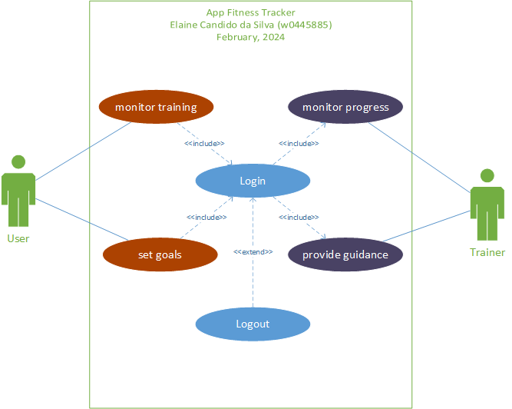

Figure 2

# Activity 4 Create two Use Cases for each actor.

1. Actors:

**User:** The individual who interacts with the fitness tracker app.

**Trainer:** A professional who guides users in achieving their fitness goals.

1. Use Cases for the User:

**Monitor Training:** The user can log various exercises (e.g., running, cycling, swimming) along with details like duration, distance, and intensity.

**Set Goals:** Users can set personalized fitness goals (e.g., steps per day, calorie burn, weight loss) within the app.

1. Use Cases for the Coach/Trainer:

**Monitor Progress:** Trainer can access aggregated data (e.g., workout frequency, heart rate trends) to tailor personalized advice.

**Provide Guidance:** Trainers can design workout plans based on individual user goals and fitness levels.

# Activity 5 Create two User Stories for each actor.

1. User Stories for the User:

**Use Case 1: Monitor Training**

* **User Story 1:** As a user, I want to track my running distance, time, and route using the GPS feature of the fitness tracker app, so that I can monitor my progress and set new goals.
* **User Story 2:** As a user, I want to log my daily calorie intake and output, so that I can maintain a balanced diet and achieve my fitness goals.

**Use Case 2: Set Goals**

* **User Story 3:** As a user, I want to set personalized fitness goals such as steps per day, active minutes, and calorie burn targets, so that I can work towards improving my overall fitness level.
* **User Story 4:** As a user, I want to receive notifications and reminders, so that I can stay on track with my fitness goals, such as reminders to drink water, take breaks, or complete workouts, to maintain consistency and motivation.

1. User Stories for the Trainer:

**Use Case 3: Monitor Progress**

* **User Story 5:** As a trainer, I want to access my clients' exercise logs and performance metrics, so that I can track their progress over time and provide personalized feedback and recommendations.
* **User Story 6:** As a trainer, I want to analyze trends in my clients' fitness data, so that I can identify areas for improvement and adjust their training plans accordingly to optimize their results.

**Use Case 4: Provide Guidance**

* **User Story 7:** As a trainer, I want to create and assign customized workout plans to my clients based on their fitness goals, preferences, and current fitness levels.
* **User Story 8:** As a trainer, I want to communicate with my clients through the app, providing them with real-time support, motivation, and guidance to help them stay committed to their fitness journey.

# References.

Admin. (2023, January 13). Use Case Template - 9+ Free Word, PDF documents download. template.net. Retrieved February 29, 2024, from <https://www.template.net/business/case-templates/use-case/>