Assignment 3

BALANCED SCORECARD AND KEY PERFORMANCE INDICATORS

Elaine Candido da Silva – W0445885 | DBAS2104 | March, 2024

Contents

Activity 1 LinkedIn Learning 2

Item 1 – Balanced Scorecard and Key Performance Indicators 2

Activity 2 Scenario evaluation. 3

Item 1 – Balanced Scorecard (BSC). 3

Item 2 – Key Performance Indicators (KPIs). 4

Item 3 – Integration. 5

References. 6

# Activity 1 LinkedIn Learning

## Item 1 – Balanced Scorecard and Key Performance Indicators

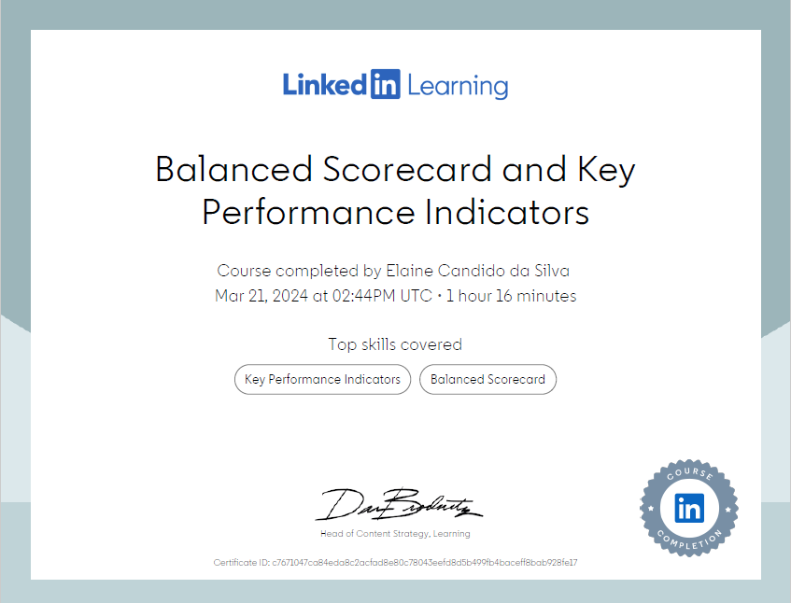

Figure 1

# Activity 2 Scenario evaluation.

## Item 1 – Balanced Scorecard (BSC).

The Balanced Scorecard (BSC) is a strategic management tool that helps organizations translate their vision and strategy into actionable objectives across four perspectives:

1. **Financial Perspective:** This perspective focuses on financial outcomes and measures the company's profitability, revenue growth, cost control, and return on investment (ROI). For GlobalMart, maintaining financial health is crucial for sustainability and growth.
2. **Customer Perspective:** Here, the emphasis is on understanding and satisfying customer needs and expectations. Metrics include customer satisfaction, retention rates, market share, and customer lifetime value. GlobalMart's success relies on delivering exceptional customer experiences both online and in-store.
3. **Internal Business Processes Perspective:** This perspective examines the internal processes and operations critical to delivering value to customers. Key metrics may include inventory turnover, order fulfillment speed, product returned, and supply chain efficiency. Efficient internal processes ensure timely delivery of products, contributing to customer satisfaction.
4. **Learning and Growth Perspective:** This perspective focuses on the organization's ability to innovate, learn, and adapt to changes. Metrics might include employee training hours, employee satisfaction, innovation rate, and employee turnover. GlobalMart's success depends on fostering a culture of innovation and continuous improvement among its employees.

## Item 2 – Key Performance Indicators (KPIs).

**a) Financial Perspective:**

1. **Revenue Growth Rate**: Measures the percentage increase in revenue over a specific period.
2. **Gross Profit Margin**: Indicates the percentage of revenue retained after deducting the cost of goods sold.
3. **Return on Investment (ROI)**: Calculates the efficiency of investments by comparing net profit to the initial investment.

**b) Customer Perspective:**

1. **Customer Satisfaction Score (CSAT)**: Measures customer satisfaction levels through surveys or feedback.
2. **Net Promoter Score (NPS)**: Evaluates customer loyalty and likelihood to recommend the brand to others.
3. **Market Share**: Assesses the company's portion of total sales within its industry or market segment.

**c) Internal Business Processes Perspective:**

1. **Inventory Turnover Ratio:** Reflects how quickly inventory is sold and replenished within a given period.
2. **Order Fulfillment Cycle Time:** Measures the time taken from order placement to delivery.
3. **Product Returned Rate:** Tracks the percentage of products that are returned by customers due to dissatisfaction, defects, or other reasons.

**d) Learning and Growth Perspective:**

1. **Employee Training Hours:** Measures the investment in employee skill development and knowledge enhancement.
2. **Employee Satisfaction Index:** Gauges employee morale and engagement levels through surveys.
3. **Innovation Rate:** Tracks the frequency and success of new ideas implemented within the organization.

## Item 3 – Integration.

The BSC and KPIs work together to provide a comprehensive view of GlobalMart's performance:

1. The BSC ensures a balanced approach by considering financial, customer, internal processes, and learning/growth aspects.
2. KPIs within each perspective offer specific metrics to measure progress toward strategic objectives.
3. By aligning KPIs with strategic goals, GlobalMart can monitor performance, identify areas for improvement, and make informed decisions.
4. Regular review of KPIs enables GlobalMart to adapt strategies, allocate resources effectively, and drive continuous improvement across all facets of the business.
5. Integration of the BSC and KPIs fosters a holistic understanding of performance, facilitating strategic alignment and sustainable growth for GlobalMart.

# References.

Improve using a balanced scorecard | Made to Measure KPIs. (2023, July 8). Made to Measure KPIs. Retrieved March 25, 2024, from https://madetomeasurekpis.com/improve-using-balanced-scorecard-bsc/#:~:text=The%20balanced%20scorecard%20approach%20is,that%20are%20important%20to%20the