Assignment 4

BUSINESS PROCESS MODELING

Elaine Candido da Silva – W0445885 | DBAS2104 | March, 2024

Contents

Activity 1 LinkedIn Learning 2

Business Analysis Foundations: Business Process Modeling 2

Activity 2 Scenario evaluation. 3

Employee Onboarding. 3

Macro steps. 3

Context Diagram. 4

Functional Flow Diagram. 5

Cross-Functional Flow Diagram. 6

References. 7

Figure 1 2

Figure 2 4

Figure 3 5

Figure 4 6

# Activity 1 LinkedIn Learning

## Business Analysis Foundations: Business Process Modeling



Figure 1

# Activity 2 Scenario evaluation.

## Employee Onboarding.

I chose the process of onboarding a New Employee because it is a relatively well-known process. I have participated in the setup of new employees or third parties and have experienced difficulties when a process is not well designed or does not flow properly.

Although the assignment requirements didn't ask for more than one type of diagram, I thought it appropriate to draw the first three, as the course suggests starting from the beginning, i.e. understanding the context.

Initially, the onboarding process begins when the selection process ends. Therefore, all the steps in the selection process should be drawn in separate diagrams.

## Macro steps.

1) After the department has selected a particular candidate, the manager fires off a request to hire a new employee.

2) The Human Resources department sends a job offer to the selected candidate.

3) If the candidate refuses, the system sends an email thanking them for taking part in the selection process and the process ends.

4) If the candidate accepts, a new employee registration request is opened with IT Operations. To simplify the process, at this point HR already has the new employee's details, such as bank account, ID and other information.

5) The system sends the credentials, setup instructions and internal policies for the new employee to read and sign.

6) After receiving the signed policies, IT Operations closes the new employee registration request.

7) HR receives notification that the request has been closed and, in parallel, notifies the department manager and sends an onboarding invitation and contract for the new employee to sign.

8) HR must receive the signed contract before the onboarding event.

9) The onboarding is an event attended by the invited new employees and the managers of the target areas.

10) Onboarding is an event with specific steps mapped out in separate diagrams.

## Context Diagram.

The context diagram illustrates the relationship between the organization and external agents. It may not have been necessary in this context, but it was used for academic purposes.

The external agents used in this diagram were:

**Employee:** in this context would still be a candidate for the job. He only becomes an employee after accepting the job offer.

**Bank:** represents the intermediary agent for remitting payment to the future employee.

**Government:** represents the agent to whom both the employee and the organization must be accountable in tax terms.

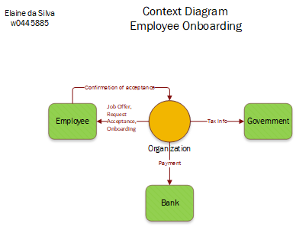

Figure 2

## Functional Flow Diagram.

The Functional Flow Diagram illustrates the interactions between the functional areas in the organization. In other words, how information and activities flow through the departments. As well as who performs and owns them.

In this flow, in addition to the **New Employee**, the HR department, IT Operations and the target department have been added.

**HR**: orchestrator of the onboarding process.

**IT Operations**: responsible for registering and setting up the new employee on the internal computer network.

**Target department**: this is the department that triggered the process of hiring the new employee and where the employee will be allocated after the onboarding process.

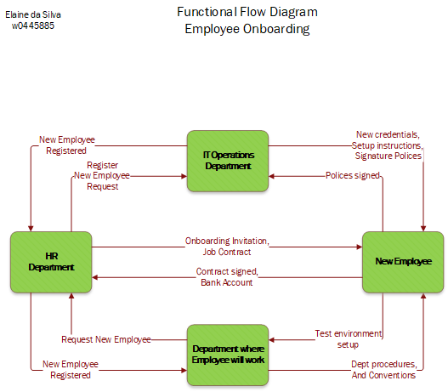

Figure 3

## Cross-Functional Flow Diagram.

The Cross-Functional Diagram shows the order of the activities in the flow. Each entity identified in the **Functional Flow Diagram** becomes a lane in this diagram.

This mapping helps to identify bottlenecks and critical points in the process. As well as identifying the activities that will be kept, removed, added, or changed.

Figure 4

# References.

* Camunda. (2024, February 7). Real-world BPMN 2.0 examples and answers to common questions. | Camunda. Retrieved March 27, 2024, from https://camunda.com/bpmn/examples/
* ConceptDraw Samples | Business Processes — BPMN diagrams. (n.d.). Retrieved March 27, 2024, from https://www.conceptdraw.com/samples/business-process-model-notation