Assignment 1

Time Management by dave crenshaw

Elaine Candido da Silva – W0445885 | ICOM2701 | January, 2024

Contents

Activity 1-1 Installing Windows 10 1

PART A 1

Item 6 2

PART B 2

Item 6 2

Activity 1-2 Switching Between Applications 3

# Activity 1-1 Installing Windows 10

Be sure to include the title of the lab in the heading. The main documentation for each activity should be listed here. Consider using lists if multiple steps are required:

1. Did a thing.
2. Nothing happened?

* I tried rebooting

1. Oh… I see. Something happened now!

## PART A

Took a screenshot:

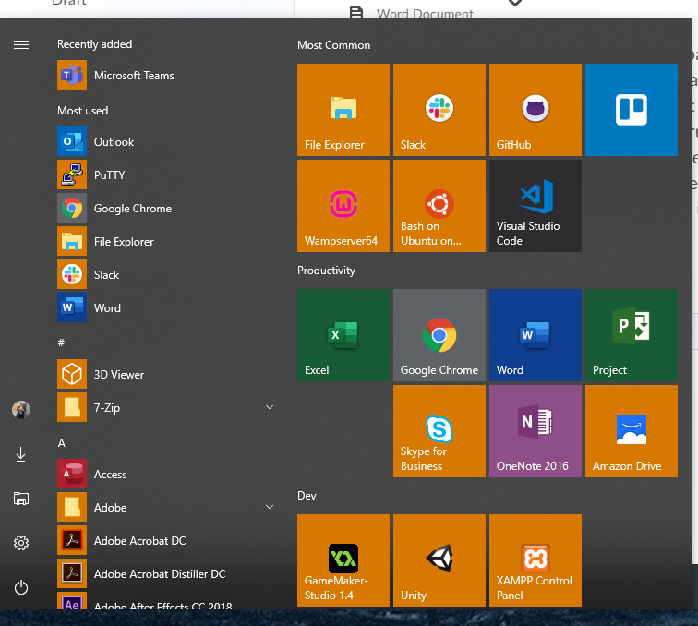

Note: This menu is cluttered.

## Item 6

## PART B BCV jvxcjvxcjvlc

## Item 6

Second section of the activity goes here!

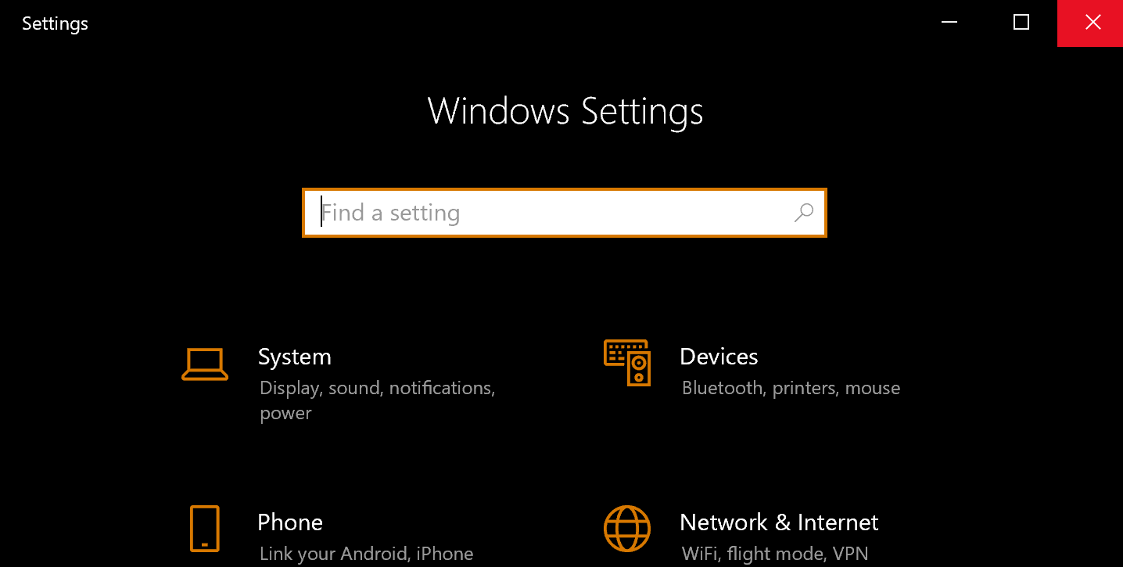

# Activity 1-2 Switching Between Applications

1. Next thing… Check!
2. More things done!