Assignment 1

CLIENT-SIDE PROGRAMMING

Elaine Candido da Silva – W0445885 | PROG2700 | January, 2024

Contents

Activity 1 – Basic JavaScript on Freecodecamp.org 2

PART A 2

Activity 2 – Collection of mini-JavaScript programs 3

Question 1 3

Code 3

Browser 5

Question 2 6

Code 6

Browser 8

Question 3 9

Code 9

Browser 10

Question 4 11

Code 11

Browser 13

References 13

# Activity 1 – Basic JavaScript on Freecodecamp.org

## PART A

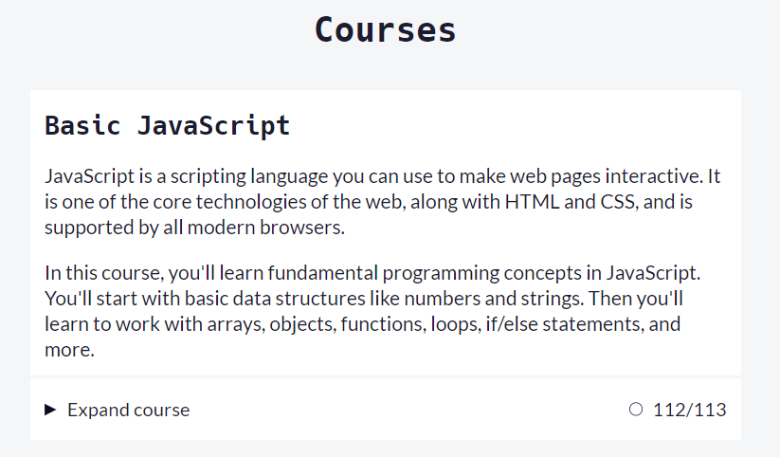

As I showed in class, I finished the exercise, but one question was not validated by the platform. The image below demonstrates that.

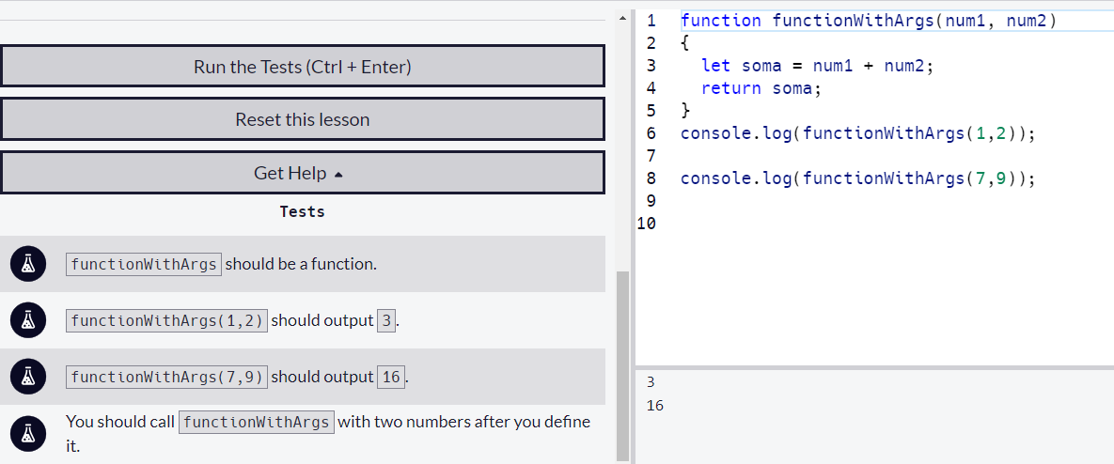

# Activity 2 – Collection of mini-JavaScript programs

## Question 1

Write a function in JavaScript that will receive a string as a parameter and then perform the following:

* You don’t have to prompt for a string. Simply assign a string to a variable in your code as your starting point to use as an argument for your function.
* If the first and last characters of the string are the same (ignoring case), the function will return the string in reverse order. Otherwise, the function will return the string with the first and last letters removed.
* Example: “Triscuit” returns “tiucsirT” but “Cracker” returns “racke”.

## Code

/*

Author: Elaine Candido da Silva

Date: 1/18/2024

Description: Write a program that get a string and do the follow:

    1. If the first and the last letter are the same,

       write the string in the reverse order;

    2. If the first and the last letter NOT are the same,

        remove the first and the last letters

*/

// Variables declaration

let myString = 'Elaina';  //My string

// Processing and Calculation

let tempString = checkString(myString);

// Output

console.log("My string before running the program: "+myString);

console.log("My string after running the program: "+tempString);

// function to check if the string begin and finish with the same letter

function checkString(nameString)

{

//    let stringSize = myString.length;   // getting the string size

    let tempString = "";                // variable to store the string after processing

    let firstLetter = myString[0];      // get the first letter of the string

    let lastLetter = myString[myString.length-1]; // get the last letter of the string

    if (firstLetter.toLowerCase() == lastLetter.toLowerCase())

    {

    // loop to replace the position of the letter in the string

    // consider the string as an array of letters

    // start the loop from the end to begin to reverve the letter in the array

    for (let i=myString.length-1; i>=0; i--) {

        tempString += myString[i];

    }

    } else {

    // removing the first and last letters when they are equals

       tempString = myString.slice(1, -1);

}

    return tempString;

}

## Browser

Running the code with a name starting and finishing with different letters.

Running the code with a name starting and finishing with same letters.

## Question 2

Write a function in JavaScript that will return the sum of the longest streak of consecutive increasing numbers within an array.

* If there are no consecutive numbers in the array, the function will return zero.
* If there are multiple instances of the same number of consecutive numbers (increasing by 1) in the array, the function will return the largest sum calculated between all instances.
* Examples:
  + [1, 2, 3, 6, 9, 34, 2, 6] would return 6 *(1+2+3)*
  + [3, 2, 7, 5, 6, 7, 3, 8, 9, 10, 23, 2, 1, 2, 3] would return 27 *(8+9+10)*
  + [100, 101, 102, 3, 4, 5, 6, 9] would return 18 *(3+4+5+6)*

## Code

/*

Author: Elaine Candido da Silva

Date: 1/18/2024

Description: Write a program that get a string and do the follow:

    1. If the first and the last letter are the same,

       write the string in the reverse order;

    2. If the first and the last letter NOT are the same,

        remove the first and the last letters

*/

// Variables declaration

let myArray = [1,2,3,4,5,45,46,47,7,8,9,10];

let tempArray = [];

let initialNumber;

let sumNumber = 0;

// Processing and Calculation

initialNumber = myArray[0]; // store the first num of the array

sumNumber = myArray[0]; // store the first num of the array to start the sum

// starting the loop by the second number of the array

for (let i=1;i<myArray.length;i++) {

    if (myArray[i] == initialNumber + 1) {

        sumNumber += myArray[i]; //summing each sequencial number

        //always replace the initial number by the next one into the array

        initialNumber = myArray[i];

    } else {

        tempArray.push(sumNumber); // adding the sum calculation into the tempArray

        sumNumber = myArray[i]; //summing each sequencial number

        //always replace the initial number by the next one into the array

        initialNumber = myArray[i];

    }

}

    // adding the last sum calculation into the tempArray

    tempArray.push(sumNumber);

    // loop to get the biggest number in the array

    initialNumber = tempArray[0]; // initialize the variable with the first number of the array

    for (i=0; i<tempArray.length;i++) {

        if (tempArray[i] > initialNumber) {

            initialNumber = tempArray[i];

        }

    }

// Output

console.log(tempArray);

console.log(initialNumber);

## Browser

## Question 3

Write a JavaScript program to calculate the number of weeks, days, hours, minutes and seconds left until midnight on your birthday.

* The script does not have to prompt for your birthdate. Simply assign it to a variable and start from there.
  + Ex: var myNextBirthday = *…your code here*
* Expected sample output (console.log()):
  + There are 35 weeks, 3 days, 13 hours, 25 minutes, and 12 seconds until my next birthday!

## Code

/*

Author: Elaine Candido da Silva

Date: 1/19/2024

Description: Calculate how many weeks, days, hour, minutes, and seconds for the next birthday:

*/

// function to calculate the interval btween today and my aniversary

function calcTimeToAniver(aniverDate) {

// Variables declaration

    let currentDate = new Date();            // Current date

    let targetDate = new Date(aniverDate);   // Target date

    // Calculate the time difference in milliseconds

    let timeDiff = targetDate - currentDate;

    // Convert milliseconds to weeks, days, hours, minutes, and seconds

    let weeks = Math.floor(timeDiff / (1000 * 60 * 60 * 24 * 7));

    let days = Math.floor((timeDiff % (1000 * 60 * 60 * 24 * 7)) / (1000 * 60 * 60 * 24));

    let hours = Math.floor((timeDiff % (1000 * 60 * 60 * 24)) / (1000 * 60 * 60));

    let minutes = Math.floor((timeDiff % (1000 * 60 * 60)) / (1000 * 60));

    let seconds = Math.floor((timeDiff % (1000 * 60)) / 1000);

    return {weeks, days, hours, minutes, seconds };

  }

// Processing and Calculation

// Set date to July 5, 2024

let aniverDate = '2024-07-05T12:59:59';

let timeToAniver = calcTimeToAniver(aniverDate);

// Output

/*

console.log(`Weeks: ${timeToAniver.weeks}`);

console.log(`Days: ${timeToAniver.days}`);

console.log(`Hours: ${timeToAniver.hours}`);

console.log(`Minutes: ${timeToAniver.minutes}`);

console.log(`Seconds: ${timeToAniver.seconds}`);

*/

console.log(' ');

console.log(`There are ${timeToAniver.weeks} weeks, ${timeToAniver.days} days, ${timeToAniver.hours} hours, ${timeToAniver.minutes} minutes, and ${timeToAniver.seconds} seconds until my next birthday!`);

console.log(' ');

## Browser

## Question 4

Write a JavaScript program to iterate through an array of ten (10) positive randomly generated numbers. Each number will then be checked to see if it’s a prime number.

* Sample Expected output (console.log()).

23-yes, 15-no, 22-no, 124-no, 11-yes, 9-no, 2-yes, 13-yes, 5-yes, 1-no

## Code

/*

Author: Elaine Candido da Silva

Date: 1/18/2024

Description: Generate randomly 10 positive numbers and check if they are prime or not.

By definition, a prime number is a positive integer divisible only for itself and 1

*/

// function to get if the number is prime or not

function isPrime(number) {

    if (number <= 1)  // 1 or below are not prime number

    {

        return false;

    } else if (number === 2) //the only even number which is prime

    {

        return true;

    }

    for (let i= 2; i < number; i++)

    { // Check if "number" is divisible by i without a remainder, it is not a prime number

     if (number % i === 0)

     {

        return false;

      }

    }

    // If number is only divided by itself and 1, it is a prime number

    return true;

    }

// Variables declaration

let numArray = [];

let resultIsPrime;

// Processing and Calculation

// Generate the 10 positive random numbers up to 100

for (let i=0; i<10; i++)

{

    let randomInteger = Math.floor(Math.random() * 100);

    numArray[i] = randomInteger;

}

// Output

console.log(numArray);

console.log("");

for (let i=0; i<numArray.length; i++)

{

    resultIsPrime = isPrime(numArray[i]);

    if (resultIsPrime)

    {

        console.log(`Number ${numArray[i]} is Prime!`);

    } else

    {

        console.log(`Number ${numArray[i]} is no Prime!`);

    }

}

## Browser

## References

(JavaScript Tutorial, 2024)

(An algorithm a day : How to check for a prime number in JavaScript, 2020)

(JavaScript: Check a number is prime or not, 2023)