Tutorial Software PolMFM for Data analysis PolMFM
Data to download: Download the folder 0 – DATA_Tutorial from the Zenodo Repository 10.5281/zenodo.22043565
Unzip and add the dataset folder to the main folder Software_PolMFM.
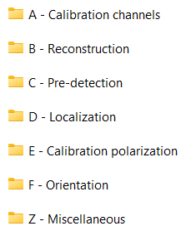
Script to run: Pipeline_PolMFM.mat, located in the folder Software_PolMFM.
The script is divided into 6 sections from A to F, calling sub-functions located in the corresponding subfolders. You are advised to run the script section by section (keyboard shortcut Ctrl+Enter).
While running the script, instruction windows will appear; read each message carefully and click OK when ready to continue. Although the script can be run by following the on-screen instructions alone, a short tutorial summarizing the main steps is provided below.
Requirements: the following MATLAB toolboxes must be installed:
- 'Signal Processing Toolbox'
- 'Image Processing Toolbox'
- 'Statistics and Machine Learning Toolbox'
- 'Curve Fitting Toolbox'
- 'Parallel Computing Toolbox'
- 'MATLAB Parallel Server'
- 'Polyspace Bug Finder'

%% Initialization : Specify file name and path
- Run the Initialization cell and select the folder Software_PolMFM.
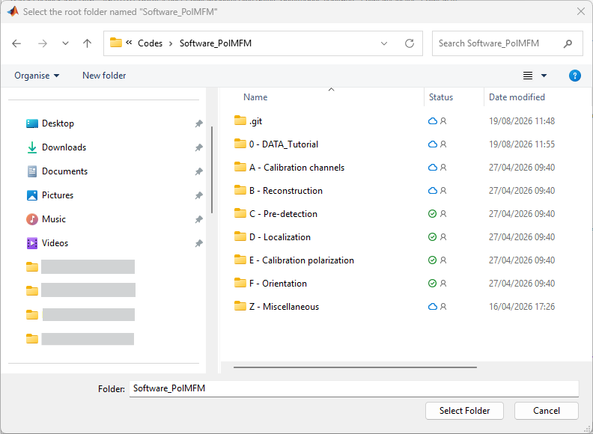
- If you want to analyze another acquisition, modify the file_data/ path_data names.

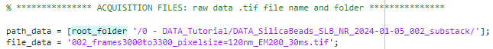

- If you want to use another calibration file, modify the file_calib/path_calib, file_calib_int/path_calib_int and path_calib_polar/file_calib_polar names.
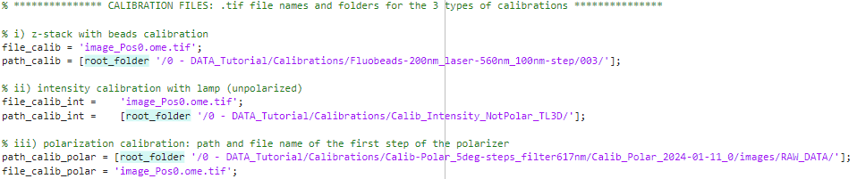
%% A - Calibration channels : build the calibration matrices

- Calibration of channel distortions: runs calib_distorsion_channels_superlocver_v2 to i) register the channels with respect to each other (translation/rotation/distortion) and ii) calculate the z spacing between the three focal planes. The input image file_calib is a z-scan of fluorescent TetraSpeck beads with a 100 nm z step.

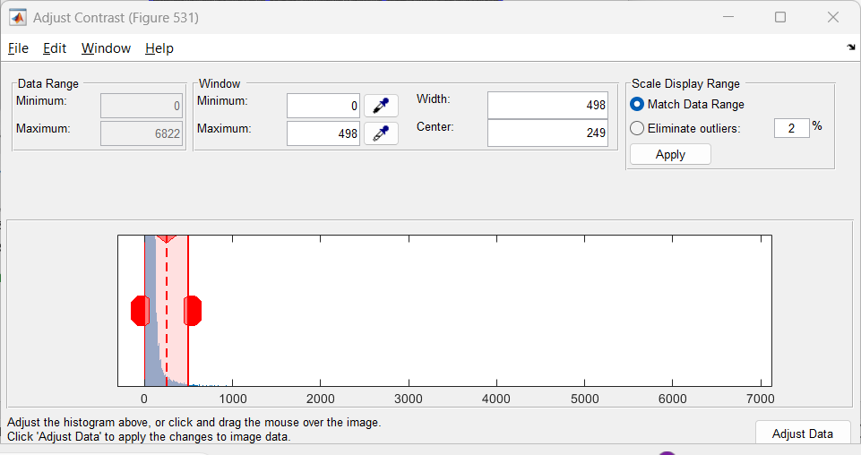
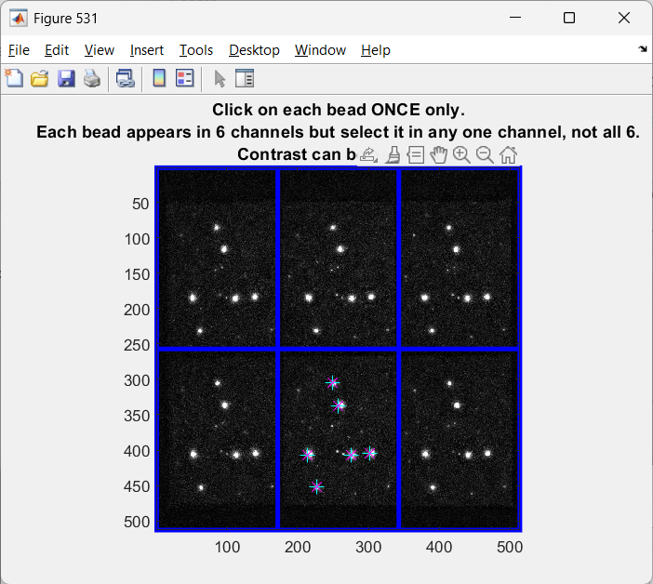
  - Select the beads with the mouse. Select each bead once only; do not select the duplicates visible in the other channels. Press Enter when done.
You can adjust the contrast of the image with the Adjust Contrast window that appears a few seconds after the image.

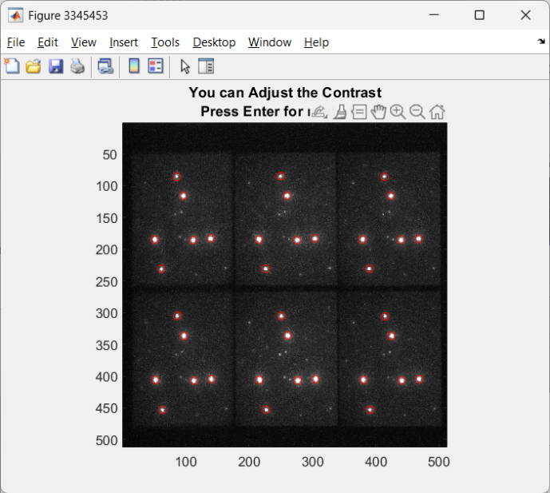
  - The next figure shows the beads you pre-selected found in all the channels of the PolMFM. Click enter to go for next step.

If you are not happy with the beads you selected, you can go back to step a. (bead selection) by choosing ‘No’ at the question.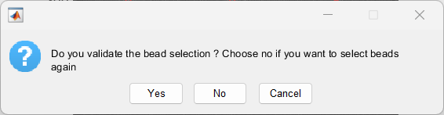
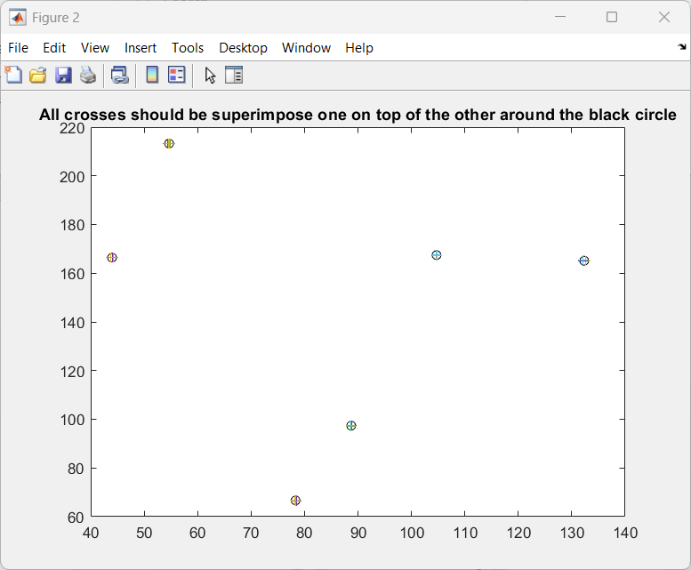
  - If the crosses (corresponding to each channel) do overlap over the black circles, it means that the registration of the channels has been properly done.
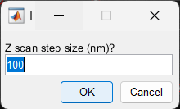
  - Enter the Z scan step size. In the data provided in the tutorial, it is 100 nm.

  - The code fits a Gaussian to the bead intensity profile along the z-scan, for each bead in each channel, to determine the best-focus position of each channel. The inter-channel z distances are then extracted by linearly fitting the channel positions across beads. A summary of the fits is displayed, both per bead and across all beads. The average z separation is reported in the Command Window (e.g. "the total average separation is 379.9632 nm"). Note this value, as it will be needed in section C. It is also saved automatically to a text file in the same folder as the calibration z-stack acquisition.
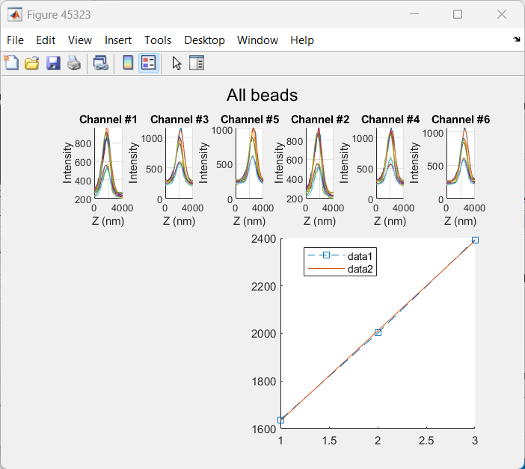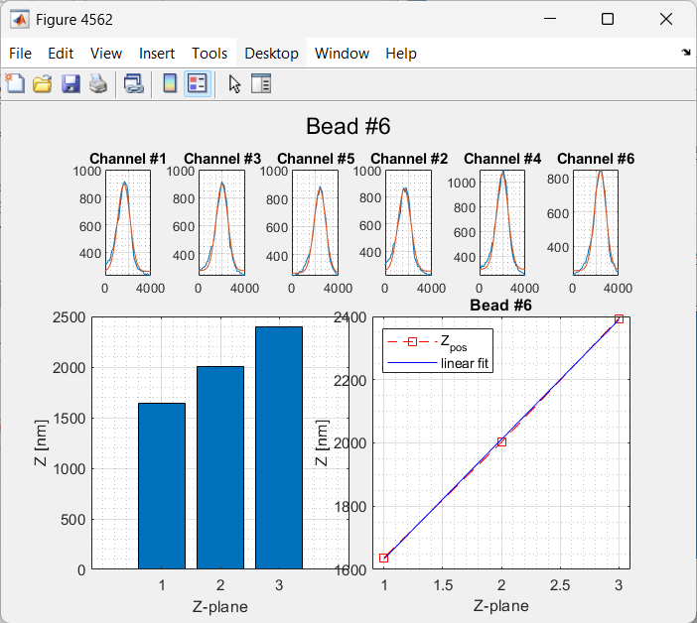
- The function calib_intensity_correction picks the mean intensity value of each channel and the background value (top-left corner of the image) to correct for intensity disparities between channels.
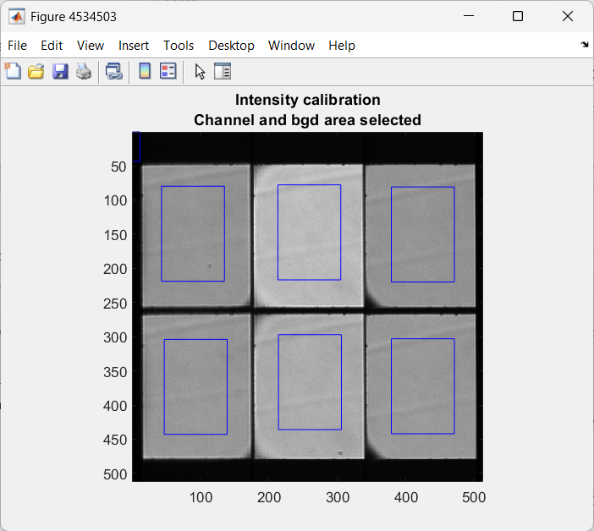
%% B - Reconstruction
This section builds one .tif 6-channel stack per frame of the raw acquisition. Each new .tif contains all channels aligned to a reference channel and corrected for intensity using the calibration performed in A. The folder containing the reconstructed .tif stacks is in the folder "path_data" and its name ands with “_reco”.
%% C - Pre-détection + D - Localization
This section performs the 3D localization of the molecules using a 3D Gaussian fitting algorithm.
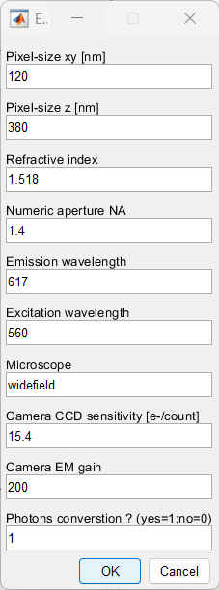
- First, do provide the microscope parameters. Here you can enter the z separation between the channels found in section A, specified as the pixel size z [nm]. The pre-defined parameters for pixel size, wavelength and camera are the correct ones corresponding to the data in the tutorial. To convert intensities to photon counts using the camera parameters, set the "Photon conversion?" parameter to 1.

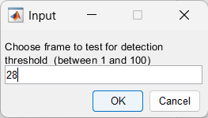
- Now we enter the molecule pre-detection step. The pre-detection threshold and image filtering parameters can be tested and adjusted on individual frames. First, select a frame number:
- You can then adjust the filtering of the image for pre-detection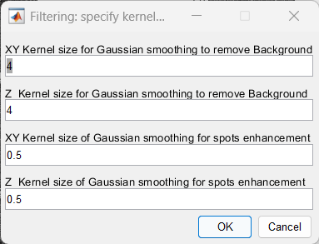
- The figure shows: on the left, the 3D stack of the raw data; on the right, the filtered maximum-intensity projections (XY top, XZ bottom) with pre-detected molecules overlaid. Press Enter and choose whether to validate the (default) threshold value (Select Yes) or change the value (No). If you select No, you will be asked to enter a new threshold value and the pre-detected molecules (red circles) will be updated accordingly.
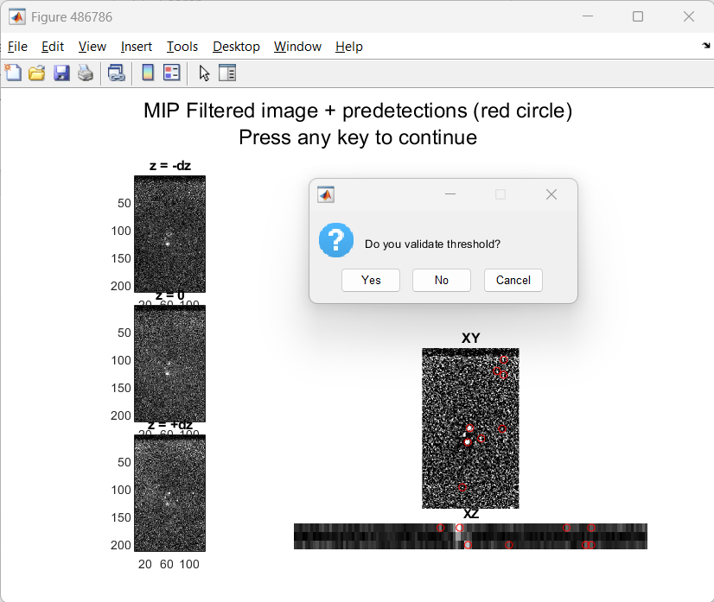

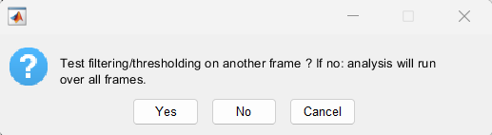
- If yes, the next window will ask whether you want to test the filtering and thresholding parameters on another frame (i.e. go back to step 2) or proceed (i.e. run pre-detection and 3D localisation on all frames).

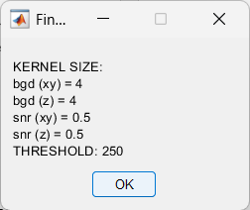
- The next window summarizes the parameters than you chose. Wait for the processing of the 3D Gaussian fitting to complete.
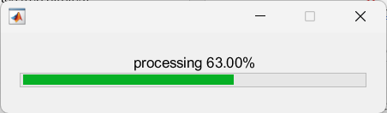

%% D bis - optional: display localizations
This section can show a preview of the localisations (3D scatter plot) and orientations (colour-coded).
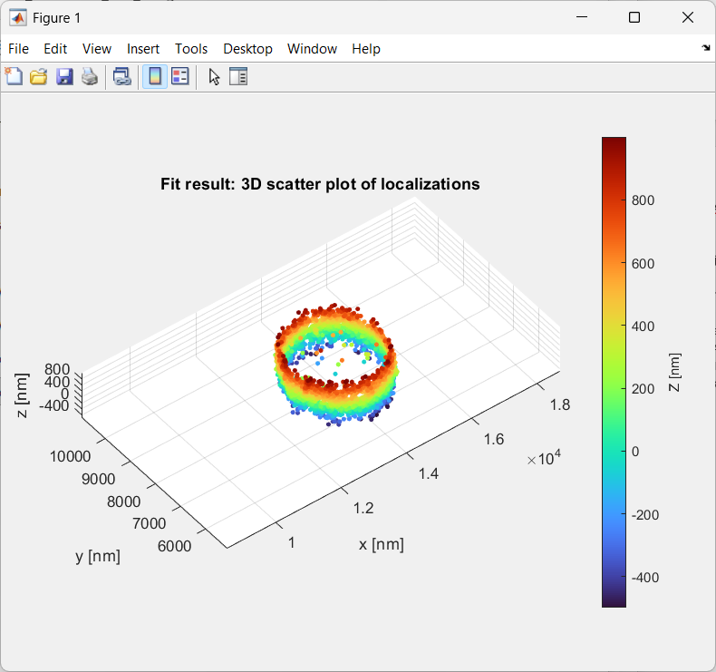
%% E - Calibration polarization
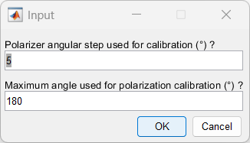
This section will create the 2nd order dipole moment matrix "K" used later to retrieve orientation parameters from the molecule intensity in each channel. It uses a polarization calibration dataset located in "Codes\DATA_Tutorial\Calibrations\Calib-Polar_5deg-steps_filter617nm". This dataset consists of intensity images acquired by illuminating the field of view with a white lamp through a polarizer placed at the sample plane, recorded at various polarization orientations. In this tutorial, polarization calibration images were acquired from 0 to 180° in steps of 5°. Each subfolder "Calib_Polar_2024-01-11_n" corresponds to one step (index "n" corresponds to a 5° increment here). The polarizer step size and maximum angle are specified in the following window:
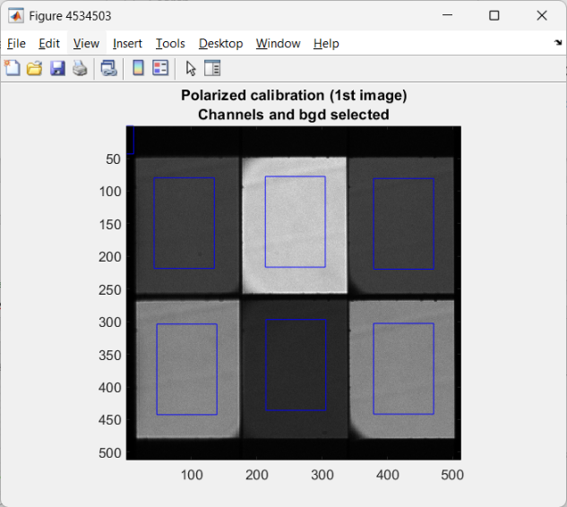
The code then selects the field of view of each channel of the MFM and a small background area (square at the top left-hand side of the image).

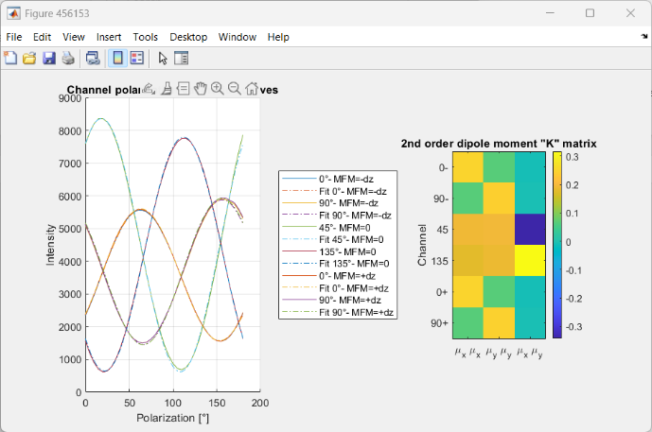
The code then fits the polarized intensity of each channel (left) to build the K matrix coefficients (right).

%% F - Orientation
This section computes the orientation of each molecule: from the localizations found in D, it goes back to the raw data images (find_spots_channels), computes the intensity of each molecule in each channel (find_intensity_spots_v2) and retrieves the corresponding orientations using the K matrix (orientation_retrieval_matrix).

%% F-bis (Optional) Scatter plot of the locs and orientations (color-coded)
This section can show preview of the localizations (3d scatter) and orientations (color-coded). Filtered localizations (with poor sigma or delta values) are shown in grey. 