**Michael Malka**

**Terraform Task:**

Terraform apply

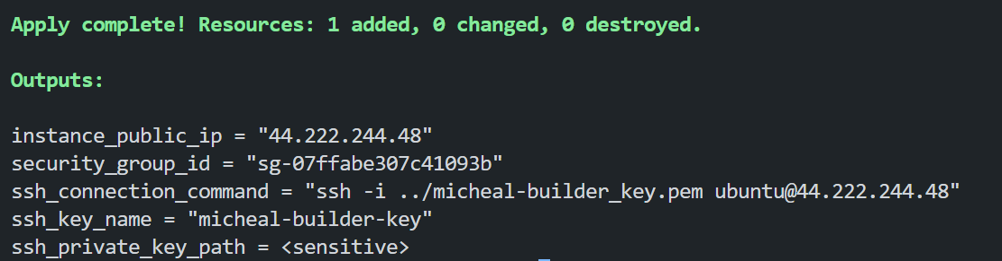

Terraform output -json > terraform_outputs.json

{

  "instance_ip": {

    "sensitive": false,

    "type": "string",

    "value": "44.204.165.207"

  },

  "security_group_id": {

    "sensitive": false,

    "type": "string",

    "value": "sg-0fac69a7d65af70c8"

  },

  "ssh_command": {

    "sensitive": false,

    "type": "string",

    "value": "ssh -i ./michael-builder-key.pem ubuntu@44.204.165.207"

  },

  "ssh_key_location": {

    "sensitive": false,

    "type": "string",

    "value": "./michael-builder-key.pem"

  }

}

Docker

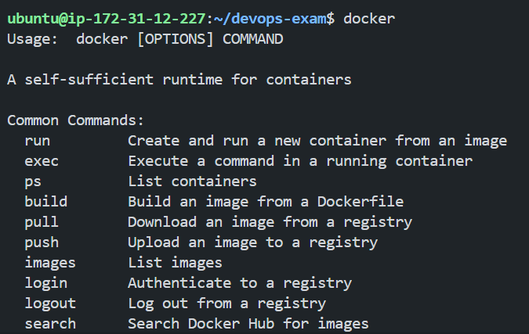

Docker compose

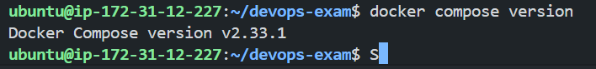

Security Group Validation:

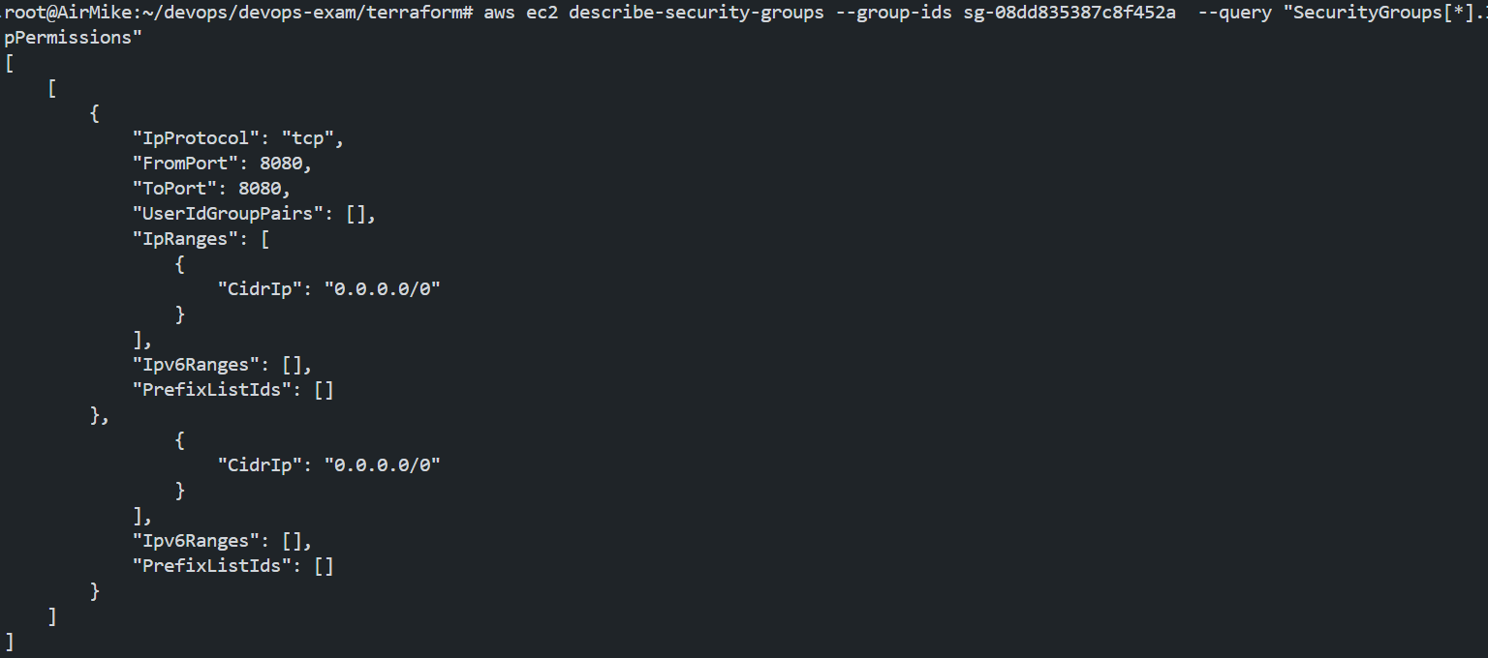

Git log –-graph

#after merging the terraform feature branch

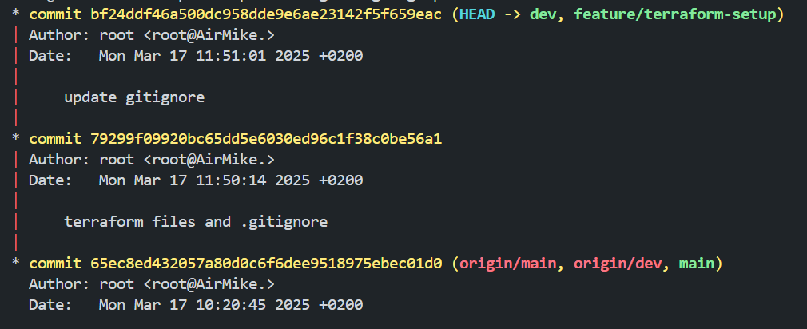

**ssh -i ./michael-builder-key.pem ubuntu@54.236.59.109**

**docker task**

**http://54.236.59.109:5001/**

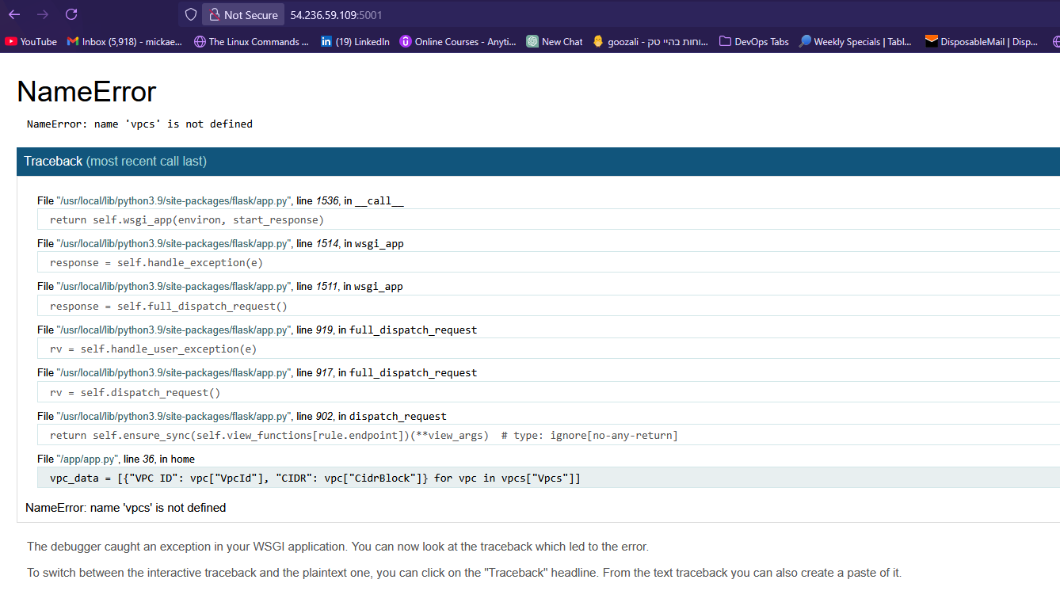

**Debugging and Fixing a Bug in the Application**

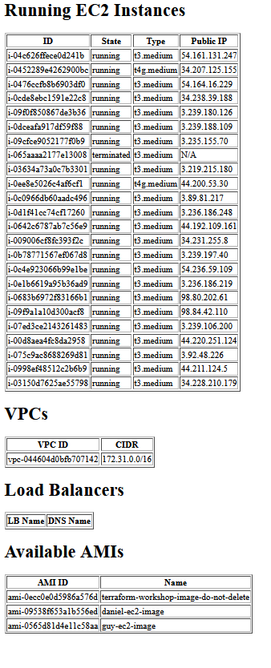

**CI/CD Integration with Jenkins**

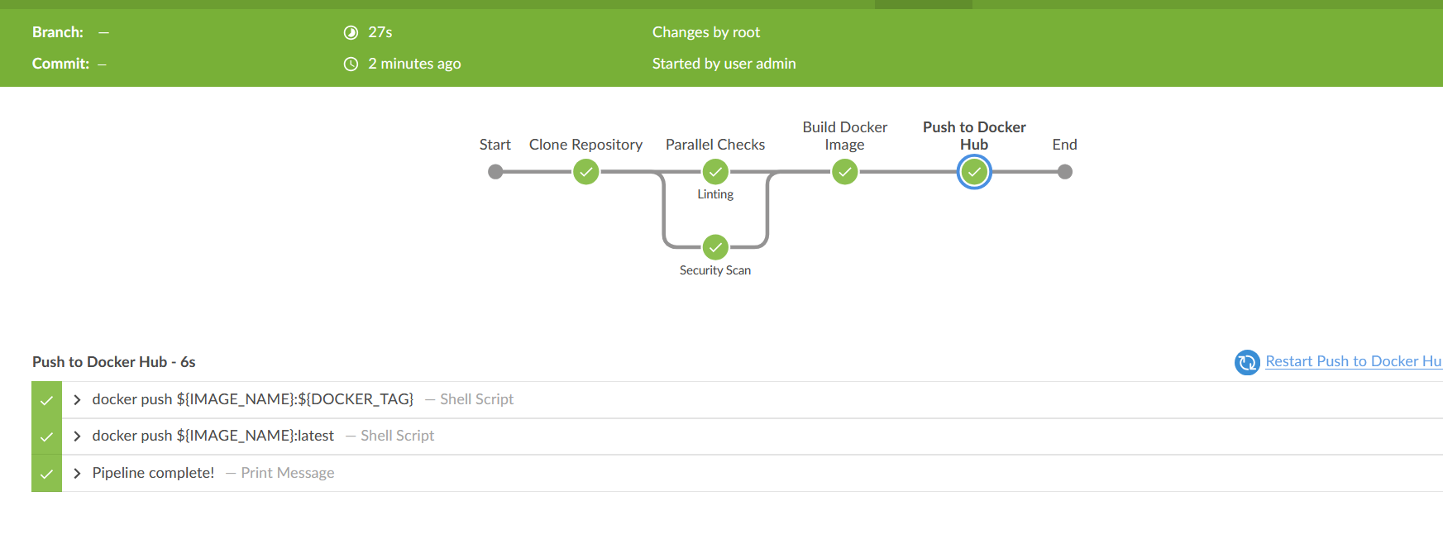

ש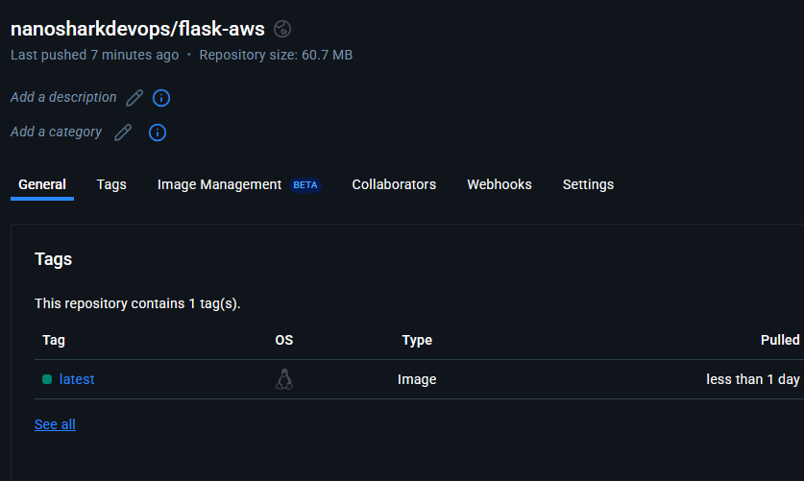

Azure pipeline:

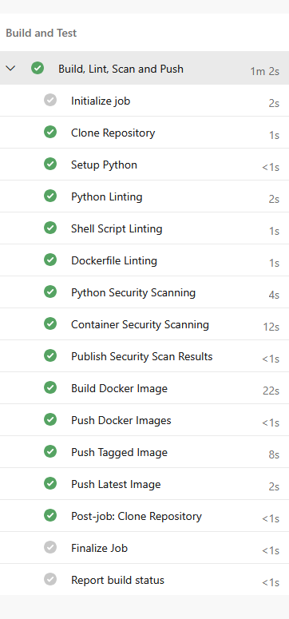

Kubernetes

