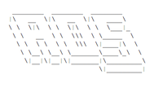

README

WHAT THIS IS

AOS is an open-source, python-made OS made by Nanobot567. If you are worried about your system getting hacked, I have Included some comments in the code explaining what is going on.

AOS will need to be run in a python launcher. Details are below.

AFFILIATIONS

AOS isn’t affiliated with anything and it’s going to stay that way. AOS is a project of mine that is just for fun.

WHY I AM DOING THIS

I’m doing this because I needed a long-term project to work on. I’m not going to use this to make any money and this will never be a paid-for OS.

QUESTIONS

If you really have the need to contact me, please do so on my blog. I won’t give away my email unless I absolutely have to.

GETTING STARTED

If you are going to use AOS, you have two options as to where to run it.

1. Download the Python IDLE and programming language by clicking [here.](https://www.python.org/downloads/)
2. Use a website that can run Python code. I suggest <https://repl.it/languages/python3>.

To run in the python IDLE, download AOS 1.1 and double click it. If a window pops up with the code, you’re on the right track.

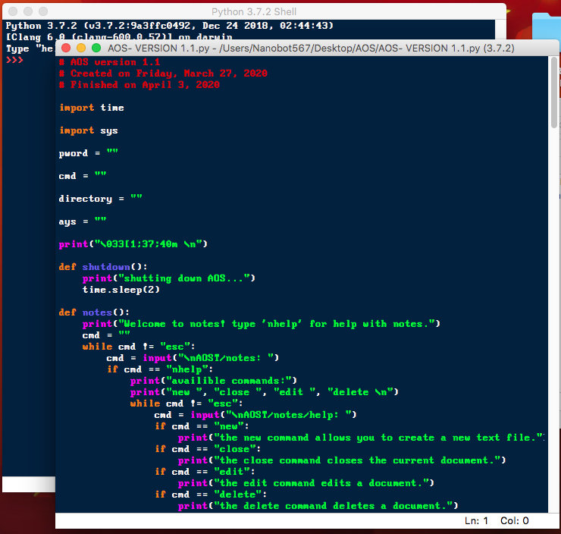

Then click on Run, then run module.

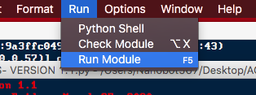

And there you go! I believe that other operating systems work this same way.

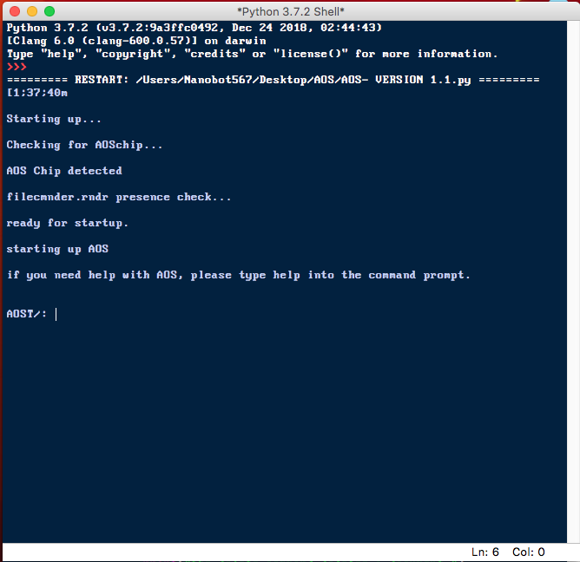

To run in <https://repl.it/languages/python3>, just copy-paste the code into the white box. (On Mac, ⌘C then ⌘V. On Linux and Windows, Ctrl-C then Ctrl-V)

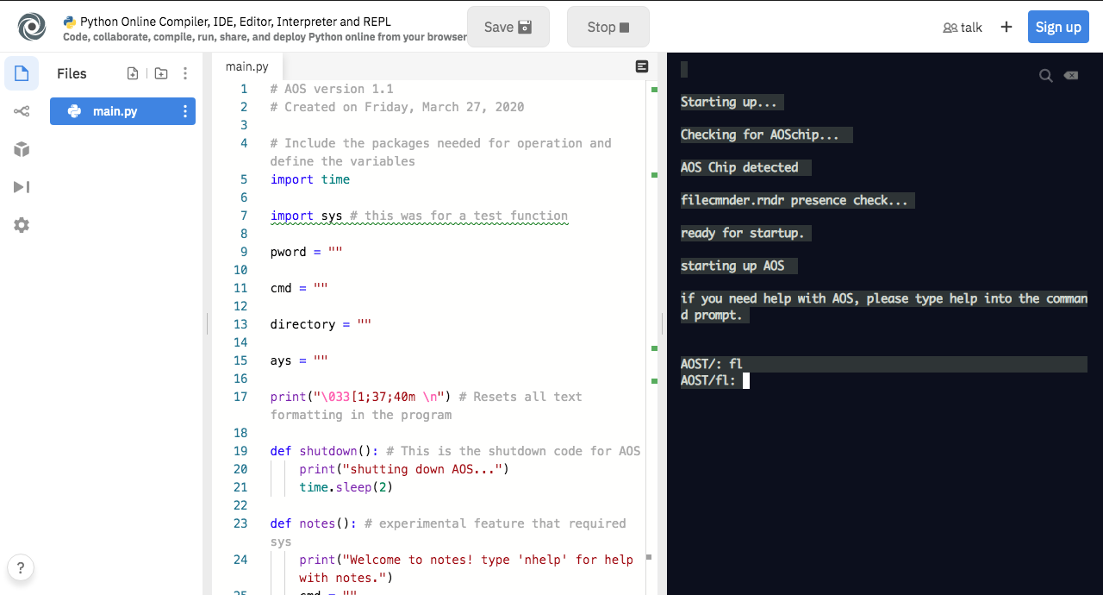

There you have it! If you have any questions or comments, please tell me on my blog.