**Occlusion Filling – Testing results**

By: Wen De Zhou

Stu#: 1001713274

Note: this assignment along with its images and decencies are too big for MarkUs. Thus this will be posted on GitHub: <https://github.com/Nanofortress/veryhiddennameidontknowthisnamecsc420projectbywendezhou.git>

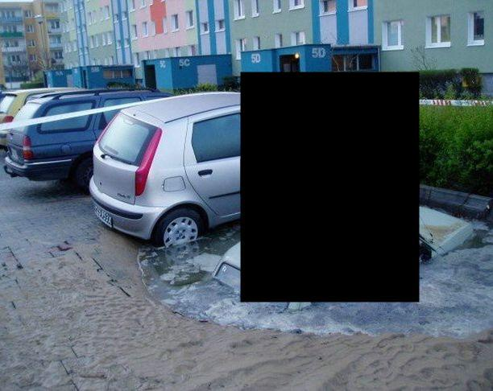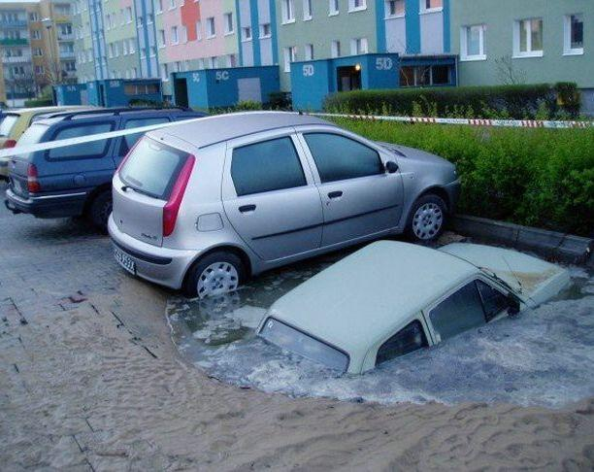This document was to evaluate the result of the occlusion filling algorithm in a controlled environment. This can be achieved by finding the average manhattan distance (color) of each filled pixels in comparison with the original image (labeled by test in the code).

Source image, with occlusion

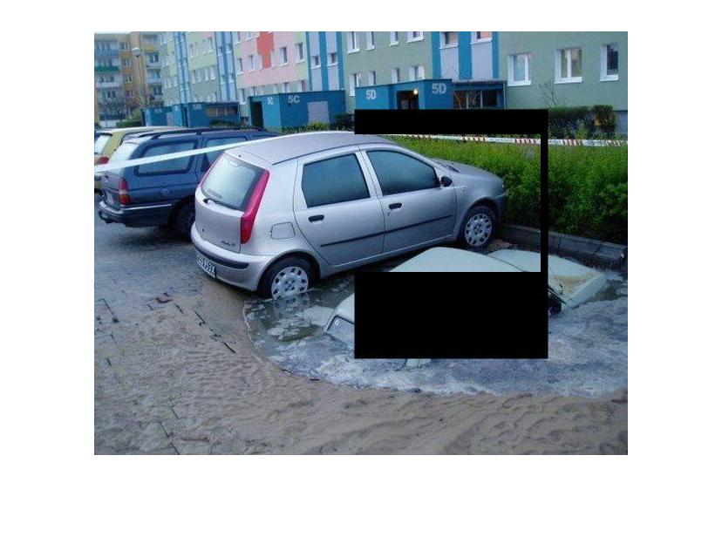

Result of occlusion filling

Data image, without occlusion

In this scenario, the result show 0, indicating that for each pixels projected from data image to the source image, it matches exactly as its original testing image (basically the same as source image except without occlusion).

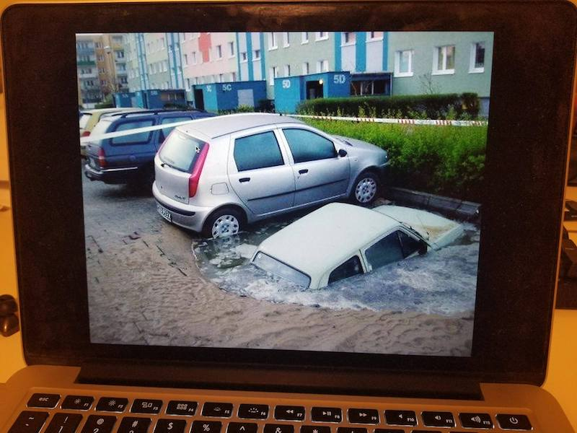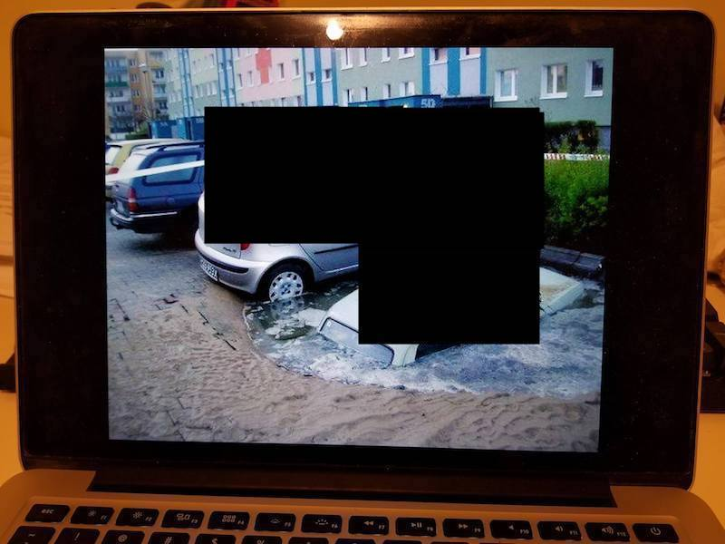Even in a more realistic simulated environment this algorithm still performs very well.

Source image, with occlusion

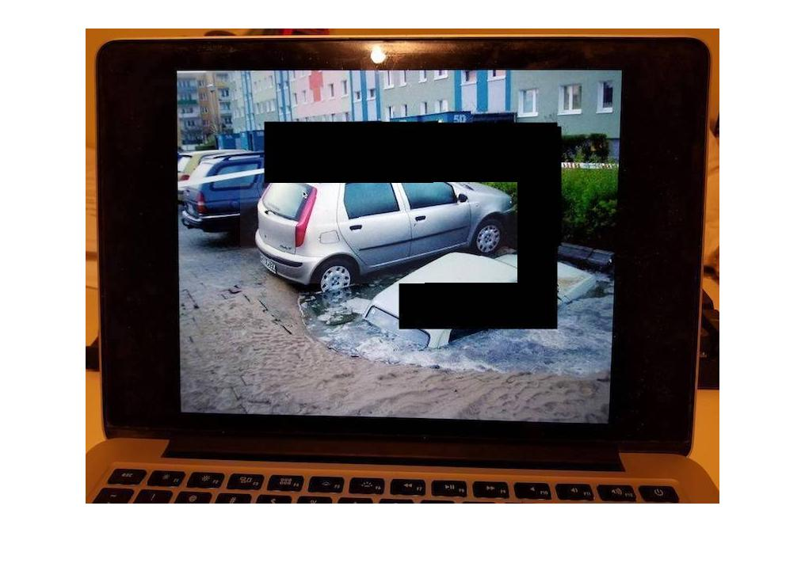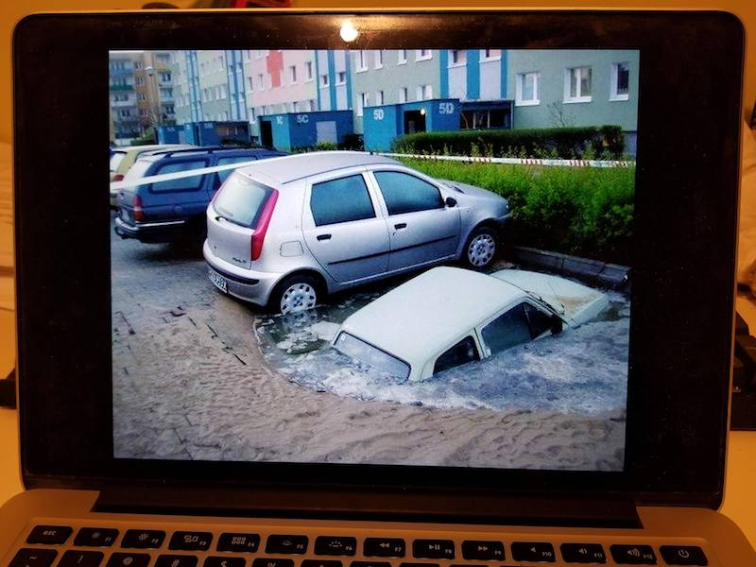

Data image, without occlusion

Result of occlusion filling

Test image, similar as source image but without occlusion (simulated environment)

This result of occlusion filling gives out an score of 29.1376, which means the average manhattan distance (color) of each filled pixel is only 29. Which indicates a very good filling of the source image.

More examples are in the folder /data/project.