**Use of the “LabeledVolcanoPlot” DSP DA plugin**

This vignette is a guide to running the LabeledVolcanoPlot DSP DA plugin and interpreting the resulting plots.

**Intended use**

This plug-in was designed for data from the GeoMx high-plex RNA assays, such as the CTA and WTA. It creates publication ready labeled volcano plots based on user inputs and statistical test results.

**Running the plugin**

The LabeledVolcanoPlot plugin requires an extra file input from DSP DA. After creating a volcano plot in DSP DA, the results file must be saved as a …

This file must be changed to a \t delimited file before running the plugin. The script will not run if this is not changed.

In addition, the plugin accepts 17 “arguments” that you can set by modifying the top of the plugin’s code. Instructions for how to use these arguments are in-line in the plugin’s R code.

Briefly, the arguments are:

1. *de_results_filename:* The \t delimited file of the volcano plot results from DSP DA. This is the name of whatever \t file you’ve uploaded to the DSP DA.
2. *output_format*: Desired output format for the volcano plot figure.
3. *plot_title*: Title for figure
4. *negative_label*: Matching negative x-axis label to the volcano plot in DSP DA; these labels are not transferred to results file so must be user added
5. *positive_label*: Matching positive x-axis label to the volcano plot in DSP DA; these labels are not transferred to results file so must be user added
6. *n_genes:* Number of top genes by pvalue/fdr to label on figure
7. *gene_list*: Specified genes that will be labeled no matter what on figure. Default labeling method over n_genes.
8. *pval_thresh*: P-value threshold on y-axis; Default over fdr_thresh
9. *fdr_thresh:* False discovery rate threshold on y-axis
10. *fc_thresh:* Fold change cutoff on x-axis.
11. *thresh_lines:* Should the threshold lines be shown on figure
12. *font_size:* Font size on figure
13. *font_family:* Font family for all text on figure
14. *plot_width:* Width of saved figure in inches
15. *plot_height:* Height of saved figure in inches
16. *target_groups:* Specific target groups to be colored in plot. All genes in given target_group are colored no matter where they are in the figure. If no group is given, targets are colored if they are above pval/fdr threshold.
17. *color_options:* List of colors to use in figure. Must have at least the number of target_groups.

**Interpretation of results**

The LabeledVolcanoPlot plugin outputs a typical volcano plot figure with fold change on the x-axis and pvalue or FDR on the y-axis for each target.

*Example figures with different input arguments.*

**n_genes = 25**

**pval_thresh = 0.05**

**fc_thresh = 0.75**

**font_family = ”mono”**

**target_groups = NULL**

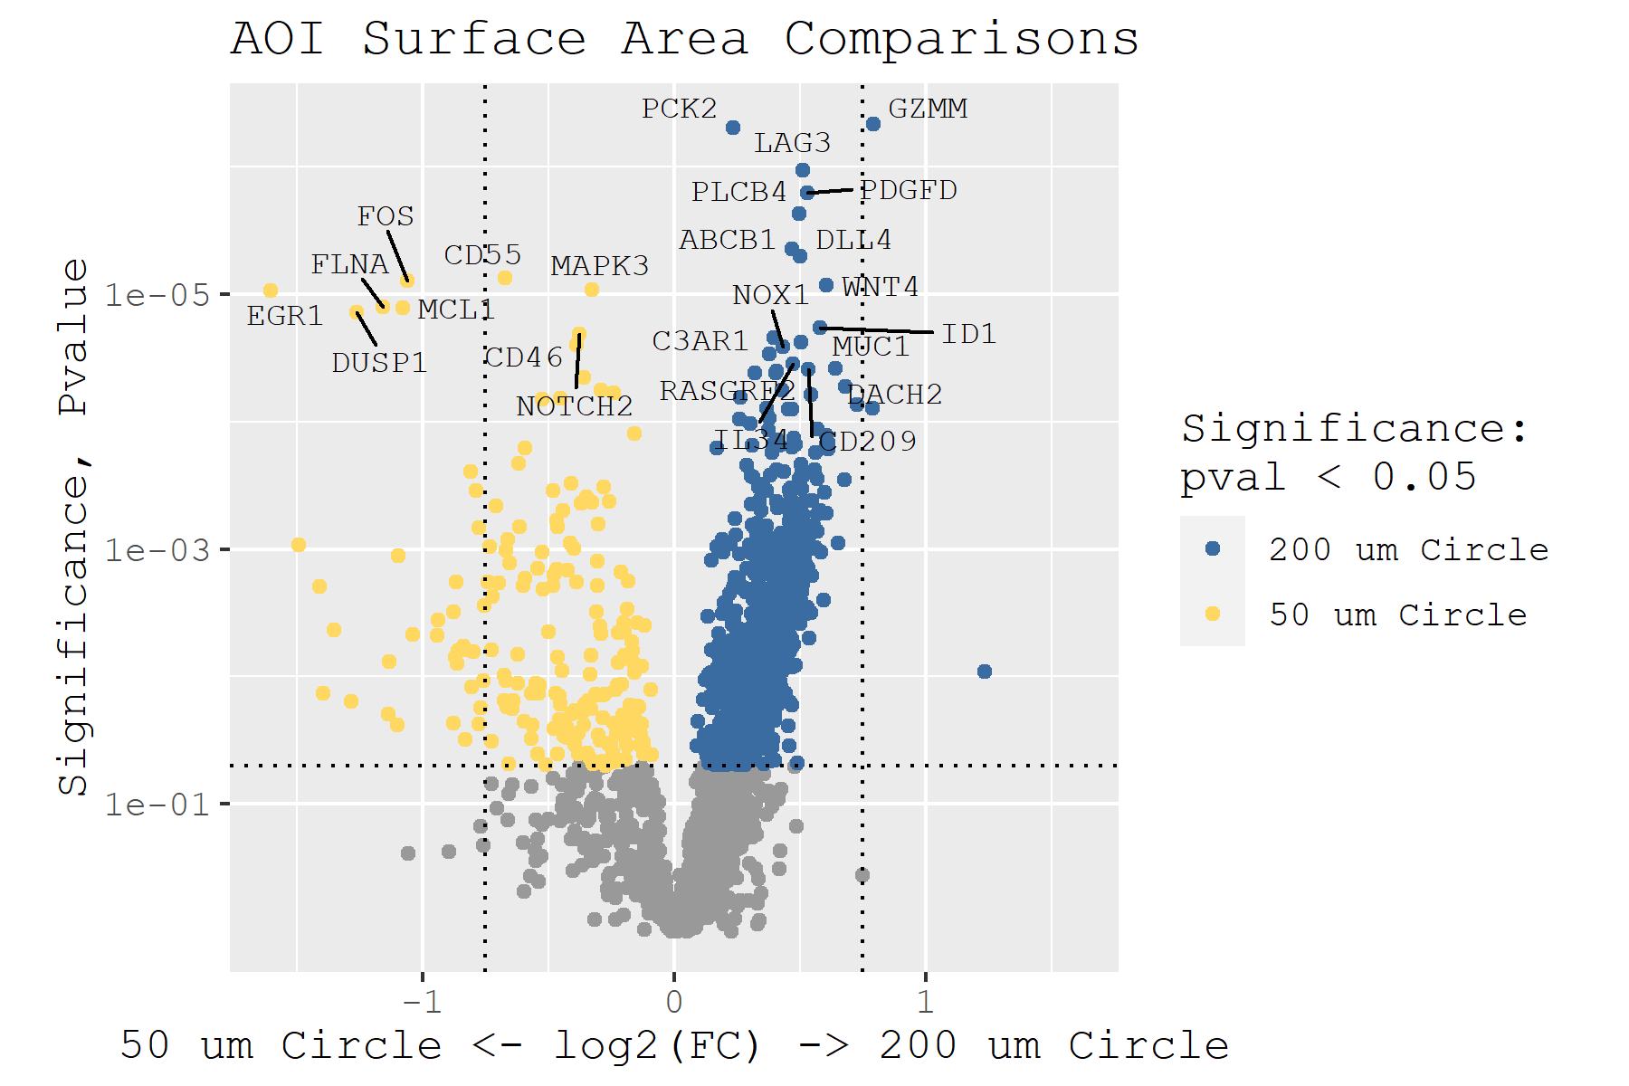

**n_genes = 40**

**fdr_thresh = 0.05**

**fc_thresh = 0.75**

**font_family = ”serif”**

**target_groups = NULL**

**thresh_lines = FALSE**

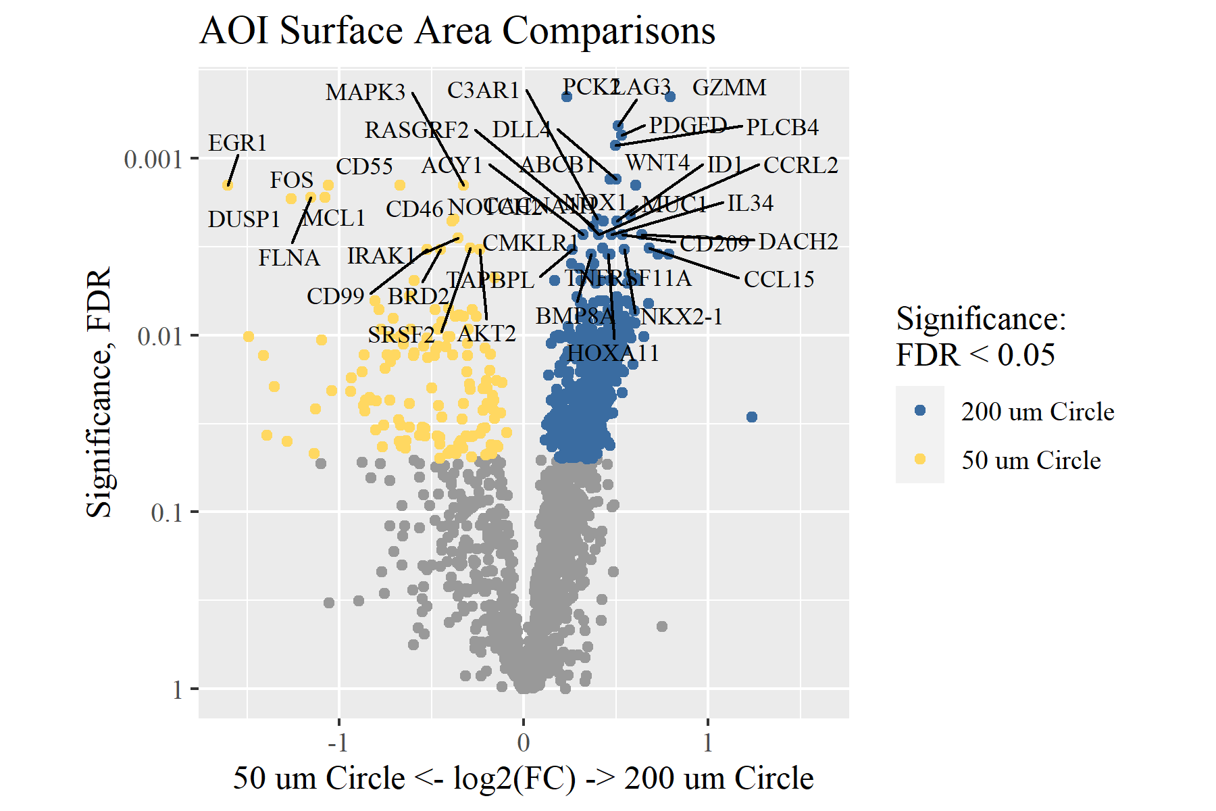

**gene_list = c("IL2RG", "GLUL", "SPIB", "C2")**

**target_groups = c("Hemostasis", "DNA Repair")**

**pval_thresh = 0.05**

**fc_thresh = 0.75**

**font_family = ”sans”**

**thresh_lines = TRUE**

