**Use of the “RNA Negative Normalization” DSP DA plugin**

This vignette is a guide to running the NGS RNA Negative Normalization DSP DA plugin.

**Intended use**

This plug-in was designed for data from the GeoMx DSP Data and is intended to support NGS RNA analyses including those consisting of multiple panels and custom kits.

This plugin does the following:

* 1. Identifies negatives and associates with corresponding panel
  2. Computes the negative normalization factor for each segment for each panel
     1. Segment negative count divided by geometric mean of all segment negative counts
  3. Normalizes results for each panel by the corresponding negative normalization factor
     1. Divide counts with corresponding negative normalization factor
  4. Returns the negative normalized results as the target count matrix

**Contents**

*Page 2*: Loading into the DSP-DA

*Page 3*: Viewing normalized results

**Loading into the DSP-DA:**

The RNANegativeNormalization.R file may be loaded into the custom scripts section of the DSP-DA after you have a QC’d dataset ready for analysis. To do so open the custom script section by clicking on the button shown below:



Select the “Manage” tab to open the area to load and edit scripts:

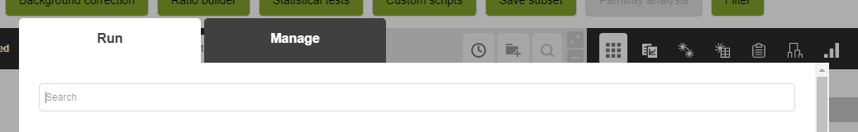

In the Management tab add a unique name for the script.

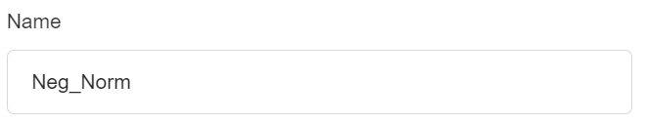

Scroll down in the Management tab and select “Create new dataset”.



Scroll to the bottom of the Management tab. Use the “+” button to add the RNANegativeNormalization.R file to the script and select the blue “Save” button.

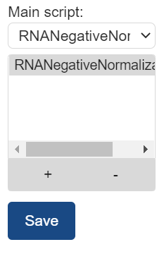

Return to the Run tab. Select the newly added script and put in a unique name to give the resulting dataset. Press the blue “Run” button when ready.

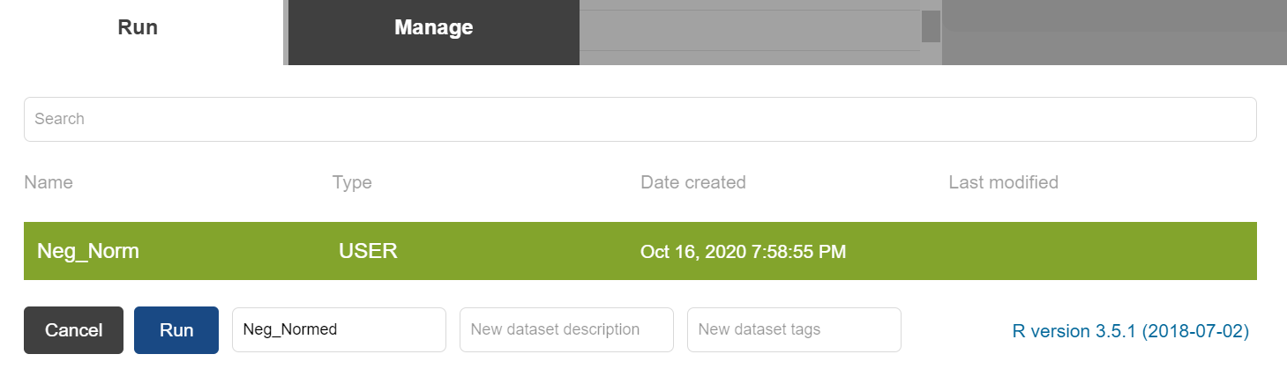

**Viewing normalized results:**

Normalized results will show up as a new dataset in DSP-DA and can be downloaded as excel exports.

