**Use of the** **“TCR_Analysis” DSP DA script**

**Intended use**

The TCR Analysis DSP DA script was designed for data from the GeoMx NGS (CTA or WTA) with TCR spike-in readout applications. It outputs an excel file with TCR genes above specified LOQ thresholds, Gini coefficients, and Shannon diversity scores.

**Contents**

*Page 2*: Loading into the DSP DA

*Page 3*: Setting User Parameters

*Page 3*: Example Parameter Set-up

**Loading into the DSP-DA:**

Download TCR_Analysis.R file from GitHub: <https://github.com/Nanostring-Biostats/DSPPlugins>

The TCR_Analysis.R file may be loaded into the custom scripts section of the DSP-DA after you have a dataset processed and ready for analysis. To do so open the custom script section by clicking on the button shown below with the BioProbeQC dataset marked:

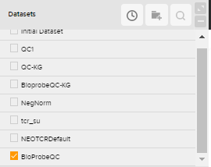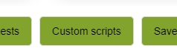

Select the “Manage” tab to open the area to load and edit scripts:

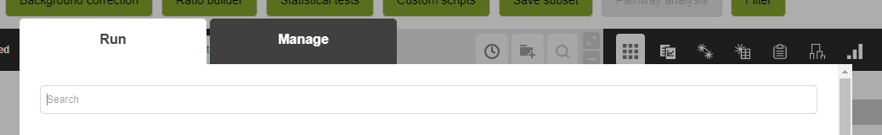

In the Management tab to add a new script and adjust parameters, fill out and then scroll to the bottom of the page. Use the “+” button to add the TCR_Analysis.R file to the script:

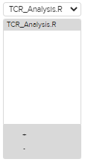

This script will work with both DataFrame and GeoMxSet inputs.

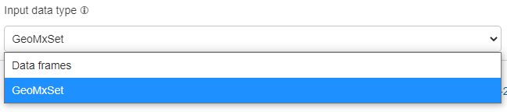

Once added the parameters of the script can be adjusted by editing the top lines in the script and hitting the “Save” button. You can optionally check the Create new dataset button.

Main script:

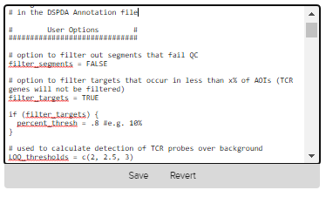

Parameter options are described in full on the next page.

**Setting User Parameters:**

There are a few settings that can be adjusted easily by the user at the top of the script. These include:

* *filter_segments* – set this to TRUE to filter out low segments. Set this to FALSE to keep all segments
* *filter_targets* – set this to TRUE to filter out targets that occur in less than x% (set by *percent_thresh* parameter) of AOIs. TCR genes will not be filtered. Set this to FALSE to keep all targets
* *percent_thresh* – if *filter_targets* = TRUE, set this to numeric less than 1
* *LOQ_thresholds* – set this to string of numeric LOQ thresholds that will be used to calculate detection of TCR probes over background
* *TCR_probes_bg_subtraction* – set this to TRUE to subtract background from TCR probes
* *background_method* – if *TCR_probes_bg_subtraction* = TRUE, set this to either “geomean” or “LOQ” to designate the background subtraction method to be used
* *Bg_LOQ_thresh* – *TCR_probes_bg_subtraction* = TRUE and *background_method* = “LOQ”, set this to numeric of LOQ threshold to use

**Example parameter setup:**

* Example 1: no segment or target filtering and no background subtraction

filter_segments = FALSE

filter_targets = FALSE

LOQ_thresholds = c(2, 2.5, 3)

TCR_probes_bg_subtraction = FALSE

* Example 2: segment and target filtering, LOQ background subtraction

filter_segments = TRUE

filter_targets = TRUE

percent_thresh = .1 #e.g. 10%

LOQ_thresholds = c(2, 2.5, 3)

TCR_probes_bg_subtraction = TRUE

background_method == "LOQ"

bg_LOQ_thresh = 2