Problem Statement

Create a Dashboard based on which User would be able to analyze the sentiment of the specific stock. You’re required to create an Analytical Server "OHLC" (Open/High/Low/Close) time series based on the ‘Stock List’ dataset which will be provided to you in a separate JSON format and its output should be a timely report printed in Charts. (Note: You can use chartjs or any other free API for displaying Charts).

Running:--------

1-)----npm install

2-)----nodemon index.js

3-)login(username->Team16

password->Team@16

)

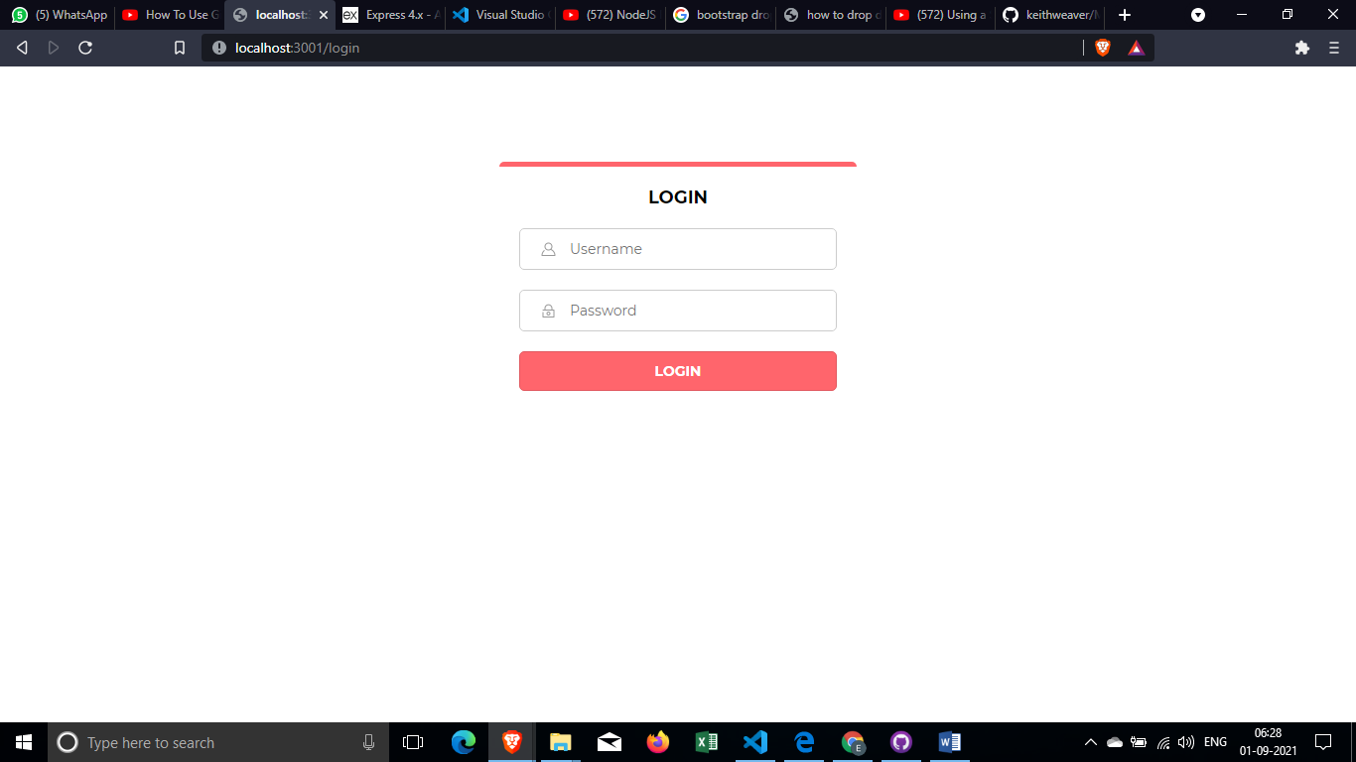

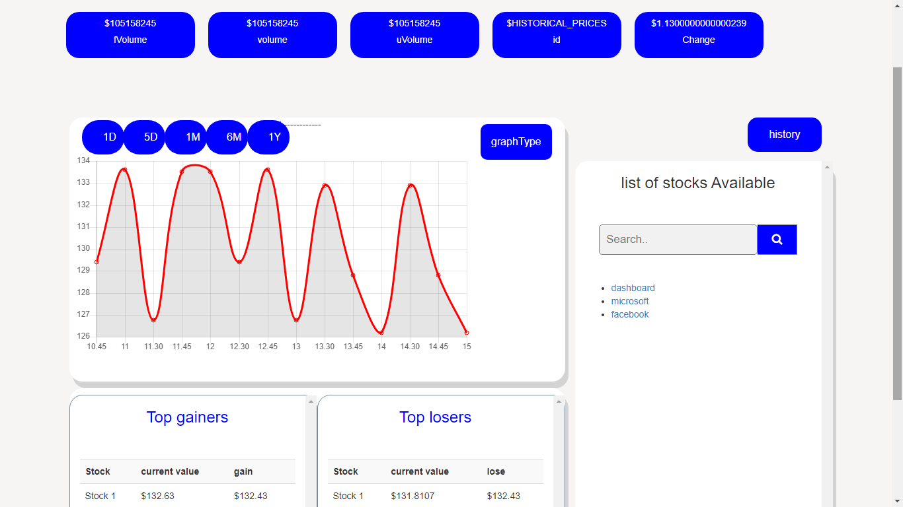

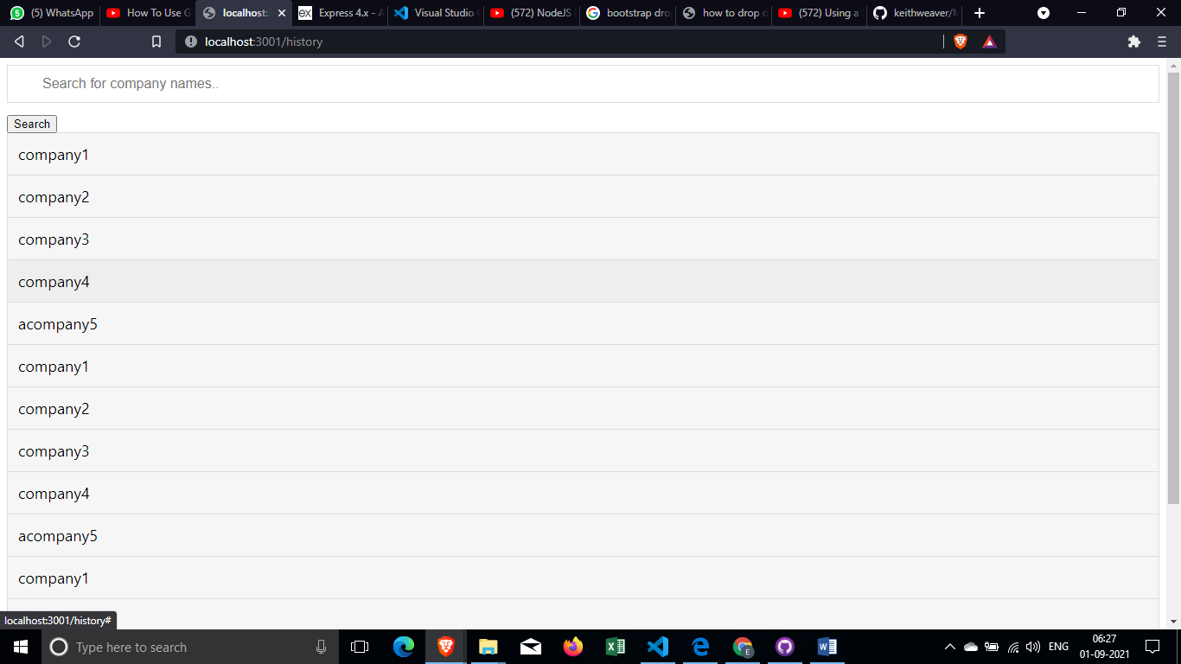

Requirements:

nodejs

express

nodemon

bootstrap

HTML

CSS

JAVASCRIPT

API CALL

explanation:------------

different div contains different information which can be easily understood.

OHLC graph is add on to the stocks data of the company