Recommendation/Committee Screen Function. Version1

This screen facilitates the Branch Sanction Stage of the loan lifecycle. It is primarily used by the recommending authority (e.g., Branch Manager, Relationship Officer) to review, modify, and recommend loan proposals for sanction. The functionality is part of the Decision-Making module in the LendPerfect LOS platform.
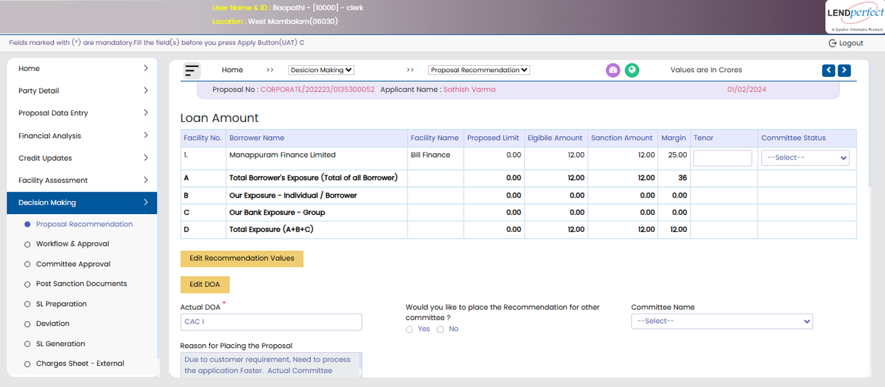
Key Functions Supported by This Screen
- View Borrower & Facility-wise Loan Proposal Details
- Edit Recommendation Values before forwarding to Approving Authority
- View & Override Derived DOA (Delegation of Authority)

Facility Grid (Upper Section)
Column Name | Description
Sl. No. | Auto-generated serial number for each facility record.
Borrower Name | Application Tagged Borrower Name
Facility Name | Auto populated based on the proposed facility
Limit | Proposed facility limit.
Amount (Requested) | Amount requested by the borrower.
Amount (Recommended) | Amount recommended by the recommending authority.
Amount (Sanctioned) | Final amount sanctioned by the approving authority (can be adjusted later).
Margin | Editable margin percentage input (editable if ‘Edit Recommendation Values’ is clicked).
Date | Proposal date or expected disbursal date.
Committee Status | Dropdown selection for whether the committee has considered the proposal.

Actions
Button Name | Description
Edit Recommendation Values | Allows certain fields (e.g., Recommended Amount, Margin) to become editable.
Edit DOA | Allows user to change the pre-filled Delegation of Authority.
Executive Summary | Generates a high-level summary view of the recommendation before forwarding.

Actual DOA (Delegation of Authority)
- The system automatically derives the Actual DOA based on internal parameters such as loan amount, borrower profile, product type, etc.
- However, this value is tentative, since many factors (e.g., business discretion, risk category) are subjective in nature.
- If the recommending user finds the derived DOA inappropriate, they may manually override it using the associated editable field and select the correct Committee Name from the dropdown.
- The system logs this override for audit purposes.

Committee Recommendation
- The user is asked: "Would you like to place the Recommendation for other committee?"
- If Yes is selected:
  - The user must select the appropriate Committee Name from the dropdown (e.g., CAC, RAC, ZAC).
- This provides flexibility to route the proposal through alternate sanctioning layers based on exception handling or urgency.

Next Steps – Workflow and Approval
Once the recommendation is finalized:
- The user must go to the Workflow & Approval section from the left navigation.
- Use the Forward/Submit functionality to send the application to the Approving Authority.
- The approving user can then:
  - Review the recommended values
  - Modify the Sanction Amount if required
  - Record final decision and proceed with workflow and approval for sanction/reject/ forward to the next approving authority the application
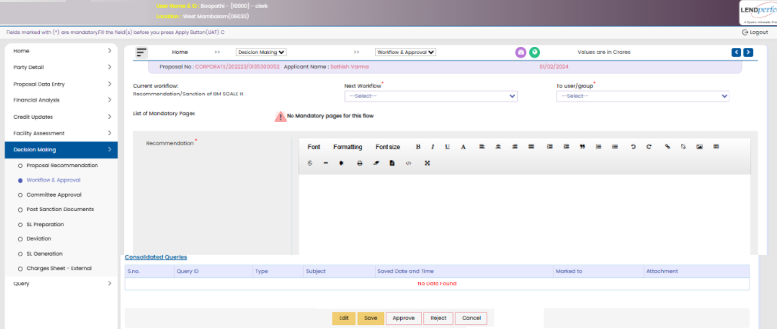
The platform will route each application to the appropriate committee for review and approval. Committees can be configured at different organisational levels, for example:
- MLP Committee
- RLC Committee
- ZLC Committee
- HO/CO Committee
This list is not exhaustive; bank administrators can create additional committees as needed to meet evolving business requirements.
This Screen auto fetches the data from the Recommendation page and is accessible by the Committee Convener once the committee's decision has been recorded.
The Committee Status dropdown is used to capture the outcome of the committee's review. It provides two options:
- Considered for Approval
- Not Considered
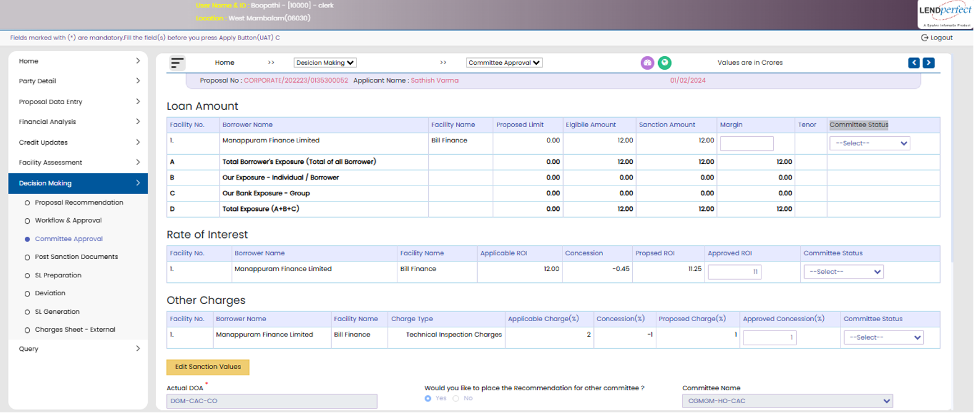

Workflow Logic
Step | Description
1. Access | Only visible to Committee Convener after proposal is forwarded.
2. Select Committee Status | Convener selects one of the status options from dropdown.
3. If "Considered for Approval" | Proposal moves to next sanction authority or is sanctioned as per DOA.
4. If "Not Considered" | Proposal is either reverted back to recommending authority or marked closed (as per policy).
5. Save / Submit | Action is logged with timestamp and user ID for audit trail.

Section | Description
List of Borrowers | Dropdown to select borrower from list (mandatory). User will be able to download ES note which is configured
Recommended Remarks | Text field to enter remarks for the proposal (mandatory).
Buttons
- Add Recommendation Comments | Opens section to enter recommendation comments.
- Add Terms and Conditions | Opens section to enter applicable terms and conditions.
- Upload Board Resolution | Opens a popup window (second image) to upload the board resolution.
Table (Recommendation Log) | Shows past recommendation actions with columns: Sl.No, Recommendation By, Role, Date, Time, Query. If empty, displays No Data Found.

Triggered when user clicks "Upload Board Resolution" from the first screen.
Field/Section | Description
Date* | Date of the meeting (mandatory).
Meeting No* | Unique number of the board meeting (mandatory).
Agenda No* | Agenda number discussed in the board meeting (mandatory).
Table Columns
- Committee Members | List of committee members who participated.
- Chairperson | Highlights who chaired the meeting.
- Attendance | Marks who attended the meeting.
Committee Remarks* | Collapsible section to capture remarks from the committee (mandatory).
Terms and Conditions* | Collapsible section to define terms and conditions discussed or approved (mandatory).

Board Details capture screen

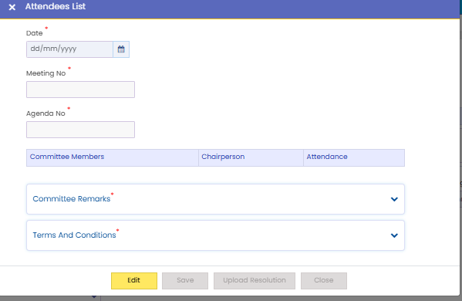

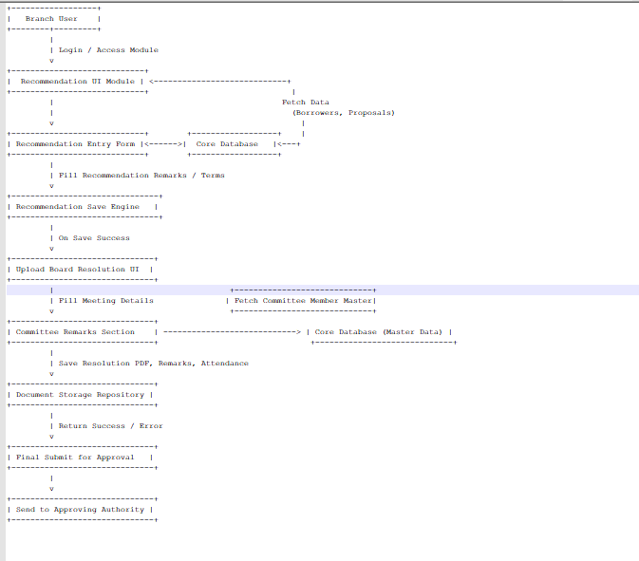

Textual Flow Description
# | Process | Input | Output | To/From
1 | Enter Recommendation | Proposal ID, Remarks, T&C, Recommended Amt | Recommendation Record | D2: Recommendation History Log
2 | Upload Board Resolution | Date, Meeting No., Agenda No., Members | Board Resolution Details | D3: Board Resolution Repository
3 | Record Attendance & Remarks | Member List, Attendance, Remarks | Updated Committee Attendance | D4: Committee Master
4 | Save Recommendation | Edited Recommendation | Proposal marked as ‘Recommended’ | D1: Proposal Master
5 | Forward to Approving Authority | Final Saved Recommendation | Notification, Sanction Review Access | Approving Authority / LOS Core System

