

ROI Measurement Framework and Simulation Model
February | 2025


Project Name: ROI Measurement Framework and Simulation Model
Version: 1.0
Date: Sep 08, 2025
Author: Pratheek Basrithaya
Revision History:
Version | Date | Author | Reviewed By | Description
0.1 | Sep 08, 2025 | Pratheek Basrithaya | Sajeesh TS | Initial Draft

INDEX

Table of Contents
ROI Measurement Framework and Simulation Model 1
INDEX 3
1 Shakeholders 4
2 Introduction 5
3 Business Background & Drivers 5
3.1 Problem 5
3.2 Solution 5
4 Objectives & Goals 6
5 Scope 6
6 Functional Requirements 7
6.1 Authentication & Access Control 7
6.2 Dynamic Filtering & Data Visualization 7
6.3 Simulation Logic & Calculations 7
6.4 Visualization & Decision Support 8
7 User Roles & Permissions 8
8 User Journey & Process Flow 9
9 Calculation Logic 11
10 Integration Points 11
11 Business Background & Drivers 12
11.1 Authentication & Access Control 12
11.2 System Architecture & Role-Based Access Control 12
11.2.1 User Access 12
11.2.2 Admin Capabilities 13
11.3 Landing Page, Selection & Filtering (User & Admin) 13
11.4 Simulation & Input 14
11.5 Srtucture and Acess control (Admin) 15
11.6 User onboading (Admin) 18
11.7 Admin Intervention Management 20
11.8 Create & Manage L2 Metrics 23
11.9 Create & Manage L1 Metrics 24
11.10 Create & Manage Business outcome (L0) Metrics 26
11.11 Logout 27

Project: ROI Measurement Framework and Simulation Model
Prepared By: Pratheek Basrithaya
Date: Sep 08, 2025

1 Shakeholders
The ROI Measurement Framework and Simulation Model you're describing is a strategic decision-support tool tailored for TP USA, built using the Power Platform (Canvas Power App + Dataverse).
This project involves key stakeholders who play distinct roles in ensuring successful delivery, alignment with business goals, and technical execution.

Role | Name | Responsibility
Project Sponsor |  | Provides overall governance, strategic direction, and budgetary approvals.
Product Owners |  | Define business requirements, lead qualification criteria, and survey logic.
Business Analyst | Pratheek Basrithaya | Responsible for documenting requirements, aligning stakeholders, and process flow.
Developer (Power Platform) |  | Designs and develops the Power App, Dataverse workflows.

These stakeholders collaborate closely to ensure the app meets functional expectations, aligns with business strategy, and delivers seamless user experience.

2 Introduction
The ROI Measurement Framework and Simulation Model is a strategic digital solution developed for TP USA to address the growing need for data-driven decision-making in solution design and sales enablement. Built on Microsoft Power Platform using Canvas App and Dataverse, the model enables stakeholders to simulate operational interventions and visualize their impact on performance metrics and business outcomes. This tool bridges the gap between tactical actions and strategic results, enhancing transparency, traceability, and confidence in projected ROI.

3 Business Background & Drivers

3.1 Problem
- Lack of Visibility Across the Value Chain
The Sales Enablement and Solutions team lacked a unified mechanism to visualize how interventions at various operational levels influence performance metrics and strategic outcomes. Existing processes were fragmented and manual, making it difficult to establish causal relationships across verticals, horizontals, and LOBs.
- Inability to Quantify Impact
There was no mathematical or logical framework to connect business actions to measurable changes in KPIs. This hindered the ability to demonstrate solution effectiveness, compare against industry benchmarks, and validate projected outcomes with clients.
- Manual and Inefficient Processes
The absence of an integrated digital tool led to reliance on manual methods for impact analysis, which were time-consuming, error-prone, and lacked scalability. This slowed down solution deployment and reduced agility in responding to client needs.

3.2 Solution
The proposed solution is a Canvas Power App integrated with Dataverse, designed to simulate and visualize the impact of business interventions across the value chain. Key features include:
- Rapid App Development: Enables quick deployment with reduced cost and time.
- Secure Data Management: Dataverse ensures robust governance, security, and complex data modelling.
- Interactive Simulation Flow:
  - Stakeholders select LOBs and input intervention values.
  - The model calculates changes in L2 and L1 metrics.
  - Business outcomes are derived using mathematical logic based on industry benchmarks.
  - ROI and business impact are visualized to support decision-making.
Solution Benefits
- Enhanced efficiency and faster deployment.
- Customizable inputs representing specific business actions.
- Intermediate and final metrics that reflect real-time impact.
- Improved stakeholder confidence through transparent ROI visualization.

4 Objectives & Goals
To develop a digital simulation model that enables data-driven decision-making by visualizing the impact of operational interventions across the value chain. The solution aims to empower stakeholders with a transparent, interactive tool that demonstrates how specific actions influence performance metrics and strategic business outcomes, ultimately supporting ROI-based prioritization.
Project Goals:
- To provide the Sales Enablement and Solutions team with a robust platform that connects interventions to measurable outcomes using mathematical logic and industry benchmarks.
- To enhance the ability of sales teams to communicate value propositions to clients through data-backed projections.
- To build trust and confidence by offering transparent visualization of how solutions drive business impact.

5 Scope
- Development of a Canvas Power App integrated with Dataverse for secure data handling and complex modelling.
- Simulation of interventions across LOBs, verticals, and horizontals with cascading effects on L2 and L1 metrics.
- Visualization of business outcomes and ROI using benchmark-based logic.
- Customizable input parameters to reflect real-world business actions.
- Enablement of impact analysis and decision support for stakeholders.

6 Functional Requirements

6.1 Authentication & Access Control
- The application must authenticate users via Microsoft 365 login.
- Access must be restricted to users within designated Microsoft Directory groups.
- Unauthorized users must be shown an “Access Denied” message upon launch.

6.2 Dynamic Filtering & Data Visualization
- Users must be able to select Vertical / Horizontal, and Line of Business (LOB) from dropdown filters.
- Based on the selected filters, the app must dynamically display:
  - Interventions relevant to the selected LOB.
  - L2 Metrics (intermediate indicators responding to interventions).
  - L1 Metrics (higher-level performance indicators influenced by L2 metrics).
  - Business Outcomes (final measurable results showing ROI and impact).
- Inputs must be customizable to reflect specific business actions or changes.

6.3 Simulation Logic & Calculations
- Users must be able to adjust intervention values using sliders.
- The app must calculate cascading impacts using the following logic:

Intervention → L2 Metrics
- Change % = (Impact Factor × Intervention New Value %) / 100
- Total Change % = Sum of Change % from all related interventions
- New Value = Default Value + (Default Value × Total Change %)

L2 Metrics → L1 Metrics
- Change % = Impact Factor × Total Change % of related L2 Metrics
- Total Change % = Sum of Change % from all related L2 Metrics
- New Value = Default Value + (Default Value × Total Change %)

L1 Metrics → Business Outcomes
- Change % = Impact Factor × Total Change % of related L1 Metrics
- Total Change % = Sum of Change % from all related L1 Metrics
- New Value = Default Value + (Default Value × Total Change %)
- The model must support manual overrides for metric values where applicable.
- All calculations must be based on predefined impact factors and default values stored in Dataverse.

6.4 Visualization & Decision Support
- The app must generate a comprehensive visualization of interdependencies across:
  - Interventions → L2 Metrics → L1 Metrics → Business Outcomes
- It must support baseline vs. ideal scenario comparison using industry benchmarks.
- The simulation must enable impact analysis to guide intervention prioritization and ROI-based decision-making.

7 User Roles & Permissions

Role | Permissions
User | - Access the app via Microsoft 365 authentication (if part of authorized Azure AD group).
 | - View and interact with the simulation model.
 | - Adjust intervention values using sliders to simulate impact.
 | - View cascading effects across Interventions → L2 Metrics → L1 Metrics → Business Outcomes.
 | - Analyse ROI and business impact based on predefined logic and benchmark data.
 | - Cannot modify mappings, logic, or user configurations.
Admin | - All User permissions.
 | - Onboard new users and manage user access rights.
 | - Modify user details and assign roles.
 | - Create, update, or delete mapping configurations between Verticals, Horizontals, and LOBs.
 | - Define and manage relationships between Interventions → L2 Metrics.
 | - Set or modify default values, impact factors, and dependencies for interventions and metrics.
 | - Maintain and update the mathematical logic used for cascading impact calculations.

8 User Journey & Process Flow
- Login & Authentication
  - App auto-authenticates via Microsoft 365.
  - Access restricted to authorized Azure AD users.
- Landing Page
  - Users see dashboard with verticals, horizontals, and LOBs.
  - Admins get extra options for mapping and user management.
- Selection & Filtering
  - Dropdown filters for Vertical, Horizontal, and LOB.
  - Displays relevant interventions, L2, L1 metrics, and outcomes.
- Simulation & Input
  - Users adjust intervention sliders.
  - System calculates cascading impact using benchmark logic.

Figure 8a. Process Flow

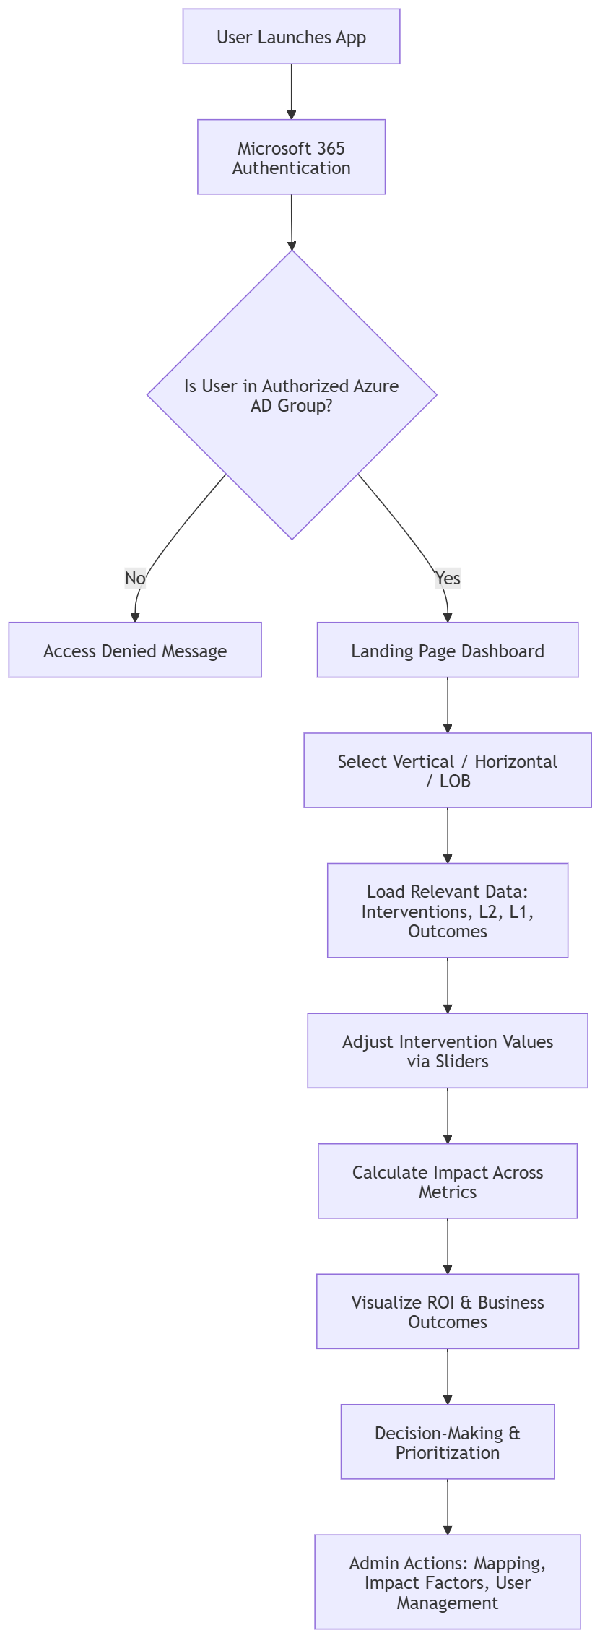

9 Calculation Logic

Metric Level | Dependency | Impact Factor Logic | Calculation Formula | New Value Formula
Intervention | Manual input via slider | Impact factor defined per intervention | Change % = (Impact Factor × Intervention New Value %) / 100 | New Value = Default Value + (Default Value × Total Change %)
L2 Metrics | Dependent on multiple interventions | Sum of change % from all related interventions | Total Change % = ∑ Change % from related interventions | New Value = Default Value + (Default Value × Total Change %)
L1 Metrics | Dependent on multiple L2 metrics | Impact factor × Total Change % of related L2 metrics | Total Change % = ∑ Change % from related L2 metrics | New Value = Default Value + (Default Value × Total Change %)
Business Outcomes | Dependent on multiple L1 metrics | Impact factor × Total Change % of related L1 metrics | Total Change % = ∑ Change % from related L1 metrics | New Value = Default Value + (Default Value × Total Change %)

Notes
- Default Values and Impact Factors are manually configured by Admins.
- Each metric can be influenced by multiple upstream dependencies.

10 Integration Points

Component | Purpose
Microsoft 365 | User authentication and access control via Azure Active Directory.
Dataverse | Secure data storage for client details, surveys, mappings, and configurations.
Power Apps (Canvas) | Front-end interface for users and admins to interact with the simulation model.

11 Business Background & Drivers

11.1 Authentication & Access Control
- Upon launching, the app must authenticate using the logged-in Microsoft 365 user.
- Only users in specified Azure AD group(s) can launch the app; others see “Access Denied”.

Figure 11a. Login Page

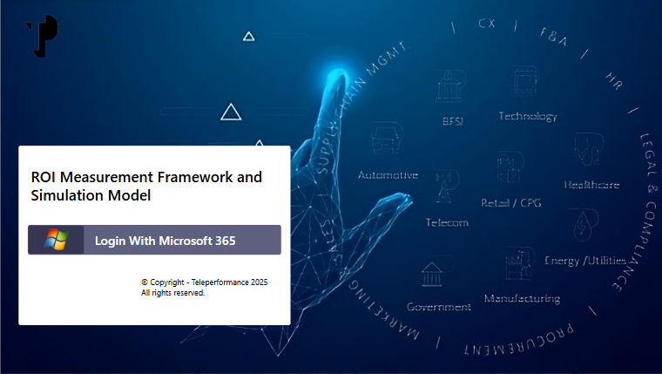

11.2 System Architecture & Role-Based Access Control
The ROI Measurement Framework and Simulation Model is designed with a secure, role-based structure to ensure appropriate access and functionality across user types.

11.2.1 User Access
- Authenticated via Microsoft 365 login.
- Access granted only to users within authorized Azure Active Directory (AD) groups.
- Unauthorized users are shown an “Access Denied” message.
User Interface & Navigation:
- Upon login, users are directed to a landing dashboard displaying available Verticals, Horizontals, and LOBs.
Users can:
  - View simulation components.
  - Adjust intervention values via sliders.
  - Access the Simulate button to run the model and analyse ROI impact.

11.2.2 Admin Capabilities
- In addition to user functionalities, admins can:
  - Navigate to a configuration page to create new Verticals, Horizontals, and LOBs.
  - Submit new entries which are dynamically added to the system.
  - Access the Mapping section to view, create, modify, or delete relationships between business dimensions.
  - Manage user onboarding, update user details, and assign roles.
This structured access model ensures secure, scalable, and governed usage of the simulation tool, aligning with enterprise standards and operational needs.

11.3 Landing Page, Selection & Filtering (User & Admin)
- Upon successful authentication, users are directed to a personalized landing dashboard that serves as the central interface for navigating the simulation model.
- The dashboard displays available Verticals, Horizontals, and Lines of Business (LOBs) in an intuitive layout.
- Users can apply dynamic filters to select a specific Vertical, Horizontal, and LOB. Based on these selections, the application automatically loads and displays:
- Relevant Interventions (business actions or changes),
- Corresponding L2 Metrics (intermediate performance indicators),
- L1 Metrics (higher-level KPIs), and
- Business Outcomes (final measurable results).
This filtering mechanism ensures that users interact only with contextually relevant data, enabling focused analysis and simulation tailored to specific business scenarios.

Figure 11b. Landing Page
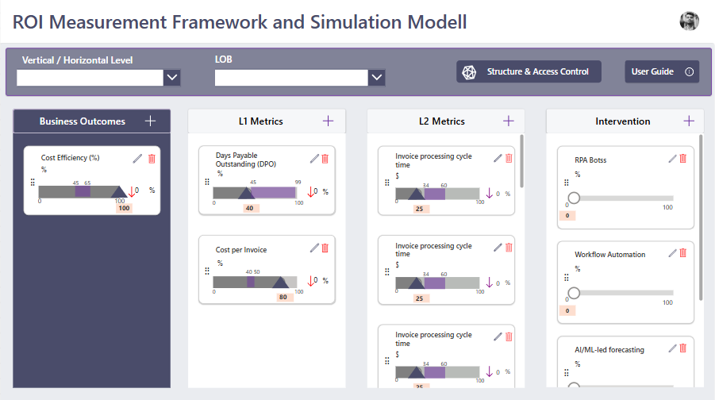

Simulation & Input
Users interact with the simulation engine by adjusting intervention values using sliders. The system then performs cascading calculations across the metric hierarchy:
- Intervention → L2 Metrics → L1 Metrics → Business Outcomes
Calculations are driven by:
- Impact Factors
- Default Values
- Industry Benchmark Logic
This simulation enables users to model baseline vs. ideal performance scenarios and understand the projected ROI of specific interventions.

Figure 11c. Landing Page

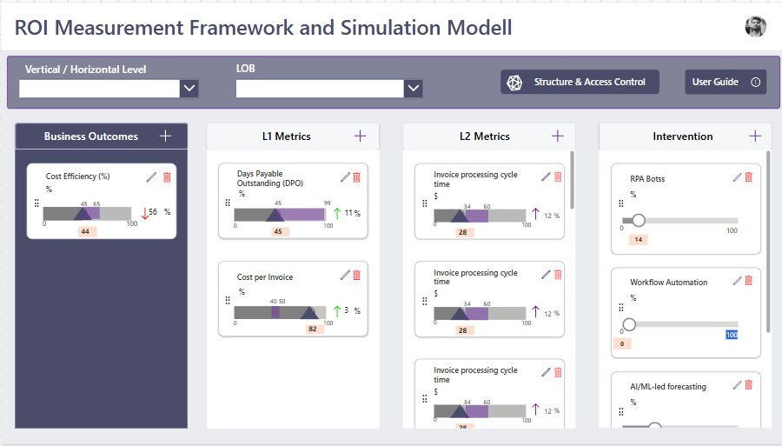

11.5 Srtucture and Acess control (Admin)
Once authenticated and on the landing page, users and admins can perform specific actions based on their roles:
- Vertical/Horizontal/LOB Creation
Users can navigate to a dedicated configuration page by clicking the “Create New” button. Here, they can define new Verticals, Horizontals, and associated LOBs.
Upon clicking Submit, the new entries are saved and reflected in the system for future selection and simulation.

Figure 11d. Vertical/Horizontal/LOB Creation
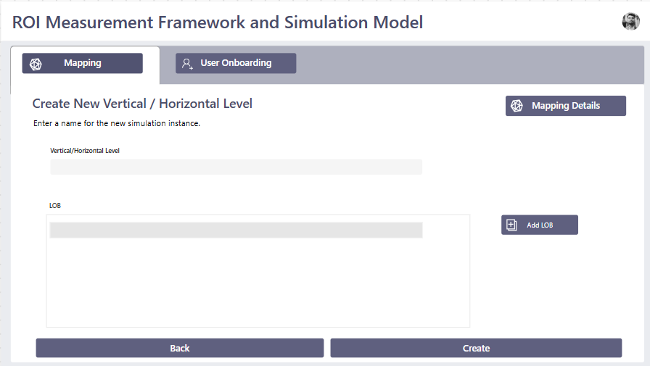

- Mapping Management (Admin Only)
Admins can access the “Mapping” section to view and manage relationships between Verticals, Horizontals, and LOBs.
They have full control to create, modify, or delete mappings, ensuring the simulation model remains aligned with evolving business structures.

Figure 11e. Mapping Management

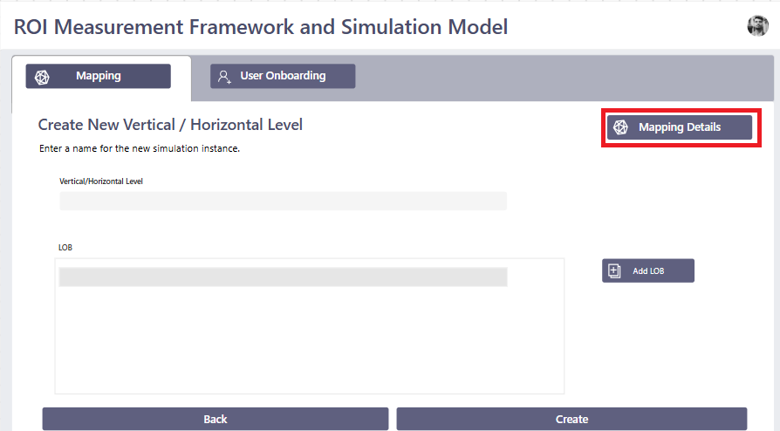

Figure 11f. Mapping Management

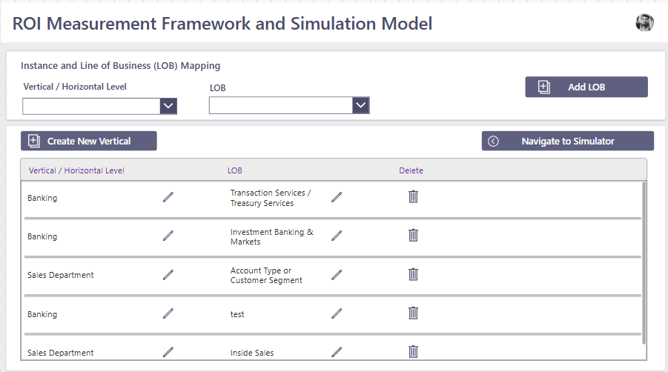

- Simulation Access
Users can click the “Simulate” button to return to the landing page and initiate the simulation process.
Admins can also use this feature to run the model with updated configurations and mappings, enabling real-time impact analysis.
This structured navigation ensures a seamless experience for both users and administrators, supporting efficient configuration, simulation, and decision-making.

Figure 11g. Simulation Access
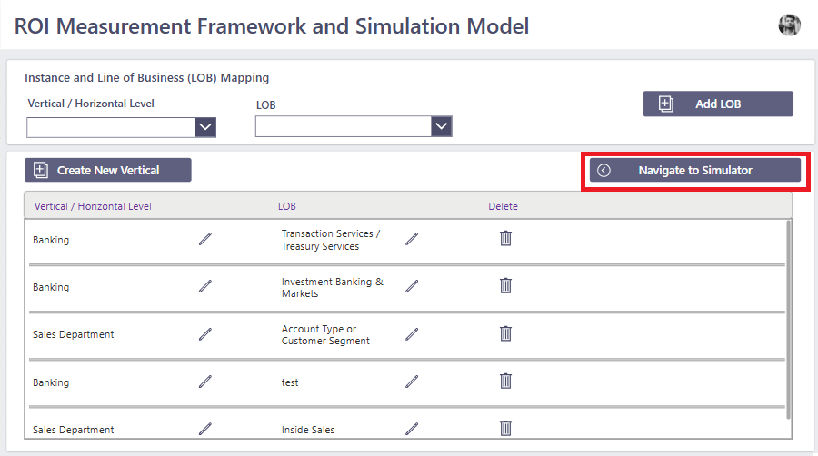

11.6 User onboading (Admin)
When an admin clicks on the “Structure & Access Control” section from the dashboard, they are navigated to a dedicated configuration page featuring two key sub-menus:
1. Create New Vertical/Horizontal/LOB
- Admins can define new Verticals, Horizontals, and their associated Lines of Business (LOBs).

2. User Onboarding
- Admins can onboard new users by accessing the User Onboarding page.
- This page displays a list of all onboarded employees, along with their details and assigned roles.
Admins can:
  - Modify user details
  - Assign or update roles (User or Admin)
  - Add new users by clicking the “New User” button

Figure 11h. User Onboarding
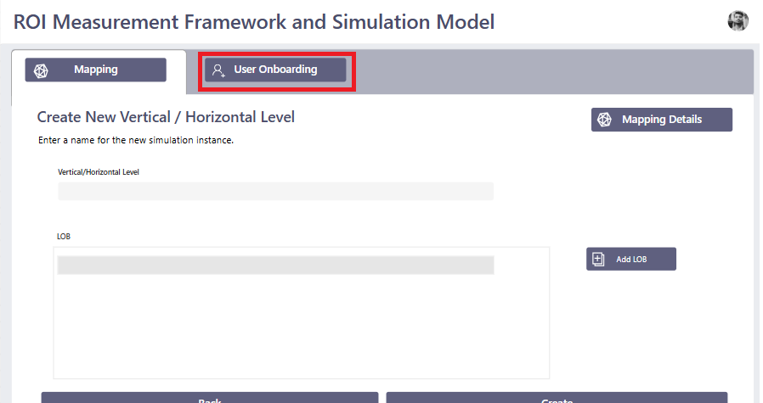

Figure 11i. User Onboarding
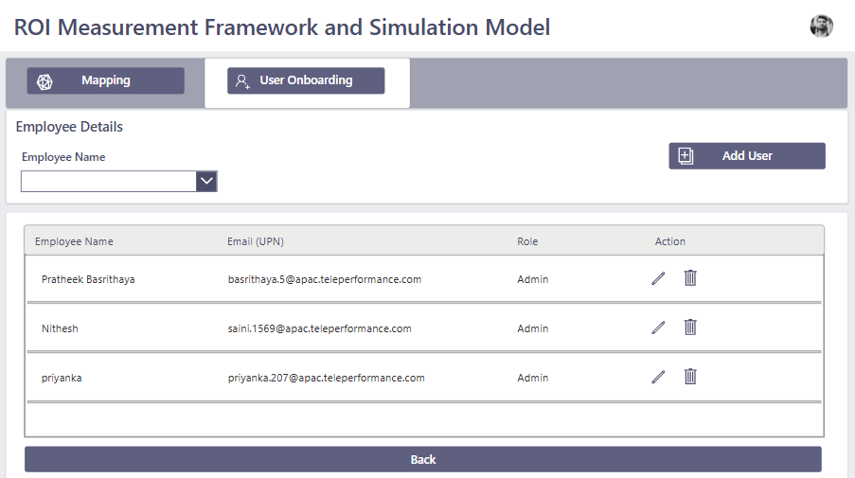

New User Creation
- When adding a new user, the admin is navigated to a form page.
- The admin fills in required user details and submits the form.
- Upon submission, the user is granted access to the application based on their assigned role and Azure AD group membership.
This structured workflow ensures secure, scalable, and governed user management, aligning with enterprise access control standards.

Figure 11j. New User Creation

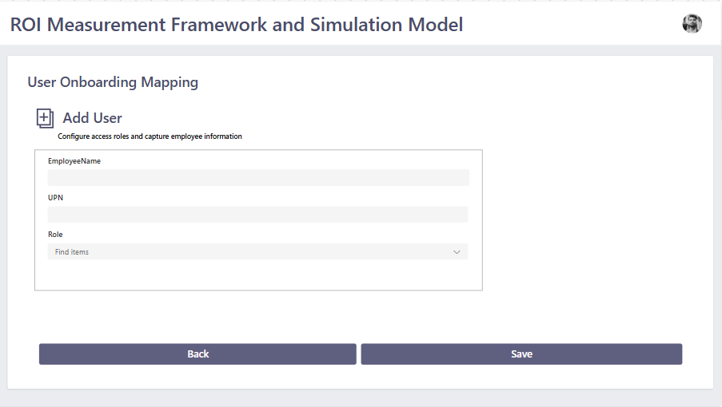

Admin Intervention Management
Admins can manage interventions directly within the simulation model to ensure alignment with evolving business strategies.
Creating a New Intervention
- By clicking the “Add Intervention” button, the admin is navigated to a dedicated input screen.
- The admin fills in all required details related to the intervention, including name, description, default values, and impact factors.
- Upon clicking Submit, the new intervention is saved and immediately reflected on the landing page for simulation use.

Figure 11k. Creating a New Intervention
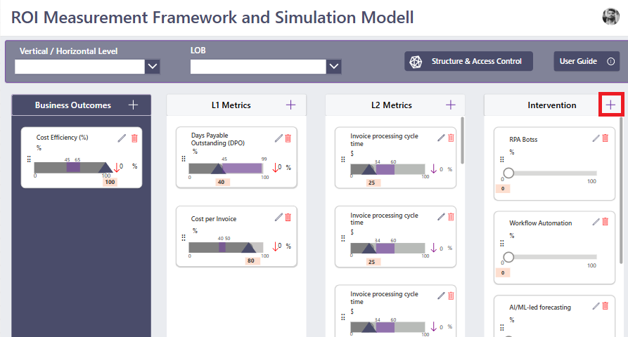

Figure 11l. Creating a New Intervention
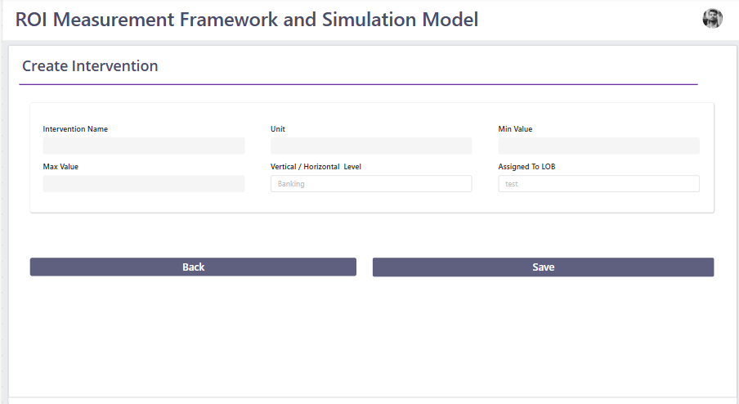

Editing & Deleting Interventions
- Existing interventions can be modified by clicking the Edit icon next to the respective entry.
- Admins can update any field and save changes, which will be reflected in real-time across the model.
- If an intervention is no longer relevant, admins can remove it using the Delete option.
This functionality ensures that the simulation model remains dynamic, accurate, and tailored to current business needs, while maintaining full administrative control over intervention data.

Figure 11m. Editing & Deleting Interventions
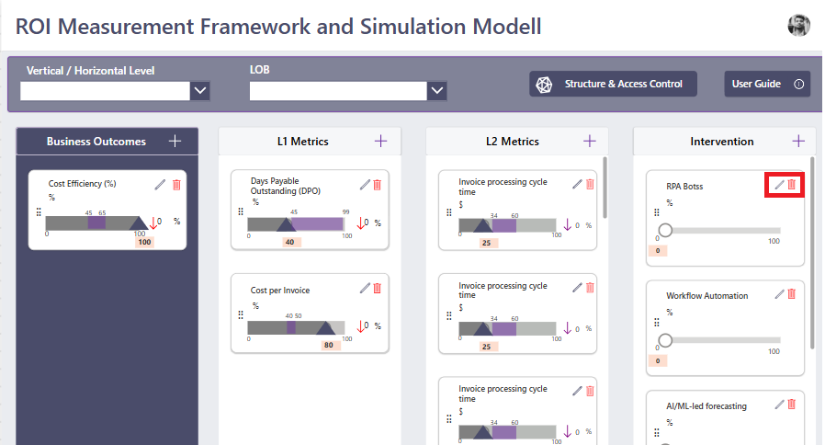

Figure 11n. Editing & Deleting Interventions
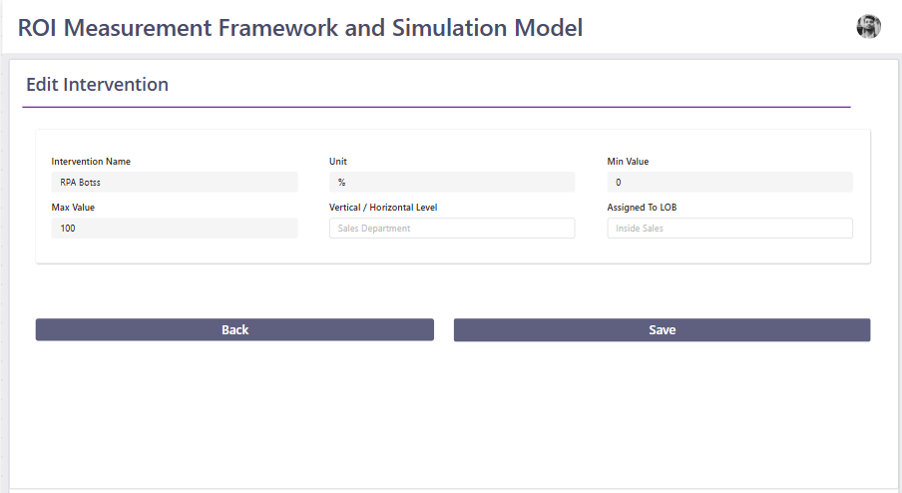

11.8 Create & Manage L2 Metrics
After creating an intervention, admins can proceed to define associated L2 Metrics by clicking the “Add L2 Metric” button.
This navigates to a form where the admin inputs:
  - Metric name
  - Dependency relationships
  - Impact factors
  - Default values
Once submitted, the L2 metric is added to the system and becomes part of the simulation flow.

Figure 11o. Creating a New L2 Metrics

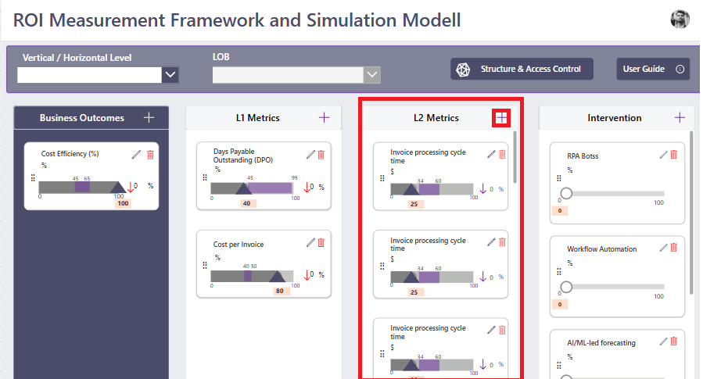

Edit & Delete Functionality
- Admins can modify existing interventions or L2 metrics by clicking the Edit icon next to each item.
- Changes are saved and updated across the model in real time.
- If a component is no longer needed, admins can remove it using the Delete option.
This functionality ensures that the simulation model remains dynamic, accurate, and aligned with business objectives, while giving admins full control over its configuration.
Figure 11p. Edit L2 Metrics
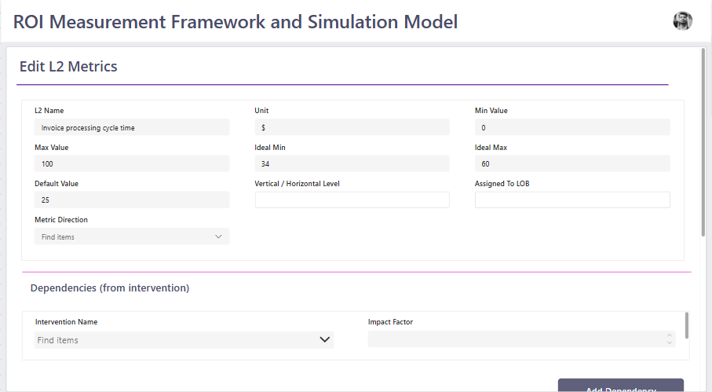

11.9 Create & Manage L1 Metrics
After creating an intervention & L2 Metrics admins can proceed to define associated L1 Metrics by clicking the “Add L1 Metric” button.
This navigates to a form where the admin inputs:
  - Metric name
  - Dependency relationships
  - Impact factors
  - Default values
Once submitted, the L1 metric is added to the system and becomes part of the simulation flow.

Figure 11q. Creating a New L1 Metrics
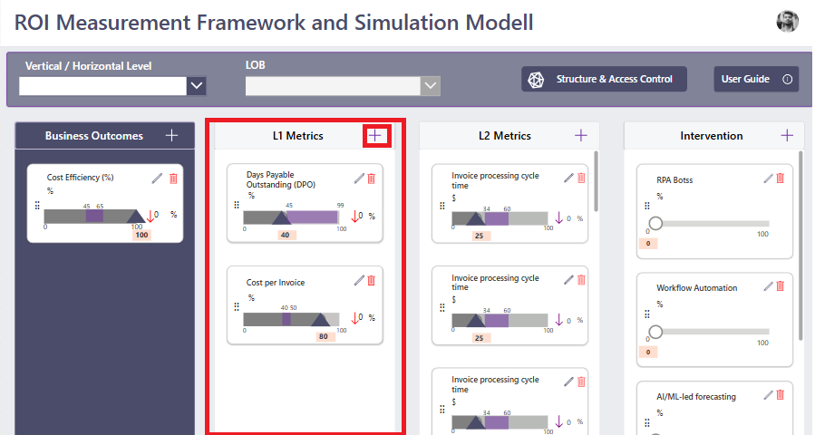

Edit & Delete Functionality
- Admins can modify existing interventions or L1 metrics by clicking the Edit icon next to each item.
- Changes are saved and updated across the model in real time.
- If a component is no longer needed, admins can remove it using the Delete option.
This functionality ensures that the simulation model remains dynamic, accurate, and aligned with business objectives, while giving admins full control over its configuration.

Figure 11r. Edit L1 Metrics
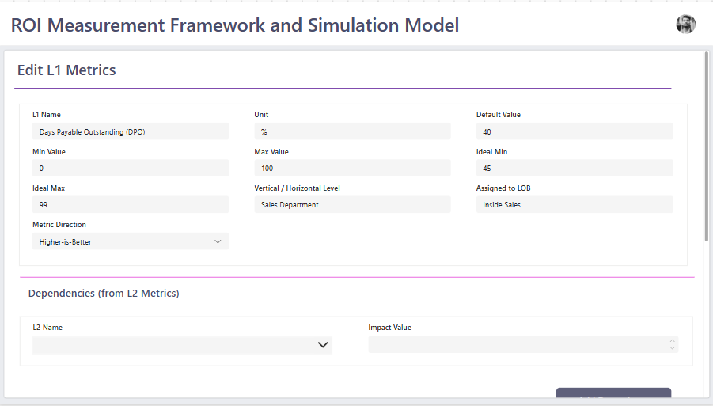

11.10 Create & Manage Business outcome (L0) Metrics
After creating an intervention, L2, L1 Metrics admins can proceed to define associated L0 Metrics by clicking the “Add L0 Metric” button.
This navigates to a form where the admin inputs:
  - Metric name
  - Dependency relationships
  - Impact factors
  - Default values
Once submitted, the L0 metric is added to the system and becomes part of the simulation flow.

Figure 11s. Creating a New L0 Metrics
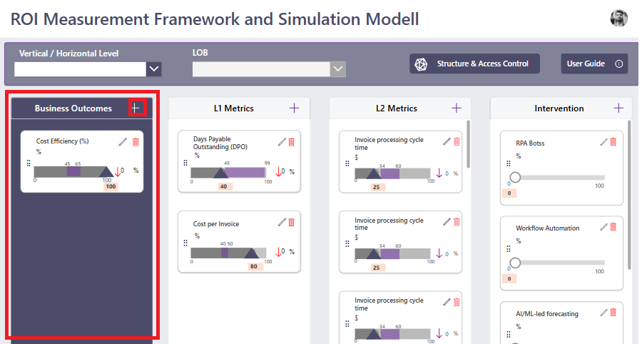

Edit & Delete Functionality
- Admins can modify existing interventions or L0 metrics by clicking the Edit icon next to each item.
- Changes are saved and updated across the model in real time.
- If a component is no longer needed, admins can remove it using the Delete option.
This functionality ensures that the simulation model remains dynamic, accurate, and aligned with business objectives, while giving admins full control over its configuration.
Figure 11 t. Edit L0 Metrics
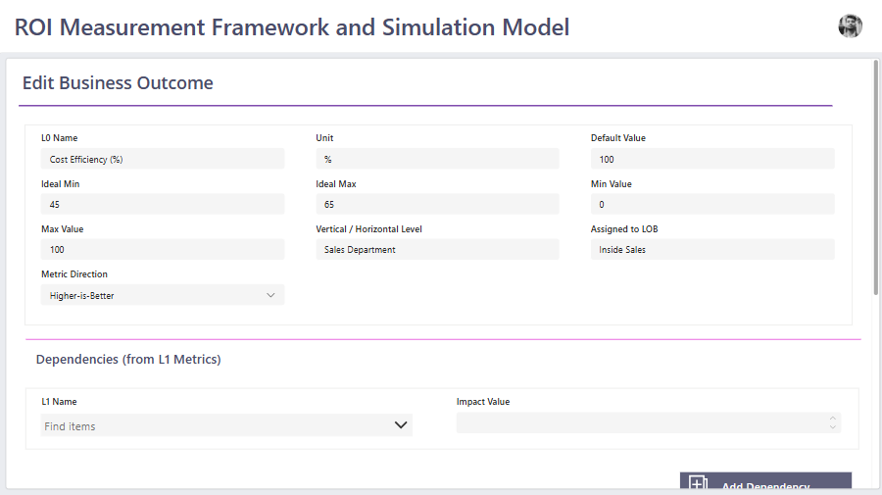

11.11 Logout
To maintain session security and support seamless navigation, the application includes a user-friendly logout mechanism for administrators:
- Admins can initiate logout by clicking on their profile picture located in the top navigation bar.
- Upon clicking, a dropdown tab appears with the “Logout” option.
- Selecting Logout immediately ends the session and redirects the admin to the login page, ensuring secure exit from the application.
This feature supports best practices in access control and session management, helping protect sensitive configuration and simulation data.

Figure 11u. Logout
