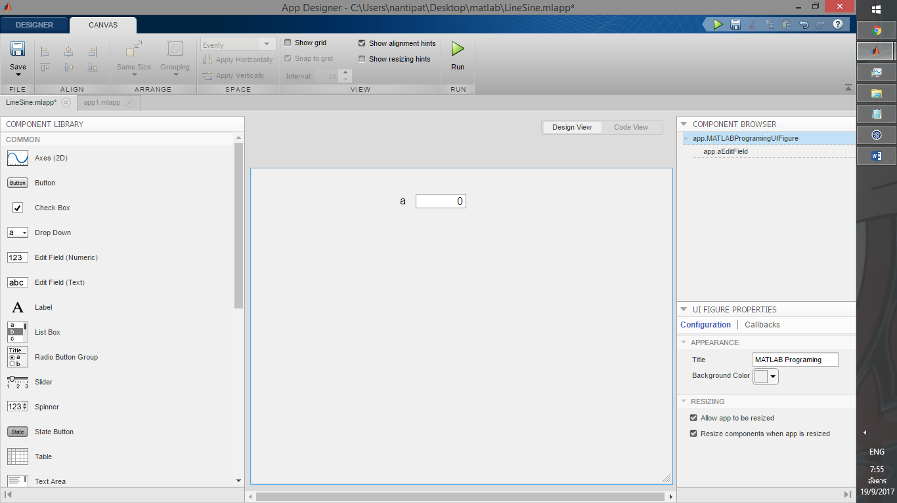

ตรง Ylabel เป็น Sin2x และเปลื่อน title เป็น sin

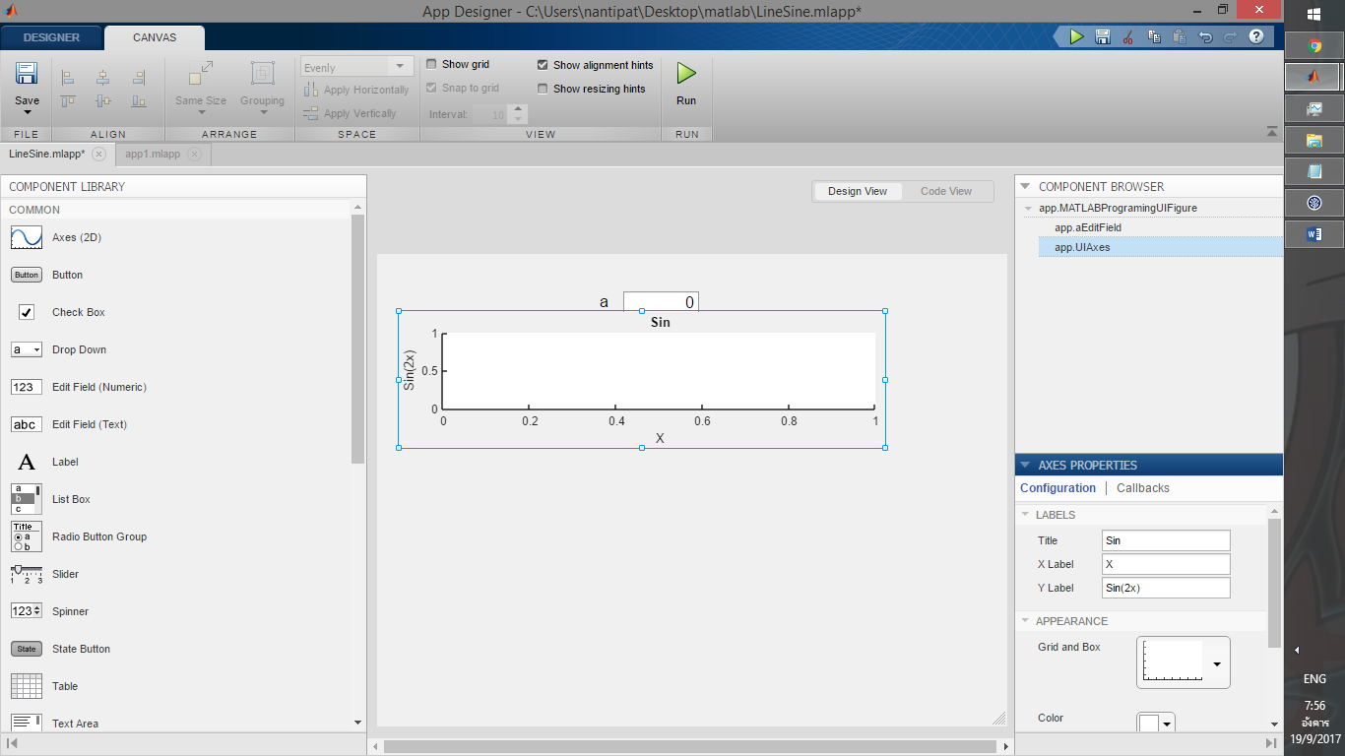

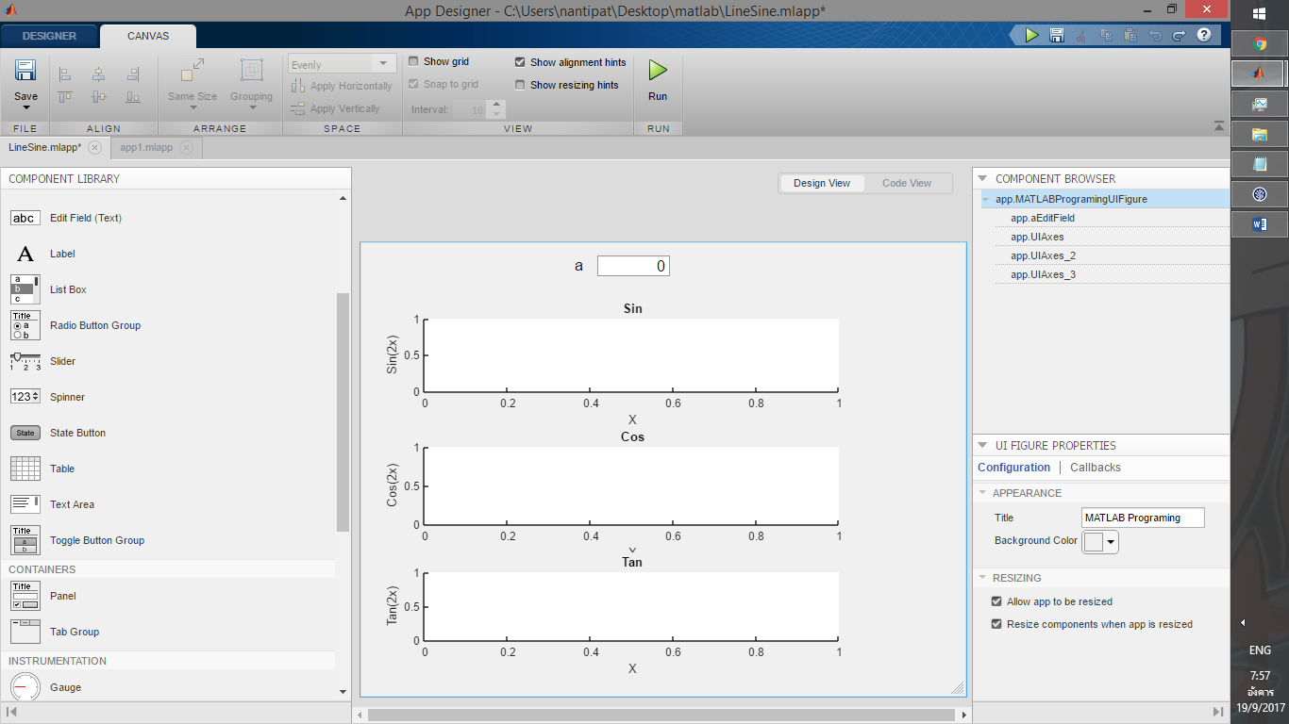ทำซ้ำๆ แล้วเปลื่อนเป็น cos tan ตามลำดับ

กด code review

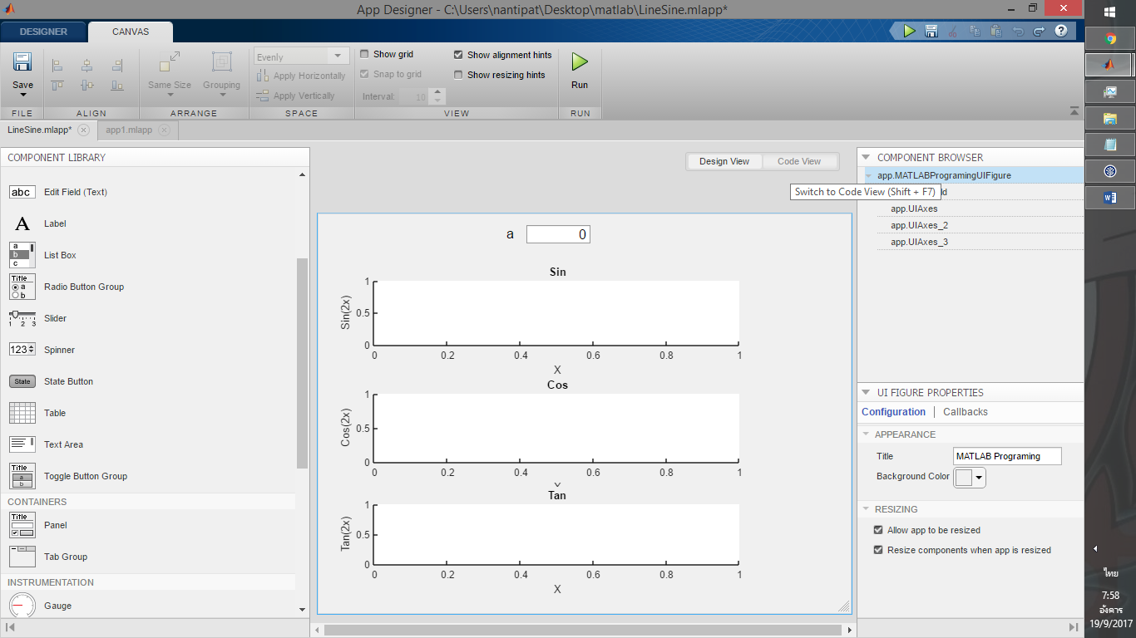

จะได้โค้ดตามนี้ที่โปรแกรมทำมาให้

classdef LineSine < matlab.apps.AppBase

% Properties that correspond to app components

properties (Access = public)

MATLABProgramingUIFigure matlab.ui.Figure

aEditFieldLabel matlab.ui.control.Label

aEditField matlab.ui.control.NumericEditField

UIAxes matlab.ui.control.UIAxes

UIAxes_2 matlab.ui.control.UIAxes

UIAxes_3 matlab.ui.control.UIAxes

end

methods (Access = private)

% Value changed function: aEditField

function aEditFieldValueChanged(app, event)

end

end

% App initialization and construction

methods (Access = private)

% Create UIFigure and components

function createComponents(app)

% Create MATLABProgramingUIFigure

app.MATLABProgramingUIFigure = uifigure;

app.MATLABProgramingUIFigure.Color = [0.9412 0.9412 0.9412];

app.MATLABProgramingUIFigure.Position = [100 100 640 480];

app.MATLABProgramingUIFigure.Name = 'MATLAB Programing';

% Create aEditFieldLabel

app.aEditFieldLabel = uilabel(app.MATLABProgramingUIFigure);

app.aEditFieldLabel.HorizontalAlignment = 'right';

app.aEditFieldLabel.FontSize = 16;

app.aEditFieldLabel.Position = [211 448 25 20];

app.aEditFieldLabel.Text = 'a';

% Create aEditField

app.aEditField = uieditfield(app.MATLABProgramingUIFigure, 'numeric');

app.aEditField.ValueChangedFcn = createCallbackFcn(app, @aEditFieldValueChanged, true);

app.aEditField.FontSize = 16;

app.aEditField.Position = [251 446 77 22];

% Create UIAxes

app.UIAxes = uiaxes(app.MATLABProgramingUIFigure);

title(app.UIAxes, 'Sin')

xlabel(app.UIAxes, 'X')

ylabel(app.UIAxes, 'Sin(2x)')

app.UIAxes.Position = [24 285 492 137];

% Create UIAxes_2

app.UIAxes_2 = uiaxes(app.MATLABProgramingUIFigure);

title(app.UIAxes_2, 'Cos')

xlabel(app.UIAxes_2, 'X')

ylabel(app.UIAxes_2, 'Cos(2x)')

app.UIAxes_2.Position = [24 144 492 142];

% Create UIAxes_3

app.UIAxes_3 = uiaxes(app.MATLABProgramingUIFigure);

title(app.UIAxes_3, 'Tan')

xlabel(app.UIAxes_3, 'X')

ylabel(app.UIAxes_3, 'Tan(2x)')

app.UIAxes_3.Position = [24 21 492 132];

end

end

methods (Access = public)

% Construct app

function app = LineSine

% Create and configure components

createComponents(app)

% Register the app with App Designer

registerApp(app, app.MATLABProgramingUIFigure)

if nargout == 0

clear app

end

end

% Code that executes before app deletion

function delete(app)

% Delete UIFigure when app is deleted

delete(app.MATLABProgramingUIFigure)

end

end

end

เพิ่มโค้ดตามนี้ลงไปเพื่อให้มันทำงานได้

